Tracy Michaels Assignment 1

1. Setting up Hadoop.

* Install java JDK and JRE
* Download Hadoop .tar file
* Uncompress file
* Update Hadoop-env.sh file to include ‘export JAVA_HOME=/usr/lib.jvm/java-11-openjdk-amd64/’
* Create tmp folder in hadoop
* Update core-site.xml in etc directory to include necessary properties
* Do the same for hdfs-site.xml
* Update .bashrc for Hadoop to append following lines to file
  + Export HADOOP_HOME=/home/rob/Hadoop
  + Export PATH=$HADOOP_HOME/bin:$PATH

(I do not have screen shots of this part as I had set it up before this assignment was assigned)

1. Setup HDFS and upload datasets ‘test.txt’ and ‘peterpan.txt’ into HDFS

* Install openssh-client and server
* Create an rsa encrypted public key and store in ‘authorized_keys’ file
* This allows ssh to local host without need for a password
* Use command ‘hsfs namenode -format’ to prepare hdfs
* Start hdfs with command ‘sbin/start-dfs.sh’ from inside the Hadoop folder
* Use command ‘hdfs dfs -mkdir /path’ to create necessary folders
* Use command ‘hdfs dfs -put [local source] [hdfs destination] to copy files from local directory to hdfs

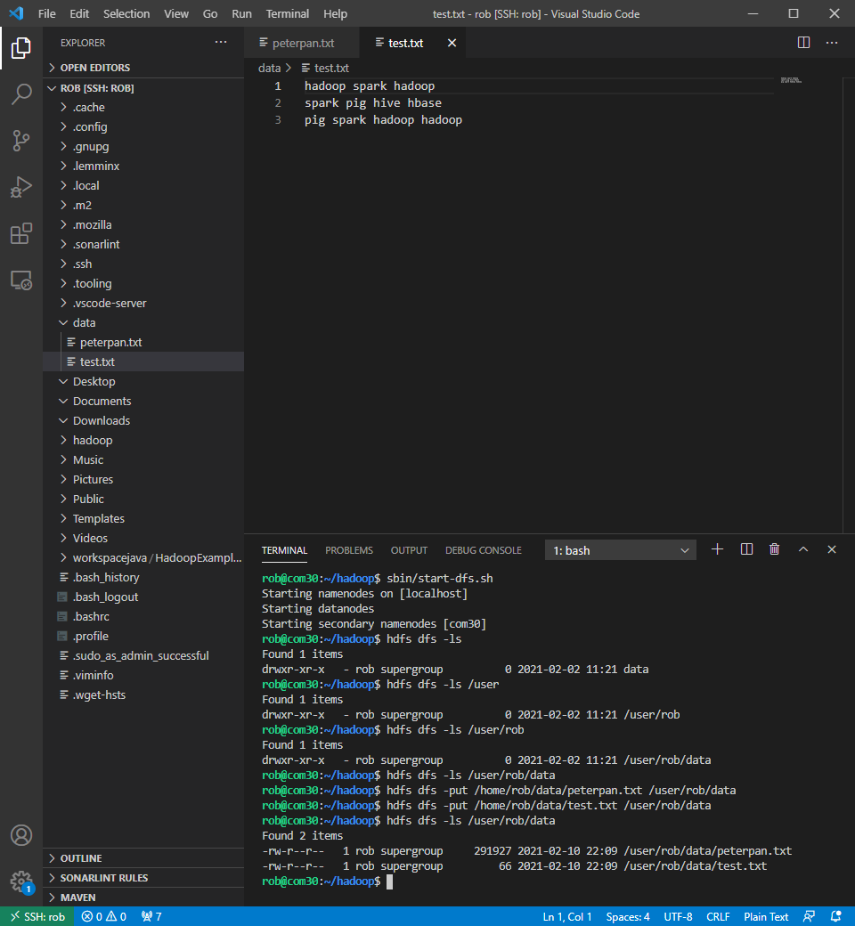

1. Create a maven project in VS Code, import the WordCount.java file

* Add dependencies and plug-ins to pom.xml file
* Create .jar file using maven
* 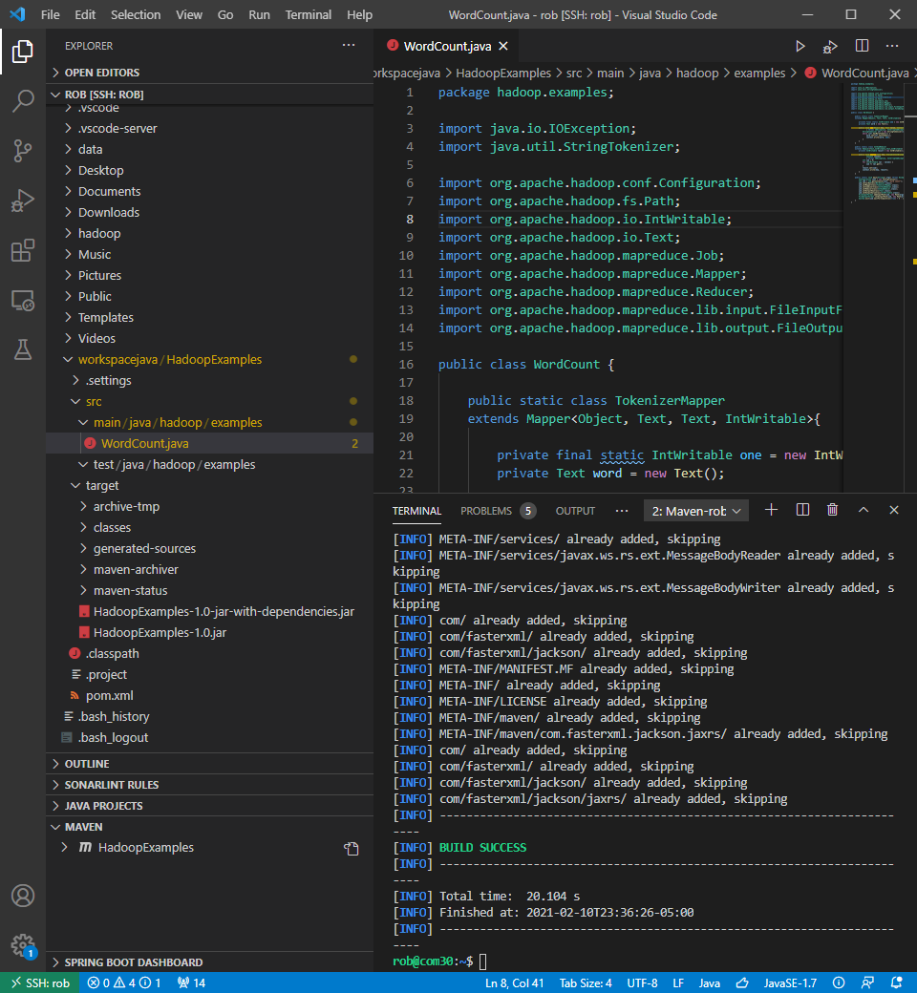

1. Open a terminal, and run the ‘WordCount.jar” file on “test.txt” and “peterpan.txt”

On test.txt:

hadoop jar /home/rob/workspacejava/HadoopExamples/target/HadoopExamples-1.0-jar-with-dependencies.jar file:///home/rob/data/test.txt file:///home/rob/test_output 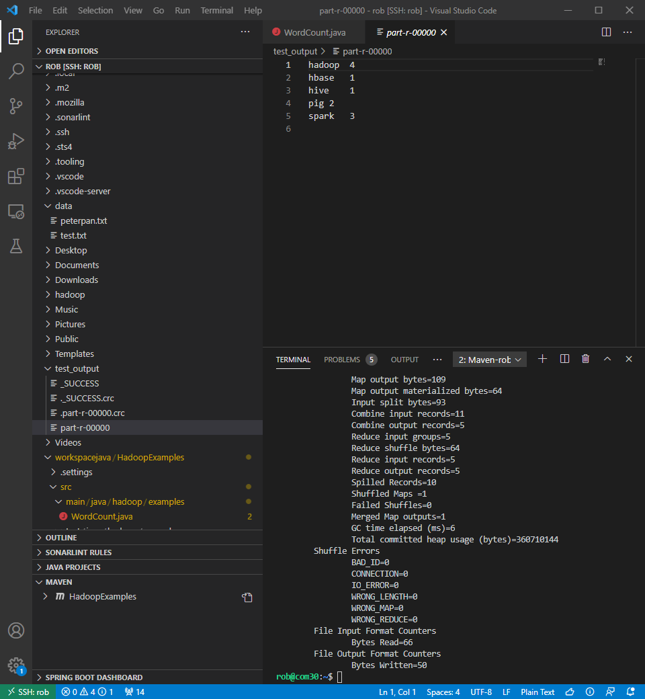

On peterpan.txt:

hadoop jar /home/rob/workspacejava/HadoopExamples/target/HadoopExamples-1.0-jar-with-dependencies.jar file:///home/rob/data/peterpan.txt <file:///home/rob/peterpan_output>

