Week 07 Lab
Finding Myself
Capability: Discovery
Technology: Query Params (keyword / page / size) · MyBatis Plus LambdaQueryWrapper + like + selectPage · Page Payload · MySQL

Course | Web Programming (AI Native)
Project | MyBlog
Week | 07 — Finding Myself / Mission 07: My Blog Finds Information
Estimated Time | approximately 75 minutes

Student Name: ______________________________
Student ID: ______________________________
Date: ______________________________

Contents
Table of contents — open in Word, right-click here, choose “Update Field”.

ABOUT THIS LAB MANUAL
This is your hands-on laboratory manual. Complete it during and after the teacher's live demonstration.
Source: lab.md (Week07 baseline — unchanged). This expanded manual adds an explicit overview, seeding ritual with evidence, a search/pagination test matrix, an evidence map, and a completion checklist; the full Level 1 → 2 → 3 chain, the bare-GET behavior note, the MyBatis Plus sketch, the required AI debug task, and all checkpoints from the baseline are preserved.
Companion files: mission.md (requirements) · assessment.md (evaluation) · common-bugs.md (fixes) · prompts/ (AI templates) · reflection.md, homework.md (submission).
Week06-pilot conventions applied: capability-shaped evidence, hypothesis-first AI loop, experience-before-explanation.

1. Lab Overview
Field | This Lab
Weekly capability | Discovery — MyBlog's memory becomes navigable: search finds the right subset, pagination opens windows onto it
Core question | How can users find information — once memory is real and growing?
Technology | Query parameters (keyword / page / size) · MyBatis Plus LambdaQueryWrapper + like + Page / selectPage (DB-side filter) · clear page payload {items, total, page, size} · HTTP client evidence
Starting state | Your Week06 project: messages persist in MySQL across restart; POST /messages and GET /messages/{id} work; layered Controller → Service → Mapper in place
Ending state | Same project, plus GET /messages?keyword=...&page=...&size=... returning filtered, paged, navigable results from MySQL — create/detail endpoints unchanged
Time | ~75 min in class
Evidence | §7 — seed record, search/page/combined HTTP evidence, test matrix, AI debug log, reflection

The transformation
Week 06: GET /messages → everything, always (memory, but noisy)
↓
Week 07: GET /messages?keyword=hello&page=1&size=5
→ the right subset, one window at a time,
with total telling you how big the match is

Keep asking "Why does MyBlog need this?" before "How do I implement this?"
Full story: story.md · mission.md.

What proves success this week
The capability is discovery. "The endpoint returns something" is not proof — GET /messages already returned something last week. Your proof:
Search: request with a keyword that SHOULD match → matching subset returned
request with a keyword that matches nothing → honest empty answer
Page: page=1 and page=2 return different, expected slices
total is present and correct
Combined: filtered results are also paged (keyword is not lost between pages)
Continuity: POST /messages and GET /messages/{id} behave as in Week06

KEY IDEA
[KEY: Remembering ≠ finding. Week06 proved memory by restart-survival.
Week07 proves discovery by asking questions of that memory
and getting the right subset back — verifiably, on real MySQL rows.]

Estimated lab time
Section | Time
Intro + environment + seeding | 5–10 min
Level 1 — Search + page + combine | 35 min
Level 2 — Understand + AI debug | 20 min
Level 3 — Personal discovery touch | 10 min
Deliverables + reflection | 5 min
Total | ~75 min

2. Starting Point & Environment Check
Discovery needs something worth finding. This week's environment check is not ceremony — the seed data you create now is what every later test stands on.

Task 2.1 — Open your Week06 project
Do NOT create a brand-new project.
MyBlog is evolving. It is not restarting.

Task 2.2 — Prove memory still works
1. Confirm messages persist across a restart (the Week06 test)
2. Confirm these still work:
POST /messages
GET /messages/{id}

Task 2.3 — Seed at least 8 messages (required)
Add 8–12 messages with varied content: some sharing a keyword (e.g. "hello", "blog", a name), some unique. Variety is the point — a search that matches 3 of 10 rows is evidence; a search over 2 rows is a coin flip.

Task 2.4 — Backup, then prepare your HTTP client
Create a backup branch or copy before discovery changes.

Checkpoint — Starting state
☐ Week06 project opens and runs
☐ Restart test passed (messages survive)
☐ POST /messages and GET /messages/{id} work
☐ ≥ 8 varied messages seeded in MySQL
☐ Backup exists
☐ HTTP client ready

EVIDENCE — capture this
[EVIDENCE: Starting state + seed record]
Messages in MySQL after seeding (count): ________________________________
A keyword I planted in ≥ 3 messages: ________________________________
A keyword that exists in NO message: ___0___________________________
Bare GET /messages response length (approx rows): ________________________________
__默认第一页，最多五条（分页后）_____________________________________________________________
______________________________________________________________________________

The planted keyword and the absent keyword are your two most important test instruments this week.

3. Level 1 — Make It Work
Goal: keyword search + pagination + combined query on MySQL messages; create/detail untouched.

Task 3.1 — Feel the overload
Call a broad list and look at the response.
Default list note: After you add discovery, document what bare GET /messages (no page/size) does in your project:
either keep a temporary full-list path for this overload demo, or default to page=1&size=N.
Either choice is fine — write your choice down so evidence stays interpretable.
What becomes hard when there are many messages?
______消息多时，全量响应难以浏览，用户无法直接找到需要的内容；一次传输全部数据也没有必要__________________________________________

My bare GET /messages behavior:
___不传参数时，默认page=1、size=5，无关键词过滤，返回分页结构_____________________________________________
Before writing any code, reason about the requirement with AI:
AI PROMPT — copy, fill in the [brackets], verify the answer
[PROMPT: Requirement reasoning — think before code]
Here is my current MyBlog: messages persist in MySQL; GET /messages
returns the full list.

I want users to find stored messages more easily.
Before writing code:
1. identify the user problem,
2. identify the information that needs to be searched,
3. propose possible API behavior,
4. explain trade-offs.
Do not write implementation code yet.

Record:
One trade-off AI named that I hadn't considered: ________________________________________________
My decision before coding: ________________________________________________

Task 3.2 — Keyword search
Implement:
GET /messages?keyword=...

Requirements:
- reads the query param
- filters persistent MySQL data
- returns matches only
Example shape (MyBatis Plus; names flexible):
// In MessageService — compose discovery in one place
public PageResult<Message> search(String keyword, long page, long size) {
LambdaQueryWrapper<Message> qw = new LambdaQueryWrapper<>();
if (keyword != null && !keyword.isBlank()) {
qw.like(Message::getContent, keyword);
}
Page<Message> mpPage = messageMapper.selectPage(new Page<>(page, size), qw);
return PageResult.of(mpPage); // map to { items, total, page, size }
}

Prefer DB-side like + selectPage over loading all rows into a Java List then filtering. Both return the same JSON at 10 rows; only one survives 100,000.

Task 3.3 — Pagination
Implement:
GET /messages?page=1&size=5

Return a clear payload:
items
total
page
size

The same service method as Task 3.2 can serve pagination with an empty/absent keyword — one composed query path, not two diverging ones.

Task 3.4 — Combine
GET /messages?keyword=...&page=1&size=5

Confirm filtered results are also paged: the keyword must survive across pages. (The classic bug: page 2 "forgets" the keyword and shows unfiltered rows.)

Task 3.5 — Continuity check
☐ POST /messages still works
☐ GET /messages/{id} still works
☐ Data still comes from MySQL (not a memory-List fallback)

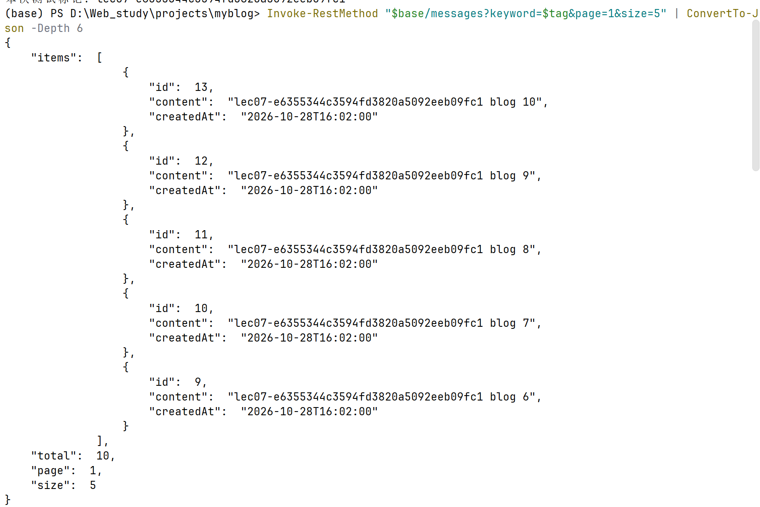
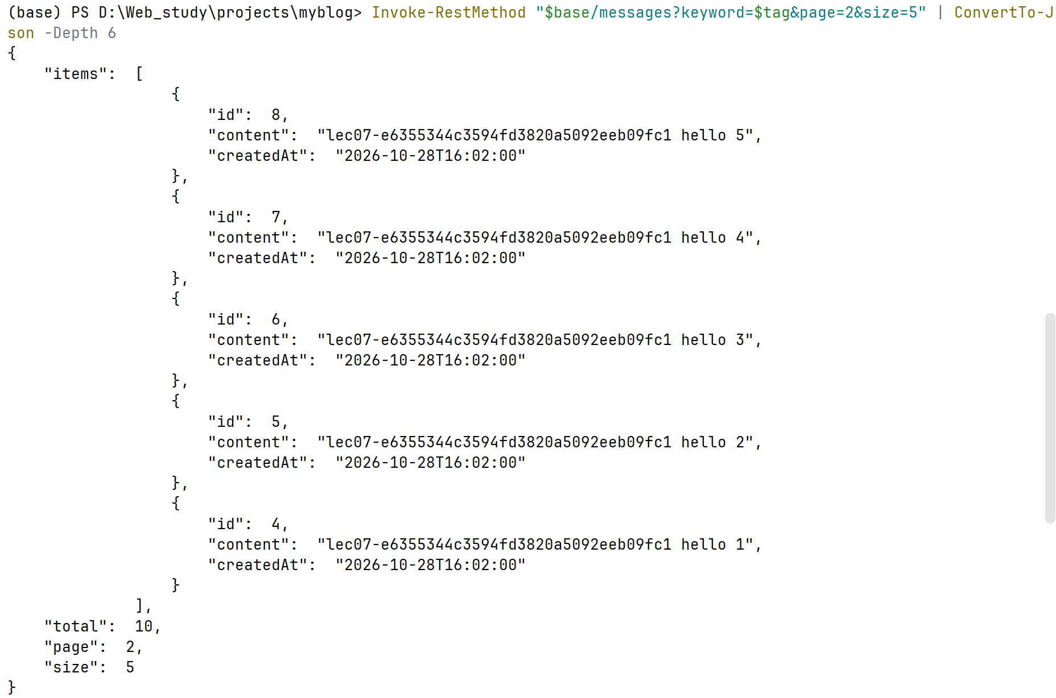
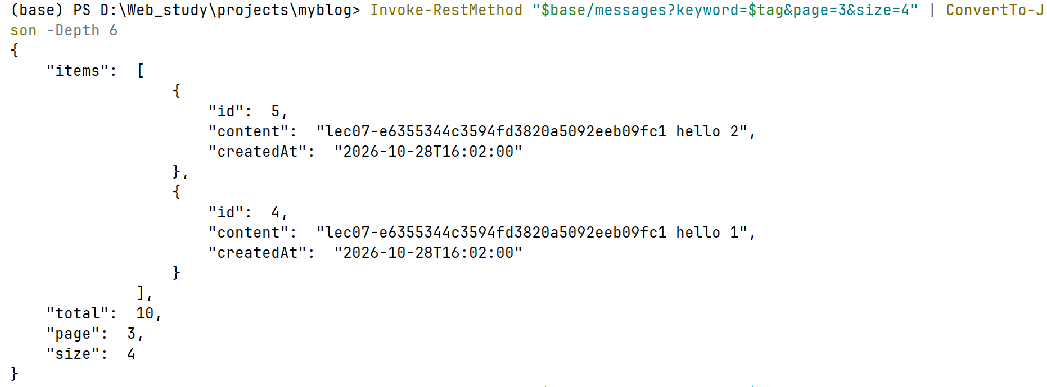
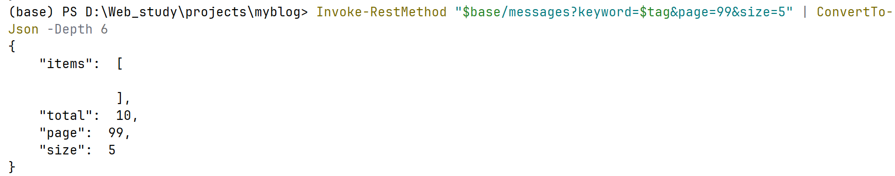
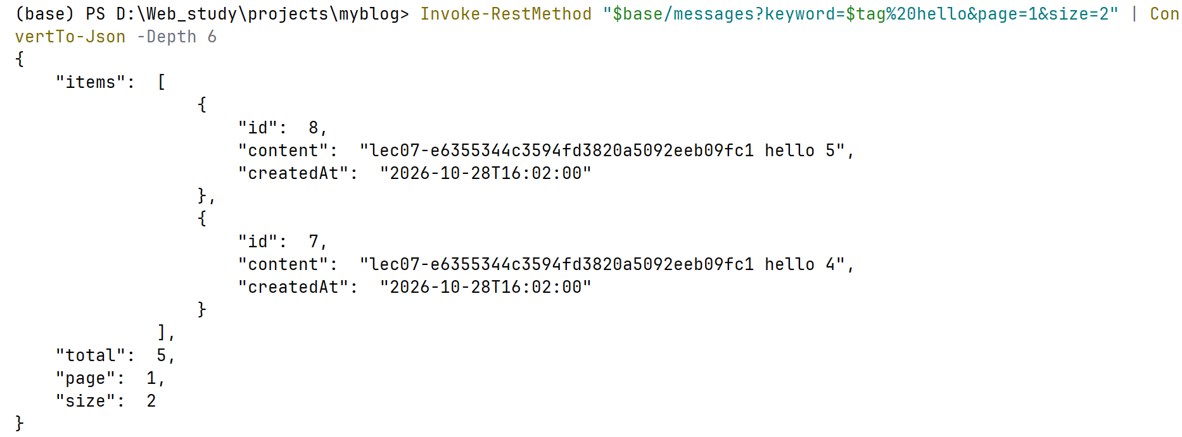
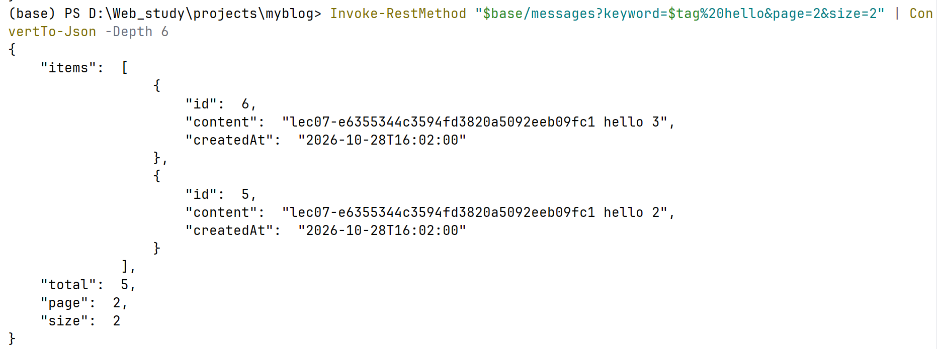
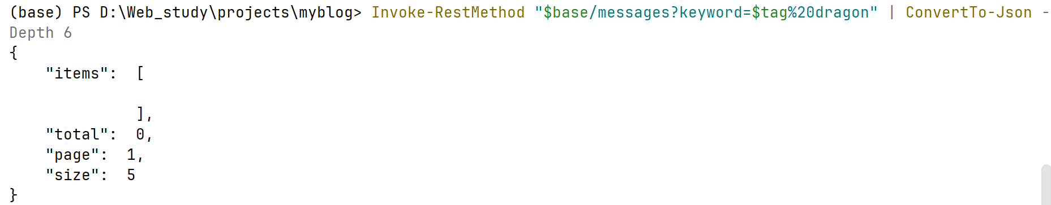
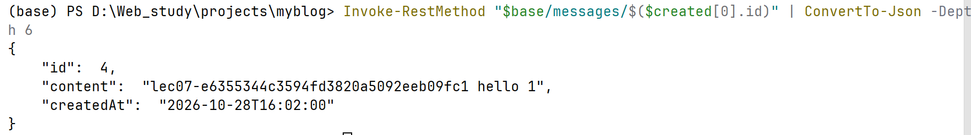
EVIDENCE — capture this
[EVIDENCE: HTTP client — discovery on real memory]
keyword (planted) search → matches: ________________________________
keyword (absent) search → items/total: ________________________________
page=1&size=5 → items count / total: ________________________________
page=2&size=5 → first item same as p1? Yes (BUG) / No (expected)
keyword + page=2 combined → still filtered? ________________________________
______________________________________________________________________________
______________________________________________________________________________

Checkpoint — Level 1
☐ Keyword search works (match AND no-match cases)
☐ Pagination works (page slices + total present)
☐ Combined query works (keyword survives across pages)
☐ POST /messages and GET /messages/{id} unchanged
☐ Evidence captured

4. Level 2 — Understand It
Goal: explain discovery, defend pagination, map your parameters, and debug one real failure with AI.

Task 4.1 — Memory vs discovery
Memory means:
__MyBlog将留言写入MySQL，应用重启后仍可取回。______________________________________________

Discovery means:
___MyBlog能从持久保存的留言中筛出相关记录，并按页返回。_____________________________________________
Explain both using your own MyBlog, not textbook words.

Task 4.2 — Why pagination
Pagination is needed because...
__数据会持续增长，返回全部记录不便浏览；分页限制一次返回量，让用户逐页查找，并通过total知道匹配规模。______________________________________________
________________________________________________
Write your answer first. Then you may pressure-test it:
AI PROMPT — copy, fill in the [brackets], verify the answer
[PROMPT: Pagination reasoning — problem before code]
Why might returning all matching records be a poor API design?

Explain the problem first.
Do not give me code yet.

Record:
AI's strongest argument: ________________________________________________
Whether it changed my answer (why): ________________________________________________

Task 4.3 — Param map
For one successful combined request, record what each parameter did:
Param | Effect
keyword
page
size

Task 4.4 — Layer check
Controller did:
__接收keyword/page/size及默认值，调用Service，把分页结果映射为PageResult。______________________________________________

Service/Mapper did:
___Service转交Repository；DBMessageRepository构造Wrapper和Page；Mapper执行数据库查询。过滤实际发生在MySQL，不在Controller的Java循环。_____________________________________________
Where does the filter live — and why there? (Week05's structure is what makes this answer clean.)

Task 4.5 — AI debug (required)
Break or observe one real issue, e.g.:
- keyword should match but returns []
- page beyond total behaves oddly
- size=0 / missing param confusion
AI PROMPT — copy, fill in the [brackets], verify the answer
[PROMPT: Query debug — context-rich, scoped]
I am on Week07 MyBlog discovery.
Request: GET /messages?keyword=...&page=...&size=...
Actual result: ...
Here are 3 DB rows + service/mapper code.
[paste]

Likely causes?
No Elasticsearch / Redis / Vue suggestions.

Record:
The failing case I used: ________________________________________________
AI's hypothesis I accepted: ________________________________________________
AI suggestion I rejected (and why): ________________________________________________
How I verified the fix (real call): ________________________________________________
Optional — have AI design your verification, not your code:
AI PROMPT — copy, fill in the [brackets], verify the answer
[PROMPT: Verification design — the discovery test matrix]
I implemented search and pagination on MySQL-backed messages.

Design a test matrix for:
- matching results
- no results
- first page
- middle page
- last page
- page beyond available data

Do not modify my code.

Then actually run the matrix:
Test case | Expected result | Actual result | Evidence
Keyword that matches | only matching items, correct total
Keyword with no match | empty items, total 0, no error
First page (page=1) | first size items of the set
Middle page | different slice, no overlap with page 1
Last page | remaining items (may be fewer than size)
Page beyond data | empty items, total still correct, no crash
Combined keyword+page | filtered set is paged; keyword not lost

Checkpoint — Level 2
☐ Memory vs discovery explained in my own words
☐ Why-pagination answer written (before AI)
☐ Param map complete
☐ Layer check written
☐ AI debug: real failure, verified fix, accept/reject recorded
☐ Test matrix executed with evidence

5. Level 3 — Make It Yours
Goal: discovery that sounds like your MyBlog. Choose at least one:

Option A — Personal filter
from / topic / mood query support.

Option B — Sort style
Newest-first or a custom default sort that fits your blog.

Option C — Empty-result voice
When nothing is found, respond like your MyBlog — an honest, personal "I looked and found nothing" instead of a bare [].
Ask:
Does this help me find myself in remembered content?
EVIDENCE — capture this
[EVIDENCE: Level 3 — what I personalized and why]
Option chosen: A / B / C
What changed (one sentence): ________________________________________________
Why this fits my MyBlog: ________________________________________________
______________________________________________________________________________
______________________________________________________________________________

Checkpoint — Level 3
☐ Personal discovery touch applied
☐ Search/page still work (re-tested)
☐ Short note written

6. Optional Extension
Only after L1–L3 are complete (details: mission.md §9, challenge.md):
- Sort by created time asc/desc
- Validate page/size bounds
- Highlight the matched keyword in a response field
- Optional one-to-many preview (message + tags) — not required
Same Week07 technology. No Vue. No Redis. No Elasticsearch.

7. Evidence & Submission

The Week07 evidence map
Capability claim | Evidence that proves it
Memory still works | Restart test + POST/GET /messages/{id} unchanged (§2, §3.5)
Search finds the right subset | Planted-keyword match evidence + absent-keyword honest empty (§3.5)
Pagination navigates memory | page=1 vs page=2 slices + correct total (§3.5)
Keyword and page compose | Combined request, keyword survives across pages (§3.5, matrix)
I understand the design | Memory-vs-discovery + why-pagination + param map + layer check (§4)
I debug with AI, own the fix | Real failure + context-rich prompt + verified fix + accept/reject (§4.5)
Discovery is mine | Level 3 personal touch + note (§5)

Submit
☐ Source code with discovery APIs
☐ HTTP evidence: search, page, combined
☐ Test matrix with results
☐ Level 2 notes + AI log
☐ Level 3 personal note
☐ Reflection

Reflection should answer (reflection.md): why GET-all stopped being enough · what each query parameter really controls · where the filter lives and why · what "no match" should mean · what AI suggested and what you kept/rejected · what you found in your own memory.

8. Troubleshooting
Symptom-first. More: common-bugs.md.
Symptom | Likely cause | First move
Search always empty | Wrong column / case mismatch / still filtering an in-memory copy | Compare one real DB row against your like condition by hand
Page ignores keyword | Combined query not applied together | Log/trace the final query: does it contain BOTH conditions?
total missing | Returned a bare list instead of the page payload | Map the MP Page object to {items, total, page, size}
Page beyond total crashes or looks wrong | No empty-page handling | Decide the honest answer: empty items + correct total
size=0 / missing params confuse the API | No defaults or validation | Pick defaults; document the bare-GET behavior choice
Create/detail broke after adding discovery | Accidental edit in shared code | Re-run §3.5 continuity; diff against backup
Want Vue / Elasticsearch now | Out of scope | API first — Week08/09 will use these endpoints

9. Completion Checklist
☐ Starting state verified: restart persistence + POST + GET by id
☐ ≥ 8 varied messages seeded; planted + absent keywords recorded
☐ Backup created before discovery changes
☐ L1: keyword search works on MySQL (match + no-match)
☐ L1: pagination returns slice + total
☐ L1: combined keyword+page works (keyword survives paging)
☐ L1: continuity check passed
☐ L2: concepts + param map + layer check written
☐ L2: AI debug with real failure, verified fix, accept/reject
☐ L2: test matrix executed with evidence
☐ L3: personal discovery touch applied and re-tested
☐ Evidence map §7 complete
☐ AI log + reflection complete
☐ Continued Week06 project — no restart
☐ No Vue / Redis / Elasticsearch / vector search / JPA rewrite

10. Technical Boundary Reminder
This lab stays inside Week07. Do not introduce:
WARNING — forbidden pattern
❌ Vue UI
❌ Redis
❌ Elasticsearch / vector search
❌ JPA rewrite
❌ Required multi-table redesign

Your entire toolbox is: query params + MyBatis Plus conditional/page queries + a clear payload. It is enough — and it is the thinking, not the engine, that transfers later.

11. Bridge Forward
Discovery APIs are ready.
GET /messages?keyword=...&page=...&size=...
↓
(a question, not yet answered)

Carry this question out of the week — do not answer it yet:
These APIs can now answer "find it" and "show me a window".
But who will ask? A person with an HTTP client can.
What if MyBlog's memory had a face that anyone could talk to —
and is the backend actually ready for one?
Week 07: Discovery
Later: a face can bind to these APIs

Do not build Vue in this lab.
Detailed troubleshooting: `common-bugs.md` · Mission and evaluation: `mission.md`, `assessment.md` · AI templates: `prompts/`.

