Week 02 Lab
My Blog Has a Voice
Capability: Structured Voice
Technology: Java Object → JSON · Content-Type · Resource Naming

Course | Web Programming (AI Native)
Project | MyBlog
Week | 02 — I Speak / Mission 02: My Blog Has a Voice
Estimated Time | approximately 90–100 minutes

Student Name: ______________________________
Student ID: ______________________________
Date: ______________________________

1. Lab Overview
Field | This Lab
Weekly capability | A Voice — MyBlog communicates structured information (JSON), not just output
Core question | How can my application express meaningful information?
Technology | Java data classes · @RestController returning objects · automatic Object→JSON (Jackson, beginner level) · Content-Type: application/json · resource naming · DevTools
Starting state | Your Week01 project: running app, GET /hello, plain-text GET /me
Ending state | Same project evolved: GET /profile returns JSON (≥3 fields); GET /me upgraded String→JSON; 3 bugs debugged with AI
Time | ~90–100 min in class (Bug 3 may finish as homework)
Evidence | §8 — JSON screenshots, Content-Type proof, AI debugging records, reflection

The transformation
Week 01: "Hello, I Exist." (one flat sentence)
↓
Week 02: { "name": "...", "owner": "...", "message": "..." } (a voice with parts)

Keep asking "Why does MyBlog need this?" before "How do I implement this?"
Full story: story.md · mission.md.

What proves success this week
The capability is structured communication. HTTP 200 alone is not proof — a plain String also returns 200 (you will demonstrate this yourself in Bug 1). Your proof is structure + content type:
Action: open GET /profile
Observable: browser shows { "name": ..., "owner": ..., "message": ... }
Verification: DevTools → Status 200 AND Content-Type: application/json;
JSON keys match your Java field names
Contrast: /hello (flat text) vs /profile (structured JSON) — same server
Evidence: §8 map — screenshots + AI records + before/after note

Estimated lab time
Section | Time
Mission intro + environment check | 5 min
L1A — Make MyBlog Speak (/profile) | 15 min
L1B — Upgrade Existing Endpoint (/me) | 10 min
L2A — Understand the Magic | 15 min
L2B — Debugging with AI (Bugs 1–2 in class) | 20–25 min
L3 — Make It Yours | 10 min
Deliverables + reflection | 5–10 min
Total (in class) | ~90–100 min

Time note: Bugs 1–2 are required in lab. Bug 3 is required for submission — finish in class if time allows; otherwise complete as homework with the same AI log format.

2. Starting Point & Environment Check
Keep this short — your tools already work from Week01. The important check is the starting state of the project, not the JDK.

Task 2.1 — Open your Week01 project
Open the Spring Boot project you built in Week01.
Do NOT create a brand-new unrelated project.
MyBlog is evolving. It is not restarting.

(Only if your teacher tells you to recover a lost project may you start fresh.)

Task 2.2 — Verify the baseline still runs
java -version

Expected: Java 17+. Then run the application and confirm the console shows Tomcat started on port(s): 8080 (http) and Started MyBlogApplication .... Open http://localhost:8080/hello — expected: your Week01 greeting.
If /hello does not work, fix Week01 first (weeks/week01/common-bugs.md). Do not build this week on a broken foundation.

Checkpoint — Starting state
☐ Week01 project opens in IDEA
☐ Application runs (Tomcat on 8080)
☐ GET /hello returns my Week01 response
☐ GET /me returns my Week01 plain-text introduction

EVIDENCE — capture this
[EVIDENCE: Starting state — record before changing anything]
Java version: ___25.0.4.1___________
GET /hello works: Yes
GET /me (text) says: __I am Tracy. I study CS. I am interested in skiing...
______________________________________________________________________________
______________________________________________________________________________

3. Level 1 — Make It Work
Level 1 has two parts, both required: 1A — Make MyBlog Speak (`/profile`) and 1B — Upgrade Existing Endpoint (`/me`).

3A. Make MyBlog Speak (GET /profile)
Goal: upgrade MyBlog from plain text to structured JSON at GET /profile.

Task 3A.1 — Why this matters (answer first)
Why is a JSON response more useful than a plain sentence when another system wants to read MyBlog's information?
My answer:
_JSON 把不同信息放在带名字的字段中，其他程序可以准确读取 name、owner 等字段，而不必猜测一句话的格式。
Do not skip this. If you cannot answer yet, continue — but return after Level 2.

Task 3A.2 — Observe the current voice
Open http://localhost:8080/me (or /hello). DevTools: F12 → Network → refresh → click the request → inspect body and headers.
EVIDENCE — capture this
[EVIDENCE: Current voice — Week01 baseline observation]
URL I opened: ____ http://localhost:8080/me________________
Response body: ____ I am Tracy. I study CS. I am interested in skiing. This is the beginning of my blog.________________
Content-Type (if visible): __ text/html;charset=UTF-8
______________________________________________________________________________
______________________________________________________________________________

Notice: readable — but still one block of text.

Task 3A.3 — Create the Java object for MyBlog's voice
Create src/main/java/com/myblog/model/BlogProfile.java (keep your own package style if different):
package com.myblog.model;

public class BlogProfile {

// These field names will become JSON keys
public String name;
public String owner;
public String message;
}

You are not decorating the project — you are deciding what MyBlog can say: name → who this application is · owner → who created it · message → what it wants to communicate.
Observation checkpoint:
1. What is BlogProfile?
Answer: _____它是一个用来保存博客结构化资料的 Java 类。___________________________
2. If I later rename owner to author, what JSON key do I expect?
Answer: ___________默认会变成 "author"。_____________________

Task 3A.4 — Return the object from the Controller
Open your Week01 Controller. Add:
@GetMapping("/profile")
public BlogProfile profile() {
BlogProfile blogProfile = new BlogProfile();
blogProfile.name = "MyBlog";
blogProfile.owner = "Your Name";
blogProfile.message = "Nice to meet you.";
return blogProfile;
}

Replace "Your Name" with your real name. Notice the return type: BlogProfile — not String. You are returning structured information, not a sentence.

Task 3A.5 — Run and observe the transformation
1. Restart the application
2. Open http://localhost:8080/profile — expected:
{
"name": "MyBlog",
"owner": "Your Name",
"message": "Nice to meet you."
}

3. DevTools → Network → click /profile → confirm: Status 200 and Content-Type includes application/json (ctrl+shift+I to open devTools or use browser optionsmore toolsDevTools)
EVIDENCE — capture this
[EVIDENCE: Screenshot — /profile JSON in the browser]
Also capture: DevTools showing Content-Type: application/json
_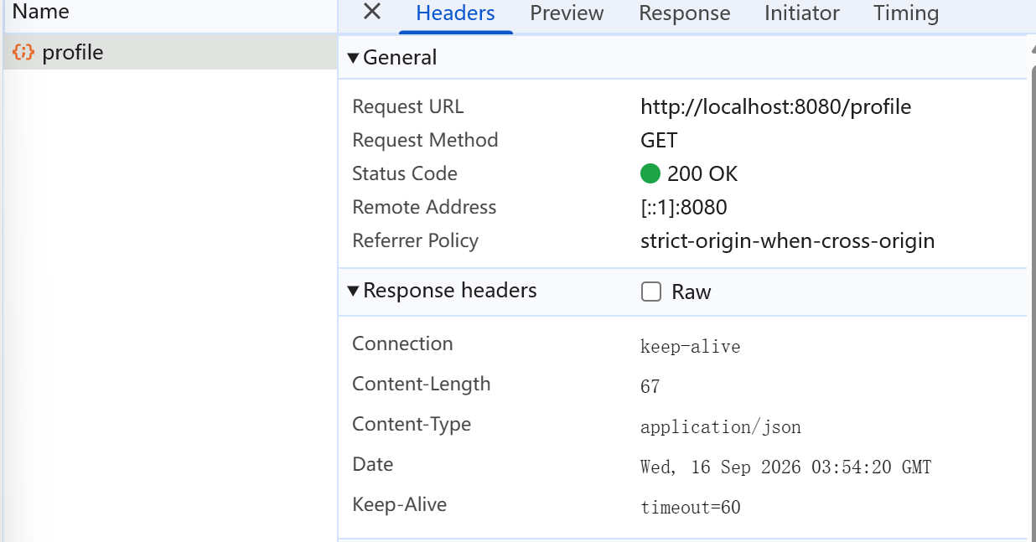_____________________________________________________________________________

Similar to this:
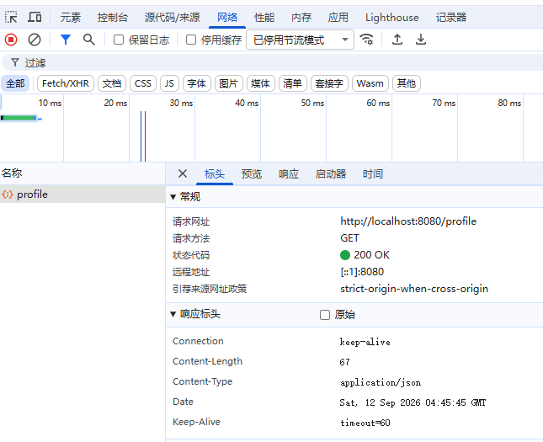

Checkpoint — Level 1A
☐ BlogProfile class created
☐ GET /profile returns JSON
☐ Browser shows name, owner, message
☐ DevTools shows application/json
☐ I did not only copy code — I observed the result

Pause and look. Say to yourself: I returned a Java object. The browser received JSON. Something converted my object into a Web message. That feeling is the center of Week02.

3B. Upgrade Existing Endpoint (GET /me)
Goal: upgrade GET /me from String to JSON — in the same project. Real systems evolve; if you rebuild from zero every week you are practicing tutorials, not software growth.

Task 3B.1 — Before / After
Before (your Week01 version):
@GetMapping("/me")
public String me() {
return "My name is MyBlog";
}

After — GET /me returns a JSON object:
{
"name": "MyBlog",
"owner": "Student"
}

Task 3B.2 — Create the response class
package com.myblog.model;

public class MeResponse {
public String name;
public String owner;
}

(You may add one more field in Level 3.)

Task 3B.3 — Upgrade the Controller method
@GetMapping("/me")
public MeResponse me() {
MeResponse meResponse = new MeResponse();
meResponse.name = "MyBlog";
meResponse.owner = "Your Name";
return meResponse;
}

Task 3B.4 — Compare before and after
Open http://localhost:8080/me. Record the transformation:
EVIDENCE — capture this
[EVIDENCE: Before/After — the upgrade in your own words]
Before (Week 01 style): _返回一整段String_______________________________________________
After (Week 02 JSON): __返回有独立字段的JSON___{
"name": "MyBlog",
"owner": "Tracy"
}
__
What feels different? _JSON 更容易被浏览器、Vue、手机应用和其他程序读取

Keep GET /hello as plain text for a side-by-side comparison:
/hello → existence (plain text)
/me → personal voice (JSON)
/profile → structured profile (JSON)

Checkpoint — Level 1
☐ GET /profile returns JSON
☐ GET /me returns JSON
☐ I continued the Week01 project (no restart)
☐ I can explain why upgrading beats restarting
☐ MyBlog feels like one evolving application

4. Level 2 — Understand It
Two parts, both required: 2A — Understand the Magic, 2B — Debugging with AI.

4A. Understand the Magic
Goal: explain Java Object → Spring Boot → JSON Response.

Exploration questions (own words; AI as partner; final answers yours)
Question 1
I returned a Java object. Why did the browser receive JSON?
My answer:
__因为 @RestController 会把方法返回值写入 HTTP 响应，Spring Boot 使用 Jackson 把 Java 对象序列化为 JSON。
Question 2
Who converted the object? (Hint: @RestController and Jackson at a beginner level — no framework internals.)
My answer:
___Spring MVC 负责处理请求和响应，Jackson 在后台进行对象到 JSON 的转换。
Question 3
What information is in the HTTP response? (DevTools: at least status code, Content-Type, response body.)
My answer:
_至少包括状态码、响应头和响应正文。这里状态是 200 OK，Content-Type 是 application/json，正文是 JSON。_
Question 4
What is the difference between return "Hello, I Exist."; and return blogProfile;?
My answer:
__前者返回普通字符串；后者返回 Java 对象，Spring 会把对象字段转换成 JSON 键值。
Question 5 — Resource naming
Why is /profile a better name than /getProfileData or /hello2? (Resource thinking, not full REST theory.)
My answer:
___/profile 表示一个资源，名字简洁且说明“这是什么”；/getProfileData 把动作写进路径，/hello2 不能说明资源含义。___

Suggested AI prompts (ask only after seeing JSON in the browser)
AI PROMPT — copy, fill in the [brackets], verify the answer
I am building a Spring Boot personal blog called MyBlog.

I have a @RestController method that returns a Java object named BlogProfile.
The browser receives JSON.
I did not configure any JSON converter myself.

Please explain at a beginner level:
1. Why the Java object becomes JSON
2. What role @RestController plays
3. What Jackson is doing conceptually

Do not explain advanced Jackson configuration.

AI PROMPT — copy, fill in the [brackets], verify the answer
I opened DevTools for GET /profile.
The Content-Type is application/json.
Please explain what Content-Type means
and why it matters for Web communication.

After AI answers
What AI said that helped me:
_我正在构建 Spring Boot 个人博客 MyBlog。
@RestController 中的一个方法返回 BlogProfile 对象，
但浏览器收到 JSON，我没有手动配置 JSON 转换器。

请按初学者水平解释：
1. Java 对象为什么变成 JSON
2. @RestController 的作用
3. Jackson 在概念上做了什么
不要讲高级 Jackson 配置。_______________________________________________

What I verified myself in the browser:
__我在 GET /profile 的开发者工具中看到：
Content-Type: application/json

请解释 Content-Type 的含义，
以及它为什么对 Web 通信很重要。______________________________________________

What I can now explain without AI:
________________________________________________

Checkpoint — Level 2A
☐ I can explain why a Java object became JSON
☐ I can name the beginner-level pieces involved
☐ I checked status code and Content-Type
☐ I can explain why /profile beats /getProfileData or /hello2
☐ I used AI to understand, not only to generate code

4B. Debugging with AI
Break things on purpose. Repair them with understanding. This is part of Understand It, not an optional extra.
In-class requirement: Bugs 1 and 2 (with an AI record each). Submission requirement: Bug 3 also — class if time allows, otherwise homework, same format.
For every bug, record: Problem → Hypothesis → AI Question → Solution → Learning.

AI debugging rules
1. Form a hypothesis before asking AI
2. Ask with context: expected result + actual result + code
3. Verify AI's suggestion in the browser
4. Write what you learned in your own words
Bad prompts: Give me the code. / Why doesn't this work?
Good pattern: Context + Expected + Actual + Code + Question

Task 4B.1 — Bug 1: Return String instead of Object
Temporarily change /profile:
@GetMapping("/profile")
public String profile() {
return "name=MyBlog, owner=Student, message=Hello";
}

Open the browser. Question: why is this not JSON communication? Even if the text looks organized to human eyes, why is it weaker than returning a Java object? (And notice: the status is still 200 — this is why 200 alone never proves this week's capability.)
Required AI question (adapt as you like):
AI PROMPT — copy, fill in the [brackets], verify the answer
[PROMPT: Bug 1 investigation — hypothesis first, then ask, then verify]
I am working on Spring Boot MyBlog Week 02.

I temporarily changed GET /profile to return a String:
"name=MyBlog, owner=Student, message=Hello"

I expected structured JSON communication.
Instead, the browser shows plain text.

Please explain at a beginner level:
1. Why returning a String is not the same as returning JSON
2. Why another program would struggle to read this response
3. What I should return instead, and why

Record:
Problem: ______我把 GET /profile 暂时改成返回 String，结果浏览器显示的是纯文本，而不是我期望的结构化 JSON。__________________________________________
Hypothesis (before asking AI): ________________________________________________
AI Question (paste your prompt): ________________________________________________
What AI suggested: __________返回 String 不等于返回JSON，由于程序没有标准字段名和固定格式，一旦文本格式改变，程序就有可能崩溃
Solution: ________________________________________________
Learning: _______200只代表请求成功，不代表发你的是JSON
Restore the object-returning version before continuing.

Task 4B.2 — Bug 2: Remove @RestController
Change @RestController → @Controller. Restart and open /profile.
Question: why does Spring not return the expected JSON response?
Required AI question:
AI PROMPT — copy, fill in the [brackets], verify the answer
[PROMPT: Bug 2 investigation — hypothesis first, then ask, then verify]
I am working on Spring Boot MyBlog Week 02.

My GET /profile method returns a BlogProfile object.
When the class uses @RestController, the browser shows JSON.
When I change @RestController to @Controller, the response is no longer the expected JSON.

Please explain at a beginner level:
1. What difference @RestController makes for the return value
2. Why @Controller alone does not give me the same JSON response
3. How I can verify the fix

Record:
Problem: ________________________________________________
Hypothesis (before asking AI): ________________________________________________
AI Question (paste your prompt): ________________________________________________
What AI suggested: ________________________________________________
Solution: ________________________________________________
Learning: ___普通 @Controller 默认把返回值用于 MVC 视图处理；@RestController 才表示把返回值直接写入响应正文。_
Restore @RestController immediately after the experiment.

Task 4B.3 — Bug 3: Wrong field name
When: in class if time remains after Bugs 1–2; otherwise required homework before submission (same AI log format).
Rename one Java field, e.g. message → note. Do not update your mental expectation. Open the browser and observe the JSON keys.
Question: why is the JSON structure different?
Required AI question:
AI PROMPT — copy, fill in the [brackets], verify the answer
[PROMPT: Bug 3 investigation — hypothesis first, then ask, then verify]
I am working on Spring Boot MyBlog Week 02.

My BlogProfile class originally had a field named message.
I renamed the Java field to note.
The JSON key also changed from "message" to "note".

Please explain at a beginner level:
1. Why the JSON key changed when I renamed the Java field
2. What this tells me about Object → JSON mapping
3. How I should choose field names when designing MyBlog's voice

Record:
Problem: ________________________________________________
Hypothesis (before asking AI): ________________________________________________
AI Question (paste your prompt): ________________________________________________
What AI suggested: ________________________________________________
Solution: ________________________________________________
Learning: ______默认情况下，Java 字段名会成为 JSON 键名
Completed in: [ ] class [ ] homework

Decide the final key — message or note — so the field name matches the meaning you want MyBlog to speak.

AI collaboration log
For each meaningful AI interaction in Level 2, keep in ai-log.md:
1. What I Asked: ________________________________________________
2. What AI Suggested: ________________________________________________
3. What I Used: ________________________________________________
4. What I Changed: ________________________________________________
5. What I Learned: ________________________________________________
6. What AI Got Wrong or Missed: ________________________________________________
Submission must include: Bugs 1–2 records (lab) · Bug 3 record (class or homework) · at least one Level 2A explanation interaction.

Checkpoint — Level 2
☐ I can explain Object → JSON mapping without reading notes
☐ I explained why /profile beats /getProfileData or /hello2
☐ I tested String vs Object (Bug 1)
☐ I tested @Controller vs @RestController (Bug 2)
☐ I observed field names becoming JSON keys (Bug 3 — class or homework)
☐ I asked AI for Bugs 1–2 in lab; Bug 3 recorded for submission
☐ I formed a hypothesis before each AI question
☐ I verified AI suggestions in the browser
☐ I recorded Problem / Hypothesis / AI Question / Solution / Learning

Only after 2A + Bugs 1–2 are complete, move to Level 3. (Finish Bug 3 before final submission if deferred.)

5. Level 3 — Make It Yours
Goal: personalize MyBlog's voice — after this level, MyBlog should sound like you. Structured communication is also identity practice: a profile full of meaningless fields is still empty.

Task 5.1 — Choose meaningful fields
Add personal information to /profile and/or /me. Candidates: favoriteQuote · introduction · vision · hobby · city · goal.
WARNING — forbidden pattern
❌ Avoid meaningless fields: a · test · asdf · field1

Ask yourself: if another system read only this JSON, would it know something true about me?
Optional AI design prompt (you decide what stays):
AI PROMPT — copy, fill in the [brackets], verify the answer
[PROMPT: Field design — AI suggests, you decide what stays]
I am designing a simple JSON profile for a personal blog.
I already have name, owner, and message.
Suggest 2 meaningful personal fields.
Keep it beginner-friendly.
No database. No nested objects.

Task 5.2 — Update classes and endpoints
Example direction for /me:
{
"name": "Alex",
"owner": "Alex",
"hobby": "Photography",
"vision": "Build my digital self",
"favoriteQuote": "Create something that responds."
}

Your fields can differ. What matters is that they are yours.
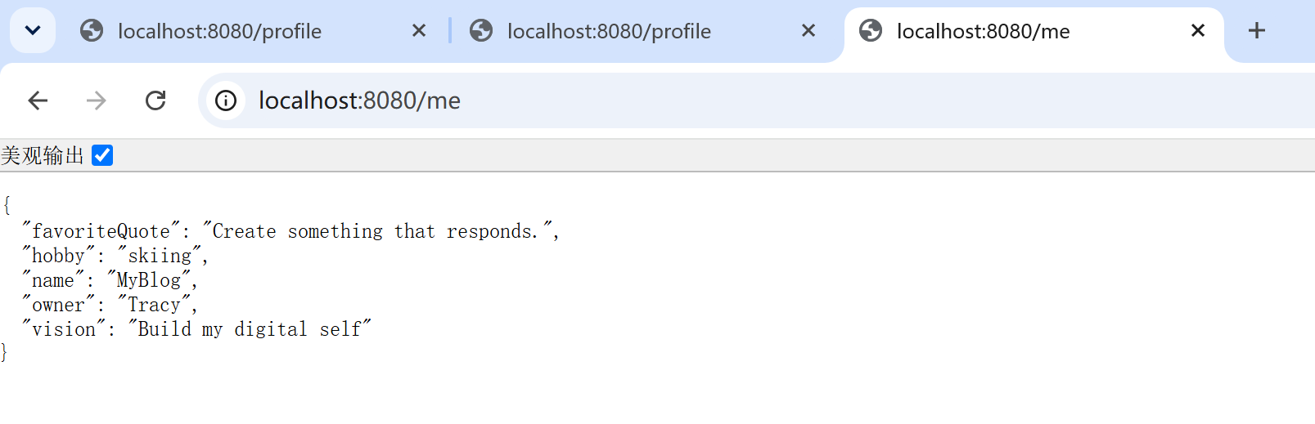

Task 5.3 — Read your voice aloud
Open the JSON in the browser. Read it as if MyBlog is speaking. Ask: does this sound like me? Does it feel generic? What one field would make it more honest? — then change one field based on that answer.

Checkpoint — Level 3
☐ JSON contains personal information
☐ Fields are meaningful, not random
☐ I can say: "MyBlog sounds like me."

6. Optional Extension
If you finish early, create GET /status:
{
"status": "alive",
"week": 2,
"ability": "I can speak."
}

Same Week02 idea. No new technology required.

7. Evidence & Submission

The Week02 evidence map
Capability claim | Evidence that proves it
MyBlog speaks in structure | Screenshot: /profile JSON with ≥3 fields in the browser
The Web recognizes it as JSON | DevTools screenshot: Content-Type: application/json (+ 200)
The project evolved (not restarted) | Before/after note for /me; Week01 endpoints still live
I understand the conversion | 2A answers + "Java object → JSON because…" in your words
I debug with a hypothesis-first AI loop | Bug 1–3 records in ai-log.md
MyBlog sounds like me | Personalized fields visible in JSON

Submit
1. Source code — the updated MyBlog project: BlogProfile (or equivalent), GET /profile, upgraded GET /me, personalized fields.
2. Screenshots — at minimum /profile returning JSON; recommended: DevTools showing Content-Type: application/json.
3. AI collaboration log — ai-log.md: one Level 2A explanation interaction · Bugs 1–2 debugging records (lab) · Bug 3 record (class or homework).
4. Reflection — answer "What did MyBlog learn this week?" and complete reflection.md (see homework.md for the full list). Minimum closing lines:
Before Week 02, my application only...
After Week 02, my application can...
The most important thing I understood is...
The thing I still want to understand better is...

8. Completion Checklist
☐ Starting state verified: Week01 project ran before I changed anything
☐ L1A: BlogProfile created; /profile returns JSON; DevTools shows application/json
☐ L1B: /me upgraded String → JSON in the SAME project
☐ L2A: Object → JSON + Content-Type + resource naming explained in my words
☐ L2B: Bug 1 and Bug 2 broken, hypothesized, AI-investigated, fixed, recorded
☐ L2B: Bug 3 recorded (class or homework) with the same format
☐ L3: personalized fields; MyBlog sounds like me
☐ Evidence map §7 complete
☐ ai-log.md + reflection.md complete
☐ I did NOT introduce database / Vue / service layer / POST

9. Technical Boundary Reminder
This lab stays inside Week02. Do not introduce:
WARNING — forbidden pattern
❌ Database / MySQL / JPA
❌ Vue
❌ IoC / DI / Service layer
❌ POST requests / @RequestBody
❌ Authentication

Feeling the urge to store data permanently? Good instinct — that is Week06 (Memory). This week is only about voice.

10. Bridge to Week03
MyBlog can speak now. But a voice needs an identity — a generic profile is still only a beginning:
{
"name": "MyBlog",
"owner": "Student",
"message": "Nice to meet you."
}

This is communication. It is not yet a full self.
Week 01: I Exist
Week 02: I Speak
Week 03: I Am Someone

Your application has a voice. Next, that voice begins to carry a real identity.
Detailed troubleshooting: `common-bugs.md` · Mission and evaluation: `mission.md`, `assessment.md` · AI templates: `prompts/`.

