Week 04 Lab
I Can Listen
Capability: Interaction
Technology: POST · @RequestBody · @PathVariable / @RequestParam · In-Memory List · HTTP Client

Course | Web Programming (AI Native)
Project | MyBlog
Week | 04 — I Can Listen / Mission 04: My Blog Can Listen
Estimated Time | approximately 65 minutes

Student Name: ______________________________
Student ID: ______________________________
Date: ______________________________

Contents
Table of contents — open in Word, right-click here, choose “Update Field”.

ABOUT THIS LAB MANUAL
This is your hands-on laboratory manual. Complete it during and after the teacher's live demonstration.
Source: lab.md (Week04 baseline — unchanged). This expanded manual adds an explicit overview, starting-state verification, evidence map, and completion checklist; the full Level 1 → 2 → 3 chain, all three bug exercises, the restart experiment, and all AI prompts from the baseline are preserved.
Companion files: mission.md (requirements) · assessment.md (evaluation) · common-bugs.md (fixes) · prompts/ (AI templates) · reflection.md, homework.md (submission).
Week06-pilot conventions applied: capability-shaped evidence, hypothesis-first AI loop, experience-before-explanation.

1. Lab Overview
Field | This Lab
Weekly capability | Interaction — MyBlog receives information from visitors and responds; heard messages can be retrieved
Core question | Can my application receive information from users?
Technology | POST · @RequestBody · @PathVariable · @RequestParam · in-memory List · HTTP client (Postman / Apifox / curl / IDEA HTTP)
Starting state | Your Week03 project: running app, rich GET /profile identity JSON, evolved GET /me
Ending state | Same project evolved: POST /messages accepts JSON, GET /messages + GET /messages/{id} retrieve what was heard, restart loss observed, 3 AI debug records
Time | ~65 min in class
Evidence | §7 — HTTP client evidence (POST + GET), restart observation, AI records, reflection

The transformation
Week 03: MyBlog speaks — every endpoint only *returns* information
↓
Week 04: MyBlog listens — a visitor's JSON arrives, is held, and can be read back

Keep asking "Why does MyBlog need this?" before "How do I implement this?"
Full story: story.md · mission.md.

What proves success this week
The capability is listening. A 200 OK on your POST is not proof — the server can return 200 without hearing anything. Your proof has two halves:
Half 1 — Heard: send { "content": "Hello, MyBlog" } via POST
→ the response carries your content
→ GET /messages later still shows it (listening accumulated)
Half 2 — Not yet remembered:
restart the application → GET /messages → empty
(heard ≠ remembered — that gap is Week06)

KEY IDEA
[KEY: A message you sent must be retrievable — retrieval proves listening.
And its disappearance after restart proves memory is still missing.
Both observations are required evidence this week.]

Estimated lab time
Section | Time
Intro + environment check | 5 min
Level 1 — Receive + retrieve | 25 min
Level 2 — Understand + AI debug + restart experiment | 20 min
Level 3 — Personalize | 10 min
Deliverables + reflection | 5 min
Total | ~65 min

2. Starting Point & Environment Check
This week adds one new tool to your kit: an HTTP client. The browser address bar can only send GET — it physically cannot send a JSON POST body.

Task 2.1 — Open your Week03 project
Open the Spring Boot project you have been growing since Week01.
Do NOT create a brand-new project.
MyBlog is evolving. It is not restarting.

Task 2.2 — Verify the baseline still runs
Run the application. Confirm http://localhost:8080/profile returns your Week03 identity JSON.
If /profile does not return your identity, fix Week03 first. Listening is built on top of identity — a blog that doesn't know who it is cannot meaningfully hear visitors.

Task 2.3 — Prepare your HTTP client
Have one ready before Level 1: Postman · Apifox · curl · IDEA HTTP — your choice.
# curl example (optional quick check that your client works):
curl http://localhost:8080/profile

Checkpoint — Starting state
☐ Week03 project opens in IDEA
☐ Application runs (Tomcat on 8080)
☐ GET /profile returns my identity JSON
☐ HTTP client is installed and can call GET /profile

EVIDENCE — capture this
[EVIDENCE: Starting state — record before changing anything]
GET /profile returns (short note): ________________________________
HTTP client I will use: ________________
_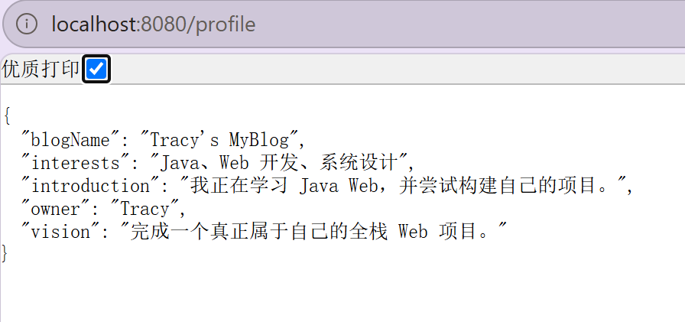_____________________________________________________________________________
______________________________________________________________________________

3. Level 1 — Make It Work
Goal: POST receive + list/retrieve messages. By the end, a message you send can be read back.

Task 3.1 — Feel the gap
Before writing any code: try to "leave a message" using only what exists (GET endpoints).
Why GET is not enough:
GET 主要用于读取资源；浏览器地址栏不能带上本实验需要的 JSON 请求体，所以要用 POST 发送消息内容。
If you are unsure, that is fine — the demo showed the failure. Write your best guess now; revisit after Level 2.

Task 3.2 — Create MessageRequest
Create the input shape — the visitor's voice:
public class MessageRequest {
public String content;
}

(Place it beside your PersonalProfile, e.g. com.myblog.model. Optional personal fields like from or topic come later, in Level 3.)
Notice: this is Week03's DTO idea facing the other direction — a data shape for incoming communication.

Task 3.3 — Receive with POST
Add to your controller:
@PostMapping("/messages")
public MessageRequest create(@RequestBody MessageRequest request) {
// store and return

}

Note：You need to import the class MessageRequest And the annotation class RequestBody as well. The following two import statements should appear at the header:
import com.myblog.model.MessageRequest;
import org.springframework.web.bind.annotation.RequestBody;

Then send, using your HTTP client:
Method: POST
URL: http://localhost:8080/messages
Header: Content-Type: application/json
Body:

{
"content": "Hello, MyBlog"
}
Using the following command in windows command line:
curl -X POST http://localhost:8080/messages -H "Content-Type: application/json" -d "{\"content\": \"hello, MyBlog\"}"
See the Screenshot below:
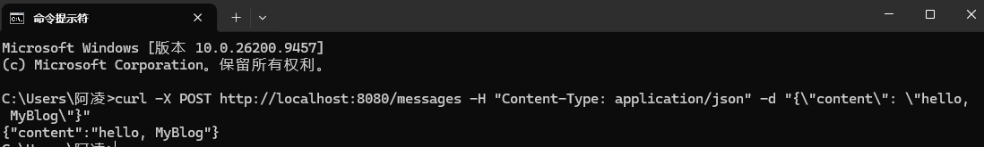
Expected result: the response includes the content you sent.
Verification: confirm the response body carries "Hello, MyBlog" — not an empty object, not null.
EVIDENCE — capture this
[EVIDENCE: HTTP client — POST /messages request + response]
Capture BOTH sides: method+URL+headers+body (request) and the JSON response.
Tool used: ________________
__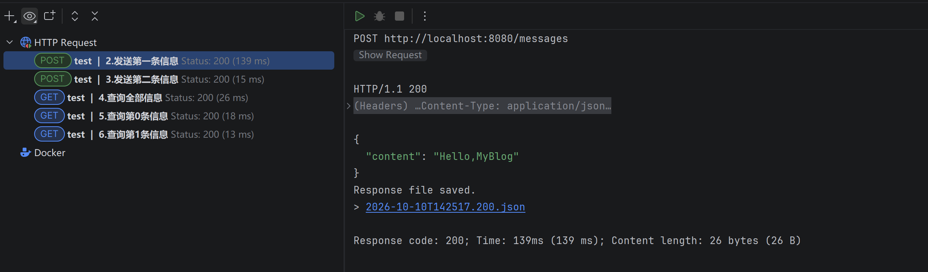____________________________________________________________________________
______________________________________________________________________________

Sample Code：
@PostMapping("/messages")
public MessageRequest create(@RequestBody MessageRequest request) {
messages.add(request);
return request;
}

Task 3.4 — Temporary memory
Keep messages in a list, inside the controller (that is intentional this week):
private final List<MessageRequest> messages = new ArrayList<>();

On each POST, add the received request to the list. ("A list inside the Controller? Yes. The itch you feel is Week05's curriculum — write the itch down, don't fix it yet.")

Task 3.5 — Retrieve what was heard
Implement at least:
GET /messages
GET /messages/{id}

Optional:
GET /messages?keyword=hello

The accumulation check (Half 1 of this week's proof):
1. POST a first message ("Hello, MyBlog")
2. POST a second, different message
3. Open GET /messages in the browser (GET is browser-friendly) — both messages must appear
4. Open GET /messages/1 (or your indexing) — one specific message appears
EVIDENCE — capture this
[EVIDENCE: Screenshot — GET /messages showing BOTH messages sent earlier]
This is what proves listening accumulated. A POST 200 alone would not.
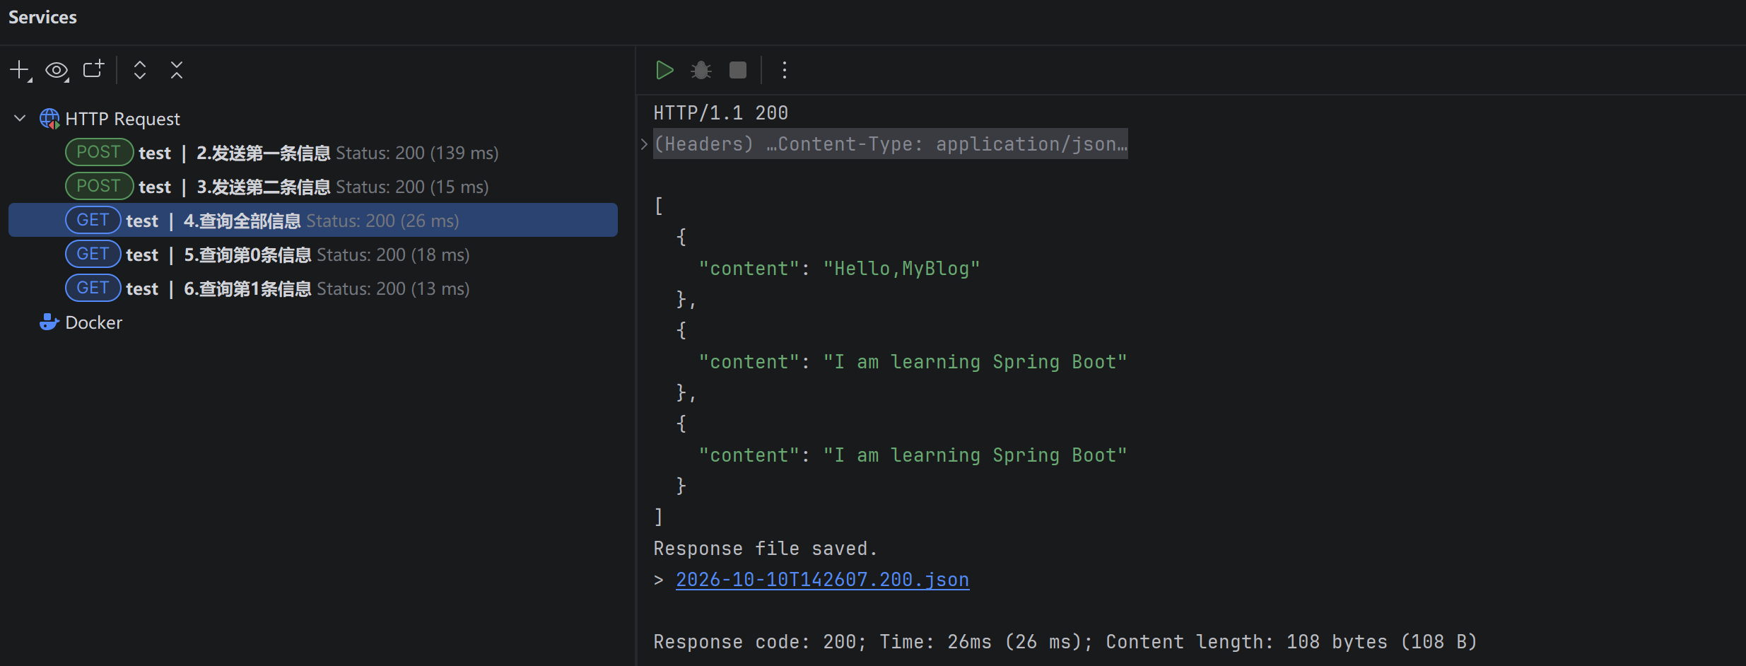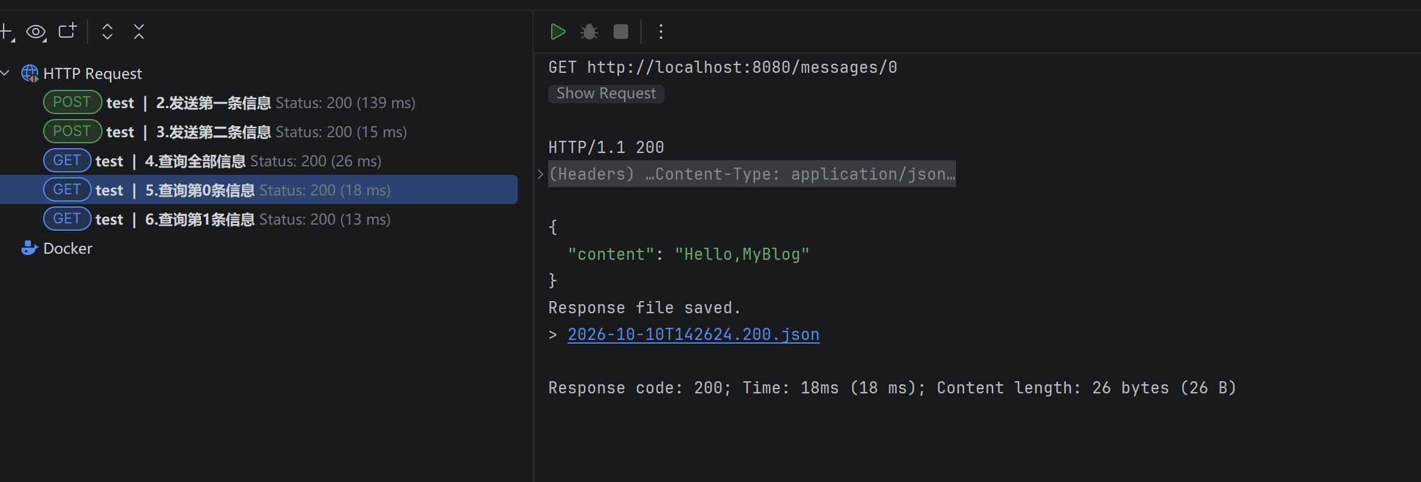______________________________________________________________________________

Sample Code:
// 1. 列出所有听到的消息
@GetMapping("/messages")
public List<MessageRequest> list() {
return messages;
}

// 2. 按位置取一条（@PathVariable：从 URL 路径里取参数）
@GetMapping("/messages/{index}")
public MessageRequest getOne(@PathVariable int index) {
return messages.get(index);
}

Checkpoint — Level 1
☐ POST accepts JSON body
☐ Received content appears in response
☐ GET can list messages
☐ PathVariable or RequestParam works
☐ HTTP client evidence saved

Pause and look. Say to yourself: a stranger's words entered my application, and I can read them back. That is the center of Week04.

4. Level 2 — Understand It
Goal: explain the binding, debug it with AI, and observe what restart destroys.

Task 4A.1 — Exploration questions (own words first)
1. What is the difference between request and response in your POST call?
2. Why use POST to leave a message?
3. Complete: "JSON became a Java object because…"
4. What happens after restart? Why?
My answers:
1. _Request是客户端发给服务端的数据，Response是服务器处理后，返回给客户端的结果__
2. _用于传数据，POST主要用于提交数据给服务器，数据放在请求体（requestbody）里面，不像GET只能拼在URL内。
3. _ Java 代码无法直接操作一段纯文本的 JSON 字符串
4. _所有的请求会刷新_______________________________________________

Task 4A.2 — AI explanation prompt
Ask only after your own answers exist:
AI PROMPT — copy, fill in the [brackets], verify the answer
[PROMPT: Understanding — @RequestBody and the reverse of Week02]
Explain @RequestBody for a beginner Spring Boot student.
Use MyBlog POST /messages as example.
No database. No security. No service layer.
Also explain how this is the reverse of returning JSON from a Java object.

Record:
What AI said that helped: ________________________________________________

What I verified myself (client/browser): ________________________________________________

What I can explain without AI: ________________________________________________

Task 4B — Debugging with AI (required)
Break things on purpose. Repair them with understanding. For each bug, record: Problem → Hypothesis → AI Question → Solution → Learning.
AI debugging rules: hypothesis before asking · ask with context (headers + body + code) · verify the fix in your HTTP client · write the learning in your own words.

Bug 1 — Wrong / missing Content-Type
Send the body without the JSON content type (or a wrong header). Observe failure/null.
AI PROMPT — copy, fill in the [brackets], verify the answer
[PROMPT: Bug 1 investigation — hypothesis first, then ask, then verify]
I POST to Spring Boot @RequestBody MessageRequest.
content is null / request fails.
Here is my request headers, body, and controller method.
Likely causes?

Record:
Problem: Content-Type 错误或缺失________________________________________________
Hypothesis (before asking AI): ________________________________________________
AI Question (paste your prompt): ________________________________________________
Solution: _尝试不发送 application/json 或设置错误类型，观察失败或字段为空；再恢复 Content-Type: application/json。_______________________________________________
Learning: ________________________________________________
Restore the correct Content-Type: application/json before continuing.

Bug 2 — JSON key mismatch
Send {"text":"hello"} while the field is content. Observe null.
Question: the request returned 200 — so why is content null? (Another case where 200 alone proves nothing.)
AI PROMPT — copy, fill in the [brackets], verify the answer
[PROMPT: Bug 2 investigation — hypothesis first, then ask, then verify]
I POST JSON to Spring Boot @RequestBody MessageRequest.
The response is 200, but content is null.
My JSON body: {"text":"hello"} — my Java field: public String content;
Here are my request body and controller method.
Likely causes?

Record:
Problem: ___ JSON 键不匹配。_____________________________________________
Hypothesis (before asking AI): ________________________________________________
AI Question (paste your prompt): ________________________________________________
Solution: __发送 {"text":"hello"}，但 Java 字段是 content。即使响应是 200，也可能 content 为 null，因为 JSON 键和 Java 字段名不匹配。______________________________________________
Learning: ________________________________________________

Bug 3 — Wrong path or GET used by mistake
Call the POST URL with GET, or a wrong path. Observe the result and explain it.
AI PROMPT — copy, fill in the [brackets], verify the answer
[PROMPT: Bug 3 investigation — hypothesis first, then ask, then verify]
I called http://localhost:8080/messages with GET instead of POST
(or a wrong path). Here is the exact request I sent and the
status code / error I received.
Why did Spring Boot respond this way?
What does the error tell me about how it matches requests to methods?

Record:
Problem: ___错误路径或请求方法。_____________________________________________
Hypothesis (before asking AI): ________________________________________________
AI Question (paste your prompt): ________________________________________________
Solution: __请求一个不存在的路径，或用错误方法访问仅支持另一方法的路径，并记录状态码和原因。______________________________________________
Learning: ________________________________________________

Task 4C — Restart experiment (Half 2 of this week's proof)
1. Create 2 messages (POST twice)
2. GET /messages — confirm both exist
3. Restart the application
4. GET /messages again
EVIDENCE — capture this
[EVIDENCE: Restart experiment — heard ≠ remembered]
Before restart, GET /messages showed: ________________________________
After restart, GET /messages showed: ________________________________
What disappeared? __消息只存在应用进程的内存列表里；程序停止后内存数据清空。______________________________
What does this teach about memory? ________________________________
_ 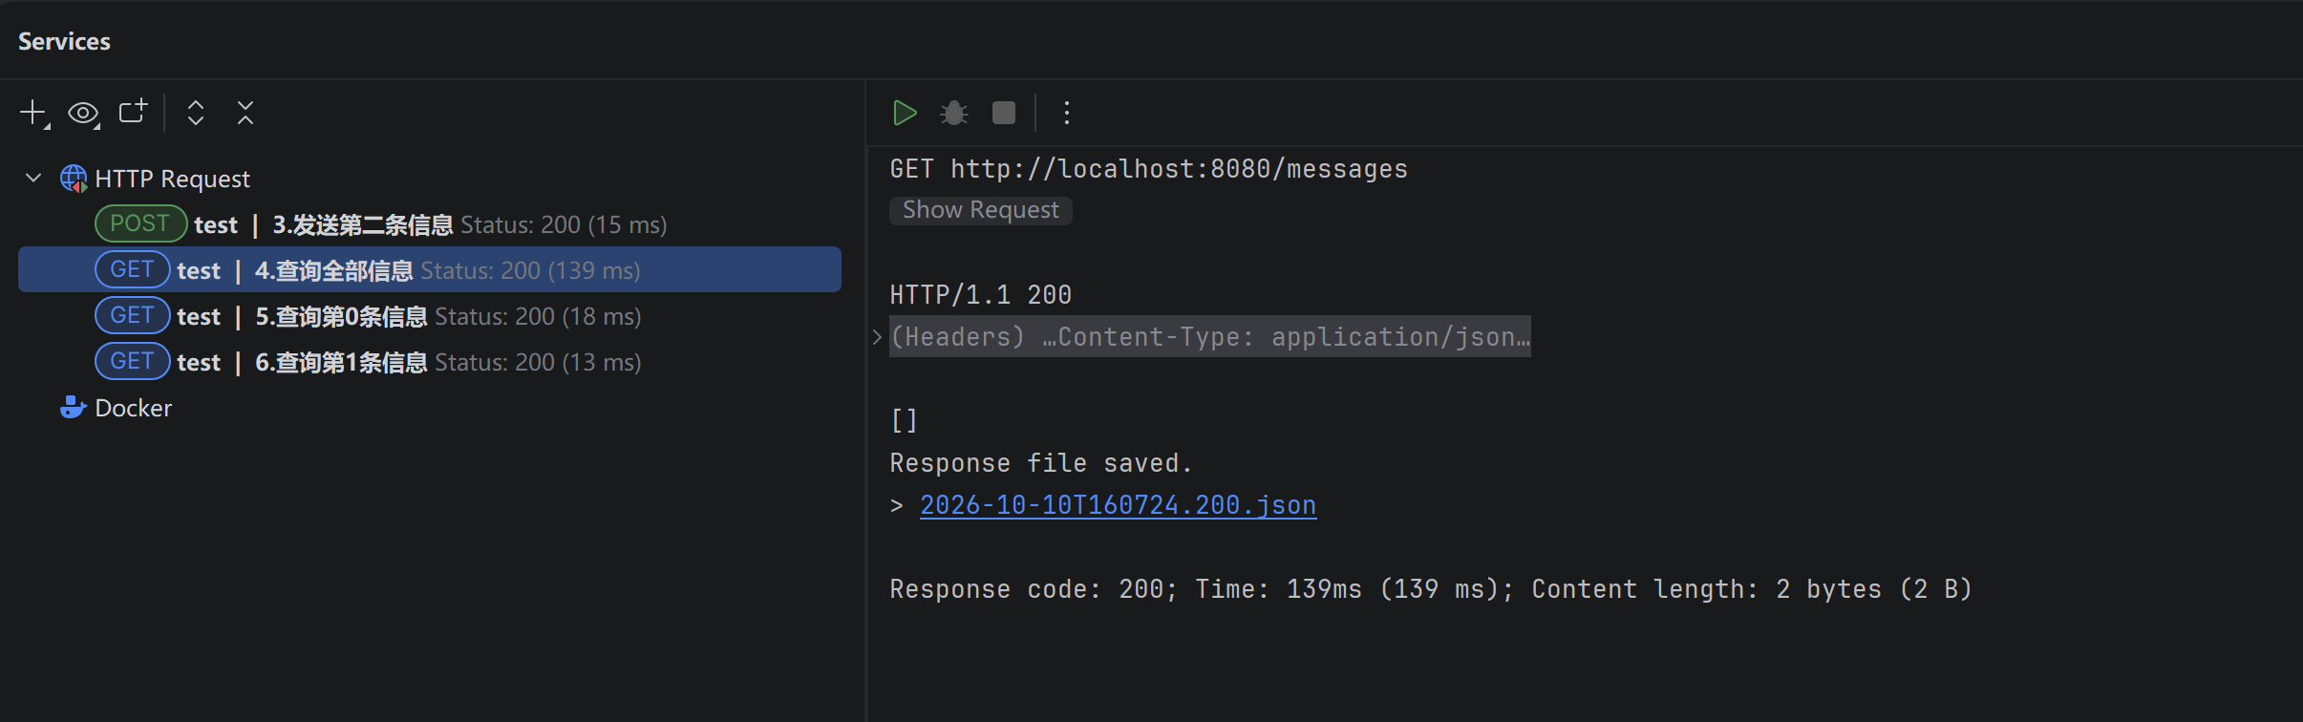_____________________________________________________________________________
______________________________________________________________________________

The code didn't change. The server didn't crash. The messages lived in memory — and memory resets. Hold onto that feeling; it has a week number (06).

Checkpoint — Level 2
☐ I can explain request vs response
☐ I can explain @RequestBody
☐ I completed 3 AI debug records
☐ I observed restart data loss
☐ I noticed the Controller is getting crowded (save this feeling for Week05)

5. Level 3 — Make It Yours
Goal: personalize the listening experience — after this level, being heard by your MyBlog should feel different from a generic API demo.

Task 5.1 — Personalize the listening voice
Choose deliberately:
- response wording ("MyBlog heard you" → your voice)
- optional fields that fit your blog (from, topic, mood…)
- message topics related to your identity
Ask:
Does this feel like my MyBlog listening, or a generic API demo?
Remember Week03: your MyBlog knows who it is. It should hear in its own voice.

Task 5.2 — Optional AI critique
AI PROMPT — copy, fill in the [brackets], verify the answer
[PROMPT: Design critique — AI suggests, you decide what stays]
Here is my listening API design and sample response.
Does it feel personal to MyBlog identity?
Suggest 2 small improvements. Do not rewrite everything.

You decide what stays. Rejecting everything is valid — if you can say why.

Checkpoint — Level 3
☐ Listening response sounds like my MyBlog
☐ Fields/naming feel intentional

6. Optional Extension
Only after L1–L3 are complete (details: mission.md §9, challenge.md):
- DELETE one message by id (still in-memory)
- Add a from field to message identity
- Reject empty content with a clear JSON error message
Same Week04 technology. No database. No service layer requirement.

7. Evidence & Submission

The Week04 evidence map
Capability claim | Evidence that proves it
MyBlog receives a visitor's message | HTTP client capture: POST request (method, URL, Content-Type: application/json, body) + response carrying the content
Listening accumulated | Screenshot: GET /messages showing both messages sent earlier
I can listen selectively | GET /messages/{id} or ?keyword= result
I understand the binding | Level 2 answers + "JSON became a Java object because…" in your words
I debug with a hypothesis-first AI loop | Bug 1–3 records in your AI collaboration log
I know what memory would add | Restart experiment record (before/after + explanation)
The listening is mine | Personalized response wording visible in the response JSON

Submit
1. Source code — the continued MyBlog project: MessageRequest, POST /messages, in-memory list, GET /messages + GET /messages/{id}
2. HTTP client evidence — POST + GET (see evidence map)
3. AI collaboration log — Bug 1–3 records + at least one Level 2A explanation interaction
4. Reflection — "How is listening different from speaking?" (see reflection.md, homework.md)

8. Completion Checklist
☐ Starting state verified: Week03 project ran before I changed anything
☐ L1: MessageRequest created; POST /messages accepts JSON body
☐ L1: received content appears in the response
☐ L1: GET /messages lists what was heard; {id} or keyword works
☐ L1: HTTP client evidence saved (both sides of the POST)
☐ L2: request vs response + @RequestBody explained in my words
☐ L2: Bugs 1–3 recorded with Problem / Hypothesis / AI Question / Solution / Learning
☐ L2: restart experiment observed and explained
☐ L3: listening voice personalized
☐ Evidence map §7 complete
☐ AI log + reflection complete
☐ Continued Week03 project — no restart
☐ No Database / Service / Auth / Vue introduced

9. Technical Boundary Reminder
This lab stays inside Week04. Do not introduce:
WARNING — forbidden pattern
❌ Database / MySQL / JPA
❌ Service layer / IoC / DI
❌ Authentication
❌ Vue

Feeling two itches? Good — they are the curriculum:
The Controller is getting crowded → Week 05: I Have Structure
Heard messages vanish on restart → Week 06: I Remember

10. Bridge to Week05
MyBlog can listen. But look at your Controller honestly: how many endpoints live in it now? And look at your message list after a restart: where did everything go?
Week 04: I Can Listen
Week 05: I Have Structure
Week 06: I Remember

Your application can hear someone. Next, it needs a place to keep what it heard — and a cleaner home for all this listening.
Detailed troubleshooting: `common-bugs.md` · Mission and evaluation: `mission.md`, `assessment.md` · AI templates: `prompts/`.

