Week 06 Lab
MyBlog Learns to Remember
Capability: Memory
Technology: MySQL + MyBatis Plus

Course | Web Programming (AI Native)
Project | MyBlog
Week | 06 — I Remember / My Blog Builds Memory Palace
Estimated Time | approximately 90–100 minutes

Student Name: ______________________________
Student ID: ______________________________
Date: ______________________________

Contents
Table of contents — open in Word, right-click here, choose “Update Field”.

ABOUT THIS LAB MANUAL
Mission 06: My Blog Builds Memory Palace
Story: I Remember
Document type: Expanded, student-executable teaching Lab
Relationship to `lab.md`:
lab.md remains the concise canonical Lab specification.
This file expands it with executable detail, verification, evidence, and troubleshooting.
Intent, sequence, scope, Mission levels, and project decisions are preserved.
If anything here seems to disagree with lab.md / mission.md, those files win — tell your teacher.

1. Lab Overview
Item | Content
Week | Week06 — I Remember
Core capability | Memory — MyBlog keeps what it heard, even across restarts
Technology | MySQL + MyBatis Plus (BaseMapper)
Estimated duration | ~80 min core + 15–20 min extra if this is your first MySQL setup (~90–100 min total)
Prerequisites | Week01–Week05 MyBlog project; MySQL installed; HTTP client (Apifox / Postman / curl); AI assistant available
Starting state | Week05 layered MyBlog: POST/GET /messages work, but data lives in an in-memory List
Final state | Same endpoints, same layers — but messages persist in MySQL and survive restart
Expected evidence | POST → restart → GET still returns the message (+ optional DB row), Level 2 explanations, AI debug log, reflection

What this lab is about:
This lab is not primarily about learning MySQL syntax.
This lab is about giving MyBlog persistent memory.
MySQL is the medium. Memory is the ability.

2. Starting Point

2.1 What you already built
Week01 MyBlog exists
Week02 MyBlog speaks (structured JSON)
Week03 MyBlog has identity
Week04 MyBlog listens (POST /messages)
Week05 MyBlog has structure (Controller / Service / Repository)

But right now, your data flow is:
POST /messages
↓
Controller → Service → Repository
↓
in-memory List ← lives inside the running Java process

Therefore:
application stops → process memory dies → List dies → messages disappear

2.2 Files to inspect before you begin
Open your Week05 project and locate:
☐ MessageController — the HTTP edge (keep it thin)
☐ MessageService — application decisions
☐ MessageRepository / InMemory... — where the List currently lives
☐ Message (model class) — fields you already designed
☐ application.yml / application.properties

Find the exact line where temporary storage lives. It probably looks like:
private List<Message> messages = new ArrayList<>();

Remember this line. Replacing what stands behind it — without breaking the API — is the heart of this week.

2.3 Environment check
☐ Week05 project starts without errors
☐ POST /messages returns success
☐ GET /messages returns a list
☐ GET /messages/{id} returns one message
☐ MySQL server is installed and running
☐ You can log into MySQL (command line or a GUI client)
☐ You created a backup branch / copy BEFORE persistence changes

Recovery note: If your Week05 endpoints are broken, fix them first. Do not build memory on a broken listener.
Continuity note: If your create path is still singular /message from older work, keep behavior continuity first; plural /messages is the course standard. Do not rename endpoints mid-lab in a panic.

3. Part A — Experience the Forgetting Problem
Do this on your current Week05 project, before changing anything.

Steps
1. Start your application.
2. POST /messages a message with distinctive content, e.g. "content": "remember-me-001".
3. GET /messages — confirm the message is there.
4. Stop the application completely.
5. Start it again.
6. GET /messages again.

Expected result
Before restart: [ { "id": 1, "content": "remember-me-001", ... } ]
After restart: [ ]
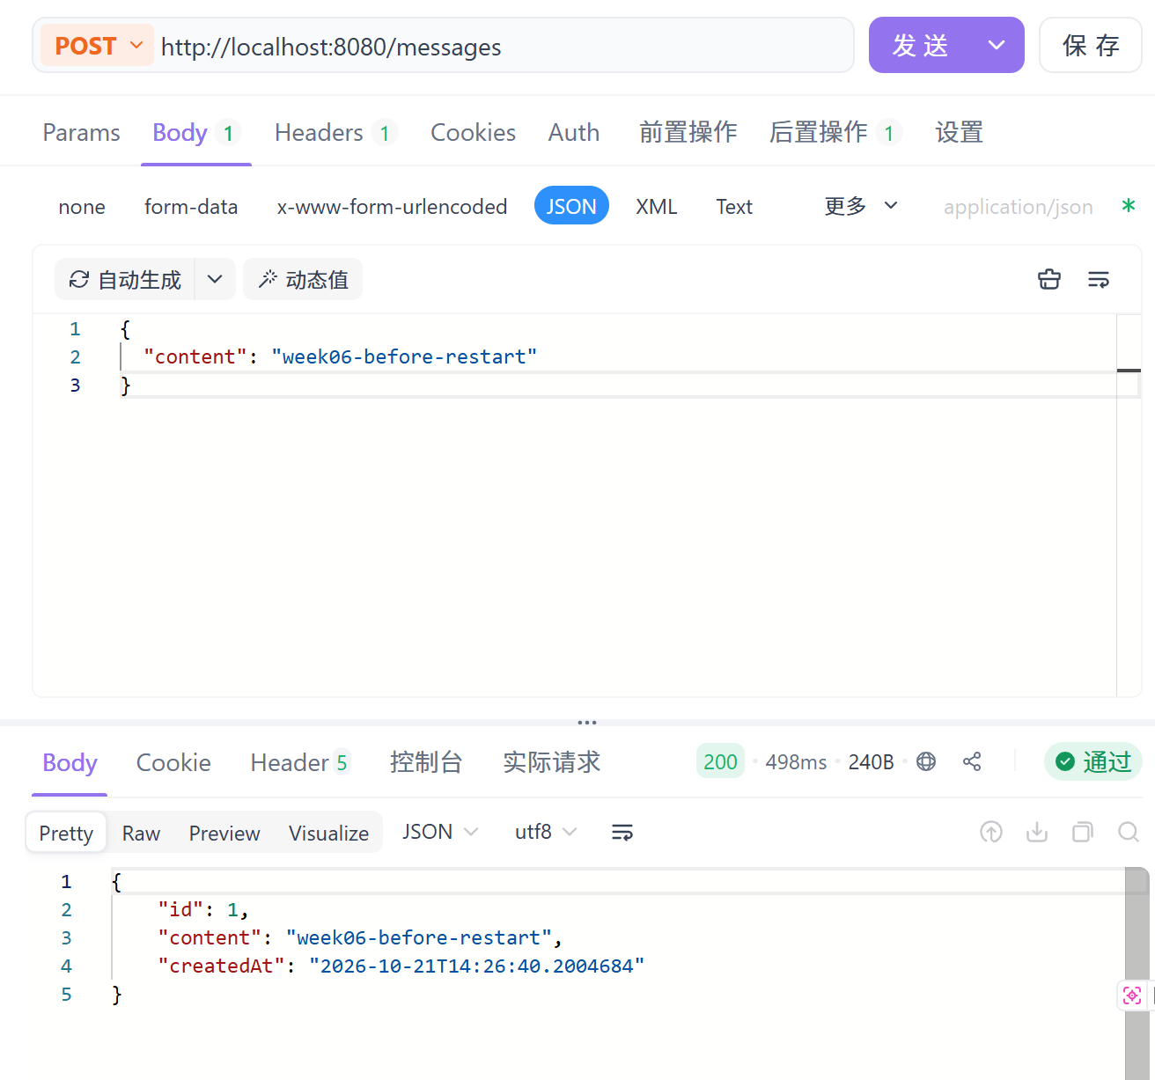

Checkpoint — Observe before explaining
Before restart:
What data exists?
________________________________

After restart:
What data remains?
________________________________

What changed?
________________________________

Why do you think it happened?
(Write your own guess first. Do not ask AI yet.)
________________________________
This is not a bug in listening. MyBlog heard you.
This is missing memory.

4. Part B — Understand Temporary vs Persistent Data

4.1 What just happened
List / Java objects
↓
application memory (the running process)
↓
process ends (you stopped the app)
↓
data disappears

versus what we are about to build:
Java application
↓
MyBatis Plus (Mapper)
↓
MySQL
↓
persistent storage — lives outside the process

4.2 Fill in the comparison
Question | In-Memory Storage | MySQL
Where is data stored?
What happens after restart?
Who owns the data lifetime?
Is it persistent?

(Hint: the third row is the deep one. With a List, the process owns the data's lifetime. With MySQL, the database owns it — your application is only a visitor.)

Understanding Checkpoint (Mission Level 2, Task 1)
Temporary meant:
________________________________

Persistent means:
________________________________
Minimum Understanding anchor (from assessment):
Temporary data lives only while the program runs and disappears on restart.
Persistent data is stored outside the process (database) and survives restart.

5. Part C — Give MyBlog a Memory
The Week06 design, in one chain:
MyBlog
↓
needs Memory
↓
persistent storage
↓
MySQL

And the course's capability-first logic:
Capability → Memory
Problem → Data disappears after restart
Technology → MySQL + MyBatis Plus
Evidence → Data survives restart

Memory palace vocabulary (use these words all week):
Piece | Role
MySQL | the palace — lasting storage outside your process
Table | one room for one kind of memory (message)
Row | one remembered message
Primary key | the stable identity of a memory
Entity | the Java name of a stored memory
Mapper | the bridge between Java and the palace

Course standard: this course uses MyBatis Plus, not JPA, for Week06.
If AI or an old tutorial suggests JPA / JpaRepository, decline politely and stay on the course path.

6. Part D — Connect Entity to Table

6.1 The mapping idea
Java Entity Database Table
┌─────────────────┐ ┌──────────────────┐
│ class Message │ ←──→ │ table: message │
│ Long id │ ←──→ │ id │
│ String content│ ←──→ │ content │
│ createdAt │ ←──→ │ created_at │
└─────────────────┘ └──────────────────┘

One Java object ↔ one row. One class ↔ one table.

6.2 Exercise — your field map (Mission Level 2, Task 3)
Open your actual Message class and your actual table. Complete:
Java field | Database column
id

Use your project's real fields. If you personalized your message model in earlier weeks, your map will have more rows — that is good.

6.3 The two annotations you actually need
@TableName("message") // "this Java class lives in the message table"
public class Message {

@TableId(type = IdType.AUTO) // "this field is the primary key; MySQL auto-increments it"
private Long id;

private String content;

private LocalDateTime createdAt;
}

- @TableName — tells MyBatis Plus which table this entity maps to (needed when the class name and table name differ or to be explicit).
- @TableId — marks the primary key; IdType.AUTO matches AUTO_INCREMENT in SQL.
That is all the annotation theory you need this week. This is not an annotation reference manual — it is a name-tag system between Java and MySQL.

Understanding question
If you renamed the Java field content to text but did nothing else, what would break, and why?

7. Part E — Configure MySQL
Placeholders look like <this>. Replace them with your own local values.
Do not invent credentials — use the username/password of your own MySQL installation.

Task E1 — Start MySQL and create the database
Goal: a living palace exists before MyBlog tries to enter it.
Steps:
1. Make sure the MySQL server is running (Windows: check Services / net start for your MySQL service name).
2. Log in with your client, then run:
CREATE DATABASE IF NOT EXISTS myblog DEFAULT CHARACTER SET utf8mb4;

Expected result: Query OK (or "1 row affected").
Verification:
SHOW DATABASES;

myblog appears in the list.

Task E2 — Create the message table
Steps:
USE myblog;

CREATE TABLE IF NOT EXISTS message (
id BIGINT PRIMARY KEY AUTO_INCREMENT, -- id：大整数主键，自动递增，插入不用管
content VARCHAR(1000) NOT NULL,
created_at DATETIME NULL DEFAULT CURRENT_TIMESTAMP -- created_at：日期时间；允许为空；插入时不填则自动填当前时间

);

Adjust column names if your personalized fields need them — but keep the Java entity and the table consistent with each other (Part D).
Verification:
SHOW TABLES;
DESCRIBE message;

You see the message table and its columns.
Common problem: Table doesn't exist later almost always means the SQL ran in a different database than the one in your datasource URL. Check USE myblog; and check the URL below.

Task E3 — Configure the Spring Boot datasource
Why: without a living connection, MyBlog has no path into the memory palace.
Steps: in application.yml (or the equivalent .properties), add/adjust:
spring:
datasource:
url: jdbc:mysql://localhost:3306/myblog?useUnicode=true&characterEncoding=utf8&serverTimezone=Asia/Shanghai
username: <your-mysql-username>
password: <your-mysql-password>
driver-class-name: com.mysql.cj.jdbc.Driver

Also confirm your project has the MyBatis Plus starter and the MySQL driver in pom.xml (course-standard dependencies for Week06).
Expected result: the application starts with no datasource errors in the console.
Verification:
☐ Application reaches "Started ...Application" without connection exceptions
☐ No "Communications link failure"
☐ No "Access denied for user"

Failure symptoms → first checks:
Symptom at startup | First thing to check
Communications link failure | Is MySQL running? Host/port correct?
Access denied for user | Username/password match your local MySQL?
Unknown database 'myblog' | Did Task E1 actually run? Same name in URL?

Teaching moment: if startup fails on the first try, that is normal and useful. Read the error. Fix one thing. Start again. (Part K formalizes this loop.)

8. Part F — Add MyBatis Plus Mapper

8.1 Why a Mapper
The application needs a bridge between Java objects and the database.
Controller
↓
Service / application logic
↓
Mapper ← the bridge (new this week)
↓
MySQL

8.2 Create the Mapper
@Mapper
public interface MessageMapper extends BaseMapper<Message> {
}

What this represents:
- MessageMapper is the bridge for the message table.
- BaseMapper<Message> gives you the basic operations — insert, select by id, select list, update, delete — without hand-writing SQL for the basics.
- @Mapper (or a @MapperScan on a configuration/application class covering the mapper package) lets Spring Boot discover it.
Checklist:
☐ Message entity exists and matches the table (Part D)
☐ MessageMapper extends BaseMapper<Message>
☐ Mapper scanning is enabled (@Mapper on the interface, or @MapperScan on a config class)
☐ Application still starts (a missing scan shows up as "Mapper bean not found")

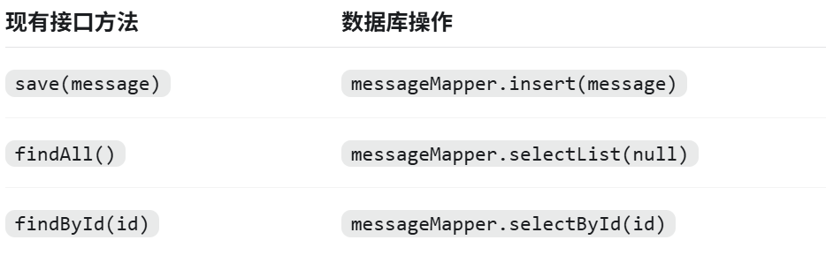

Understanding Checkpoint (Mission Level 2, Task 4)
Explain MyBatis Plus using your Mapper, in plain words:
MyBatis Plus is ...
It saves me from ...
I still need to understand ... about tables and columns.
________________________________
ORM reduces boilerplate. It does not erase the need to understand tables, columns, and keys.

9. Part G — Replace In-Memory Storage
This is the critical section of the whole lab.

9.1 Identify the old design
Find the line you marked in §2.2:
private List<Message> messages = new ArrayList<>();

The List was the application's temporary source of truth.

9.2 The new source of truth
Before: After:

Service Service
↓ ↓
List (process memory) MessageMapper
↓
MySQL ← persistent source of truth

9.3 The forbidden pattern — dual storage
WARNING — forbidden pattern
POST
├── write to List ← ❌
└── write to MySQL

Why this is dangerous:
Two sources of truth can become inconsistent.
The List says one thing, MySQL says another, and after restart you discover which one was lying.
The desired design — one source of truth:
POST → Service → Mapper → MySQL
GET → Service → Mapper → MySQL

9.4 What to change
What: update the Service/Repository path so that create / list / get-by-id all go through MessageMapper (directly in Service, or via a DB-backed repository implementation — both are acceptable in the Week06 architecture; pick one and be consistent).
Why: the API stays the same; only the storage behind it changes. This is exactly what Week05's layering was preparing for.
Rules:
☐ Controller stays thin — no raw SQL, no datasource code in the Controller
☐ The in-memory List is removed from, or no longer used by, the create/read path
☐ create → mapper insert
☐ list → mapper select list
☐ get by id → mapper select by id

Verify: after restarting the app with an empty table, GET /messages returns [] from the database — not a stale List.

Understanding Checkpoint (Mission Level 2, Task 5)
What I reused from Week05:
________________________________

What I replaced:
________________________________

10. Part H — Verify POST and GET

Task H1 — POST writes persistent data
What: create a message through the API.
Request:
POST /messages
Content-Type: application/json

{
"content": "my-first-durable-memory"
}

Expected result: success response with the created message, including a database-generated id, e.g.:
{
"id": 1,
"content": "my-first-durable-memory",
"createdAt": "2026-08-30T22:10:00"
}

Verification (two views of the same truth):
☐ API view: GET /messages returns the new message
☐ DB view: SELECT * FROM message; shows the same row
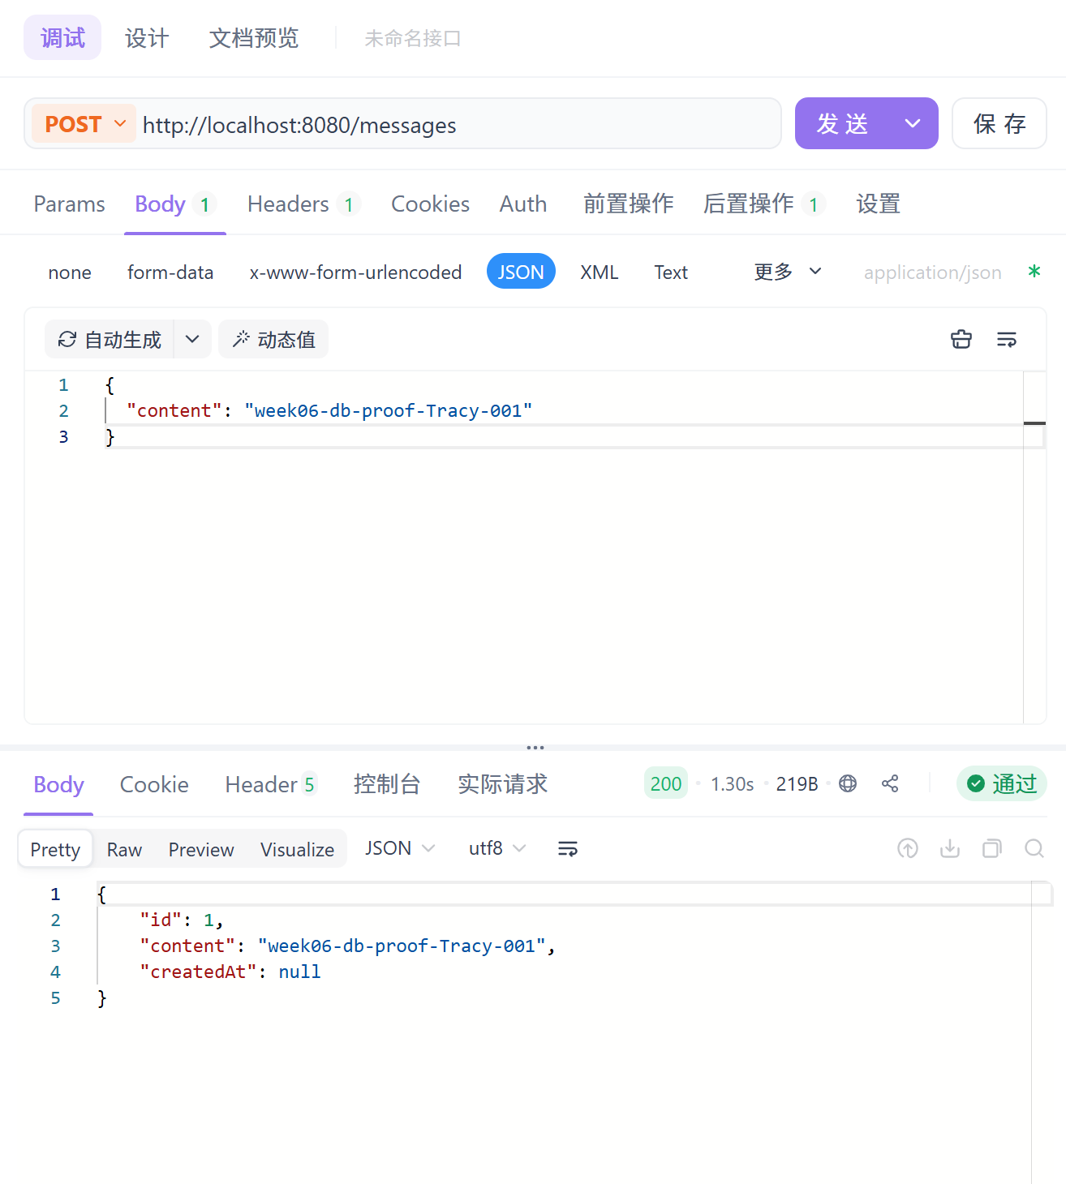

Task H2 — GET reads persistent data
☐ GET /messages lists rows that exist in MySQL
☐ GET /messages/{id} returns exactly one row
☐ A row inserted directly in MySQL (SELECT-checkable) appears in GET /messages

The third check is powerful: it proves GET reads from the database, not from a List.
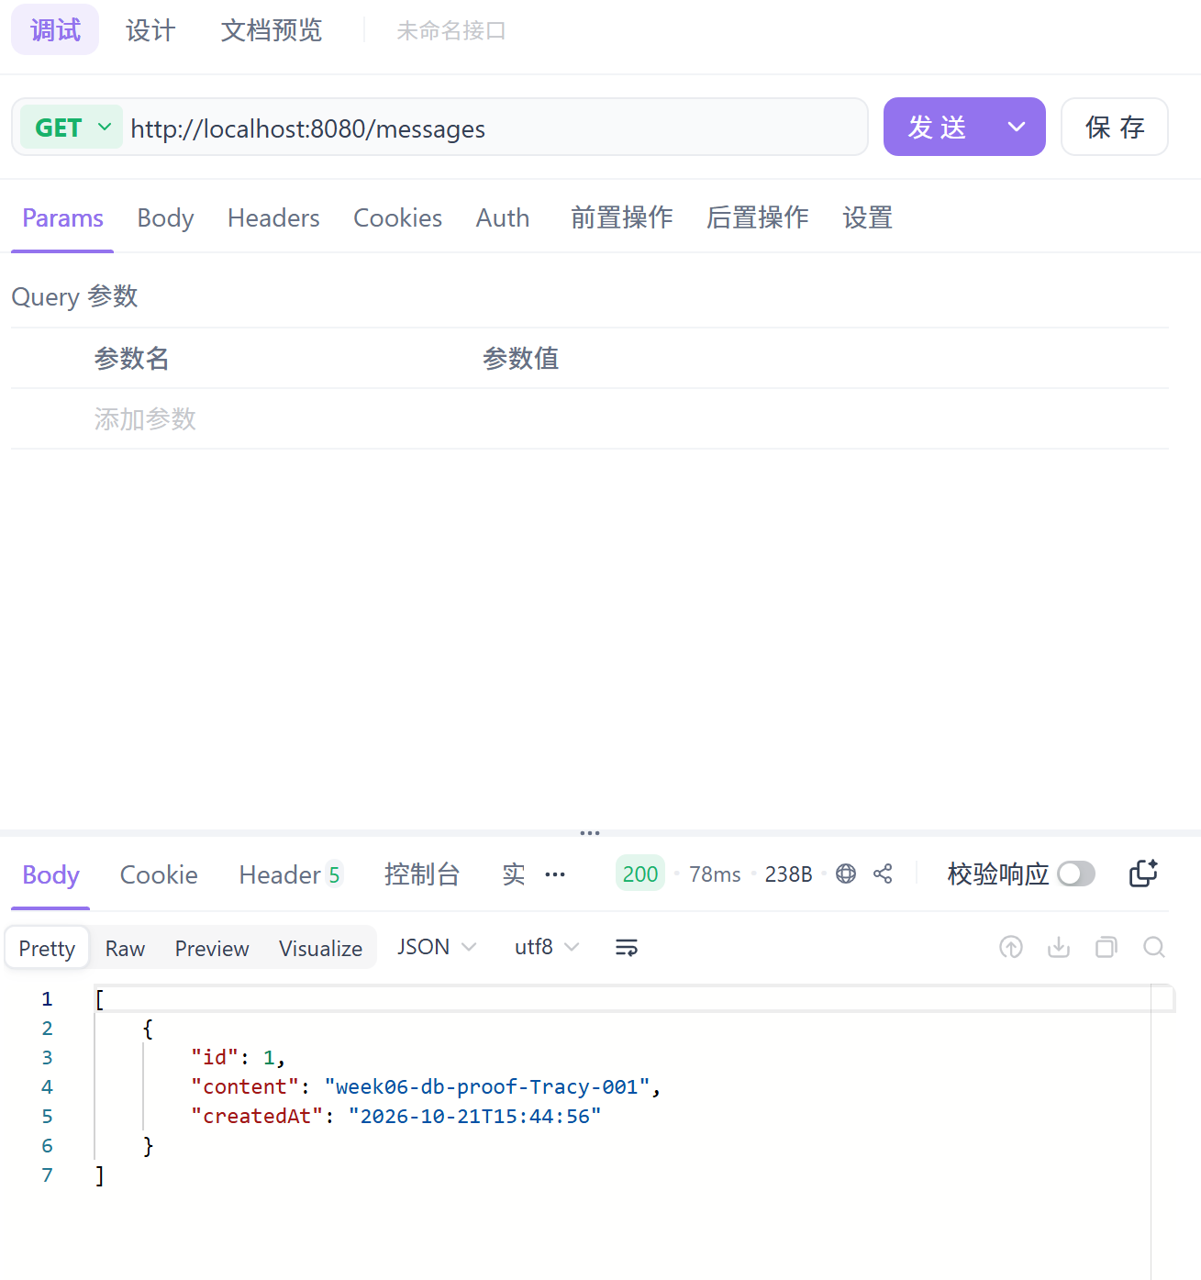
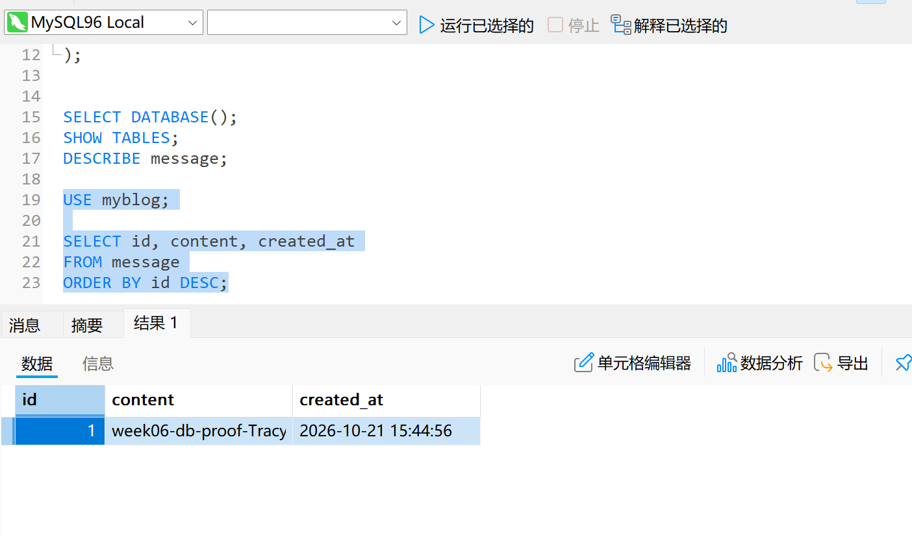

11. Part I — The Restart Test

Persistence Proof
This is the signature moment of Week06. Do not skip it. Do not fake it.

The ritual
Step 1 POST a new, unique message
(e.g. "content": "restart-proof-<your-name>-001")

Step 2 GET /messages
→ confirm it is there

Step 3 Record the result (screenshot / copy the JSON)

Step 4 STOP the application completely

Step 5 START the application again

Step 6 GET /messages again

Step 7 Compare with Step 3

The key question
Did the data survive the restart?

What counts as proof — and what does not
KEY IDEA
HTTP 200
≠
persistence proof

HTTP 200 only means "the request was answered." It says nothing about where the answer came from.
The actual proof is:
POST
→ restart
→ GET
→ the same data is still there

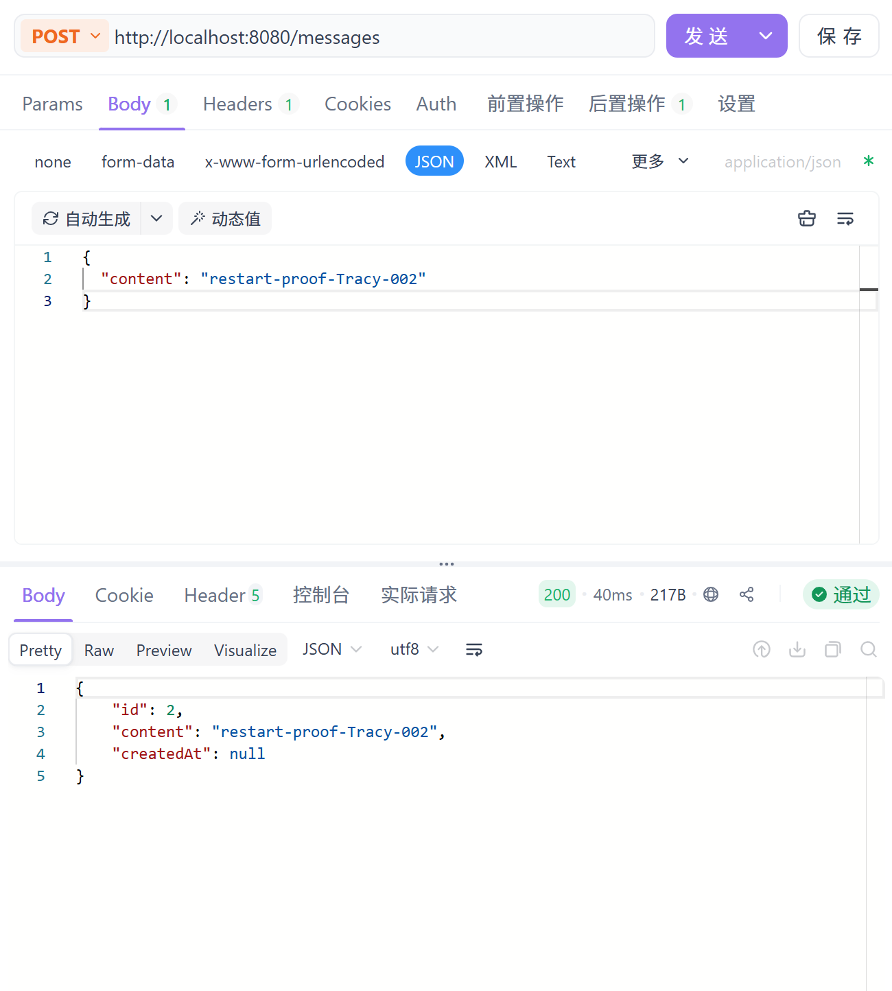
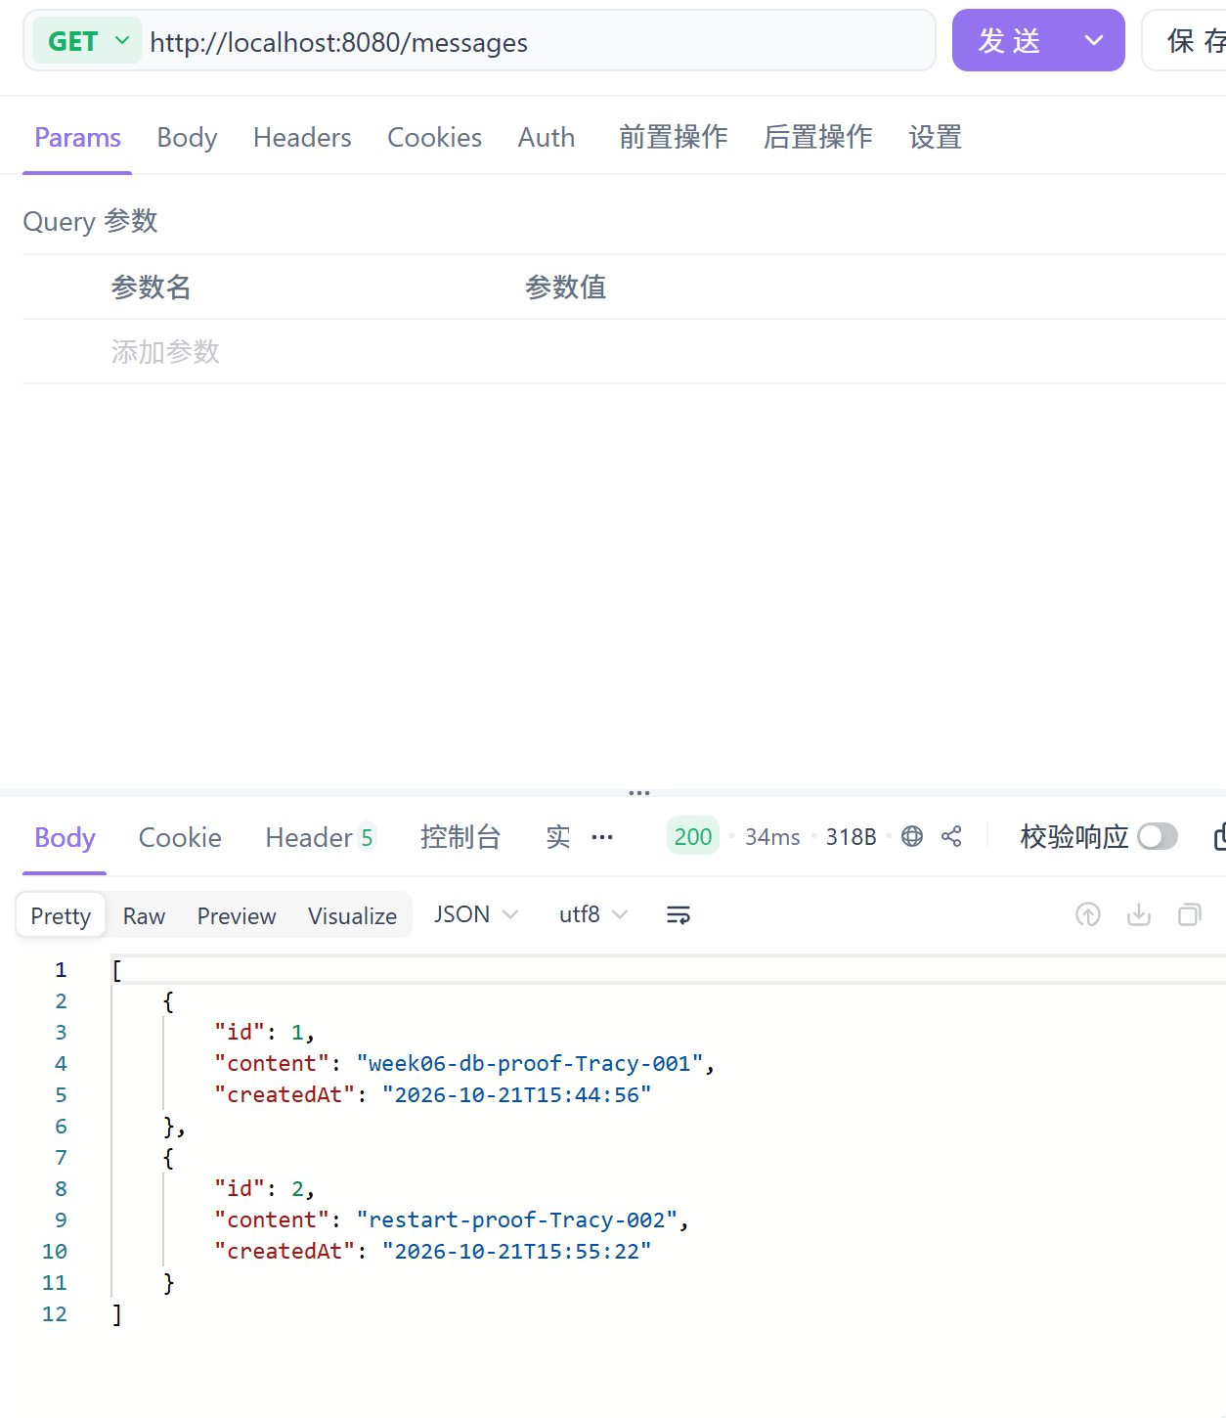
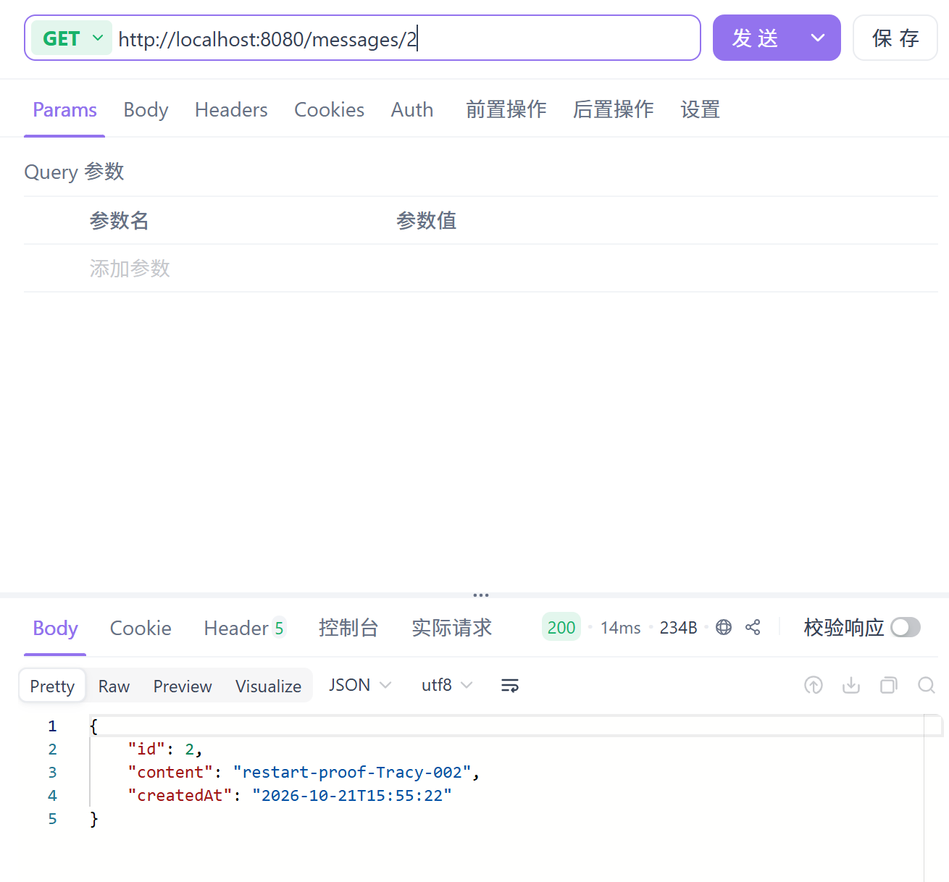
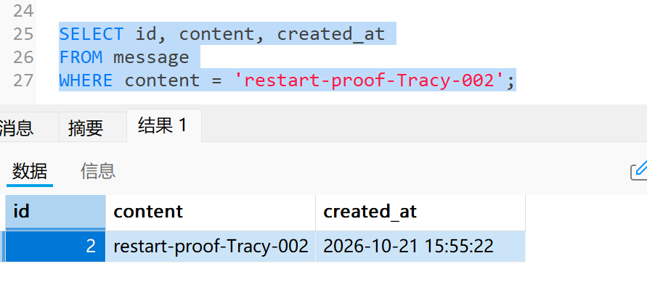

Checkpoint
☐ Message still present after restart
☐ The id and content match what I recorded before restart
☐ (Optional, strong) SELECT * FROM message; shows the row

Understanding Checkpoint (Mission Level 2, Task 2)
Complete:
After restart, the message is still there because...
________________________________

12. Part J — Persistence Evidence
Collect evidence as you go. This list is aligned with assessment.md and homework.md — do not invent extra requirements, and do not drop these.

Evidence 1 — Database
EVIDENCE — capture this
[EVIDENCE: SELECT * FROM message; showing your row]
______________________________________________________________________________
______________________________________________________________________________

Evidence 2 — POST
EVIDENCE — capture this
[EVIDENCE: POST /messages request body + success response]
______________________________________________________________________________
______________________________________________________________________________

Evidence 3 — Restart
EVIDENCE — capture this
[EVIDENCE: note/screenshot showing the application was stopped and started again
(e.g. console stop/start, timestamps)]
______________________________________________________________________________
______________________________________________________________________________

Evidence 4 — GET after restart
EVIDENCE — capture this
[EVIDENCE: GET /messages response AFTER restart, same message present]
______________________________________________________________________________
______________________________________________________________________________

Evidence 5 — Explanation
Answer in your own words:
Why did the data survive the application restart?
________________________________

Level 2 evidence (Understanding)
☐ Temporary vs persistent explanation (Part B)
☐ Entity ↔ table field map (Part D)
☐ ORM in plain words (Part F)
☐ Week05 structure payoff (Part G)
☐ AI debug record with verification (Part K)

Level 3 evidence (Make It Yours)
☐ One personal durable improvement applied
☐ Restart test re-run and still safe
☐ Short note: what MyBlog remembers about me now

13. Part K — AI Partner Debugging
AI is your learning partner. It proposes hypotheses; you verify them.

13.1 The debugging loop
Observe
↓
Hypothesis
↓
Ask AI
↓
Evaluate the suggestion
↓
Change ONE thing
↓
Test
↓
Verify (POST → restart → GET)

Change one thing at a time. If you change three things and it works, you learned nothing.

13.2 Prompt — Explanation
AI PROMPT — copy, fill in the [brackets], verify the answer
Explain this Spring Boot/MyBatis Plus error.
Do not modify my code.
First explain the likely cause.

13.3 Prompt — Diagnosis
AI PROMPT — copy, fill in the [brackets], verify the answer
Here is my error and datasource configuration.
Give me the three most likely causes and a test for each cause.

13.4 Prompt — Verification
AI PROMPT — copy, fill in the [brackets], verify the answer
I changed this configuration.
What evidence would prove that the database connection is actually fixed?

13.5 Full-context version (from prompts/debug-mysql-connection.md)
AI PROMPT — copy, fill in the [brackets], verify the answer
My Week06 MyBlog uses MySQL + MyBatis Plus.

Symptom:
[cannot connect / table missing / unknown column / restart still empty]

Error message:
[paste]

Relevant files:
[application yml excerpt]
[Message entity]
[MessageMapper]
[Service create/list methods]

Please list likely causes in order and how to verify each.
Do not rewrite the project with JPA, Redis, Docker, or Vue.

More templates: prompts/explain-temporary-vs-persistent.md, prompts/explain-mybatis-plus.md, prompts/explain-structure-payoff.md.

13.6 AI log (required — Mission Level 2, Task 6)
What I asked:
________________________________

What AI suggested:
________________________________

AI suggestion I accepted:
________________________________

AI suggestion I rejected (and why):
________________________________

What I changed:
________________________________

How I verified (POST → restart → GET result):
________________________________

What AI got wrong:
________________________________
Weak evidence: pasting AI config with no verification.
Strong evidence: context-rich prompt + accept/reject decision + restart-survival verification.

14. Part L — Mission
Authoritative definition: mission.md. This section only connects the lab work to it.
Level 1 — Make It Work
Level 2 — Understand It
Level 3 — Make It Yours

L1 — Make It Work
The application persists and retrieves data. You reached this when:
☐ MySQL database available (e.g. myblog)
☐ message table exists
☐ Datasource configured
☐ Message entity exists
☐ MessageMapper (BaseMapper) exists
☐ POST /messages writes to DB
☐ GET /messages and GET /messages/{id} read from DB
☐ Restart survival proof captured ← Checkpoint 1 of the original lab

L2 — Understand It
You can explain:
- Entity ↔ Table (Part D exercise)
- Datasource (Part E)
- Mapper / ORM in plain words (Part F)
- Temporary vs persistent (Part B)
- Why the data survived restart (Part I)
- What Week05 made easier (Part G)
- One real AI-assisted debug, verified (Part K)

L3 — Make It Yours
Choose at least one (from mission.md / lab.md):
- Option A — Personal message field: persist from / topic / mood (or your own field)
- Option B — Identity fragment: store one profile field durably
- Option C — Memory voice: make responses sound like your MyBlog remembering someone
Then ask:
Does this feel like my digital self now has a past?
Level 3 safety rule: after your personalization, re-run the restart test. A personal field that breaks persistence is not an upgrade.
☐ One personal durable improvement applied
☐ Restart still safe
☐ Short note: what MyBlog remembers about me now

Optional extensions (clearly optional — from challenge.md)
Update one message in DB · soft-delete flag · simple schema diagram of message · seed a few starter memories.
No Redis. No Vue. No required search/pagination engine (Week07).

15. Troubleshooting
Symptom-first. Diagnose before changing. Full bank: common-bugs.md.

15.1 MySQL connection failure
Check, in order:
☐ Is MySQL actually running?
☐ Database name in the URL matches the database you created?
☐ Host and port correct (localhost:3306)?
☐ Username correct?
☐ Password correct?

15.2 Table not found
☐ Did the CREATE TABLE run in the SAME database as the datasource URL?
☐ Table name matches @TableName / entity mapping?
☐ SHOW TABLES; inside myblog shows message?

15.3 Mapper failure
☐ MessageMapper declared as interface extending BaseMapper<Message>?
☐ @Mapper present, or @MapperScan covers the mapper package?
☐ MyBatis Plus starter + MySQL driver present in dependencies?
☐ Did the application fully restart after the change?

15.4 Data disappears after restart (the Week06 classic)
Ask yourself:
Is GET still reading from a List?

Is POST actually writing to MySQL?
(Check: SELECT * FROM message; right after POST.)

Are there two sources of truth? (dual storage — Part G)

Did the application really restart?

Are you checking the same database?

15.5 Insert "works" but the DB has no row
☐ Are you looking at the same database/schema the app writes to?
☐ Does the Service actually call the Mapper on the create path?
☐ Is a fake success path still returning a hand-made object?

15.6 Fields are null in responses
☐ Java field names ↔ column names aligned (content vs created_at / createdAt)?
☐ Entity mapping consistent with the table?

16. Reflection
Answer briefly, in your own words (full set in reflection.md):
1. What was MyBlog forgetting before Week06?
2. Where was the data stored before?
3. Where is it stored now?
4. Why does restarting the application no longer erase it?
5. What is the role of MyBatis Plus?
6. Why should we avoid maintaining both a List and MySQL as independent sources of truth?
Then complete the transformation:
Before Week 06, my application...
After Week 06, my application...

And keep the key sentence:
MyBlog did not merely gain a database. It gained Memory.

17. Completion Checklist
☐ MySQL is running
☐ Database exists
☐ Table exists
☐ Entity ↔ Table mapping works
☐ Datasource configuration works
☐ Mapper works
☐ POST writes persistent data
☐ GET reads persistent data
☐ Application restart does not erase the data
☐ Database evidence collected
☐ Restart persistence evidence collected
☐ I can explain why persistence works
☐ Required mission level completed

Submission package (aligned with `homework.md` / `assessment.md`):
☐ Source code — continued Week01–Week05 project with MySQL + MyBatis Plus persistence
☐ HTTP + restart evidence — create message, restart, still retrievable
☐ AI collaboration log
☐ Reflection — complete reflection.md

18. Bridge to Week07
MyBlog can now remember many posts.
Then a new desire appears:
How can it find the one I want?
Week06: Memory
Week07: Discovery

Do not build search or pagination in this lab. Memory first. Then discovery.

Final Lab Feeling
I restarted.
It was still there.
MyBlog remembers.
Expansion notes: this file preserves `lab.md`'s Level 1→2→3 spine, step order, SQL sample, BaseMapper pattern, restart-survival signature, legacy `/message` continuity note, and technology boundary. Expansions are limited to executability (config, mapping, verification), evidence, troubleshooting, AI Partner workflow, and reflection — per `CONTENT-EXPANSION-RULES.md` and `LAB-PRODUCTION-SPEC.md`. No new technologies, APIs, or mission requirements were introduced.

