Week 08 Lab
I Am Complete (Backend)
Capability: Completeness
Technology: Article CRUD · MyBatis Plus · Search + Pagination Reuse · Result Wrapper · @RestControllerAdvice

Course | Web Programming (AI Native)
Project | MyBlog
Week | 08 — I Am Complete (Backend) / Mission 08: My Blog Completes The Backend
Estimated Time | approximately 80 minutes

Student Name: ______________________________
Student ID: ______________________________
Date: ______________________________

Contents
Table of contents — open in Word, right-click here, choose “Update Field”.

ABOUT THIS LAB MANUAL
This is your hands-on laboratory manual. Complete it during and after the teacher's live demonstration.
Source: lab.md (Week08 baseline — unchanged). Scope: Option A — Article + discovery list + API polish. This expanded manual adds an explicit overview, inventory-with-evidence, an Article test matrix, an evidence map, and a completion checklist; the full Level 1 → 2 → 3 chain, the bare-list behavior note, the MyBatis Plus discovery sketch, the Result + advice sketches, the required AI readiness review, and all checkpoints from the baseline are preserved.
Companion files: mission.md (requirements) · assessment.md (evaluation) · common-bugs.md (fixes) · prompts/ (AI templates) · reflection.md, homework.md (submission).
Week06-pilot conventions applied: capability-shaped evidence, hypothesis-first AI loop, experience-before-explanation.

1. Lab Overview
Field | This Lab
Weekly capability | Completeness — MyBlog's backend becomes ready for a face: publishable Articles, predictable contracts, nothing old broken
Core question | Is MyBlog's backend ready to meet the world through a face?
Technology | Article domain on MySQL + MyBatis Plus (BaseMapper, LambdaQueryWrapper + like, Page/selectPage reused from Week07) · CRUD incl. first PUT/PATCH + DELETE/soft-delete · Result<T> wrapper (code/message/data) · light @RestControllerAdvice
Starting state | Your Week07 project: messages persist and are searchable/pageable; identity endpoint (/profile or /me) works; layered architecture intact
Ending state | Same project, plus durable Article APIs (POST / GET {id} / GET ?keyword&page&size / `PUT
Time | ~80 min in class
Evidence | §7 — inventory note, CRUD + discovery + contract HTTP evidence, continuity re-test, AI readiness log, reflection

The transformation
Week 07: /messages remembers and can be discovered (conversation memory)
↓
Week 08: /articles publishable, discoverable, contract-clean
+ /messages and identity still working (ready for a face)

Keep asking "Why does MyBlog need this?" before "How do I implement this?"
Full story: story.md · mission.md.

What proves success this week
The capability is completeness — readiness for Week09's face. "The articles table exists" proves nothing. Your proof:
Articles: publish → read one → discover (keyword+page) → update → delete
each step verified by HTTP evidence
Contract: one Result-wrapped success body AND one not-found JSON body
(same skeleton, success or failure)
Continuity: /messages discovery and /profile|/me re-tested AFTER articles work
Reuse: you can name exactly what moved from Week07 (pattern, not copy-paste)

KEY IDEA
[KEY: A face mainly binds and presents. It cannot invent content or
forgive a changing response shape. Completeness = content a face
can show + contracts a face can trust + nothing old broken.]

Estimated lab time
Section | Time
Intro + environment check | 5 min
Level 1 — Article CRUD + discovery + Result | 40 min
Level 2 — Understand + AI readiness review | 20 min
Level 3 — Make it yours | 10 min
Deliverables + reflection | 5 min
Total | ~80 min

2. Starting Point & Environment Check
This week you add a new resource to a living system. The starting-state check is how you'll later prove "nothing old broke" — record before you build.

Task 2.1 — Open your Week07 project
Do NOT create a brand-new project.
MyBlog is evolving. It is not restarting.

Task 2.2 — Confirm the Week07 final state
1. Messages persist in MySQL across restart
2. Message discovery works:
GET /messages?keyword=...&page=...&size=...

3. The identity endpoint works (/profile or /me)

Task 2.3 — Backup
Create a backup branch or copy before adding the article table. New tables, entities, and mappers are exactly where old endpoints quietly break.

Task 2.4 — Scope lock
No Vue project creation this week. The face is Week09.

Checkpoint — Starting state
☐ Week07 project opens and runs
☐ Message search + pagination verified working
☐ Identity endpoint verified working
☐ Backup exists
☐ HTTP client ready
☐ No Vue project created

EVIDENCE — capture this
[EVIDENCE: Starting state — inventory before Articles]
GET /messages?keyword=<planted>&page=1&size=5 → total: {
"items": [
{
"id": 13,
"content": "lec07-e6355344c3594fd3820a5092eeb09fc1 blog 10",
"createdAt": "2026-10-28T16:02:00"
},
{
"id": 12,
"content": "lec07-e6355344c3594fd3820a5092eeb09fc1 blog 9",
"createdAt": "2026-10-28T16:02:00"
},
{
"id": 11,
"content": "lec07-e6355344c3594fd3820a5092eeb09fc1 blog 8",
"createdAt": "2026-10-28T16:02:00"
},
{
"id": 10,
"content": "lec07-e6355344c3594fd3820a5092eeb09fc1 blog 7",
"createdAt": "2026-10-28T16:02:00"
},
{
"id": 9,
"content": "lec07-e6355344c3594fd3820a5092eeb09fc1 blog 6",
"createdAt": "2026-10-28T16:02:00"
}
],
"total": 13,
"page": 1,
"size": 5
}
________________________________
Identity endpoint I have (/profile or /me):
Profile:
_{
"blogName": "Tracy's MyBlog",
"interests": "Java、Web 开发、系统设计",
"introduction": "我正在学习 Java Web，并尝试构建自己的项目。",
"owner": "Tracy",
"vision": "完成一个真正属于自己的全栈 Web 项目。"
}
_

Me:
{
"favoriteQuote": "我正在学习 Java Web，并尝试构建自己的项目。",
"hobby": "Java、Web 开发、系统设计",
"name": "Tracy's MyBlog",
"owner": "Tracy",
"vision": "完成一个真正属于自己的全栈 Web 项目。"
}
______________________________
Backup (branch name / copy location): ________________________________
__backup/week08-articles
____________________________________________________________________________
______________________________________________________________________________

You will re-run the first two calls in Task 3.6, after Articles exist. Identical behavior = continuity preserved.

3. Level 1 — Make It Work
Goal: Article CRUD + search/page + Result wrapper; messages and identity untouched.

Task 3.1 — Name the gap
Before any code, write:
What can a future face bind to today?
___未来的前端可以绑定到 Article 的新增、查询、搜索分页、修改和删除接口，
并读取统一的 JSON 返回结构。
_____________________________________________

What is missing?
___之前缺少的是完整的 Article 后端能力、更新和删除能力，
以及统一稳定的接口响应格式。
_____________________________________________
If "publishable articles" is not in your second answer, discuss with a classmate before continuing — the gap must be yours, not the manual's.

Task 3.2 — Article schema + entity + mapper
Example columns:
id, title, content, created_at

Optional: summary, status, author_name (save these for Level 3 unless you have time).
public interface ArticleMapper extends BaseMapper<Article> {
}

Create the table in the same MySQL database MyBlog already uses. Same stack, same layers — Week05's structure and Week06's persistence simply receive a new member.
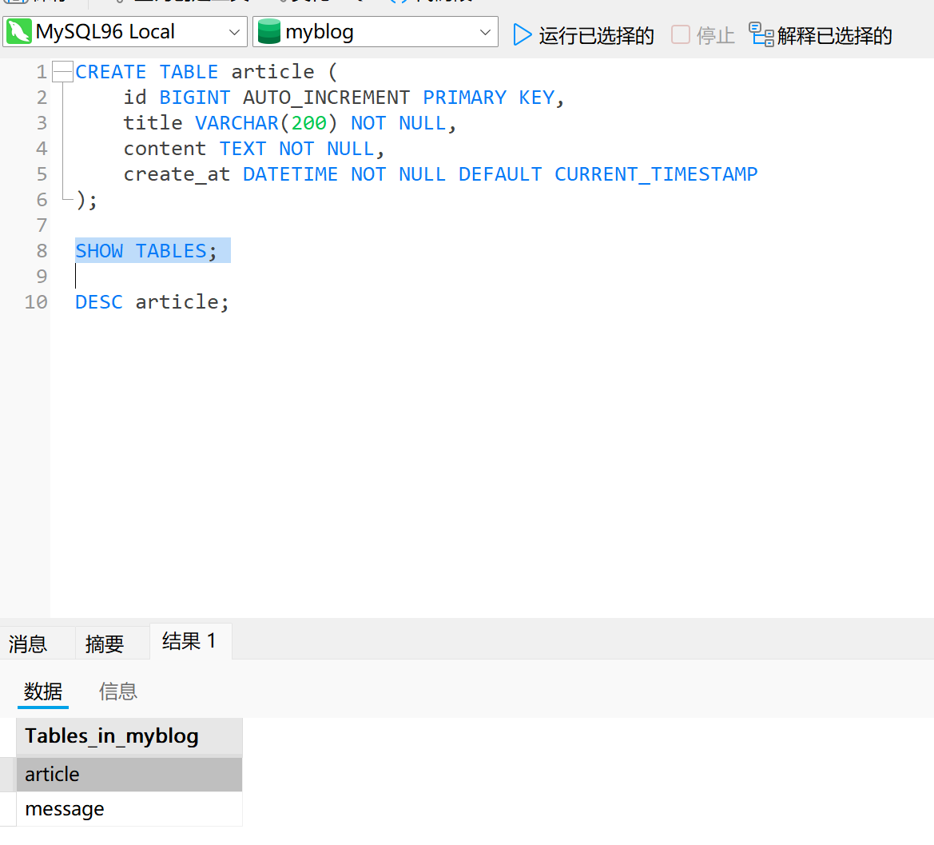

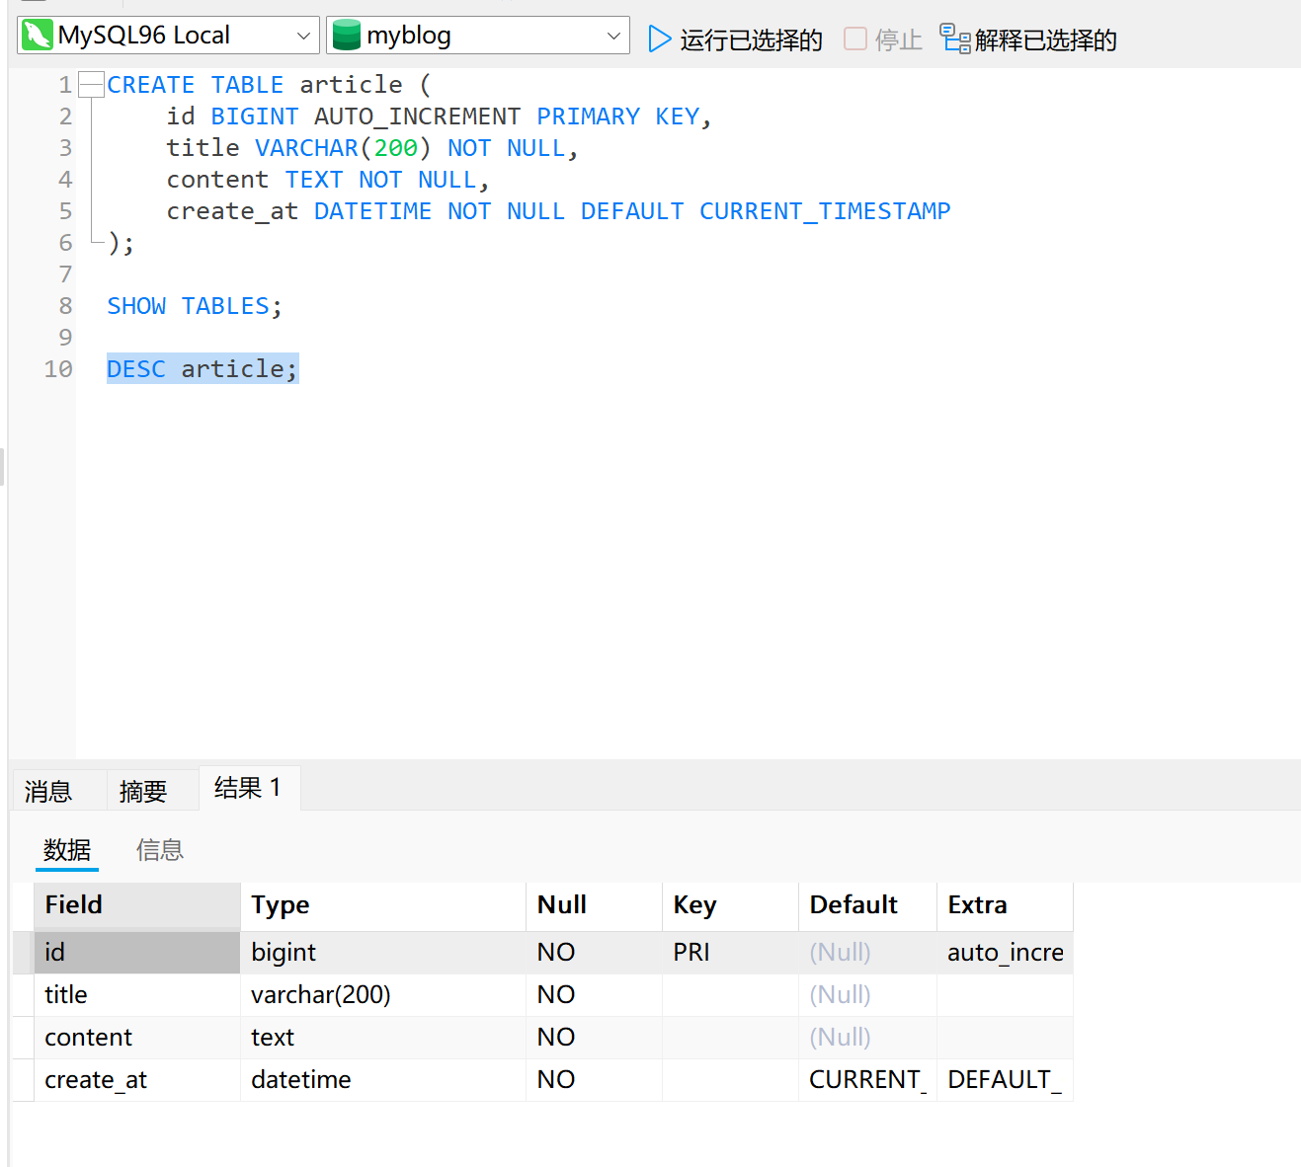Task 3.3 — CRUD
Implement, keeping the Controller thin (receive → call → return, as since Week05):
POST /articles
GET /articles/{id}
PUT or PATCH /articles/{id}
DELETE /articles/{id} (or soft-delete)

Note the moment: PUT/PATCH is the first update verb in eight weeks. MyBlog can now revise what it published — a digital self that can change its mind.
If you choose soft-delete, say so in one sentence in your notes — it is a philosophy, not just a flag.

Task 3.4 — Discovery list (Week07 transfer)
GET /articles?keyword=&page=&size=

Default list note: Document what bare GET /articles (no page/size) does:
keep a temporary full-list path for demos, or default to page=1&size=N.
Write your choice so evidence stays interpretable.
Reuse the Week07 pattern:
LambdaQueryWrapper<Article> qw = new LambdaQueryWrapper<>();
if (keyword != null && !keyword.isBlank()) {
qw.like(Article::getTitle, keyword)
.or()
.like(Article::getContent, keyword);
}
Page<Article> pageData = articleMapper.selectPage(new Page<>(page, size), qw);

Return { items, total, page, size } inside your Result wrapper if possible. Same discovery muscle as messages — new domain. If this felt familiar, that familiarity is the lesson of the last three weeks.

Task 3.5 — API polish
Add a simple contract (names flexible):
public class Result<T> {
public int code;
public String message;
public T data;

public static <T> Result<T> ok(T data) {
Result<T> r = new Result<>();
r.code = 0;
r.message = "ok";
r.data = data;
return r;
}

public static <T> Result<T> fail(int code, String message) {
Result<T> r = new Result<>();
r.code = code;
r.message = message;
r.data = null;
return r;
}
}

Light not-found advice (example shape):
@RestControllerAdvice
public class ApiExceptionAdvice {
@ExceptionHandler(NoSuchElementException.class)
public Result<Void> notFound(NoSuchElementException ex) {
return Result.fail(404, ex.getMessage() == null ? "not found" : ex.getMessage());
}
}

Apply Result on article success paths at minimum. Keep it three fields — an over-fancy Result framework is this week's named trap.
Result 统一了成功和失败的返回结构，使前端不需要为每个接口单独猜测返回格式。
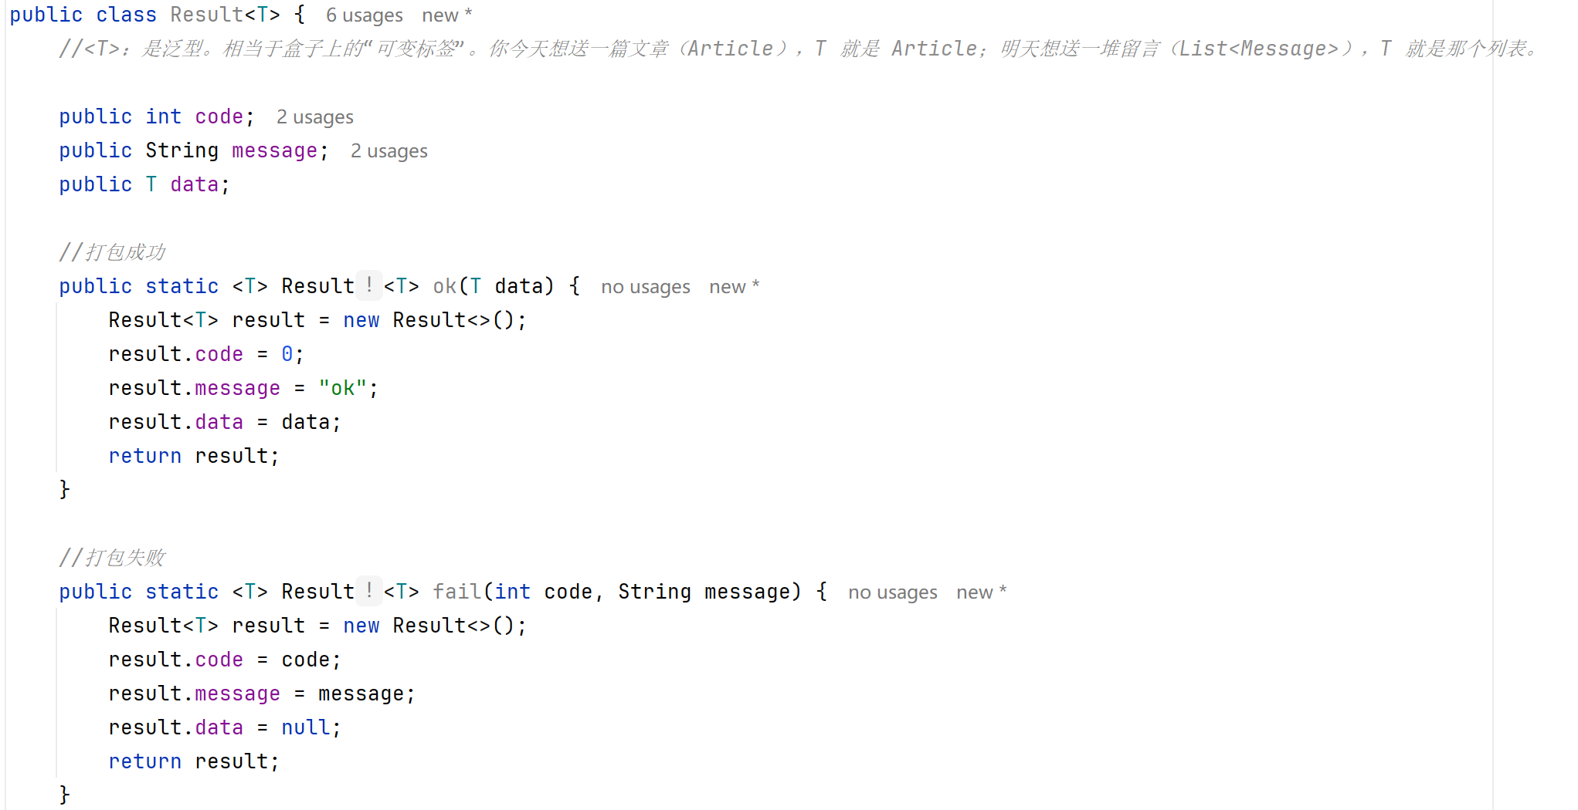

Task 3.6 — Continuity
Re-run the exact calls from §2, now that Articles exist:
☐ /messages discovery still works (compare with §2 evidence)
☐ /profile or /me still works

EVIDENCE — capture this
[EVIDENCE: HTTP client — Articles + contract + continuity]
POST /articles → created id: ________________________________
GET /articles/{id} → title matches: Yes / No
GET /articles?keyword=...&page=1&size=5 → total: ________________________________
PUT/PATCH /articles/{id} → field changed: ________________________________
DELETE /articles/{id} → subsequent GET shows: ________________________________
Result success body (code/message/data): ________________________________
Not-found body for GET /articles/99999: ________________________________
/messages discovery after all this: same as §2? Yes / No
______________________________________________________________________________
______________________________________________________________________________

Checkpoint — Level 1
☐ Article CRUD evidence (all five paths)
☐ Article search/page evidence
☐ Result-wrapped responses (success + not-found)
☐ Continuity evidence (messages + identity unchanged)

4. Level 2 — Understand It
Goal: explain readiness, contrast the two resources, show the contract, name the transfer — and have AI critique your work without taking it over.

Task 4.1 — Why not Vue now?
The backend must be complete before the face because:
_Vue页面主要负责绑定和展示数据，不能自动补充后端没有提供的文章、搜索条件或稳定的错误结构。如果后端接口和返回格式还在变化，前端会被迫不断修改，因此第八周先完成Article接口和Result契约，第九周再开发Vue页面。_______________________________________________
________________________________________________

Task 4.2 — Article vs Message
In my MyBlog, an Article is:
_Message是访客发送给MyBlog的内容，属于对话记忆____________________________________________

In my MyBlog, a Message is:
__ Article是MyBlog主动发布的内容，属于可以展示给读者的文章。两者来源和用途不同，因此需要不同的资源接口，新增Article不能删除或替代Message。_________________________________________________
Different origin, different meaning — your words, not the manual's.

Task 4.3 — Contract
Show, side by side, one success Result body and one not-found style body from your running app:
Success body: {
"code": 0,
"message": "ok",
"data": {}
} ________________________________________________
Not-found body: _{
"code": 404,
"message": "article not found",
"data": null
}_______________________________________________
Same skeleton? Yes / No — if No, fix before continuing

Task 4.4 — Discovery transfer
What I reused from Week07 (pattern, not paste):
_我复用了 Week07 中的 LambdaQueryWrapper、like、Page 和 selectPage 查询分页模式。_______________________________________________

What had to change for Articles:
__Article 与 Message 的区别是实体类型、Mapper、查询字段和业务名称不同，
但搜索分页的整体实现模式保持一致。______________________________________________

Task 4.5 — AI readiness review (required)
AI PROMPT — copy, fill in the [brackets], verify the answer
[PROMPT: Readiness review — critic, not generator]
Here are my Article endpoints and Result wrapper.
[paste endpoint list + one success body + one not-found body]

Next week I will bind Vue to these APIs.
What is missing for a beginner face to consume them?
Do not generate Vue/Axios code.

Record:
Gap AI found that I accept (and will note/fix): ________________________________________________
AI suggestion I rejected (and why): ________________________________________________
Did AI try to write Vue code? How did I respond: ________________________________________________
Rejecting out-of-scope generation is the assessment criterion this week — record it proudly.

Checkpoint — Level 2
☐ Why-not-Vue explained in my own words
☐ Article vs Message contrasted
☐ Success + not-found bodies shown from my running app
☐ Week07 transfer named
☐ AI readiness review with accept/reject recorded

5. Level 3 — Make It Yours
Goal: the backend starts sounding like your MyBlog. Choose one:
- personal article fields (coverMood, series, status…)
- draft/published status
- soft-delete wording in your voice
- optional Comment under Article (one-to-many preview — keep it small)
- CORS prepare note for local Week09 (config location only, no Vue app)
Ask yourself:
Would a face built on my backend feel like meeting me?
EVIDENCE — capture this
[EVIDENCE: Level 3 — what I personalized and why]
Option chosen: ________________________________
What changed (one sentence): ________________________________________________
Why this fits my MyBlog: ________________________________________________
______________________________________________________________________________
______________________________________________________________________________

Checkpoint — Level 3
☐ One personal improvement applied
☐ Article APIs + continuity re-tested after it
☐ Short note written

6. Optional Extension
Only after L1–L3 are complete (details: mission.md §9, challenge.md):
- Article status draft/published
- Batch seed articles
- OpenAPI/Swagger (optional)
- Comment under article (optional)
Same Week08 technology. No Vue. No Redis. No auth product requirement.

7. Evidence & Submission

The Week08 evidence map
Capability claim | Evidence that proves it
MyBlog can publish | POST /articles + GET /articles/{id} evidence (§3.6)
Articles are discoverable | keyword+page evidence with total (§3.6)
MyBlog can revise and withdraw | PUT/PATCH + DELETE evidence (§3.6)
The contract is predictable | success + not-found bodies, same skeleton (§4.3)
Nothing old broke | §2 evidence vs §3.6 continuity — identical
I understand readiness | why-not-Vue + Article-vs-Message + transfer notes (§4)
I kept authorship under AI review | accept/reject record incl. refused Vue code (§4.5)
Completeness is mine | Level 3 personal touch + note (§5)

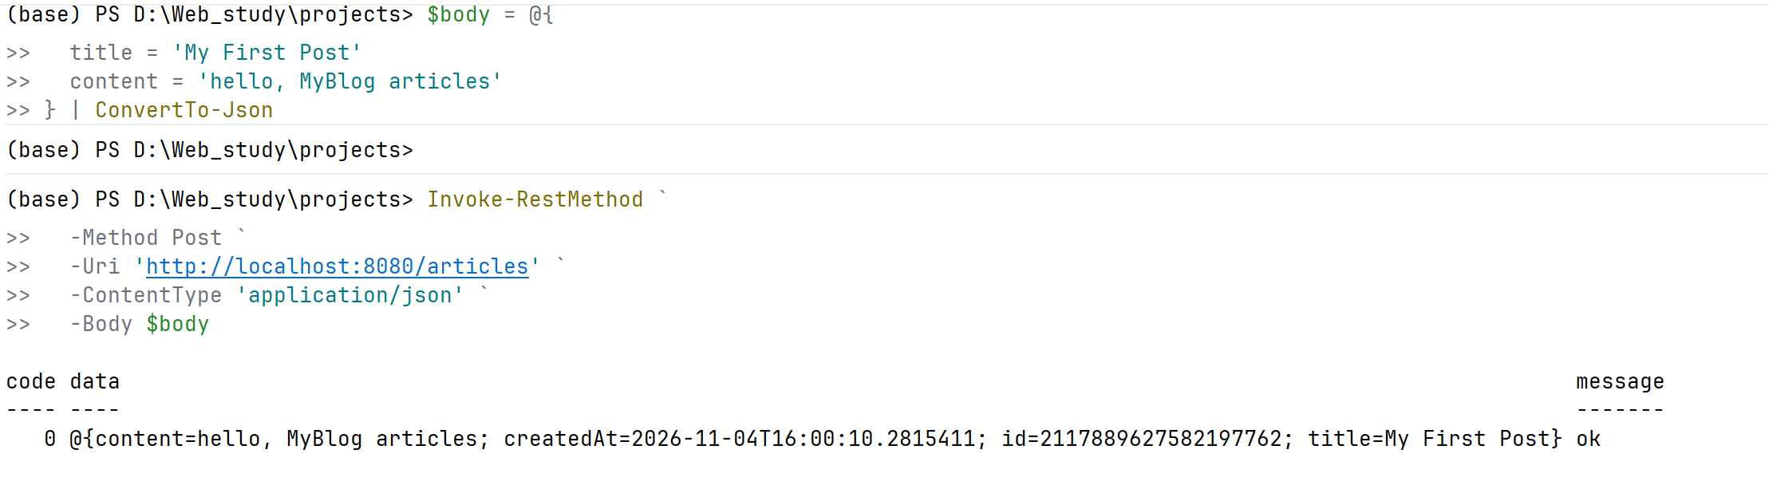
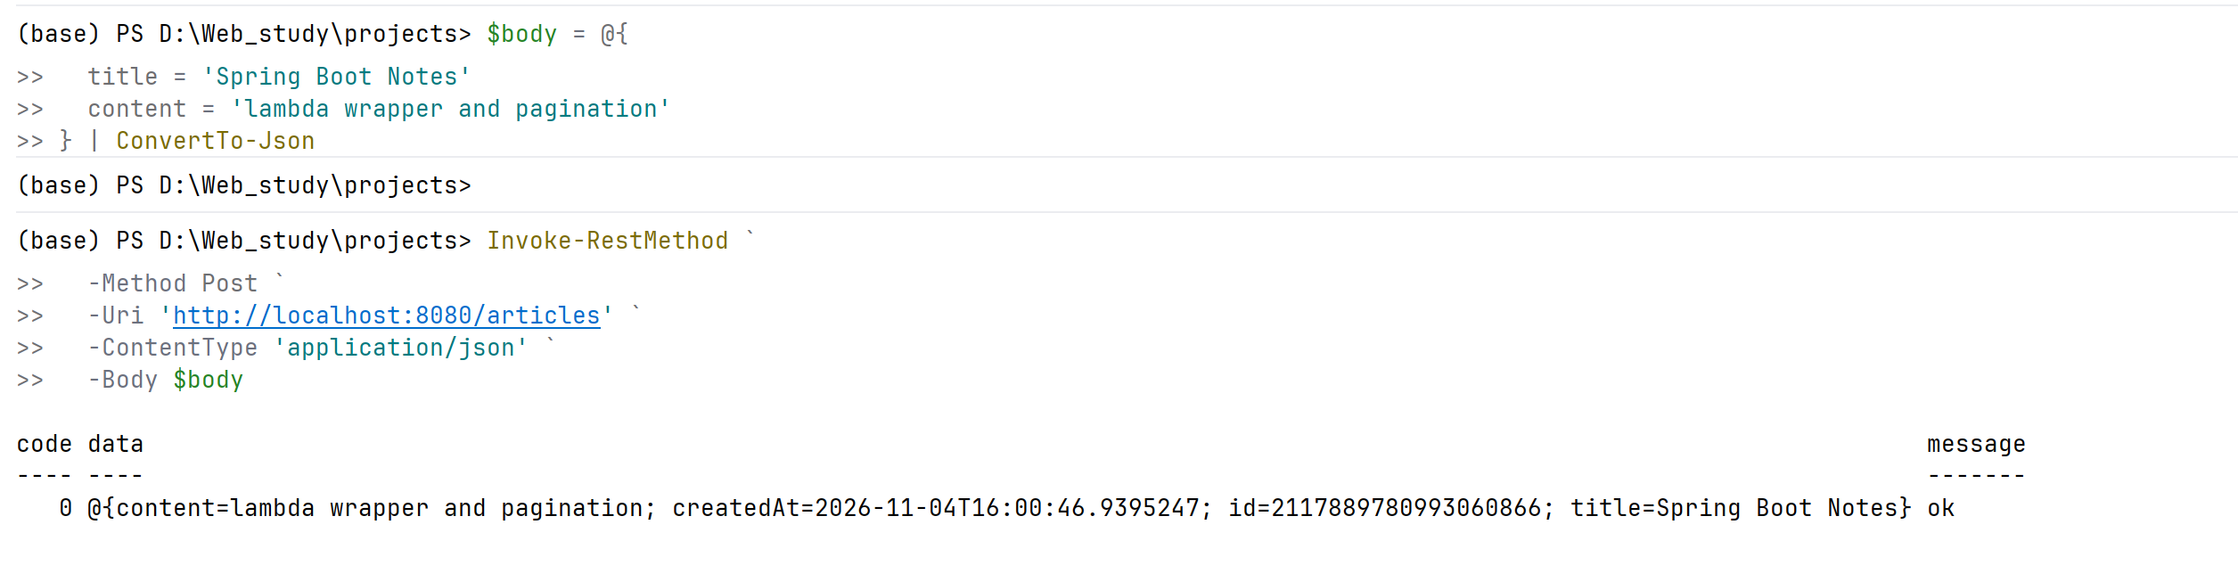
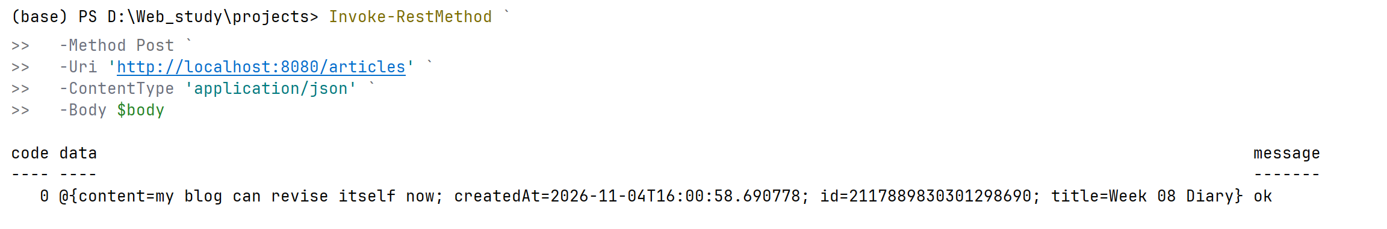
My First Post ID：__ 2117889627582197762______
Spring Boot Notes ID：___ 2117889780993060866_____
Week 08 Diary ID：__ 2117889830301298690______
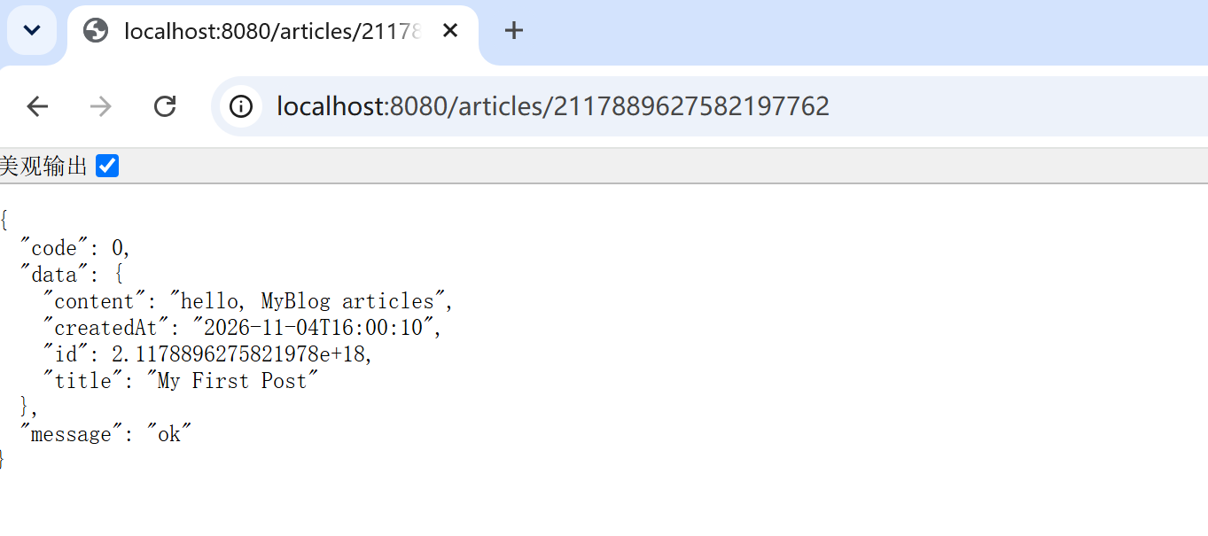
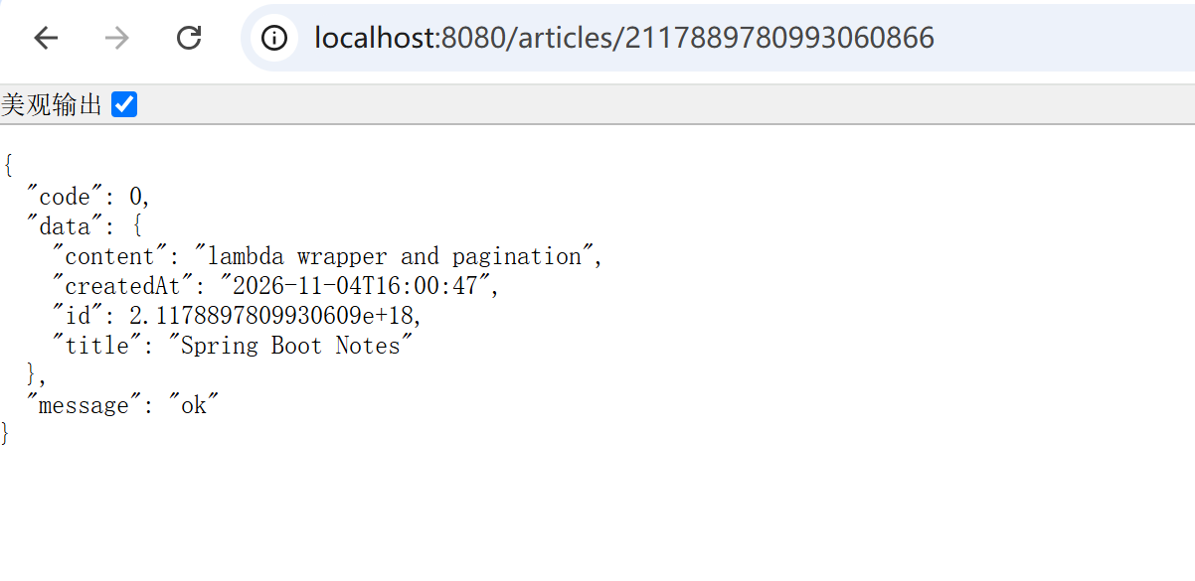
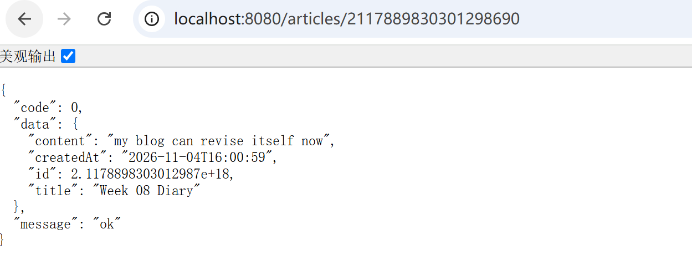
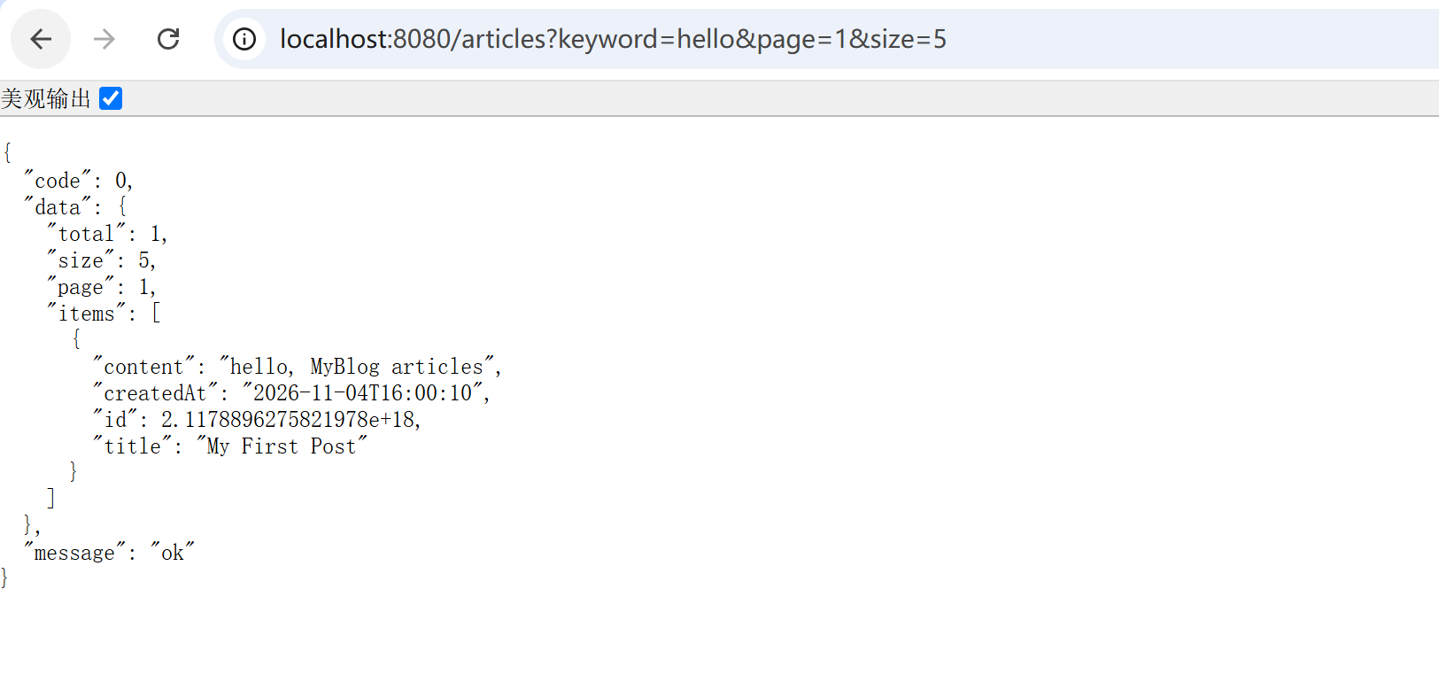
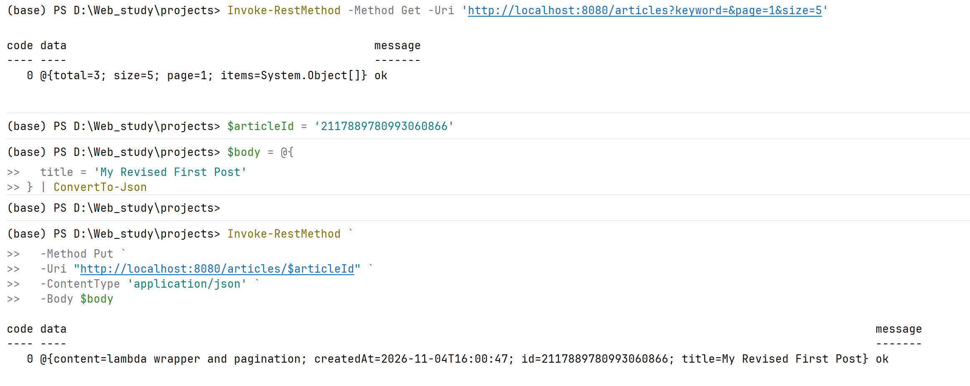
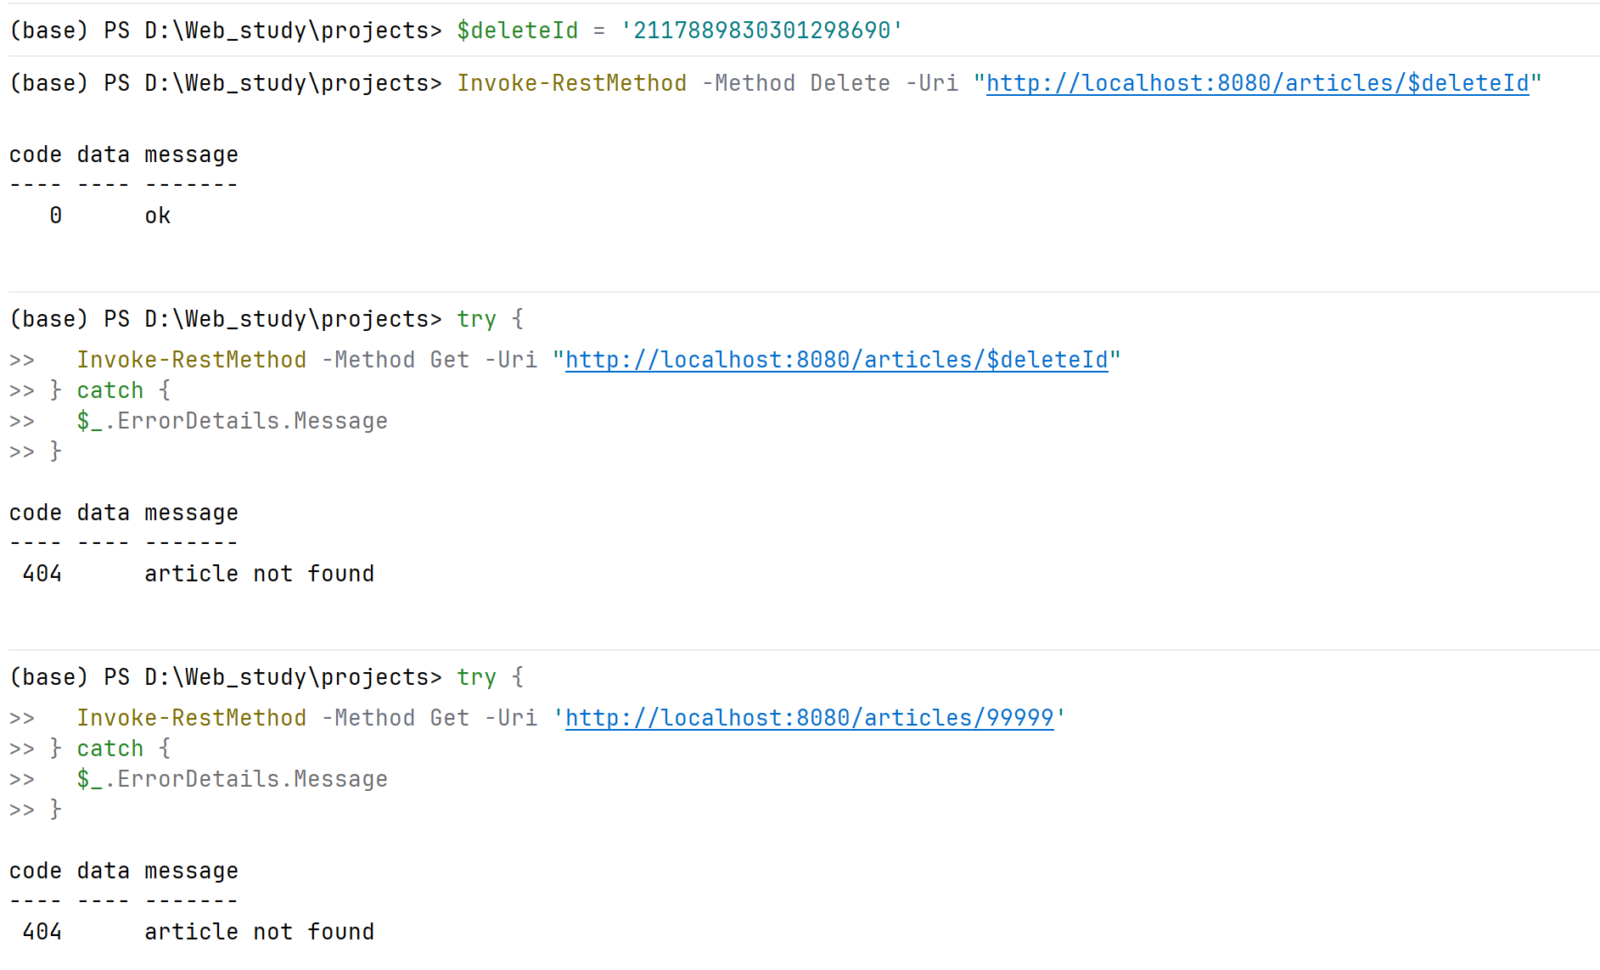

Submit
☐ Source code
☐ HTTP evidence (CRUD + search/page + Result + continuity)
☐ Level 2 notes + AI log
☐ Level 3 personal note
☐ Reflection

Reflection should answer (reflection.md): what was missing for a face · what Articles mean vs Messages · what you reused from Week07 · why contracts matter before UI · what AI suggested and what you kept/rejected · why the backend should be ready before MyBlog gets a face.

8. Troubleshooting
Symptom-first. More: common-bugs.md.
Symptom | Likely cause | First move
Want to start Vue | Out of scope — Week09 | Write the urge down as a Week09 question; continue the lab
Articles break messages | Shared config/scan issue introduced with new entity/mapper | Re-run §3.6 continuity; diff against backup
Article search always empty | Wrapper condition / wrong columns (e.g. only title, expected content) | Hand-check one real row against your like chain
Inconsistent JSON across article paths | Result not applied everywhere | Apply Result on all article success paths; one skeleton
Not-found returns HTML or stack trace | No advice handling for the exception | The @RestControllerAdvice shape from Task 3.5
PUT/PATCH "works" but nothing changes | Update not reaching the mapper / id mismatch | Verify the row in MySQL directly, then trace the layer chain
Delete then GET still returns the article | Soft-delete chosen but list query doesn't filter it | Decide: filter the flag in the discovery query — that's the point of soft

9. Completion Checklist
☐ Starting state verified (messages discovery + identity) with evidence
☐ Backup created before adding the article table
☐ L1: article table + entity + mapper exist
☐ L1: POST / GET by id / discovery list / PUT|PATCH / DELETE all evidenced
☐ L1: Result wrapper on article paths; not-found returns JSON Result
☐ L1: messages + identity re-tested AFTER articles — unchanged
☐ L2: why-not-Vue + Article-vs-Message + contract + transfer written
☐ L2: AI readiness review with accept/reject (incl. refused Vue code)
☐ L3: one personal improvement applied and re-tested
☐ Evidence map §7 complete
☐ AI log + reflection complete
☐ Continued Week07 project — no restart
☐ No Vue / Axios / SPA / Redis / ES / required JWT

10. Technical Boundary Reminder
This lab stays inside Week08. Do not introduce:
WARNING — forbidden pattern
❌ Vue / Axios / SPA
❌ Redis / Elasticsearch / RAG
❌ Required JWT login system

The face is next week. Every hour of UI now is an hour of confusion in Week09 — hold the line, finish the backend, and let the anticipation build.

11. Bridge to Week 09
Complete backend
↓
Face (Vue binds to /articles)

One question to carry into next week — do not answer it yet, just look at your own JSON:
Open your GET /articles?keyword=&page=1&size=5 response.
Imagine it as cards on a web page someone else will see.
Which field becomes the title? Which becomes the preview text?
And what would that page need to do when someone types in a search box?
Week 08: I Am Complete (Backend)
Week 09: I Have a Face

Do not build Vue in this lab.
Detailed troubleshooting: `common-bugs.md` · Mission and evaluation: `mission.md`, `assessment.md` · AI templates: `prompts/`.

