Coding Rationale

Research Aim and Objectives
China National Radio (CNR) posted the topic “Trump Wins the 2024 U.S. Presidential Election” on Weibo, one of the most popular social media platforms in China, which quickly topped the trending list, garnering over 2.9 billion views within just one hour (Lin, 2024). This phenomenon demonstrates the immense interest of Chinese netizens in the newly elected U.S. President, Donald Trump. However, different from the passion of Chinese netizens, Chinese officials hold a more pessimistic view regarding the future development of Sino-U.S. relations, particularly after Trump's re-election, largely due to Trump’s assertive and unpredictable governing style (Jie, 2024). Even under the deliberate guidance of official media's emphasis on reporting about the United States, the majority of netizens on Chinese social media (Weibo) express a supportive attitude toward the Washington government (Guan, 2018). However, through a questionnaire survey, Fang (2022) argues that young Chinese individuals with higher education exhibit a negative attitude toward the Washington government.
In summarize, this project aims to reveal the attitudes of Chinese Generation Z netizens toward the U.S. government and the underlying reasons behind them. The findings will provide empirical evidence for future Sino-U.S. diplomatic policymaking and contribute a fresh public perspective, enriching the research on the influence of international diplomatic images on social media.
Objective
- Identify the high-frequency words used by netizens on the Bilibili platform regarding Trump’s image, which will help uncover the factors shaping the perception of Trump among Gen Z. This also offers a foundation for future research on how different Chinese social media platforms shape public opinion about Sino-U.S. relations.
- Analyze the sentiment orientation of high-frequency words to reveal the attitudes and ideologies of netizens, providing insights into the discourse and rhetoric gap between official media narratives and public opinions.

Research Question
How do Chinese Gen Z netizens construct Trump’s personal image?

Approach, Method, Data, and limitation
Approach：
I adopt the exploratory approach to uncover patterns and themes of the image construction of Trump in Chinese netizens. This is because the approach is beneficial to mine the underlying information as much as possible and enhance the opportunity of interdisciplinary dialogue in research.
Method：
- Collect: Manually cut and paste the data of comments under the relevant videos to the CSV file.
- Clean: Use Regex method to pre-process the data.
- Extract: Use Python to extract the concordance sentences with the name of Trump and other nick name.
- Organize: use Pandas to form a structured and clear data form.
- Analysis：Use SnowNLP to analyze the sentiment of those comments related to Trump.
- Visualization: Use seaborn and matplotlib to visualize the sentiment orientation results of Chinese netizens and use Word Cloud to generate the images based on the frequency list.

Data
The video selection criteria:
- Time: News reports about Trump during the week of November 5–November 19 in the 2020 U.S. presidential election and the same time frame in the 2024 election.
- Popularity: The videos with over 1 million views and over 1,000 comments, and the comments with up to 100 likes.
- Authority: Source from the chinese official media organization——CCTV News Channel and College Daily, a private new media publication whose primary audience is Chinese oversea student.
- Theme: The feature story about Donald Trump

Thus, the data finally sources from the total of three videos, respectively, “Trump 2.0: a divisive dilemma” as well as “Separation of Powers” to “Unification of Powers”? A look ahead at the Trump 2.0 era” in 10.11.2024, 17.11.2024. from CCTV, and "Time to say goodbye" in 7.11.2020 from College Daily.

Limitations：

In terms of data enrichment, due to the manual collection, insufficient data samples will result in low credibility. Meanwhile, regarding data processing, the sentiment analysis model of SnowNLP shows the limitations of its difficulty in dealing with complex semantics, especially in politics context. This is because in this context, Chinese text has more symbolic and satirical semantics.

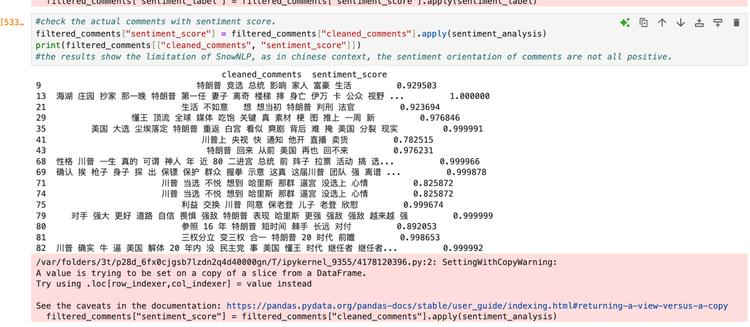
Figure 1 The sentiment analysis of SnowNLP in cleaned comments

Discussion and Conclusion:
# Comparing Figure 2 and Figure 3, generally, Chinese netizens demonstrate a positive attitude toward Trump between 2020 and 2024 (in 2020, Positive accounts for 66.7%, while in 2024, it accounts for 31.2%). However, contrary to Fang's pessimistic perspective, the trend shows a significant decline in positive comments from elite young Chinese netizens, accompanied by a rise in neutral comments. This suggests a waning interest among netizens in Trump.
# According to most common collocations related to Trump (shown as Figure4 and Figure5), In 2020, netizens paid more attention to the domestic political and diplomatic environment in the United States. For example, there were frequent mentions of former U.S. presidents Obama and Biden, Japanese Prime Minister Abe, and British King Charles. In contrast, later online commentary in 2024 was more focused on Trump’s personal life, with frequent mentions of “Ivanka”, “wife”, and “life”. Discussions about other political figures were significantly fewer, with only occasional mentions of Harris or the Democratic Party.

# The shift in comments between the two elections reflects a transition in Chinese netizens’ focus on Trump (from a national political perspective to a more personal one). However, their emotional orientation toward him has become more moderate. This indicates that Chinese Gene Z netizens have adopted a more composed view of Sino-U.S. relations with their interest in Trump being driven more by his personal life than his political achievements. In other words, the tendency of Gen Z Chinese netizens’ opinion on Sino-US relationship has become more “outsider” and indifference.

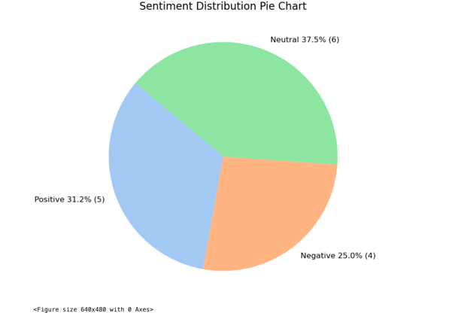  Figure 2 The image of the comment’s sentiment distribution from the video named “Trump 2.0": a divisive dilemma" and ““Separation of Powers” to ‘Unification of Powers’? A look ahead at the Trump 2.0 era” during the pos-election of 2024. | 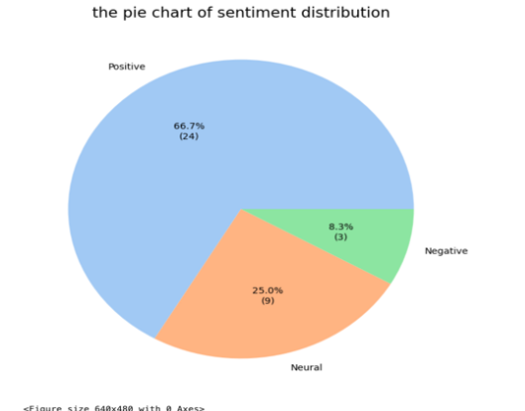  Figure 3 The image of the comment’s sentiment distribution from the video named "Time to say goodbye" during the pos-election of 2020.

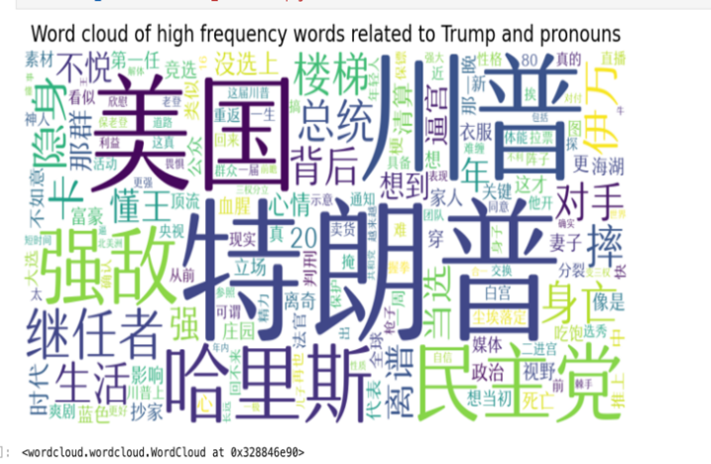  Figure 4 The word cloud of most common collocations related to Trump in the video of 2024. | 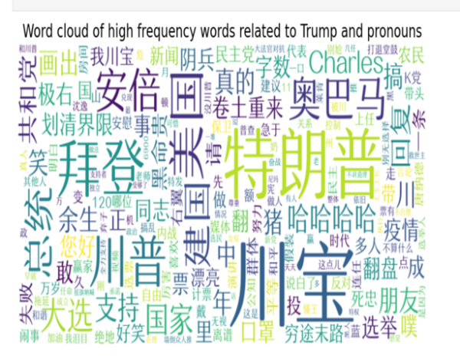Figure 5 The word cloud of most common collocations related to Trump in the video of 2020.

From the perspective of Sino-U.S. relations, these findings help uncover the significant impact of Chinese diplomatic strategy—promoting the “wolf warrior” tactic—on netizens, particularly young Chinese netizens, over the past four years. This may be attributed to an increased confidence in Chinese diplomatic policies, leading to a decline in enthusiasm among Gen Z netizens toward the United States.

Regarding the difference between official and private discourse, while public attitudes differ somewhat from the persistently pessimistic stance of the official narrative, the overall gap is not significant. This insight could be valuable for the future adjustment of Chinese diplomatic policies.

As for the limitations of this project, in the future, I plan to analyze a broader range of video comments from different sources on the Bilibili platform to enhance the credibility of the conclusions. Additionally, I will explore other sentiment analysis models, such as SpaCy and NLTK, to improve the accuracy of sentiment analysis.

AI declaration:

I declare that parts of this submission has contributions from AI software and that it aligns with acceptable use as specified as part of the assignment brief/ guidance and is consistent with good academic practice. The content can still be considered as my own words. I understand that as long as my use falls within the scope of appropriate use as defined in the assessment brief/guidance then this declaration will not have any direct impact on the grades awarded.

I acknowledge use of software to [include as appropriate]:

(i) Generate ideas or structure suggestions, for assistance with understanding core concepts, or other substantial foundational and preparatory activity.

[ChatGPT/ openai.com]

Reference
Fang, S.Y., Li, X.J., and Liu, Y., 2022. Chinese Public Opinion about US–China Relations from Trump to Biden. The Chinese Journal of International Politcs.15(1). pp.27-46.
Guan, Y.C., Tingley, D., Romney, D., Jamal, A., and Keohane, R., Chinese views of the United States: evidence from Weibo, International Relations of the Asia-Pacific, 20, 1, pp.1–30.
Hou, L., Zhang, J., 2019. Resistance in Discourse to Identity in Trump Tweets: In the Perspective of Critical Discourse Analysis. Macau University of Science and Technology.[5.1.2025]
Jie, Y., 2024. China ‘under siege’: How the US’s hardening China policy is seen in Beijing. Chatham House, [online]Available at: https://www.chathamhouse.org/2024/07/china-under-siege/key-issues-china-us-relationship. [7.1.2025]
Lin, N.J., 2024. When Chinese netizens watched Trump’s victory, they were both excited and worried that “China will have a hard time.”. VOA Chinese. [online] 7 November. Available at: https://www.voachinese.com/a/chinese-public-opinion-s-evaluation-of-trump-s-victory. [7.1.2025]
Michael Tomz, et al., “Public Opinion and Decisions About Military Force in Democracies,” International Organization, Vol. 74, No. 1 (2020), pp. 119–43.
Shirky, C.,2011. The Political Power of Social Media: Technology, the Public Sphere, and Political Change. Foreign Affairs, 90(1), 28–41.

