Design a project to sketch women: a corpus-based approach to representations of postcolonial feminism in Macanese literature —— A comparative analysis between the novels of Deolinda da Conceição and Maria Ondina Braga
- Introduction
Macanese or Filhos da Terra, in Portuguese, is a mixed race rooted between Portuguese and Chinese who live in Macao, situated in Southeast China. The Macanese people not only adopted the Western rituals from Portugal, such as Catholicism but also inherited the oriental mindset of Confucianism, especially the patriarchal hierarchy, as well as the three Obedience and four Virtues of the Chinese traditional ethical system. Moreover, Macau holds a unique historical background as compared to other colonies occupied by the Portuguese. Unlike other territories, the Portuguese occupied Macau through deceit rather than violence, resulting in a relatively harmonious cultural stance between Chinese and Western communities. The emergence of the Macanese community became a representation of this postcolonial hybridity（Bhabha，2012, pp.145-174）. In literature, the construction of the female image in Macau reflects new discursive expressions within this postcolonial context. This proposal aims to explore Macanese culture from a postcolonial feminist perspective, focusing on the ideological representations of Macanese women in the literature of Deolinda da Conceição and Maria Ondina Braga.
- Project Summary
The project aims to deconstruct women’s representation in Macanese literature from a postcolonial feminism perspective and protect this literature genre with a sustainability strategy. The methodology is based on postcolonial feminism, comparative analysis, and corpus linguistics frameworks. Under these frameworks, the project process mainly requires four steps: designing the organizational plan, collecting and processing data, validating, and publishing. Regarding the expected results, the outcome will reveal the differences in writing style and implicit cultural context between Deolinda da Conceição and Maria Ondina Braga, which will benefit the enrichment of Portuguese Creole society research and Macanese literature study. This proposal’s structure is divided into ten parts: introduction, summary, key research questions and their statement, project aims, methodology and methods, initial organizational plan, critical reflection, conclusion and future work, AI declaration, and the bibliography.

- Project Aims
- Fill the academic gap of Macanese gender study in Macanese and Portuguese literature domains.
- Enrich the implementation of digital humanities.
- Utilize knowledge of digital humanities discipline to activate the global dialog about Macanese creole society among others creole societies.
- Promote Macanese cultural heritage through the lens of Macanese literature.

  - Project Aims Statement
According to the research gap in the Macanese literature study, from a data-driven perspective, using statistical data from Google Books Ngram Viewer (https://books.google.com/ngrams/) (shown as Figure 1), I indexed the frequency of terms related to Macanese identity and Macao itself, aiming to explore the popularity of topics about Macanese people in mainstream academia. The terms include “Filhos da terra”—a historic Portuguese term for those of mixed Portuguese descent within Portuguese colonies—and “Macanese People,” referring to second-generation and later Macanese of Portuguese descent (Mo, 2007).
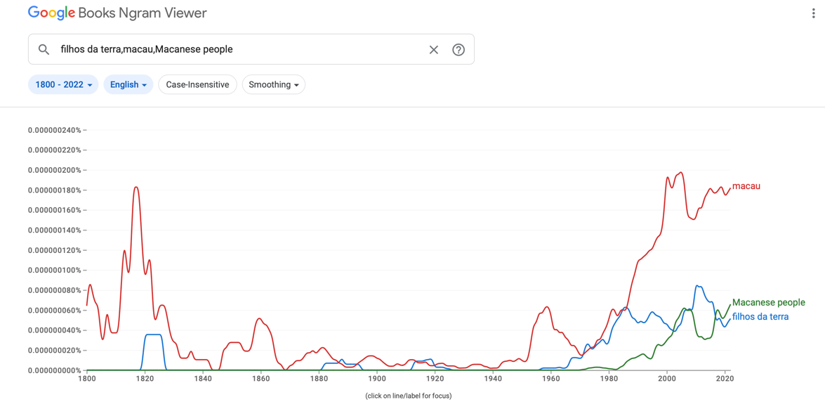
Figure 1 The statistics graph of the terms “filhos da terra,” “Macau,” and “Macanese people” in the Google Books Ngram Viewer.

The data reveal that discussions on Macao reached an initial peak in 1828 results between 1815 and 1820, followed by an unprecedented high in the early 21st century (1947 results in 2005), with relatively stable growth thereafter. These peaks correspond to significant political events: the first wave aligns with Portugal’s Liberal Revolution of 1820, marking its transition toward a constitutional monarchy—a period when Macao’s politics began to take on a distinctly colonial character. The second peak corresponds with the 1999 transfer of Macao’s sovereignty to China, sparking increasing interest in the region and its unique Creole-speaking society within the context of former Portuguese colonies. These two peaks suggest that mainstream academic attention on Macao and the Macanese community primarily focuses on political and economic dimensions, while literary exploration remains relatively underrepresented.
Recently, the awkwardness of Macanese literature has been alleviated. Studies are emerging in Macanese literature, primarily focusing on exploring its cultural identity and characteristics—core concerns within postcolonial theory. However, there appears to be a linguistic tilt within this research direction, especially regarding drama and poetry (Wang, 1995). Despite this interest, corpus-based methodologies are seldom applied; most studies rely on qualitative text analysis, with few employing quantitative approaches to literary analysis.
Furthermore, there are pieces of literature about gender study in Macanese literature. For example, Liao (2000, pp.144-146) analyzed the works of Macanese women writers at different stages of their careers, classified according to age. She claimed that the writing style of middle-aged female authors in Macau tends to be relatively conservative and uniform. Their description of female characters often focuses on inherent personality traits, such as motherhood's nurturing and self-sacrificing spirit or the romantic sentiments of girlhood. However, it lacks a narrative perspective that explores the acquired traits of womanhood shaped by societal norms, particularly the qualities associated with being a wife. He (2018) also talked about the women’s image issues in the literature of Deolinda. However, from a feminist perspective, she considered that the feminist ideas embodied in Deolinda’s female characters are in line with the Portuguese feminist movement. They share the view that women can only liberate themselves through education. Gago (2017) also highlighted the depiction of women’s struggles under patriarchal societal domination in Braga’s works and emphasized how Braga uses a unique “Outsider” perspective to analyze the struggles of Macanese women. In the study of cultural hybridity reflected in Macanese Creole literature, unlike the “Outsider” perspective of Braga, it is noted that Deolinda, as an “intervenor” rather than a “sympathizer,” constructs the women’s image in her stories. This approach reflects the ideology of postcolonial feminism present in Deolinda’s works.
Regarding the gender studies in Macanese literature mentioned above, firstly, these studies primarily adopt close reading to analyze texts. However, none of them employ digital humanities methods for text-mining research. Secondly, from the perspective of analytical approaches, existing studies remain relatively singular. For instance, Liao categorized and compared Macanese female authors based on their age without considering the actual background and identity of the authors. This approach interprets their works solely from a generic historical perspective. On the other hand, Liao, He, and Gago all adopt a text-based approach, conducting only descriptive analyses of the literary works of Macanese female authors. For example, they inferred the authors’ ideologies and writing styles based on relevant spots in the novels. Xiong’s (2019) study, while analyzing from the unique perspective of cultural hybridity, lacks quantitative research, resulting in somewhat unconvincing conclusions. Thus, by employing corpus analysis methods combined with the qualitative research perspective of postcolonial feminism, an analysis of the works of Deolinda and Braga can supplement the age-based categorization of female authors. To be specific, the selection of these two authors is based on their personal experiences: one being a native Macanese Creole and the other a Portuguese writer who lived in Macau for a long time. This classification rationale allows for a multifaceted interpretation of their literary works. For example, although both authors have a profound understanding of Macanese culture due to their long-term residence there, their cultural attributes differ under the influence of their “roots”——One was born in the East, while the other was born in the West, reflecting distinct cultural orientations. Therefore, a comparative analysis of the novels of these two authors can provide a deeper understanding of how female writers from different cultural backgrounds reflect and critique Macanese Creole culture. From the perspective of postcolonial feminism, this approach can also address the current limitations in the analytical angles of gender studies in Macao and enrich the practical research within the framework of postcolonial feminism. Charles Boxer (1975), a famous British historian dedicated to studying Creole societies during the Portuguese empire, also discussed the social identity and recognition of Macanese Creole women under the Portuguese Empire’s rule in his work “Mary and Misogyny.” He argued that similar to African Creole women, Macanese women achieved social mobility through intermarriage with Portuguese men. However, influenced by Western religious beliefs, the notions of “innate masculine superiority” and women’s “intellectual inferiority,” as well as the Church’s veneration of the Virgin Mary, led to a severe misogynistic orientation within Creole societies in Portuguese colonies. This misogynistic system is similar to the principles prescribed for women in Eastern Confucian thought. However, in Boxer’s discussion, he analyzed women in Macao and other Portuguese Creole societies solely from a Western culture perspective, without considering Eastern cultural influences. Therefore, the postcolonial feminist theory applied in this project can offer a new research perspective, enriching the understanding of how Eastern cultural thought shaped Macanese Creole society or other Creole societies influenced by East Asian culture, such as Manila.
All in all, through the lens of digital humanities, according to the opinions about “joint” and “creative” advantages of the digital humanities discipline of McGillivray and Toth (2022), it is beneficial for scholars to mine the socialist information hidden in text based on the quantitative evidence of computational tools, such as digital corpora, with previous academic background in humanities discipline. In terms of society, using a digital humanities perspective to answer Macanese culture issues enables Macanese culture to develop a new promotion angle, stimulating the preservation of its cultural heritage, especially the Macanese literature, as well as the cultural diversity in Macao society. Meanwhile, for the digital humanities discipline, studying Macanese literature could expand the range of its implementation and offer an opportunity for the interaction of global dialog in digital humanities academia, such as the comparative study of other intercultural literature (Angola Portuguese literature, Goan Literature in Portuguese).

- Key Research Questions
- What corpus linguistic characteristics in terms of syntax and semantics do Deolinda da Conceição and Maria Ondina Braga display in their depiction of the figure of Macanese/Chinese women?
- From a postcolonial feminist perspective, what similarities and differences can be observed in the portrayal of Macanese/Chinese women by Macanese-born Portuguese-speaking women writers versus Portuguese-born women writers?
- What factors contribute to the unique style of female image construction among Macanese-born Portuguese-speaking women writers?

- Methodology
  - Theoretical Framework
This project will adopt a Corpus-Based Critical Discourse Analysis (CDA) framework, integrating postcolonial feminist literary analysis and comparative methodology. Corpus-based tools will identify linguistic patterns and semantic characteristics in the novels of Deolinda da Conceição and Maria Ondina Braga. These patterns will then be critically interpreted through a postcolonial feminist lens to uncover ideological representations of women in a hybrid cultural context. Finally, the comparative approach will highlight differences and similarities between the two authors’ portrayals of Macanese/Chinese women, considering their distinct cultural and linguistic backgrounds.
  - The Types of Data
- By medium: Literary Texts
The selected novels mainly narrate Chinese or Macanese societies, written by Deolinda da Conceição and Maria Ondina Braga. For example, Cheong-Sam (1995)——Cheongsam, the Mandarin Gown by Deolinda da Conceição, and the novels of Braga: A China Fica ao Lado (1968)——China is next door, Estátua de Sal (1969)—— Salt Statue, Nocturno em Macau (1984)——Macau Nocturne.
- By language: Monolingual Corpus
It only contains texts in Portuguese because all selected novels have Portuguese versions rather than Chinese or English. Also, a monolingual corpus is beneficial for directly analyzing the linguistic patterns of Macanese literature, such as vocabulary and syntax, without losing authenticity due to translation.
- By Annotation: Raw corpus
The selected material has no annotation initially.
- By Data Format: PDF format
Most of the targeted materials only have online PDF format files.

  - Methods and Tools
According to TaDiRAH (n.d.), a digital humanities web-based project that aims to develop an ontology of digital research methods in the digital humanities domain, this project method will consist of four parts: Capturing, Enriching, Discovering, and Analyzing.
- Capturing
  - Data Recognition: Use optical character recognition (OCR) to scan the novels without being digitized.
  - Converting: covert all digitized materials into plain text words using Free Online OCR (2025), a website served as free online PDF to Word converter.
  - Encoding: Use the TEI encoding standard to build up a metadata system for the corpus to make the datasets more accessible and searchable.
- Enriching
  - Annotating: Use POS tagging in SpaCy to reveal the syntax structure in the novels.
  - Data Cleansing: Use the Regex in CotEditor to pre-process the materials, such as removing stop words.
- Discovering
- Querying: Use Regex methods in TXM software to query based on the research question. For example, the collocation between “women” and “girl” and their lemmas can be extracted from two women writers’ works.
- Analyzing
- Stylometry: Use TXM software query to output the frequency of occurrence of individual words, length of sentences, complexity of sentences, and frequent words from the literature of two women authors.
- Content analysis: Use sentiment orientation analysis in SpaCy to analyze the most common collocations with “girl,” “women,” and their lemmas.
- Visual analysis: Use Gephi and Seaborn in Python to visualize the results.
- Creating
- Wireframing: Use Figma to represent the project website in the future.

- Organizational plan
6.1. Project Milestones
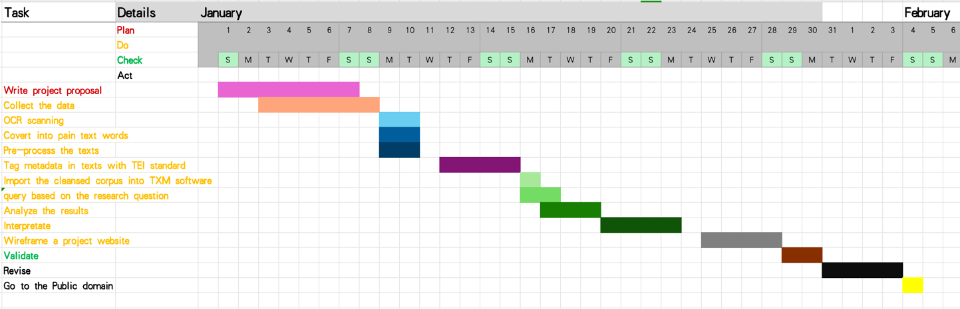
Figure 2 the screenshot of Microsoft Excel about the Gantt chart of project milestones
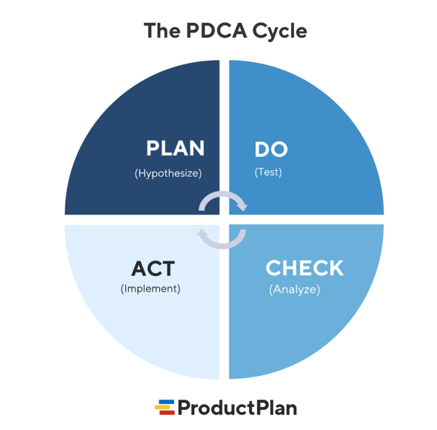
Figure 3 is the screenshot of the PDCA cycle project framework from https://www.productplan.com/glossary/pdca-cycle/
According to the PDCA cycle (shown as Figure 3), a project management framework (Product Plan, n.d. ), there are four main phrases in the project milestones, which are Plan, Do, Check, and Act, highlighted with red, yellow, green, and black in the detailed steps respectively (shown as Figure 2). Generally, the project starts on the 1st of January and ends on the 4th of February. The first phrase (Plan) will take about a week to be finished (the 1st of January——the 7th of January), the second phrase (Do) will last about a month (3rd of Jan.——28th of Jan.), the third phrase (Check) will last 2 days (the 29th of January to the 30th of January), and finally, the Act phrase will take about five days (the 31st of January——the 4th of February). However, the timeline of the project is flexible. Since the project framework operates in a cyclical rather than a linear flow, if a specific step cannot be completed as required, it will return to the previous step for further adjustments until the issue is resolved.

In terms of affordance, after the first phase, the expected outcome is that there will be a comprehensive project proposal, which enables the stakeholders to gain an understanding of the project value and attract their sponsorship. After the second phase, the research questions will be resolved, and the academic output with its documentation, including raw materials as well as user guidance will be organized into XML format files. These documents will finally be presented on the website in HTML format. After the Check phase, the project website should be improved or modified based on the usability and accessibility test. After the Act step, the website will be shown in the public domain with an open-sourcing program.
6.2. Stakeholders
Client | Instituto Cultural do Governo da Região Administrativa Especial de Macau (in English: Cultural Affairs Bureau of the Government of the Macao Special Administrative Region)/ Scholars who are interested in Macanese study or Portuguese creole society
Project Sponsor | Instituto Cultural do Governo da Região Administrativa Especial de Macau (in English: Cultural Affairs Bureau of the Government of the Macao Special Administrative Region)/ Instituto Português do Oriente (in English: Portuguese Institute of the Orient)
Project Manager | Me
Project Team | Me and relevant digital humanities scholars/ UX and UI designers/ Humanities Experts/ Technical Support Staff/ Digitization Specialists/ Communications Specialists/ Content manager

6.3. Limitations
Compared to traditional humanities, the advantage of digital humanities scholars lies in integrating emerging digital tools into conventional academic practices, thereby uncovering additional research dimensions and information（Weller, 2011）. Thus, to harness the advantages of this subject, critically utilizing digital methods has become one of the major topics in the digital humanities discipline. In the proposal, the limitations discussion will focus on utilizing computational methods in the project, including Capturing, Enriching, and Discovering, which are mentioned in Chapter 5. 3..
Regarding Capturing, using TEI as a metadata standard requires more learning costs and compatibility consideration. For instance, the TEI tagging system is highly comprehensive, covering a wide range of textual features. This complexity requires beginners to invest significant time and effort to learn and master it. Moreover, with the continuous development of internet technologies, the TEI standard itself undergoes frequent changes and upgrades, which may impact project implementation progress.
Additionally, TEI focuses on text encoding, but when dealing with multimedia or complex data structures, it may need to be combined with other metadata standards, such as Dublin Core or MODS. This compatibility issue could increase the complexity of the project.
In the enriching process, SpaCy, as a language model database primarily dedicated to English, has relative shortcomings in advanced functions such as part-of-speech tagging, dependency parsing, and named entity recognition for non-English languages, such as Portuguese (Almeida, 2023). Furthermore, compared to large language models like ChatGPT, SpaCy demonstrates lower accuracy and efficiency in handling large volumes of text (Deepdata_cn, 2024). Therefore, in this project, special attention should be paid to dividing chapters into manageable sections to avoid processing multiple texts simultaneously.
In terms of the discovering method, the project will use TXM software to query specific collocates with “woman,” “girl,” or their lemmas to analyze the sentiment orientation and the representation of Macanese women. However, the selected collocates have the problem of subjectivity (Ketzan, Edmond & Vogel, 2023). Due to the “purely descriptive” characteristics of dictionary-based queries in NLP (Schmidt, et al. 2021), The query terms I have chosen remain confined to a descriptive level and fail to delve into the semantic depth. For instance, over time or across different cultural contexts, the vocabulary and grammar used to describe women may vary from time to time. Consequently, the choice of different query methods relative to terms will naturally yield varying results, thereby influencing the interpretation of the research questions.

6.4. Wireframes
Following the text, there are three screenshots of the project wireframe. As Figure 4 shows, it is the home page of the project. Generally, there is a navigation bar at the top, including Home, E-book Resource, Research, and About. In the hero of this page, a different photo of famous Macanese women writers will be presented daily, with their corresponding quotations below the project title. The featured news will be presented in a one-column layout to present current project-related information. Below the news, there are Announcements, Upcoming events, as well as Blog posts columns. For these parts, the design will adopt the sidebar layout to enhance the readability of the website.
Figure 5 is the research page. The layout adopts the sidebar and two-column layout. The current research articles, such as the project proposal and project publication, will be included on this page. Furthermore, there is a button on the left sidebar called Explore. After clicking on this button, the page will be redirected to the external website(shown as Figure 7)——Voyant (https://voyant-tools.org), enabling the users to explore the texts, which are also be analyzed in the existing project, and gain a deeper understanding of the research process and its outcome.
Finally, in terms of Figure 6, it is the page of the e-book resource of Macanese women writers. This page includes one hero section with a graphic background and one grid-card layout of e-book resources, allowing users to learn more about the literature from Macanese women writers and have more opportunities to contribute to this cultural heritage aspect.
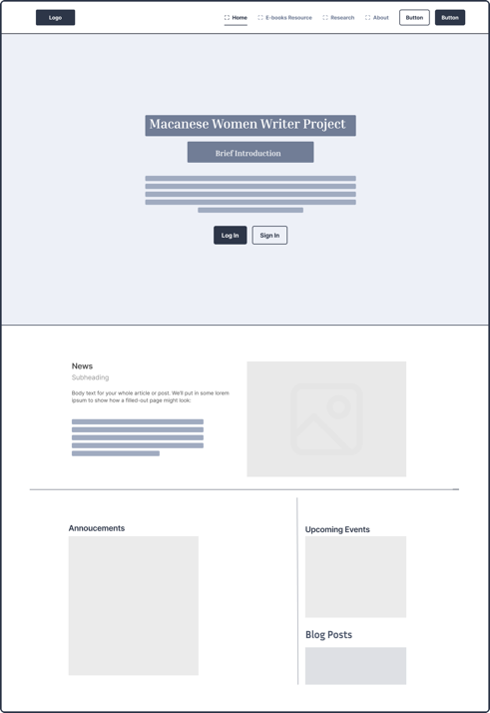  Figure 4 The home page of the project website, designed by Figma | 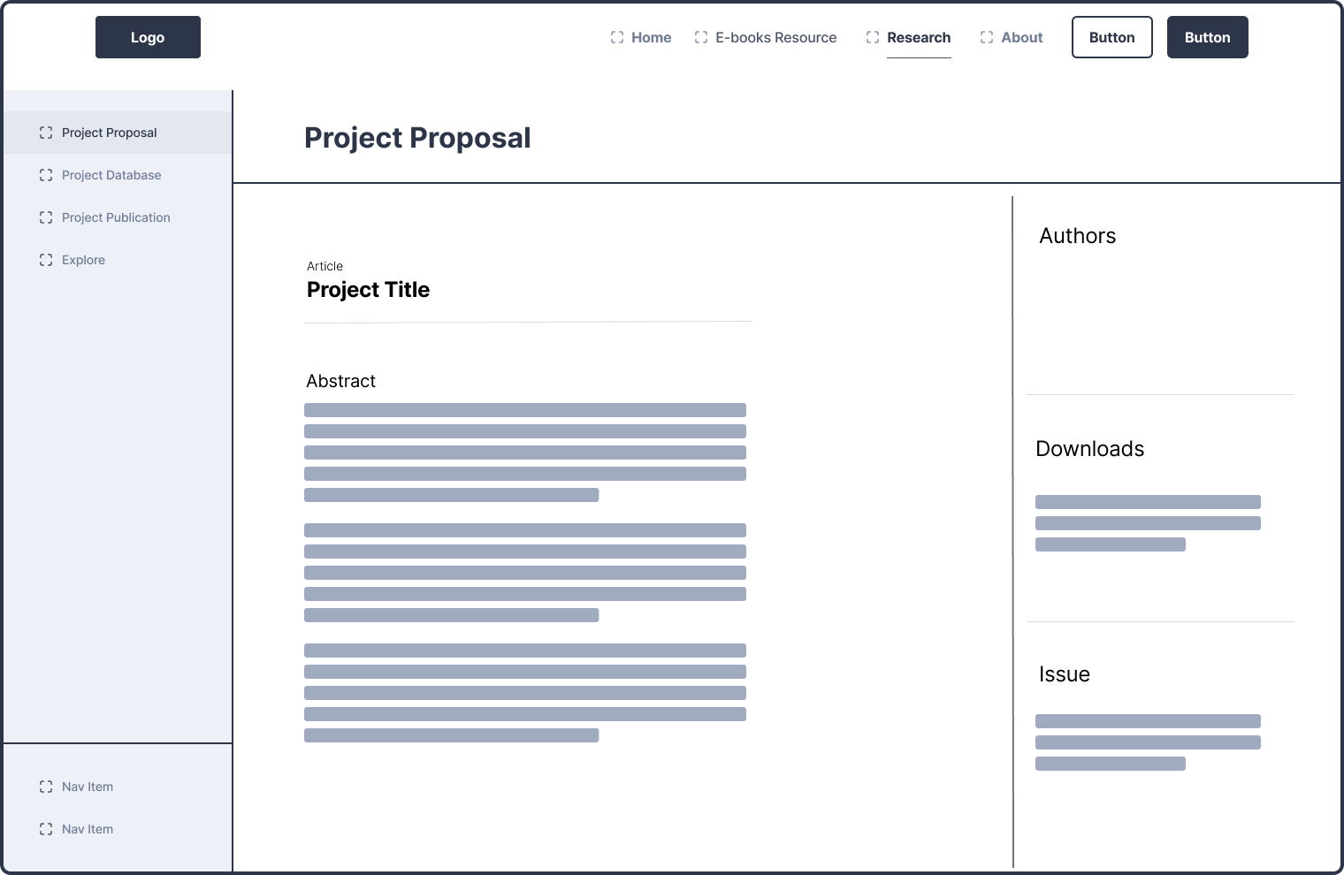  Figure 5 The Research page of the project website, designed by Figma
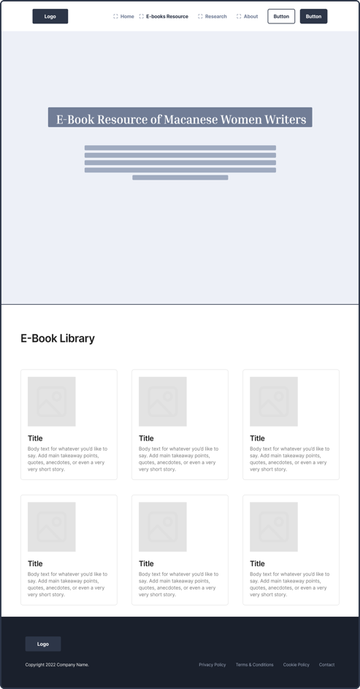  Figure 6 The E-book resource page of the project website, designed by Figma | 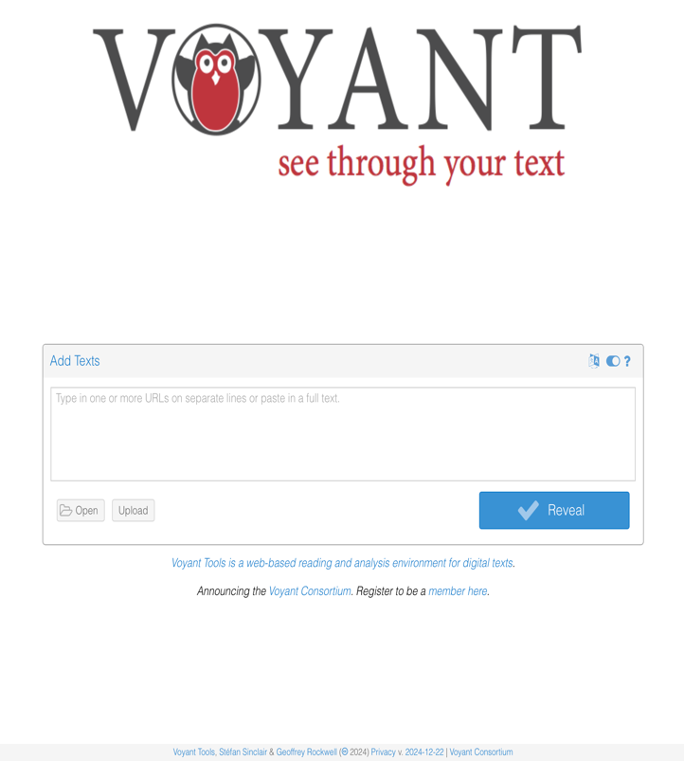  Figure 7 The redirected page of the Voyant Tool website, available at: https://voyant-tools.org.

- Critical reflection
In this project, my work could be divided into three parts——Literature review, Methodology, and Project planning.
For the first part, I make a reading list for the expected bibliography, including the required and recommended readings from the course syllabus as well as the extracurricular literature. This step enables the literature review to become more efficient and targeted, avoiding overwhelming and time wastage due to excessive readings. Moreover, using Ngram query, such as Google Books Ngram Viewer, offers quantitative evidence to support the literature review.
Regarding the methodology, I focus on the description and categorization of the data. Since one of the main steps of this project is the creation of the corpus, unlike general qualitative research methods, such as interviews or pure data analysis, the materials in the corpus should be selected in principle as the basis for analysis based on the significant characteristics of the corpus approach (Bennett, 2010, p.7). For example, to reduce the difficulty in analyzing the texts, data is limited in the Portuguese version, avoiding the interpretation issues due to semantic changes in other translations.
For project planning, I drew inspiration from the business planning strategy——the PDCA cycle to arrange my project milestones so that I could ensure that the project is comprehensive. Also, it can be iterated in the future based on the cycle framework.
Meanwhile, in this project, I have learned how to plan and design a project dedicated to the digital humanities domain and have opportunities to apply the knowledge that I have been taught in lectures to a specific case, such as combining distant reading——corpus analysis and close reading——interpretation, to analyze literature, the critical thinking about the methods in digital humanities, and the mindset for designing an organizational plan. Based on the PDCA cycle (Product Plan, n.d.), although the project’s formulation and operation are well-developed and feature self-iteration capabilities, sustainable preservation is crucial for ensuring a comprehensive curatorial cycle in future development. Thus, in the future, the project should concentrate on sustainability development, such as open-source development as well as community investment to tackle the trouble of future policy, funding, resource inherent vice, as well as engagement.
8. Conclusion and future work
Overall, in terms of academic perspective, using the corpus-based method, this project aims to sketch the women’s image and ideology by analyzing two Macanese women writers’ literature and filling the academic gap in Macanese literature. Meanwhile, from a cultural heritage perspective, the project also aims to preserve and promote Macanese cultural heritage in order to activate global dialogue in Macanese literature and enrich global cultural diversity.
In the future, according to six sustainable -design strategies (shown in Figure 8) (Mouëllic, et al., 2023), there are four dimensions (Sourcing, Operations, Usage, and End of life) to develop the project sustainability. Firstly, in terms of dematerialization, the literature of Macanese women writers should be digitized as much as possible so as to preserve those physical versions of books. Secondly, policies for standardization and modularity during operations dimension are designed, and thirdly, dynamic communities are built up, such as crowdsourcing. In project communities, the provision of various material sources, as well as a sufficient workforce, would stimulate the longevity and effective usage of Macanese literature, product efficiency, and circularity.

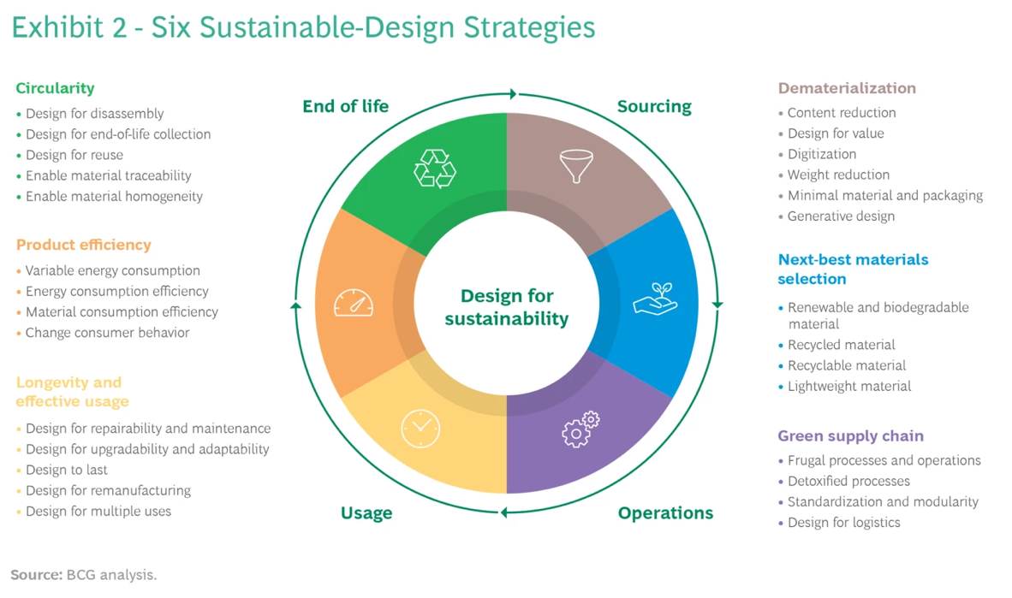
Figure 8 Six Sustainable-Design Strategies (Mouëllic, et al., 2023).
9. AI declaration
In my work, I used AI tools for grammar checking and literature searches. For grammar checking, I relied on AI to identify and correct language errors, enhancing clarity and coherence. For literature searches, I utilized AI-powered tools to locate relevant academic sources efficiently. While these tools improved productivity, their limitations include occasional misinterpretation of context in grammar and potential biases in search results. I ensured all findings and corrections were critically reviewed to maintain accuracy and originality. The use of AI was supplementary, and all intellectual contributions are my own.

Bibliography
Almeida,R., 2023. Building Portuguese Language Resources for Natural Language Processing Tasks. University of Porto.
Baker, P., 2006. Using Corpora in Discourse Analysis. London/New York: Continuum.
Barbara McGillivray, G. M. T., 2020. Applying Language Technology in Humanities Research: Design, Application, and the Underlying Logic. [Online]. Cham: Springer International Publishing.
Bhabha, H. K., 2012. Signs taken for wonders: Questions of ambivalence and authority under a tree outside Delhi, May 1817. 2nd ed. Hoboken: Taylor and Francis.
Boxer, C. R., 1975. Mary and misogyny: Women in Iberian expansion overseas, 1415-1815, some facts, fancies, and personalities. London: Duckworth.
Braga, M. O., 1968. China is nextdoor. Panorama.
Braga, M. O., 1969. Salt Statue. Sociedade de Expansão cultural.
Braga, M. O., 1984. Macau Nocturne. Editorial Caminho.
Conceição, D.D., 1995. Cheong-sam. Instituto Cultural de Macau.
Deepdata_cn, 2024. Natural Processing Language Tool (Spacy), CSDN [online]. Available at: https://blog.csdn.net/weixin_43156294/article/details/142673754. [Accessed at 2.1.2025]
Free Online OCR, 2025. Free Online OCR [Online]. Available at: https://www.newocr.com [4/1/2025].
Gago, D. N., 2017. Female Figurations in the Works of Deolinda da Conceição, Maria Ondina Braga and Fernanda Dias: The Arduous Paths of Exile and Emancipation. Review of Culture. Vol.54, pp. 7-17.
Gena R. Bennett, 2010. An IntroductIon to corpus LInguIstIcs Part 1 Using Corpora in the Language Learning Classroom: Corpus Linguistics for Teachers. https://www.press.umich.edu/pdf/9780472033850-part1.pdf.
Havik, P.J. and Newitt, M.D.D., 2015. Creole societies in the Portuguese colonial empire. United Kingdom: Cambridge Scholars Publishing.
He, M. L., 2018. Women in Kang Do-ryun's works. Administrative. Vol. 31, General 122, No. 4, pp.73-89.
Hu, J.,2021. Cultural Identity and Aesthetic Choices in Macanese Literature, Chinese Literature, (4), pp. 50–55.
Karimullah, K.,2020. Sketching women: a corpus-based approach to representations of women’s agency in political Internet corpora in Arabic and English. Corpora.15 (1), pp. 21–53.
Ketzan, E., Edmond J., and Vogel, C., 2023. Need a Good Book about Privacy? Evaluating Dictionary-Based Corpus Query for Detecting the Topic of Privacy in Literary Texts, Journal of Computational Literary Studies 2(1), 1–19.
Lewis, R. and Mills, S., 2013. Feminist Postcolonial Theory: A Reader. Hoboken: Taylor and Francis.
Liao, Z. X., 2000. Characteristics of modern women's literature in Macao. The social science of Jiangsu, pp.144-146.
Mo, X.S., 2007. A Study of 20th-Century Macanese Fiction. China: East China Normal University.
Mouëllic, M.L., et al., 2023. Six Strategies for Designing Sustainable Products. Boston Consulting Group, [online] Available at: https://www.bcg.com/publications/2023/six-strategies-to-lead-product-sustainability-design [2/1/2025].
Product Plan, n.d. PDCA Cycle:What Is the PDCA Cycle?.Available at: https://www.productplan.com/glossary/pdca-cycle/ [4/1/2025].
Schmidt et al., 2021. SentText: A Tool for Lexicon-based Sentiment Analysis in Digital Humanities. In: Information between Data and Knowledge. 74. Werner Hülsbusch, 156–172.
Spivak, G.C., 1985. Three Women’s Texts and a Critique of Imperialism. Critical Inquiry, Vol. 12, No.1, pp.243-261.
Vocabs, n.d.. TaDiRAH: Taxonomy of Digital Research Activities in the Humanities [Online]. Available at: https://vocabs.dariah.eu/tadirah/en/ [4/1/2025].
Wang, C., 1995. On Macanese Literature and its Cultural Values in Macau. Review of Culture. Summer edition, p.99.
Weller, M., 2011. The digital scholar: how technology is transforming scholarly practice. London: Bloomsbury Academic.
Xiong, Z. J., 2019. A study of cultural intermingling embodied in the literature of native Portuguese in Macao. Comparative Research on Cultural Innovation, 3(5), pp. 167-168.

