# T0: Exploring PyCharm

* Assignment T0 should be done in pairs.
* To begin, change the file name of this document to **T0: Exploring PyCharm - username1, username2** (for example, **T0:Exploring PyCharm - heggens, marrerrob**). To do this, click the label in the top left corner of your browser.

## Learning Objectives:

* Explore your PyCharm IDE environment
* Understand Python files
* Take a first dive into Python code
* Use some Python commands and understand what they do

## 

## Working with a Partner

Team assignment T0 should be explored in class with a pair partner from your team. In future work, we will work as "pair programmers", a technique used in industry. Today, we are **not** going to work that way completely because I want everyone to get their laptops set up and to get comfortable with the PyCharm IDE. Work in parallel with your partner to answer questions in this document, but be sure to follow all steps on your own computer so you’re ready for future classes as well.

There will be a lot of steps in this teamwork assignment which may assume some understanding of your Windows operating system. If you find yourself confused by an instruction, first ask your partner for help. If you are both unable to determine what I meant, you should feel encouraged to raise your hand. The instructor or a TA will come help.

## File Extensions

Before we get started, I want to help you to improve your Windows environment. If you are not using Windows, please let the instructor know and he will walk you through this process for your operating system.

Go to your Control Panel.

In the Control Panel, Go to Folder Options, and then go to the View Tab. Un-check the box that says "Hide extensions for known file types"

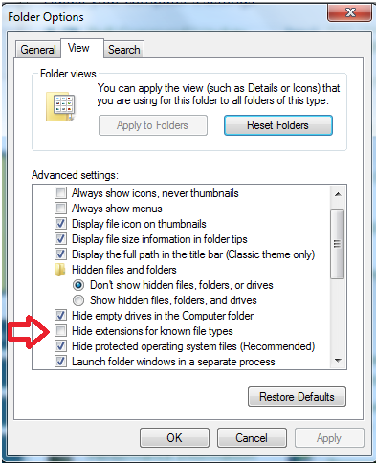

This will allow us to see the ".py" extensions on our Python programs. Click Ok and close any other unneeded open Windows.

## The PyCharm IDE

According to Wikipedia, An integrated development environment (IDE) is a software application that helps edit and debug code. In other words, it is a program used to create other programs. Our IDE is PyCharm. Open up PyCharm and we’ll start exploring.

**NOTE**: PyCharm is a large IDE, and often takes a long time to load. When you come to class in the future, start up PyCharm right away so you are not wasting time waiting on it.

### The Projects Page

As PyCharm opens, you get a Welcome screen. As time goes on, this screen will fill up with all the work you are doing. Right now, it’s probably pretty empty.

To begin, click “Create a new project.”

In the “Location” field, change the word “untitled” to “T0_username”, replacing username with your username (e.g., **C:\Users\heggens\PyCharmProjects\T0_heggens**). If you’ve installed the Google Drive application, as suggested in A0, you could store all your projects there instead (e.g., **C:\Users\heggens\Google Drive\T0_heggens**). If not, this default location will suffice.

Also, change the “Interpreter” field to the Anaconda version of Python. Again, if you haven’t installed that yet as part of A0, use the default setting for now:

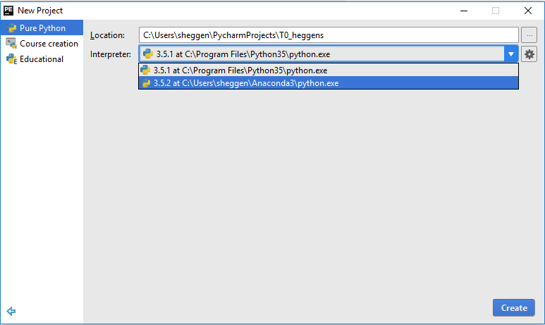

Click **Create**. This will take you into the main PyCharm programming environment.

**NOTE**: Projects are not code. Their not even files. In fact, they’re really just a directory on your computer where you can place things, plus a special hidden file which tracks your PyCharm activity in that folder. You can verify that by looking at the directory (i.e., “Location”) you used in the previous step.

### The Panes of PyCharm

PyCharm has three main areas you’ll be working in: the Project Navigation pane, the Active Editor pane, and the Tools pane.

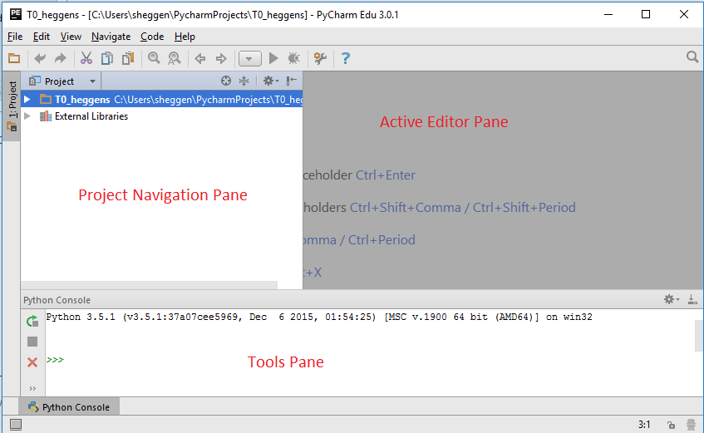

Let’s start by playing with the Tools pane. Click the “Python Console” button. It is an interpreter window which you can think of as a scratch pad. Hence, you can type commands directly into it, and they’ll execute.

|  |  |
| --- | --- |
| Try typing some arithmetic statements like "20 + 23" (without the quotation marks) into this console. What is the result? | 1. 43 |

The Active Editor pane is where you will be doing the majority of your work. Once we open a file (in a few steps), this is where you’ll edit the file. Think of it like the area where you edit the page in a Word document; you’ll edit code in the Active Editor pane.

The Project Navigation pane is where you’ll find all of your files related to a project. Eventually (not today!), we will be creating code where we’ll need to break it up into multiple files. This helps keep all that organized.

## Your Tasks

Follow the instructions below, and record what is happening. For the first few questions, you can use the Python Console, as described above.

|  |  |
| --- | --- |
| Use the Python Console for arithmetic. Be sure to try each of the following operators: +, -, *, and / with positive and negative integers as well as positive and negative non-integer real numbers. In the space to the right, report what happens (generally) for each operator. Is it what you expect, in all cases? What cases did something unexpected? | 2.  7 + 39 = 46  11 * 11 = 121  4 - 10 =-6  9 / 3 =3.0  Each one of these came out like we expected. |
| Use the Python Console to determine what // (two backslashes) does when used as an operator with integers. Try enough examples to determine precisely what it does. Explain. | 3. Divides, but it rounds down to the nearest decimal. |
| Use the Python console to determine what ** does when used with integers. Try enough examples to determine precisely what it does. Explain. | 4.**, is raising the first number to the power of the second number. |
| Use the Python console with ^ and integers to determine that it does not do the same thing as **. Report what you tried and what you got. Try the same numbers with ** and report what you got. Do not worry about trying to figure out what ^ does quite yet -- I give you some additional tools to figure that out with the next bullet. Just report on what you got and whether or not they are the same. | 5. 3^4=7  30^7=25  3**=81  30**7=21870000000  (6^3=5,6**3=216)  (5^2=7,5**2=25)  They are different. |
| Type "help('^')" in PyCharm's Python console without the double quotes and look through to see what it says about the ^ operator. Feel free to spend some time discussing this and Googling if you are interested in what this is. I mostly wanted you to know about the help feature. :) | 6. Bitwise xor |
| Do not Google this next one first. Instead, just guess. Use the Python console to see if you can figure out how to take the absolute value of a negative number in Python. Report how you do it and also how many guesses it took until you figured it out. | 7. abs () 2 tries |
| Do not Google on this one either at first. Instead, just guess. Use the Python console to see if you can figure out how to convert a non-integer like 3.4 or 6.78 to an integer number in Python. Report how you do it and also how many guesses it took until you figured it out. Note that there are different ways, and they do different things. You only need to find one of them, but please try enough examples so you can describe precisely what it does. | 8. round () 2 tries |
| Do not Google this one either at first. Instead, just guess. Computers use binary numbers internally for everything. Binary is a base-2 number system which represents values using two different symbols: typically written as 0 and 1. Use the Python Console to see if you can figure out how to convert a positive integer like 2 (binary 01) or 3 (binary 11) or 5 (binary 101) or 8 (binary 1000) or 2000 (binary 11111010000) to a binary number in Python. Report how you do it and also how many guesses it took until you figured it out. | 9. bin () 3 tries |
| Type "x = 5" in the PyCharm's Python console, without the double quotes.  Then type "print(x)" without the double quotes. Report what happens. | 10.After I input x = 5, then did print (x) the console showed 5. |
| Do these steps in order:   1. Type "x == 10" without the double quotes. Note the number of equal signs. Report what happens. 2. Next type "x == 5" without the double quotes. Report what happens. 3. Next type "x = 10" without the double quotes. Report what happens. 4. Next type "x == 10" without the double quotes. Report what happens. | 11.a. The console said False  11.b. The console said True  11.c. Nothing happened  11.d. The console said True |
| Explore the use of "=" and "==" until you understand how they differ. Then precisely describe their differences. | 12. (=) sets the x as a value  (==) checks if two variables are equal |

Next we are going to explore the Active Editor pane. Download [t0_chocolate.py](https://drive.google.com/file/d/0B0J8Yj0B6KRSeDV5aDBCVDZXUzQ/view?usp=sharing) and save it in a folder where you plan to keep code for this course (likely, your project folder when you started this activity).



Now, open the file in PyCharm by double-clicking the file in PyCharm.

|  |  |
| --- | --- |
| Run the program by clicking the green Run button. What happens in the PyCharm IDE? | 13. The console asks for my name. |
| In the Python Console, you’ll notice a question. Follow the questions, clicking Enter between each question. What’s happening? How is it related to the code in the Active Editor pane?  Rerun the code multiple times (use the green Run button) if you need to see it all again. | 14.The console is running the code that is written in the Active Editor pane |
| Describe what the following appear to do in Python 3.5:   1. input() 2. str() 3. int() 4. print() 5. the + sign in: "Hello " + entered_name + "! \n" 6. the "\n" in: "Hello " + entered_name + "! \n" 7. The "#" sign in: *# The code starts here. I've broken it into 4 sections, to make the logic more clear* | 15.a. This allows the person to type something into the console  15.b. This allows a number to be printed into the console  15.c. This forces the console to only accept a number that is an integer  15.d. This will display the text in the parenthesis in the console  15.e. This is used to insert a variable into a print statement  15.f. This is to move the console to a new line  15.g. This is a comment and won’t show up when the code is run |
| Discuss with your partner and reflect on what the most surprising thing you and your partner(s) learned in this teamwork. Explain why it was surprising. | 16. We thought that it was surprising that you could work with binary and absolute value. We did not expect we would be able to work with binary and absolute value is something didn’t expect to use in this course. |
| Discuss with your partner and reflect on what the most interesting thing you and your partner(s) learned in this teamwork. Explain why it was interesting. | 17. The help was the most interesting to us. It was very useful for answering a lot of these questions |
| Describe your team's reaction to this teamwork. Did you achieve the learning objectives listed at the top? How might I consider ways of making it even better in the future? | 18. It helped with jumping into python and getting us started looking at code |

Congratulations! You’ve completed your first teamwork assignment. Submitting teamwork assignments are easy. Always read the instructions below, though, as there might be slight differences each time. For example, sometimes you’ll need to submit multiple files; I’ll provide instructions on how to ZIP files together.

For all teamwork assignments, you’ll be working with one or more partners. Only one person will need to submit this document; the other members of your team will submit a different document. First, nominate a submitter:

|  |  |
| --- | --- |
| Submitter: | Tradd Schmidt |
| Partner 1: | Jacob Walker |
| Partner 2 (if a team of three): |  |

## Submission Instructions

1. (Submitter) Download this document as a PDF. To do this, go to File >> Download as...
2. (Submitter) Rename the document to***T0_usernames.pdf.*** Replace *usernames* with your Berea usernames. For example, the TA Bianca Marrero and my document would be named **T0_heggens_marrerob.pdf.   
   NOTE:** From now on**,** incorrect filenames will automatically reduce your grade by 1 point for each assignment. Fortunately, the format is always the same no matter what the assignment.
3. (Submitter) Upload the document to Moodle by the due date listed on the course website: <https://trello.com/b/w7bIrLoV/>.
4. (All Partners) Open up Wordpad. Create a new text document (.txt) and include the table above will all members names in it.
5. (All Partners) Save the document as ***T0_usernames.txt***. Replace *usernames* with your Berea usernames. For example, the TA Bianca Marrero and my document would be named **T0_heggens_marrerob.txt.**
6. (All Partners) Upload the document to Moodle by the due date listed on the course website: <https://trello.com/b/w7bIrLoV/>.