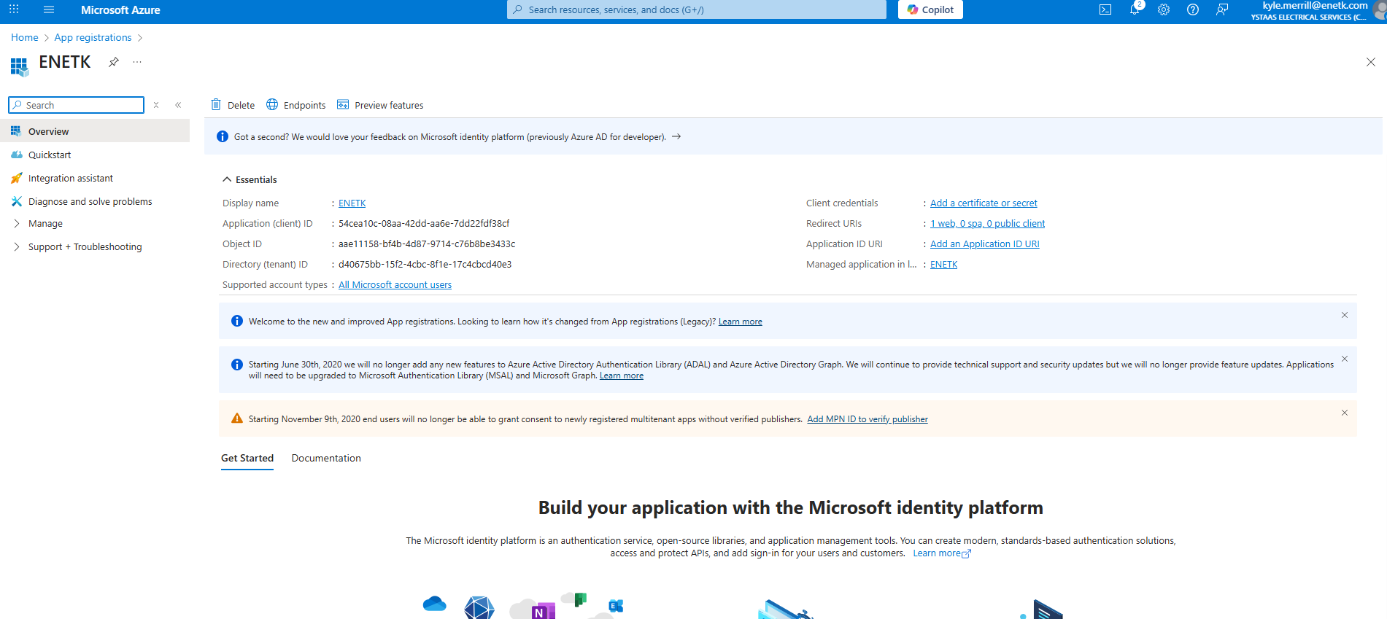

Display name
:
ENETK
Application (client) ID
:
54cea10c-08aa-42dd-aa6e-7dd22fdf38cf
Object ID
:
aae11158-bf4b-4d87-9714-c76b8be3433c
Directory (tenant) ID
:
d40675bb-15f2-4cbc-8f1e-17c4cbcd40e3
Supported account types
:
All Microsoft account users
Client credentials
:
Add a certificate or secret
Redirect URIs
:
1 web, 0 spa, 0 public client
Application ID URI
:
Add an Application ID URI
Managed application in local directory
:
ENETK

enetk pm app
6/13/2026
enetk pm app
6/13/2026
J-E8Q~upiF3mFbNSAkqHNw1l6pwOZCyGXHE02anN
fbaecd23-0f9a-4410-bfb5-b0e6129d07ba

