Excel ECU (Engine Control Unit) setup

The ECU utilises slightly modified Speeduino firmware, with the Speeduino manual available at https://wiki.speeduino.com/en/home
This ECU should be accompanied by three files, speeduinoExcel.ini, speeduinoExcel.msq and this one; copy the ini and msq files to disk on the PC that runsTunerStudio.

Speeduino is one-size-fits-all firmware and has a considerable number of configurable options to suit engines from single cylinder motor bikes to V8 drag racers.

The Speeduino firmware is configured, and engine tuning carried out, using TunerStudio software, available from http://www.tunerstudio.com/index.php/downloads
Windows and Linux versions are available.
Help is included on the T/S screen.
Note that a free version is available, with useful, but limited functionality, and it is highly recommended to upgrade to a paid version. Dyno users would get best use from the ‘Ultra” edition.

Do NOT download Speeduino firmware from the Speeduino site, as it will NOT work without modifications, on this ECU. (Requiring an update is unlikely, as the majority of updates are for additional features that the Excel is unable to use.)
Current Speeduino firmware version (signature) used in the ECU is "speeduino 202002"

You will however, find all the features not used by Excel, displayed in the various T/S menus. Leave those features deselected.
The T/S setting ‘Reset Control’ only applies to Arduino units and is not used (or needed) with this ECU.

In the Speeduino manual, reference is made to the use of Arduino Processing Units. This ECU does not use an Arduino, but rather a smaller, faster, more capable unit – a Teensy 3.5.
(The Arduino was too large to fit in the Excel ECU box.)

A considerable part of the Speeduino manual introduction can be skipped, since as this unit is plug and play, it requires NO wiring changes.

Before running the engine for the first time, open the TunerStudio ‘Tools’ dropdown and calibrate ALL sensors. If values are not known, they MUST be obtained (usually by measurement). The ‘Set Analog Sensor Filters’ can be skipped – they can be adjusted at a later time, if required.

TunerStudio requires a project to be created and a base tune added, before it will connect to the ECU. The base tune provides ‘sensible’ but not necessarily correct values for the ECU.

Occasionally, when making a change with T/S, “Settings Changed that Require a Power Cycle to Take Effect” will appear. Simply turn ignition key off, then on. (Occasionaly after changing a value using T/S, the new value will appear to not be in effect, cycling the ignition should correct this.)

When creating a project, do not select the option to ‘Detect’ firmware, rather, select the ‘other/browse’ option button and browse to the location where the SpeeduinoExcel.ini file exists, and load that file. (The ‘Detect’ button will download a file, but not one this ECU can use.)

The Excel ECU is supplied with firmware and base tune already loaded, so if you are careful, the existing tune can be used after creating a new project.

On starting the new TunerStudio project, T/S may complain that the data in T/S is different from that in the ECU, and display many pages of difference. Select the ‘Use Controller Settings’ button and the settings, already in the ECU will be loaded back to tuner studio.
The next time T/S is started with the new project, T/S will start without compaint, using the created project, if the ‘options → preferences → Load Last Project on Startup’ option has been selected.
If, by accident, or some other issue occurs, the ‘Send Current TunerStudio Settings’ button is pressed, rather than the ‘Use Controller Settings’ button then the Excel base tune in the ECU will be destroyed. In that case, use the ‘File’ dropdown in T/S and ‘Load Tune’. Select and load the speeduinoExcel.msq file supplied with the ECU.

At various stages during the tuning sessions, the current tune can be saved (File → Save Tune). These saved tunes can be loaded at any time, using ‘Load Tune’.

The following screenshots show the engine configuration parameters for the Excel and should not be changed, except for the injector flow rate, if incorrect.

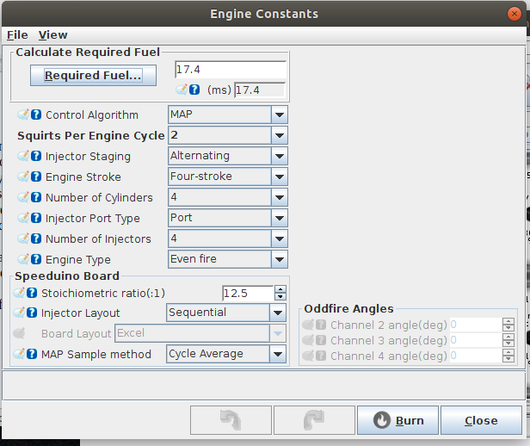
Required fuel has been calculated using injector flow rate of 170 CC/Min. Alter this if your injectors are different. This setting effects the tuning, so needs to be correct.

Again, before starting any work, make sure that ALL sensors have been correctly calibrated.

Note: ‘Squirts per engine cycle’ set to 2, is a T/S artifact and is automatically set to 1 inside the Speeduino firmware. (One squirt, per injector, per cycle.)

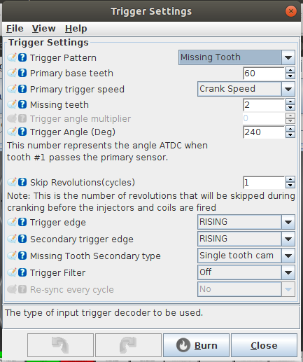

Parameters above ‘Skip Revolutions’ should not be altered, as timing critically depends on those.

The engine firing order 1 - 3 - 4 - 2 is set in the firmware. (Really only applies to injectors, since the ignition is wasted spark.)

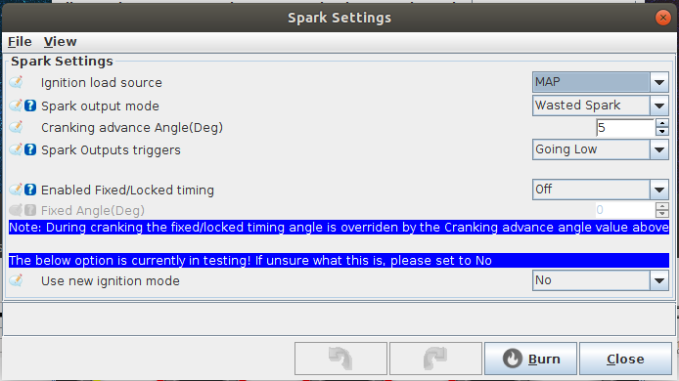
None of the above should be altered, in particular ‘Spark Output Triggers’ as any change to this will probably burn out your spark coils.

In all the above screenshots, the little blue question mark will display help if selected via the T/S screen.

Be very aware, that this version of the hardware and firmware does not include knock control.

The base tune supplied should be sufficient to start the engine.

Have a good look at the features and functionality of Tuner Studio, before embarking on any tuning exercise - there are an enormous number of values that can be changed.
Note that TunerStudio was originally designed as the tuning front-end to MegaSquirt ECUs, so the T/S help files consistently mention MegaSquirt. Other than that, T/S works as expected with Speeduino driven ECUs. Note that Speeduino does use interpolated values from tables.

Auto tuning is available in the paid version of T/S - see ‘VE Analyze Live’ in the Help section.

