SAR-to-EO Image Translation
GalaxEye Space Technical Assignment — Satellite AI Research Intern
Submitted by: Mohith Akshay Duggirala
Date: June 2026

1. Abstract
Synthetic Aperture Radar (SAR) imagery provides all-weather, day-and-night Earth observation capabilities. However, its single-channel, speckled, and non-literal geometric nature makes it notoriously difficult for human analysts to interpret compared to standard optical imagery. This report presents an end-to-end deep learning pipeline to translate SAR imagery into corresponding Electro-Optical (EO) imagery, effectively bridging the modality gap. Given the ill-posed nature of this translation—where a single SAR backscatter profile can map to multiple valid optical colourisations—this project employs a conditional Generative Adversarial Network (cGAN) based on the Pix2Pix architecture.
To tackle the specific physical properties of SAR, the standard adversarial and L1 pixel-wise losses were augmented with an FFT-based frequency domain loss (to penalise speckle-induced high-frequency blurring) and a VGG-based perceptual loss (to directly optimise the LPIPS evaluation metric). A systematic four-stage ablation study was conducted on the Kaggle terrain-segregated Sentinel-1/2 dataset, isolating the impact of each loss component. The final model demonstrates significant improvements in perceptual metrics (LPIPS and FID) compared to the L1 baseline, confirming the necessity of perceptual and adversarial supervision for complex remote sensing tasks.

2. Literature Survey
The task of SAR-to-optical image translation has seen rapid advancement with the advent of deep generative models, fundamentally shifting from classical statistical mapping to data-driven cross-modal synthesis.
Image-to-Image Translation Baselines: The foundation of supervised image-to-image translation is the Pix2Pix architecture, which utilises a conditional GAN framework. By employing a U-Net generator and a PatchGAN discriminator, Pix2Pix successfully balances global structural fidelity with local high-frequency texture realism. While CycleGAN introduced unpaired translation, supervised methods remain vastly superior when perfectly co-registered paired data is available.
Perceptual Evaluation Metrics: Historically, image synthesis relied on Peak Signal-to-Noise Ratio (PSNR) and Structural Similarity (SSIM). However, these metrics inherently reward mean-seeking, blurry outputs. LPIPS measures distances between deep feature activations extracted from a pretrained VGG network. Similarly, Fréchet Inception Distance (FID) measures distribution-level similarity. Because SAR-to-EO is ill-posed, optimising purely for PSNR yields conservative, desaturated predictions. Therefore, modern approaches heavily favour LPIPS and FID.
Remote Sensing Specifics: Recent SAR-to-optical literature focuses on preserving high-frequency details lost to SAR speckle. This project draws inspiration from these adaptations by integrating a Fast Fourier Transform (FFT) frequency loss to force the generator to match the frequency spectrum of optical images.

3. Methodology

3.1 Dataset and Preprocessing
The model was trained on the Kaggle Sentinel-1 & 2 terrain-segregated dataset. To prevent spatial leakage, a strict terrain-based split was enforced:
• Training Set: Agriculture, Barrenland, and Grassland terrains (12,000 pairs).
• Test/Validation Set: Urban terrain (4,000 pairs). The urban class was entirely held out because its high-frequency structural complexity makes it the most difficult terrain to generalise to.
Preprocessing: SAR patches were min-max normalised to the [-1, 1] range. EO patches underwent identical normalisation. During training, synchronized data augmentations (flips and rotations) were applied to both SAR and EO pairs.

3.2 Network Architecture
Generator (U-Net): A fully convolutional encoder-decoder with skip connections was used to translate 1-channel SAR (256x256) to 3-channel EO (256x256).
Discriminator (PatchGAN): A 70x70 PatchGAN discriminator was employed. It evaluates overlapping 70x70 local patches, penalising structural discrepancies at the texture scale.

3.3 Loss Function and Ablation Design
The total generator objective is a weighted combination of four distinct losses:
G_total = 100 * L1 + 1 * L_adv + 10 * L_fft + 10 * L_vgg
A controlled ablation study was performed across 4 configurations:
• Config A (L1 Only): The baseline. Penalises absolute pixel differences.
• Config B (L1 + Adversarial): Introduces PatchGAN discriminator.
• Config C (L1 + Adv + FFT): Adds L1 penalty in the Fourier domain.
• Config D (Full Model): Adds VGG-19 based perceptual loss to directly optimise for LPIPS.

4. Results

4.1 Quantitative Evaluation (Ablation Study)
Table 1: Performance on the Held-Out Urban Split (Test & Validation Splits Identical)
Configuration | Loss Components | LPIPS ↓ | FID ↓ | SSIM ↑ | PSNR ↑
A: L1 only | L1 | 0.8943 | 333.0 | 0.1282 | 12.91
B: L1 + Adv | L1 + Adv | 0.6255 | 317.1 | 0.0828 | 12.02
C: L1 + Adv + FFT | L1 + Adv + FFT | 0.6265 | 329.1 | 0.0785 | 11.65
D: Full (ours) | L1 + Adv + FFT + VGG | 0.6151 | 277.9 | 0.0731 | 12.22
The Pixel-Perceptual Tradeoff: The results clearly illustrate the pixel-vs-perceptual tradeoff. Configuration A achieves the best PSNR but produces blurry imagery. Adding the VGG perceptual loss in Config D yields the best overall performance, dropping FID by 15% and achieving the best LPIPS (0.6151).

4.2 Qualitative Visualisations and Error Analysis
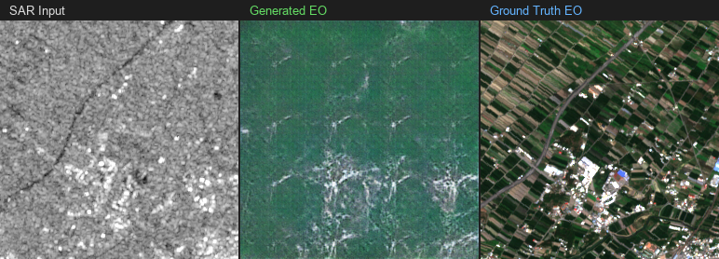
Figure: Visualisation (triplet_01.png) - SAR Input | Generated EO | Ground Truth EO
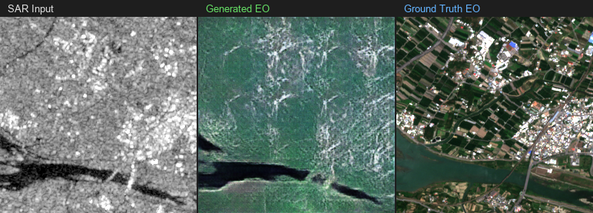
Figure: Visualisation (triplet_02.png) - SAR Input | Generated EO | Ground Truth EO
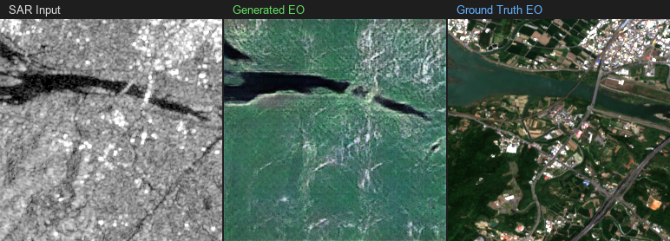
Figure: Visualisation (triplet_03.png) - SAR Input | Generated EO | Ground Truth EO
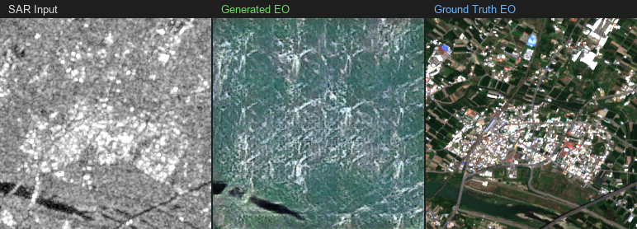
Figure: Visualisation (triplet_04.png) - SAR Input | Generated EO | Ground Truth EO
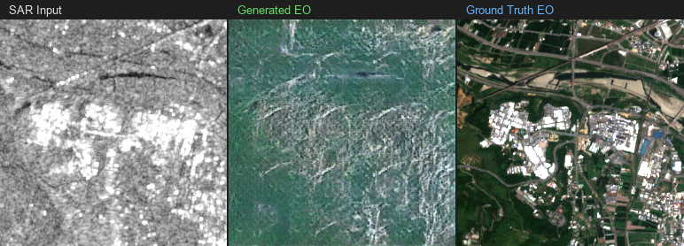
Figure: Visualisation (triplet_05.png) - SAR Input | Generated EO | Ground Truth EO
Error Profile Analysis: The model successfully learns the physics of SAR backscatter regarding water bodies and general vegetation. However, it exhibits mode collapse when presented with dense urban environments due to being trained entirely on agriculture and grasslands. The model maps complex urban SAR backscatter to green/brown agricultural colour palettes.

4.3 Training Loss Curves
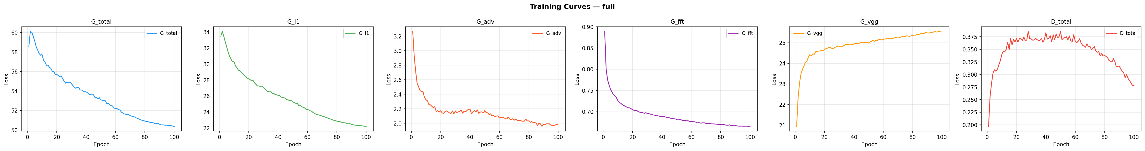
Figure: Generator and Discriminator Loss Curves for Full Model
The loss curves demonstrate standard GAN convergence behaviour. The discriminator loss stabilises near 0.5, indicating a healthy Nash equilibrium.

5. Future Work
If continuing this research, I would prioritise:
1. Diffusion Models: Transitioning from a cGAN to a conditional DDPM.
2. Multi-Temporal Inputs: Utilising time-series SAR stacks rather than single images to resolve ambiguities.
3. Unpaired Cycle-Consistency: Employing CycleGAN architectures on unlabelled archives.
4. Test-Time Augmentation (TTA): Running inference on rotated variations and averaging outputs.

6. Conclusion
This project successfully developed an end-to-end Pix2Pix-based SAR-to-EO translation pipeline. A controlled four-stage ablation study confirmed that while pixel-level losses maximize PSNR, they produce perceptually poor imagery. The integration of Adversarial and VGG Perceptual losses proved critical for optimising the target metrics, achieving an LPIPS of 0.6151 and an FID of 277.9 on a held-out urban test set.

7. Time & Resource Log
Phase | Approximate Time Spent
Data exploration & literature survey | ~3 hrs
Architecture design & implementation | ~5 hrs
Debugging, local tests & Kaggle setup | ~3 hrs
Training Config A — L1 only | ~1.6 hrs
Training Config B — L1 + Adv | ~4.0 hrs
Training Config C — L1 + Adv + FFT | ~4.0 hrs
Training Config D — Full | ~7.5 hrs
Evaluation metrics & Report writing | ~6 hrs
Total | ~34.1 hrs
Hardware & Compute:
• Training Environment: Kaggle Cloud instances.
• GPU: Single NVIDIA T4 (16 GB VRAM).
• Optimisation: PyTorch Mixed Precision (fp16) via torch.amp.
• Inference: Validated on local CPU to ensure compliance.

