GBMvis：Visual Analytics for Interpreting Gradient Boosting Machine

Abstract: The gradient boosting machine (GBM) composed of multiple weak learners is an efficient and widely used machine learning method. As a key factor in the prediction process of the gradient boosting machine, feature affects the performance of the gradient boosting machine when splitting nodes. The idea of GBM gives it a natural advantage to discover a variety of distinguishing features and feature combinations. Once the gradient boosting machine has the correct features, other factors play a relatively weak role. However, the feature selection of the model is a complicated and tedious process with diverse structure and attributes of decision tree, leading the model to be less interpretable, and many experienced experts still use manual iterative methods. To tackle this issue, we have proposed an interactive visual analytic system, GBMvis, to help experts quickly analyze and select the input features of the gradient boosting machine. In addition to providing information about the features, we have also designed a main decision path visualization, which aims to display the major data flow in the gradient boosting machine. We have demonstrated the effectiveness of our system in two case studies.
Keywords:
- Introduction
Gradient boosting machine, an ensemble machine learning model that consists of many independent weak learners, has been proved to be widely utilized in different areas, such as regression methods and classification[]. Machine learning has great contribution in calculating the potential effect of a product to a user, and help improve user experience and change development directions. The algorithm GBM used called gradient boosting decision tree (GBDT) is one of the best traditional machine learning algorithms for fitting real distributions. It is an algorithm that classifies or regresses data by using an additive model (i.e., a linear combination of basis functions) and continuously reducing the error generated by the training process. Due to its effectiveness, GBM is applied to commercial tasks. The GBDT plus linear regression (LR) model, proposed by Facebook in 2014, uses GBDT to automatically filter and combine features to generate a new discrete feature vector, which is then used as input to the LR model to generate the final prediction results, and the model can combine different features such as users, items and contexts to generate more comprehensive recommendation results, which is widely used in click through rate (CTR) click rate prediction scenarios[]. Before deep learning was a big deal, GBDT was a big hit in various competitions because of its stable performance, diverse applications and the function of filtering features. For example, GBDT appears in the solution of the champion team at KDD Cup in 2016. Besides, gradient boosting machine has been adopted by 9 of the first 14 teams in Kaggle competition since 2016[].
Despite the wide use and high efficiency, the GBM still meets the function flaw and the performance limitation in the practical application. The first comes from the complex structure of the GBM model and its algorithm. Although GBDT, as an implementation of GBM, has the advantage of fewer parameters, the training process is faster and more stable, it also has some limitations. For a large number of identity features, GBDT can not store them effectively due to the tree depth and tree limitation (to prevent overfitting); in addition, there is a performance bottleneck in a large number of features, and when the one-hot feature of GBDT is larger than 100,000 dimensions, distributed training must be done to ensure that the memory is not burst. Therefore, GBDT is usually expressed with a small amount of feedback CTR features, which has certain normalization ability, but at the same time there will be information loss, and the head resources can not be expressed and interpreted effectively. The second challenge is the output of features engineering. Compared to deep learning models, GBM lacks a certain encoder capability, which is a different feature point organization method that gives flexibility in constructing the network, and corresponding network is usually constructed to better encode the features according to the specific problem. Therefore, to generate useful features is a difficult work with manually selecting process. The third issue stems from the need to interpret the GBM model completely and intuitively. One of the drawbacks of GBDT algorithm is that it requires careful tuning of parameters, and the training time may be longer owing to confusing information, which affects performance analysis.
The challenges mentioned above demonstrate that an interactive visualization approach attaches great importance to interpreting GBM model. To tackle these challenges, we develop GBMVis, an interactive visualization system, to help users and machine learning experts interpret gradient boost machine from different perspectives. The visualization result is shown above as Fig. 1, which aims to perform different feature information. First, we construct a Data Overview to demonstrate the distribution and samples of our case study data. In the middle of the graph the feature view is shown to help understand the process of feature selection. At the right of the figure are a scatter diagram aiming to interpret the relationship between TP and TN and a data flow view, which intuitively reveals the complete decision path of GBM and contribute to better comprehend the principle of tree boosting method.
During the experiment, we use data collected at school about students' academic life to conduct case study, such as academic performance, the number of visits to the library and the frequency of using hot water. After feature selection and combination by using GBM, the results show that GBMvis can better help experts to analyze the process of GBM automatic feature selection and present the results of feature engineering. It also helps to find anomalous results values quickly and efficiently and to indicate clearly the causes of this anomaly through images.
Specifically, our contributions in this paper are summarized as follows:
• An interactive visualization system, GBMvis, that assists users in interpreting gradient boost decision tree models and predictions through three levels: overview level, feature level and prediction level.
• A combination of diverse feature bar chart design that reveals the complicated process of feature selection.
• A usage scenarios and qualitative user research. Among them, in the application of educational data, the F1-score is increased to 65%, which proves the effectiveness and usefulness of GBMVis on incomplete data sets.

- Background
In this paper, the prediction model is from the GBDT plus LR model adopted by Facebook in 2014[]. The model structure is shown below as Fig 2. It is a hybrid model with input features transformed by boosted decision tree method and output of each tree treated as categorical input to a linear classifier, respectively. We choose boosted decision tree approach due to its high effectiveness in feature transform.
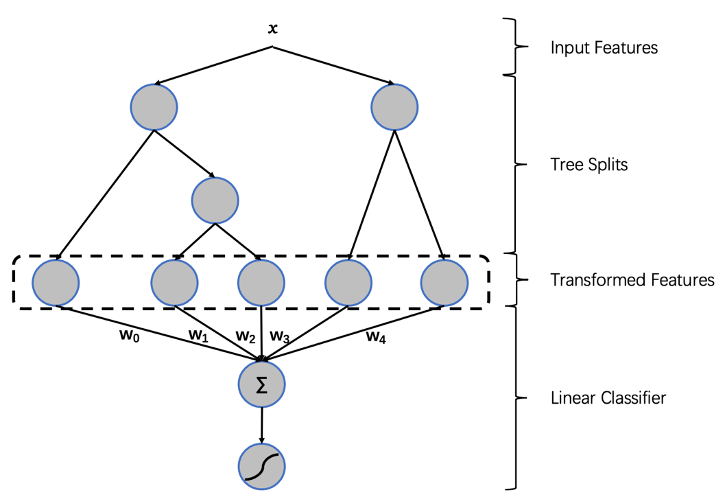
The fundamental algorithm in GBDT is two-class logistic regression and classification. The loss function is
$$\begin{aligned}L\left(y, F\right)=\log\left(1 +\exp\left(-2yF\right)\right), y∈\left\{-1, 1\right\}\#\left(1\right)\end{aligned}$$
where
$$\begin{aligned}F\left(x\right)=\frac{1}{2}log\left[\frac{\operatorname{Pr}\left(y=1 | x\right)}{\operatorname{Pr}\left(y= -1 | x\right)}\right]\#\left(2\right)\end{aligned}$$
The pseudoresponse is
$$\begin{aligned}{\tilde{y}}_{i}= {-\left[\frac{∂L\left(y_{i}, F\left(x_{i}\right)\right)}{∂F\left(x_{i}\right)}\right]}_{F\left(x\right)=F_{m-1}\left(x\right)}=\frac{2y_{i}}{1+\exp\left(2y_{i}F_{m-1}\left(x_{i}\right)\right)}\#\left(3\right)\end{aligned}$$
line search is
$$\begin{aligned}ρ_{m}=\arg{\min_{ρ}{\sum_{i=1}^{N}{\log\left(1+\exp\left(-2y_{i}\left(F_{m-1}\left(x_{i}\right) + ρh\left(x_{i};a_{m}\right)\right)\right)\right)}}}\#\left(4\right)\end{aligned}$$
Then use separate updates in each terminal node and treat regression trees as base learners:
$$\begin{aligned}γ_{jm}=\arg{\min_{γ}{\sum_{x_{i}∈R_{jm}}{\log\left(1+\exp\left(-2y_{i}\left(F_{m-1}\left(x_{i}\right) + γ\right)\right)\right)}}}\#\left(5\right)\end{aligned}$$
(5) has no close-form solution. Then approximate the loss function by a single Newton-Raphson step:
$$\begin{aligned}γ_{jm}= {\sum_{x_{i}∈R_{jm}}{{\tilde{y}}_{i}}}/{\sum_{x_{i}∈R_{jm}}{\left|{\tilde{y}}_{i}\right|\left(2-\left|{\tilde{y}}_{i}\right|\right)}}\#\left(6\right)\end{aligned}$$
${\tilde{y}}_{i}$ is from (3). the whole algorithm is below.

ALGORITHM 1 (L_{k}-TreeBoost)
$$F_{0}\left(x\right)= \frac{1}{2}\log{\frac{1+ \tilde{y}}{1- \tilde{y}}}$$
For m =1 to M do:
$${\tilde{y}}_{i} =\frac{2y_{i}}{1+\exp\left(2y_{i}F_{m-1}\left(x_{i}\right)\right)}, i=1, N$$
${\left\{R_{jm}\right\}}_{1}^{J}$ = J-terminal node $tree\left({\left\{{\tilde{y}}_{i}, x_{i}\right\}}_{1}^{N}\right)$
$$γ_{jm}= {\sum_{x_{i}∈R_{jm}}{{\tilde{y}}_{i}}}/{\sum_{x_{i}∈R_{jm}}{\left|{\tilde{y}}_{i}\right|\left(2-\left|{\tilde{y}}_{i}\right|\right)}}, j=1, J$$
$$F_{m}\left(x\right)= F_{m-1}\left(x\right)+ \sum_{j=1}^{J}{γ_{jm}1(x ∈ R_{jm})}$$
end For
end Algorithm

F_{M}(x) has relationship to the odds of log in (2), which can be transformed to yield probability estimates
$$\begin{aligned}ρ_{+}\left(x\right)= \hat{Pr}\left(y=1 | x\right)=\frac{1}{1+ e^{-2F_{M}\left(x\right)}}\#\left(7\right)\end{aligned}$$
$$\begin{aligned}ρ_{-}\left(x\right)= \hat{Pr}\left(y=-1 | x\right)=\frac{1}{1+ e^{2F_{M}\left(x\right)}}\#\left(8\right)\end{aligned}$$
Then it can be classified:
$$\begin{aligned}\hat{y}\left(x\right)=2∙1\left[c\left(-1, 1\right)ρ_{+}\left(x\right)>c\left(1, -1\right)ρ_{-}\left(x\right)\right]-1\#\left(9\right)\end{aligned}$$
c($\hat{y}$,y) is the cost related to $\hat{y}$ when the truth is y

After transforming feature, the output of GBDT is sent to sparse linear classifier which adopts Stochastic Gradient Descent (SGD) algorithm. A vector x representing transformed data is proposed as x = (e_{i1}, ..., e_{in}). i_{n} is the value of a single input feature and e_{i} is the unit vector. When training the data, a binary label y = +1 or -1 is also used to classify data.
The linear combination of active weights is
$$\begin{aligned}s\left(y, x, ω\right)=y∙ω^{T}x= y\sum_{j=1}^{n}{ω_{j,i_{j}}}\#\left(10\right)\end{aligned}$$
where (x,y) is a labeled data and w is the weight vector. The likelihood function of SGD is
$$\begin{aligned}p\left(y | x,ω\right)=sigmoid\left(s\left(y, x, ω\right)\right)\#\left(11\right)\end{aligned}$$
Where sigmoid(t) = exp(t) / (1 + exp(t)). Then p is called Logistic Regression. The inference of the model is to calculate the derivative of the log-likelihood and to walk this asymptotic direction at each coordinate according to the step size:
$$\begin{aligned}ω_{i_{j}}← ω_{i_{j}}+y∙n_{i_{j}}∙g\left(s\left(y, x, ω\right)\right)\#\left(12\right)\end{aligned}$$
Where g is given by g(s) = and the log-likelihood gradient for all non-zero parts.

- Conclusion

  - A Subsection Sample
Please note that the first paragraph of a section or subsection is not indented. The first paragraphs that follows a table, figure, equation etc. does not have an indent, either.
Subsequent paragraphs, however, are indented.

Sample Heading (Third Level). Only two levels of headings should be numbered. Lower level headings remain unnumbered; they are formatted as run-in headings.

Sample Heading (Forth Level). The contribution should contain no more than four levels of headings. The following Table 1 gives a summary of all heading levels.
Table 1. Table captions should be placed above the tables.
Heading level | Example | Font size and style
Title (centered) | Lecture Notes | 14 point, bold
1st-level heading | 1 Introduction | 12 point, bold
2nd-level heading | 2.1 Printing Area | 10 point, bold
3rd-level heading | Run-in Heading in Bold. Text follows | 10 point, bold
4th-level heading | Lowest Level Heading. Text follows | 10 point, italic
Displayed equations are centered and set on a separate line.
x + y = z (1)
Please try to avoid rasterized images for line-art diagrams and schemas. Whenever possible, use vector graphics instead (see Fig. 1).

Fig. 1. A figure caption is always placed below the illustration. Short captions are centered, while long ones are justified. The macro button chooses the correct format automatically.
For citations of references, we prefer the use of square brackets and consecutive numbers. Citations using labels or the author/year convention are also acceptable. The following bibliography provides a sample reference list with entries for journal articles [1], an LNCS chapter [2], a book [3], proceedings without editors [4], as well as a URL [5].

