POULTRY CAGE SALES AND
MANAGEMENT SYSTEM
System Documentation

Introduction

Purpose
The Poultry Cage Sales and Management System (PCSMS) is designed to provide an efficient, automated, and centralized platform for managing poultry cage sales operations, inventory tracking, customer records, and order processing. The system helps administrators and sales staff reduce manual work, improve accuracy of records, and monitor business activities in real time.
Traditional poultry cage businesses often rely on manual processes such as paper-based ledgers, handwritten order forms, and spreadsheets. These methods are prone to errors, delayed transaction processing, and difficulties in tracking inventory levels, customer orders, and revenue. PCSMS aims to fully replace these outdated workflows with a modern, digitized solution.

Scope
The Poultry Cage Sales and Management System is a web-based application built using PHP, MySQL, HTML/CSS, and JavaScript. It supports two primary user roles:
- Admin users (business owners / sales staff)
- Customer users (buyers / clients)

Major capabilities of the system include:
- Customer self-registration and login
- Product (cage) catalog management with categories and pricing
- Inventory tracking and stock level monitoring
- Order placement, processing, and status tracking
- Sales recording and payment monitoring with receipt generation
- Customer account and profile management
- Announcements and notification broadcasting
- Admin-to-customer messaging
- Revenue reporting and sales analytics

Users and Actors
The system involves the following users and actors:
- Admin: Manages products, inventory, customers, orders, payments, announcements, messages, and reports.
- Customer: Registers an account, logs in, browses the cage catalog, places orders, views order history, and accesses payment receipts.
- System: Enforces authentication and authorization rules, persists all data in the MySQL database, and automates notifications and status updates.

Definitions and Abbreviations
Term / Abbreviation | Definition
PCSMS | Poultry Cage Sales and Management System
Admin | System administrator or business owner with full access rights
Customer | A registered buyer who can place orders through the system
SKU | Stock Keeping Unit – a unique identifier for each cage product variant
POS | Point of Sale – the point at which a sales transaction is completed
CRUD | Create, Read, Update, Delete – basic database operations
PHP | Hypertext Preprocessor – server-side scripting language
MySQL | Relational database management system used for data storage

System Overview

Technology Stack
The system is developed using the following technologies:
Layer | Technology | Details
Backend | PHP | Procedural style with PDO for secure database access
Database | MySQL | Database name: pcsms; stores all business and user data
Frontend | HTML / CSS | Custom stylesheet (assets/style.css) for consistent UI
Scripting | JavaScript | UI helpers via assets/app.js (confirmations, toggles)
Sessions | PHP Sessions | session_start() in config.php for authentication management

High-Level Features

Authentication & Session Management
- config.php: Sets up DB connection and helper functions isLoggedIn(), isAdmin(), isCustomer().
- index.php: Login page; redirects to the appropriate dashboard based on user role.
- register.php: Customer self-registration with product/cage selection preferences.
- logout.php: Destroys the current session and returns the user to the login page.

Layout & Navigation
- header.php / footer.php: Shared layout components, top navigation bar, asset loading.
- assets/style.css: Global layout styles including cards, tables, forms, buttons, and receipt formatting.
- assets/app.js: Simple UI helpers such as delete confirmation dialogs and quick link toggles.

Admin Area (/admin)
- dashboard.php: Summary tiles showing total active customers, available stock, pending orders, and monthly revenue.
- products.php: Full CRUD management for cage products (name, category, dimensions, price, stock quantity).
- inventory.php: Real-time stock level management and restocking records.
- customers.php: Add and manage customer records, view order history per customer.
- orders.php: Process and monitor all customer orders with status updates (Pending, Confirmed, Shipped, Delivered, Cancelled).
- payments.php: Record and monitor all payments with receipt generation capabilities.
- announcements.php: Post announcements and broadcast notifications to customers.
- messages.php: Direct messaging between admin and a selected customer.
- reports.php: Revenue summaries, top-selling products, and payment analytics by date range.

Customer Area (/customer)
- dashboard.php: Shows latest notifications, recent orders, and announcements.
- catalog.php: Browse available poultry cages with filtering by category and price range.
- orders.php: View full order history with current status for each order.
- payments.php: Access payment history and download or print receipts.

Shared Modules
- receipt.php: Printable payment receipt with watermark, payment details, and order summary.
- notification.php: Automated notification system triggered by order and payment events.

Database and Data Model

Main Tables
The following database tables are used within the PCSMS database:

users
Column | Type | Description
id | INT (PK, AUTO_INCREMENT) | Unique identifier for each user
username | VARCHAR(100) | Login username (must be unique)
password | VARCHAR(255) | Hashed password (password_hash)
full_name | VARCHAR(200) | Full display name of the user
role | ENUM('admin','customer') | Determines access level and UI view
email | VARCHAR(150) | Contact email address
phone | VARCHAR(20) | Contact phone number
address | TEXT | Customer delivery address
created_at | DATETIME | Account creation timestamp

products
Column | Type | Description
id | INT (PK, AUTO_INCREMENT) | Unique product identifier
name | VARCHAR(200) | Product name (e.g., Standard Layer Cage)
category | VARCHAR(100) | Cage category (Layer, Broiler, Breeder, etc.)
description | TEXT | Detailed product description
dimensions | VARCHAR(100) | Physical dimensions (L x W x H in cm)
capacity | INT | Number of birds the cage can hold
unit_price | DECIMAL(10,2) | Selling price per unit
stock_quantity | INT | Current available stock
sku | VARCHAR(50) | Stock Keeping Unit code (unique)
is_available | TINYINT(1) | 1 = available for sale, 0 = unavailable
created_at | DATETIME | Record creation timestamp

customers
Column | Type | Description
id | INT (PK, AUTO_INCREMENT) | Unique customer profile identifier
user_id | INT (FK → users.id) | Reference to the user account
business_name | VARCHAR(200) | Name of the customer's poultry farm or business
status | ENUM('active','inactive') | Current account status
created_at | DATETIME | Profile creation timestamp

orders
Column | Type | Description
id | INT (PK, AUTO_INCREMENT) | Unique order identifier
customer_id | INT (FK → customers.id) | Reference to the customer who placed the order
order_date | DATETIME | Date and time the order was placed
total_amount | DECIMAL(10,2) | Total cost of all items in the order
status | ENUM('pending','confirmed','shipped','delivered','cancelled') | Current order status
delivery_address | TEXT | Shipping/delivery address for the order
notes | TEXT | Optional order notes or special instructions
created_at | DATETIME | Record creation timestamp

order_items
Column | Type | Description
id | INT (PK, AUTO_INCREMENT) | Unique line item identifier
order_id | INT (FK → orders.id) | Reference to the parent order
product_id | INT (FK → products.id) | Reference to the ordered product
quantity | INT | Number of units ordered
unit_price | DECIMAL(10,2) | Price per unit at time of order
subtotal | DECIMAL(10,2) | quantity × unit_price

payments
Column | Type | Description
id | INT (PK, AUTO_INCREMENT) | Unique payment identifier
order_id | INT (FK → orders.id) | Reference to the paid order
customer_id | INT (FK → customers.id) | Reference to the customer
amount | DECIMAL(10,2) | Amount paid
payment_method | VARCHAR(50) | Payment method (Cash, GCash, Bank Transfer, etc.)
payment_date | DATETIME | Date and time payment was recorded
status | ENUM('paid','partial','refunded') | Payment status
receipt_number | VARCHAR(50) | Unique receipt identifier (auto-generated)
notes | TEXT | Optional remarks for the payment
created_at | DATETIME | Record creation timestamp

inventory_logs
Column | Type | Description
id | INT (PK, AUTO_INCREMENT) | Unique log entry identifier
product_id | INT (FK → products.id) | Reference to the affected product
change_type | ENUM('restock','sale','adjustment') | Type of inventory change
quantity_change | INT | Positive (added) or negative (deducted) quantity change
reference_id | INT | Optional reference to order or restock record
notes | TEXT | Reason or notes for the inventory change
created_at | DATETIME | Timestamp of the inventory event

announcements
Column | Type | Description
id | INT (PK, AUTO_INCREMENT) | Unique announcement identifier
title | VARCHAR(255) | Short title of the announcement
content | TEXT | Full announcement message body
created_at | DATETIME | Publication timestamp

notifications
Column | Type | Description
id | INT (PK, AUTO_INCREMENT) | Unique notification identifier
user_id | INT (FK → users.id) | Target user for the notification
type | VARCHAR(50) | Notification type (order_update, payment, announcement)
message | TEXT | Notification message content
is_read | TINYINT(1) | 0 = unread, 1 = read
created_at | DATETIME | Notification creation timestamp

messages
Column | Type | Description
id | INT (PK, AUTO_INCREMENT) | Unique message identifier
sender_id | INT (FK → users.id) | User who sent the message
receiver_id | INT (FK → users.id) | User who receives the message
message | TEXT | Message content
is_read | TINYINT(1) | 0 = unread, 1 = read by receiver
created_at | DATETIME | Message timestamp

Key Relationships (Entity-Relationship Summary)
- One User (role = customer) has one Customer profile.
- One Customer can place many Orders over time.
- One Order contains one or more Order Items.
- Each Order Item references one Product.
- One Order can have one or more Payments.
- Each Product has many Inventory Log entries tracking stock changes.
- One User can receive many Notifications.
- Messages are exchanged between Users (admin to customer and vice versa).

System Design Diagrams

Use Case Diagram — PCSMS Overview
The use case diagram illustrates the interactions between the two primary actors and the system functionalities available to each.

Actors
- Admin — The business owner or authorized sales staff.
- Customer — A registered buyer accessing the system online.

Use Cases for Admin
- Log in and manage admin account
- Manage cage products (add, edit, delete, view)
- Manage inventory and restock records
- View and process customer orders
- Record and monitor payments
- Generate sales and revenue reports
- Post announcements and broadcast notifications
- Send and receive messages with customers

Use Cases for Customer
- Register a new account
- Log in and log out securely
- Browse and search the cage product catalog
- Place and manage orders
- View order status and history
- View payment history and print receipts
- Read announcements and notifications
- Send and receive messages from admin
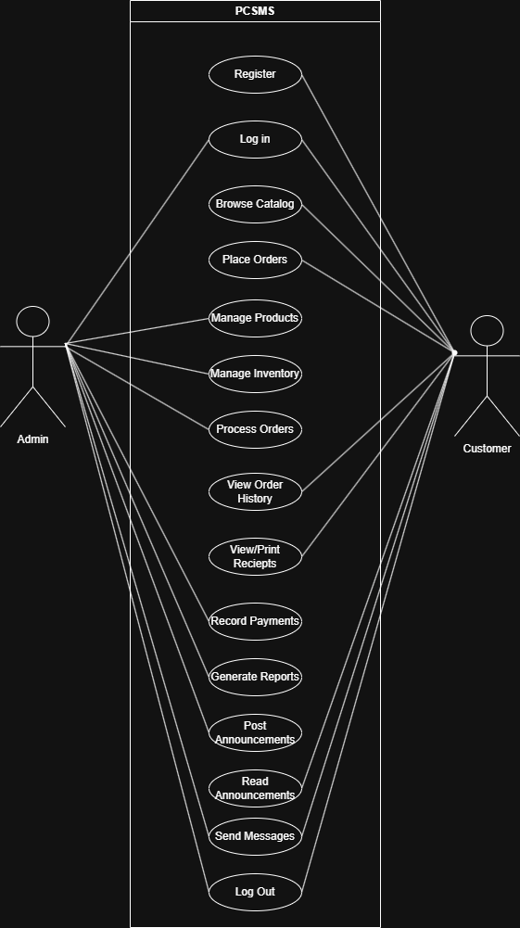

[Figure 4.1 — Use Case Diagram]

Data Flow Diagram
The Data Flow Diagram (DFD) illustrates how data moves through the Poultry Cage Sales and Management System. It shows the external entities that interact with the system, the internal processes that transform data, and the data stores where information is persisted. The DFD is presented at two levels: Level 0 (Context Diagram) provides a high-level overview of the entire system, and Level 1 breaks down the major processes in greater detail.

Level 0 — Context Diagram
The Level 0 DFD treats the entire system as a single process. It shows the two external entities — Admin and Customer — and the data flows entering and leaving the system boundary.
External Entities:
- Admin — Inputs: product data, inventory updates, order status changes, payment records, announcements. Outputs: order lists, revenue reports, customer records.
- Customer — Inputs: registration details, login credentials, order requests, payment information. Outputs: product catalog, order confirmations, payment receipts, notifications.
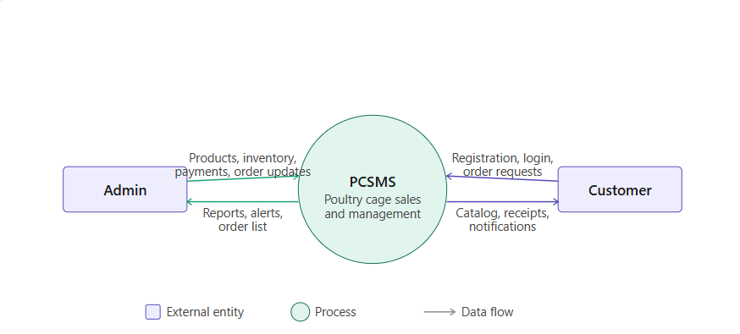
[Figure 4.2a — Level 0 Context Diagram]

Level 1 — Process Decomposition
The Level 1 DFD decomposes the single system process into its major functional sub-processes. Each process shows which data stores it reads from and writes to, and which external entities trigger or receive data from it.
Processes:
- P1 — User Authentication: Receives login credentials from Customer or Admin; validates against the Users data store; returns session token or error.
- P2 — Product Management: Receives product data from Admin; reads and writes to the Products data store; outputs updated catalog to Customer.
- P3 — Order Processing: Receives order request from Customer; reads Products store to validate stock; writes to Orders and Order Items stores; deducts stock via Inventory Logs; sends order confirmation to Customer and notification to Admin.
- P4 — Payment Processing: Receives payment data from Admin; reads Orders store; writes to Payments store with auto-generated receipt number; sends payment confirmation and receipt to Customer.
- P5 — Inventory Management: Receives stock adjustment data from Admin; reads and writes to Products and Inventory Logs stores; outputs low-stock alerts to Admin dashboard.
- P6 — Reporting: Receives date range parameters from Admin; reads Orders, Payments, and Products stores; outputs revenue summaries and top-selling product reports to Admin.
- P7 — Notifications and Messaging: Receives announcement or message data from Admin; writes to Notifications and Messages stores; delivers notifications and messages to Customer.
Data Stores:
- D1 — Users: Stores user accounts, credentials, and roles.
- D2 — Products: Stores cage product catalog, pricing, and availability.
- D3 — Orders and Order Items: Stores all customer orders and their line items.
- D4 — Payments: Stores payment records and auto-generated receipt numbers.
- D5 — Inventory Logs: Stores all stock changes with type, quantity delta, and timestamp.
- D6 — Notifications: Stores in-system alerts triggered by order and payment events.
- D7 — Messages: Stores direct messages exchanged between Admin and Customer.

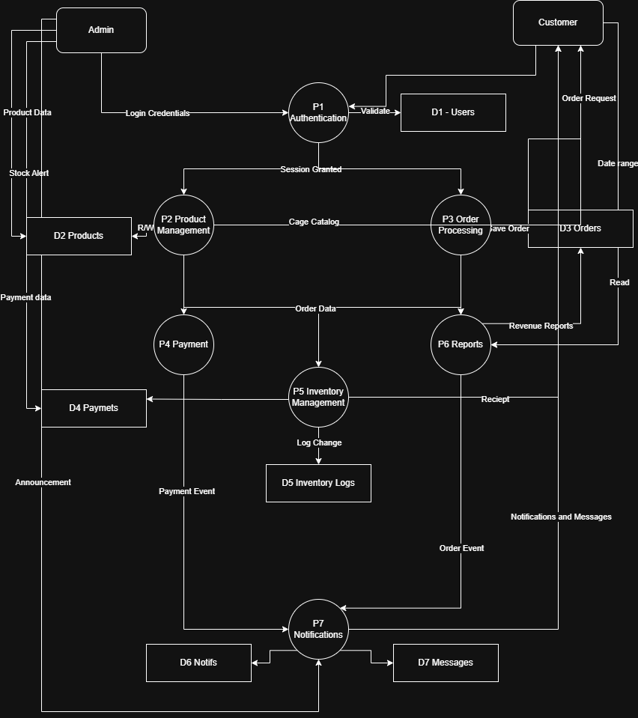
[Figure 4.2b — Level 1 Data Flow Diagram]

Entity-Relationship Diagram
The Entity-Relationship Diagram (ERD) illustrates the structure of the PCSMS database by mapping all tables, their attributes, and the relationships between them. It uses crow’s-foot notation to indicate cardinality — showing whether a relationship is one-to-one, one-to-many, or many-to-one.

Entities and Relationships
The PCSMS database consists of nine core entities. Each entity maps directly to a database table. The relationships defined below govern how data is linked and enforced through foreign key constraints.

Relationship Summary
- USERS ||--o| CUSTOMERS — One user has at most one customer profile (role = “customer”).
- CUSTOMERS ||--o{ ORDERS — One customer can place zero or many orders.
- ORDERS ||--|{ ORDER_ITEMS — One order contains one or many line items.
- ORDER_ITEMS }o--|| PRODUCTS — Each order item references exactly one product.
- ORDERS ||--o{ PAYMENTS — One order can have zero or many payment records.
- PRODUCTS ||--o{ INVENTORY_LOGS — One product has zero or many inventory log entries.
- USERS ||--o{ NOTIFICATIONS — One user receives zero or many notifications.
- USERS ||--o{ MESSAGES — One user can send and receive zero or many messages.

Key Design Decisions
- USERS and CUSTOMERS are separated so that the system can support multiple user roles (admin, customer) under a single authentication table without duplicating login fields.
- ORDER_ITEMS is a separate table to support multi-product orders. Each row stores the unit_price at the time of purchase, preserving the price even if the product price changes later.
- INVENTORY_LOGS uses an append-only pattern — stock is never directly decremented silently. Every change is recorded with a change_type, quantity_change, and timestamp to support full audit trails.
- MESSAGES uses sender_id and receiver_id as separate foreign keys both pointing to USERS, enabling two-way conversations between any two users without a separate “conversation” entity.

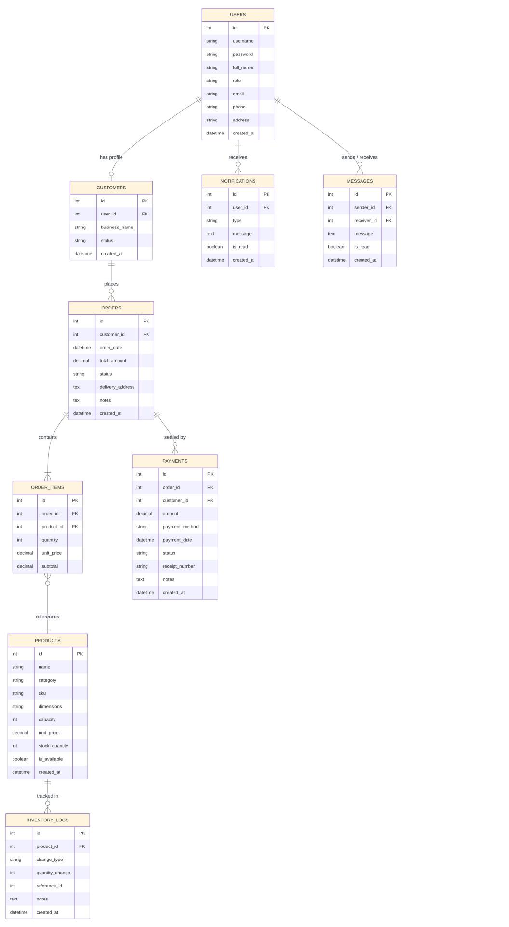
[Figure 4.3 — Entity-Relationship Diagram]

Activity Diagram — Customer Self-Registration Flow
The following activity diagram describes the step-by-step flow for a new customer registering an account in the system.

- Customer navigates to the registration page (register.php).
- System loads the registration form with an optional product interest field.
- Customer fills in personal information: full name, username, password, email, phone, and delivery address.
- Customer optionally provides a business or farm name.
- System validates all required fields and confirms that the password and confirm-password fields match.
- System checks whether the entered username already exists in the database.
- If username is taken, system returns an error and prompts the customer to choose a different username.
- If username is available, the system proceeds to create the account.
- System inserts a new row in users (role = 'customer') and a corresponding row in customers with status = 'active'.
- System redirects to index.php with a success message.
- Customer can now log in and access the customer dashboard.

Swimlanes
- Customer
- PCSMS Web UI
- Application Logic
- Database

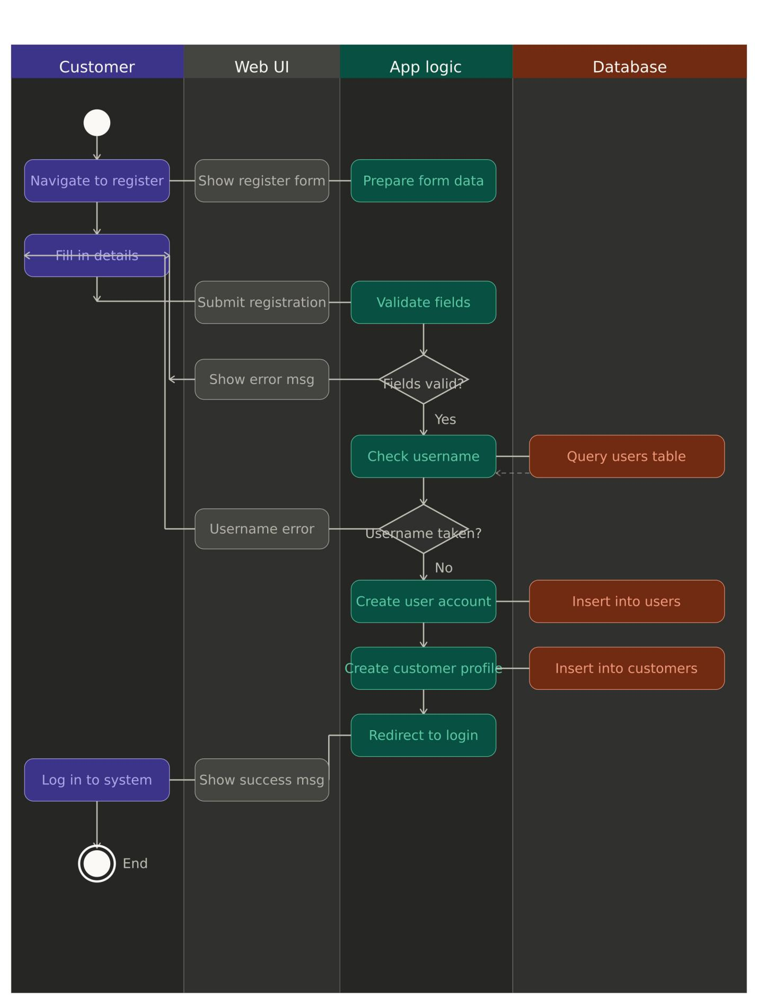
[Figure 4.4 — Activity Diagram: Customer Registration]

— End of Document —

