ADVANCED MONGODB DOCUMENT
1. Aggregation
Aggregation operations process data records and return computed results. Aggregation operations group values from multiple documents together, and can perform a variety of operations on the grouped data to return a single result
Aggregation Pipeline
https://docs.mongodb.com/manual/core/aggregation-pipeline/

MongoDB’s aggregation framework is modeled on the concept of data processing pipelines. Documents enter a multi-stage pipeline that transforms the documents into an aggregated result
Operator aggregation https://docs.mongodb.com/manual/reference/operator/aggregation/#aggregation-expression-operators

The aggregation pipeline can use indexes to improve its performance during some of its stages. In addition, the aggregation pipeline has an internal optimization phase
https://docs.mongodb.com/manual/core/aggregation-pipeline/#aggregation-pipeline-operators-and-performance

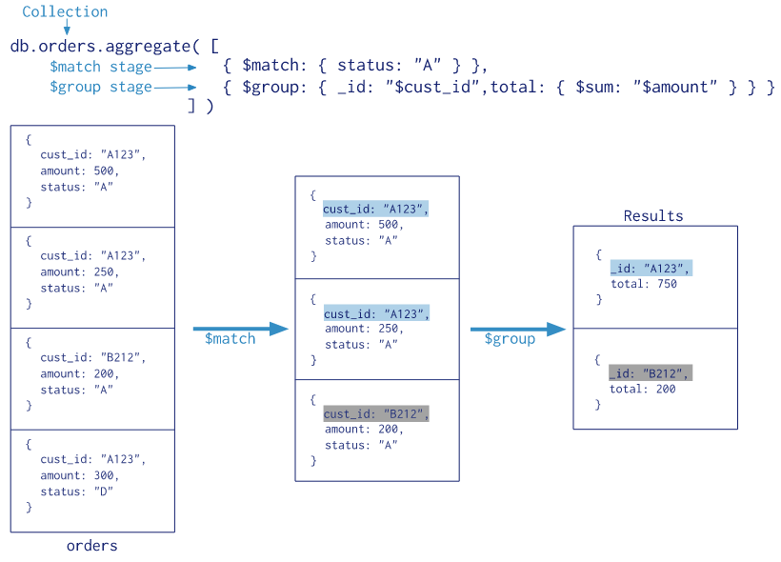
Map-Reduce
Map-reduce is a data processing paradigm for condensing large volumes of data into useful aggregated results.
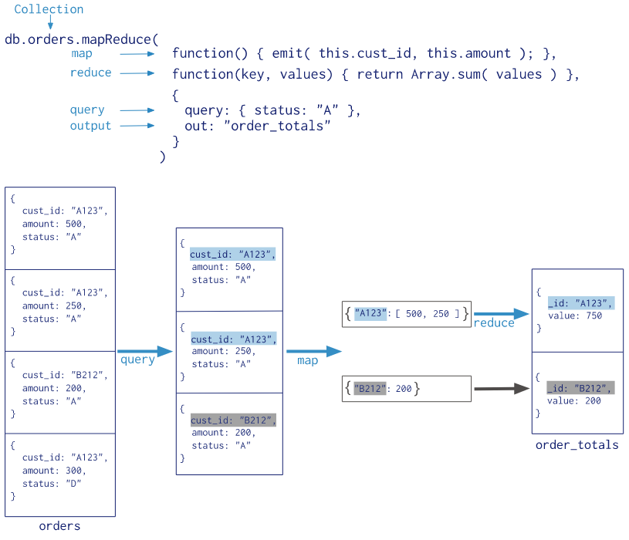

2. Text Search
MongoDB supports query operations that perform a text search of string content.
To perform text search, MongoDB uses a text index and the $text operator.
https://docs.mongodb.com/manual/text-search/

Text Index
To perform text search queries, you must have a text index on your collection. A collection can only have one text search index, but that index can cover multiple fields.
To perform text search queries, you must have a text index on your collection. A collection can only have one text search index, but that index can cover multiple fields.
db.stores.createIndex( { name: "text", description: "text" } )

$text Operator
Use the $text query operator to perform text searches on a collection with a text index.
$text will tokenize the search string using whitespace and most punctuation as delimiters, and perform a logical OR of all such tokens in the search string.
db.stores.find( { $text: { $search: "java coffee shop" } } )

You can also search for exact phrases by wrapping them in double-quotes
db.stores.find( { $text: { $search: "java \"coffee shop\"" } } )

To exclude a word, you can prepend a “-” character.
db.stores.find( { $text: { $search: "java shop -coffee" } } )

MongoDB will return its results in unsorted order by default. However, text search queries will compute a relevance score for each document that specifies how well a document matches the query.
To sort the results in order of relevance score, you must explicitly project the $meta textScore field and sort on it:
db.stores.find(
{ $text: { $search: "java coffee shop" } },
{ score: { $meta: "textScore" } }
).sort( { score: { $meta: "textScore" } } )

3. Index
Indexes support the efficient execution of queries in MongoDB. Without indexes, MongoDB must perform a collection scan, i.e. scan every document in a collection, to select those documents that match the query statement. If an appropriate index exists for a query, MongoDB can use the index to limit the number of documents it must inspect.
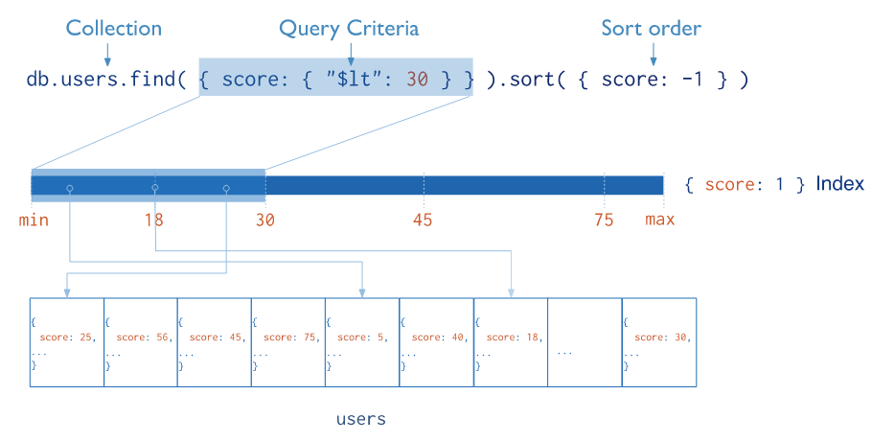
Default _id Index
MongoDB creates a unique index on the _id field during the creation of a collection. The _id index prevents clients from inserting two documents with the same value for the _id field. You cannot drop this index on the _id field.

Create index
db.collection.createIndex(keys, options)
The db.collection.createIndex() method only creates an index if an index of the same specification does not already exist.
https://docs.mongodb.com/manual/reference/method/db.collection.createIndex/#db.collection.createIndex

Single index
In addition to the MongoDB-defined _id index, MongoDB supports the creation of user-defined ascending/descending indexes on a single field of a document.
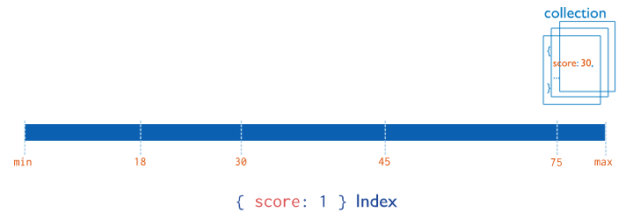
For a single-field index and sort operations, the sort order (i.e. ascending or descending) of the index key does not matter because MongoDB can traverse the index in either direction.

Compound index
MongoDB also supports user-defined indexes on multiple fields, i.e. compound indexes.
The order of fields listed in a compound index has significance. For instance, if a compound index consists of { userid: 1, score: -1 }, the index sorts first by userid and then, within each userid value, sorts by score.
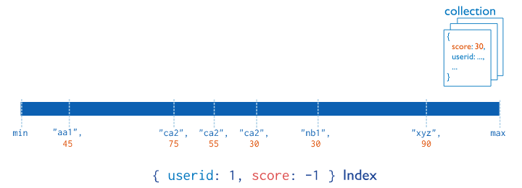
Multikey index

MongoDB uses multikey indexes to index the content stored in arrays. If you index a field that holds an array value, MongoDB creates separate index entries for every element of the array. These multikey indexes allow queries to select documents that contain arrays by matching on element or elements of the arrays. MongoDB automatically determines whether to create a multikey index if the indexed field contains an array value; you do not need to explicitly specify the multikey type.

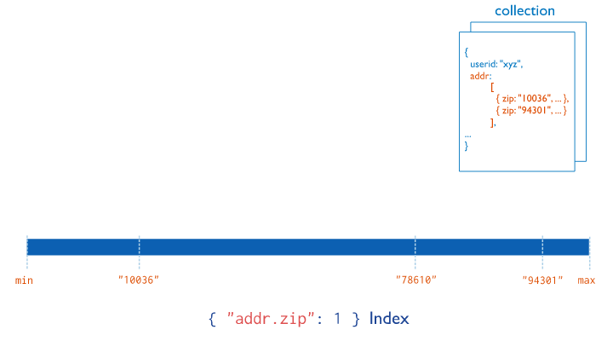
4. Storage
https://docs.mongodb.com/manual/core/wiredtiger/

WiredTiger is the default storage engine starting in MongoDB 3.2. It is well-suited for most workloads and is recommended for new deployments. WiredTiger provides a document-level concurrency model, checkpointing, and compression, among other features.
MMAPv1 is the original MongoDB storage engine and is the default storage engine for MongoDB versions before 3.2. It performs well on workloads with high volumes of reads and writes, as well as in-place updates.

WiredTiger Storage Engine
Document Level Concurrency
WiredTiger uses document-level concurrency control for write operations. As a result, multiple clients can modify different documents of a collection at the same time.
WiredTiger uses only intent locks at the global, database and collection levels. When the storage engine detects conflicts between two operations, one will incur a write conflict causing MongoDB to transparently retry that operation.

Snapshots and Checkpoints
WiredTiger uses MultiVersion Concurrency Control (MVCC). At the start of an operation, WiredTiger provides a point-in-time snapshot of the data to the transaction. A snapshot presents a consistent view of the in-memory data.

MongoDB configures WiredTiger to create checkpoints (i.e. write the snapshot data to disk) at intervals of 60 seconds or 2 gigabytes of journal data.
Journal
WiredTiger uses a write-ahead transaction log in combination with checkpoints to ensure data durability
The WiredTiger journal persists all data modifications between checkpoints. If MongoDB exits between checkpoints, it uses the journal to replay all data modified since the last checkpoint.
Compression
With WiredTiger, MongoDB supports compression for all collections and indexes. Compression minimizes storage use at the expense of additional CPU.

By default, WiredTiger uses block compression with the snappy compression library for all collections and prefix compression for all indexes.

