DESIGN PATTERN OOP JAVA

1.Builder Pattern
https://www.tutorialspoint.com/design_pattern/builder_pattern.htm
Builder pattern builds a complex object using simple objects and using a step by step approach. This type of design pattern comes under creational pattern as this pattern provides one of the best ways to create an object.
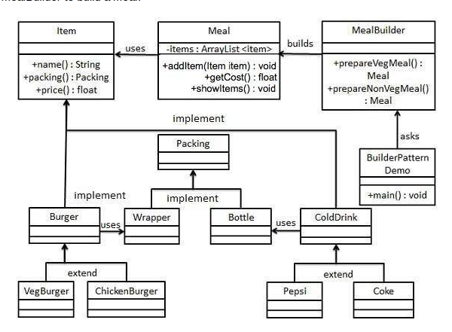
Ex: http://www.javaworld.com/article/2074938/core-java/too-many-parameters-in-java-methods-part-3-builder-pattern.html

2.Singleton Pattern
https://www.tutorialspoint.com/design_pattern/singleton_pattern.htm
This type of design pattern comes under creational pattern as this pattern provides one of the best ways to create an object.
This pattern involves a single class which is responsible to create an object while making sure that only single object gets created.
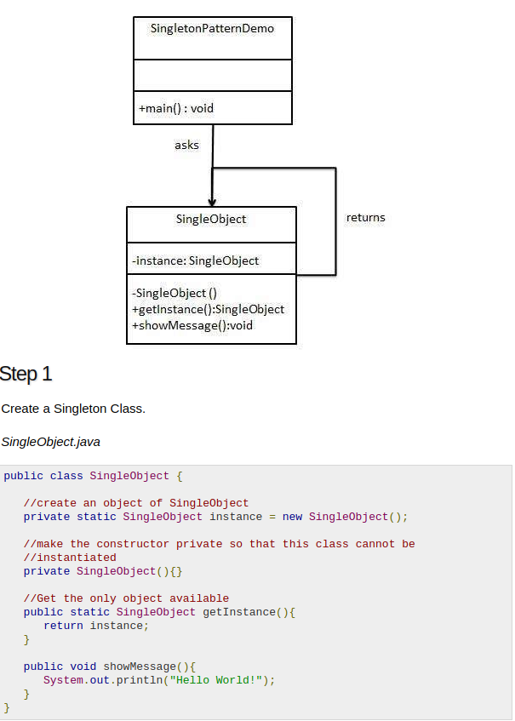

3.Factory Pattern
https://www.tutorialspoint.com/design_pattern/factory_pattern.htm

This type of design pattern comes under creational pattern as this pattern provides one of the best ways to create an object.
In Factory pattern, we create object without exposing the creation logic to the client and refer to newly created object using a common interface.

FactoryPatternDemo, our demo class will use ShapeFactory to get a Shape object. It will pass information (CIRCLE / RECTANGLE / SQUARE) to ShapeFactory to get the type of object it needs.

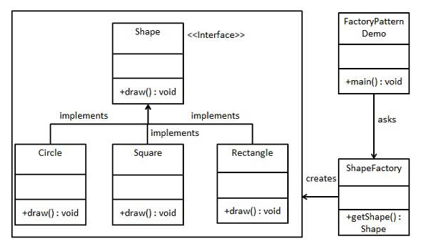
4.Prototype Pattern
https://www.tutorialspoint.com/design_pattern/prototype_pattern.htm

This pattern involves implementing a prototype interface which tells to create a clone of the current object. This pattern is used when creation of object directly is costly.
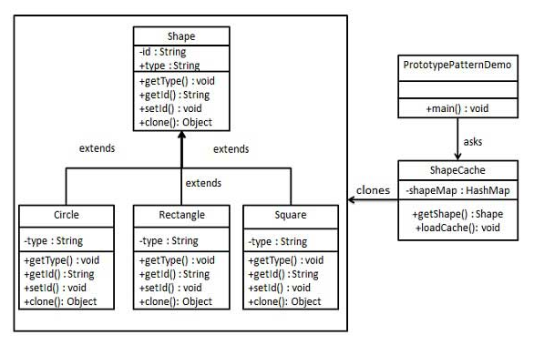
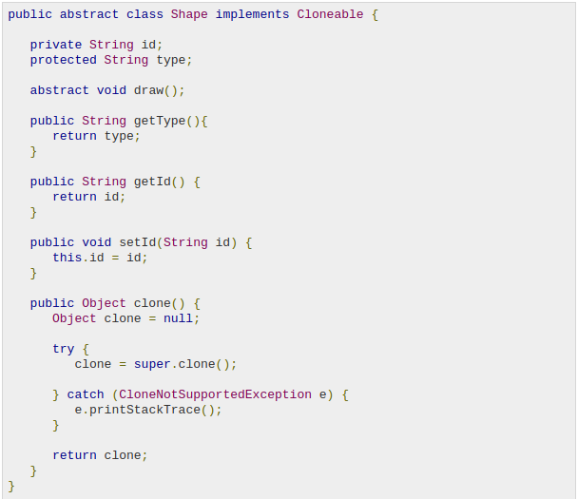
5. Composite Pattern
https://www.tutorialspoint.com/design_pattern/composite_pattern.htm

Composite pattern is used where we need to treat a group of objects in similar way as a single object. Composite pattern composes objects in term of a tree structure to represent part as well as whole hierarchy. This type of design pattern comes under structural pattern as this pattern creates a tree structure of group of objects.
This pattern creates a class that contains group of its own objects. This class provides ways to modify its group of same objects.
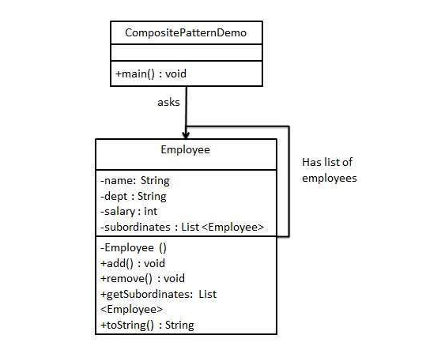
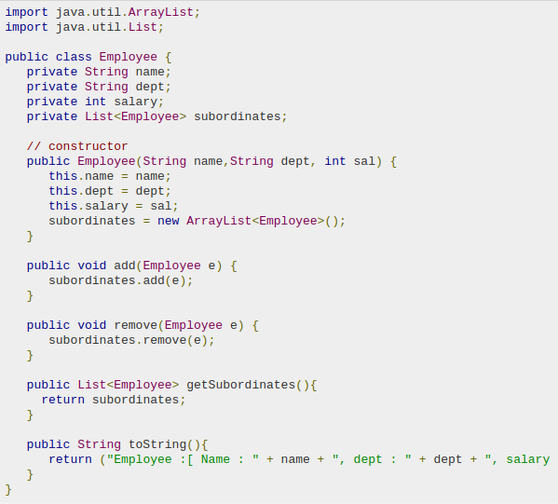

6.Observer Pattern

https://www.tutorialspoint.com/design_pattern/observer_pattern.htm

Observer pattern is used when there is one-to-many relationship between objects such as if one object is modified, its depenedent objects are to be notified automatically. Observer pattern falls under behavioral pattern category.

Observer pattern uses three actor classes. Subject, Observer and Client. Subject is an object having methods to attach and detach observers to a client object. We have created an abstract class Observer and a concrete class Subject that is extending class Observer

