IBM Data Science Applied Data Science Capstone

The Battle of Neighborhoods

## OPENING FRUIT JUICE AND HEALTH DRINK BAR IN CALGARY

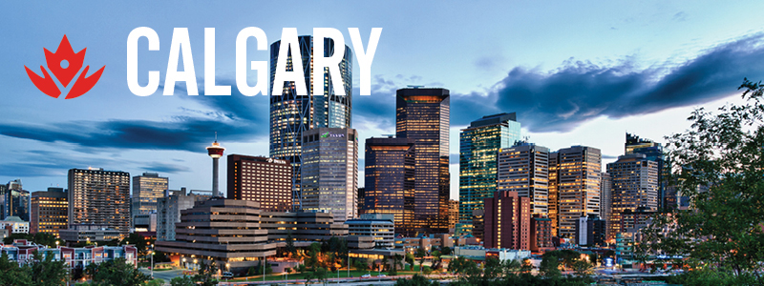

BY

TADEPALLI SARADA KIRANMAYEE

22 NOV 2020

# Data

Data that will be used to solve the above business problems are collected from various publicly- available sources.

# The list of Planning Areas in Singapore are collected from a Wikipedia article entitled “List of neighbourhoods in Calgary” from <https://en.wikipedia.org/wiki/List_of_neighbourhoods_in_Calgary>. This dataset lists the names of all Communities (Neighbourhood), Sector, areas (in km2), and population details etc.

# The coordinates of each community is extracted from “<https://data.calgary.ca/resource/j9ps-fyst.json>”. The coordinates obtained for each community will be used to plot map markers on the map for visualization.

# The Foursquare API is used to extract the top 100 venues in each community within 500 radius. The data from the Foursquare API are extracted for relevant information, and descriptive statistics is performed for further analysis.