**Data Mining Taxi Trips in Brooklyn**

**Section 1 Introduction**

In the New York City, the yellow cab may be as iconic as Broadway and the Empire State Building. It is really an essential part of the life in the city of New York. Taken the cab data with detail information such as cab pick-up and drop-off time and locations, passengers count, trip distance, and total fare amount as a whole, it is more than a collection of trip data but a story of the urban life in the New York City. Such data can tell the stories like how does the city’s rush hour traffic look like, where does the crowding traffic head to, what is the cab commuting pattern in the city, and how can it be taken advantage by transportation engineers and traffic policy makers for improving the city traffic management.

To figure out how people in New York travel across the city through the yellow cabs within an ordinary month of a year, what is the relationship between these cab trips and city land uses, and what are the meaning and stories that can be extracted from their daily trip-level data, we choose yellow cab’s data of the New York City in October 2015 as our analysis dataset, which consists of trip information like cab pick-up and drop-off time and coordinates, passengers count, trip distance, and total fare amount.

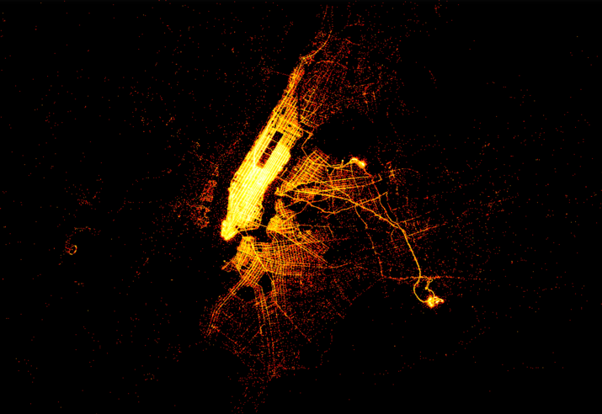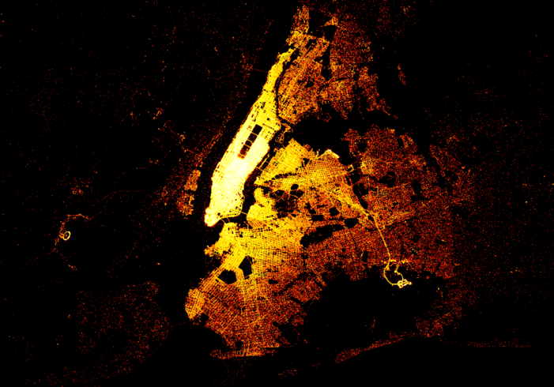

By mapping and coloring the coordinates of each cab pick-up trip and drop-off trip happening in October 2015 in the New York City, we obtained two maps, one visualizes all pick-up trips of October 2015 in New York City while the other one visualizes all drop-off trips of October 2015 in the New York City. From the results, we realize that Manhattan, as an extremely compact, highly mixed-use and traffic-concentrated area, is too special for our analysis of the relationship between cab trip and land uses. Therefore, the analysis site is chosen to be zoomed to Brooklyn, NY, instead of the entire city.

By zooming to Brooklyn, it is obvious that the pick-up trip map and the drop-off trip map have very different patterns. From the pick-up trip map, we can tell most of the pick-up trips in Brooklyn in October happen within 5 miles around Manhattan and area close to John F. Kennedy International Airport. While from the drop-off trip map, the pattern is quite different as the drop-off trips, instead of gathering in certain area, scatter around the entire Brooklyn.

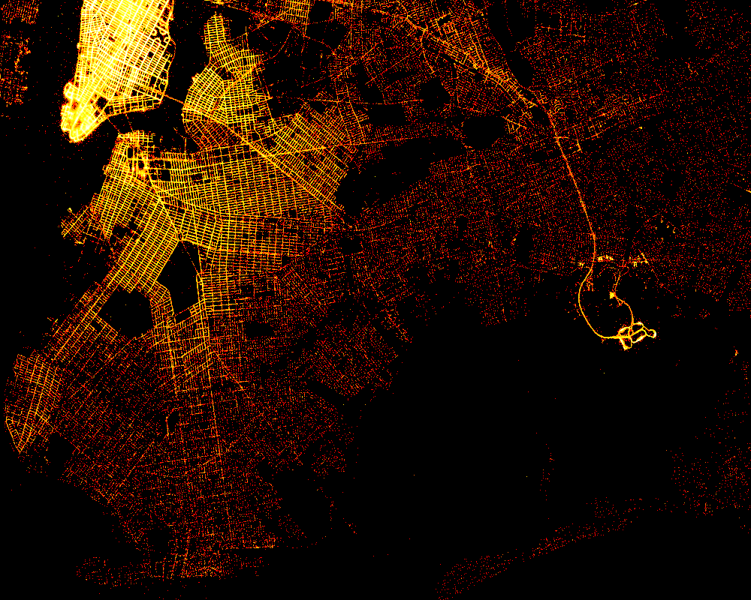It is obviously that Brooklyn has much more drop-off trips than pick-up trips, which means, people are more likely to take cabs to Brooklyn, while few of them take cabs from Brooklyn. The reason of rare pick-up trips departing from Brooklyn might be that the yellow cabs are mainly concentrated in the borough of Manhattan, although it can be hailed anywhere within the five boroughs of New York City with a raised hand or by waiting at a taxi stand. Therefore, we assume that in Brooklyn, people living far away from Manhattan are less likely to hail a yellow cab.

The results of above analysis make us curious about Brooklyn people’s daily travel pattern through the yellow cabs in certain time period of a day and in certain days of a week, which trips are the most typical ones in Brooklyn, and make us wonder whether it will show some relationships with the land uses, specifically, the commercial and residential land uses.

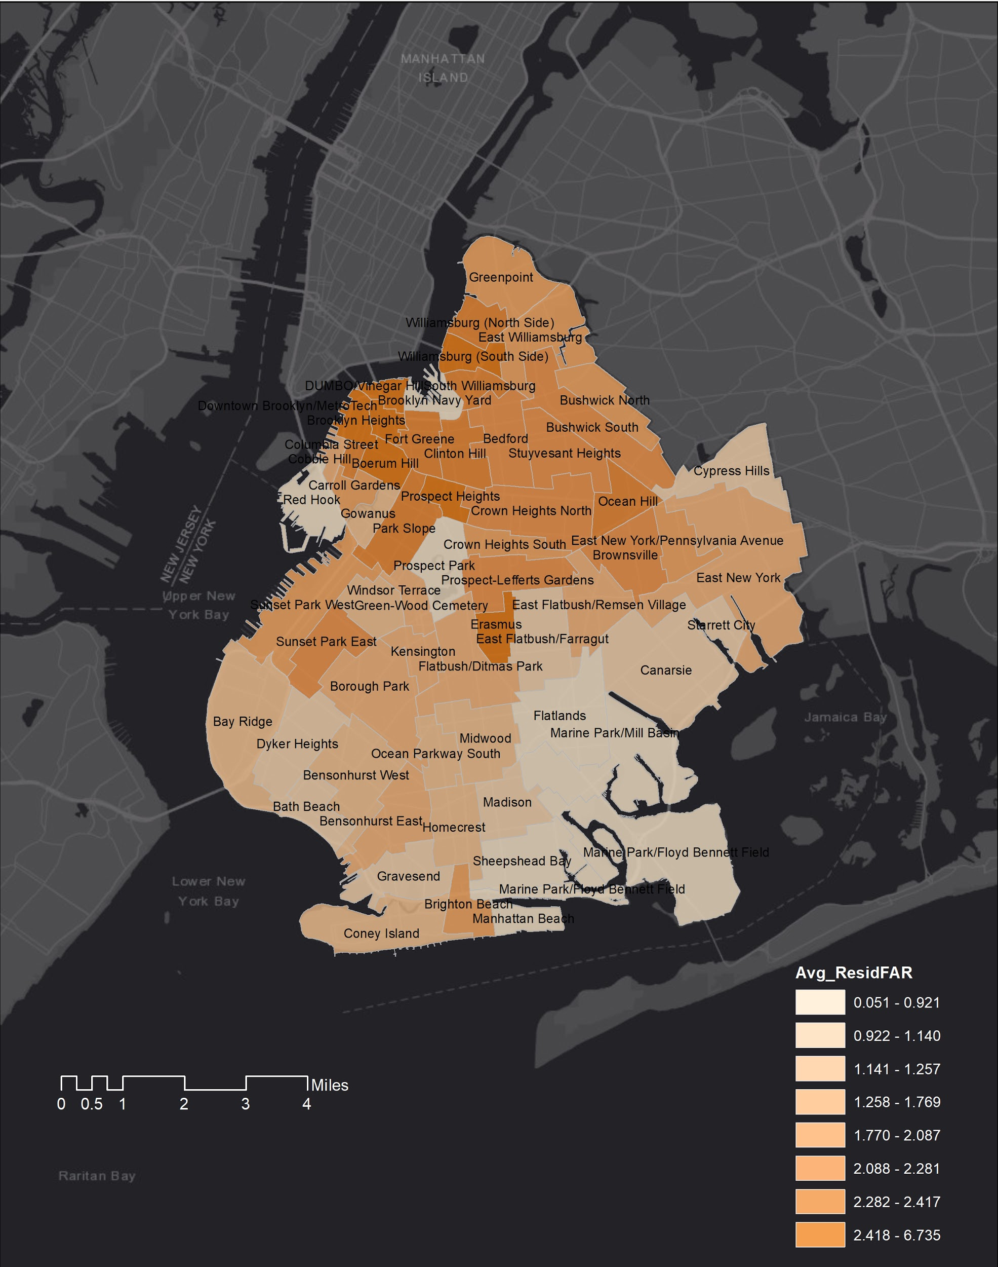

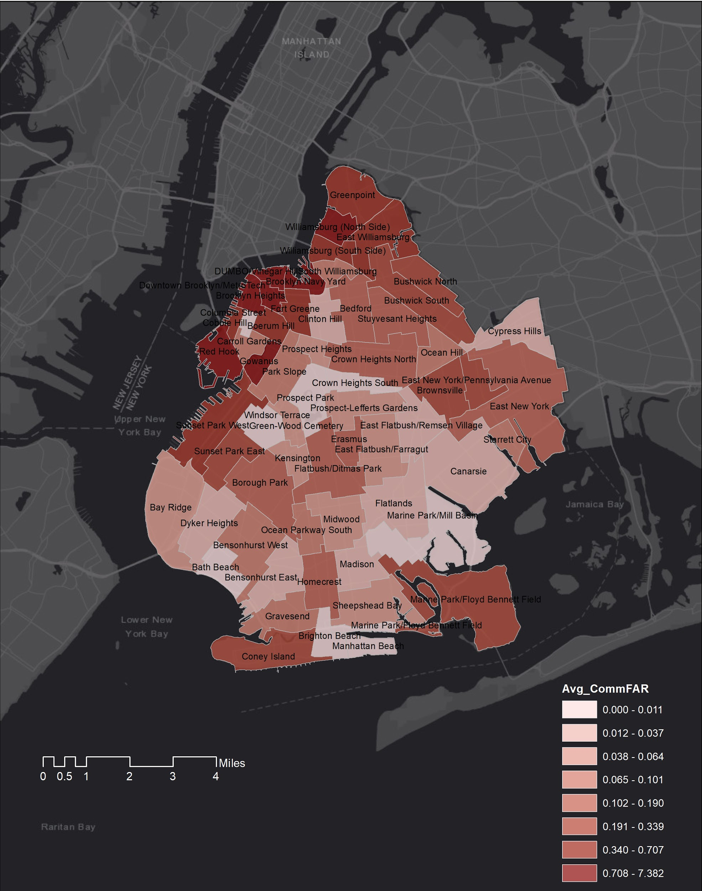We looked at the commercial FAR and residential FAR in Brooklyn based on taxi zone and found out that the places with relatively high commercial FAR are clustering around Manhattan (Red Hook, Gowanus, Downtown Brooklyn/ Metrotech, Brooklyn Heights, DUMBO, Brooklyn Navy Yard, and Williamsburg (North Side) etc.) and in the Southern Brooklyn (Marine Park/Floyd Bennett Field, Coney Island etc.). While the places with relatively high residential FAR are also clustering in the northern Brooklyn (Williamsburg (North Side), Williamsburg (South Side), Downtown Brooklyn/ Metrotech, Brooklyn Heights, DUMBO, Brooklyn Navy Yard, Boerum Hill, Prospect Heights, Park Slope and East Flatbush, etc). however, generally speaking, commercial FAR and residential FAR show the same pattern in Brooklyn since taxi zones with higher commercial FAR are also tend to have higher residential FAR. In addition, from the two FAR maps, it is obvious that northern Brooklyn has higher commercial and residential FAR than any other area in Brooklyn, which means northern Brooklyn is relatively denser area in Brooklyn and matches what we observed from the pick-up trip map and the drop-off trip map – more cab trips happened in northern Brooklyn, closer to Manhattan. Therefore, we assume that denser places with more population would generate more cab trips. This is furthered analyzed in the next part when using Spearman's rank correlation analysis.

We conduct Spearman's rank correlation analysis to verify the above assumption. The results show that no matter for overall cab trips in Brooklyn in October 2015, or weekend cab trips in Brooklyn in October 2015, or weekday cab trips in Brooklyn in October 2015, they all show positive relationships with the Average Commercial FAR and Average Residential FAR calculated based on taxi zone, with slight difference. Generally speaking, the Spearman's rank correlation coefficient, or the statistical dependence between the rankings of two variables of the cab pick-up trips of October 2015 in Brooklyn and the Average Commercial FAR (calculated based on taxi zone) is around 0.48; the Spearman's rank correlation coefficient of two variables of the cab drop-off trips of October 2015 in Brooklyn and the Average Commercial FAR is around 0.44; the Spearman's rank correlation coefficient of two variables of the cab pick-up trips of October 2015 in Brooklyn and the Average Residential FAR is around 0.7 (calculated based on taxi zone); the Spearman's rank correlation coefficient of two variables of the cab drop-off trips of October 2015 in Brooklyn and the Average Residential FAR is around 0.68. To summarize the cab trip data of October 2015 in Brooklyn has stronger positive relationship with residential FAR than commercial FAR. In other words, high average residential FAR of a taxi zone is more related to high volume of cab trips in Brooklyn than high average commercial FAR.

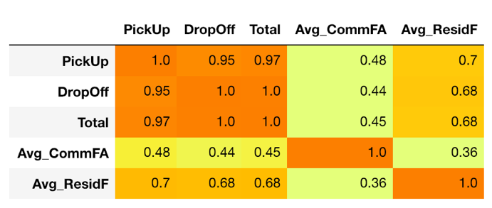

Figure 1 Correlation_Analytics_BK_all

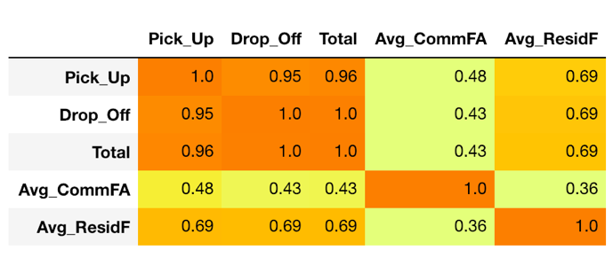

Figure 2 Correlation_Analytics_BK_weekend

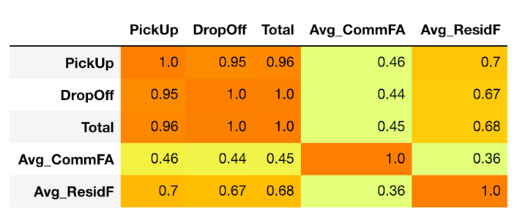

Figure 3 Correlation_Analytics_BK_weekday

However, based on two maps of commercial FAR and residential FAR in Brooklyn, it can not be concluded that there is or is not relationship between cab trips and land uses. Therefore, to answer this questions, further analysis is conducted in the next section.

**Section 2 Land Uses**

According to New York City Zoning regulations, Brooklyn is divided into five basic zoning districts: Residential Districts(R), Commercial Districts (C), Manufacturing Districts (M), Park Areas (P) and Battery Park (B) to distinguish various building forms and permitted uses.

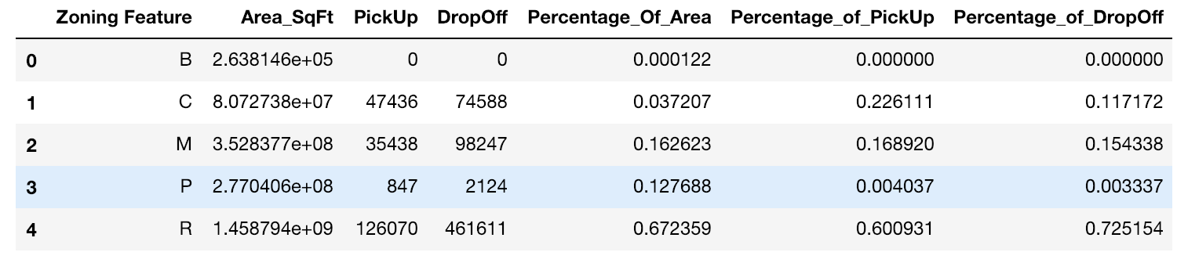

We calculate the percentages of different land uses in Brooklyn, the result of which show that 16.26% of Brooklyn are manufacturing districts, 12.77% are park area, 3.72% are commercial districts, while most of the area are residential districts that account for 67.23% of the total area in Brooklyn.

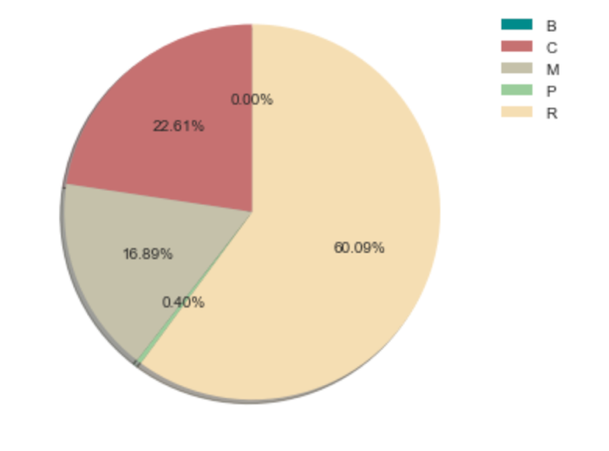 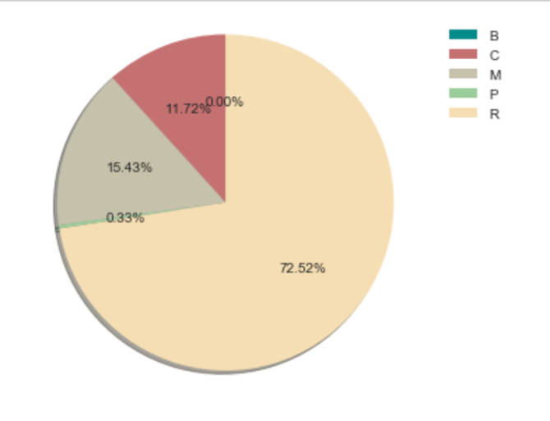

We also calculate the percentages of pick-up trips and drop-off trips in different land zones of Brooklyn, in other words, we calculate how many percentages of pick-up trips departed from either residential districts, commercial districts, manufacturing districts, park areas or Battery Park, and how many percentages of drop-off trips arrived in either residential districts, commercial districts, manufacturing districts, park areas or Battery Park. The results show that for the pick-up trips, rare percent of trips departed from park areas or Battery Park while about 16.89% of the pick-up trips departed from manufacturing districts, 22.61% of the pick-up trips departed from commercial districts, and most of the pick-up trips (60.09%) departed from residential districts. And for the drop-off trips, also rare percent of trips arrived in park areas or Battery Park while about 15.43% of the pick-up trips arrived in manufacturing districts, 11.72% of the pick-up trips arrived in commercial districts, and most of the pick-up trips (72.52%) arrived in residential districts.

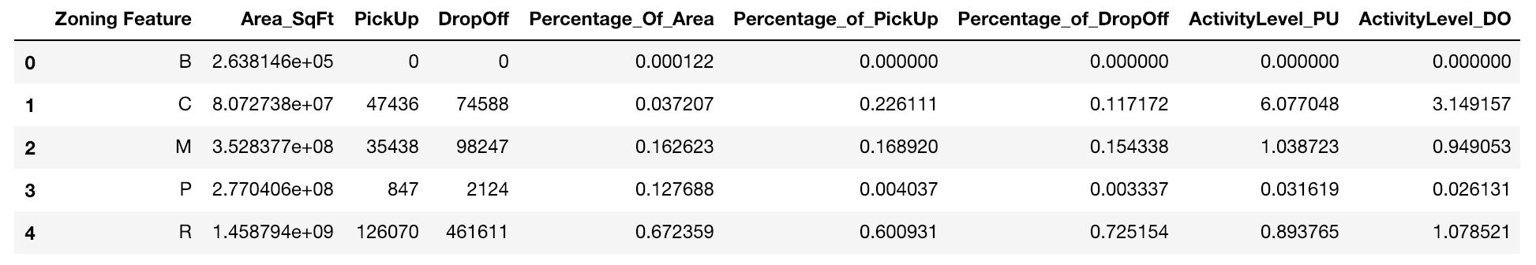

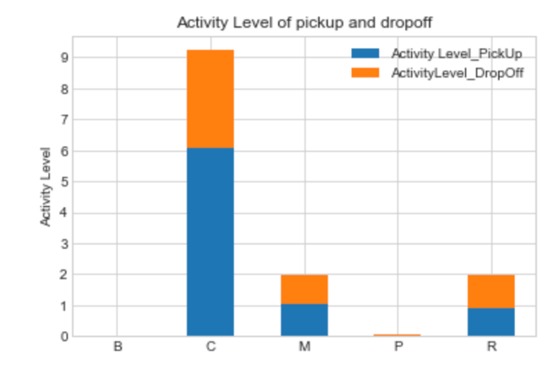

In order to measure the activity level of different zoning districts, we respectively divide percentage of pick-up trips (“Percentage_of_PickUp” column in the table) by the percentage of zoning district area (“Percentage_Of_Area” column in the table), and divide percentage of drop-off trips (“Percentage_of_DropOff” column in the table) by the percentage of zoning district area (“Percentage_Of_Area” column in the table). Therefore, we have activity level of both pick-up and drop-off trips. From the results (column “ActivityLevel_PU” and “ActivityLevel_DO”) in the table, it is obvious that in Brooklyn, the commercial districts have the highest level of cab pick-up activity, with the activity level value being 6.08 compared with that of manufacturing districts (1.04) and residential districts (0.89). The commercial districts also have the highest level of cab drop-off activity, with the activity level value being 3.14 compared with that of manufacturing districts (0.95) and residential districts (1.08). In other words, more people hail cabs in the commercial districts to somewhere else, and more people take a cab to the commercial district through a cab, compared with the cab activities in residential districts and manufacturing districts.

Comparing the level of cab pick-up activity (6.08) and the level of cab drop-off activity in the commercial districts (3.14), we can conclude that people are more likely to hail cabs when they leave the places in the commercial districts such as shops, offices, theaters, restaurants than they come to the commercial districts.

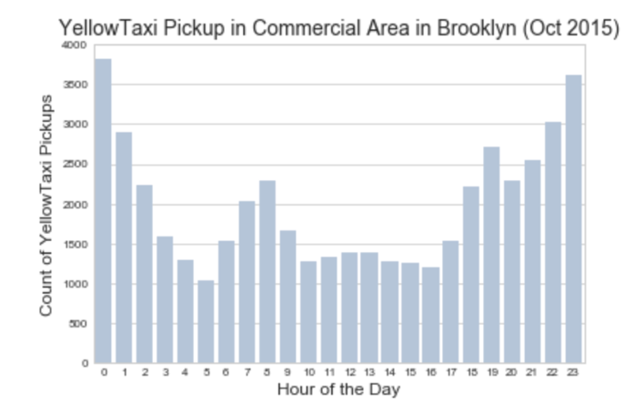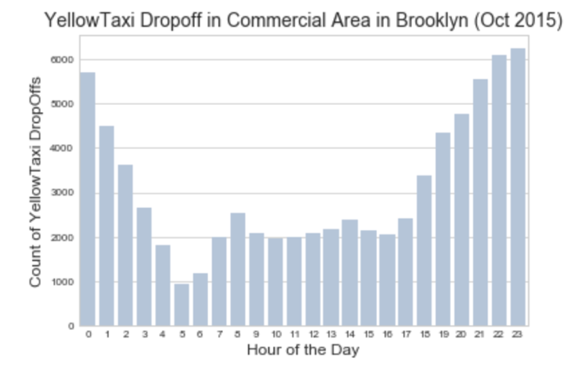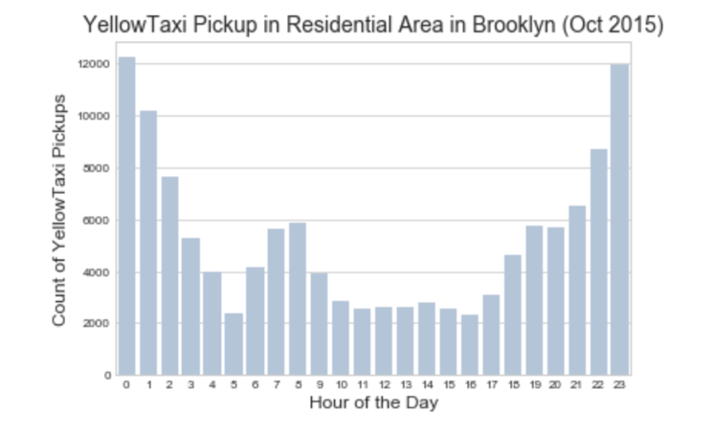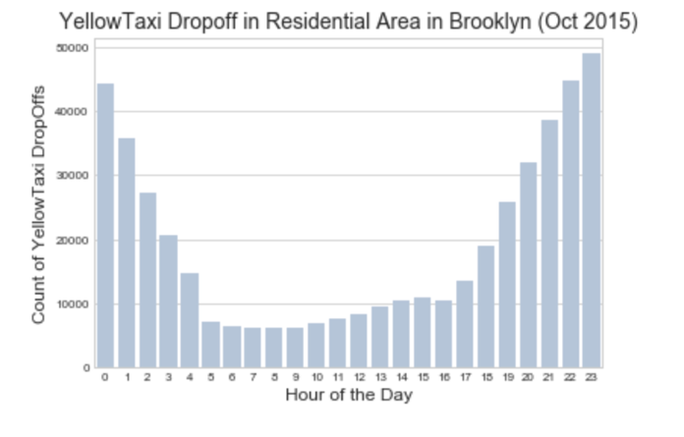

From the above analysis, except that more pick-up trips departed from the residential district instead of the commercial districts and more drop-off trips arrived in the residential district instead of the commercial districts, two patterns of all pick-up and drop-off trips in the commercial districts show that in the mid of the day, there is a trend of increasing pick-up and drop-off trips in the commercial area, compared with the same time period in the figure showing the pattern of all pick-up and drop-off trips in the residential districts. Therefore, we can conclude that in the mid of the day, compared with other time period, commercial districts are more likely to expect the increasing trips than the residential districts, no matter for the pick-up or drop-off trips.

**Section 3 Typical trips**

We are also curious about what is Brooklyn people’s daily travel pattern through the yellow cabs in certain time period of a day and in certain days of a week and which trips (which originations and destinations) are the most typical ones in Brooklyn.

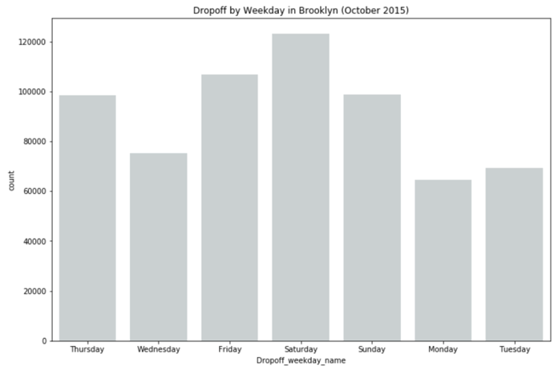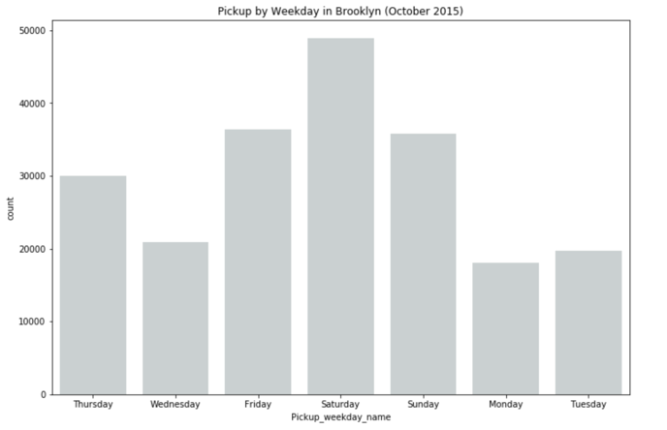

From the analysis shown above, in October 2015, there would be more cab trips in Saturday than other days in a week, no matter for drop-off trips or pick-up trips.

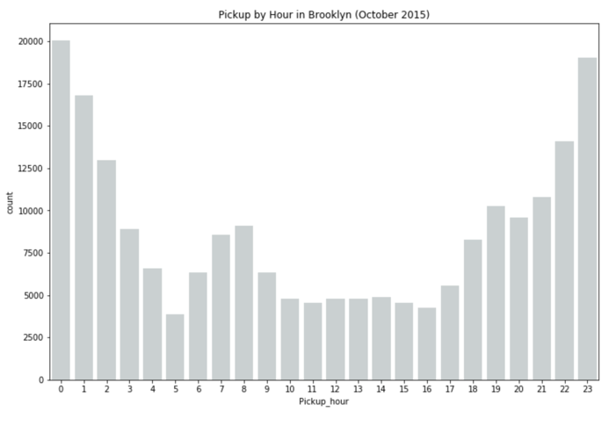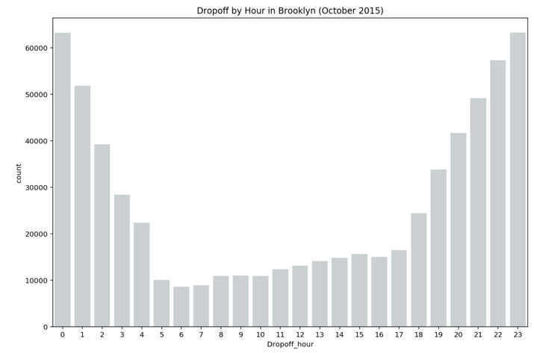

In addition, in days of October 2015, Brooklyn has much more drop-off trips in Brooklyn from 10:00 pm to 0:00 am than any other time period, while has more pick-up trips from 11:00 pm to 1:00 am. In addition, it is obvious that there are much more drop-off trips (with maximum 50000 volume on Saturday) than pick-up trips (with maximum 12000 volume on Saturday) in Brooklyn, which matches what we found in previous analysis.

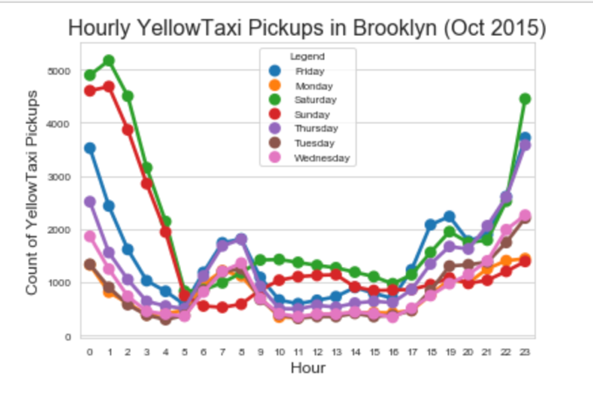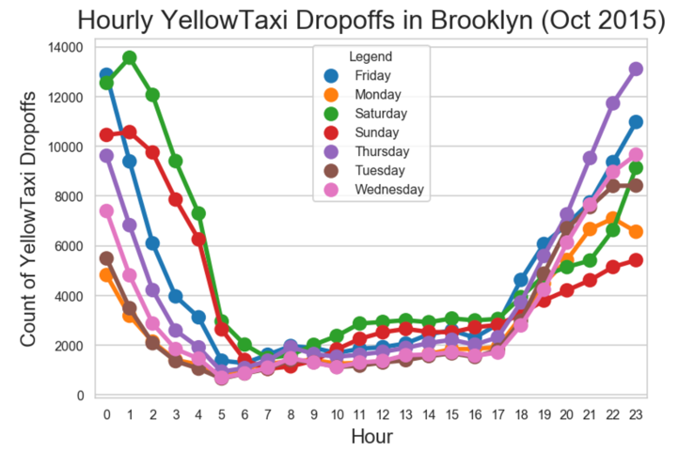

From the additional visualization of hourly yellow cab pick-up and drop-off trips in Brooklyn above, we found that the cab travel pattern are different on weekdays and on the weekend.

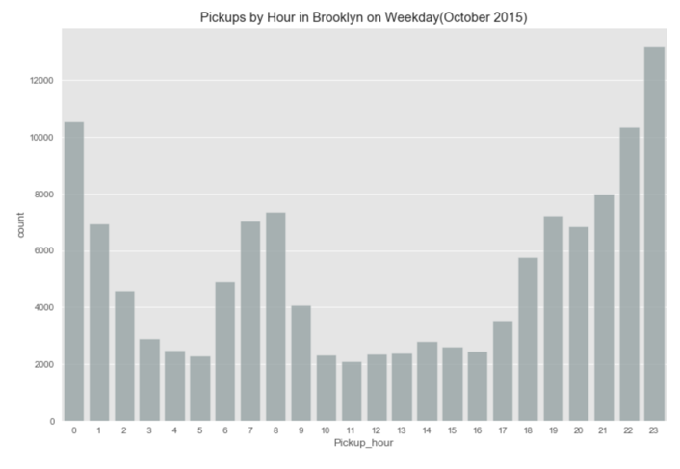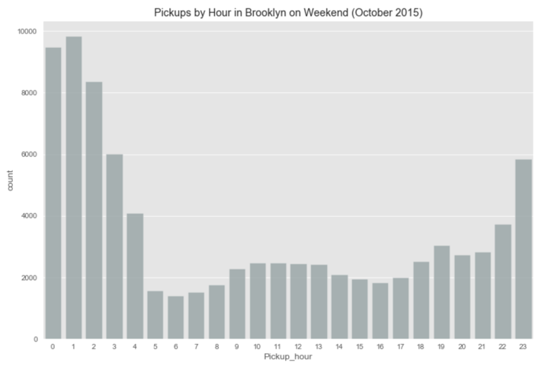

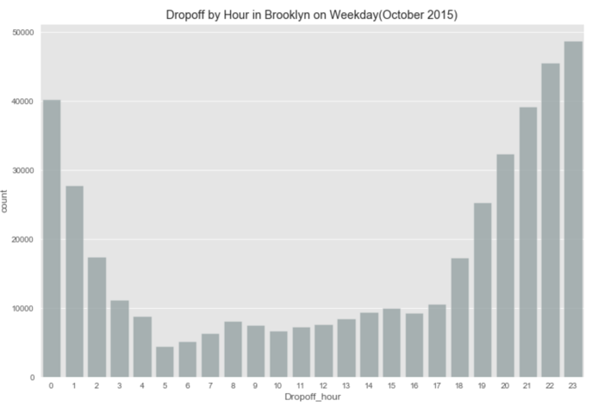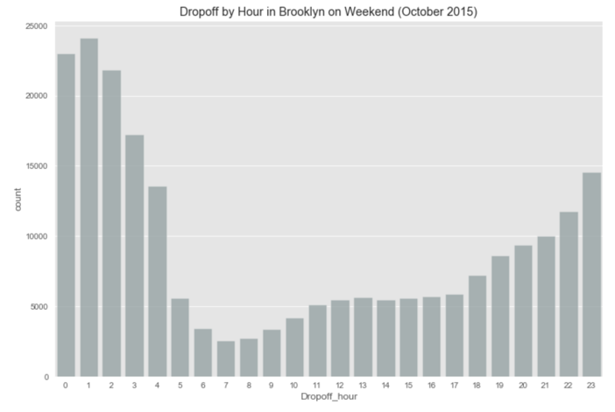

Therefore, to differentiate cab trips on weekdays and weekend, the volumes of pick-up trip in Brooklyn by hour on weekdays and weekend are plotted, the same to the volumes of drop-off trip in Brooklyn by hour on weekdays and weekend. The results show that on weekdays, the peak hours of both pick-up and drop-off trips in Brooklyn is from 10:00 pm to 0:00 am, while on weekend, the peak hours of both pick-up and drop-off trips in Brooklyn is from 0:00 am to 2:00 am, although, the volume of drop-off trips is much larger than that of pick-up trips no matter when.

**Typical pick-up and drop-off trips**

To identify the most typical pick-up and drop-off trips and their destinations and originations in Brooklyn, we cluster all pick-up and all drop-off trips into 50 groups on weekdays and on weekend respectively in four maps. In the map, pink points represent originations while blue points represent destinations.

Comparing two typical pick-up trip maps on weekdays and on weekend respectively, the common thing is that the originations of most typical pick-up trips, no matter on weekdays and on weekend are concentrating in west Brooklyn around Williamsburg and Brooklyn Heights. The difference is that for all pick-up trips on weekdays, trips from Brooklyn to John F. Kennedy International Airport become typical, compared with all pick-up trips on weekend, in other words, more people take cabs from Brooklyn to the airport on weekdays.

Comparing two typical drop-off trip maps on weekdays and on weekend respectively, the common thing is that the destinations of most typical drop-off trips, no matter on weekdays and on weekend are concentrating in northwest Brooklyn around Bedford-stuyvesant, Red Hook, Williamsburg and Brooklyn Heights. The difference is that for all drop-off trips on weekdays, there are more typical trips from Manhattan to Brooklyn, compared with all drop-off trips on weekend, in other words, more people take cabs from Manhattan to Brooklyn on weekdays.

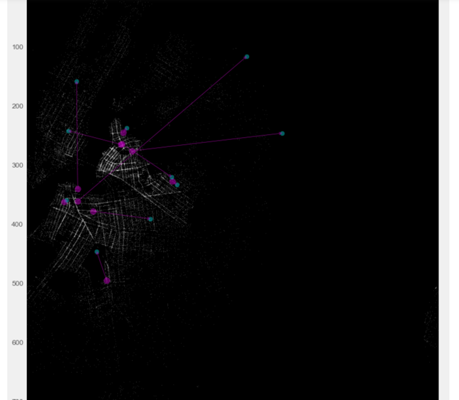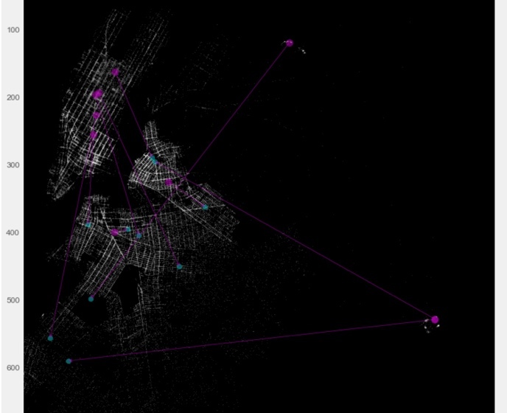

Figure weekend typical pick-up trips Figure : weekend typical drop-off trips

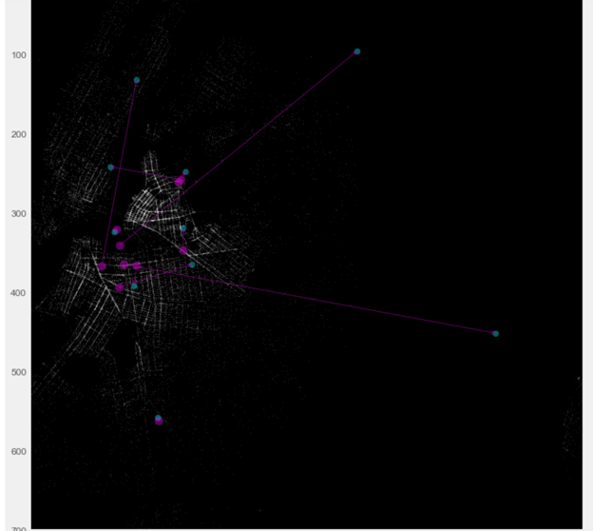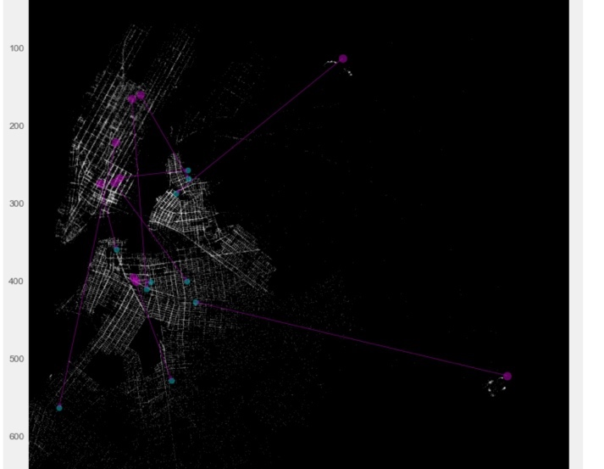

Figure weekday typical pick-up trips Figure weekday typical drop-off trips

**Popular trips**

To identify the most popular pick-up and drop-off trips, we group trips according to their pick-up (origination) longitude, pick-up latitude, drop-off (destination) longitude, and drop-off latitude. The results below show that the most popular drop-off trips in Brooklyn are the ones have same location coordinates for both originations and destinations. In other words, the most popular trips are those without trip distance.

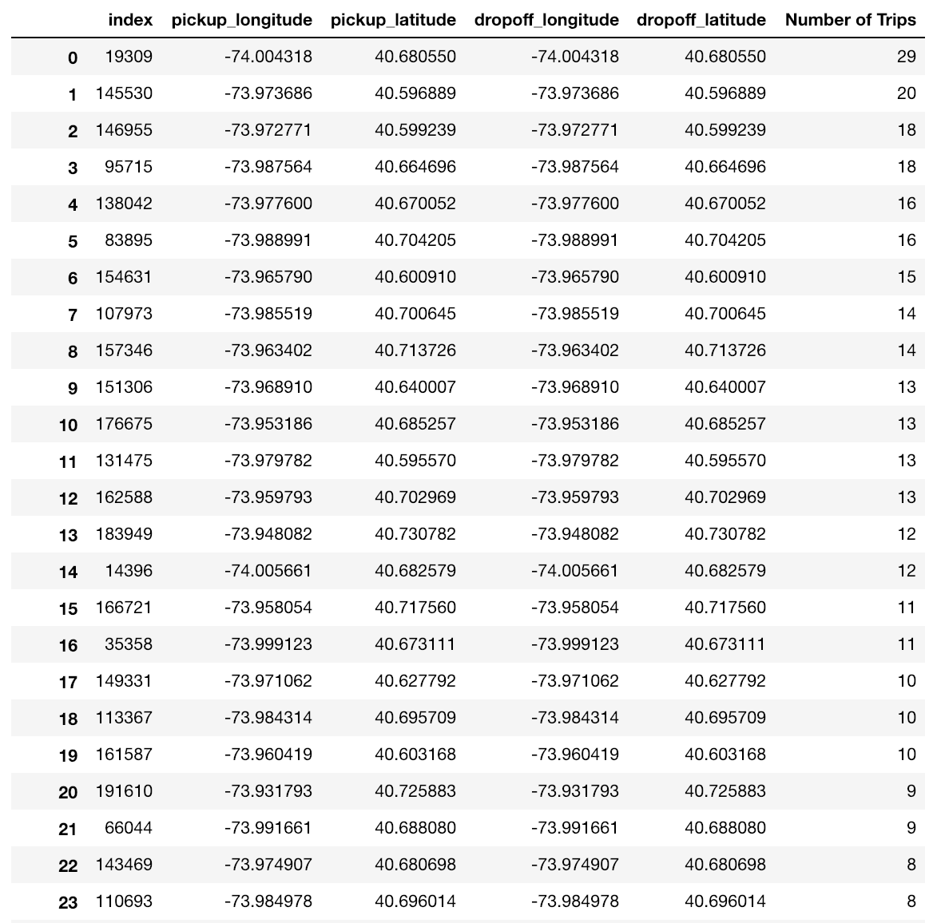

Interestingly, when we figure out the trip cost of those popular trips without any trip distance, they are not zero! This might because of the

