Created by Unlicensed Version
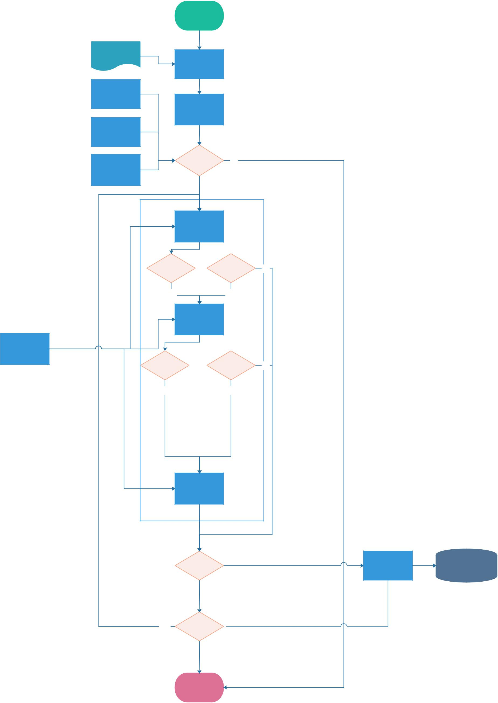

Start

Config File
Load Config

Test Bed

Initialize Test

Set Up

Software

Check _{No}
Test Dependency?

Equipments

Yes

Run Test

Step 1

Pass? Ignore? No

Yes Yes

Run Test

Step 2

Test

Parameters

Pass? Ignore? No

Yes Yes

Run Test

Step n

Store? Yes

No

Yes Recurrence?

No

Terminate

Created by Unlicensed Version

Update in DB | Database

No

Created by Unlicensed Version

