SQL Assignment 1 : Where Clause

**Given :**

Drop table Workers;

CREATE TABLE Workers (

WORKER_ID INT NOT NULL PRIMARY KEY ,

FIRST_NAME VARCHAR(25),

LAST_NAME VARCHAR(25),

SALARY INT,

JOINING_DATE DATE,

DEPARTMENT VARCHAR(25)

);

INSERT INTO Workers

(WORKER_ID, FIRST_NAME, LAST_NAME, SALARY, JOINING_DATE, DEPARTMENT) VALUES

(001, 'Jay', 'Arora', 100000, '2015-06-24', 'HR'),

(002, 'Vijay', 'Verma', 80000, '2011-06-14', 'Admin'),

(003, 'Sunil', 'Singhal', 300000, '2020-02-14', 'HR'),

(004, 'Mahendra', 'Singh', 500000, '2020-02-14', 'Admin'),

(005, 'Rashmi', 'Bhati', 500000, '2011-06-14', 'Admin'),

(006, 'Anuskha', 'Diwan', 200000, '1011-06-14', 'Account'),

(007, 'Manish', 'Kumar', 75000, '2020-01-14', 'Account'),

(008, 'Rekha', 'Chauhan', 90000, '2011-04-14', 'Admin'),

(009, 'Sanjay', 'Sharma', null, '2015-06-23', 'HR'),

(010, 'Anand', 'Joshi', null, '2012-06-15', 'Admin');

select * from Workers

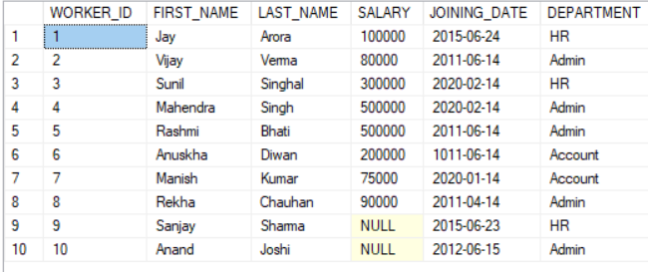

Solve

--Select all records of Workers from table Workers

Ans : SELECT * FROM WORKERS

1> FIND ALL THE DETAILS OF WORKER WHO'S ID IS 4

2> FIND ALL WORKERS WHO'S SALARIES ARE MORE THAN 100000

3> FIND THE FIRST NAME AND SALARY DETAILS OF WORKERS FROM ACCOUNT DEPARTMENT

4> SEARCH FIRST NAME AND JOINING DATE OF WORKERS FROM HR DEPARTMENT

5> FIND ALL THE WORKERS WHO ARE EARNING MORE THAN 10000 SALARIES FROM HR DEPARTMENT

6> SEARCH ALL THE WORKERS FROM DEPARTMENT ADMIN AND HR WITHOUT USE OF IN OPERATOR

7> FIND THE DETAILS OF WORKERS WITH IDS 3, 6, 7

8> FIND THE DETAILS OF WORKERS WITH IDS STARTING FROM 2 TO 7

9> FIND THE DETAILS OF WORKERS WHO'S SALARIES ARE WITHIN RANGE OF 100000 TO 30000

10> LIST ALL AVAILABLE DEPARTMENTS ( DON'T DISPLAY DUPLICATE RECORDS )

11> FIND ALL WORKERS WHO'S NAMES START WITH 'R'