<https://keras.io/>

<https://keras.io/getting-started/sequential-model-guide/>

**Keras HelloWorld**

There are many framework in working with Artificial Neural Networks (ANNs), for example, Torch, TensorFlow. In this tutorial, we present a framework, [Theano](http://deeplearning.net/software/theano/), to create and evaluate ANN models in Microsoft Windows Environment.

**Content**

1. [Prerequisites](http://keras.dhpit.com/#prerequisites)
2. [Your First Neural Network in Keras](http://keras.dhpit.com/#your-first-neural-network-in-keras)
3. [Convolutional Neural Network in Handwritten Digit Recognition](http://keras.dhpit.com/#handwritten-digit-recognition)
4. [References](http://keras.dhpit.com/#references)
5. [Contributors](http://keras.dhpit.com/#contributors)
6. [Contact](http://keras.dhpit.com/#contact)

Prerequisites

In order to work with this example program, and also to know how Theano works, you need to have the following prerequisites:

* Microsoft Windows 10 (Build 1607), aka Windows 10 Anniversary Update or higher versions
* **Bash on Ubuntu on Windows** must be enabled [[Readme](https://msdn.microsoft.com/en-us/commandline/wsl/install_guide)]
* **Keras** with **Theano** backend in virtual Ubuntu on Windows must be installed [[Readme](http://www.pyimagesearch.com/2016/07/18/installing-keras-for-deep-learning/)]
* Basic understanding of **Python** programming language [[Readme](https://www.tutorialspoint.com/python/)]
* Basic understanding of machine learning, artificial neural network [[ML](http://cs229.stanford.edu/) | [ANN](https://en.wikipedia.org/wiki/Artificial_neural_network)]

Your First Neural Network in Keras

In the following Python program, you will go through the steps to build and evaluate an ANN model on the pima-indians-diabetes dataset. The program includes 5 main steps as follows:

* Loading dataset
* Defining model
* Compiling model
* Inputing dataset into model
* Evaluating model

# create first network with Keras

from keras.models import Sequential

from keras.layers import Dense

import numpy

# fix random seed for reproducibility

seed = 7

numpy.random.seed(seed)

# load pima indians dataset

dataset = numpy.loadtxt("pima-indians-diabetes.csv", delimiter=",")

# split into input (X) and output (Y) variables

X = dataset[:,0:8]

Y = dataset[:,8]

# create model

model = Sequential()

model.add(Dense(12, input_dim=8, init='uniform', activation='relu'))

model.add(Dense(8, init='uniform', activation='relu'))

model.add(Dense(1, init='uniform', activation='sigmoid'))

# compile model

model.compile(loss='binary_crossentropy' , optimizer='adam', metrics=['accuracy'])

# input the dataset into created model

model.fit(X, Y, nb_epoch=150, batch_size=10)

# evaluate the model

scores = model.evaluate(X, Y)

print("%s: %.2f%%" % (model.metrics_names[1], scores[1]*100))

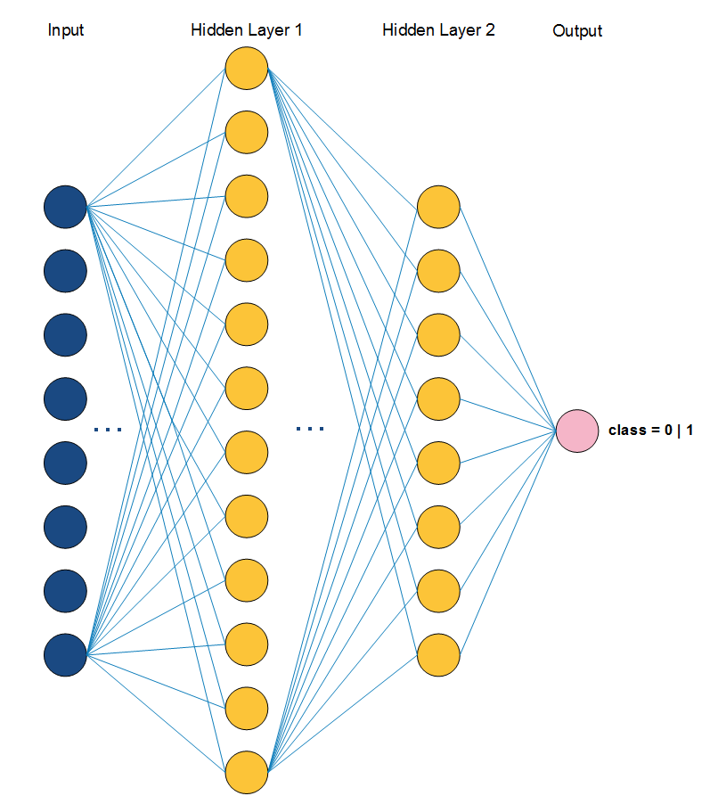The above image illustrates the defined ANN model. After programming your prefer ANN model, now, compile and run it in Keras environment by using the following steps:

* Open Bash on Ubuntu on Windows and change the directory to the project location. You need to put both the program and dataset in the same location.
* Type the command workon keras
* Then, python sample.py

Handwritten Digit Recognition

At this point, you completed your first beginning program with Keras. Now, let's dive into something interested, computer vision. We present a basic demo with Convolutional Neural Network (CNN) with handwritten digit recognition problem. The program is available at this repository, named mnist_cnn.py.  
There are few standard datasets in digit recognition problem, thus, in this tutorial, we use the [MNIST](http://yann.lecun.com/exdb/mnist/)dataset, which contains 70,000 images of handwritten numbers from 0 to 9. The digit in each image has been size-normalized and centered in a fixed-size.  
Like your first program, in this example, first, we need to read the input dataset. Each image is represented as matrix with 28 x 28 dimension. Next, we define size of pooling area for max pooling. Then, define the number of convolutional filters (feature detectors) to be used and the size of them also.

# input image dimensions

img_rows, img_cols = 28, 28

# number of convolutional filters to use

nb_filters = 32

# convolution kernel size

kernel_size = (3, 3)

# size of pooling area for max pooling

pool_size = (2, 2)

Second, we reshape all image to 28 x 28 dimension by calling the defined reshape function in Keras (in line 35). The function contains four arguments (samples, channels, height, width), where channelsis 0 or 3, which means, gray-scale or RGB mode, respectively.  
Third, we define the CNN model as follows:

# define model

model = Sequential()

model.add(Convolution2D(nb_filters, kernel_size[0], kernel_size[1],

border_mode='valid',

input_shape=input_shape))

model.add(Activation('relu'))

model.add(Convolution2D(nb_filters, kernel_size[0], kernel_size[1]))

model.add(Activation('relu'))

model.add(MaxPooling2D(pool_size=pool_size))

model.add(Dropout(0.25))

model.add(Flatten())

model.add(Dense(128))

model.add(Activation('relu'))

model.add(Dropout(0.5))

model.add(Dense(nb_classes))

model.add(Activation('softmax'))

# compile model

model.compile(loss='categorical_crossentropy',

optimizer='adadelta',

metrics=['accuracy'])

Forth, after define the model, now input the dataset into it and then, run and evaluate. The nb_epochaffects the time-consuming when running this example, we recommend to edit nb_epoch to a lower number when running time is too long.

# input the dataset

model.fit(X_train, Y_train,

batch_size=batch_size,

nb_epoch=nb_epoch,

verbose=1,

validation_data=(X_test, Y_test))

# evaluate model

score = model.evaluate(X_test, Y_test, verbose=0)

print('Test score:', score[0])

print('Test accuracy:', score[1])

References

1. Keras Documentation - <https://keras.io/>
2. Machine Learning Mastery - <https://goo.gl/2EovtJ>