BetBuddy

Version <1.0>

Revision History

|  |  |  |  |
| --- | --- | --- | --- |
| **Date** | **Version** | **Description** | **Author** |
| 29/09/2022 | 1.0 | First Draft | Aaron Reith |
|  |  |  |  |
|  |  |  |  |
|  |  |  |  |

Table of Contents

1. Use-Case Model 5

1.1 Introduction 5

1.2 General Actors Descriptions 5

1.3 Use-Case Model Hierarchy 5

1.4 Diagrams of the Use-Case Model 6

2. Menu 6

2.1 Brief Description 6

2.2 Flow of Events 6

2.3 Preconditions 6

2.4 Postconditions 7

2.5 Extension Points 7

2.6 Relationships 7

2.7 Use-Case Diagrams 7

2.8 Other Diagrams 7

3. Track History 7

3.1 Brief Description 7

3.2 Flow of Events 7

3.3 Preconditions 7

3.4 Postconditions 7

3.5 Extension Points 7

3.6 Relationships 8

3.7 Use-Case Diagrams 8

3.8 Other Diagrams 8

4. Input New 8

4.1 Brief Description 8

4.2 Flow of Events 8

4.3 Preconditions 8

4.4 Postconditions 8

4.5 Extension Points 8

4.6 Relationships 8

4.7 Use-Case Diagrams 8

4.8 Other Diagrams 8

5. Edit 9

5.1 Brief Description 9

5.2 Flow of Events 9

5.3 Preconditions 9

5.4 Postconditions 9

5.5 Extension Points 9

5.6 Relationships 9

5.7 Use-Case Diagrams 9

5.8 Other Diagrams 9

6. Delete 9

6.1 Brief Description 9

6.2 Flow of Events 9

6.3 Preconditions 10

6.4 Postconditions 10

6.5 Extension Points 10

6.6 Relationships 10

6.7 Use-Case Diagrams 10

6.8 Other Diagrams 10

7. View Stats 10

7.1 Brief Description 10

7.2 Flow of Events 10

7.3 Preconditions 10

7.4 Postconditions 11

7.5 Extension Points 11

7.6 Relationships 11

7.7 Use-Case Diagrams 11

7.8 Other Diagrams 11

8. View Profile 11

8.1 Brief Description 11

8.2 Flow of Events 11

8.3 Preconditions 11

8.4 Extension Points 11

8.5 Relationships 11

8.6 Use-Case Diagrams 11

8.7 Other Diagrams 12

9. View Graphs 12

9.1 Brief Description 12

9.2 Flow of Events 12

9.3 Preconditions 12

9.4 Postconditions 12

9.5 Extension Points 12

9.6 Relationships 12

9.7 Use-Case Diagrams 12

9.8 Other Diagrams 12

# Use-Case Model

## Introduction

There is only one user type in this system, which is the user of the application. The user accesses the system by opening the application on their mobile device where they are able to track their betting history by inputting new bets they’ve placed or editing old bets by updating the results or deleting them. The user also has the option to view their stats. Within stats the user can access their betting profile or view graphs of associated statistics. All data is stored and accessed locally on the user's device.

## General Actors Descriptions

### User

The user has access to all the features of the program as of the build downloaded. This includes tracking their history and viewing the extrapolated statistics based on said history.

### System

The system is an external actor. It has access to all the same features as the user because it has the obligation of storing the information within the application on a file and then importing/exporting all the information back and forth whenever the user tries to access it.

## Use-Case Model Hierarchy

### Interface Usage

* **Description**

As the sole package currently in the use-case model, Interface Usage manages both the interactions of the user and the system with the interface through the various use cases.

* **Use Cases**
  + **Menu**
  + **Track History**
  + **Input New**
  + **Edit**
  + **Delete**
  + **View Stats**
  + **View Profile**
  + **View Graphs**
* **Actors**
  + **User**
  + **System**
* **Relationships**
  + **None**
* **Packages Owned**
  + **None**

#### Packages Diagram

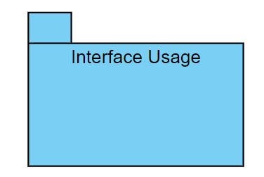

**Figure 1 – Interface Usage Use Package**

## ****Diagrams of the Use-Case Model****

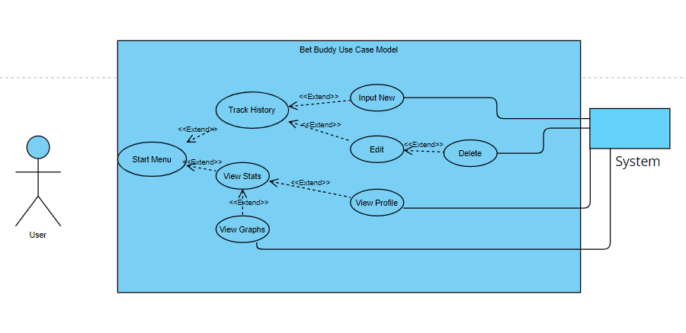

**Figure 2 – BetBuddy Use Case Model**

# Menu

## Brief Description

The Menu is entered upon loading the application and displays the two main usages of the application, “Track History” and “View Stats”.

## Flow of Events

### Basic Flow

After successfully loading/accessing the application, the user can select “Track History” to do various actions such as inputting a new bet and/or editing/deleting an existing bet or select “View Stats” to see graphs and their profile, both based on their previously input statistics.

### Alternative Flows

#### < First Alternative Flow >

The singular alternative flow from the initial startup of the application is to quit, as in closing the application before accessing other use cases.

## Preconditions

None.

## Postconditions

None.

## Extension Points

### < Track History - extend>

Track History is one of two use cases that directly follows “Menu” in the flow of events.

### < View Stats - extend >

View Stats is the second of the two use cases that directly follows “Menu” in the flow of events.

## Relationships

Menu is associated with the User and is the base case of its two children, “Track History” and “View Stats”.

## Use-Case Diagrams

Refer to Use-Case Diagram (Figure 2)

## Other Diagrams

None.

# Track History

## Brief Description

The Track History case is an integral part of the user’s interactions with the application. Once loaded at the menu, the option to track history is one of the few options available initially. Upon clicking “Track History”, the user is able to access more specific options within its scope.

## Flow of Events

### Basic Flow

After successfully loading/accessing the application, the user can select “Track History” from the menu to do various actions such as inputting a new bet and/or editing/deleting an existing bet.

### Alternative Flows

#### < First Alternative Flow >

The singular alternative flow from the “Track History” is to quit, as in closing the application before accessing other use cases.

## Preconditions

None.

## Postconditions

None.

## Extension Points

### < Input New - extend>

Input New is one of two use cases that directly follows “Track History” in the flow of events.

### < Edit - extend >

Edit is the second of the two use cases that directly follows “Track History” in the flow of events.

## Relationships

Tracking History is an extension of “Menu” and is the base case of its two children listed above, “Input New” and “Edit”.

## Use-Case Diagrams

Refer to Use-Case Diagram (Figure 2).

## Other Diagrams

None.

# Input New

## Brief Description

The user inputs a new bet, including all necessary information about odds, spread, sport, betting site used, and amount bet. The input information is then stored locally in the system.

## Flow of Events

### Basic Flow

After selecting “Track History” from the menu, the user is able to select “Input New” to add a new bet into their betting history.

### Alternative Flows

#### < First Alternative Flow >

The singular alternative flow from the “Input New” screen of the application is to quit, as in closing the application before accessing other use cases.

## Preconditions

None.

## Postconditions

None.

## Extension Points

None.

## Relationships

Input New is an extension of “Track History” and is associated with the system as the system needs to save the information.

## Use-Case Diagrams

Refer to Use-Case Diagram (Figure 2)

## Other Diagrams

None.

# Edit

## Brief Description

The Edit case allows the user to modify previous betting data that is stored in the system.

## Flow of Events

### Basic Flow

After selecting “Edit” the user is able to select “Delete” to remove a bet from their betting history.

### Alternative Flows

#### < First Alternative Flow >

The singular alternative flow from the “Edit” is to quit, as in closing the application before accessing other use cases.

## Preconditions

### < Data Required >

The User Must Have data that they can edit.

## Postconditions

None.

## Extension Points

### <Delete - extend>

Delete is the singular use cases that directly follows “Edit” in the flow of events.

## Relationships

Edit is an extension of “Track History”.

## Use-Case Diagrams

Refer to Use-Case Diagram (Figure 2)

## Other Diagrams

None.

# Delete

## Brief Description

Delete is useful to the user as it deletes all information associated with the selected bet.

## Flow of Events

### Basic Flow

Once the user accesses the “Delete” option, the user is able to delete all information concerning one or more bets.

### Alternative Flows

#### < First Alternative Flow >

The singular alternative flow from “Delete” is to quit, as in closing the application before accessing other use cases.

## Preconditions

### < Data Required >

The User Must Have data that they can delete.

## Postconditions

None.

## Extension Points

None.

## Relationships

“Delete” is an extension of “Edit” and is associated with the system, as the system must be able to see what the user wants to delete and then be able to actually delete the selected bet and its information.

## Use-Case Diagrams

Refer to Use-Case Diagram (Figure 2)

## Other Diagrams

None.

# View Stats

## Brief Description

The user can view a variety of statistics about their betting tendencies. The user is also able to make the decision to view that statistics in graphical form or view their betting profile.

## Flow of Events

### Basic Flow

After selecting “View Stats” from the menu, the user is able to view all their betting statistics. Simultaneously, the user is presented with the options to “View Graphs” or “View Profile”.

### Alternative Flows

#### < First Alternative Flow >

The singular alternative flow from the “View Stats” is to quit, as in closing the application before accessing other use cases.

## Preconditions

### < Data Required >

The User Must Have data that they can view.

## Postconditions

None.

## Extension Points

### < View Graphs – extend >

< *View Profile – extend* >

## Relationships

View Stats is an extension of “Menu” and is the base case of its two children listed above, “View Graphs” and “View Profile”.

## Use-Case Diagrams

Refer to Use-Case Diagram (Figure 2)

## Other Diagrams

None.

# View Profile

## Brief Description

View profile is an option for the user to be able to view different descriptors about them based on their betting habits and outcomes. This is useful for giving the user information about how to improve or what they need to continue to do for success.

## Flow of Events

### Basic Flow

“View Profile” is able to be selected from within the “View Stats” use case and is loaded upon the user selecting the option.

### Alternative Flows

#### < First Alternative Flow >

The singular alternative flow from the “View Profile” is to quit, as in closing the application before accessing other use cases.

## Preconditions

### < Data Required >

The User Must Have data that they can view.

## Extension Points

None.

## Relationships

“View Profile” is an extension of “View Stats” as the information necessary to create a user’s profile must exist and be selected from within the “View Stats” case.

## Use-Case Diagrams

Refer to Use-Case Diagram (Figure 2).

## Other Diagrams

None.

# View Graphs

## Brief Description

View Graphs is an option for the user to view various graphs that were created using extrapolated data from the user’s betting data.

## Flow of Events

### Basic Flow

“View Graphs” is able to be selected from within the “View Stats” use case and is loaded upon the user selecting the option.

### Alternative Flows

#### < First Alternative Flow >

The singular alternative flow from the “View Stats” is to quit, as in closing the application before accessing other use cases.

## Preconditions

### < Data Required >

The User Must Have data that they can view.

## Postconditions

None.

## Extension Points

None.

## Relationships

View Graphs is an extension of “View Stats” as well as being associated with the System.

## Use-Case Diagrams

Refer to Use-Case Diagram (Figure 2)

## Other Diagrams

None.