BetBuddy

Version <2.0>

Revision History

|  |  |  |  |
| --- | --- | --- | --- |
| **Date** | **Version** | **Description** | **Author** |
| 19/10/2022 | 1.0 | First Iteration | Aaron Reith |
| 30/10/2022 | 2.0 | Second Iteration | Aaron Reith |
|  |  |  |  |
|  |  |  |  |

Table of Contents

1. Introduction 5

1.1 Purpose 5

1.2 Scope 5

1.3 Definitions, Acronyms, and Abbreviations 5

1.4 References 5

1.5 Overview 5

2. USE CASE <Menu> 5

2.1 Flow of Events - Design 5

2.2 Interaction Diagrams 5

2.3 Class Diagrams 6

2.4 Derived Requirements 6

3. USE CASE <Track History> 6

3.1 Flow of Events 6

3.2 Interaction Diagrams 6

3.3 Class Diagrams 7

3.4 Derived Requirements 7

4. USE CASE <Input New> 7

4.1 Flow of Events - Design 7

4.2 Interaction Diagrams 7

4.3 Class Diagrams 8

4.4 Derived Requirements 8

5. USE CASE <Edit> 8

5.1 Flow of Events – Design 8

5.2 Interaction Diagrams 8

5.3 Class Diagrams 9

5.4 Derived Requirements 9

6. USE CASE <Delete> 9

6.1 Flow of Events – Design 9

6.2 Interaction Diagrams 9

6.3 Class Diagrams 9

6.4 Derived Requirements 9

7. USE CASE <View Stats> 10

7.1 Flow of Events - Design 10

7.2 Interaction Diagrams 10

7.3 Class Diagrams 10

7.4 Derived Requirements 10

8. USE CASE <View Profile> 10

8.1 Flow of Events - Design 10

8.2 Interaction Diagrams 11

8.3 Class Diagrams 11

8.4 Derived Requirements 11

9. USE CASE <View Graphs> 11

9.1 Flow of Events - Design 11

9.2 Interaction Diagrams 11

9.3 Class Diagrams 12

9.4 Derived Requirements 12

# Introduction

## Purpose

This document provides a comprehensive overview of the system, using a number of different diagrams for representing the system functions.

## Scope

BetBuddy is a mobile app that provides a log of bet history and informational graphs created using the extrapolated data to advise the customer of their betting tendencies and financial returns, which equips the user with the knowledge needed to create and maintain a stable, profitable return on investment. This Use   
Case Realization document provides an overview of the use cases developed in Bet Buddy.

## Definitions, Acronyms, and Abbreviations

BB: Bet Buddy

## References

None

## Overview

The sections of the Use-Case Realization document describe the use cases in terms of their flow of   
events, participant objects and corresponding diagrams.

# USE CASE <Menu>

## Flow of Events - Design

Upon opening the application, the user is sent to the Menu. The Menu displays the two main usages of the application, “Track History” and “View Stats”

## Interaction Diagrams

* User opens the application
* User is presented the option to “Track History” or “View Stats”

### Sequence Diagrams

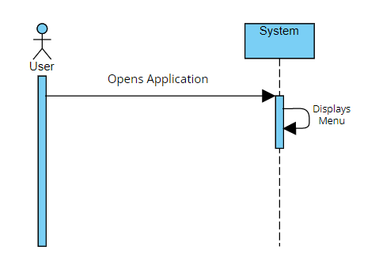

**Figure 1 – Sequence Diagram: Menu**

### Participating objects

The following objects collaborate and define the Use-Case < Menu > behavior:

|  |  |
| --- | --- |
| **System** | This object represents that the user interacts with to navigate the application |

## Class Diagrams

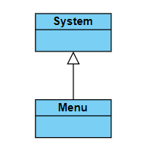

**Figure 2 – Menu Class Diagram**

## Derived Requirements

None.

# USE CASE <Track History>

## Flow of Events

After successfully loading/accessing the application, the user can select “Track History” from the menu to do various actions such as inputting a new bet and/or editing/deleting an existing bet.

## Interaction Diagrams

* The user presses the track History button
* A button to input a new bet is presented to the user and an option to edit/delete an existing bet is presented to them

### Sequence Diagrams

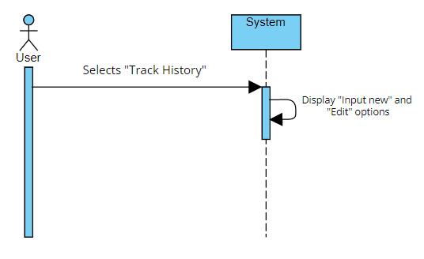

**Figure 3 – Sequence Diagram: Track History**

### Participating objects

The following objects collaborate and define the Use-Case <Track History> behavior:

|  |  |
| --- | --- |
| **System** | This object represents that the user interacts with to navigate the application |

## Class Diagrams

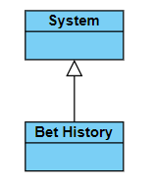

**Figure 4 – Bet History Class Diagram**

## Derived Requirements

None.

# USE CASE <Input New>

## Flow of Events - Design

After selecting “Track History” from the menu, the user is able to select “Input New” to add a new bet into their betting history.

## Interaction Diagrams

* The user presses the “Input New” Button

### Sequence Diagrams

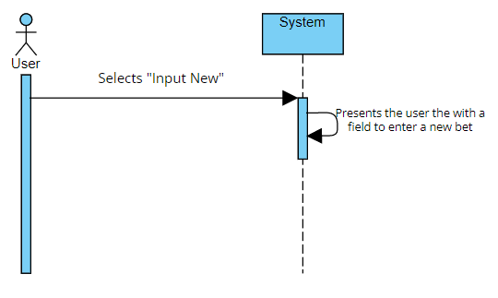

**Figure 5 – Sequence Diagram: Input New**

### Participating objects

The following objects collaborate and define the Use-Case <Input New> behavior:

|  |  |
| --- | --- |
| **System** | This object represents that the user interacts with to navigate the application |

## Class Diagrams

Refer to **Figure 4**

## Derived Requirements

None.

# USE CASE <Edit>

## Flow of Events – Design

After selecting “Edit” the user is able to select “Delete” to remove a bet from their betting history.

## Interaction Diagrams

* The User presses the Edit button
* The User is presented the option to change specific bets as well as the option to “delete”

### Sequence Diagrams

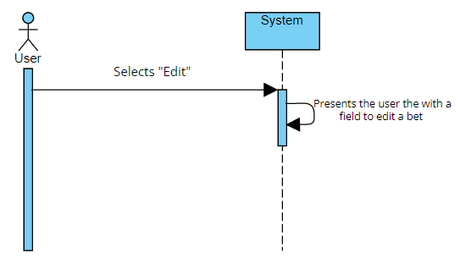

**Figure 6 – Sequence Diagram: Edit**

### Participating objects

The following objects collaborate and define the Use-Case <Edit> behavior:

|  |  |
| --- | --- |
| **System** | This object represents that the user interacts with to navigate the application |

## Class Diagrams

Refer to **Figure 4**

## Derived Requirements

None.

# USE CASE <Delete>

## Flow of Events – Design

Once the user accesses the “Delete” option, the user can delete all information concerning one or more bets.

## Interaction Diagrams

### Sequence Diagrams

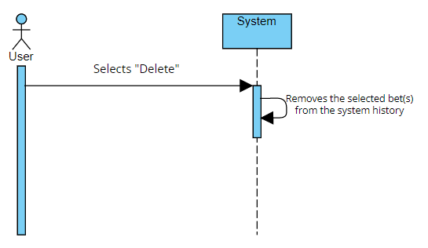

**Figure 7 – Sequence Diagram: Delete**

### Participating objects

The following objects collaborate and define the Use-Case <Delete> behavior:

|  |  |
| --- | --- |
| **System** | This object represents that the user interacts with to navigate the application |

## Class Diagrams

Refer to **Figure 4**

## Derived Requirements

None.

# USE CASE <View Stats>

## Flow of Events - Design

After selecting “View Stats” from the menu, the user is able to view all their betting statistics. Simultaneously, the user is presented with the options to “View Graphs” or “View Profile”.

## Interaction Diagrams

### Sequence Diagrams

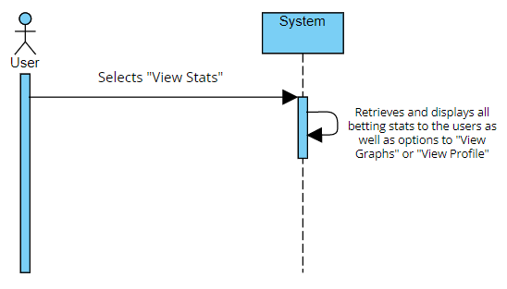

**Figure 8 – Sequence Diagram: View Stats**

### Participating objects

The following objects collaborate and define the Use-Case <View Stats> behavior:

|  |  |
| --- | --- |
| **System** | This object represents that the user interacts with to navigate the application |

## Class Diagrams

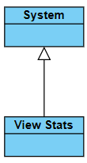

**Figure 9 – View Stats Class Diagram**

## Derived Requirements

None.

# USE CASE <View Profile>

## Flow of Events - Design

“View Profile” is able to be selected from within the “View Stats” use case and is loaded upon the user selecting the option.

## Interaction Diagrams

### Sequence Diagrams

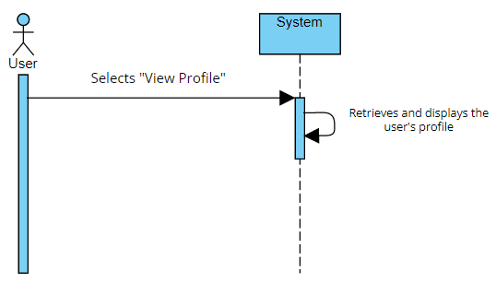

**Figure 10 – Sequence Diagram: View Stats**

### Participating objects

The following objects collaborate and define the Use-Case <View Profile> behavior:

|  |  |
| --- | --- |
| **System** | This object represents that the user interacts with to navigate the application |

## Class Diagrams

Refer to **Figure 9**

## Derived Requirements

None.

# USE CASE <View Graphs>

## Flow of Events - Design

“View Graphs” is able to be selected from within the “View Stats” use case and is loaded upon the user selecting the option. View Graphs is an option for the user to view various graphs that were created using extrapolated data from the user’s betting data.

## Interaction Diagrams

### Sequence Diagrams

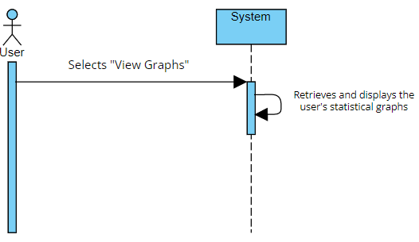

**Figure 11 – Sequence Diagram: View Graphs**

### Participating objects

The following objects collaborate and define the Use-Case <View Graphs> behavior:

|  |  |
| --- | --- |
| **System** | This object represents that the user interacts with to navigate the application |

## Class Diagrams

Refer to **Figure 9**

## Derived Requirements

None.