

SMART PARKING MANAGEMENT SYSTEM
Object-Oriented Programming in C++ – Mini Project

A MINI PROJECT REPORT
Submitted by:
Arun Saini
UID: 25BCD10196

Submitted to:
Mr. Abhinay Sood
Designation: Professor

in partial fulfillment of the Object-Oriented Programming (C++) course

Chandigarh University
Date of Submission: 31 October 2026

TABLE OF CONTENTS
Section | Page
1. Introduction | 3
2. Objectives / Problem Statement | 4
3. Modules, Tools and Technologies Used | 5
4. Code with Output | 10
5. Conclusion | 19
6. References | 19
7. GitHub Upload | 20

1. INTRODUCTION
Parking is a daily problem in cities, colleges, malls and offices. A parking attendant has to remember which slots are free, which vehicle is parked where, when it came in and how much it should be charged when it leaves. Doing this on paper is slow and error-prone, and a small mistake directly causes loss of money or an argument with a customer.
This mini project, Smart Parking Management System, is a menu-driven console application written in C++ that solves this problem using Object-Oriented Programming (OOP). Different kinds of vehicles – Car, Bike and Truck – are modelled as classes that inherit from a common abstract class called Vehicle. A ParkingLot class manages the slots, parks and removes vehicles, prints a parking ticket with the correct fee, and keeps the day's earnings.
The project was chosen because parking is a real-life system that maps naturally onto OOP: every real-world entity becomes an object, and each type of vehicle behaves slightly differently (for example, trucks pay a heavy-vehicle charge). This makes it an ideal way to practise the four pillars of OOP – encapsulation, abstraction, inheritance and polymorphism.

1.1 Background
Programming languages have evolved through several styles. Early programs were written in the procedural style, where a program is a long list of instructions grouped into functions, and data is kept separately from the functions that work on it. As programs became larger, this separation made them hard to understand, hard to change and easy to break. Object-Oriented Programming (OOP) was introduced to solve this problem. In OOP the data and the functions that operate on that data are kept together inside a unit called a class, and the program is built from many small objects that talk to each other.
C++ was created by Bjarne Stroustrup at Bell Laboratories in the early 1980s as an extension of the C language, and it was originally called “C with Classes”. It keeps the speed and low-level control of C but adds classes, inheritance, polymorphism, templates and many other features. Today C++ is used in operating systems, game engines, embedded systems, databases and high-performance applications, which is why learning OOP through C++ is an important part of a computer science course.

1.2 Need of the Project
Reading about OOP is not enough to understand it; the concepts become clear only when they are used to solve a real problem. A parking system is a good example because everyone is familiar with it and it contains natural “objects”: vehicles, slots, tickets and a parking lot. The project also shows why OOP is useful – if tomorrow a new vehicle type such as a bus has to be added, only one new class is written and the rest of the program continues to work without any change.

1.3 Scope of the Project
The system works as a console application for a small parking lot with five slots. It supports three types of vehicles and handles the complete life cycle of a vehicle: entry, slot allocation, exit, fee calculation and reporting. The program keeps its data in memory while it is running. It does not use a database or a graphical interface, so that the focus remains on the OOP design.

2. OBJECTIVES / PROBLEM STATEMENT

2.1 Problem Statement
To design and implement a simple parking management system in C++ that stores vehicles in a fixed number of slots, prevents duplicate or overflow entries, calculates the parking fee according to vehicle type and time spent, and shows the current status and daily earnings – using the principles of Object-Oriented Programming.

2.2 Objectives
- To apply the four pillars of OOP: encapsulation, abstraction, inheritance and polymorphism.
- To create an abstract base class with pure virtual functions and derive Car, Bike and Truck from it.
- To use virtual functions and function overriding so that each vehicle calculates its own fee.
- To use constructors, destructors and dynamic memory (new / delete) correctly, without memory leaks.
- To use static data members, a friend function and operator overloading (<<).
- To build a simple, menu-driven interface with input validation and clear error messages.

2.3 Expected Outcomes
- A working C++ program that can be compiled with any standard C++ compiler and run on the console.
- Correct fee calculation for every vehicle type, including the extra charge for trucks.
- A clean class design in which new vehicle types can be added without changing existing code.
- Safe handling of wrong input such as duplicate plates, unknown vehicles and a full parking lot.

2.4 Assumptions and Limitations
- Time is entered by the user as a whole hour between 0 and 23; minutes are not considered.
- Every started hour is charged as a full hour, and the minimum charge is for one hour.
- A vehicle must exit on the same day it entered (exit hour not earlier than entry hour).

3. MODULES, TOOLS AND TECHNOLOGIES USED

3.1 Header Files (Modules)
Header file | Purpose in the project
iostream | Input and output on the console (cin, cout)
iomanip | Formatting output into neat columns (setw)
string | Storing number plates using the string class
vector | Storing the parking slots as a dynamic array of Vehicle pointers

3.2 Classes Used
Class | Type | Responsibility
Vehicle | Abstract base class | Stores plate and entry hour; declares type(), ratePerHour() and calculateFee()
Car | Derived class | Rate Rs. 20 per hour
Bike | Derived class | Rate Rs. 10 per hour
Truck | Derived class | Rate Rs. 40 per hour plus a Rs. 50 heavy-vehicle charge (overrides calculateFee)
ParkingLot | Manager class | Holds the slots, parks / removes vehicles, shows status and daily report

3.3 OOP Concepts Used
Concept | Where it is used
Encapsulation | Data members of Vehicle and ParkingLot are protected / private and accessed through member functions
Abstraction | Vehicle is an abstract class with pure virtual functions; the user only sees park / remove operations
Inheritance | Car, Bike and Truck inherit from Vehicle
Polymorphism | slots[i]->calculateFee() calls the correct version for each vehicle at run time (virtual function)
Constructors / destructors | Vehicle and ParkingLot use constructors; destructors release memory and update the static counter
Static member | Vehicle::totalParked counts all vehicles currently in the lot
Friend function and operator overloading | operator<< is a friend of Vehicle and prints a vehicle in one line
Composition (has-a) | A ParkingLot has many Vehicle objects

3.4 Tools and Technologies
Tool / Technology | Details
Programming language | C++ (C++11 standard)
Compiler | GCC (g++) – compiled with g++ parking_system.cpp -o parking
Editor / IDE | VS Code / Code::Blocks / Dev-C++
Version control | Git and GitHub

3.5 Theoretical Background

3.5.1 Class and Object
A class is a user-defined data type that acts as a blueprint. It describes what data (data members) and what operations (member functions) something will have. An object is a real instance created from that blueprint. In this project Vehicle, Car, Bike, Truck and ParkingLot are classes, while each parked vehicle such as “Car PB12AB1234” is an object. Many objects can be made from the same class, and each object keeps its own copy of the data.

3.5.2 Encapsulation
Encapsulation means wrapping data and the functions that use it together inside a class and controlling access to them using the keywords private, protected and public. In ParkingLot the slots, earnings and counters are private, so other parts of the program cannot change them directly; they can only use the public functions park(), removeVehicle(), showStatus() and report(). This protects the data from accidental misuse and makes it possible to change the inside of a class later without affecting the rest of the program.

3.5.3 Abstraction
Abstraction means showing only the essential features and hiding the details. The attendant who uses the menu only chooses “Park a vehicle” or “Remove a vehicle”; he does not need to know how the slot is searched or how the fee is calculated. In code, abstraction is achieved with abstract classes. A class that has at least one pure virtual function (declared with = 0) is abstract, and no object of it can be created. Vehicle is abstract because a plain “vehicle” does not exist in real life – there is always a particular type such as a car or a bike.

3.5.4 Inheritance
Inheritance allows a new class (derived class) to acquire the data members and functions of an existing class (base class). It supports code reuse and creates an “is-a” relationship: a Car is a Vehicle. The plate number, entry hour and the common fee logic are written only once in Vehicle, and Car, Bike and Truck simply reuse them. This project uses single, public inheritance, where public members of the base class stay public in the derived class.

3.5.5 Polymorphism
Polymorphism means “many forms”: the same function call behaves differently depending on the object. C++ supports compile-time polymorphism (function and operator overloading) and run-time polymorphism (virtual functions). In this project the ParkingLot stores base-class pointers (Vehicle*), yet when it calls slots[i]->calculateFee() the correct version is chosen at run time – the Truck version adds the extra Rs. 50, while Car and Bike use the base-class version. This dynamic binding is possible because calculateFee() is declared virtual, and the compiler uses a table of function addresses (the vtable) behind the scenes.

3.5.6 Constructors and Destructors
A constructor is a special member function with the same name as the class that runs automatically when an object is created and is used to initialise data members. A destructor has the same name preceded by a tilde (~) and runs automatically when the object is destroyed. In this project the Vehicle constructor increases the static counter and its destructor decreases it, while the ParkingLot destructor deletes every vehicle still parked, so that no memory is leaked. The destructor of Vehicle is declared virtual so that deleting a Car through a Vehicle pointer correctly calls the Car destructor as well.

3.5.7 Static Data Member
A static data member belongs to the class as a whole rather than to any single object, so all objects share one copy. Vehicle::totalParked is static and always shows how many vehicles are currently in the parking lot, regardless of which object changed it. It is defined once outside the class (int Vehicle::totalParked = 0;) and can be read through the static function Vehicle::getTotalParked().

3.5.8 Friend Function and Operator Overloading
A friend function is not a member of a class but is allowed to access its private and protected data. Operator overloading gives a new meaning to an existing operator for user-defined types. Here the insertion operator << is overloaded as a friend function of Vehicle, so a vehicle object can be printed simply by writing cout << vehicle, exactly like an int or a string. This makes the status display and the parking ticket code short and readable.

3.5.9 Dynamic Memory Management
Vehicles are created with the new operator, which allocates memory on the heap, and they are released with delete when the vehicle leaves or when the parking lot is destroyed. Memory that is not released causes a memory leak. The project avoids leaks by always deleting a vehicle when it is rejected (duplicate or lot full), when it exits, and in the ParkingLot destructor. The slots are held in a vector of pointers, where nullptr marks an empty slot.

3.5.10 Standard Template Library – vector
The vector is a container of the C++ Standard Template Library (STL). It behaves like an array that can manage its own memory and size, and it provides safe, convenient access with the [] operator. The parking slots are stored in a vector<Vehicle*> created with the capacity of the lot and initialised with nullptr, which is simple and avoids manual array handling.

3.6 System Design

3.6.1 Class Diagram
The class diagram below shows the classes of the project, their main members and the relationship between them. Car, Bike and Truck inherit from the abstract class Vehicle, and ParkingLot contains many Vehicle objects.
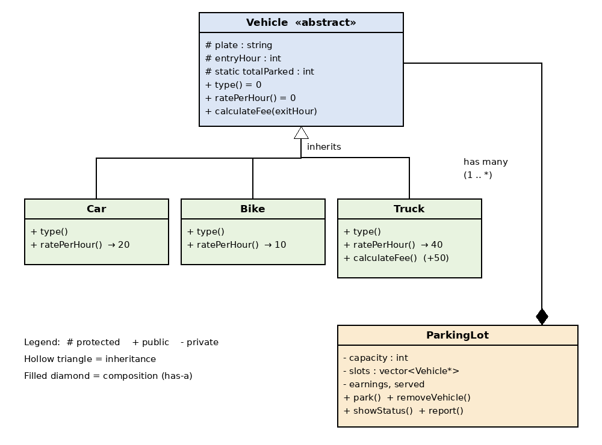
Figure 1: Class diagram of the Smart Parking Management System

3.6.2 Algorithm
Main program:
- Create a ParkingLot object with five slots and show the heading.
- Repeatedly display the menu and read the user's choice until 0 (Quit) is chosen.
- Call the matching function of ParkingLot for choices 1 to 4; for any other number print an error.
Parking a vehicle:
- Read the vehicle type, number plate and entry hour, and create a Car, Bike or Truck object with new.
- If the same plate is already in the lot, show a message and delete the new object.
- Otherwise search the slots from the first one; put the vehicle in the first empty slot and print the slot number.
- If no slot is empty, print “Parking lot is FULL!” and delete the new object.
Removing a vehicle:
- Read the plate and the exit hour and search for the plate in the slots; if it is not found, print an error.
- If the exit hour is earlier than the entry hour, reject the request.
- Call calculateFee(exitHour) through the base-class pointer, print the ticket, add the fee to the earnings and increase the vehicles-served counter.
- Delete the vehicle object and make the slot empty again.

3.6.3 Fee Rules
Vehicle | Rate per hour | Rule
Car | Rs. 20 | hours × 20
Bike | Rs. 10 | hours × 10
Truck | Rs. 40 | hours × 40 + Rs. 50 heavy-vehicle charge
Hours = exit hour − entry hour, with a minimum of 1 hour.

4. CODE WITH OUTPUT

4.1 Source Code – parking_system.cpp
The complete program is shown below in three parts: the Vehicle class hierarchy, the ParkingLot class and the main program.
Part 1 – Vehicle classes (abstraction and inheritance)
/*
* Smart Parking Management System - C++ OOP Mini Project
* Submitted by : Keshav Saini (UID: 25BCD10101)
* Submitted to : Mr. Jitendra Kumar, Professor
*
* Concepts: classes & objects, encapsulation, abstraction,
* inheritance, polymorphism, constructors/destructors,
* static members, friend function, operator overloading.
*/
#include <iostream>
#include <iomanip>
#include <string>
#include <vector>
using namespace std;

// ===== PART 1: Vehicle classes (abstraction, inheritance) =====
class Vehicle { // abstract base class
protected:
string plate;
int entryHour;
static int totalParked; // shared by all objects
public:
Vehicle(const string& p, int h) : plate(p), entryHour(h) {
totalParked++;
}
virtual ~Vehicle() { totalParked--; }

virtual string type() const = 0; // pure virtual
virtual double ratePerHour() const = 0; // pure virtual

virtual double calculateFee(int exitHour) const {
int hours = exitHour - entryHour;
if (hours < 1) hours = 1; // minimum 1 hour
return hours * ratePerHour();
}
string getPlate() const { return plate; }
int getEntryHour() const { return entryHour; }
static int getTotalParked() { return totalParked; }

friend ostream& operator<<(ostream& os, const Vehicle& v);
};
int Vehicle::totalParked = 0;

ostream& operator<<(ostream& os, const Vehicle& v) {
os << left << setw(7) << v.type() << setw(12) << v.plate
<< "Entry: " << v.entryHour << ":00";
return os;
}

class Car : public Vehicle {
public:
Car(const string& p, int h) : Vehicle(p, h) {}
string type() const override { return "Car"; }
double ratePerHour() const override { return 20; }
};

class Bike : public Vehicle {
public:
Bike(const string& p, int h) : Vehicle(p, h) {}
string type() const override { return "Bike"; }
double ratePerHour() const override { return 10; }
};

class Truck : public Vehicle {
public:
Truck(const string& p, int h) : Vehicle(p, h) {}
string type() const override { return "Truck"; }
double ratePerHour() const override { return 40; }
double calculateFee(int exitHour) const override {
return Vehicle::calculateFee(exitHour) + 50; // heavy charge
}
};

Part 2 – ParkingLot class (encapsulation and composition)
// ===== PART 2: ParkingLot class (encapsulation, composition) =====
class ParkingLot {
private:
int capacity;
vector<Vehicle*> slots;
double earnings;
int served;

int findPlate(const string& plate) const {
for (int i = 0; i < capacity; i++)
if (slots[i] && slots[i]->getPlate() == plate) return i;
return -1;
}
public:
ParkingLot(int cap) : capacity(cap), slots(cap, nullptr),
earnings(0), served(0) {}
~ParkingLot() {
for (Vehicle* v : slots) delete v;
}

void park(Vehicle* v) {
if (findPlate(v->getPlate()) != -1) {
cout << "\nVehicle already parked!\n";
delete v;
return;
}
for (int i = 0; i < capacity; i++) {
if (!slots[i]) {
slots[i] = v;
cout << "\n" << v->type() << " " << v->getPlate()
<< " parked in Slot " << i + 1 << ".\n";
return;
}
}
cout << "\nParking lot is FULL!\n";
delete v;
}

void removeVehicle(const string& plate, int exitHour) {
int i = findPlate(plate);
if (i == -1) { cout << "\nVehicle not found!\n"; return; }
if (exitHour < slots[i]->getEntryHour()) {
cout << "\nExit time cannot be before entry time!\n";
return;
}
double fee = slots[i]->calculateFee(exitHour); // polymorphism
cout << "\n------------- PARKING TICKET -------------\n";
cout << *slots[i] << "\n";
cout << "Exit : " << exitHour << ":00\n";
cout << "Fee : Rs. " << fee << "\n";
cout << "------------------------------------------\n";
earnings += fee;
served++;
delete slots[i];
slots[i] = nullptr;
}

void showStatus() const {
cout << "\n--------------- PARKING STATUS ---------------\n";
for (int i = 0; i < capacity; i++) {
cout << "Slot " << i + 1 << " : ";
if (slots[i]) cout << *slots[i] << "\n";
else cout << "Empty\n";
}
cout << "Vehicles parked now: " << Vehicle::getTotalParked() << "\n";
}

void report() const {
cout << "\n----------------- TODAY'S REPORT -----------------\n";
cout << "Vehicles served : " << served << "\n";
cout << "Total earnings : Rs. " << earnings << "\n";
}
};

Part 3 – Main program (menu-driven)
// ===== PART 3: main program (menu-driven) =====
int main() {
ParkingLot lot(5);
int choice;
cout << "========================================\n";
cout << " SMART PARKING MANAGEMENT SYSTEM\n";
cout << "========================================\n";
do {
cout << "\n1. Park a vehicle\n2. Remove a vehicle (exit)\n";
cout << "3. Show parking status\n4. Today's report\n0. Quit\n";
cout << "\nEnter your choice: ";
cin >> choice;

if (choice == 1) {
int t, hour; string plate;
cout << "Type (1-Car 2-Bike 3-Truck): "; cin >> t;
cout << "Number plate: "; cin >> plate;
cout << "Entry hour (0-23): "; cin >> hour;
if (t == 1) lot.park(new Car(plate, hour));
else if (t == 2) lot.park(new Bike(plate, hour));
else if (t == 3) lot.park(new Truck(plate, hour));
else cout << "\nInvalid vehicle type!\n";
} else if (choice == 2) {
int hour; string plate;
cout << "Number plate: "; cin >> plate;
cout << "Exit hour (0-23): "; cin >> hour;
lot.removeVehicle(plate, hour);
} else if (choice == 3) lot.showStatus();
else if (choice == 4) lot.report();
else if (choice != 0) cout << "\nInvalid choice, try again.\n";
} while (choice != 0);

cout << "\nThank you for using the Parking System!\n";
return 0;
}

4.2 Code Explanation
Vehicle class. The class is abstract because type() and ratePerHour() are pure virtual functions. The protected members plate and entryHour are available to the derived classes, and the static member totalParked counts the objects alive at any moment. The constructor increases this counter and the virtual destructor decreases it. calculateFee() contains the common logic: it finds the number of hours, applies the minimum of one hour and multiplies by the rate.
Car, Bike and Truck. Each derived class passes the plate and entry hour to the base-class constructor using an initialiser list and overrides type() and ratePerHour(). The override keyword asks the compiler to check that the function really overrides a virtual function of the base class, which prevents spelling mistakes. Truck also overrides calculateFee(); it calls the base version and adds the heavy-vehicle charge, which shows how a derived class can extend rather than replace the behaviour of its parent.
operator<<. This friend function prints the type, number plate and entry time in aligned columns using setw() from the iomanip header. Because it takes a Vehicle reference, it works for every kind of vehicle and calls the correct virtual type() function.
ParkingLot class. The vector slots holds one pointer for each slot. The private helper findPlate() returns the index of a vehicle or −1, and is used for both the duplicate check and the exit operation. park() performs the duplicate and full checks and stores the pointer; removeVehicle() validates the request, calculates the fee polymorphically, prints the ticket, updates the earnings and releases the memory. showStatus() and report() are const functions because they only read the data. The destructor deletes all vehicles that are still parked.
main() function. A do-while loop shows the menu and reads the choice with cin. Depending on the choice it reads the required details and calls the matching member function. Because the loop condition is choice != 0, the program continues until the user selects Quit, and any other number outside 0–4 produces an “Invalid choice” message.

4.2.1 Compilation and Execution
The program is compiled with the GNU C++ compiler using the command g++ -std=c++11 parking_system.cpp -o parking and executed with parking.exe on Windows or ./parking on Linux and macOS. The compiler gave no errors or warnings, which was checked with the -Wall option.

4.3 Output
The screenshots below show the program being compiled and run in the console.
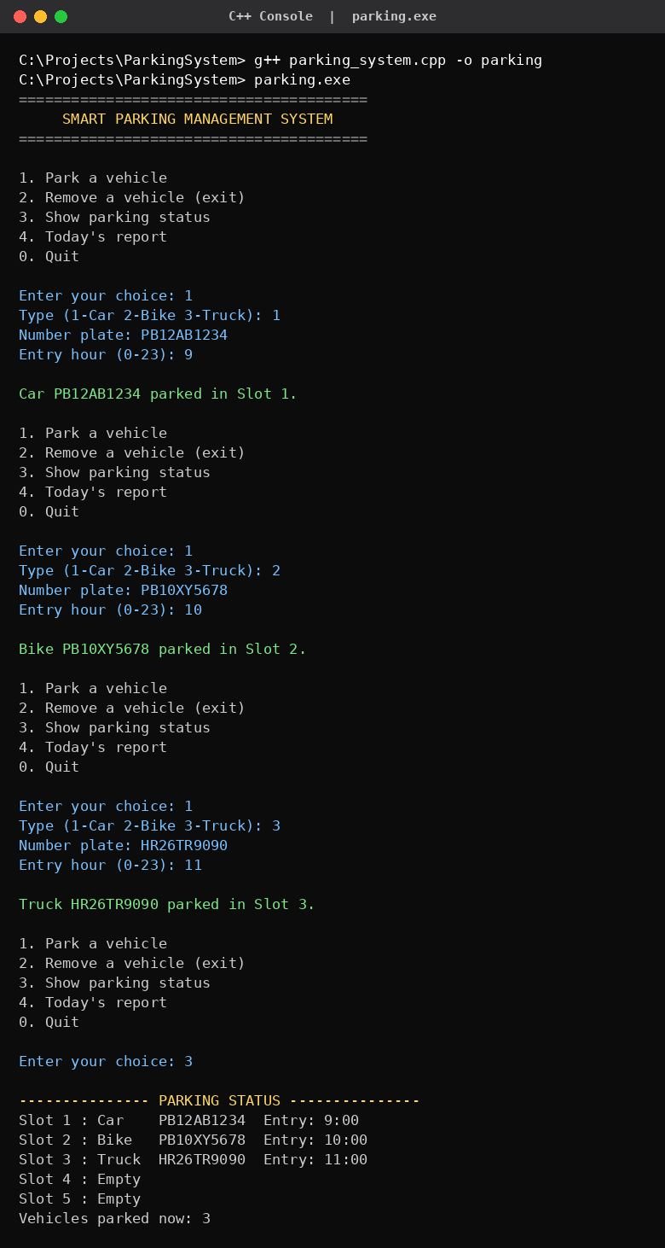
Output 1: Compiling the program and parking a Car, a Bike and a Truck

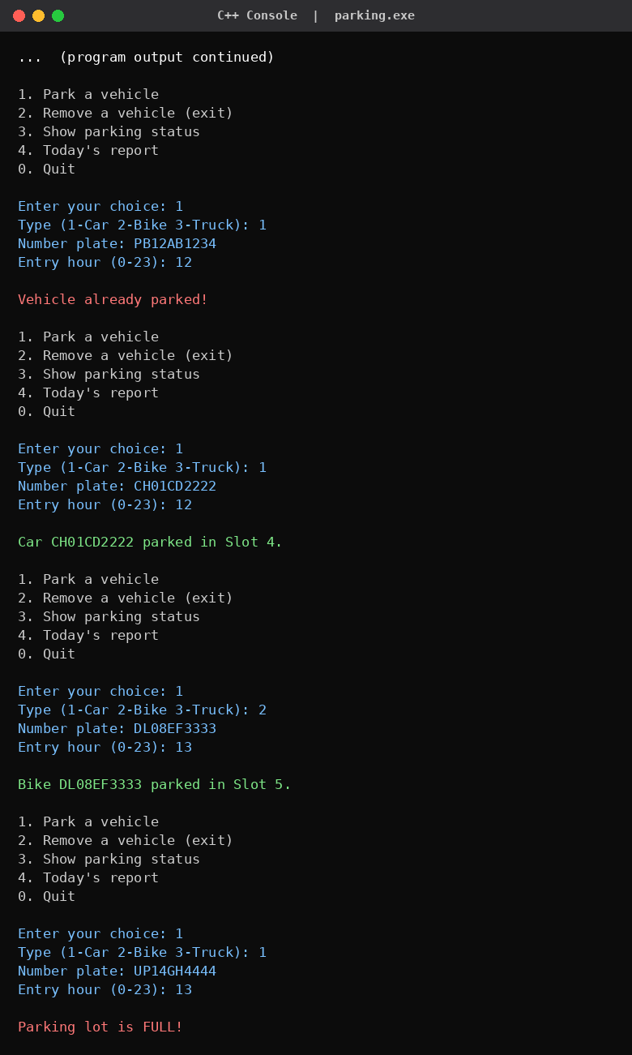
Output 2: Duplicate vehicle check, filling the lot and the “FULL” message

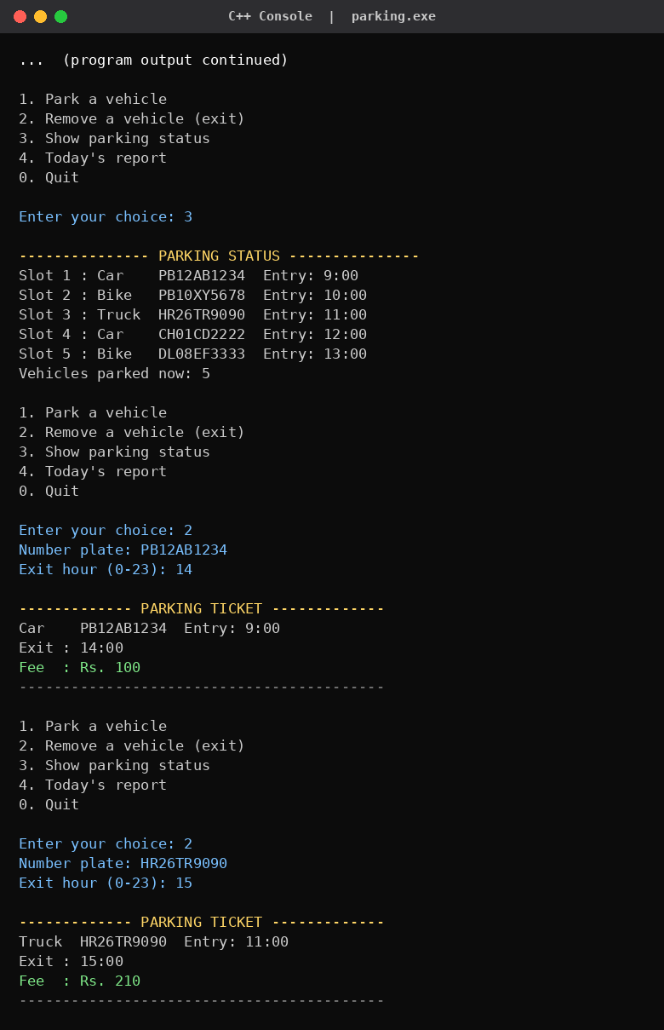
Output 3: Removing vehicles – parking tickets with fees (polymorphism)

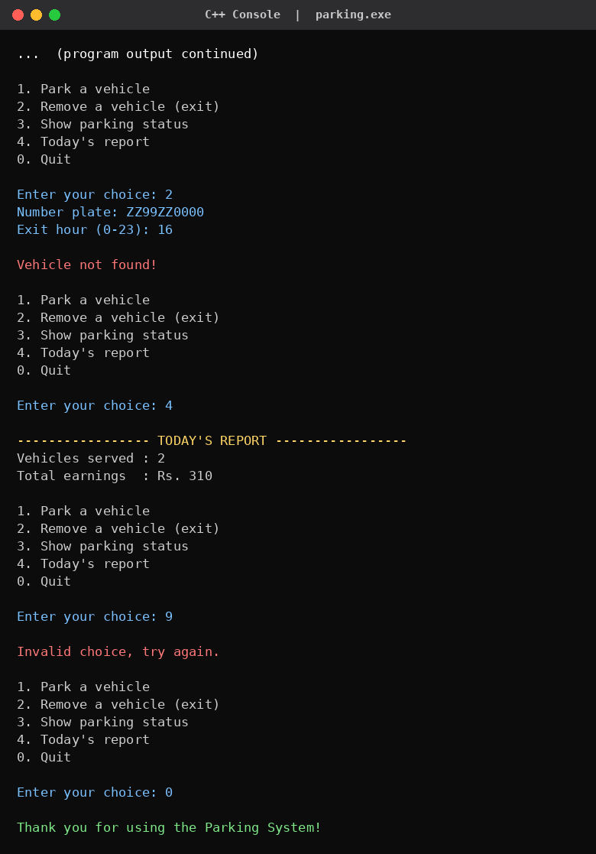
Output 4: Daily report, invalid choice and quitting the program

4.4 Test Cases
No. | Test performed | Expected result | Result
1 | Park a Car, a Bike and a Truck | Vehicles placed in slots 1, 2 and 3 | Pass
2 | Park the same plate twice | “Vehicle already parked!” | Pass
3 | Park a vehicle when all 5 slots are full | “Parking lot is FULL!” | Pass
4 | Remove a Car after 5 hours | Fee = 5 × 20 = Rs. 100 | Pass
5 | Remove a Truck after 4 hours | Fee = 4 × 40 + 50 = Rs. 210 | Pass
6 | Remove a plate that is not parked | “Vehicle not found!” | Pass
7 | Enter a menu choice such as 9 | “Invalid choice, try again.” | Pass
8 | Show the report after two exits | Served = 2, earnings = Rs. 310 | Pass

4.5 Fee Calculation Check
Vehicle | Parked time | Calculation | Fee
Car PB12AB1234 | 9:00 to 14:00 (5 hrs) | 5 × 20 | Rs. 100
Truck HR26TR9090 | 11:00 to 15:00 (4 hrs) | 4 × 40 + 50 | Rs. 210
Total earnings |  | 100 + 210 | Rs. 310

5. CONCLUSION
The Smart Parking Management System was successfully designed and implemented in C++ using Object-Oriented Programming. The program parks and removes vehicles, prevents duplicate and overflow entries, calculates the fee correctly for each vehicle type and reports the day's earnings, as shown in the outputs.
Through this project I understood how real-world entities can be converted into classes and objects, how inheritance avoids repeating code, and how virtual functions allow the same call to behave differently for a Car, a Bike and a Truck. I also learned to manage dynamic memory safely using constructors and destructors.

Advantages of the System
- Easy to extend – a new vehicle type needs only one new derived class.
- The code is organised and readable because each class has a single clear responsibility.
- Protected data and checks on input make wrong operations difficult.
- The fee is calculated automatically, which avoids human calculation mistakes.

Limitations
- Records are kept only in memory and are lost when the program ends.
- Only whole hours are used, and the interface is text-based.

Future Scope
- Save and load parking records from a file so data is not lost when the program closes.
- Add more vehicle types (for example bus or electric car) simply by deriving new classes.
- Add a graphical user interface or a booking feature using a database.
- Calculate the fee using actual date and time instead of manually entered hours.

6. REFERENCES
- Bjarne Stroustrup, The C++ Programming Language, Addison-Wesley.
- E. Balagurusamy, Object-Oriented Programming with C++, McGraw-Hill Education.
- Robert Lafore, Object-Oriented Programming in C++, Sams Publishing.
- cppreference.com – C++ language and standard library reference: https://en.cppreference.com
- GeeksforGeeks – C++ OOP concepts: https://www.geeksforgeeks.org/cpp-oops-concepts/

7. GITHUB UPLOAD
As instructed, the project is uploaded to GitHub. The repository contains the following files:
- parking_system.cpp – the complete source code
- README.md – description of the project and instructions to compile and run it
GitHub repository link: https://github.com/TrakinMining/Parking_Management_System.git

Commands used
git init
git add parking_system.cpp README.md
git commit -m "Smart Parking Management System - C++ OOP mini project"
git branch -M main
git remote add origin https://github.com/TrakinMining/Parking_Management_System.git
git push -u origin main

