
INTERNET SEARCH ASSISTANT
Python Mini Project

A MINI PROJECT REPORT
Submitted by:
Arun Saini
UID: 25BCD10196

Submitted to:
Dr. Komal Mishra
Designation: Assistant Professor

in partial fulfillment of the Python Programming course

Chandigarh University
Date of Submission: 31 October 2026

TABLE OF CONTENTS
Section | Page
1. Introduction | 3
2. Objectives / Problem Statement | 3
3. Modules, Tools and Technologies Used | 4
4. Code with Output | 5
5. Conclusion | 11
6. GitHub Upload | 12

1. INTRODUCTION
The internet holds an enormous amount of information, and searching it quickly is one of the most common things a computer user does. Normally we open a browser, type a query and scroll through pages of results. Python makes it possible to automate this process: with just a few lines of code a program can send a request to a web service, receive the data and present only the useful part to the user.
This mini project, Internet Search Assistant, is a menu-driven command-line application written in Python. It searches the internet through two free public services – the Wikipedia API and the DuckDuckGo Instant Answer API – and displays clean, readable results directly in the terminal. The user can also open a Google search in the browser, and every search is saved in a history file so that earlier queries can be reviewed later.
The project demonstrates practical use of Python concepts such as functions, loops, file handling, JSON, exception handling and working with web APIs, which makes it a useful learning exercise as well as a handy tool.

2. OBJECTIVES / PROBLEM STATEMENT

2.1 Problem Statement
Searching for a simple fact normally requires opening a browser, loading a full web page full of advertisements and navigating between links. The problem is to build a lightweight program that can fetch and display search results from the internet inside the terminal, without any API key or paid service, while keeping a record of what was searched.

2.2 Objectives
- To learn how Python programs communicate with the internet using HTTP requests.
- To search Wikipedia and display the top results along with a summary of the selected article.
- To fetch quick answers for a question using the DuckDuckGo Instant Answer API.
- To open a Google search in the default web browser from within the program.
- To store and display search history using file handling and JSON.
- To handle network errors and invalid input without the program crashing.
- To design a simple, menu-driven interface that any user can operate easily.

3. MODULES, TOOLS AND TECHNOLOGIES USED

3.1 Python Modules
Module | Type | Purpose in the project
requests | Third-party | Sends HTTP GET requests to the Wikipedia and DuckDuckGo APIs
json | Built-in | Reads and writes the search history file; parses API responses
os | Built-in | Checks whether the history file exists and deletes it
textwrap | Built-in | Wraps long summaries to fit neatly in the terminal
webbrowser | Built-in | Opens links and Google searches in the default browser
datetime | Built-in | Records the date and time of every search
urllib.parse | Built-in | Encodes search text safely for use inside a URL

3.2 Tools and Technologies
Tool / Technology | Details
Programming language | Python 3.8 or later
Editor / compiler | VS Code / IDLE with the Python interpreter (terminal output)
Web services (APIs) | Wikipedia MediaWiki API and REST summary API; DuckDuckGo Instant Answer API
Data format | JSON (API responses and history storage)
Protocol | HTTP / HTTPS
Version control | Git and GitHub

4. CODE WITH OUTPUT

4.1 Source Code – search_assistant.py
The complete program is shown below in four parts: imports and constants, history handling, searching functions, and the main menu loop.
Part 1 – Imports, constants and menu
"""
Internet Search Assistant - Python Mini Project
Submitted by : Keshav Saini (UID: 25BCD10101)
Submitted to : Mrs. Preeti, Assistant Professor

A command-line tool that searches the internet using free public APIs
(Wikipedia + DuckDuckGo), shows readable results in the terminal,
opens links in the browser and keeps a search history in a JSON file.
"""

import json
import os
import textwrap
import webbrowser
from datetime import datetime
from urllib.parse import quote_plus

import requests

HISTORY_FILE = "search_history.json"
HEADERS = {"User-Agent": "InternetSearchAssistant/1.0 (student mini project)"}
WIKI_API = "https://en.wikipedia.org/w/api.php"
WIKI_SUMMARY = "https://en.wikipedia.org/api/rest_v1/page/summary/"
DDG_API = "https://api.duckduckgo.com/"

def banner():
print("=" * 56)
print(" INTERNET SEARCH ASSISTANT (Python)")
print("=" * 56)

def menu():
print("\n1. Search Wikipedia")
print("2. Quick answer (DuckDuckGo)")
print("3. Open a Google search in browser")
print("4. View search history")
print("5. Clear search history")
print("0. Exit")
return input("\nEnter your choice: ").strip()

Part 2 – Search history (file handling)
# ---------------------------------------------------------------- history
def load_history():
if os.path.exists(HISTORY_FILE):
with open(HISTORY_FILE, "r", encoding="utf-8") as f:
return json.load(f)
return []

def save_history(query, source):
history = load_history()
history.append({
"query": query,
"source": source,
"time": datetime.now().strftime("%d-%m-%Y %H:%M:%S"),
})
with open(HISTORY_FILE, "w", encoding="utf-8") as f:
json.dump(history, f, indent=2)

def show_history():
history = load_history()
if not history:
print("\nNo searches yet.")
return
print(f"\n{'No.':<5}{'Time':<22}{'Source':<12}Query")
print("-" * 56)
for i, item in enumerate(history, 1):
print(f"{i:<5}{item['time']:<22}{item['source']:<12}{item['query']}")

def clear_history():
if os.path.exists(HISTORY_FILE):
os.remove(HISTORY_FILE)
print("\nHistory cleared.")

Part 3 – Searching the internet
# ------------------------------------------------------------- searching
def wiki_search(query):
params = {"action": "query", "list": "search", "srsearch": query,
"srlimit": 5, "format": "json"}
try:
r = requests.get(WIKI_API, params=params, headers=HEADERS, timeout=10)
r.raise_for_status()
except requests.RequestException as err:
print(f"\nNetwork error: {err}")
return
results = r.json()["query"]["search"]
if not results:
print("\nNo results found.")
return
save_history(query, "Wikipedia")
print(f"\nTop {len(results)} results for '{query}':\n")
for i, item in enumerate(results, 1):
print(f" {i}. {item['title']}")
pick = input("\nEnter result number to read summary (Enter to skip): ")
if pick.isdigit() and 1 <= int(pick) <= len(results):
wiki_summary(results[int(pick) - 1]["title"])

def wiki_summary(title):
url = WIKI_SUMMARY + quote_plus(title.replace(" ", "_"))
try:
r = requests.get(url, headers=HEADERS, timeout=10)
r.raise_for_status()
except requests.RequestException as err:
print(f"\nNetwork error: {err}")
return
data = r.json()
print("\n" + "-" * 56)
print(data["title"].upper())
print("-" * 56)
print(textwrap.fill(data["extract"], width=56))
link = data["content_urls"]["desktop"]["page"]
print(f"\nRead more: {link}")
if input("Open in browser? (y/n): ").lower() == "y":
webbrowser.open(link)

def quick_answer(query):
params = {"q": query, "format": "json", "no_html": 1, "skip_disambig": 1}
try:
r = requests.get(DDG_API, params=params, headers=HEADERS, timeout=10)
r.raise_for_status()
data = r.json()
except (requests.RequestException, ValueError) as err:
print(f"\nNetwork error: {err}")
return
save_history(query, "DuckDuckGo")
answer = data.get("AbstractText") or data.get("Answer")
if answer:
print("\n" + textwrap.fill(answer, width=56))
print(f"\nSource: {data.get('AbstractSource', 'DuckDuckGo')}")
print(f"Link : {data.get('AbstractURL', '-')}")
else:
print("\nNo instant answer found. Try option 1 or 3.")

def google_search(query):
save_history(query, "Google")
webbrowser.open("https://www.google.com/search?q=" + quote_plus(query))
print("\nOpening Google in your browser...")

Part 4 – Main program
# ------------------------------------------------------------------ main
def main():
banner()
while True:
choice = menu()
if choice == "1":
wiki_search(input("Enter search topic: ").strip())
elif choice == "2":
quick_answer(input("Enter your question: ").strip())
elif choice == "3":
google_search(input("Enter search text: ").strip())
elif choice == "4":
show_history()
elif choice == "5":
clear_history()
elif choice == "0":
print("\nThank you for using Internet Search Assistant!")
break
else:
print("\nInvalid choice, please try again.")

if __name__ == "__main__":
main()

4.2 Output
The screenshots below show the program running in the terminal.
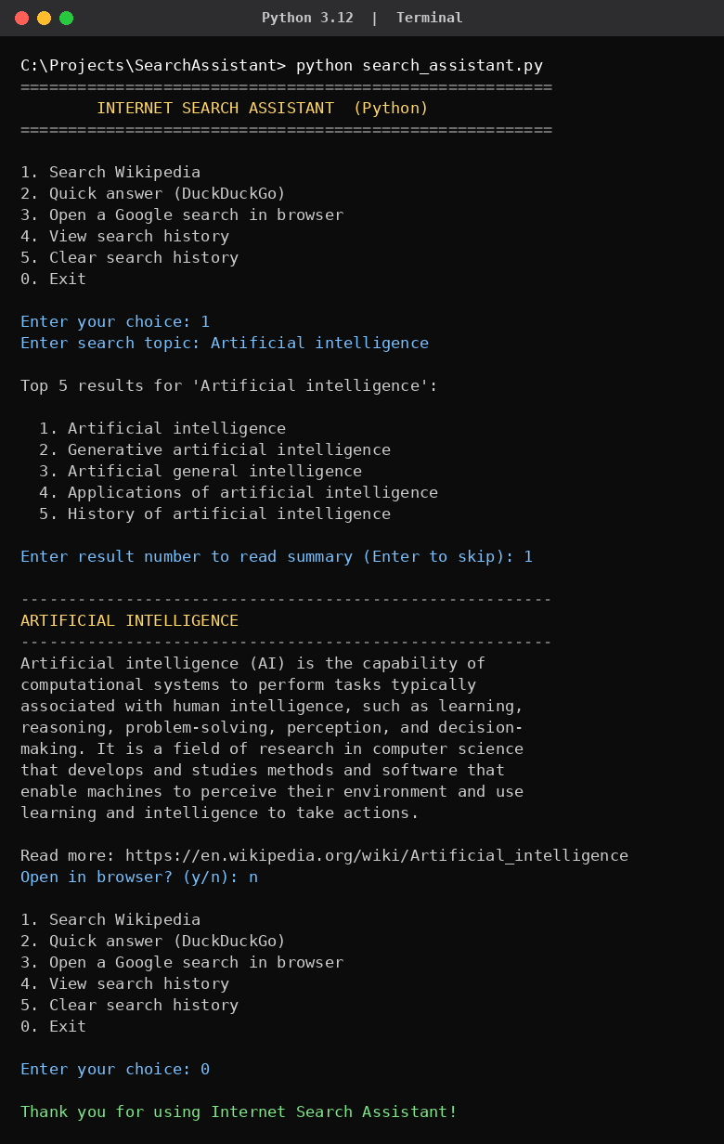
Output 1: Searching Wikipedia for “Artificial intelligence” and reading the summary

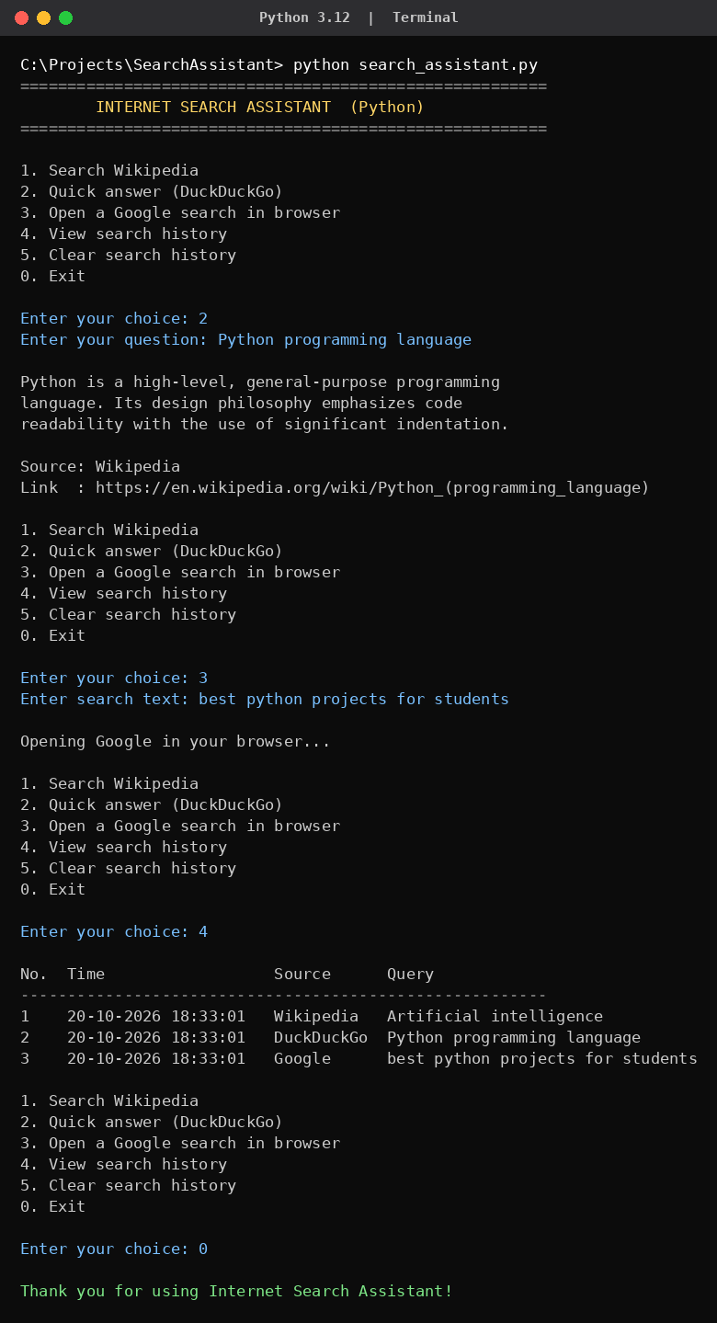
Output 2: Quick answer from DuckDuckGo and a Google search from the program

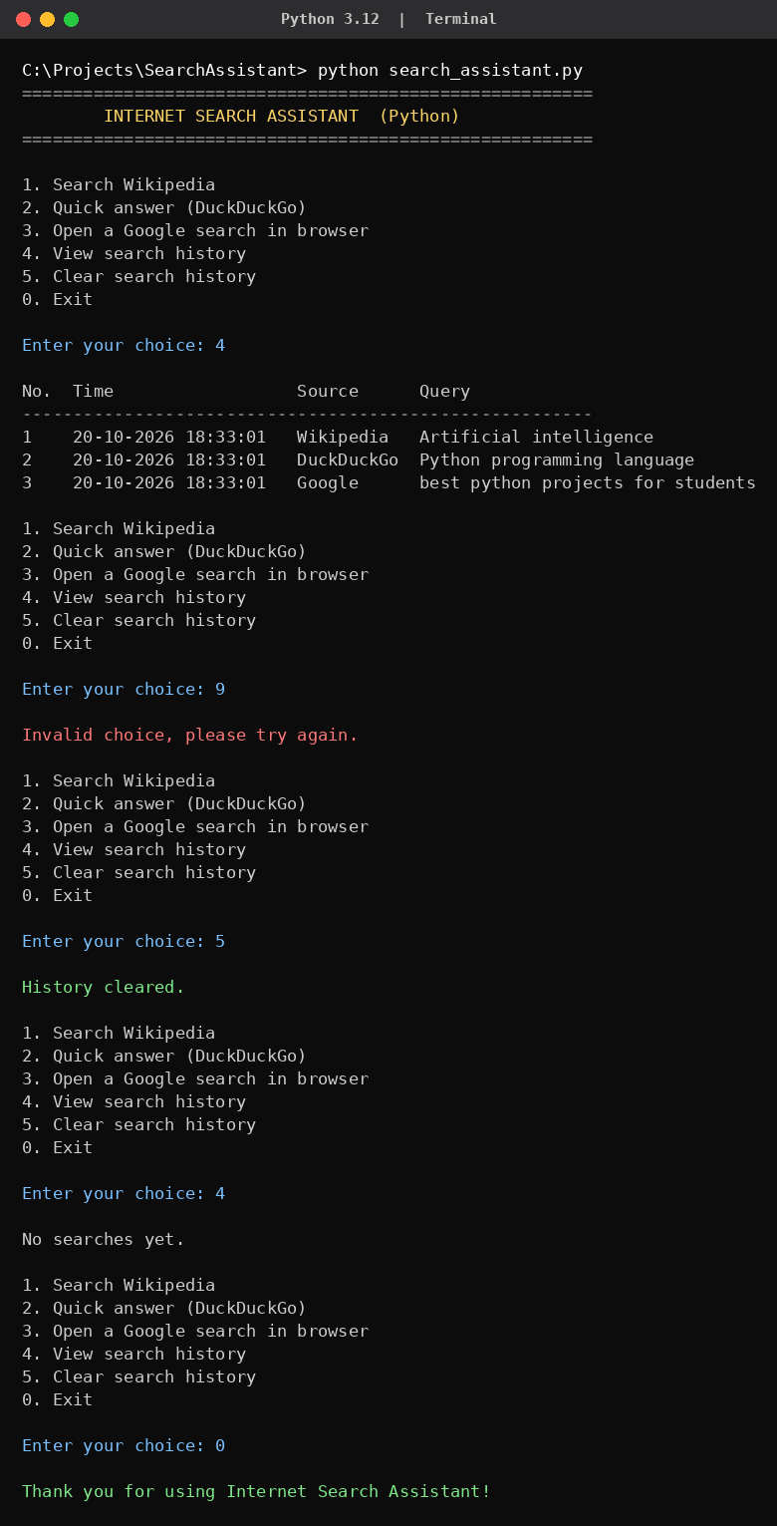
Output 3: Viewing history, handling an invalid choice and clearing history

5. CONCLUSION
The Internet Search Assistant successfully shows how Python can be used to search the internet and present results in a clean, simple form. The program fetches data from the Wikipedia and DuckDuckGo APIs, displays summaries in the terminal, opens Google searches in the browser, and maintains a persistent search history using a JSON file.
While building this project I learned how to send HTTP requests with the requests library, parse JSON responses, structure a program into small reusable functions, handle exceptions for network failures and work with files. The project also gave me a practical understanding of how real applications consume web APIs.

Future Scope
- Add a graphical interface using Tkinter or a web interface using Flask.
- Add news, weather and image search through additional APIs.
- Allow saving selected results to a text or PDF file.
- Add voice input using the speech_recognition module.

6. GITHUB UPLOAD
As instructed, the project has been uploaded to GitHub. The repository contains the following files:
- search_assistant.py – the main program
- requirements.txt – list of dependencies (requests)
- README.md – description and instructions for running the project

GitHub repository link: https://github.com/TrakinMining/internet-search-assistant.git

Commands used
git init
git add search_assistant.py requirements.txt README.md
git commit -m "Internet Search Assistant - Python mini project"
git branch -M main
git remote add origin https://github.com/TrakinMining/internet-search-assistant.git
git push -u origin main

