Technical Report
This report demonstrates, in a short document, the running header and footer, the explicit page break, the table style, the inline formatting and the quote and code blocks.

Scope
The example uses its own template in this folder, which replaces the shared template of the parent folder. Without a letterhead, both margins are free for the running content, and level one opens each section on a new page.

Inline formatting
The text accepts emphasis, bold, strikethrough and inline code, as well as links and footnotes.

Lists
- A simple item;
- An item with bold and code;
  - A subitem with a second-level marker;
    - A sub-subitem with a third-level marker;
- An item with an example site.
- First step;
  - An inner step with alphabetic numbering;
  - Another inner step;
- Second step;
- Third step.
[x] Completed task;
[ ] Pending task.
The table below uses the border, the header fill and the color defined in the template.
Stage | Deadline | Owner
Survey | 5 days | Analysis
Execution | 10 days | Production
Review | 3 days | Quality
The header shows the author, the title and the page numbers; the footer repeats the notice and the program name.

Quote and alert
A block quote, with code and emphasis, to show the vertical bar and the background declared in the template.
An alert uses the same quote syntax, with a type in brackets:
[!NOTE]
An alert is a quote with a type, and keeps the label in brackets.

Code
The block below uses the monospaced face, the background and the rules declared in the template.
fn main() {
println!("hello");
}
A rule closes this section.

Image
The image below uses the width, the alignment, the border and the background defined in the template.
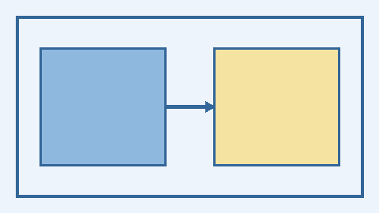

Results
The engine computes pagination and numbering from the whole document, so the total in the header matches the final number.
The same model drives the six formats: Typst for PDF, internal writers for ODT and DOCX, a semantic view for HTML and EPUB, and a plain-text view for TXT. A single template keeps the face, the colors, the spacing and the blocks consistent.
The table below summarizes what each format preserves from the template.
Format | Layout | Colors | Blocks
PDF | own pagination | yes | yes
ODT/DOCX | Writer and Word pagination | yes | yes
HTML/EPUB | semantic and reflowable | yes | yes
TXT | no layout | no | text
This paragraph forces an explicit page break before the annex.

Annex
The annex starts on a new page because of the paragraph that contains only the page-break marker, written as -pagebreak- or with the -!- shortcut. Any other occurrence, such as -!- in this sentence, remains ordinary text.

Appendix
This appendix starts on a new page because of page_break_before on level one of the template, without any marker in the text. The break is weak, so it does not create an empty page when the heading is already at the top.

The footnote is collected at the end of the document.

