Let it Go – Part 3

New Words

**distance** – length; space between things

The ___________ from here to Beijing is about 11,000 km.

**control** – determine behavior; regulate

You can’t tell me what to do, you don’t __________ me.

Beijing _______________ all of China.

**test the limits** – find the maximum and minimum values

How fast can the car go? I don’t know, let’s ____________.

I can barely see the bacteria, it is ____________ of the microscope.

**break through** – force through something; achieve something

We must ____________ this ice to get to the other side.

She is really trying to ______________ and win the medal.

**rules** – laws; something you must follow

You know the __________! No running in the classroom!

Don’t run, be quiet, no eating… There are too many rules!

**one with** – in agreement; relaxed; peaceful

I am _______________________ nature.

The two parties are at ________________ each other on this.

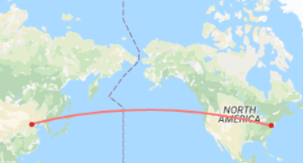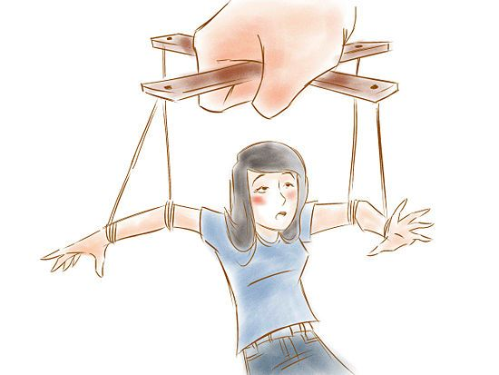

distance: 11,000 km

Someone is controlling me.

It's funny how some **distance**

makes everything seem small  
And the fears that once **controlled** me

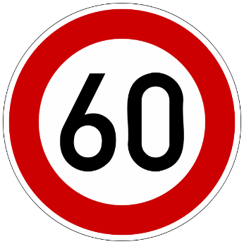can't get to me at all

breaking through a wall

speed limit: 60 kilometers per hour

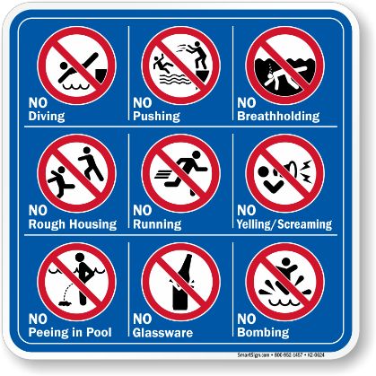

It's time to see what I can do  
To **test the limits** and **break through**  
No right, no wrong, no **rules** for me  
I'm free

rules

Let it go, let it go  
I am **one with** the wind and sky  
Let it go, let it go  
You'll never see me cry  
Here I stand and here I stay  
Let the storm rage on

She is at one with herself.