Tram Nguyen

CIS 450

Lab 9

1. First of all open terminal and then type **setoolkit** and hit enter.

1. From the menu enter 1 to choose Social-Engineering Attacks
2. from below menu select "Website Attack Vectors" i,e press 2 and hit enter

1. from menu below select "Credential Harvester Attack Method" i,e press 3 and hit enter

1. Option 1: from menu below select "Web Templates" i,e press 1 and hit enter

Enter the IP address

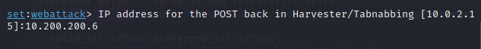

Choose Google or enter 2

And then copy the IP address to browser and it should show the gmail login page

Enter the gmail address and password

In terminal, it got the mail address and password

Option 2: from menu below select “Site Clones” or press 2 and hit enter

Enter IP address and target url: www.gmail.com

Same as the option 1: copy IP address to browser and it will show the gmail login, enter the email address and password

The running terminal records my address and password

