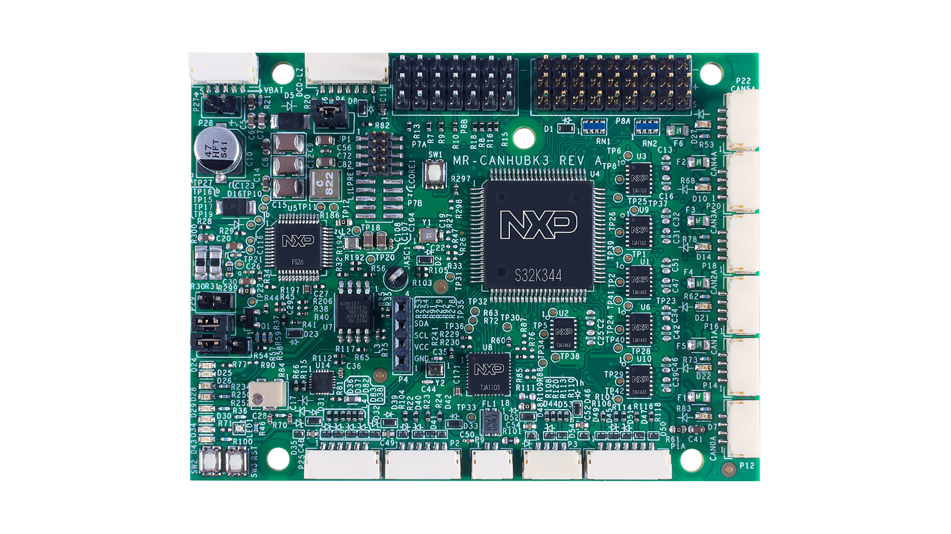
Document information
Info | Content
Keywords | MR-CANHUBK3, S32K344, FS26, SE050, TJA1103, TJA1443, TJA1463, TJA1153
Abstract | Release notes describing package contents, instructions, open issues, fixes and limitations.

Revision history
Rev | Date | Description
0.1 | 20220208 | Release notes for MR-CANHUBK3

Introduction
This document is the release notes for the MR-CANHUBK3 demonstration software. This which converts Ethernet to CAN and CAN to Ethernet using the IEEE 1722 ACF-CAN protocol.
The release notes describe the contents of the kit, open issues, changes, fixes and limitations of the released version.
This release of the switch code supports all 6 CAN ports and 100BASE-T1 Ethernet port. The 100BASE-T1 port have automatic mode detection enabled so no further adjustments are needed.

Abbreviations
IEEE 1722 Layer 2 transport protocol working group for time-sensitive streams
100BASE-T1 Full-duplex single twisted pair ethernet
CAN Controller Area Network
JTAG Joint Test Action Group, interface commonly used for software debugging
KB 1024 bytes
MAC Media Access Control, a MAC address is a so called physical address.
Mbps Million bits per second (10⁶ bits/s)
NFC Near Field Communication
PCB Printed Circuit Board
SDK Software Development Kit

Contents
The released package consists of:
- Hardware
  - MR-T1ETH8 board
  - TODO IAIN
- Documentation and software
  - Release notes
  - Project.zip S32 Design Studio project file

Changes
- Changes
Item | Description
Release package | MR-CANHUBK3 IEEE1772 ACF-CAN over ethernet demo
Documentation

Limitations
Table 1 Limitations
Item | Description
Software stack | Limitation: TODO.  Impact: No Time Sensitive Networking or other features.

Known issues
Table 2 Known issues
Item | Description
Hardware bugs PCB version1 | Limitation: The industrial ethernet connector is wired incorrectly.  Impact: A re-wired connection is needed to use this interface.

Board connections
The MR-CANHUBK3 board has a large number of connectors. The application space is intended to be mobile robotics, which defined the used connectors. To support the battery power a large input voltage range is supported (up to 40V).

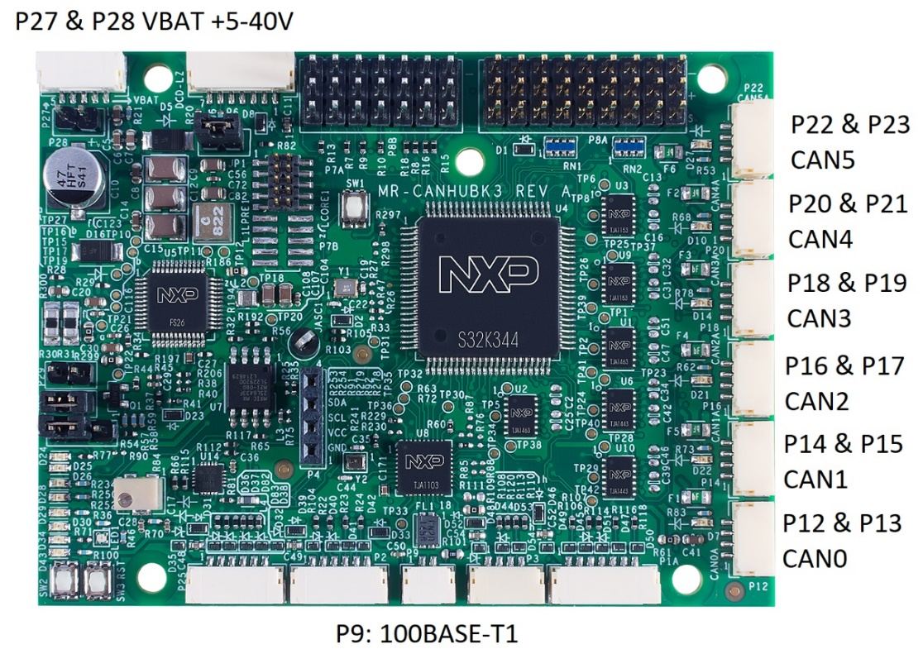
Figure 1 Connector locations MR-CANHUBK3 for the demo software
The power is to be supplied at the 5 pin P27 (Pin 1-2 power, Pin 3 NC, Pin 4-5 ground) connector at the top left corner of the board (see Figure 1). The board draws about XXXmA @ 12V.

P12-P23 are CAN connectors with following pinout.
pin # | signal | specification
1 | 5V4 | 5.4V
2 | CANx_H | 5.0V
3 | CANx_L | 5.0V
4 | GND | 0V

A CAN Bus requires termination which can be done by connection the included CAN-therm board.
The T1 connector (P9) is an automotive ethernet connectors for 2 wire 100Mbps ethernet. So the basic ethernet traffic to/from the board is 100Mbps.
The Amber LED (D88) at the backside of the PCB indicates the link status, when it’s flashing it means there’s a link.

Main components
The compact board holds some key components which are briefly described in this section. More documentation on these components can be found on-line.

S32K344
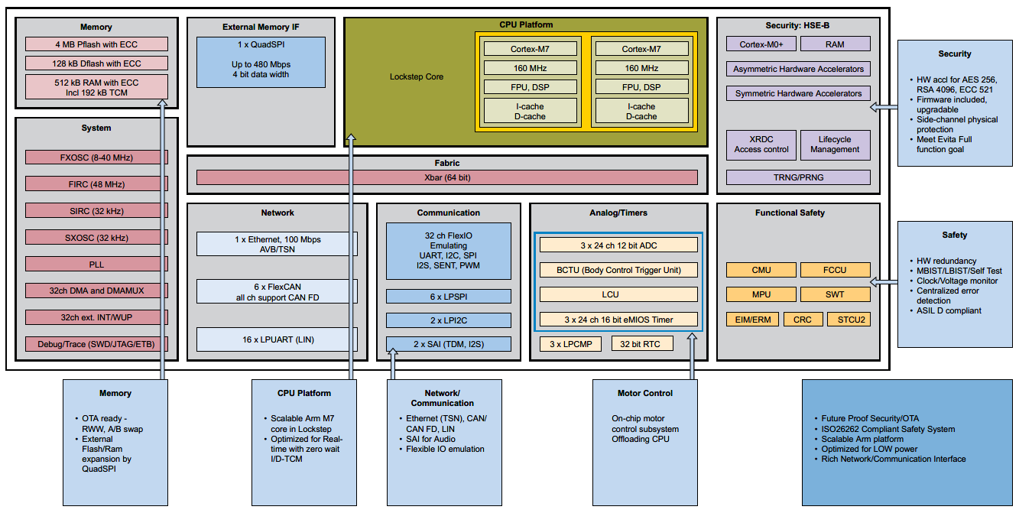
The S32K344 is an Automotive General Purpose MCU of NXP Semiconductors. Figure 2 gives the block diagram of this chip. The software discussed in this document is running on the Lockstep Arm Cortex M7 embedded in this chip.
Figure 2 S32K344 Block diagram

FS26
The FS26 is the ‘Safety System Basis Chip with Low Power Fit for ASIL D’ of NXP Semiconductors. Figure 3 gives the block diagram of this power supply chip. Although capable of much more, in this design it allows for a compact power supply design and high input voltage.

The FS26 is connected through SPI to the S32K344 and implements a challenger window watchdog. Sending challenges to the through SPI S32K344 as the window watchdog when the response is invalid or not during the timing window the FS26 will reset the S32K344 MCU. In this included sample code the challenge watchdog has not been implement. Instead during the initialization of the S32K344 it sends a request to the FS26 to disable the watchdog functionality thus avoiding that the S32K344 will be reset.

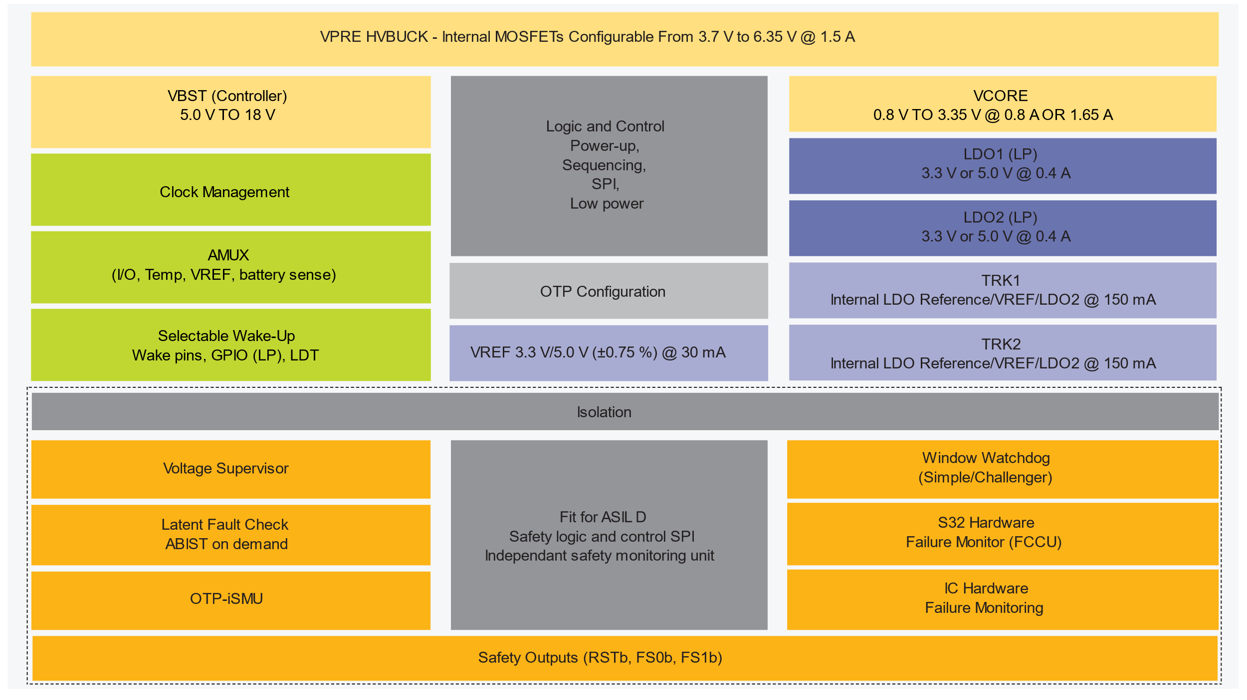
Figure 3 FS26 Block diagram

Board bring up
As described in 6.1.2 the FS26 by default implements a challenger window watchdog that would reset the S32K344 MCU continuously if the challenge will not be handled.
To circumvent this the FS26 has to be put into debug mode. Which is done by removing the JP1 and then supplying exactly 12.0V on P27 or P28 and then insert the JP1 jumper.
Now the reset LED D24 shouldn’t blink anymore and thus the S32K344 will not be reset continuously by the FS26.

S32 Design Example project
The included Project.zip project file is compatible with S32 Design Studio version 3.4
The following extensions are required to build the porject6
- FreeRTOS for S32K3 2.0.0
- S32K3 RTD AUTOSAR 4.4 Version 2.0.0
- S32K3xx development package Version 3.4.3
Figure 4 gives an overview what the S32 Design Studio extension manager should show.

To import the the included Project.zip you’ve to open File -> Import -> General -> Project from Folder or Archive and then select the Project.zip archive.

Once the project has been imported right click on “MR_CANHUBK3_IEEE1722” in the projects explorer and select S32 Configuration Tools -> Open Pins. The S32 Pin tool will appear and in the menu there’s a button “Update Code” and select “OK” now the driver will be generated.
Go back to the Project Explorer right click on “MR_CANHUBK3_IEEE1722” and select “Build Project”. Now you can flash the “MR_CANHUBK3_IEEE1722.elf” using your programmer.

For more information regarding S32 Design Studio, S32 Configuration Tools and debugging please refer to the to the “Getting started with S32K3 & S32DS” guide

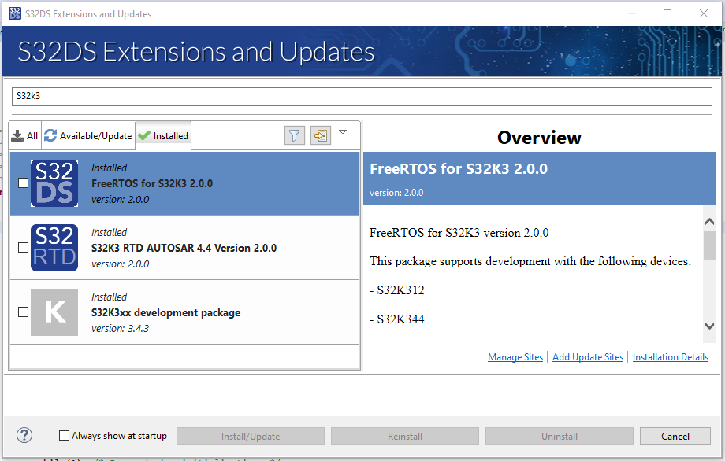
Figure 4 Required S32 Design Studio 3.4 extensions

Application
Once “MR_CANHUBK3_IEEE1722” has been successfully flashed on the MR-CANHUBK3 board, it will act as an ETH <-> CAN IEEE1722 protocol converter.
CAN messages on CAN0..CAN5 will converted to an IEEE1722 ACF-CAN fame and will be broadcasted to the ethernet. To view incoming the CAN frames you can install Wireshark on a Windows / Linux machine.
You can also simulate CAN messages by pressing SW1 or SW2. SW1 will send a CAN message to CAN0 and SW2 will send a CAN message to CAN1.
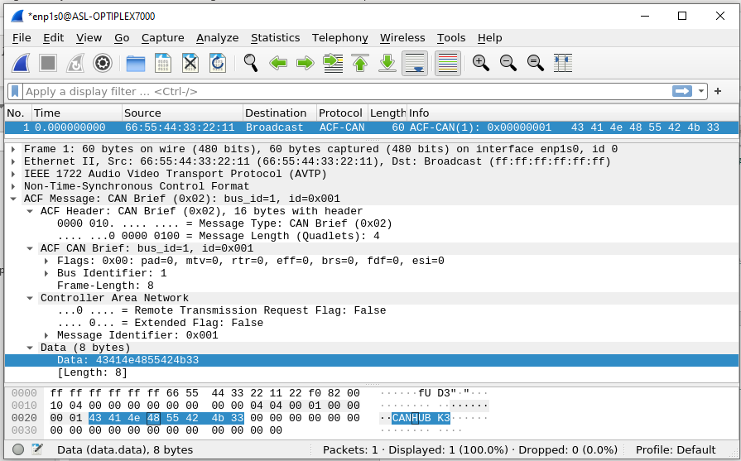
For a setup without CAN peripherals you can connect CAN0 (P12) to CAN1 (P14) to create a bus using included cable and connect the CAN-Therm board to P13 to terminate the bus. When pressing either SW1 or SW2 both LEDs D7 and D22 turn on briefly indicating there’s CAN packet. When connected to a PC running Wireshark it will show there’s a CAN packet send using IEEE1722 as shown in Figure 5.
Figure 5 Wireshark output of an IEEE1722 ACF-CAN Frame

Board status LEDs
The MR-CANHUBK3 has various LEDs to indicate status as shown in Figure 6. Under normal circumstances the state of the LEDs should as indicate in the table below.

LED Name | Normal State | Description
RESET_K3 | Off | Indicates if the S32K344 is in reset
P1V8_TRK2 | On | Indicates FS26 SBC 1V8_TRK2 status
P3V3_TRK1 | On | Indicates FS26 SBC 3V3_TRK1 status
P3V3_LDO2 | On | Indicates FS26 SBC 3V3_LDO2 status
P3V3_LDO1 | On | Indicates FS26 SBC 3V3_LDO1 status
VBATP_SW | On | Indicates VBAT status
V15_MCU | On | Indicates FS26 SBC V15 status
P5V4 | On | Indicates FS26 SBC P5V4 status
RGB Status led | Green | Controlled by the software, green indicates normal operation, blue indicates initialization, red indicates that an error has occurred.
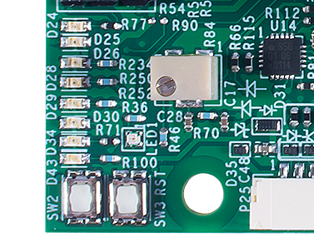
P5V4
V15_MCU
VBATP_SW
P3V3_LDO1
P3V3_LDO2
P3V3_TRK1
RESET_K3
P1V8_TRK2
RGB Status led

Figure 6 Led overview

Legal information

Definitions
Draft — The document is a draft version only. The content is still under internal review and subject to formal approval, which may result in modifications or additions. NXP Semiconductors does not give any representations or warranties as to the accuracy or completeness of information included herein and shall have no liability for the consequences of use of such information.

Disclaimers
Limited warranty and liability — Information in this document is believed to be accurate and reliable. However, NXP Semiconductors does not give any representations or warranties, expressed or implied, as to the accuracy or completeness of such information and shall have no liability for the consequences of use of such information. NXP Semiconductors takes no responsibility for the content in this document if provided by an information source outside of NXP Semiconductors.
In no event shall NXP Semiconductors be liable for any indirect, incidental, punitive, special or consequential damages (including - without limitation - lost profits, lost savings, business interruption, costs related to the removal or replacement of any products or rework charges) whether or not such damages are based on tort (including negligence), warranty, breach of contract or any other legal theory.
Notwithstanding any damages that customer might incur for any reason whatsoever, NXP Semiconductors’ aggregate and cumulative liability towards customer for the products described herein shall be limited in accordance with the Terms and conditions of commercial sale of NXP Semiconductors.
Right to make changes — NXP Semiconductors reserves the right to make changes to information published in this document, including without limitation specifications and product descriptions, at any time and without notice. This document supersedes and replaces all information supplied prior to the publication hereof.
Suitability for use — NXP Semiconductors products are not designed, authorized or warranted to be suitable for use in life support, life-critical or safety-critical systems or equipment, nor in applications where failure or malfunction of an NXP Semiconductors product can reasonably be expected to result in personal injury, death or severe property or environmental damage. NXP Semiconductors and its suppliers accept no liability for inclusion and/or use of NXP Semiconductors products in such equipment or applications and therefore such inclusion and/or use is at the customer’s own risk.
Applications — Applications that are described herein for any of these products are for illustrative purposes only. NXP Semiconductors makes no representation or warranty that such applications will be suitable for the specified use without further testing or modification.
Customers are responsible for the design and operation of their applications and products using NXP Semiconductors products, and NXP Semiconductors accepts no liability for any assistance with applications or customer product design. It is customer’s sole responsibility to determine whether the NXP Semiconductors product is suitable and fit for the customer’s applications and products planned, as well as for the planned application and use of customer’s third party customer(s). Customers should provide appropriate design and operating safeguards to minimize the risks associated with their applications and products.
NXP Semiconductors does not accept any liability related to any default, damage, costs or problem which is based on any weakness or default in the customer’s applications or products, or the application or use by customer’s third party customer(s). Customer is responsible for doing all necessary testing for the customer’s applications and products using NXP Semiconductors products in order to avoid a default of the applications and the products or of the application or use by customer’s third party customer(s). NXP does not accept any liability in this respect.
Export control — This document as well as the item(s) described herein may be subject to export control regulations. Export might require a prior authorization from competent authorities.
Translations — A non-English (translated) version of a document is for reference only. The English version shall prevail in case of any discrepancy between the translated and English versions.
Evaluation products — This product is provided on an “as is” and “with all faults” basis for evaluation purposes only. NXP Semiconductors, its affiliates and their suppliers expressly disclaim all warranties, whether express, implied or statutory, including but not limited to the implied warranties of non-infringement, merchantability and fitness for a particular purpose. The entire risk as to the quality, or arising out of the use or performance, of this product remains with customer.
In no event shall NXP Semiconductors, its affiliates or their suppliers be liable to customer for any special, indirect, consequential, punitive or incidental damages (including without limitation damages for loss of business, business interruption, loss of use, loss of data or information, and the like) arising out the use of or inability to use the product, whether or not based on tort (including negligence), strict liability, breach of contract, breach of warranty or any other theory, even if advised of the possibility of such damages.
Notwithstanding any damages that customer might incur for any reason whatsoever (including without limitation, all damages referenced above and all direct or general damages), the entire liability of NXP Semiconductors, its affiliates and their suppliers and customer’s exclusive remedy for all of the foregoing shall be limited to actual damages incurred by customer based on reasonable reliance up to the greater of the amount actually paid by customer for the product or five dollars (US$5.00). The foregoing limitations, exclusions and disclaimers shall apply to the maximum extent permitted by applicable law, even if any remedy fails of its essential purpose.

Licenses
Purchase of NXP <xxx> components
<License statement text>

Patents
Notice is herewith given that the subject device uses one or more of the following patents and that each of these patents may have corresponding patents in other jurisdictions.
<Patent ID> — owned by <Company name>

Trademarks
Notice: All referenced brands, product names, service names and trademarks are property of their respective owners.
<Name> — is a trademark of NXP Semiconductors N.V.

Contents

1. Introduction 3
1.1 Abbreviations 3
2. Contents 4
3. Changes 5
4. Limitations 6
5. Known issues 7
6. Board connections 8
6.1 Main components 8
6.1.1 SJA1110 8
6.1.2 VR5510 10
6.1.3 SE050 11
7. Firmware 12
7.1 TFTP update 12
7.1.1 Ubuntu Linux example 13
7.2 Settings 13
7.2.1 Loading settings 13
7.2.2 Creating a new settings file 13
7.3 Image file 14
7.3.1 S32DS 14
7.3.1.1 Building compactImage.exe 14
7.4 Upgrading from previous version 14
7.5 NFC support 15
7.6 LED behavior 16
7.6.1 Hardware defined LEDs 16
7.6.2 Software defined LEDs 17
8. Legal information 18
8.1 Definitions 18
8.2 Disclaimers 18
8.3 Licenses 18
8.4 Patents 18
8.5 Trademarks 18
9. Contents 19

