
RIGA TECHNICAL UNIVERSITY
Faculty of Computer Science and Information Technology Institute of Applied Computer Systems

“Data Strcture Indvidual Assignmnet”
TASK OF INDIVIDUAL WORK
"DIP203 - Data Structures”

Asst: Prof, Padmaraj Nidagundi

Student Name:
Student Card No:

2025./2026.
Index

Basic Data Structure 4
1. a) Write a program to display "Hello world!" string to the console. 4
1. b) Write a program to add two number and display results. 4
2. a) Make 5-page short report about different data structures. 5
Non-Primitive ( Linear data structure ) 8
1. a) Write the algorithm for the Queue 8
1. b) Write the algorithm for the Tree 9
1. c) Write a program for show 2 tables only on the screen 9
2. a) Use data structure visualizations to understand data structure concepts and make a 5-page report on any 5 topics 13
2. b) Write a program for "Binary Tree" 17
2. c) Write a program for "Queue" 20
3. a) What is a data structure and why we use data structure? 22
3. b) Explain different types of data structure 22
3. c) What are the different types of nonprimitive data structure, write a simple program for each of them. 23
3. Lab work >> 1) Create a simple tree with 4 nodes in C/Java 34
3. Lab work >> 2) Program for reversing a queue in C/Java 36
4. Write short 5-page short information and example programming to demonstrate implementation about Stacks, Queues 37
5. Write short 5-page short information and example programming to demonstrate implementation about Linked Lists, Type of Linked Lists 42
6. What is an array? How to do Declaring Array Variables. Write a program for array impregnation using a stack concept. 46
Non-Primitive ( Non-Linear data structure ) 48
1. What is Trees? How to implement a Binary search tree 48
2. What are the graphs? explain Directed Graphs with example 51
Overall 52
1. What is the difference between Non-Primitive ( Non-linear data structure ) and Primitive ( Linear data structure ) 52
2. Why we need to learn data structure? 53
3. What are Big-O complexities and why they used in Computer Science( programming)? How to select appropriate data structure in your (problem-solving) programming? 54
4. Bibliography 56

Basic Data Structure

a) Write a program to display "Hello world!" string to the console.

Program :
package helloworld;

public class HelloWorld {

public static void main(String[] args) {
System.out.println("Hello World!");
}
}

Output :
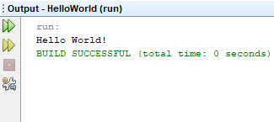

b) Write a program to add two number and display results.

Program:
package addtwonumbers;

import java.util.Scanner;

public class AddTwoNumbers {

public static void main(String[] args) {
int a, b, c;
Scanner in = new Scanner(System.in);

System.out.println("Please enter first number");
a = in.nextInt();
System.out.println("Please enter second number");
b = in.nextInt();
c = a + b;
System.out.println("Sum of numbers : " + c);

}

}
Output :
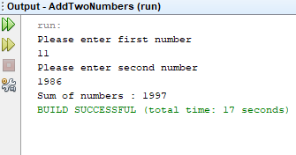

a) Make 5-page short report about different data structures.

Data structure is a way how we store and retrive data for easy search and efficient use. There are different data structures for different problems. There are 2 different types of data structure, primitive data structure and nonprimitive data structure. Primitive data structures are integer, float, char,boolean. We can also separate nonprimitive data structure into two parts, linear data structure and nonlinear data structure. We check whether the data is arranged in chronological order or not. Most common nonprimitive data structures are Array,Stack,Queue, Linked list, Tree, Graph, Trie, Hash Table.

Some common features of data structures are;
- Linear and Nonlinear : As I said before, whether the data is arranged in chronological order or not. For Example in Array we store data as linear but in Tree we store it as nonlinear.
- Static and Dynamic : Static data structures have fixed size, structures and memory locations but dynamic data structures’s size, structure and memory locations can expand or contract.
- Homogeneous and Nonhomogeneous : In homogeneous data structures all elements must to be same type but in nonhomogeneous, elements can be different type.

Now I am going to explain some most common non primitive data structures.

Array : Lenght of arrays can be fixed or flexible, usually contains same type of data. We can read an array element easily with using indexes.
Stack : Data is stored linearly and we process data with LIFO (last in first out) method.
Basic stack operations are :
- push() − Storing an element on the stack.
- pop() − Removing or accessing an element from the stack.
- peek() − Geting the top data element of the stack, without removing it.
- isFull() − Checking if stack is full.
- isEmpty() − Checking if stack is empty.
Queue : Can store data as stack but it uses FIFO (first in first out) method.
Basic queue operations are :
- enqueue() − Storing an element to the queue.
- dequeue() − Removing or accessing an element from the queue.
- peek() − Geting the element at the front of the queue without removing it.
- isfull() − Checking if the queue is full.
- isempty() − Checking if the queue is empty.
Linked List: Data is stored linearly. Nodes are used to store data and establish connection to the next data.
Tree : Data is stored in a hierarchical and nonlinear way. This structure is called a tree because order formed by data looks like a tree.
Graph : It stores the data in nonlinear way, they contain limited number of nodes and lines which connect nodes. For example they are mostly used in systems such as social networks or to find shortest path between cities.
Trie : It is a data structure similar tree data structure, nodes stores usually strings.

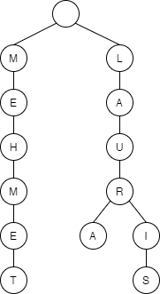
Hash Table :

The hash table is built on a array and data is accessed with the help of a key. The key is unique, it means there is no same key in another record but data can be the same.
For example students in a class.

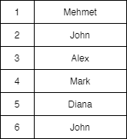

Student numbers (keys) can not be the same but student names (data) can be the same in hash table. Accessing to data is very fast if we know the index of the data.

Non-Primitive ( Linear data structure )

1. a) Write the algorithm for the Queue

I am going to write an algorithm for “BANK ATM” where people waits on line to make transaction.
We can split into 2 parts, first algorithm is for adding costumers to queue and second algorithm is for removing costumer from queue.

ADD COSTUMER TO QUEUE:
Step 1 - Start
Step 2 – Check if the bank ATM is busy.
Step 3 – If bank ATM isn’t busy, let user to use atm and mark as “first” & “last”. Go to step 6.
Step 4 – Add costumer to behind of the last costumer.
Step 5 – Remove “last” marking from last costumer and mark current costumer as “last”.
Step 6 – Stop

REMOVE COSTUMER FROM QUEUE:
Step 1 - Start
Step 2 – Remove “first” marking from the costumer.
Step 3 – Mark the costumer which is behind as “first”.
Step 4 – Remove costumer from queue.
Step 5 – Let first costumer to use ATM.
Step 6 – Stop

1. b) Write the algorithm for the Tree

Tree is a hierarchical, non-linear data structure and nodes are connected via edges. We can give many examples for that, I think best example from real life is family tree.
Here is flowchart of my family algorithm :

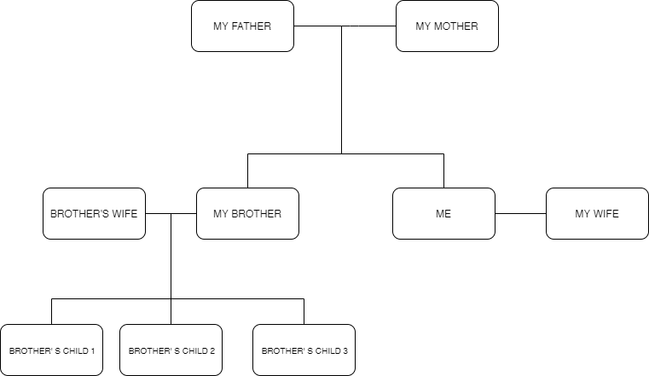

1. c) Write a program for show 2 tables only on the screen

I wrote a program which creates 2 tables 15*15 (it is possible to change it) and first table is for multiplication of numbers and second table is addition of numbers.
Program :
package tables;

public class Tables {

public static void main(String[] args) {
//First Table------------------------------------------
int first = 15;
int second = 15;

System.out.print(" ");

for (int b = 1; b <= first; b++) {
if (b < 10) {
System.out.print(b + " ");
} else {
System.out.print(b + " ");
}
}
System.out.println();
for (int c = 1; c <= 6.3 * first; c++) {
System.out.print("_");
}
System.out.println();

for (int d = 1; d <= second; d++) {
if (d < 10) {
System.out.print(d + " | ");
} else {
System.out.print(d + " | ");
}

for (int e = 1; e <= second; e++) {
if ((d * e) < 10) {
System.out.print((d * e) + " ");
} else if ((d * e) >= 10 && (d * e) < 100) {
System.out.print((d * e) + " ");

} else {
System.out.print((d * e) + " ");
}
}
System.out.println();
}
System.out.print('\n');
//Second Table------------------------------------------
int first2 = 15;
int second2 = 15;

System.out.print(" ");

for (int b = 1; b <= first2; b++) {
if (b < 10) {
System.out.print(b + " ");
} else {
System.out.print(b + " ");
}
}
System.out.println();
for (int c = 1; c <= 6.3 * first2; c++) {
System.out.print("_");
}
System.out.println();

for (int d = 1; d <= second2; d++) {
if (d < 10) {
System.out.print(d + " | ");
} else {
System.out.print(d + " | ");
}

for (int e = 1; e <= second2; e++) {
if ((d + e) < 10) {
System.out.print((d + e) + " ");
} else if ((d + e) >= 10 && (d + e) < 100) {
System.out.print((d + e) + " ");

} else {
System.out.print((d + e) + " ");
}
}
System.out.println();
}}}

Output :
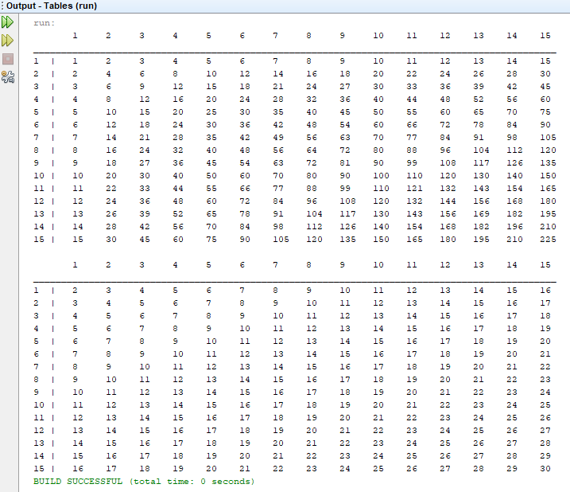

2. a) Use data structure visualizations to understand data structure concepts and make a 5-page report on any 5 topics
I tested all visualizations for data structures and algorithms, I will make a report about Bubble Sort, Heap, Depth-First Search, Bucket Sort and Red-Black Tree

Bubble Sort : Bubble Sort is the easiest one to write between sorting algorithms but it works too slow in big arrays. I will explain shortly how bubble sort algorithm works.
If we arrange the elements of array horizontally. Algorithm starts from beginning of the array and compare the elements one by one.
- First Pass : First element is compared to the second element of the array, if the larger element is on the left side, algorithm changes the place of two elements (swap) and the larger element moves to right side. This process continues until algorithm compares the last element of the array and at the end of this pass, the largest element of the given array is placed to the right side of the array.
- Second Pass : After the largest element located on the right side of the array, algorithm starts to compare rest of array in this pass, similar to the first pass starts from left side of the array and compares the elements one by one and swaps until the largest element moves to the right side.
- N Pass : Algorithm continues to work until a whole pass without any swap occurs.

For Example : Given array is 6 2 5 3 9
First Pass |  | Second Pass |  | Third Pass
6 2 5 3 9 -> | 2 6 5 3 9 | 2 5 3 6 9 -> | 2 5 3 6 9 | 2 3 5 6 9 -> | 2 3 5 6 9
2 6 5 2 9 -> | 2 5 6 3 9 | 2 5 3 6 9 -> | 2 3 5 6 9 | 2 3 5 6 9 -> | 2 3 5 6 9
2 5 6 3 9 -> | 2 5 3 6 9 | 2 3 5 6 9 -> | 2 3 5 6 9 | 2 3 5 6 9 -> | 2 3 5 6 9
2 5 3 6 9 -> | 2 5 3 6 9 | 2 3 5 6 9 -> | 2 3 5 6 9 | 2 3 5 6 9 -> | 2 3 5 6 9

Sorted array is 2 3 5 6 9

Heap : Heap is a binary tree structure, but there are differences from the binary search tree. Heap has two types, maximum and minimum. For minimum the main idea is each node should be less than or equal to the child nodes and opposite for maximum heap type. Heap converts dataset to binary tree, the elements are added to the tree in order without any conditions.Starting from last element of tree sorting and placement operations are repeated until only root element stays in tree.
A sorted minimum heap example :
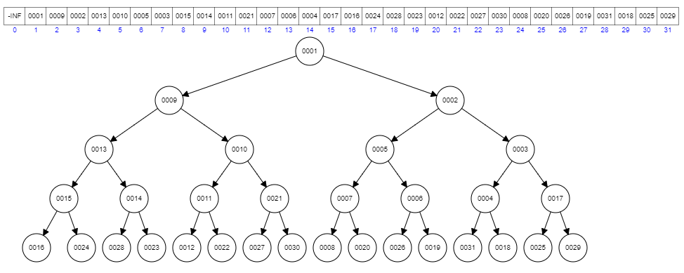

Depth-First Search :
Deptf-First Search (DFS) is a graph algorithm, starts from a root node which we choose and it selects any of its children. After this, algorithm goes to any other child which is not visited before. There are two rules for moving to other node; there should be a direct path to the other node and other node should not have been visited before.
When there is no place to go. In such a case, we return to the last node we visited before this node and see if there are other paths to go. Since the algorithm works recursively, it allows us to go one step up every time we hang. Our algorithm ends when we get to where we started and when we already visit all our possible children.
In this example we started from 0, algorithm visited all nodes because we have direct connection to each other, found roots and children.
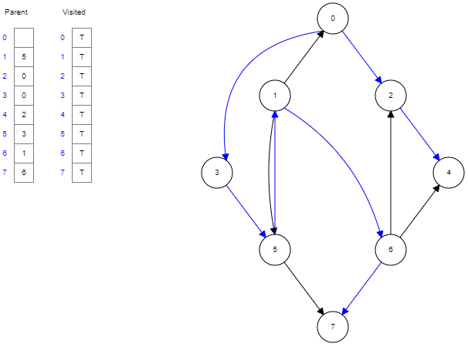
Bucket Sort : Bucket Sort is a sorting algorithm. This algorithm divides the array into limited parts and sorts.

First of all algorithm creates empty buckets, starting from left side, it throws the elements into the buckets one by one. For example, If in our array the biggest number is 100 and smallest number is 1, algorithm creates 10 buckets, throws numbers between 1-10 into first bucket, between 10-20 in second bucket...It sorts individual buckets using insertion sort. After all numbers are thrown into buckets, algorithm sorts all non-empty buckets and reloads all elements which are in non-empty buckets to the array back.
For example :
1st line is array to sort, second line is buckets.
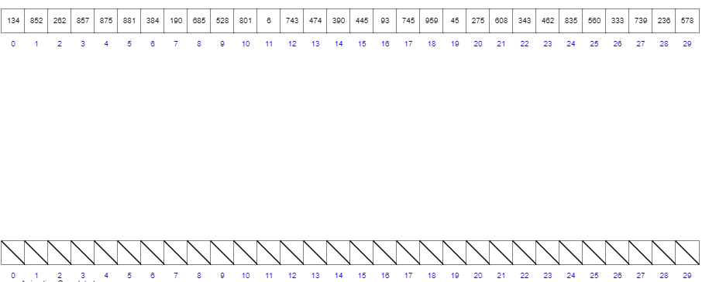

All numbers are thrown into related buckets.
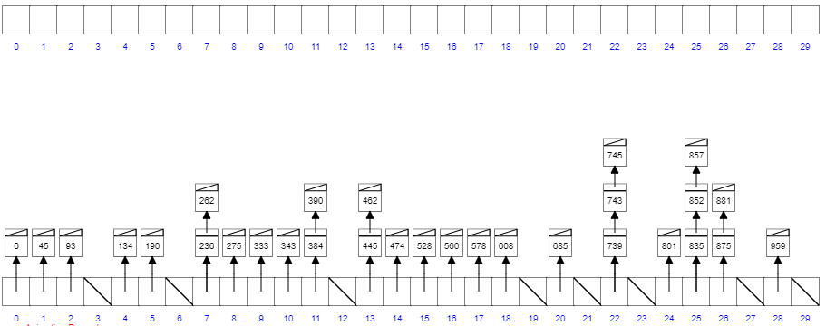

Algorithm reloaded all numbers into array back as sorted.
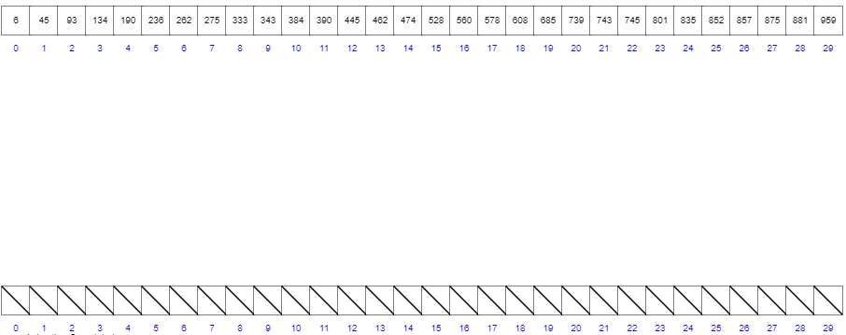

Red-Black Tree : It is used to make a binary search tree balanced. By balancing, it is meant to ensure that the time complexity of the search remains below a certain upper limit when searching for a value in a tree.

Red-black trees are binary search trees, the only difference from binary search trees is that it has a structure that keeps the color of each node. These colors are red or black.

Rules of nodes :

- All nodes are black or red color
- Root node is always black color
- All leaf nodes are bloack color
- Any child of red node is black color
- There are equal number of black nodes on all paths from any node to the leaf node.

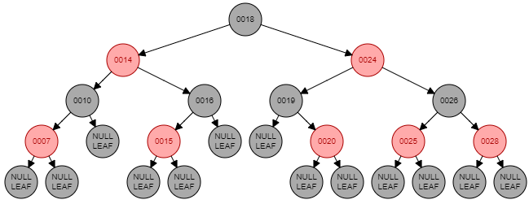

As in this example, the root node is black, the null nodes in the leaf are black, except these nodes, the children of each node are opposite color of parents. For example, the children of 14 are black, and the children of 26 are red. The nodes at the same level are the same color, except null ones.

2. b) Write a program for "Binary Tree"

I wrote a simple program to show binary tree, it can only add node, add value to node and print binary tree from left to right.

Program :
package binarytree;

public class BinaryTree {

class Node {

int data;
Node left;
Node right;

public Node(int data) {

this.data = data;
}
}
private Node Root;

private void addNode(Node node, int data) {
if (data < node.data) {
if (node.left != null) {
addNode(node.left, data);
} else {
node.left = new Node(data);
}
} else if (data > node.data) {
if (node.right != null) {
addNode(node.right, data);
} else {
node.right = new Node(data);
}
}
}

public void insert(int data) {
if (this.Root == null) {
this.Root = new Node(data);
} else {
addNode(this.Root, data);
}
}

private void printBinaryTree(Node node) {
if (node != null) {
printBinaryTree(node.left);
System.out.println(node.data);
printBinaryTree(node.right);
}
}

public void print() {
printBinaryTree(this.Root);
}

public static void main(String[] args) {

BinaryTree tree = new BinaryTree();
tree.insert(15);
tree.insert(25);
tree.insert(5);
tree.insert(3);
tree.insert(77);
tree.insert(11);
tree.insert(23);
tree.insert(1);
tree.insert(8);
tree.insert(33);
tree.print();

}

}

Output :

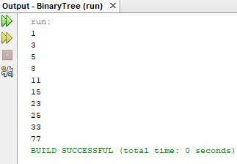

2. c) Write a program for "Queue"

I wrote a program for a simple queue, it is possible to define queue size, add element to queue and get an element form the queue and print it.
Program :
package queue;

public class Queue {

int size;
int[] queue_array;
int first;
int last;
int element_count;

public Queue(int q) {

size = q;
queue_array = new int[size];
first = 0;
last = -1;
element_count = 0;
}

public boolean isEmpty() {
return (element_count == 0);
}

public void add(int elementtoadd) {
if (last == size - 1) {
last = -1;
}
queue_array[++last] = elementtoadd;
element_count++;
System.out.println("Added to queue: " + elementtoadd);

}

public int dequeue() {

int actual = queue_array[first++];
if (first == size) {
first = 0;
}
element_count--;
return actual;
}

public static void main(String[] args) {

Queue M = new Queue(10);
M.add(18);
M.add(12);
M.add(31);
M.add(49);
M.add(50);
M.add(16);
M.add(17);
M.add(68);
M.add(99);
M.add(12);
while (!M.isEmpty()) {
System.out.println(M.dequeue());
}
}

}
Output :
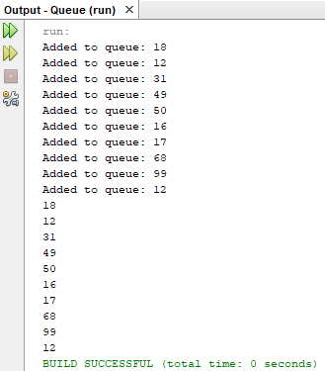

a) What is a data structure and why we use data structure?

Data structure is a way how we store and retrive data for easy search and efficient use. Main aim of computer programming is solving a problem. While we are solving a problem, we should use fastest way and less resource. Popular way of solving a problem is dividing it into parts and we use algorithms for this. While data structures are used to hold data, algorithms solve the problem using this data. Therefore, an algorithm becomes stronger when used with suitable data structures. Data structures and algorithms are problem important for problem solving.. The more information we have in data structures and algorithms, the more problems we can solve. Also, our chances of finding new solutions to new problems will increase, if we know data sturctures well. That is the main reason why we should learn data structures. Data Structures are required to store data in an efficient way and that is the reason why we should use them.

3. b) Explain different types of data structure

As I already explained it in 2nd assignment, there are 2 different types of data structure, primitive data structure and nonprimitive data structure. Primitive data structures are integer, float, char,boolean. We can also separate nonprimitive data structure into two parts, linear data structure and nonlinear data structure. We check whether the data is arranged in chronological order or not. Most common nonprimitive data structures are Array,Stack,Queue, Linked list, Tree, Graph, Trie, Hash Table.

Common features of data structures are;
- Linear and Nonlinear : As I said before, whether the data is arranged in chronological order or not. For Example in Array we store data as linear but in Tree we store it as nonlinear.
- Static and Dynamic : Static data structures have fixed size, structures and memory locations but dynamic data structures’s size, structure and memory locations can expand or contract.
- Homogeneous and Nonhomogeneous : In homogeneous data structures all elements must to be same type but in nonhomogeneous, elements can be different type.

3. c) What are the different types of nonprimitive data structure, write a simple program for each of them.

As I already explain it one by one in 2nd assignment, the most common nonprimitive data structures are Array, Stack, Queue, Linked list, Tree, Graph, Hash Table. I will show each of them in a simple program.
Array
Program :
package array;
import java.util.Arrays;
import java.util.Random;
public class Array {
static int[] RandomnumberArray;

public static void main(String args[]) {
RandomnumberArray = new int[10];
Random rand = new Random();
for (int i = 0; i < 10; i++) {
RandomnumberArray[i] = rand.nextInt(100);
}
System.out.println(Arrays.toString(RandomnumberArray));
}

}
Output :
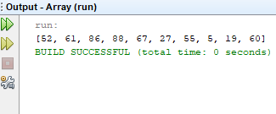

Stack

Program :
package stack;

public class Stack {

private int head;
private int StackSize;
private int[] stackArray;

public Stack(int size) {
StackSize = size;
stackArray = new int[StackSize];
head = -1;
}

public void push(int i) {
stackArray[++head] = i;
}

public int pop() {
return stackArray[head--];
}

public int peek() {
return stackArray[head];
}

public boolean isFull() {
return (head == StackSize - 1);
}

public boolean isEmpty() {
return (head == -1);
}

public static void main(String[] args) {

Stack NewStack = new Stack(10);
NewStack.push(13);
NewStack.push(44);
NewStack.push(8);
NewStack.push(11);
NewStack.push(23);
NewStack.pop();
NewStack.push(1);

System.out.println("Stack Elements: ");

while (!NewStack.isEmpty()) {
int data = NewStack.pop();
System.out.print(data);
System.out.print(" ");
}
System.out.println('\n');

}
}
Output :
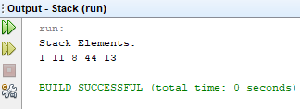

Queue
Program :
package queue2;

import java.util.ArrayList;

public class Queue2 {

public static void main(String[] args) {

ArrayList<String> costumer = new ArrayList<String>();

costumer.add("Hagi");
costumer.add("Messi");
costumer.add("Ronaldo");
costumer.add("Sneijder");
costumer.add("Drogba");

for (String c : costumer) {

System.out.println(c);
}
System.out.println("---- Adding One More Costumer to Queue -----");
costumer.add("Maradona");
for (String c : costumer) {

System.out.println(c);
}
}

}
Output :

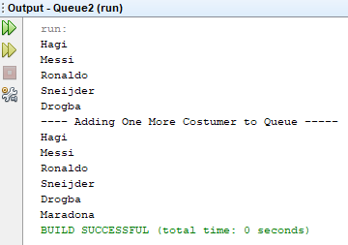

Linked List

Program :
package linkedlist;
import java.util.*;
public class LinkedList {

public static void main(String[] args) {

ArrayList<String> movie = new ArrayList<String>();

movie.add("Godfather");
movie.add("Titanic");
movie.add("Braveheart");
movie.add("Gladiator");

for (String m : movie) {

System.out.println(m);
}
System.out.println("---- Adding Movie at specified position in the list -----");
movie.add(1,"Matrix");
for (String m : movie) {

System.out.println(m);
}

}

}

Output :
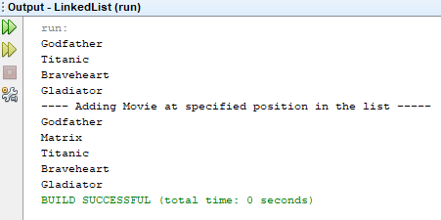

Tree
Program :
package tree;
public class Tree {

private static class Nodes {

String value;
Nodes left;
Nodes right;

Nodes(String value) {
this.value = value;
}

Nodes(String data, Nodes left, Nodes right) {
this.value = data;
this.left = left;
this.right = right;
}

}

public static void printTree(Nodes node) {
if (node == null) {
return;
} else {
System.out.printf("%s ", node.value);
}
printTree(node.left);
printTree(node.right);
}

public static void main(String[] args) {

Nodes c220 = new Nodes("c220");
Nodes mclaren = new Nodes("mclaren");
Nodes x5 = new Nodes("x5");
Nodes x6 = new Nodes("x6");
Nodes mercedes = new Nodes("mercedes", c220, mclaren);
Nodes bmw = new Nodes("bmw", x5, x6);
Nodes root = new Nodes("cars", bmw, mercedes);

System.out.println("---- Printing car brands and models ----");
printTree(root);
System.out.println('\n');

}
}
Output :
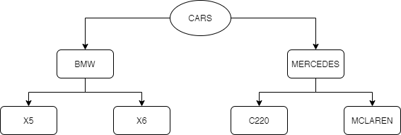

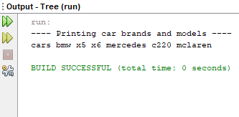

Graph
Program :
package graph;

import java.util.*;

public class Graph {

LinkedList<Integer> graphlist[];
int vertex;

public Graph(int vertex) {
this.vertex = vertex;
graphlist = new LinkedList[vertex];
for (int m = 0; m < vertex; m++) {
graphlist[m] = new LinkedList<>();
}
}

public void addGraphEdge(int from, int to) {

graphlist[from].addFirst(to);

graphlist[to].addFirst(from);
}

public void print() {
for (int i = 0; i < vertex; i++) {
if (graphlist[i].size() > 0) {
System.out.print(i + " is connected with ");
for (int j = 0; j < graphlist[i].size(); j++) {
System.out.print(graphlist[i].get(j) + " ");
}
System.out.println();
}
}
}

public static void main(String[] args) {
Graph NewGraph = new Graph(4);
NewGraph.addGraphEdge(0, 1);
NewGraph.addGraphEdge(0, 3);
NewGraph.addGraphEdge(1, 2);
NewGraph.addGraphEdge(1, 3);
NewGraph.addGraphEdge(2, 3);
NewGraph.print();

}

}

Output:

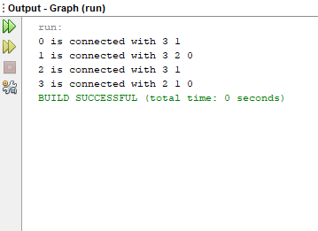

Hash Table

Program :
package hashtable;
import java.util.*;
public class HashTable {

public static void main(String[] args) {

Hashtable<Integer, String> students = new Hashtable<Integer, String>();

students.put(122, "Laura");
students.put(399, "Mehmet");
students.put(41, "Didzis");
students.put(13, "Murat");
students.put(444, "Muzeyyen");
students.put(38, "Ahmet");
students.put(3, "Mehmet");

System.out.println(students);
}
}
Output :

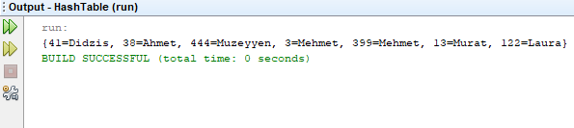

3. Lab work >> 1) Create a simple tree with 4 nodes in C/Java

This is my tree :

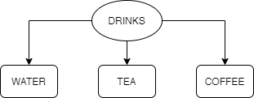

Program :
package treefournodes;

public class TreeFourNodes {

private static class Nodes {

String value;
Nodes left;
Nodes right;
Nodes middle;

Nodes(String value) {
this.value = value;
}

Nodes(String data, Nodes left, Nodes middle, Nodes right) {
this.value = data;
this.left = left;
this.right = right;
this.middle = middle;
}

}

public static void printTree(Nodes node) {
if (node == null) {
return;
} else {
System.out.printf("%s ", node.value);
}
printTree(node.left);
printTree(node.middle);
printTree(node.right);
}

public static void main(String[] args) {

Nodes Coffee = new Nodes("Coffee");
Nodes Tea = new Nodes("Tea");
Nodes Water = new Nodes("Water");
Nodes root = new Nodes("Drinks", Water, Tea, Coffee);

System.out.println("---- Printing Drinks ----");
printTree(root);
System.out.println('\n');
}

}
Output :

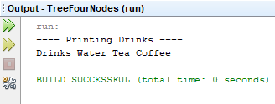

3. Lab work >> 2) Program for reversing a queue in C/Java

Program :
package reversequeue;

import java.util.*;

public class ReverseQueue {

public Queue<Integer> queue;

public ReverseQueue() {
this.queue = new LinkedList<Integer>();
}

public void push(int data) {
this.queue.add(data);
}

public void reverse() {

int data;
if (!queue.isEmpty()) {
data = this.queue.remove();
this.reverse();
this.queue.add(data);
}
}

public void print() {
System.out.println(this.queue.toString());
}

public static void main(String[] args) {

ReverseQueue Numbers = new ReverseQueue();
Numbers.push(11);
Numbers.push(22);
Numbers.push(33);
Numbers.push(44);
Numbers.push(55);
Numbers.print();
Numbers.reverse();
Numbers.print();

}

}

Output :

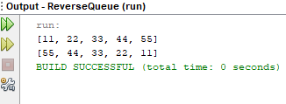

4. Write short 5-page short information and example programming to demonstrate implementation about Stacks, Queues

Stack : Data is stored linearly and we process data with LIFO (last in first out) method.
Basic stack operations are :
- push() − Storing an element on the stack.
- pop() − Removing or accessing an element from the stack.
- peek() − Geting the top data element of the stack, without removing it.
- isFull() − Checking if stack is full.
- isEmpty() − Checking if stack is empty.
Example Stack Programming :
package stack;

public class Stack {

private int head;
private int StackSize;
private int[] stackArray;

public Stack(int size) {
StackSize = size;
stackArray = new int[StackSize];
head = -1;
}

public void push(int i) {
stackArray[++head] = i;
}

public int pop() {
return stackArray[head--];
}

public int peek() {
return stackArray[head];
}

public boolean isFull() {
return (head == StackSize - 1);
}

public boolean isEmpty() {
return (head == -1);
}

public static void main(String[] args) {

Stack NewStack = new Stack(10);
NewStack.push(111);
NewStack.push(18);
NewStack.push(85);
NewStack.push(23);
NewStack.push(98);
NewStack.pop();
NewStack.push(10);

System.out.println("Our Stack : ");

while (!NewStack.isEmpty()) {
int data = NewStack.pop();
System.out.print(data);
System.out.print(" ");
}
System.out.println('\n');

}
}

Output :
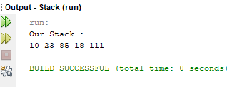

Queue : Can store data as stack but it uses FIFO (first in first out) method.
Basic queue operations are :
- enqueue() − Storing an element to the queue.
- dequeue() − Removing or accessing an element from the queue.
- peek() − Geting the element at the front of the queue without removing it.
- isfull() − Checking if the queue is full.
- isempty() − Checking if the queue is empty.

Example Queue Programming :
package queue;

public class Queue {

int size;
int[] queue_array;
int first;
int last;
int element_count;

public Queue(int q) {

size = q;
queue_array = new int[size];
first = 0;
last = -1;
element_count = 0;
}

public boolean isEmpty() {
return (element_count == 0);
}

public void add(int elementtoadd) {
if (last == size - 1) {
last = -1;
}
queue_array[++last] = elementtoadd;
element_count++;
System.out.println("Added : " + elementtoadd);

}

public int dequeue() {

int actual = queue_array[first++];
if (first == size) {
first = 0;
}
element_count--;
return actual;
}

public static void main(String[] args) {

Queue M = new Queue(10);
M.add(1);
M.add(9);
M.add(7);
M.add(8);
M.add(11);
while (!M.isEmpty()) {
System.out.println(M.dequeue());
}
}

}
Output :
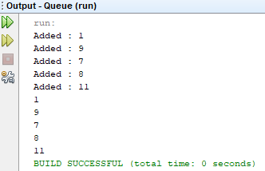

5. Write short 5-page short information and example programming to demonstrate implementation about Linked Lists, Type of Linked Lists

Linked lists are formed from nodes which are connected one after another. There are two things that these nodes hold. The first is the data we want to keep and second one is the address information (pointer) of next node in the list.

The bad side of the linked lists is that the middle elements on it are not easy to access and the search complexity is relatively big in applications that require frequent searches.
Types of Linked List :
- Singly Linked List
- Doubly Linked List
- Circular Linked List

Singly Linked List : There are two variables in the node. One of them is reserved for data. The other variable is the pointer, keeping the address of the next node.
Doubly Linked List : There are 3 variables in the node. One of them is reserved for data. The other two variables are the pointer, one of which holds the previous node and the other holds the next node.
Circular Linked List : If the last node is connected to the first node, a circular list is created. We can move from the last node to the first node or from the first node to the last node in one move.
Example Linked List Programming :
package linkedlistexample;

public class LinkedListExample {

Student first = null, last = null;

public void add(int number, String name, String surname) {
Student stu = new Student(number, name, surname);
if (first == null) {
first = stu;
last = stu;
} else {
last.next = stu;
last = stu;
}
}

public void List() {
Student temp = first;
while (temp != null) {
System.out.println(temp.number + " " + temp.name + " " + temp.surname);
temp = temp.next;
}
}

public void delete(int number) {
Student temp = first, onebefore = first;
while (temp != null) {
if (temp.number == number) {
break;
}
onebefore = temp;
temp = temp.next;
}
if (temp == null) {
System.out.println("Student number " + number + " is not in list");
} else {
if (first == last) {
first = null;
last = null;
} else {
if (temp == first) {
first = temp.next;
} else {
if (temp == last) {
last = onebefore;
onebefore.next = null;
} else {
onebefore.next = temp.next;
}
}
}
}
}

class Student {

int number;
String name, surname;
Student next;

Student(int number, String name, String surname) {
this.number = number;
this.name = name;
this.surname = surname;
this.next = null;
}
}

public static void main(String[] args) {

LinkedListExample studentlist = new LinkedListExample();

studentlist.add(121, "Mehmet", "Dikici");
studentlist.add(333, "Harry", "Potter");
studentlist.add(12, "Bill", "Clinton");
studentlist.add(98, "Michael", "Jordan");
studentlist.add(256, "Elon", "Musk");
studentlist.add(7, "Cristiano", "Ronaldo");
studentlist.add(1879, "Albert", "Einstein");
studentlist.add(1856, "Nikola", "Tesla");
studentlist.delete(7);
studentlist.add(1643, "Isaac", "Newton");
studentlist.List();

}
}

Output :

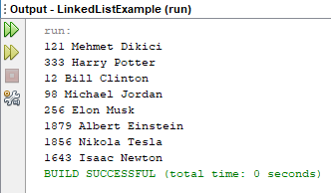

6. What is an array? How to do Declaring Array Variables. Write a program for array impregnation using a stack concept.

Array is a data structure with a certain length, which allows to user store more than one data in the same type of data.
First of all we need to create a variable that will hold the array. Variables shows us type of object the array will hold and the name of the array.
Some examples of array variable declarations:
String[] nameList;
int numbers[];
int[] numbers;
double[] doubleList;
boolean[] boolList;
char charList[] = new char[10];
int[] numbers = {5,6,7};

Example Program :
package arrayexample;

import java.util.Arrays;
public class ArrayExample {

int sizeofarray;
int headofarray;
int array[];

ArrayExample(int n) {

array = new int[n];
sizeofarray = n;
headofarray = -1;

}

void addtoarray(int x) {

if (headofarray < sizeofarray - 1) {
headofarray++;
array[headofarray] = x;
} else {
System.out.println("Array is full");
}
}

int removefromarray() {

if (headofarray >= 0) {
int x = array[headofarray];
headofarray--;
return x;
} else {
System.out.println("Array is Empty");
}
return 0;
}

public static void main(String[] args) {

ArrayExample newarray = new ArrayExample(5);
newarray.addtoarray(11);
newarray.addtoarray(18);
newarray.addtoarray(4);
newarray.addtoarray(35);
newarray.addtoarray(4);
newarray.removefromarray();
newarray.addtoarray(3);

System.out.println(Arrays.toString(newarray.array));
}
}
Output :
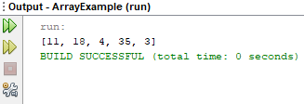

Non-Primitive ( Non-Linear data structure )

1. What is Trees? How to implement a Binary search tree

Tree : If a graph is a linked graph and contains no loops, this graph is called a tree. Data is stored in a hierarchical and nonlinear way. It is called a tree because order formed by data looks like a tree. Each element of a tree is called a node. The data is kept in nodes. Nodes are connected to each other by edge.

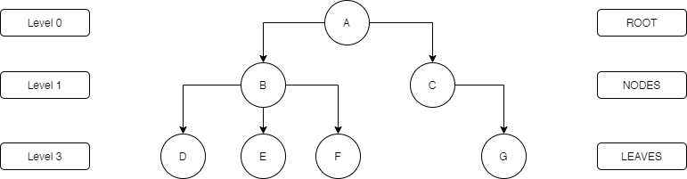

Binary Search Tree :
The basic rule in binary search tree is if a data is smaller, it must be in the left subtree if it is larger in the right subtree, and this applies to all subtrees.

For example : Root is 50, 70 is bigger than 50 and goes to right side, 25 is smaller than 50 and goes to left side, same as other nodes.
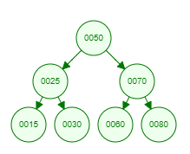

Example in Program:
package binarysearchtree;

public class BinarySearchTree {

class Node {

Node left;
Node right;
int data;
}

public Node addNode(int value) {
Node newNode = new Node();
newNode.data = value;
newNode.left = null;
newNode.right = null;
return newNode;
}

public void inordertree(Node node) {
if (node == null) {
return;
}

inordertree(node.left);
System.out.print(node.data + " ");
inordertree(node.right);
}

public boolean Search(Node node, int pointer) {
if (node == null) {
return false;
}

if (node.data == pointer) {
return true;
}

return Search(node.left, pointer) || Search(node.right, pointer);
}

public static void main(String[] args) {

BinarySearchTree example = new BinarySearchTree();
Node root = example.addNode(50);
root.left = example.addNode(25);
root.right = example.addNode(70);
root.left.left = example.addNode(15);
root.left.right = example.addNode(30);
root.right.right = example.addNode(80);
root.right.left = example.addNode(60);
System.out.print("Tree : ");
example.inordertree(root);
System.out.println();
System.out.println("Searched element is on tree : " + example.Search(root, 60));
System.out.println();

}
}

Output :

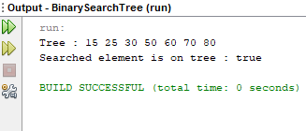

2. What are the graphs? explain Directed Graphs with example

The graph is a set of nodes and edges that show the relationship between these nodes. Graph is a non-linear data structure, linked lists and trees are most common graph examples. We can use graphs in many cases, for example, a decision tree, a network, maps. There are many ways to draw a graph, directed graph is one of these types.

Directed Graphs :
Directed graph is a graph which contains ordered pair of vertices. If an edge is represented using a pair of vertices (A1, A2), the edge is said to be directed from A1 to A2. The first element of the pair A1 is called the start vertex and the second element of the pair A2 is called the end vertex.

For Example :
Set of Vertices V = {A, B, C, D, E}
Set of Edges W = {(A,B),(A,C),(A,D),(B,E),(C,B),(D,C),(D,E)}

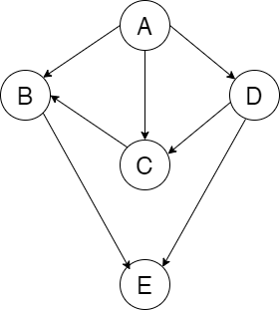

Overall

1. What is the difference between Non-Primitive ( Non-linear data structure ) and Primitive ( Linear data structure )

In linear data structure, data is arranged in a linear sequence and elements are linked one after the other. In non-linear data structure, elements are hierarchically connected and are present at different levels. In linear data structure elements are easy to be retrieved as they can be accessed in one run. In non-linear data structure elements are not easy to be retrieved or stored as there is a strict relationship between the different elements. Linear data structure is easier to implement. In linear data structure memory utilization is inefficient but in non-linear data structure memory utilization is efficient.

Why we need to learn data structure?

The way how we store and retrive data for easy search and efficient use is data structure. As I wrote in assignment 3, the main aim of computer programming is solving a problem. While we are solving a problem, we should use fastest way and less resource. Popular way of solving a problem is dividing it into parts and we use algorithms for this. While data structures are used to hold data, algorithms solve the problem using this data. Therefore, an algorithm becomes stronger when used with suitable data structures. The more information we have in data structures and algorithms, the more problems we can solve. Also, our chances of finding new solutions to new problems will increase, if we know data sturctures well. That is the main reason why we should learn data structures.

Second reason why we need to learn data structure is that it effects the performance of a program which we write. If we choose the wrong data structure, the performance of our program can be insufficient. That is why is important to get know different data structures and how to apply them properly.

It is also very important to know the most famous algorithms. For example many algorithms have been developed to sort the elements, but quicksort is the fastest sorting algorithm that makes this operation. It doesn’t mean that we don’t need other algorithms or other algorithms are bad. There are some cases that other algorithms perform better.

Working as a programmer means that we are able to solve problems with the help of programming languages, and data structure is important piece of solutions, so if we want to be a good software developer we must learn data structures well.

3. What are Big-O complexities and why they used in Computer Science( programming)? How to select appropriate data structure in your (problem-solving) programming?

Big O notation is used in Computer Science to show the performance or complexity of an algorithm. Big O describes the execution time required or the space used by an algorithm. For example in many products there are some units which display the quality of it, such as Ghz in processors or Watt in bulbs. In computer science this unit which shows the quality of algorithm is Big O Notation. The more efficient an algorithm is, the more quality it is.

Big-O Nation Complexities :

- O(1) - Constant Runtime : In this case, algorithm runs the same time, regardless of the given input data set. The runtime is constant no matter the size of the input given.
- O(n) - Linear Runtime : Linear runtime happens when the runtime grows in proportion with the size of the input data set. n is the size of the input data set.
- O($n^{2}$) - Quadratic Runtime : An algorithm whose runtime is directly proportional to the square of the size of the input data set.
- O(log n) - Logarithmic runtime : In this case, the runtime it takes for the algorithm to run will plateau no matter the size of the input data set.
- O(n log n) - Linearithmic runtime : The runtime of the algorithm depends on running a logarithm operation n times.
- O($2^{n}$) - Exponential runtime : This happens in algorithms where for each increase in the size of the data set, the runtime is doubled.
- O(n!) - Factorial runtime : The algorithm runs in factorial time. The factorial of a non-negative integer (n!) is the product of all positive integers less than or equal to n.

How to select appropriate data structure?

We must choose the appropriate data structure for better performance. If we choose a bad data structure, the system does not perform well. First of all we are going to analyze our problem and we should know what we need to solve our problem, after this we need to check performance of available data structures and choose a data structure which performs best with our program.
For example we can choose linked list when :
- We need constant time for addition and deletion.
- Our data dynamically grows
- Do not access random elements from the linked list.
- Insert the element in any position of the list.
So if we know the properties of different data structures, we can easily choose correct one for our program, after using the data structure in our program we can check Big-O complexities if choosen data structure performs well or not. For example, O(n log n) or O(n) algorithm would be an effective algorithm for large tasks, such as sorting or searching.

Bibliography
1. Tutorials Point - https://www.tutorialspoint.com/data_structures_algorithms/index.htm
2. Tutorials Point - https://www.tutorialspoint.com/data_structures_algorithms/linked_list_algorithms.htm
3. Afteracademy - https://afteracademy.com/blog/types-of-linked-list-and-operation-on-linked-list
4. GeeksforGeeks - https://www.geeksforgeeks.org/arrays-in-java/
5. TutorialRida - https://www.tutorialride.com/data-structures/graphs-in-data-structure.htm
6. Pediaa - https://pediaa.com/what-is-the-difference-between-linear-and-non-linear-data-structures/
7. https://www.thecrazyprogrammer.com/2018/08/difference-between-linear-and-non-linear-data-structure.html
8. Learning JavaScript Data Structures and Algorithms - Loiane Groner - Packt Publishing Ltd, Jun 23, 2016
9. https://rob-bell.net/2009/06/a-beginners-guide-to-big-o-notation/
10. https://dev.to/sarah_chima/the-big-o-notation-an-introduction-34f7
11. https://www.careerdrill.com/blog/coding-interview/choosing-the-right-data-structure-to-solve-problems/

