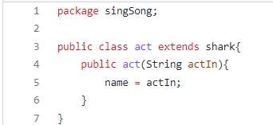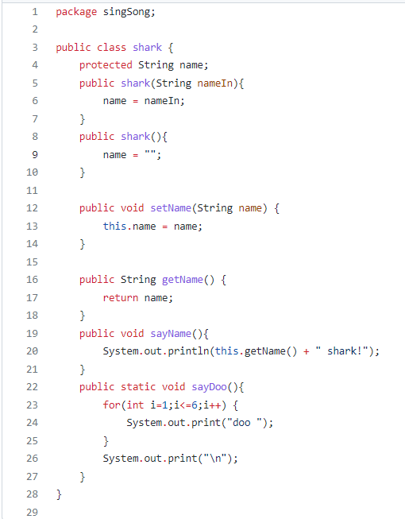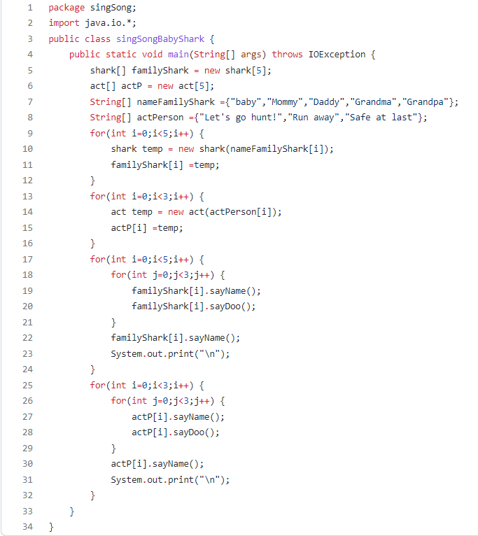

**singSongBabyshark.java**

**shark.java**

**act.java**

[**https://www.youtube.com/watch?v=XqZsoesa55w**](https://www.youtube.com/watch?v=XqZsoesa55w)

[**https://github.com/Tran-Duc-Duy/singSongBabyShark.git**](https://github.com/Tran-Duc-Duy/singSongBabyShark.git)