**Trần Mai Anh – 2231200062 – Lab2**

**[Link Github](https://github.com/Tran-Mai-Anh/CSE441-MobileProgramming/tree/main/Lab2)**

**Question 1. Build APIs using MVC Asp.net.**

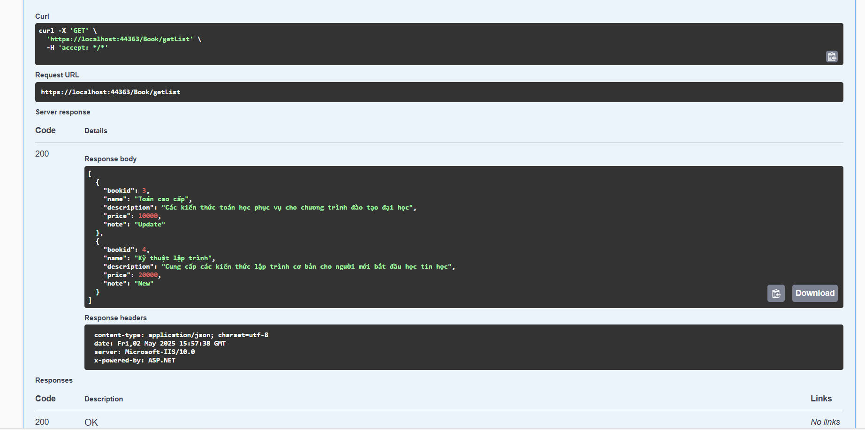

**Question 2. Login screen interface design.**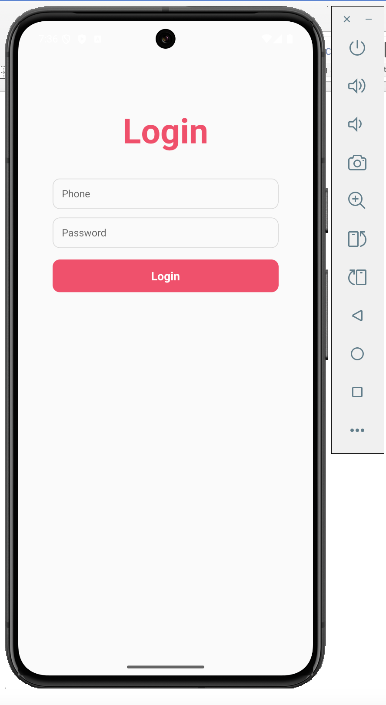

**Question 3. Write the Personal Income Tax Calculation program as shown**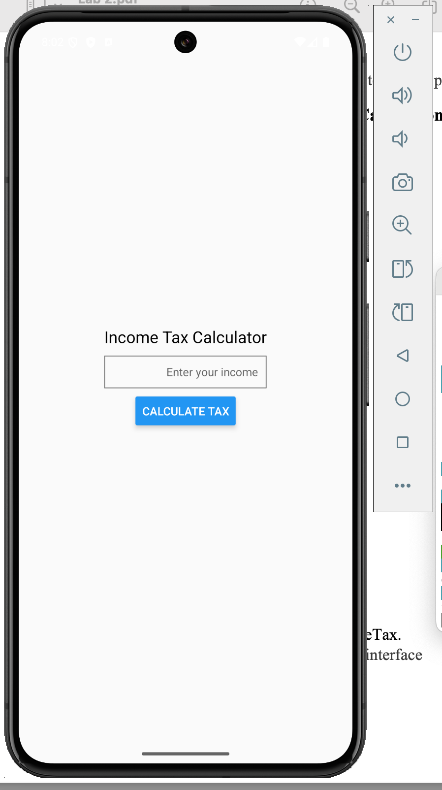

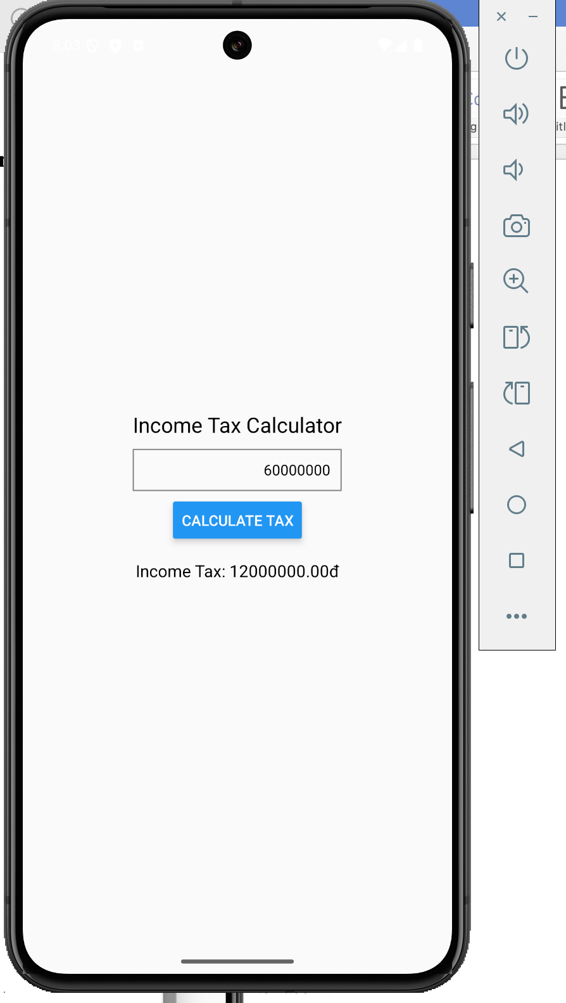

**Question 4. Calculator screen interface design**