CURTIN ISAD 3000 · PROJECT PORTAL
Login Guide
Curtin ISAD 3000 Project Portal
Project | Curtin ISAD 3000 Project Portal
Document ID | CP-LG-001
Version | 4.0
Date | 25 October 2026
Author | Darren
Status | Draft for review
Classification | Internal

How to sign in to the Curtin ISAD 3000 Project Portal with an emailed 6-digit code, what each message means, and how to fix the most common problems.

Document Control

Document information
Document title | Login Guide
Document ID | CP-LG-001
Project | Curtin ISAD 3000 Project Portal
Document type | Short illustrated sign-in guide
Version | 4.0
Author | Darren
Date issued | 25 October 2026
Status | Draft for review
Classification | Internal
Intended audience | All users; the last section is for administrators

Revision history
Version | Date | Author | Description of change
1.0 | 21 October 2026 | Darren | First full-length version.
2.0 | 21 October 2026 | Darren | Shortened and rebuilt with screenshots of the Portal.
3.0 | 23 October 2026 | Darren | Added the Student / Lecturer choice and lecturer messages.
4.0 | 25 October 2026 | Darren | Rebuilt for Sign in / Create account tabs; role now belongs to the account.

Review and approval
Role | Name | Signature | Date
Author | Darren |  | 25 October 2026
Reviewer
Approver

Related documents
Document ID | Title
CP-SRS-001 | Software Requirements Specification
CP-UAT-001 | User Acceptance Testing (UAT) Document
CP-UG-001 | User Guide
CP-LG-001 (this document) | Login Guide

1. How sign-in works
Portal address: https://capstone-portal-test.tranphucdang0709.workers.dev/
There is no password. You enter your email, the Portal emails you a 6-digit code, and you type it in. Each code works once and lasts 10 minutes. You then stay signed in for 8 hours.
1 | 2 | 3 | 4
Enter your email (new users: Create account first) | Click "Email me a code" | Read the code in your email | Type the 6 digits

NOTE
Only approved email addresses receive a code. Ask your lecturer if you are unsure which address is approved.

2. Step by step

Step 1 - Enter your email
Open the Portal address. Keep the Sign in tab (1) selected, click the Email box (2), type your address, then click Email me a code (3). The button is grey until you type something.
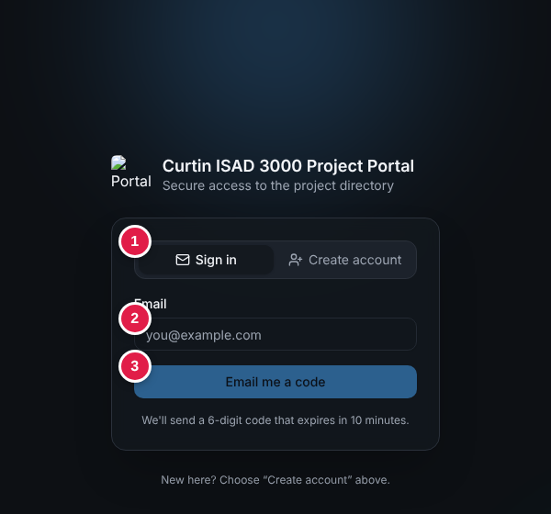
Sign in tab: (1) tabs, (2) email, (3) Email me a code

First time? Create your account
- Click the Create account tab (1).
- Enter your name (2, optional) and email (3).
- Choose the account type (4): Student (default) or Lecturer. Lecturer is only granted to approved emails; otherwise you get a student account and a message says so.
- Click Email me a code to create my account (5) and enter the code. "Account created. Welcome!" confirms it.
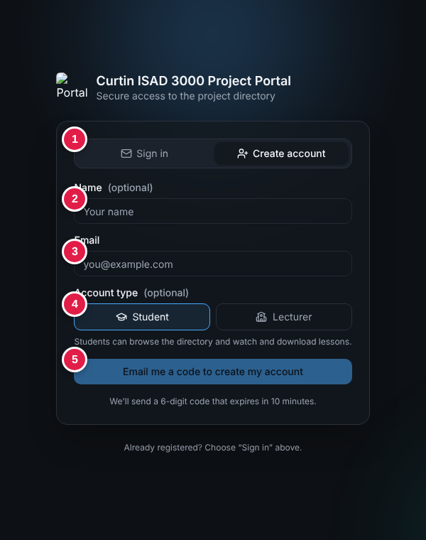
Create account tab: (1) tabs, (2) name, (3) email, (4) account type, (5) button
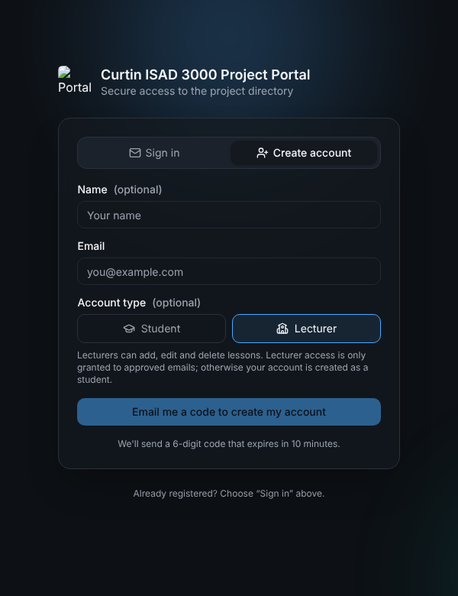
Lecturer chosen: the note explains approval

Step 2 - Get the code
A green message says "If that email has access, a code is on its way." (the same message appears for every address). Open your mailbox and find:
Subject: Your Capstone Portal sign-in code: 482915

The email shows a large 6-digit code. It normally arrives within a minute; check Spam / Junk if not. Only the newest code works.

Step 3 - Type the code
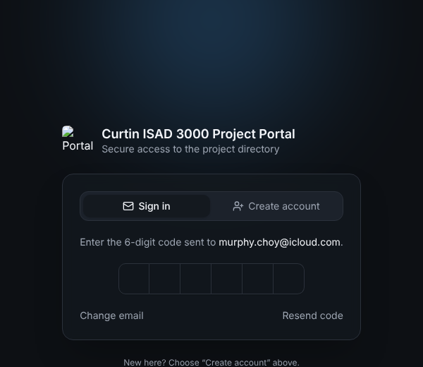
Code step: type the six digits (for a new account it ends "to create your account.")
Click the first box and type all six digits (or paste them). The Portal checks the code automatically on the sixth digit - there is no button to press.
Link | Use it when
(1) Change email | You typed the wrong address.
(2) Resend code | The email did not arrive or the code expired. Wait 30 seconds between requests.

Step 4 - You are in
A green "Signed in." message appears and the Project Directory opens. Your name and role are at the top right.
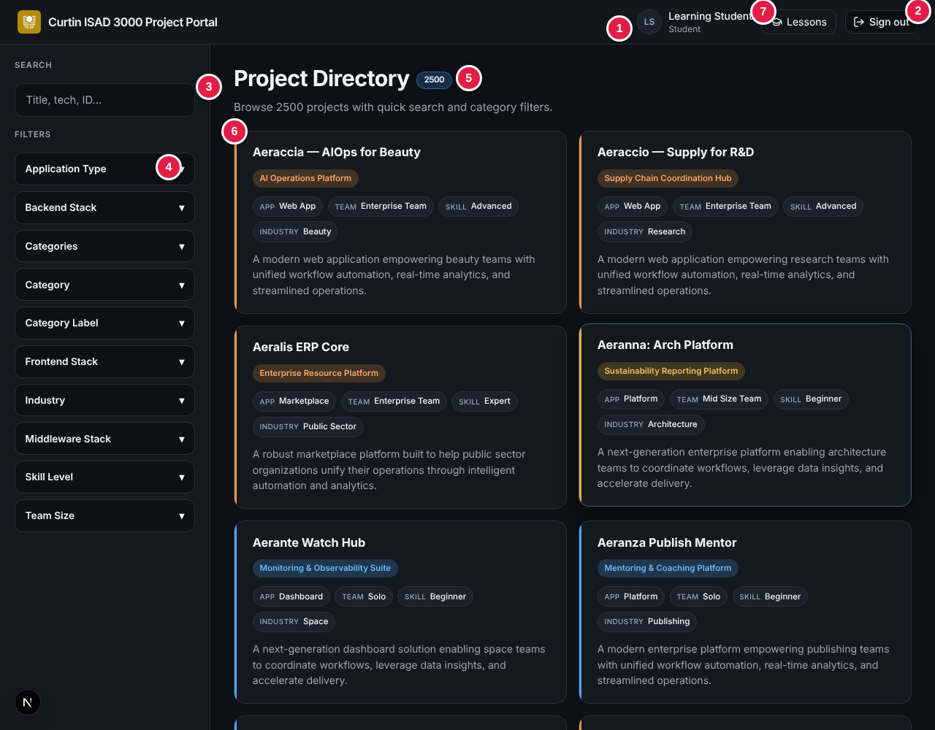
Signed in: the directory opens with your name and role top right

If you have no account yet
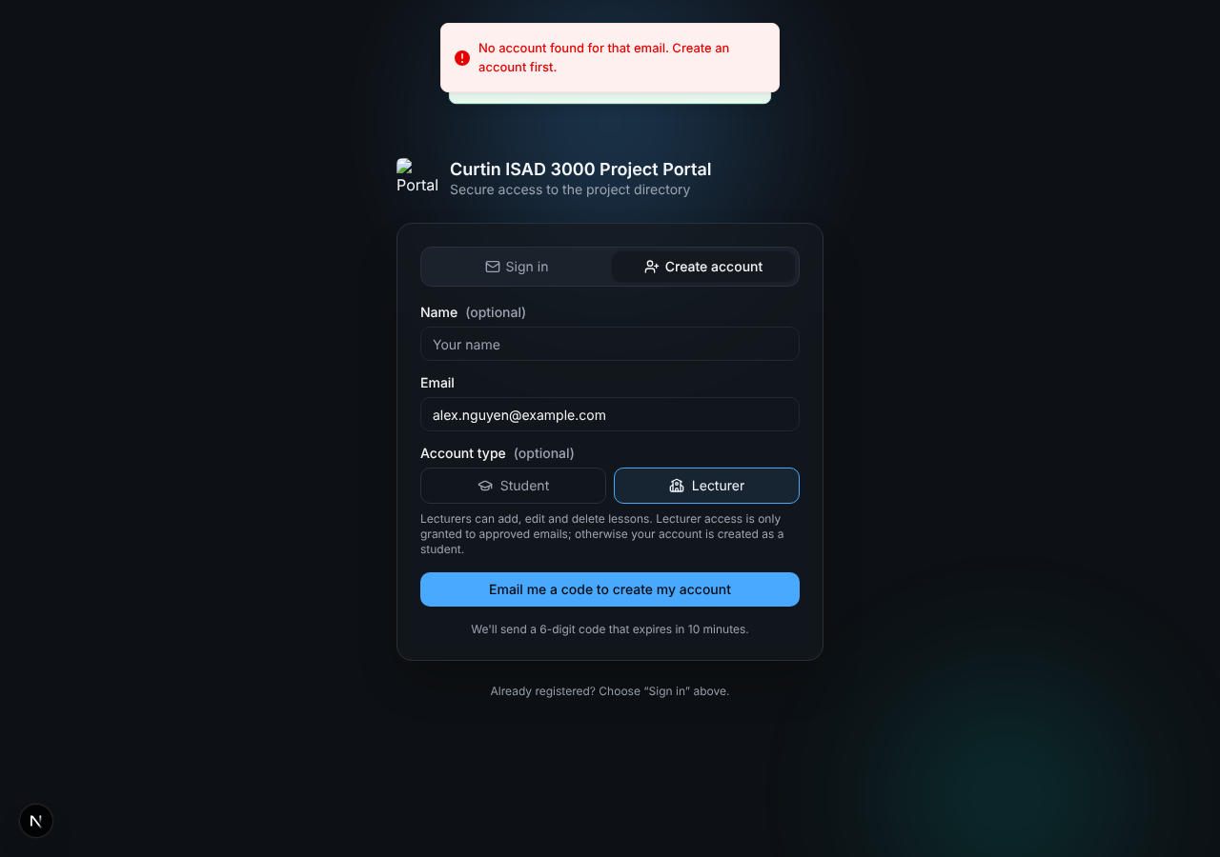
Signing in without an account sends you to Create account
The message reads "No account found for that email. Create an account first." and the page switches to Create account. If you try to create an account that already exists you see "An account with this email already exists. Sign in instead."

If the code is wrong
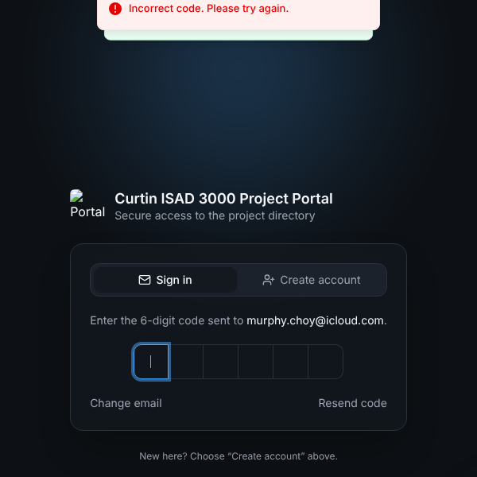
Wrong code: the boxes clear and you can try again
You get 5 tries per code. After that, request a new code.

3. Rules at a glance
Rule | Value
Code | 6 digits, one use, valid 10 minutes
Wrong tries | Up to 5 per code, then request a new one
Request a new code | Wait 30 seconds between requests
Session | 8 hours, then sign in again
Sign out | Sign out button, top right of every page

4. Troubleshooting
Message or problem | What to do
Please enter a valid email address. | Check the address for typos or a missing @.
Please wait Ns before requesting another code. | Wait the seconds shown, then click Resend code.
Incorrect code. Please try again. | Use the newest email and retype the digits.
Too many attempts. Request a new code. | Click Resend code (after 30 s) and use the new code.
No code was requested, or it expired. | More than 10 minutes passed, or cookies are blocked. Request a new code and allow cookies.
No email arrives | Wait 2 minutes, check Spam, confirm the address is approved, then Resend code.
No account found for that email. Create an account first. | Use the Create account tab.
An account with this email already exists. Sign in instead. | Use the Sign in tab.
Account created as a student | Your email is not approved as a lecturer. Ask the portal owner.
Sent back to sign-in | Your 8-hour session ended. Sign in again.

TIP
Request the code and type it in the same browser. Do not clear cookies between the two steps.

5. Stay safe
- Never share your code. Nobody from the course will ask for it.
- Ignore a code email you did not request - it cannot be used without your email.
- Sign out on shared computers.

6. For administrators (summary)
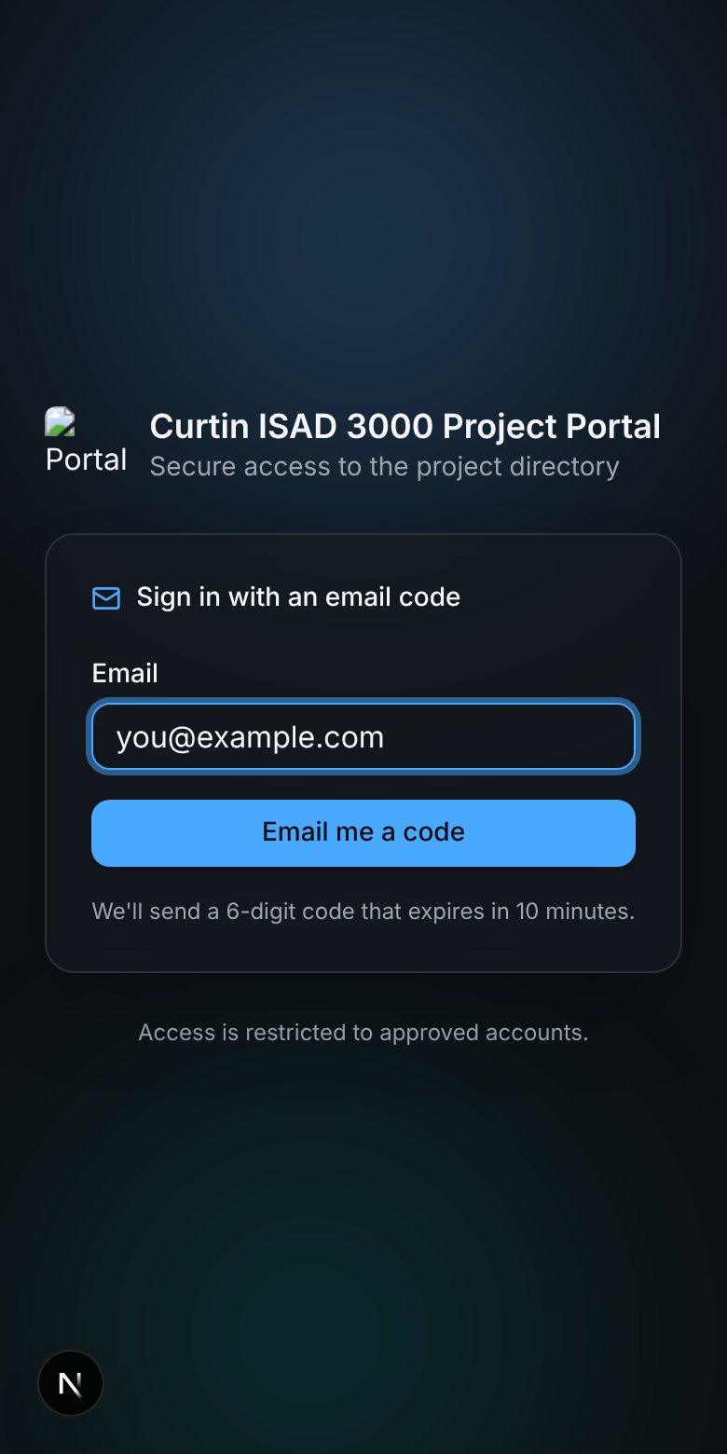
The sign-in page also works on a phone
Setting | Purpose
SESSION_SECRET | Required. 16+ characters. Without it sign-in fails with "Server error".
ALLOWED_EMAILS | Comma-separated approved emails. If empty, any valid email can sign in (development only).
RESEND_API_KEY or SMTP_* | How the code email is sent (Resend API, or SMTP such as Gmail with an app password). EMAIL_FROM sets the sender.
data/users.json, LECTURER_EMAILS | Emails approved to be Lecturers (users.json role Lecturer, or the comma-separated LECTURER_EMAILS). Everyone else gets a Student account.
DATABASE_URL | Writable database where new accounts are saved. Read-only hosts show "Could not save the account...".
AUTH_DEV_ECHO=1 | Development only: shows the code on screen. Never use in production.

