CURTIN ISAD 3000 · PROJECT PORTAL
Software Requirements Specification
Curtin ISAD 3000 Project Portal
Project | Curtin ISAD 3000 Project Portal
Document ID | CP-SRS-001
Version | 4.0
Date | 25 October 2026
Author | Darren
Status | Draft for review
Classification | Internal

This document specifies the functional, data, interface and quality requirements of the Curtin ISAD 3000 Project Portal: a secured web application that gives approved students and lecturers access to a searchable directory of 2,500 capstone project ideas, with passwordless email-code sign-in.

Document Control

Document information
Document title | Software Requirements Specification
Document ID | CP-SRS-001
Project | Curtin ISAD 3000 Project Portal
Document type | Software Requirements Specification (SRS)
Version | 4.0
Author | Darren
Date issued | 25 October 2026
Status | Draft for review
Classification | Internal
Intended audience | Lecturers, project sponsors, developers, testers, system administrators

Revision history
Version | Date | Author | Description of change
1.0 | 21 October 2026 | Darren | First full-length version.
2.0 | 23 October 2026 | Darren | Added Lessons & Videos, maintenance notice and screenshots.
3.0 | 23 October 2026 | Darren | Updated for the later 23 October 2026 portal changes: lecturer-managed lessons (documents, video files, YouTube links), new requirements, use cases and screenshots.
4.0 | 25 October 2026 | Darren | Updated for the account change: Sign in and Create account tabs, roles stored with the account, approved-lecturer rule (user list or LECTURER_EMAILS), new messages and screenshots.

Review and approval
Role | Name | Signature | Date
Author | Darren |  | 25 October 2026
Reviewer
Approver

Related documents
Document ID | Title
CP-SRS-001 (this document) | Software Requirements Specification
CP-UAT-001 | User Acceptance Testing (UAT) Document
CP-UG-001 | User Guide
CP-LG-001 | Login Guide

Table of Contents

1. Introduction

1.1 Purpose
This Software Requirements Specification (SRS) describes what the Curtin ISAD 3000 Project Portal ("the Portal") shall do. It is the agreed baseline against which the system is designed, built, tested and accepted. It is written for the people who commission, build, test, operate and use the Portal, and it is the source for the User Acceptance Testing document (CP-UAT-001), the User Guide (CP-UG-001) and the Login Guide (CP-LG-001).

1.2 Scope
The Portal is a protected web application that lets students of the ISAD 3000 capstone module explore a catalogue of project ideas. The system covers:
- Secure access - passwordless sign-in with a 6-digit code sent by email, signed session cookies and server-side route protection.
- Project directory - 2,500 projects with live search, automatically generated filters, project cards and a detailed project view.
- Lessons & Videos - lecturers add lessons with documents, uploaded videos or YouTube links; students search, watch and download them.
- Accounts - users create an account (Student, or Lecturer if their email is approved) and then sign in with an emailed code; the role belongs to the account.
- Maintenance notice - a one-time message shown after sign-in when the Portal has been updated.
- Platform services - SQLite/libSQL data store with bundled fallbacks, health endpoint, security headers and a three-environment delivery pipeline with an AI maintenance agent.
Out of scope: password management, self-registration, uploading or editing projects in the user interface, student submissions or grading, and any integration with the Curtin learning management system.

1.3 Definitions, acronyms and abbreviations
Term | Meaning
Portal | The Curtin ISAD 3000 Project Portal (repository name "Capstone Portal").
OTP | One-time password; here, a 6-digit code emailed to the user and valid for one sign-in.
Challenge | The signed, httpOnly cookie (otp_challenge) that carries the hashed code, email and attempt counter.
Session | A signed JSON Web Token (JWT) in the portal_session cookie that proves the user is signed in.
JWT | JSON Web Token (HS256) created and verified with the jose library.
Lecturer | Module staff role, shown in the page header.
Student | Role allowed to browse projects.
Facet / filter group | A project field (such as Industry) offered as a set of filter chips.
Card | The summary tile for one project in the directory.
SMTP | Simple Mail Transfer Protocol, used through Nodemailer to send email.
Resend | An email API used over HTTPS as an alternative to SMTP.
libSQL / Turso | SQLite-compatible database engine and its hosted service; used for user accounts.
Digital twin | The anonymised replica of live data used in the test environment.
UAT | User Acceptance Testing.

1.4 References
Reference | Description
README.md | Project overview, setup and layout.
DEPLOY.md | Deployment to Vercel and Node hosts; database notes.
docs/PIPELINE.md | Environments, digital twin and AI maintenance agent.
.env.example | List of supported environment variables.
Source code | app/, components/, lib/, proxy.ts, next.config.ts, data/, scripts/, tests/.
CP-UAT-001 | User Acceptance Testing document.
CP-UG-001 / CP-LG-001 | User Guide / Login Guide.

1.5 Document conventions
Requirements are identified as FR-nn (functional) and NFR-nn (non-functional). The words "shall" (mandatory) and "should" (recommended) are used deliberately. Each requirement has a MoSCoW priority (Must, Should, Could) and a source reference to the file that implements it, so that every statement can be verified in the product.

2. Overall description

2.1 Product perspective
The Portal is a self-contained web application built with Next.js (App Router), React 19, TypeScript, Tailwind CSS v4 and shadcn/ui components. It runs on Vercel, on any Node.js host, or on Cloudflare Workers. It depends on an email provider to deliver sign-in codes and, in production, a hosted libSQL (Turso) database for user accounts.

Logical context
Layer | Component | Responsibility
Client | Browser (React client components) | Login form, project directory (search, filters, cards, detail window) and toast messages.
Edge / routing | proxy.ts | Verifies the session cookie on every route and redirects visitors to /login.
Application | Next.js route handlers | /api/auth/request, /api/auth/verify, /api/auth/logout, /api/projects, /api/health.
Domain libraries | lib/* | JWT sessions, OTP challenge, allowlist, email sending, user lookup, project store.
Content | lessons and lesson_files tables, data/maintenance-notice.json | Lessons with their uploaded files, and the current maintenance notice.
Data | SQLite / libSQL + bundled JSON | users, projects tables; data/projects.json (2,500 records) and data/users.json as fallbacks.
External | SMTP server or Resend API; Turso | Email delivery and hosted database.
Table 1 - Logical architecture of the Portal

2.2 Product functions (summary)
- Sign in with an email address and a 6-digit one-time code; sign out.
- Automatically protect all pages and APIs for signed-in users only.
- Browse, search and filter 2,500 projects; open a project for full details and technology stack.
- Browse and search course lessons, watch lecture videos and download lesson documents.
- Lecturers: add lessons (documents, video file, YouTube link) and delete them.
- See a one-time notice after maintenance.
- Operate and maintain the system through health checks, automated tests and a gated release pipeline.

2.3 User classes and characteristics
User class | Description | Technical skill | Key needs
Student | ISAD 3000 student choosing a capstone project. Seeded accounts include Dang Tran, Learning Student, Course Mentor and Demo Account. | Basic web use | Find suitable projects quickly by topic, industry, skill level, team size or technology.
Lecturer | Module staff (Murphy Choy, Goladin). | Moderate | Browse the catalogue, guide students to suitable projects, and add lessons with documents and videos. Becomes a Lecturer only with an approved email.
Visitor (unauthenticated) | Anyone without a session. | Any | May only see the login page, /api/auth/* and /api/health.
Administrator / maintainer | Person who deploys the Portal and manages configuration, users and the database. | High | Simple deployment, clear errors, safe promotion between environments.
AI maintenance agent | Scheduled GitHub Actions job that proposes dependency and code fixes on the dev branch. | n/a | Operates within strict file and command limits and passes an independent quality gate.
Table 2 - User classes

2.4 Operating environment
Item | Specification
Client | Current Chrome, Edge, Firefox, Safari on desktop, tablet and phone; JavaScript and cookies enabled.
Server runtime | Node.js 20 or later (CI uses Node 22). Next.js 16.3.4, React 19.3.
Hosting | Vercel (default), any Node host (npm run build && npm start), or Cloudflare Workers through vinext.
Database | Local file data/portal.db; production libsql:// (Turso) via DATABASE_URL and DATABASE_AUTH_TOKEN.
Email | Resend API (RESEND_API_KEY) or any SMTP provider (Gmail, SendGrid, Brevo, etc.).
Delivery | GitHub repository with workflows ci.yml, promote.yml and agent-maintenance.yml.

2.5 Design and implementation constraints
- Authentication shall be stateless (signed cookies) so that it works across serverless instances without a session store.
- The Portal shall remain usable when the database is read-only or unreachable, by falling back to bundled data.
- Passwords are not used. Any future password feature requires a change to this SRS.
- Secrets shall be provided only through environment variables; .env.local is git-ignored.
- The user interface is a dark-theme dashboard using Tailwind CSS v4 and shadcn/ui.

2.6 Assumptions and dependencies
- Users have working access to the mailbox of the email address they sign in with.
- The email provider delivers messages within a few minutes and is configured with a valid sender.
- SESSION_SECRET (16+ characters, recommended 64 hex characters) is set in every environment.
- The approved-email list is controlled with ALLOWED_EMAILS; if empty, any syntactically valid email may request a code (intended for local development only).

3. System features and functional requirements
This section lists every functional requirement. Priority uses MoSCoW (Must, Should, Could). "Source" names the implementing file(s).

3.1 Access control and routing
ID | Requirement | Priority | Source
FR-01 | The system shall redirect every unauthenticated request to /login, except requests for static assets (/_next/static, /_next/image, favicon.ico), the login page, /api/auth/* and /api/health. | Must | proxy.ts
FR-02 | When redirecting to /login, the system shall append the originally requested path as the from query parameter (omitted when the path is /), and shall return the user to that path after a successful sign-in. | Should | proxy.ts, login-form.tsx
FR-03 | The system shall validate the session cookie signature and expiry on every protected request; an invalid, tampered or expired cookie shall be treated as signed out. | Must | lib/auth.ts

3.2 Email one-time-code sign-in
ID | Requirement | Priority | Source
FR-04 | The login page shall present an email field and an "Email me a code" button; the button shall be disabled while the field is empty or a request is in progress. | Must | login-form.tsx
FR-05 | The system shall reject a malformed email address with HTTP 400 and the message "Please enter a valid email address." | Must | api/auth/request
FR-06 | The system shall generate a cryptographically random 6-digit numeric code (000000-999999) for each valid request. | Must | lib/otp-challenge.ts
FR-07 | The system shall not store the code in clear text. A SHA-256 hash of the email, code and server secret shall be placed in a signed, httpOnly challenge cookie (otp_challenge) that expires after 10 minutes. | Must | lib/otp-challenge.ts
FR-08 | The system shall enforce a resend cooldown of 30 seconds, returning HTTP 429 with "Please wait Ns before requesting another code." while the cooldown is active. | Must | api/auth/request
FR-09 | The system shall respond identically ("ok") whether or not an email is on the approved list, so that account existence cannot be discovered; no code is generated or sent for unapproved emails. | Must | api/auth/request
FR-10 | The system shall deliver the code by email using, in order of precedence: the Resend HTTPS API (when RESEND_API_KEY is set), SMTP via Nodemailer (when SMTP_HOST, SMTP_USER, SMTP_PASS are set), or a server-console log (development fallback). | Must | lib/email.ts
FR-11 | The email shall have the subject "Your Capstone Portal sign-in code: ######" and state that the code expires in 10 minutes. | Should | lib/email.ts
FR-12 | In non-production environments with AUTH_DEV_ECHO=1, the system shall return the code in the API response and skip email delivery. This mode shall be inert when NODE_ENV=production. | Could | api/auth/request
FR-13 | After a code is requested, the login page shall switch to a six-box code-entry step that shows the target email, a "Change email" action and a "Resend code" action. | Must | login-form.tsx
FR-14 | The code-entry step shall submit automatically when the sixth digit is entered and shall clear the boxes after a failed attempt. | Should | login-form.tsx
FR-15 | The system shall accept only a 6-digit numeric code and a valid email at the verify endpoint (HTTP 400 "Enter your email and the 6-digit code." otherwise). | Must | api/auth/verify
FR-16 | The system shall bind a code to the email it was issued for; verification with a different email shall fail with "Incorrect code." | Must | lib/otp-challenge.ts
FR-17 | The system shall allow at most 5 incorrect attempts per challenge; the 6th attempt shall fail with "Too many attempts. Request a new code." and clear the challenge cookie. | Must | lib/otp-challenge.ts
FR-18 | A missing or expired challenge shall produce "No code was requested, or it expired. Request a new one." and clear the cookie. | Must | lib/otp-challenge.ts
FR-19 | On successful verification the system shall clear the challenge cookie, so that a code cannot be reused. | Must | api/auth/verify
FR-20 | Email comparison shall be case-insensitive and ignore leading/trailing spaces. | Should | lib/users.ts, lib/allowlist.ts

3.3 Session management
ID | Requirement | Priority | Source
FR-21 | On successful verification the system shall issue a signed JWT (HS256) session containing email, name and role, valid for 8 hours. | Must | lib/auth.ts
FR-22 | The session shall be stored in the portal_session cookie with attributes HttpOnly, SameSite=Lax, Path=/, Max-Age=28800 and Secure in production. | Must | lib/auth.ts
FR-23 | The system shall refuse to sign or verify tokens when SESSION_SECRET is missing or shorter than 16 characters, and shall surface a clear server error. | Must | lib/auth.ts
FR-24 | The Sign out button shall POST to /api/auth/logout, expire the session cookie and redirect (HTTP 303) to /login. | Must | api/auth/logout

3.4 Roles and user accounts
ID | Requirement | Priority | Source
FR-25 | The system shall resolve the signed-in user's name and role from the users table, falling back to the bundled data/users.json if the database is unavailable. | Must | lib/users.ts
FR-26 | Two roles shall be supported, Lecturer and Student. The role is stored with the user's account and carried in the session; it is shown in the page header and is not chosen at sign-in. | Must | api/auth/verify, lib/users.ts
FR-27 | An approved email that has no account shall not be able to sign in; the system shall tell the user to create an account first (see FR-94). | Must | api/auth/verify
FR-28 | The login page shall offer two tabs, Sign in (default) and Create account; switching tab returns to the email step. The footer reads "New here? Choose “Create account” above." on Sign in and "Already registered? Choose “Sign in” above." on Create account. | Must | login-form.tsx
FR-29 | The Create account tab shall ask for a name (optional, up to 80 characters), an email and an account type (optional): Student (default) or Lecturer, with an explanatory note for each; its button reads "Email me a code to create my account" and its code step ends "to create your account." | Must | login-form.tsx
FR-30 | Sign in shall work only for existing accounts. For an email without an account the system shall answer HTTP 404 "No account found for that email. Create an account first." and the page shall switch to the Create account tab. | Must | api/auth/verify
FR-31 | Create account for an email that already has an account shall answer HTTP 409 "An account with this email already exists. Sign in instead." and the page shall switch to the Sign in tab. | Must | api/auth/verify
FR-32 | After the code is verified, Create account shall store the user (the name defaults to the part of the email before @), sign the user in and show "Account created. Welcome!". The role is Student unless Lecturer was requested and the email is approved as a lecturer (listed as Lecturer in the user list or in LECTURER_EMAILS); an unapproved Lecturer request creates a Student account and shows "Account created as a student - Lecturer access needs approval. Ask the portal owner to add your email as a lecturer." | Must | api/auth/verify, lib/users.ts
FR-33 | If the account cannot be saved because the database is read-only, the system shall answer HTTP 500 "Could not save the account (database is read-only). Set DATABASE_URL on the server." | Should | api/auth/verify
FR-34 | The page header shall show the user's initials avatar, name (or email) and role. The initials shall be derived from the first two words/segments of the name or email. | Should | app/page.tsx

3.5 Project directory
ID | Requirement | Priority | Source
FR-35 | The directory shall load all projects from GET /api/projects and display a total count chip and the subtitle "Browse N projects with quick search and category filters." | Must | directory.tsx
FR-36 | Each project shall be displayed as a card with title, category label, four metadata pills (App, Team, Skill, Industry) and the short description. | Must | directory-logic.ts
FR-37 | The search box shall match against id, title, short and full description, category fields, industry, application type, team size, skill level and all technology-stack values. | Must | directory-logic.ts
FR-38 | Search shall be case-insensitive and diacritic-insensitive and shall split the query into terms; a project is shown if at least one term matches and projects are ranked by the share of terms matched, with a bonus for title matches. | Must | directory-logic.ts
FR-39 | The directory shall update live on every keystroke and show "Showing X of Y projects." | Must | directory-logic.ts
FR-40 | The system shall automatically build filter groups from the data: any field with at least two distinct values, a distinct-to-populated ratio of 0.6 or less, and an average option length of 40 characters or less. | Must | directory-logic.ts
FR-41 | Filter groups shall be collapsible, sorted alphabetically by title, and offer an "All" chip plus one chip per option. One option may be active per group; the active chip shall be highlighted. | Must | directory-logic.ts
FR-42 | Filters across groups shall be combined with logical AND, and shall be combined with the search query. | Must | directory-logic.ts
FR-43 | Matching projects shall be listed first, ordered by relevance then alphabetically by title. | Should | directory-logic.ts
FR-44 | Selecting a card shall open a detail window with title, category, metadata pills and a multi-paragraph overview generated from the project's own fields. | Must | directory-logic.ts
FR-45 | The detail window shall show Front End, Back End and Middleware technology stacks as collapsible sections (collapsed by default) with colour-coded chips. | Should | directory.tsx
FR-46 | The detail window shall close with the × button or by clicking outside the window. | Must | directory-logic.ts
FR-47 | All project text shall be HTML-escaped before display to prevent script injection. | Must | directory-logic.ts

3.6 Lessons and videos
ID | Requirement | Priority | Source
FR-48 | Signed-in users shall see a Lessons button in the page header that opens /lessons. | Must | app/page.tsx
FR-49 | The /lessons page and every /api/lessons endpoint shall require a valid session; signed-out requests are redirected to /login. | Must | proxy.ts, api/lessons
FR-50 | The Lessons page shall show the heading "Curtin ISAD 3000 lessons". Students see "Watch lecture videos and download lesson documents."; Lecturers see "Add lessons with documents and videos. Students and mentors can watch and download them." | Should | app/lessons/page.tsx
FR-51 | The page shall list lessons newest first; each card shows the section (if any), the date, the title and icons for video and number of documents. | Must | lessons-browser.tsx, lib/lessons.ts
FR-52 | The page shall provide a search box that matches title, description and section, case-insensitively, updating on every keystroke. | Must | lessons-browser.tsx
FR-53 | When at least one lesson has a section, the page shall provide a section selector ("All sections" plus one entry per section). | Should | lessons-browser.tsx
FR-54 | The Watch / Open button shall expand a lesson (Hide collapses it) to show the description, the YouTube video as an embedded player, an uploaded video in a video player that supports seeking, and each document with its file name, size and a Download link. | Must | lessons-browser.tsx, api/lessons/files
FR-55 | When no lessons exist the page shall say "No lessons yet." followed by "Your lecturer will add them soon." (students) or "Use “Add lesson” to upload the first documents and videos." (Lecturers). | Should | lessons-browser.tsx
FR-56 | The Lessons page shall provide a "Back to directory" link to /. | Should | app/lessons/page.tsx
FR-57 | Lecturers (only) shall see an Add lesson button that opens a form with: title (required, up to 160 characters), section or module (optional, 80), description (optional, 2,000), YouTube link (optional), video file (optional) and documents (optional). | Must | lessons-browser.tsx
FR-58 | The server shall require a title ("Please enter a title.") and at least one of a document, a video file or a YouTube link ("Add at least one document, video file or YouTube link."). | Must | api/lessons
FR-59 | The server shall accept a YouTube link in watch, youtu.be, embed or shorts form, or a bare 11-character id, and otherwise reject it with "That does not look like a YouTube link." | Must | lib/lessons.ts
FR-60 | A lesson shall hold at most 5 documents of 10 MB each (PDF, Word, PowerPoint, Excel, text, Markdown, zip, PNG, JPEG) and one video file of up to 20 MB (.mp4 or .webm); other types or larger files shall be rejected with a clear message (for an oversized video: upload to YouTube and paste the link). | Must | api/lessons, lib/lessons.ts
FR-61 | On success the system shall store the lesson and its files in the database, show "Lesson added.", close the form and refresh the list. | Must | api/lessons, lessons-browser.tsx
FR-62 | Adding and deleting lessons shall be allowed only for the Lecturer role; other signed-in users shall receive HTTP 403 "Lecturer access required." | Must | api/lessons
FR-63 | Lecturers shall see a delete (trash) button on each lesson; after confirming "Delete "title" and its files?" the lesson and its files are removed and "Lesson deleted." is shown. | Must | lessons-browser.tsx, api/lessons/[id]
FR-64 | Files shall be served from /api/lessons/files/{id} to signed-in users only: documents as downloads, videos inline with byte-range support. | Must | api/lessons/files
FR-65 | If the database cannot be written (for example a read-only hosted deployment) the system shall show the error together with a hint to configure a writable libSQL / Turso database. | Should | api/lessons

3.7 Maintenance notice
ID | Requirement | Priority | Source
FR-66 | After sign-in the system shall display a dialog with the title and message of the current maintenance notice, unless the signed-in account has already dismissed that notice in the current browser. | Must | maintenance-notice.tsx
FR-67 | The notice shall close with Got it, the × button or the Escape key; dismissal shall be remembered per account email and notice ID in browser storage so that the same notice does not reappear. | Must | maintenance-notice.tsx
FR-68 | The notice (id, title, message) shall be read from data/maintenance-notice.json; publishing a notice with a new id shall show it again to every user. | Must | data/maintenance-notice.json
FR-69 | An automated test shall fail if the notice file lacks a non-empty id, title or message. | Should | tests/integrity.test.mjs

3.8 Data and platform
ID | Requirement | Priority | Source
FR-70 | The system shall store user accounts in a SQLite/libSQL database (file:data/portal.db locally; a hosted libSQL/Turso URL in production), creating the schema and syncing users from data/users.json on first use. | Must | lib/db.ts
FR-71 | If the database is unavailable the system shall continue to serve the bundled projects and users (read-only operation). | Must | lib/projects-store.ts, lib/users.ts
FR-72 | GET /api/projects shall return the complete project list with Cache-Control: no-store. | Must | api/projects
FR-73 | GET /api/health shall be publicly available and return { ok, env, version }. | Should | api/health
FR-74 | Every response shall carry security headers: X-Frame-Options DENY, X-Content-Type-Options nosniff, Referrer-Policy strict-origin-when-cross-origin, Permissions-Policy (camera, microphone, geolocation and topics disabled), Strict-Transport-Security (2 years, includeSubDomains, preload) and X-DNS-Prefetch-Control off. | Must | next.config.ts

3.9 Use cases
ID | Use case | Actor | Preconditions | Main flow | Alternative / exception flows | Postcondition
UC-01 | Sign in | Visitor with an account | The visitor has an approved email, an account and mailbox access. | 1. Visitor opens the Portal and is redirected to /login (Sign in tab).  2. Visitor enters their email and selects "Email me a code".  3. System validates the email, generates a code, stores its hash in the challenge cookie and emails the code.  4. Visitor enters the 6-digit code.  5. System verifies the code, issues the session cookie and opens the requested page. | Invalid email (FR-05); cooldown active (FR-08); wrong code (FR-17); expired code (FR-18); email failure (502); no account (FR-94). | Visitor is signed in for 8 hours with the role of the account.
UC-10 | Create an account | Visitor without an account | The visitor has an approved email and mailbox access. | 1. Visitor selects the Create account tab.  2. Visitor enters an optional name, the email and an optional account type (Student or Lecturer).  3. Visitor selects "Email me a code to create my account" and enters the code.  4. System stores the account, signs the visitor in and shows "Account created. Welcome!" | Account already exists (FR-95); Lecturer requested but email not approved: account created as Student with a notice (FR-96); database read-only (FR-97). | Account exists; visitor is signed in as Student, or as Lecturer if approved.
UC-02 | Search the directory | Student, Lecturer | User is signed in. | 1. User types words in Search.  2. System ranks and shows matching cards and updates the count. | No results: count shows 0 of 2500. | Relevant projects are listed first.
UC-03 | Filter the directory | Student, Lecturer | User is signed in. | 1. User opens a filter group.  2. User selects an option chip.  3. System shows only matching projects; further groups narrow the list (AND). | Select "All" to clear a group. | List reflects all active filters and search text.
UC-04 | View project details | Student, Lecturer | User is signed in; a card is visible. | 1. User selects a card.  2. System opens the detail window with overview and stacks.  3. User expands stack sections and closes the window. | Click outside the window to close. | User returns to the same list state.
UC-05 | Sign out | Any signed-in user | User is signed in. | 1. User selects Sign out.  2. System expires the session cookie and redirects to /login. | - | User is signed out.
UC-06 | Browse lessons and videos | Student, Lecturer | User is signed in. | 1. User selects Lessons in the header.  2. User searches or picks a section.  3. User selects Watch on a lesson.  4. System shows the description, video player(s) and documents.  5. User plays a video or selects Download. | No lessons: "No lessons yet." No match: empty list. | Video watched or document downloaded; user returns with Back to directory.
UC-07 | Add a lesson | Lecturer | User is signed in with a Lecturer account and is on the Lessons page. | 1. Lecturer selects Add lesson.  2. Lecturer enters a title and optional section and description.  3. Lecturer adds a YouTube link, a video file and/or up to 5 documents.  4. Lecturer selects Save lesson.  5. System validates, stores the lesson and shows "Lesson added." | Missing title or content, bad link, wrong type or too large: an error message is shown and nothing is saved. | Lesson is listed first for all users.
UC-08 | Delete a lesson | Lecturer | A lesson exists. | 1. Lecturer selects the trash button.  2. Lecturer confirms.  3. System deletes the lesson and its files and shows "Lesson deleted." | Lecturer cancels: nothing changes. | Lesson and files are gone for everyone.
UC-09 | Read a maintenance notice | Student, Lecturer | User signs in and the current notice has not been dismissed in this browser. | 1. System shows the notice dialog after sign-in.  2. User selects Got it.  3. System remembers the dismissal for this account and notice ID. | User closes with × or Escape: same result. | Notice does not reappear until a new notice ID is published.
Table 3 - Use case catalogue

4. External interface requirements

4.1 User interface
Screen | Route | Access | Main elements
Login | /login | Public | Logo, title, email form, six-box code entry, Change email / Resend links, toast messages, approved-accounts notice.
Project directory | / | Signed in | Header (logo, title, avatar, name, role, Sign out), Search box, collapsible filter groups, count chip, subtitle, project cards, detail window.
Project detail window | (overlay on /) | Signed in | Title, category, App/Team/Skill/Industry pills, overview, collapsible Front End / Back End / Middleware chips, close button.
Lessons & Videos | /lessons | Signed in | Header with Back to directory, search box, section list, lesson cards with Watch / Hide, video players, documents with Download. Lecturers also see Add lesson (form) and delete buttons.
Maintenance notice | (dialog on /) | Signed in | Title, message, Got it button, close (×) button.
Table 4 - Screens

Screen illustrations
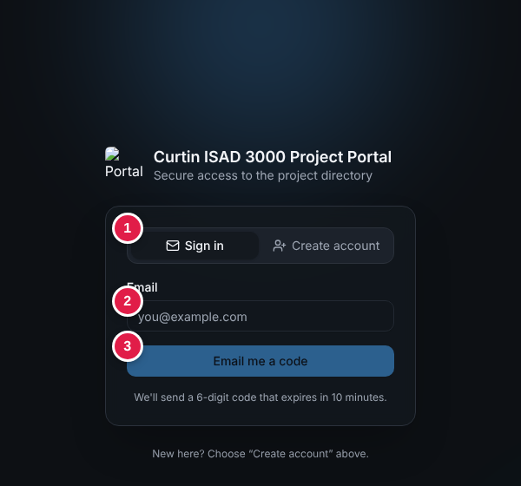
Figure 1 - Sign in tab: (1) tabs, (2) email, (3) Email me a code
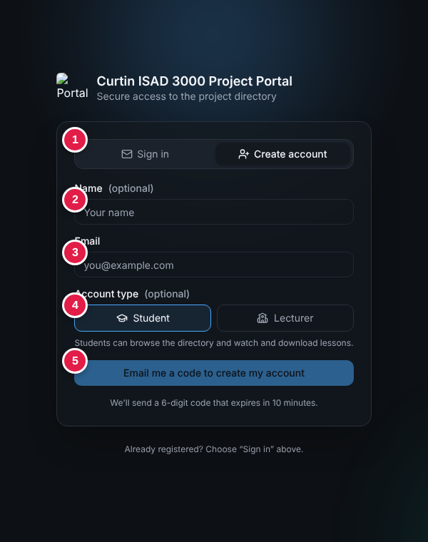
Figure 2 - Create account tab: (1) tabs, (2) name, (3) email, (4) account type, (5) button
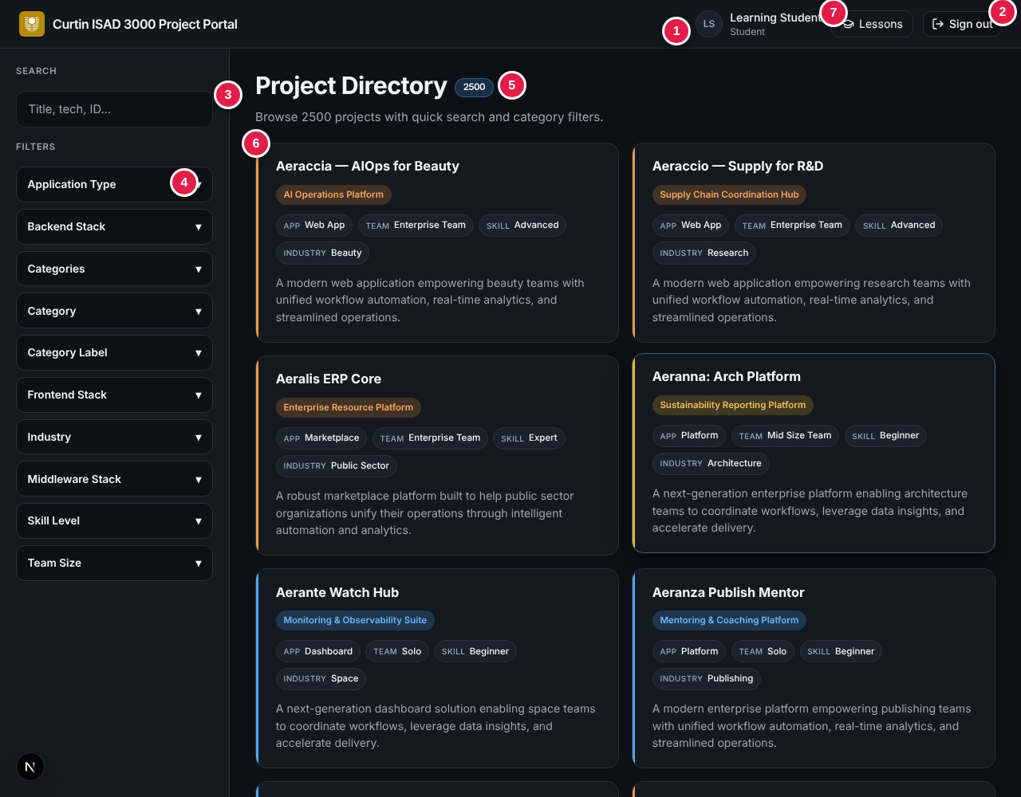
Figure 3 - Project directory: (7) Lessons button in the header
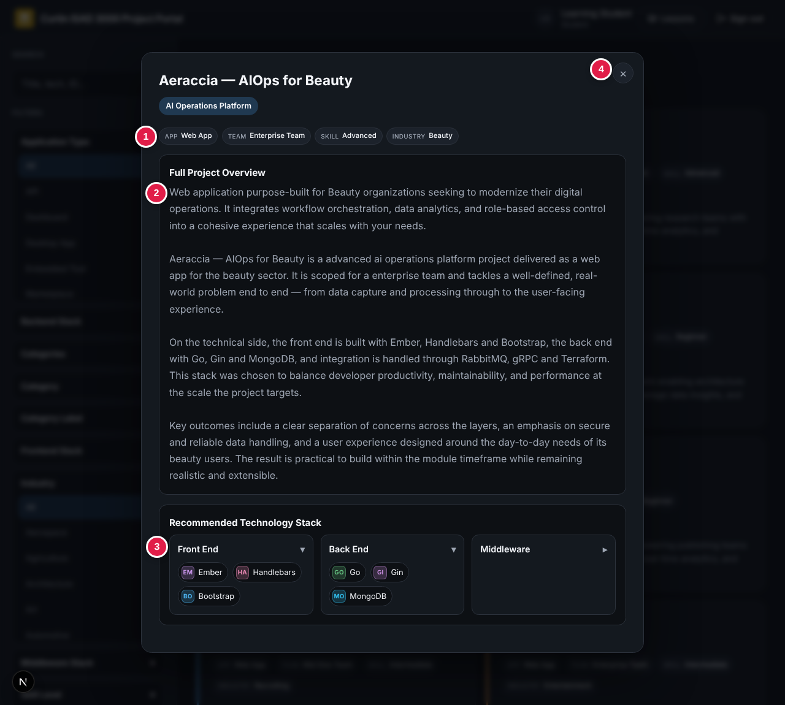
Figure 4 - Project detail window
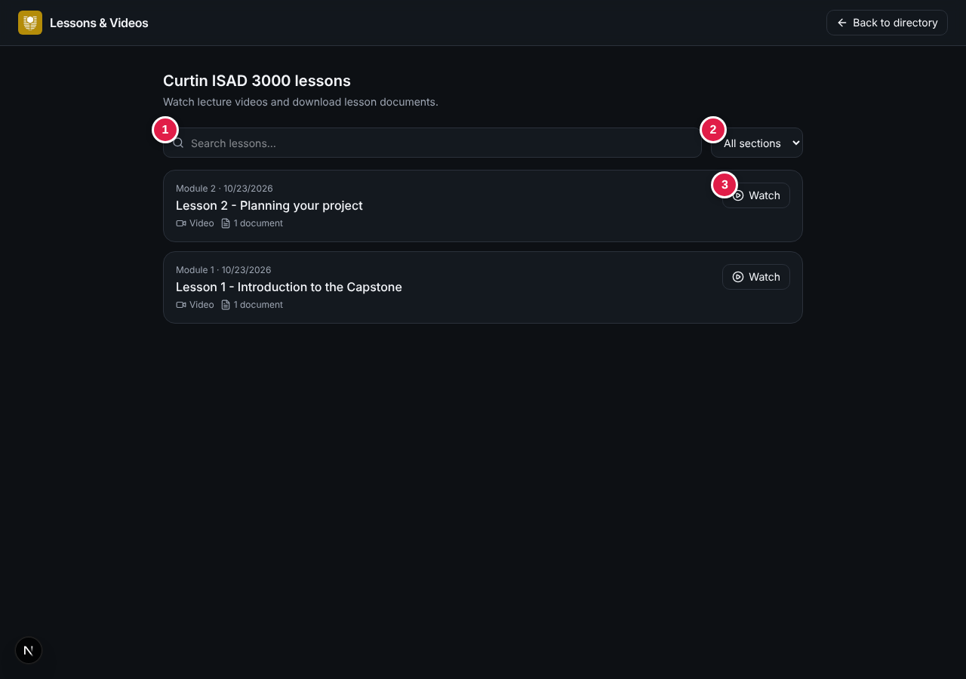
Figure 5 - Lessons (student view)
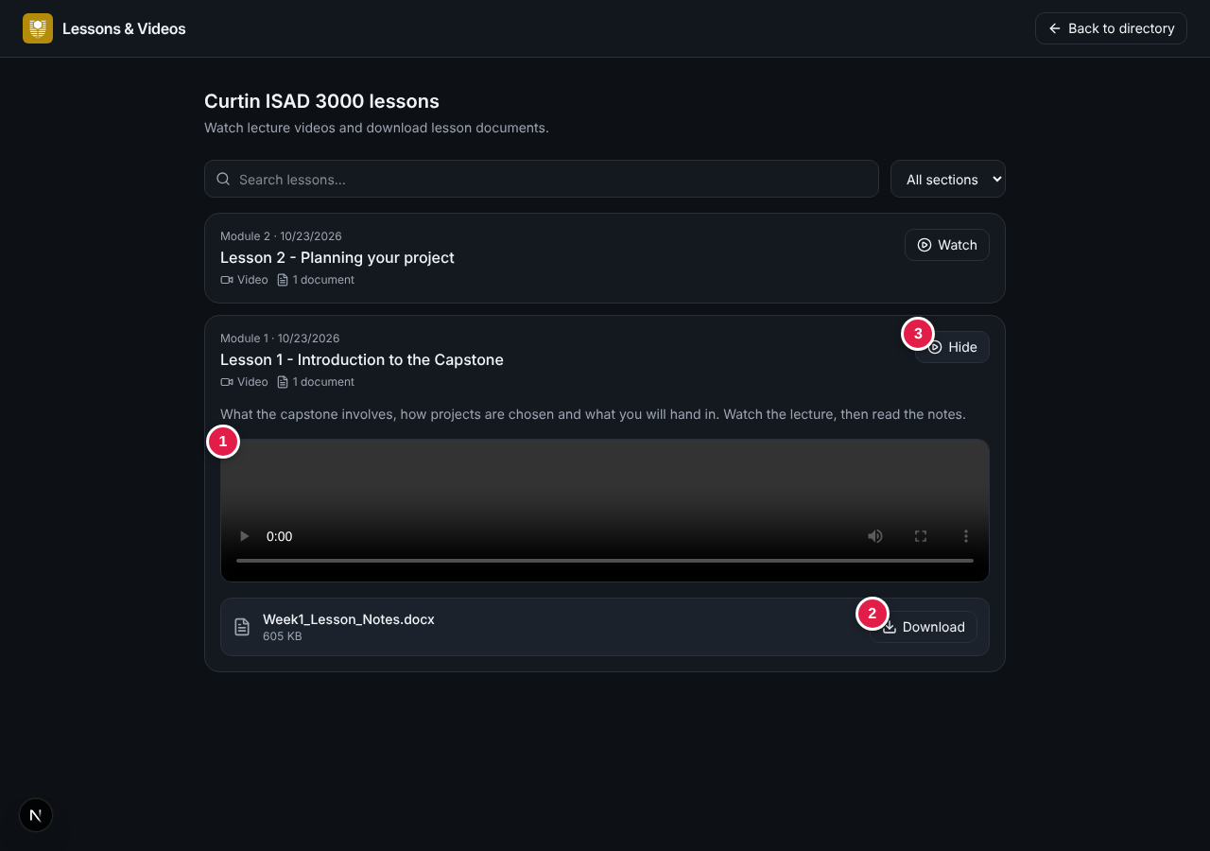
Figure 6 - An open lesson with video player and document
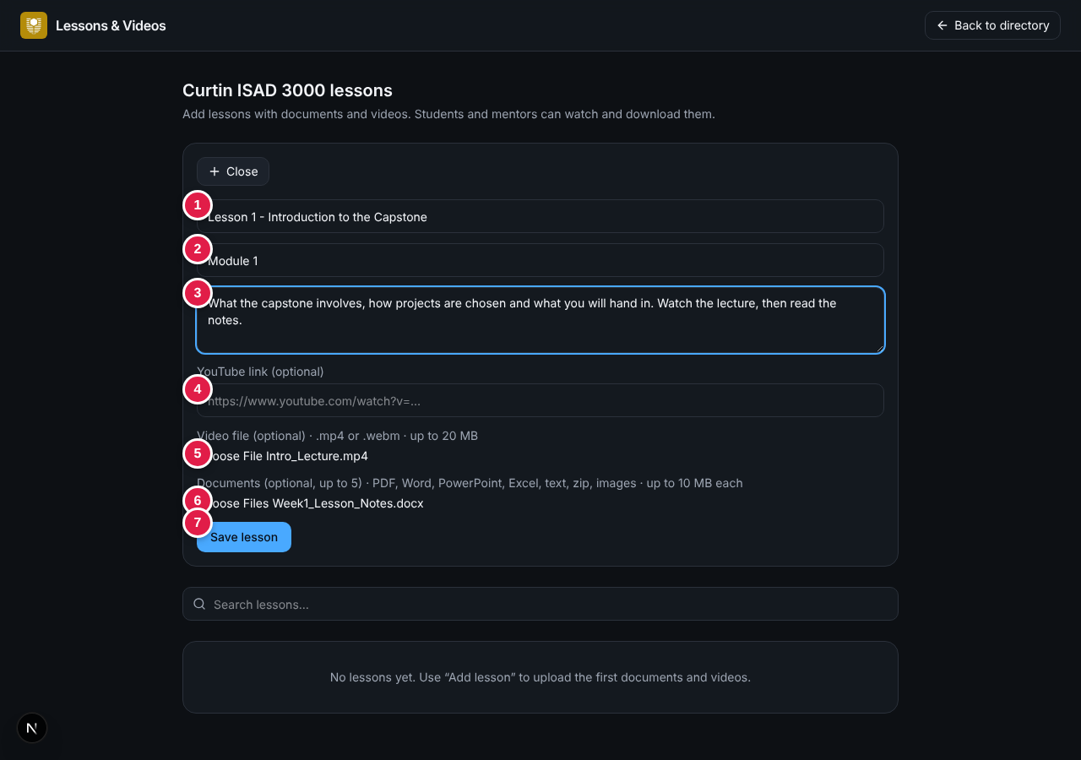
Figure 7 - Lecturer: Add lesson form
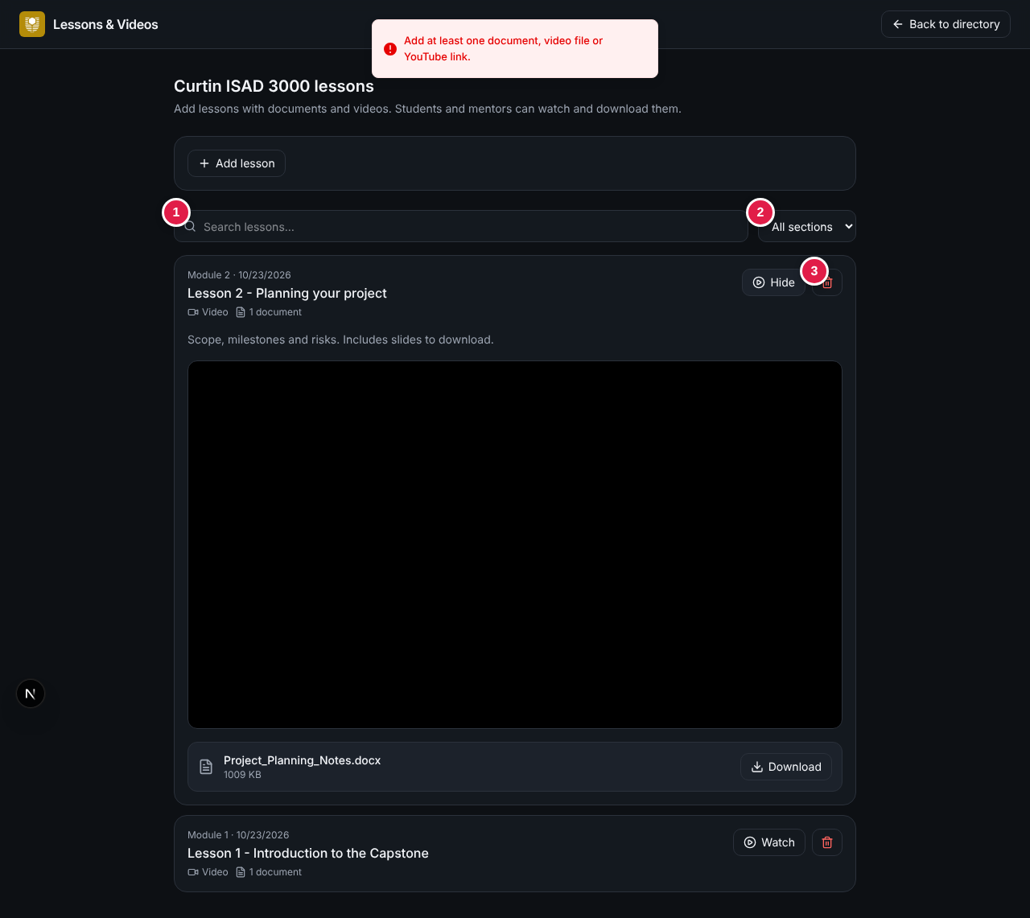
Figure 8 - Lecturer: lessons with search, section list and delete buttons
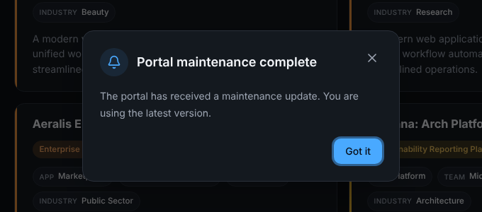
Figure 9 - Maintenance notice

4.2 Application programming interfaces
Method and path | Auth | Request | Success response | Error responses
POST /api/auth/request | Public | JSON { email } | 200 { ok: true } (plus devCode in dev echo); sets otp_challenge cookie | 400 invalid email/body; 429 cooldown; 502 email failure; 500 server error
POST /api/auth/verify | Public | JSON { email, code, mode } (6 digits; mode signin or signup; signup also sends name and role) | 200 { ok: true }; sets portal_session, clears otp_challenge | 400 bad input; 401 incorrect / expired / too many attempts; 404 no account; 409 account exists; 500 database read-only
POST /api/auth/logout | Public | None (form post) | 303 redirect to /login; clears portal_session | -
GET /api/projects | Session | None | 200 JSON array of project objects; Cache-Control: no-store | Redirect to /login without a session
GET /api/lessons | Session | None | 200 { lessons: [...] }, newest first, with file metadata | 401 not signed in; 500 database error
POST /api/lessons | Lecturer | multipart form: title, section, description, youtube, video, documents | 200 { ok: true, id } | 400 validation messages; 401; 403 Lecturer access required; 500 database error
DELETE /api/lessons/{id} | Lecturer | None | 200 { ok: true } | 401; 403; 500
GET /api/lessons/files/{fileId} | Session | Optional Range header | 200 or 206: documents as attachment, videos inline | 401; 404 File not found; 416 bad range
GET /api/health | Public | None | 200 { ok: true, env, version } | -
Table 5 - HTTP interfaces
NOTE
The route guard in proxy.ts runs before the handlers. A request without a valid session to /api/projects is therefore redirected to /login.

4.3 Software and service interfaces
Interface | Protocol | Purpose | Configuration
Resend | HTTPS REST (api.resend.com) | Send sign-in code email | RESEND_API_KEY, EMAIL_FROM
SMTP provider | SMTP 465 (SSL) / 587 (STARTTLS) via Nodemailer | Send sign-in code email | SMTP_HOST, SMTP_PORT, SMTP_USER, SMTP_PASS, EMAIL_FROM
Turso / libSQL | libSQL over HTTPS or local file | User accounts | DATABASE_URL, DATABASE_AUTH_TOKEN
GitHub Actions | Workflow YAML | CI, promotion, AI maintenance | Secrets and variables in repository settings
OpenAI API | HTTPS REST | AI maintenance agent | OPENAI_API_KEY, OPENAI_MODEL

4.4 Communications
All traffic in production shall use HTTPS with HSTS (two years, includeSubDomains, preload). Cookies are exchanged only with the Portal origin.

5. Data requirements

5.1 Database schema
Table | Column | Type | Notes
users | email | TEXT PRIMARY KEY | Lower-case address
 | name | TEXT | Display name
 | role | TEXT | "Lecturer" or "Student"
 | salt, hash | TEXT | Legacy scrypt password fields; unused by the current email-code login
At first use the application creates the table (if missing) and synchronises it from data/users.json (name and role are updated on conflict). Project records are served from the bundled dataset data/projects.json.

5.2 Project record
Field | Type | Description | Example
id | string | Unique project ID | PRJ-0001
title | string | Project name | Hypesco - AIOps for Edu
category / categoryLabel | string | Short category key and its display name (100 distinct values) | Aiops / AI Operations Platform
shortdesc | string | One-sentence summary shown on the card | -
fulldesc | string | Longer description used in the detail window | -
applicationType | string | One of 8: Web App, Mobile App, Desktop App, API, Dashboard, Platform, Marketplace, Embedded Tool | Web App
teamSize | string | Solo, Mid Size Team or Enterprise Team | Solo
skillLevel | string | Beginner, Intermediate, Advanced or Expert | Beginner
industry | string | One of 57 industries (Education, Healthcare, Finance, ...) | Education
frontendStack | string[] | Front-end technologies (17 distinct) | React, Next.js, Tailwind CSS
backendStack | string[] | Back-end technologies (18 distinct) | Node.js, Express, PostgreSQL
middlewareStack | string[] | Middleware / infrastructure (17 distinct) | Redis, Kafka, Docker
categories | string[] | Tags (150 distinct) | Aiops, Education
Table 6 - Project record fields (bundled dataset: 2,500 projects with unique IDs)

5.3 Tokens and cookies
Name | Content | Lifetime | Attributes
portal_session | JWT HS256 with email, name, role, subject = email, issued-at, expiry | 8 hours | HttpOnly, SameSite=Lax, Path=/, Secure (production)
otp_challenge | JWT HS256 with email, h (SHA-256 of email:code:secret), att (attempt count), issued-at | 10 minutes | HttpOnly, SameSite=Lax, Path=/, Secure (production)

5.4 Business rules and constants
Rule | Value
Code length / format | 6 digits, 000000-999999
Code validity | 10 minutes
Maximum wrong attempts per challenge | 5
Resend cooldown | 30 seconds
Session length | 8 hours
Minimum SESSION_SECRET length | 16 characters
Filter eligibility | >= 2 options, options/populated <= 0.6, average option length <= 40 characters
Search relevance | 0.74 x query coverage + 0.26 x filter coverage + 0.12 title bonus

5.5 Lesson and notice data
Table | Column | Type | Notes
lessons | id | TEXT PRIMARY KEY | Random UUID
 | title | TEXT NOT NULL | Up to 160 characters
 | description, section | TEXT | Up to 2,000 and 80 characters
 | youtube_id | TEXT | 11-character YouTube id, or empty
 | created_by, created_at | TEXT NOT NULL | Lecturer email and ISO timestamp
lesson_files | id, lesson_id | TEXT | File id and owning lesson (indexed)
 | kind | TEXT | "document" or "video"
 | filename, mime, size | TEXT, TEXT, INTEGER | Cleaned file name, content type, bytes
 | data | BLOB NOT NULL | File content
Table 7 - Lesson tables (created automatically on first use)
Rule | Value
Documents per lesson / size each | Up to 5 / 10 MB
Document types | pdf, doc, docx, ppt, pptx, xls, xlsx, txt, md, zip, png, jpg, jpeg
Video file / size | One .mp4 or .webm, up to 20 MB
YouTube links accepted | watch, youtu.be, embed, shorts, or a bare 11-character id
Notice file | data/maintenance-notice.json with id, title, message; dismissal stored as portal-maintenance-notice:<email>:<id> in the browser
NOTE
Hosted deployments need a writable libSQL / Turso database (DATABASE_URL, DATABASE_AUTH_TOKEN) for uploaded lessons to persist.

6. Non-functional requirements
ID | Category | Requirement | Priority
NFR-01 | Performance | The directory shall render and respond to search/filter input for 2,500 projects without perceptible delay (target: result update within 1 second on a typical laptop). | Should
NFR-02 | Performance | The login page and the code-request API shall respond within 3 seconds under normal conditions, excluding third-party email delivery time. | Should
NFR-03 | Security | Secrets (SESSION_SECRET, SMTP password, API keys, database token) shall be supplied only through environment variables and shall never be committed to the repository (enforced by an automated test). | Must
NFR-04 | Security | Session and challenge cookies shall be httpOnly and SameSite=Lax, and Secure in production; transport shall be HTTPS with HSTS. | Must
NFR-05 | Security | Authorisation shall be enforced on the server for every protected route and API; hiding a link in the UI shall never be the only control. | Must
NFR-06 | Reliability | The application shall degrade gracefully: database or email failures shall produce a clear message and shall not crash the page. | Must
NFR-07 | Usability | Sign-in shall be completable in three user actions (enter email, open email, enter code) with no password to remember. | Should
NFR-08 | Usability | The interface shall provide immediate feedback through toast notifications for success, errors and network failures. | Should
NFR-09 | Compatibility | The portal shall work on the current versions of Google Chrome, Microsoft Edge, Mozilla Firefox and Apple Safari, and on tablet/phone screen widths. | Must
NFR-10 | Portability | The application shall run on Vercel, any Node.js 20+ host (npm run build && npm start) and Cloudflare Workers (vinext build). | Should
NFR-11 | Maintainability | The code base shall pass npm run check (typecheck, lint, tests, build) in continuous integration before promotion between environments. | Must
NFR-12 | Maintainability | The environment pipeline (dev, test/digital twin, live) shall require explicit human approval for promotion to live. | Must
NFR-13 | Privacy | The test (digital-twin) database shall contain anonymised user emails only. | Must
NFR-14 | Accessibility | Form controls shall have labels and be operable by keyboard; colour shall not be the only means of conveying state. | Should
NFR-15 | Security | Lesson pages, lesson files and the lesson APIs shall be reachable only through a valid session, and changes to lessons only by Lecturers, enforced on the server. | Must
NFR-16 | Compatibility | The Lessons page shall remain usable at phone widths without horizontal scrolling. | Should
NFR-17 | Maintainability | An administrator shall be able to publish a maintenance notice by editing one data file, without changing program code. | Should
NFR-18 | Reliability | Uploads shall be limited (5 documents of 10 MB, one video of 20 MB per lesson) and rejected with a clear message when over the limit. | Must

6.1 Security controls summary
Threat | Control in the Portal
Unauthorised access | Server-side route guard (proxy.ts), signed session JWT.
Code guessing | 6-digit random code, 10-minute validity, 5 attempts per challenge, 30-second resend cooldown.
Code disclosure at rest | Only a salted-by-secret SHA-256 hash is stored, inside a signed cookie.
Account enumeration | Identical response for approved and unapproved emails.
Cookie theft / forgery | HttpOnly, SameSite=Lax, Secure, HS256 signature, expiry.
Clickjacking, MIME sniffing, downgrade | X-Frame-Options DENY, nosniff, HSTS, restrictive Permissions-Policy.
Cross-site scripting | All project text is HTML-escaped before rendering.
Secret leakage | Environment variables only; automated test scans the repository for key patterns.
Unsafe automated change | AI agent limited to a fixed tool set and path allow-list; independent gate re-runs typecheck, lint, tests and build; human approval for live.

7. Environments, configuration and deployment

7.1 Environments
Environment | Git branch | Hosting | Database | Purpose
Development | dev | Preview deployment or npm run dev | Local data/twin.db or Turso portal-dev | Developers and the AI agent make changes.
Test (digital twin) | test | Preview deployment | Turso portal-twin (anonymised copy) | Safe replica; smoke-tested.
Live | main | Production | Turso portal-live | Real users. Promotion needs human approval.
Flow: dev > (CI green) > test > (smoke test green and approval in the GitHub live environment) > main.

7.2 Environment variables
Variable | Required | Purpose
SESSION_SECRET | Yes | Signs sessions and challenges, and is mixed into code hashes. Minimum 16 characters.
RESEND_API_KEY | No | Use the Resend API to send codes.
SMTP_HOST, SMTP_PORT, SMTP_USER, SMTP_PASS | No* | SMTP delivery (port 465 = SSL, otherwise STARTTLS). *Needed if neither Resend nor dev echo is used.
EMAIL_FROM | No | Sender, e.g. "Capstone Portal <address>".
LECTURER_EMAILS | No | Comma-separated emails that may create Lecturer accounts, in addition to lecturers in data/users.json.
ALLOWED_EMAILS | Recommended | Comma-separated list of emails allowed to receive codes. Empty = any valid email.
DATABASE_URL, DATABASE_AUTH_TOKEN | For hosted user store | Hosted libSQL (Turso). Default is file:data/portal.db.
AUTH_DEV_ECHO | Never in production | Returns the code in the response (non-production only).
PORTAL_ENV | No | Environment name returned by the health endpoint.

7.3 Quality gates
- npm run check = TypeScript typecheck, ESLint, automated tests (node --test), production build.
- Automated tests verify unique project IDs and titles, the exact Lecturer list, and that no secrets are committed.
- scripts/smoke.mjs verifies health, login page, security headers, protected projects API on a running environment.

8. Known limitations and recommendations
The following observations were found while reviewing the code base against this specification. They do not stop the Portal meeting its requirements but should be considered for a later release.
# | Observation | Impact | Recommendation
1 | The README still describes a password sign-in (/api/auth/login, demo passwords). The current code has no such route; only email-code sign-in exists. The salt and hash columns are unused. | Documentation is misleading; the demo accounts listed there cannot be used with a password. | Update the README and DEPLOY.md, or remove the unused columns.
2 | The five-attempt limit and 30-second cooldown are held in the challenge cookie. Requesting a new code (after 30 seconds) starts a new challenge with zero attempts, and a client can discard the cookie. | Brute-force protection is per cookie, not per account or IP. | Add server-side rate limiting per email/IP (for example in the database or an edge KV store).
3 | After each wrong code the challenge is re-signed with a fresh 10-minute expiry. | A challenge can stay valid longer than 10 minutes if attempts continue. | Keep the original expiry when incrementing the attempt counter.
4 | When ALLOWED_EMAILS is empty any valid email can obtain a Student session. | Any email owner could browse the directory. | Always set ALLOWED_EMAILS (or require a user-table match) in production.
5 | The email subject and body use the name "Capstone Portal" while the interface uses "Curtin ISAD 3000 Project Portal". | Inconsistent branding. | Align the names.
6 | Dev-only items remain in the repository (allowedDevOrigins IP address, a real address in the README demo table). | Minor information exposure. | Remove before wider distribution.
7 | The logo image on the sign-in page is blocked for signed-out visitors because the route guard also covers /logo.png. | Broken logo on the login screen. | Exclude the logo path in proxy.ts.
8 | .env.example contains a realistic SESSION_SECRET value. | Risk if the value was ever reused. | Replace with a placeholder and rotate the live secret.
9 | Files are stored inside the database (up to 20 MB per video), and the maintenance-notice dismissal is stored per browser only. The login screen text says lecturers can "edit" lessons, but only adding and deleting exist. | Database size grows with videos; the notice can reappear on another device; text promises a missing function. | Move large videos to YouTube or object storage; store dismissals with the account; add an edit function or change the text.
10 | The lecturer Upload link and /admin page for projects are still present in the code. | Inconsistent with the statement that the Portal has no project upload function. | Remove the page and API if not wanted.

9. Requirements traceability
The matrix links each requirement to the UAT test cases that verify it. Requirements without a dedicated test case are verified by inspection or by automated tests, as noted.
Requirement | Area | Verified by (UAT-...)
FR-01 | Access control and routing | AUTH-02, SESS-06
FR-02 | Access control and routing | AUTH-02, AUTH-18
FR-03 | Access control and routing | SESS-04, SESS-05
FR-04 | Email one-time-code sign-in | AUTH-01, AUTH-03, AUTH-04
FR-05 | Email one-time-code sign-in | AUTH-05
FR-06 | Email one-time-code sign-in | AUTH-03, AUTH-12
FR-07 | Email one-time-code sign-in | AUTH-10
FR-08 | Email one-time-code sign-in | AUTH-11, AUTH-12
FR-09 | Email one-time-code sign-in | AUTH-17
FR-10 | Email one-time-code sign-in | AUTH-06, AUTH-20
FR-11 | Email one-time-code sign-in | AUTH-06
FR-12 | Email one-time-code sign-in | AUTH-19
FR-13 | Email one-time-code sign-in | AUTH-03, AUTH-13
FR-14 | Email one-time-code sign-in | AUTH-07, AUTH-08, AUTH-14
FR-15 | Email one-time-code sign-in | AUTH-14
FR-16 | Email one-time-code sign-in | AUTH-15
FR-17 | Email one-time-code sign-in | AUTH-08, AUTH-09
FR-18 | Email one-time-code sign-in | AUTH-10
FR-19 | Email one-time-code sign-in | AUTH-07
FR-20 | Email one-time-code sign-in | AUTH-16
FR-21 | Session management | AUTH-07, SESS-02, SESS-04
FR-22 | Session management | SESS-01
FR-23 | Session management | SESS-07
FR-24 | Session management | SESS-03
FR-25 | Roles and user accounts | Inspection / automated test
FR-26 | Roles and user accounts | AUTH-24, AUTH-29, ROLE-01, ROLE-02
FR-27 | Roles and user accounts | ROLE-03
FR-28 | Roles and user accounts | AUTH-01, AUTH-22
FR-29 | Roles and user accounts | AUTH-22, AUTH-23, AUTH-24
FR-30 | Roles and user accounts | AUTH-26, ROLE-03
FR-31 | Roles and user accounts | AUTH-27
FR-32 | Roles and user accounts | AUTH-24, AUTH-25, AUTH-28
FR-33 | Roles and user accounts | AUTH-30
FR-34 | Roles and user accounts | ROLE-01, ROLE-02, ROLE-04
FR-35 | Project directory | DIR-01
FR-36 | Project directory | DIR-02
FR-37 | Project directory | DIR-03, DIR-04, DIR-05
FR-38 | Project directory | DIR-06, DIR-07
FR-39 | Project directory | DIR-03, DIR-08, DIR-09
FR-40 | Project directory | DIR-10
FR-41 | Project directory | DIR-10, DIR-11, DIR-12, DIR-15
FR-42 | Project directory | DIR-12, DIR-13, DIR-14, DIR-16
FR-43 | Project directory | DIR-07, DIR-17
FR-44 | Project directory | MOD-01, MOD-02, MOD-06
FR-45 | Project directory | MOD-03
FR-46 | Project directory | MOD-04, MOD-05
FR-47 | Project directory | Inspection / automated test
FR-48 | Lessons and videos | LESS-01
FR-49 | Lessons and videos | LESS-02
FR-50 | Lessons and videos | LESS-01, LESS-04
FR-51 | Lessons and videos | LESS-07, LESS-14
FR-52 | Lessons and videos | LESS-15
FR-53 | Lessons and videos | LESS-16
FR-54 | Lessons and videos | LESS-17, LESS-18, LESS-19, LESS-20
FR-55 | Lessons and videos | LESS-03, LESS-04
FR-56 | Lessons and videos | LESS-26
FR-57 | Lessons and videos | AUTH-29, LESS-04, LESS-05, LESS-06
FR-58 | Lessons and videos | LESS-08, LESS-09
FR-59 | Lessons and videos | LESS-07, LESS-10
FR-60 | Lessons and videos | LESS-06, LESS-11, LESS-12, LESS-13
FR-61 | Lessons and videos | LESS-06, LESS-07, LESS-24
FR-62 | Lessons and videos | AUTH-28, LESS-23
FR-63 | Lessons and videos | LESS-21, LESS-22
FR-64 | Lessons and videos | LESS-02, LESS-18, LESS-19
FR-65 | Lessons and videos | LESS-25
FR-66 | Maintenance notice | NOTE-01
FR-67 | Maintenance notice | NOTE-02, NOTE-03, NOTE-04
FR-68 | Maintenance notice | NOTE-01, NOTE-05
FR-69 | Maintenance notice | NOTE-06
FR-70 | Data and platform | Inspection / automated test
FR-71 | Data and platform | Inspection / automated test
FR-72 | Data and platform | Inspection / automated test
FR-73 | Data and platform | PLAT-01, PLAT-03
FR-74 | Data and platform | PLAT-02, PLAT-03
NFR-01 | Performance | DIR-18
NFR-02 | Performance | Inspection
NFR-03 | Security | PLAT-04
NFR-04 | Security | SESS-01, PLAT-02
NFR-05 | Security | SESS-05, SESS-06
NFR-06 | Reliability | AUTH-21, DIR-19
NFR-07 | Usability | PLAT-08
NFR-08 | Usability | AUTH-21
NFR-09 | Compatibility | ROLE-05, LESS-27, PLAT-05, PLAT-06
NFR-10 | Portability | Inspection
NFR-11 | Maintainability | PLAT-04
NFR-12 | Maintainability | PLAT-10
NFR-13 | Privacy | PLAT-09
NFR-14 | Accessibility | PLAT-07
NFR-15 | Security | LESS-02, LESS-23
NFR-16 | Compatibility | LESS-27
NFR-17 | Maintainability | NOTE-05
NFR-18 | Reliability | LESS-11, LESS-13

Appendix A. Role and permission matrix
Capability | Visitor | Student | Lecturer
View login page, request and verify code | Yes | Yes | Yes
View project directory and details | No | Yes | Yes
Search and filter | No | Yes | Yes
Lessons & Videos: browse, watch, download documents | No | Yes | Yes
Add and delete lessons | No | No | Yes
Create an account | Yes | - | -
Be a Lecturer | No | No | Approved emails only
See maintenance notice | No | Yes | Yes
Sign out | - | Yes | Yes
Health endpoint | Yes | Yes | Yes

Appendix B. Message catalogue
Where | HTTP | Message
Request code | 400 | Please enter a valid email address. / Invalid request.
Request code | 429 | Please wait Ns before requesting another code.
Request code | 502 | Email could not be sent. <provider reason>
Request code | 500 | Server error: <reason> (for example, SESSION_SECRET is missing or too short)
Request code (UI) | 200 | If that email has access, a code is on its way.
Verify code | 400 | Enter your email and the 6-digit code.
Verify code | 401 | Incorrect code. / Incorrect code. Please try again.
Verify code | 401 | No code was requested, or it expired. Request a new one.
Verify code | 401 | Too many attempts. Request a new code.
Verify code (UI) | 200 | Signed in.
Any (UI) | - | Network error. Please try again.
Directory (UI) | - | Unable to load project data.
Verify code | 404 | No account found for that email. Create an account first.
Verify code | 409 | An account with this email already exists. Sign in instead.
Verify code | 500 | Could not save the account (database is read-only). Set DATABASE_URL on the server.
Verify code (UI) | 200 | Account created. Welcome! / Account created as a student - Lecturer access needs approval. Ask the portal owner to add your email as a lecturer.
Lessons | 400 | Please enter a title. / Add at least one document, video file or YouTube link. / That does not look like a YouTube link.
Lessons | 400 | You can attach up to 5 documents per lesson. / Document type X is not allowed. / <name> is larger than 10 MB. / Video files must be .mp4 or .webm. / The video is larger than 20 MB...
Lessons | 401 / 403 | Not signed in. / Lecturer access required.
Lessons (UI) | - | Lesson added. / Lesson deleted. / No lessons yet.
Maintenance notice (UI) | - | Portal maintenance complete (title and message from the notice file)

Appendix C. Seeded user accounts
Name | Email | Role
Murphy Choy | murphy.choy@icloud.com | Lecturer
Goladin | goladin@gmail.com | Lecturer
Dang Tran | tranphucdang0709@gmail.com | Student
Demo Account | admin@portal.com | Student
Learning Student | student@portal.com | Student
Course Mentor | mentor@portal.com | Student

Source: data/users.json. The automated test requires the Lecturer list to be exactly the first two accounts.

