CURTIN ISAD 3000 · PROJECT PORTAL
Technical Design and Architecture
Curtin ISAD 3000 Project Portal
Project | Curtin ISAD 3000 Project Portal
Document ID | CP-TDD-001
Version | 1.2
Date | 25 October 2026
Author | Darren
Status | Draft for review
Classification | Internal

How the Curtin ISAD 3000 Project Portal is built: technology, structure, sign-in, account and role design, data stores including lessons and uploaded files, the directory and lessons features, environments, delivery pipeline and security controls.

Document Control

Document information
Document title | Technical Design and Architecture
Document ID | CP-TDD-001
Project | Curtin ISAD 3000 Project Portal
Document type | Technical design document
Version | 1.2
Author | Darren
Date issued | 25 October 2026
Status | Draft for review
Classification | Internal
Intended audience | Developers and technical reviewers

Revision history
Version | Date | Author | Description of change
1.0 | 23 October 2026 | Darren | First issue for the 23 October 2026 maintenance update.
1.1 | 23 October 2026 | Darren | Lecturer-managed lessons and role choice at sign-in.
1.2 | 25 October 2026 | Darren | Reissued for the account change: Sign in and Create account tabs, role stored with the account, approved lecturers.

Review and approval
Role | Name | Signature | Date
Author | Darren |  | 25 October 2026
Reviewer
Approver

Related documents
Document ID | Title
CP-SRS-001 | Software Requirements Specification
CP-UAT-001 | User Acceptance Testing (UAT) Document
CP-UG-001 | User Guide
CP-LG-001 | Login Guide

Table of Contents

1. Purpose and scope
This document describes the design of the Portal so that a new developer can understand, run and extend it. It complements the Software Requirements Specification (CP-SRS-001), which says *what* the Portal must do; this document says *how* it does it.

2. Technology overview
Layer | Technology
Framework | Next.js 16 (App Router), React 19, TypeScript
Styling / UI | Tailwind CSS v4, shadcn/ui, lucide-react icons, sonner toasts, input-otp code boxes
Authentication | Email one-time code; signed cookies using the jose library (HS256)
Data | libSQL / Turso (or local file database): users, projects, lessons and lesson files; bundled JSON for projects and users as fallback
Email | Resend API, SMTP through Nodemailer, or console output (development)
Hosting | Vercel or any Node host, or Cloudflare Workers through vinext
Automation | GitHub Actions (ci, promote, agent-maintenance) and a maintenance agent
Testing | Node test runner (tests/*.test.mjs), smoke script, TypeScript and ESLint checks

3. Architecture

3.1 Logical view
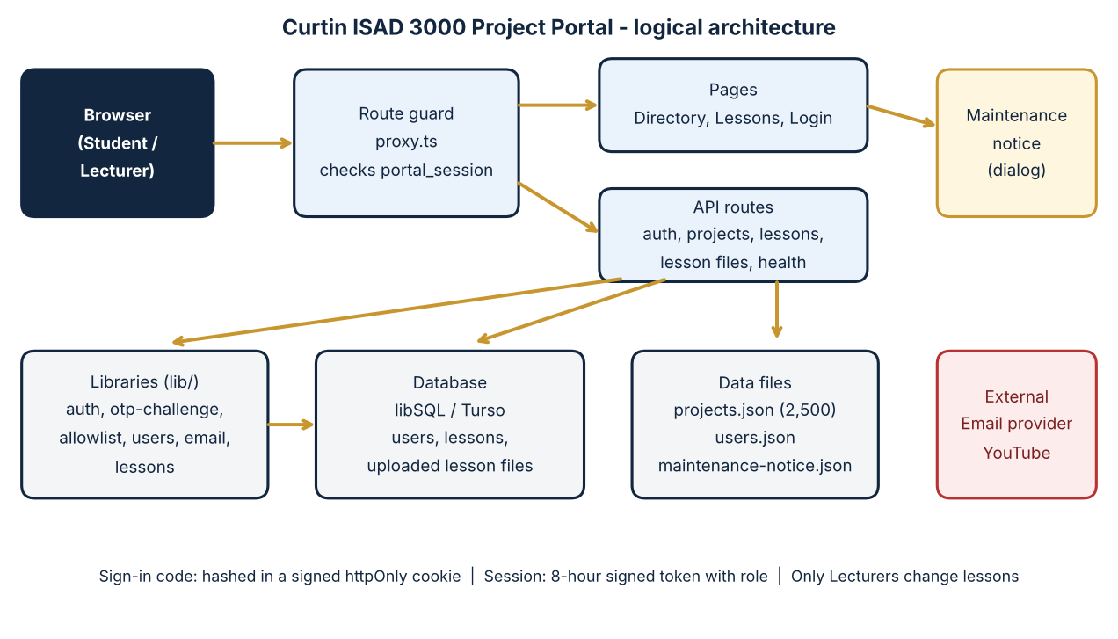
Figure 1 - Logical architecture
Component | Location | Responsibility
Route guard | proxy.ts | Checks the session cookie on every request; sends signed-out visitors to /login. Excludes static assets, /login, /api/auth and /api/health.
Pages | app/page.tsx, app/lessons/page.tsx, app/login, app/admin | Directory (home), Lessons & Videos, sign-in, and the lecturer project-upload page.
UI components | components/directory, lessons, auth, brand, ui, maintenance-notice.tsx | Directory, Lessons browser (with the lecturer form), sign-in form with role choice, maintenance dialog.
API routes | app/api/auth/{request,verify,logout}, projects, health, lessons, lessons/[id], lessons/files/[fileId] | Codes and sessions, project list, health, and lesson list / add / delete / file download.
Libraries | lib/auth, otp-challenge, allowlist, users, email, db, projects-store, lessons | Sessions, challenge cookie, approved emails, users, email, database, lesson schema and rules.
Data | data/projects.json, users.json, maintenance-notice.json; database tables | Content and records.

3.2 Request flow
- The browser requests a page. The route guard reads the portal_session cookie.
- No valid session: redirect to /login. Valid session: the page renders on the server with the user's email and role.
- The Directory fetches /api/projects. The Lessons page renders a client component that calls GET /api/lessons.
- Lesson videos and documents come from /api/lessons/files/{id}; YouTube videos are embedded from youtube.com.
- The maintenance notice is a client dialog driven by data/maintenance-notice.json and browser storage.

4. Sign-in, roles and sessions
Step | Behaviour
Tabs | The login form has Sign in and Create account modes; the mode (and, for sign-up, name and role) is sent with the code.
Request code | POST /api/auth/request validates the email and approved list, applies a 30 s cooldown, creates a random 6-digit code, stores only its SHA-256 hash (with email and expiry) in a signed httpOnly otp_challenge cookie (10 minutes) and sends the email. The reply is identical for known and unknown addresses.
Verify code | POST /api/auth/verify re-hashes the typed code, allows 5 attempts, then branches on mode. signin: the user must exist (otherwise 404 "No account found..."); the session uses the stored role. signup: an existing user gives 409; otherwise lib/users.ts createUser inserts the user (name defaults to the part before @). Role is Lecturer only if requested and isApprovedLecturer is true (role Lecturer in the bundled user list, or listed in LECTURER_EMAILS); otherwise Student and the response carries lecturerDenied so the page can explain.
Session | portal_session JWT (HS256), httpOnly, 8 hours, containing email, name and the role stored with the account. Signed with SESSION_SECRET (16+ characters).
Sign out | POST /api/auth/logout clears the cookie.
Email delivery | Resend API, then SMTP/Nodemailer, then console. AUTH_DEV_ECHO=1 (development only) returns the code in the response.
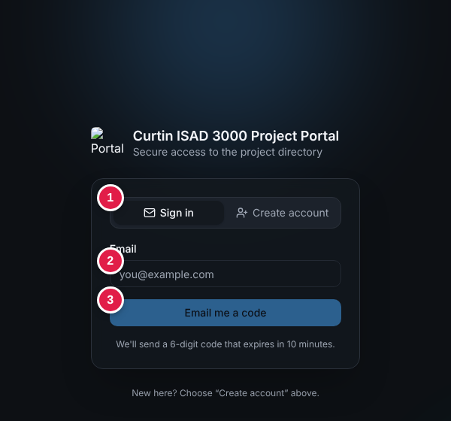
Figure 2 - Sign in tab
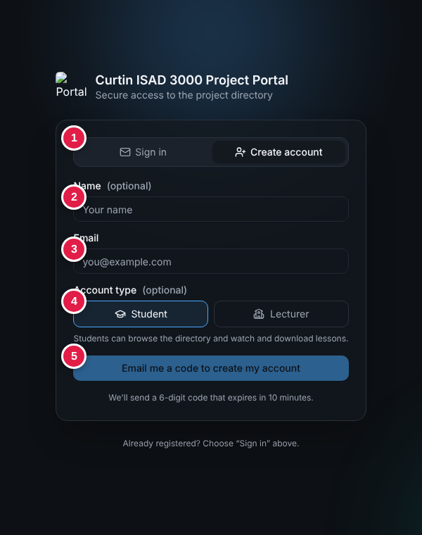
Figure 3 - Create account tab
NOTE
Authorisation is decided on the server from the signed role in the session. Hiding buttons is only a convenience; the lesson APIs check the role themselves.

5. Features

5.1 Project Directory
- 2,500 projects served by /api/projects; filter groups are generated from the data (ten groups); filters combine with AND; the search box ranks results; a detail window shows overview and technology stack.

5.2 Lessons & Videos
- Storage: tables lessons (title, description, section, youtube_id, created_by, created_at) and lesson_files (kind document or video, filename, mime, size, data BLOB). Created automatically by lib/lessons.ts on first use.
- List: GET /api/lessons returns lessons newest first with file metadata (any signed-in user).
- Add: POST /api/lessons (multipart form, Lecturer only) validates the title, at least one item, the YouTube link (watch, youtu.be, embed, shorts or bare id), up to 5 documents of 10 MB from an allowed type list, and one .mp4/.webm video up to 20 MB; stores the lesson and files in one batch.
- Delete: DELETE /api/lessons/{id} (Lecturer only) removes the files and the lesson.
- Files: GET /api/lessons/files/{id} (signed in): documents download as attachments; videos are served inline with byte-range support so players can seek.
- UI: components/lessons/lessons-browser.tsx - search (title, description, section), section list, expandable cards, YouTube iframe or video element, document cards with Download, lecturer form and trash button, empty states, toasts.
- Hosting note: a read-only host cannot save uploads; the API returns the error with a hint to set DATABASE_URL and DATABASE_AUTH_TOKEN.
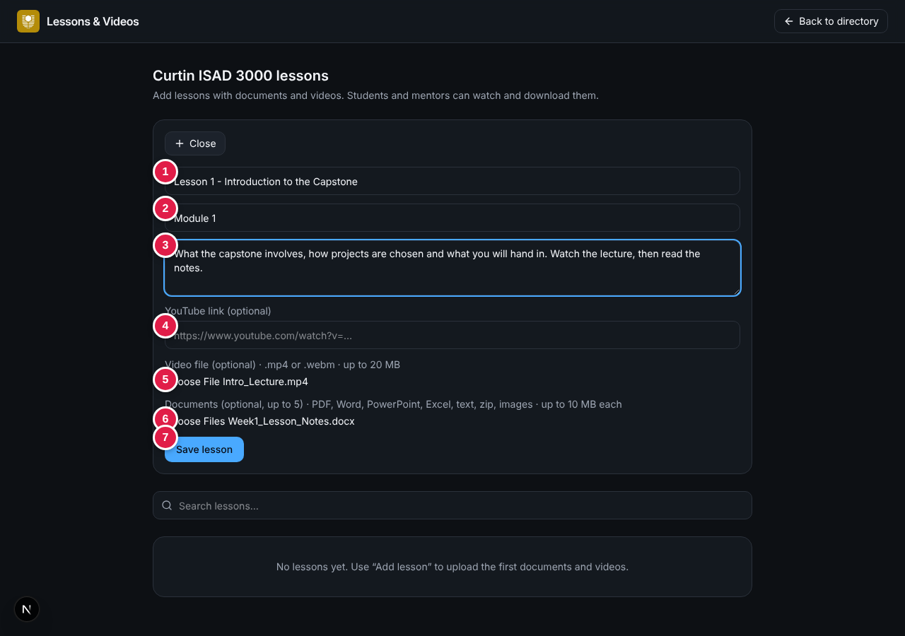
Figure 4 - Lecturer form
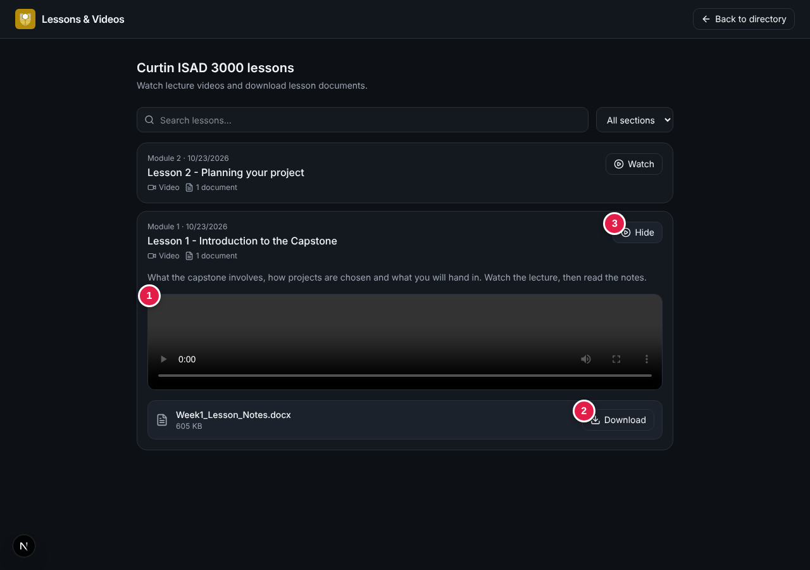
Figure 5 - Student view

5.3 Maintenance notice
- data/maintenance-notice.json: { id, title, message }; components/maintenance-notice.tsx shows a modal dialog keyed by account email and notice id.
- Dismissal (Got it, X or Escape) stores "dismissed" in localStorage under portal-maintenance-notice:{email}:{id}. A new id shows the notice again to everyone.
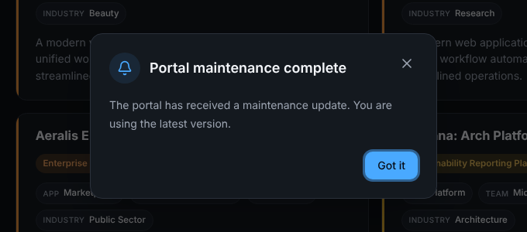
Figure 6 - Maintenance notice

6. Data design
Store | Content | Notes
users | Email, name, role (stored with the account) | Seeded from data/users.json; new rows added by Create account; fallback file if the database is down.
projects.json | 2,500 project ideas | Read-only in normal use.
lessons, lesson_files | Lessons and their uploaded files | Written by lecturers through the API; files stored as BLOBs.
maintenance-notice.json | One notice | Edited after each maintenance.
Browser localStorage | Notice dismissals | Per browser and account.

7. Environments and delivery
Environment | Purpose | Notes
Development | Local work | npm run dev; AUTH_DEV_ECHO=1 shows the code on screen.
Test (digital twin) | Safe copy for checking changes | twin:dev uses a separate database; test address https://capstone-portal-test.tranphucdang0709.workers.dev/
Live | Real users | Real email, approved list on, AUTH_DEV_ECHO unset, writable libSQL / Turso database.
GitHub Actions: ci runs type check, lint, tests and build; promote moves a tested change from test to live; agent-maintenance supports the maintenance agent. npm run check runs typecheck, lint, test and build.

8. Security design
Control | Implementation
No stored passwords | Passwordless sign-in.
Code protection | Hash only; signed httpOnly cookie; 10-minute expiry; 5 attempts; 30 s cooldown.
Account privacy | Identical response for known and unknown emails.
Roles | Lecturer role granted only to approved emails (user list or LECTURER_EMAILS) at account creation; lesson changes require the Lecturer role on the server.
Uploads | File type allow-list, size and count limits, cleaned file names, X-Content-Type-Options nosniff, documents served as downloads.
Sessions | Signed JWT, httpOnly, 8 hours; every route and lesson API requires it.
Secrets | Environment variables only; a test checks that no secrets are committed. SESSION_SECRET must be unique per environment.
Headers / transport | HTTPS with HSTS, frame denial and other security headers.

9. Known limitations and suggestions
- Logo is blocked for signed-out users on the sign-in page (guard exclusion missing).
- Sample .env.example contains a realistic secret; replace and rotate.
- Videos in the database can be large; prefer YouTube links or object storage.
- Lecturer text mentions "edit" but only add and delete exist.
- Notice dismissal is per browser; move to the user store if needed.
- The project upload page (/admin) is still in the code base.

