CURTIN ISAD 3000 · PROJECT PORTAL
Deployment and Administration Guide
Curtin ISAD 3000 Project Portal
Project | Curtin ISAD 3000 Project Portal
Document ID | CP-DAG-001
Version | 1.1
Date | 23 October 2026
Author | Darren
Status | Draft for review
Classification | Internal

Practical steps to run, configure and maintain the Curtin ISAD 3000 Project Portal: settings, approved users and lecturers, lesson management and storage, the maintenance notice, deployment, checks and troubleshooting.

Document Control

Document information
Document title | Deployment and Administration Guide
Document ID | CP-DAG-001
Project | Curtin ISAD 3000 Project Portal
Document type | Handover guide for administrators
Version | 1.1
Author | Darren
Date issued | 23 October 2026
Status | Draft for review
Classification | Internal
Intended audience | Project owner and administrators

Revision history
Version | Date | Author | Description of change
1.0 | 23 October 2026 | Darren | First issue for the 23 October 2026 maintenance update.
1.1 | 23 October 2026 | Darren | Reissued for the later 23 October 2026 changes: lecturer-managed lessons, Student / Lecturer sign-in choice.

Review and approval
Role | Name | Signature | Date
Author | Darren |  | 23 October 2026
Reviewer
Approver

Related documents
Document ID | Title
CP-SRS-001 | Software Requirements Specification
CP-UAT-001 | User Acceptance Testing (UAT) Document
CP-UG-001 | User Guide
CP-LG-001 | Login Guide

Table of Contents

1. Overview
This guide is for the people who look after the Portal. It lists every setting, the routine jobs (add a user or lecturer, manage lessons, announce maintenance), how a change goes live and what to do when something breaks.
Test address: https://capstone-portal-test.tranphucdang0709.workers.dev/

2. Settings (environment variables)
Setting | Required | Purpose
SESSION_SECRET | Yes | Long random string (16+ characters) that signs sessions. Use a different value for test and live. Generate: node -e "console.log(require('crypto').randomBytes(32).toString('hex'))".
ALLOWED_EMAILS | Live: yes | Comma-separated approved addresses. Empty means anyone with a valid email can sign in (as a Student) - never leave empty on live.
RESEND_API_KEY | One email method | Sends sign-in emails through Resend.
SMTP_HOST, SMTP_PORT, SMTP_USER, SMTP_PASS | One email method | Sends through any SMTP provider (Gmail app password, SendGrid, Brevo).
EMAIL_FROM | Recommended | Sender shown in the email. Default: Capstone Portal <no-reply@alionova.online>.
DATABASE_URL, DATABASE_AUTH_TOKEN | Live: yes | Writable libSQL / Turso database. Needed for lesson uploads to persist on hosted deployments.
AUTH_DEV_ECHO | Never on live | Development only. Shows the code on screen and skips email.
WARNING
Keep real values only in the host's secret settings or a local .env.local file that is not committed. Do not copy real secrets into .env.example.

3. Users, students and lecturers

3.1 Add or remove someone
- Add the person's email to ALLOWED_EMAILS (or remove it to block them).
- Add or edit their entry in data/users.json (name and role).
- Redeploy so the change takes effect, then ask the person to sign in once to confirm.

3.2 Who can be a lecturer
Users choose Student or Lecturer on the sign-in page. Lecturer works only for emails whose role in data/users.json is Lecturer; anyone else sees "This email is not registered as a lecturer. Sign in as a student, or ask the portal owner to add you as a lecturer." To make someone a lecturer, set their role to Lecturer in data/users.json (and keep them in ALLOWED_EMAILS) and redeploy.
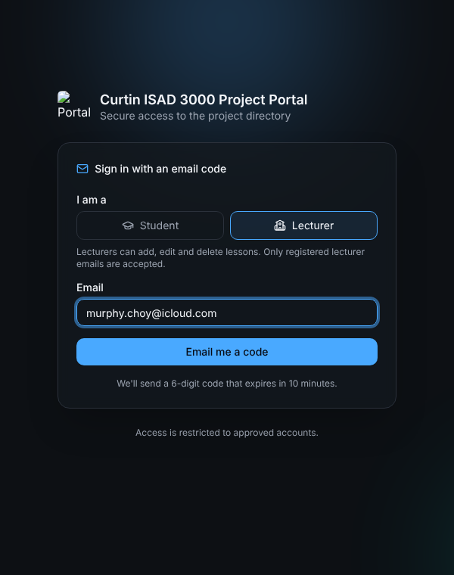
Sign-in page with Lecturer chosen
Role | What they can do
Student (everyone) | Search and filter projects, read details, browse lessons, watch videos, download documents.
Lecturer | Everything a student can, plus add lessons (documents, video file, YouTube link) and delete lessons.

4. Sign-in email
- Set one email method (Resend key or SMTP details) and EMAIL_FROM.
- Request a code for a test address; the email "Your Capstone Portal sign-in code" should arrive within a minute.
- If no email is configured, codes are only printed in the server log - fine for development, not for live.

5. Announce maintenance (maintenance notice)
- Open data/maintenance-notice.json.
- Change id to a new unique value, for example 2026-11-05-portal-maintenance. The same id as before means nobody sees it again.
- Change title (short) and message (one or two sentences).
- Save, run npm test, and deploy.
- Sign in as a user who has not seen it and confirm the dialog appears; click Got it and confirm it does not return.
Field | Example
id | 2026-10-23-portal-maintenance
title | Portal maintenance complete
message | The portal has received a maintenance update. You are using the latest version.
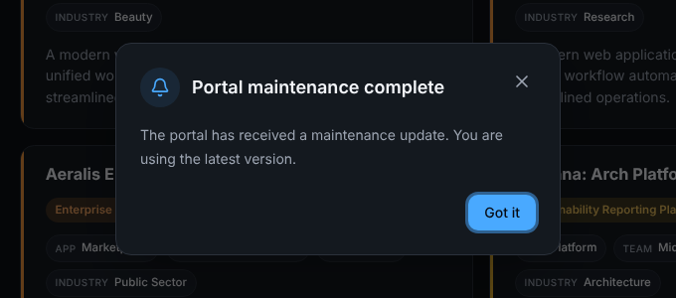
What users see

6. Manage lessons
Lessons are managed in the Portal itself by lecturers; no file editing or release is needed. Everything is stored in the database (tables lessons and lesson_files).

6.1 Add a lesson (lecturer)
- Sign in with the Lecturer option and open Lessons.
- Click Add lesson and enter a title (required), an optional section such as "Module 3", and a description.
- Add a YouTube link, a video file (.mp4 or .webm up to 20 MB) and/or up to five documents (10 MB each).
- Click Save lesson. "Lesson added." appears and the lesson is listed first for everyone.
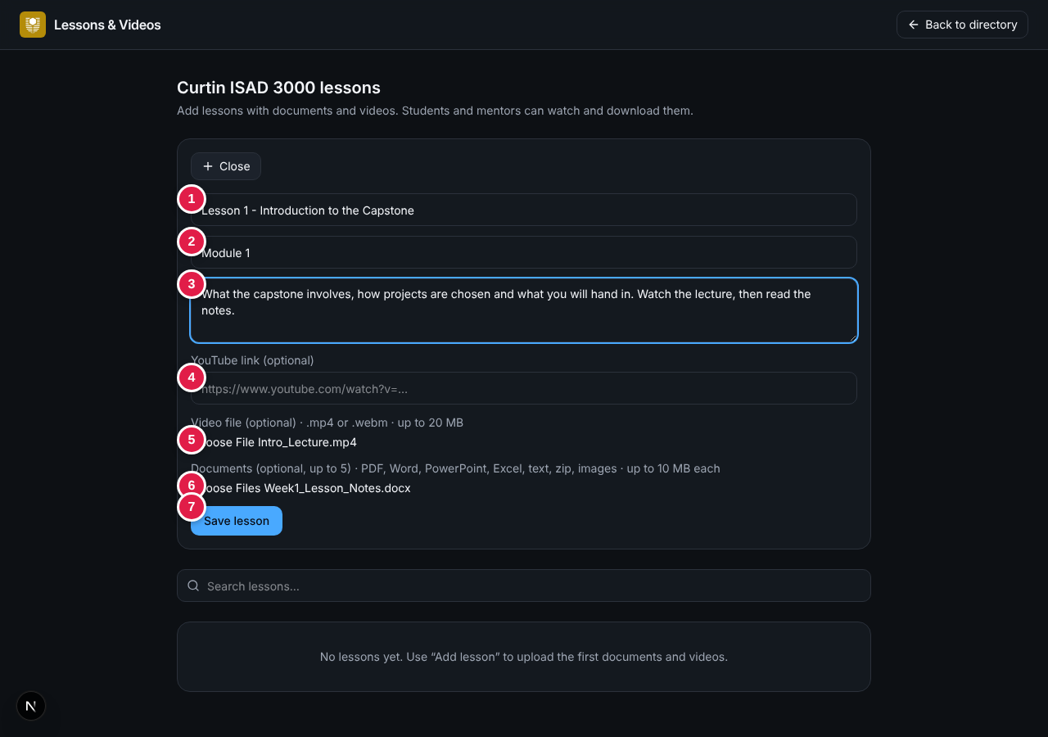
Add lesson form

6.2 Delete a lesson
Click the trash button on the lesson and confirm. The lesson and all its files are removed for everyone and cannot be recovered.
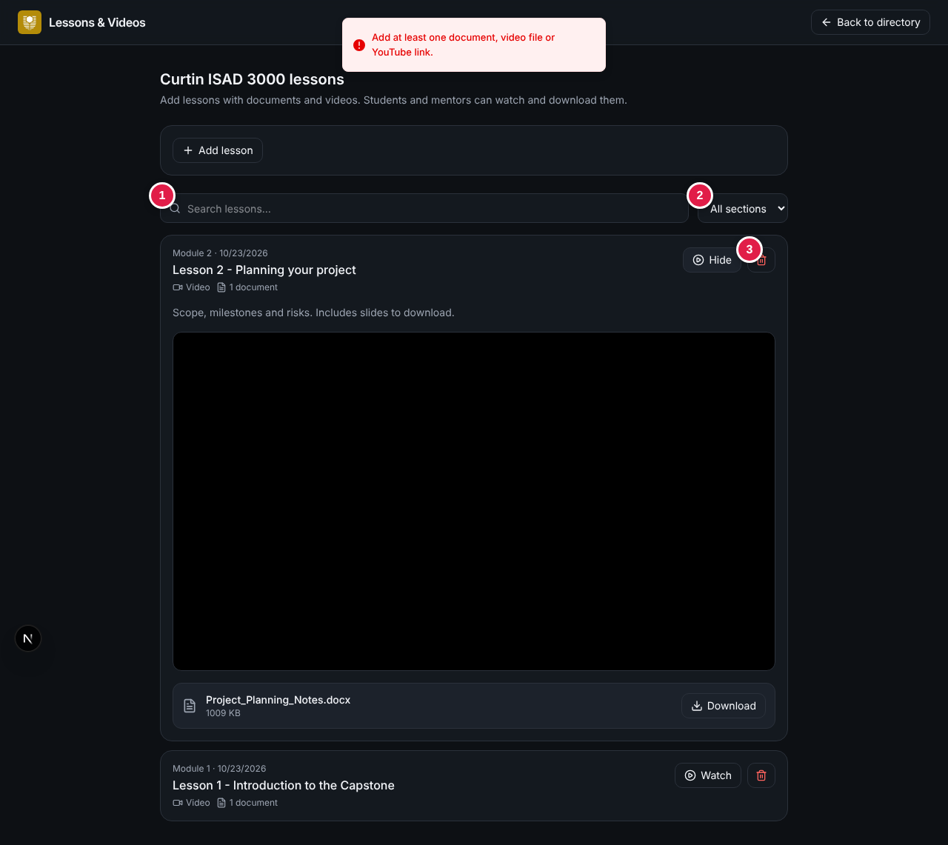
Lecturer view with delete buttons (3)

6.3 Limits and storage
Item | Limit
Documents | Up to 5 per lesson, 10 MB each; PDF, Word, PowerPoint, Excel, text, Markdown, zip, PNG, JPEG
Video file | One per lesson, .mp4 or .webm, up to 20 MB. For longer videos use a YouTube link.
Where files live | Inside the database as binary data - the database grows with every upload
Hosting | A read-only host cannot save lessons; set DATABASE_URL and DATABASE_AUTH_TOKEN to a writable libSQL / Turso database
TIP
Back up the database before large clean-ups; deleted lessons cannot be restored from the Portal.

7. Deploy a change
Step | Action
1 | Make the change on a branch (data file edits are changes too).
2 | Run npm run check (type check, lint, tests, build). Fix anything that fails.
3 | Push. GitHub Actions ci repeats the checks.
4 | Check the change at the test address.
5 | Run the promote workflow to release to live.
6 | Confirm live with the quick checks in section 8.
Hosting options: Vercel or any Node host (npm run build, npm start), or Cloudflare Workers through vinext (npm run build:vinext, npm run deploy:vinext). Set all environment variables in the host before the first release.

8. Routine checks
Check | How | Expected
Health | Open /api/health | A success response.
Sign-in (student) | Request a code with an approved email, choose Student | Email arrives; code signs in.
Sign-in (lecturer) | Choose Lecturer with a registered lecturer email | Signed in as Lecturer.
Directory | Sign in | "2500" shown; search and filters work.
Lessons | As lecturer add a test lesson, as student watch and download, then delete it | Each step works.
Notice | First sign-in after a new id | Dialog appears once.
Smoke test | npm run test:smoke | Passes.
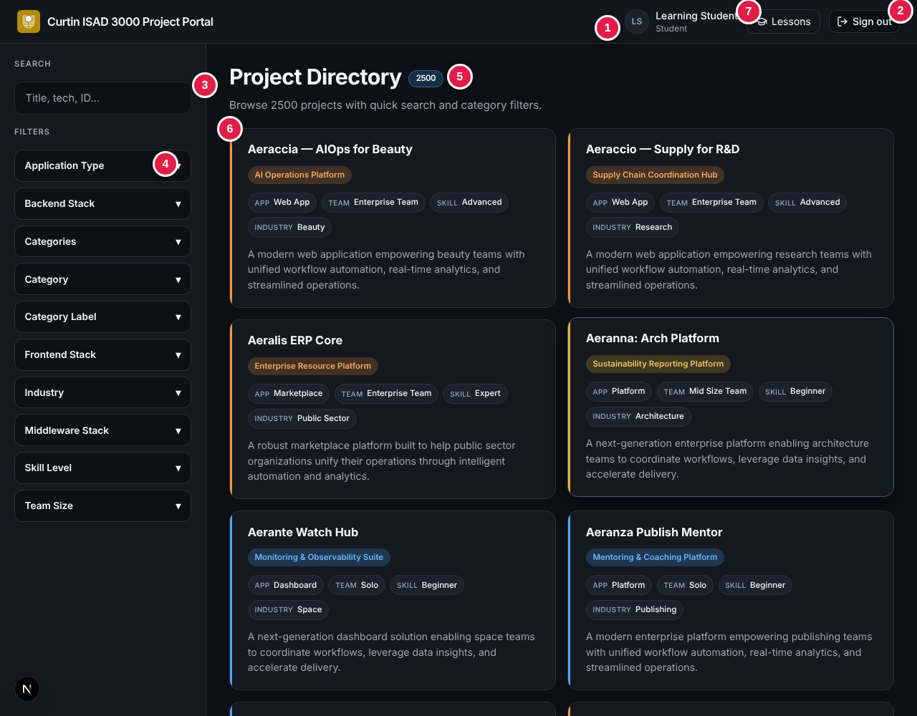
Directory after a successful release

9. Troubleshooting
Problem | Likely cause | Fix
"Server error" at sign-in | SESSION_SECRET missing or too short | Set it (16+ characters) and redeploy.
No sign-in email | No email method, wrong credentials, address not approved, spam folder | Check settings, ALLOWED_EMAILS and the provider log.
"Not registered as a lecturer" | Role in data/users.json is not Lecturer | Set the role, redeploy; or sign in as Student.
No Add lesson button | Signed in as Student | Sign out and choose Lecturer.
Lesson will not save (error with database hint) | Database read-only or not configured | Set DATABASE_URL and DATABASE_AUTH_TOKEN.
"The video is larger than 20 MB" | File over the limit | Upload to YouTube and paste the link.
Lessons vanish after a redeploy | Local file database used on a host that resets its disk | Use a hosted libSQL / Turso database.
Everyone is sent back to sign-in | SESSION_SECRET changed | Expected after a change; users sign in again.
Notice does not appear | Same id already dismissed | Use a new id.
Logo missing on sign-in page | Route guard blocks /logo.png | Exclude the logo path in proxy.ts.

10. Security reminders
- Use a unique SESSION_SECRET per environment and rotate it if it may have been shared. The sample .env.example holds a realistic value - replace it with a placeholder and rotate the live secret.
- Never enable AUTH_DEV_ECHO on live.
- Keep ALLOWED_EMAILS and lecturer roles up to date; remove people who leave the course.
- Never commit .env.local or provider keys.

11. Related documents
Document | ID
Software Requirements Specification | CP-SRS-001
User Acceptance Testing | CP-UAT-001
User Guide | CP-UG-001
Login Guide | CP-LG-001
Release Notes | CP-RN-001
Technical Design and Architecture | CP-TDD-001

