CURTIN ISAD 3000 · PROJECT PORTAL
Login Guide
Curtin ISAD 3000 Project Portal
Project | Curtin ISAD 3000 Project Portal
Document ID | CP-LG-001
Version | 3.0
Date | 23 October 2026
Author | Darren
Status | Draft for review
Classification | Internal

How to sign in to the Curtin ISAD 3000 Project Portal with an emailed 6-digit code, what each message means, and how to fix the most common problems.

Document Control

Document information
Document title | Login Guide
Document ID | CP-LG-001
Project | Curtin ISAD 3000 Project Portal
Document type | Short illustrated sign-in guide
Version | 3.0
Author | Darren
Date issued | 23 October 2026
Status | Draft for review
Classification | Internal
Intended audience | All users; the last section is for administrators

Revision history
Version | Date | Author | Description of change
1.0 | 21 October 2026 | Darren | First full-length version.
2.0 | 21 October 2026 | Darren | Shortened and rebuilt with screenshots of the Portal.
3.0 | 23 October 2026 | Darren | Added the Student / Lecturer choice and lecturer messages.

Review and approval
Role | Name | Signature | Date
Author | Darren |  | 23 October 2026
Reviewer
Approver

Related documents
Document ID | Title
CP-SRS-001 | Software Requirements Specification
CP-UAT-001 | User Acceptance Testing (UAT) Document
CP-UG-001 | User Guide
CP-LG-001 (this document) | Login Guide

1. How sign-in works
Portal address: https://capstone-portal-test.tranphucdang0709.workers.dev/
There is no password. You enter your email, the Portal emails you a 6-digit code, and you type it in. Each code works once and lasts 10 minutes. You then stay signed in for 8 hours.
1 | 2 | 3 | 4
Choose Student or Lecturer, enter your email | Click "Email me a code" | Read the code in your email | Type the 6 digits

NOTE
Only approved email addresses receive a code. Ask your lecturer if you are unsure which address is approved.

2. Step by step

Step 1 - Enter your email
Open the Portal address. Under I am a (1) keep Student or choose Lecturer. Click the Email box (2), type your address, then click Email me a code (3). The button is grey until you type something.
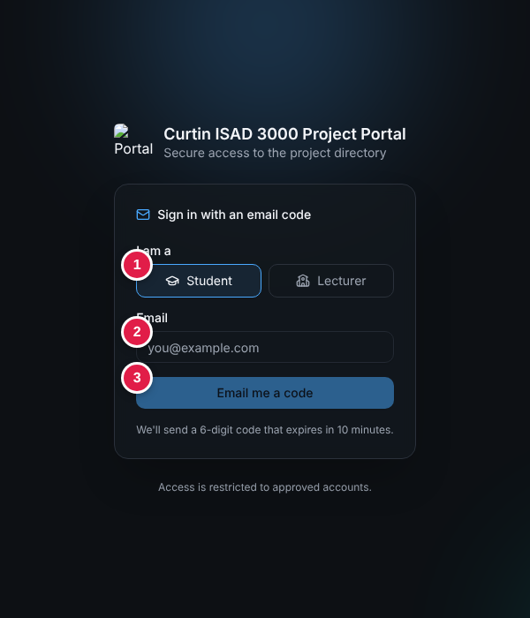
Sign-in page: (1) Student or Lecturer, (2) email, (3) Email me a code
NOTE
Lecturer is only for emails registered as lecturers. Choosing it shows: "Lecturers can add, edit and delete lessons. Only registered lecturer emails are accepted."
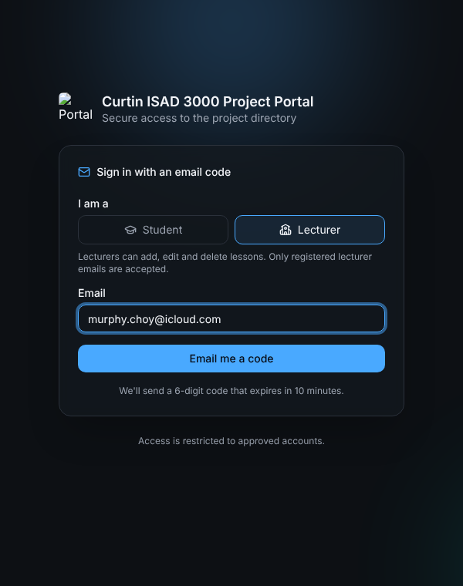
Lecturer option selected

Step 2 - Get the code
A green message says "If that email has access, a code is on its way." (the same message appears for every address). Open your mailbox and find:
Subject: Your Capstone Portal sign-in code: 482915

The email shows a large 6-digit code. It normally arrives within a minute; check Spam / Junk if not. Only the newest code works.

Step 3 - Type the code
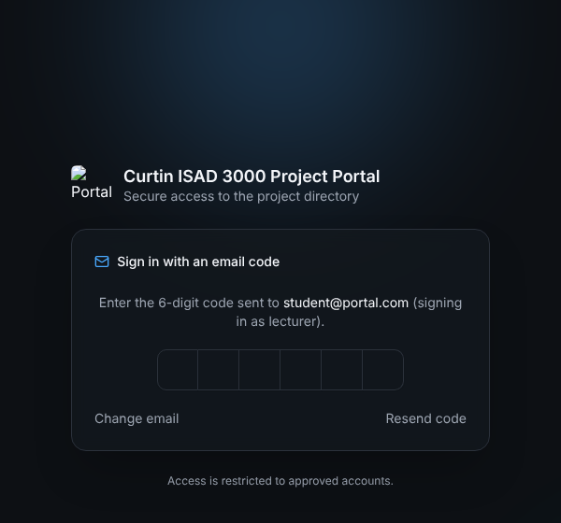
Code step: it repeats your role, for example "(signing in as student)"
Click the first box and type all six digits (or paste them). The Portal checks the code automatically on the sixth digit - there is no button to press.
Link | Use it when
(1) Change email | You typed the wrong address.
(2) Resend code | The email did not arrive or the code expired. Wait 30 seconds between requests.

Step 4 - You are in
A green "Signed in." message appears and the Project Directory opens. Your name and role are at the top right.
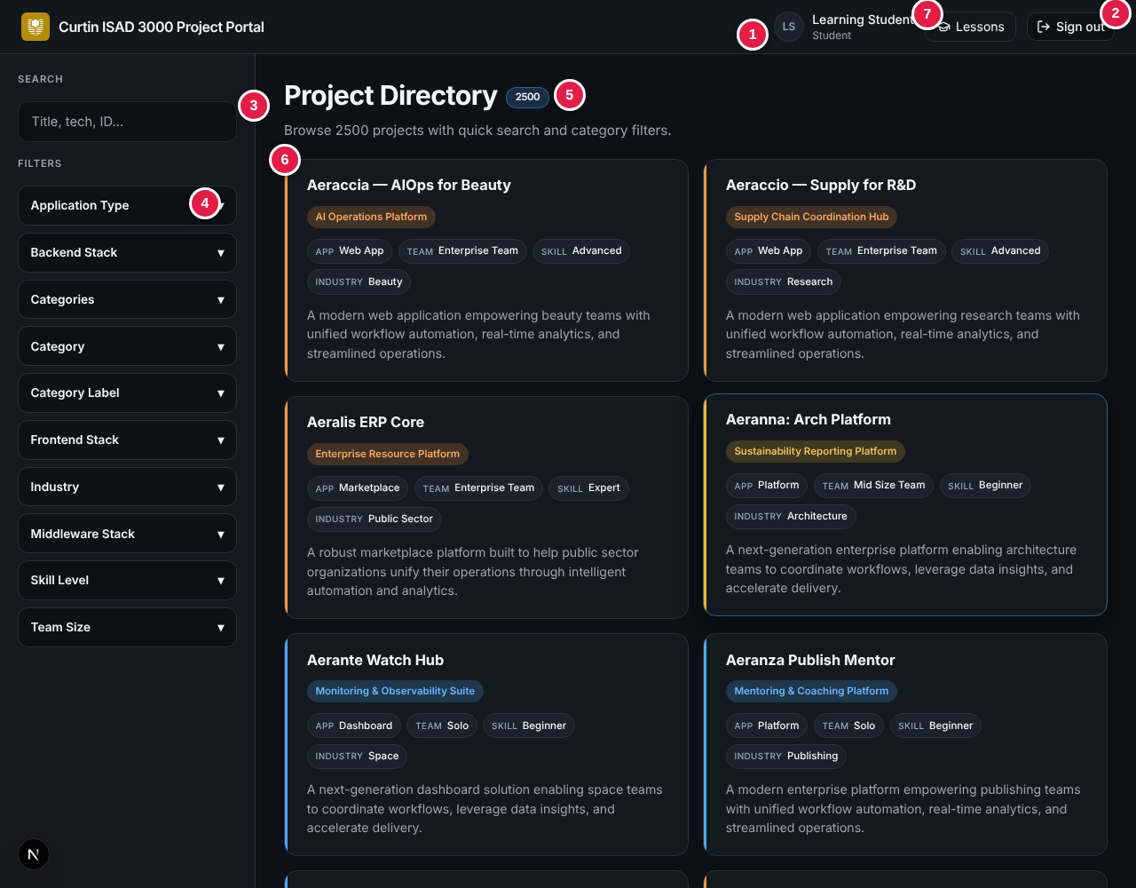
Signed in: the directory opens with your name and role top right

If you are not a registered lecturer
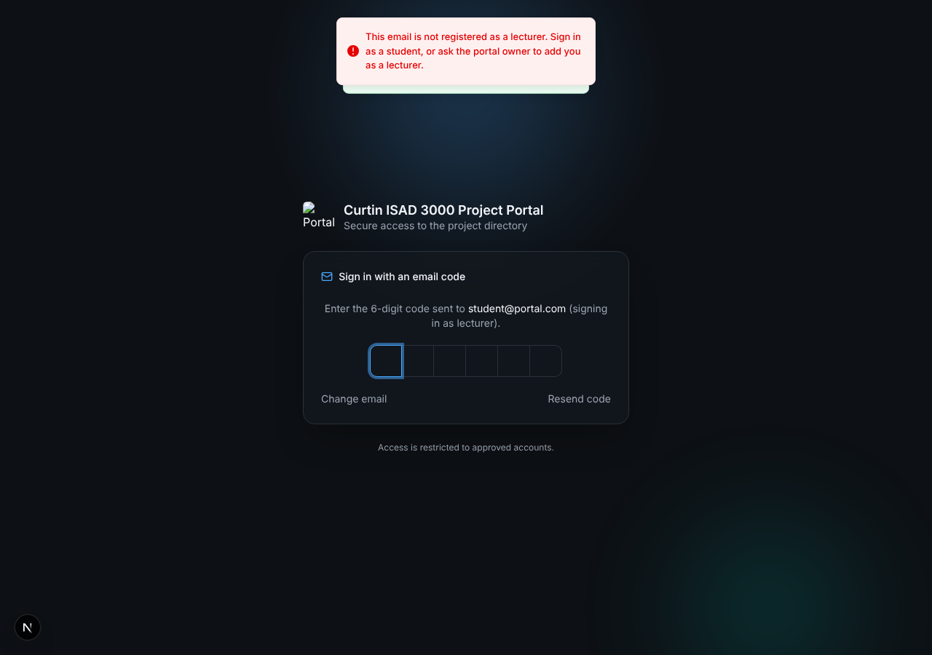
Refusal message when a non-lecturer chooses Lecturer
The message reads "This email is not registered as a lecturer. Sign in as a student, or ask the portal owner to add you as a lecturer." Start again and choose Student.

If the code is wrong
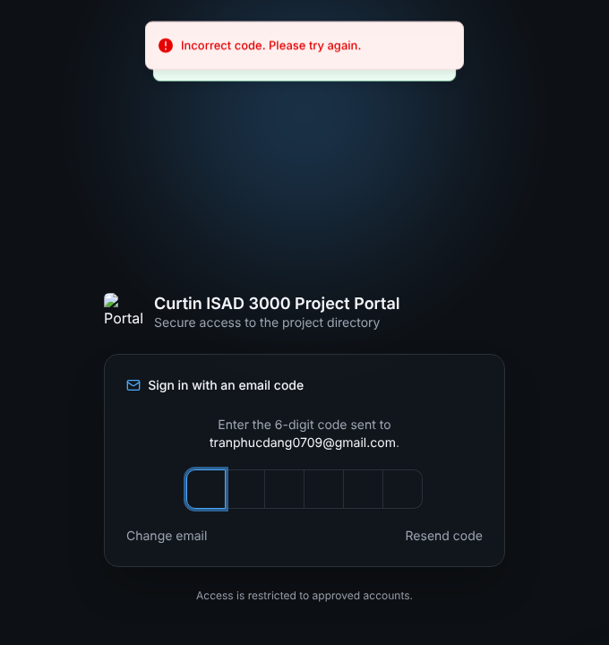
Wrong code: the boxes clear and you can try again
You get 5 tries per code. After that, request a new code.

3. Rules at a glance
Rule | Value
Code | 6 digits, one use, valid 10 minutes
Wrong tries | Up to 5 per code, then request a new one
Request a new code | Wait 30 seconds between requests
Session | 8 hours, then sign in again
Sign out | Sign out button, top right of every page

4. Troubleshooting
Message or problem | What to do
Please enter a valid email address. | Check the address for typos or a missing @.
Please wait Ns before requesting another code. | Wait the seconds shown, then click Resend code.
Incorrect code. Please try again. | Use the newest email and retype the digits.
Too many attempts. Request a new code. | Click Resend code (after 30 s) and use the new code.
No code was requested, or it expired. | More than 10 minutes passed, or cookies are blocked. Request a new code and allow cookies.
No email arrives | Wait 2 minutes, check Spam, confirm the address is approved, then Resend code.
This email is not registered as a lecturer. | Choose Student, or ask the portal owner to register your email as a lecturer.
Sent back to sign-in | Your 8-hour session ended. Sign in again.

TIP
Request the code and type it in the same browser. Do not clear cookies between the two steps.

5. Stay safe
- Never share your code. Nobody from the course will ask for it.
- Ignore a code email you did not request - it cannot be used without your email.
- Sign out on shared computers.

6. For administrators (summary)
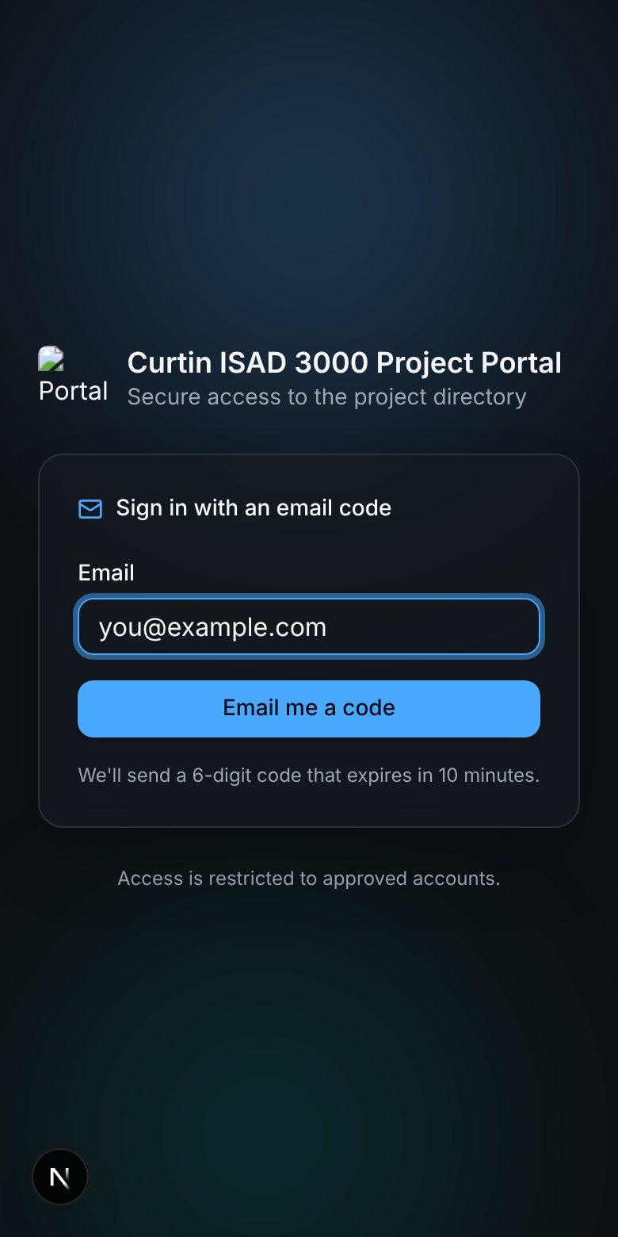
The sign-in page also works on a phone
Setting | Purpose
SESSION_SECRET | Required. 16+ characters. Without it sign-in fails with "Server error".
ALLOWED_EMAILS | Comma-separated approved emails. If empty, any valid email can sign in (development only).
RESEND_API_KEY or SMTP_* | How the code email is sent (Resend API, or SMTP such as Gmail with an app password). EMAIL_FROM sets the sender.
data/users.json | Names, and which emails may sign in as Lecturer. Everyone else signs in as Student.
AUTH_DEV_ECHO=1 | Development only: shows the code on screen. Never use in production.

