CURTIN ISAD 3000 · PROJECT PORTAL
Release Notes
Curtin ISAD 3000 Project Portal
Project | Curtin ISAD 3000 Project Portal
Document ID | CP-RN-001
Version | 1.1
Date | 23 October 2026
Author | Darren
Status | Draft for review
Classification | Internal

What changed in the 23 October 2026 update of the Curtin ISAD 3000 Project Portal: lecturer-managed Lessons & Videos with uploads, a Student / Lecturer choice at sign-in, a one-time maintenance notice and quality checks.

Document Control

Document information
Document title | Release Notes
Document ID | CP-RN-001
Project | Curtin ISAD 3000 Project Portal
Document type | Release notes and change summary
Version | 1.1
Author | Darren
Date issued | 23 October 2026
Status | Draft for review
Classification | Internal
Intended audience | Project owner, lecturers, administrators

Revision history
Version | Date | Author | Description of change
1.0 | 23 October 2026 | Darren | First issue for the 23 October 2026 maintenance update.
1.1 | 23 October 2026 | Darren | Reissued for the later 23 October 2026 changes: lecturer-managed lessons, Student / Lecturer sign-in choice.

Review and approval
Role | Name | Signature | Date
Author | Darren |  | 23 October 2026
Reviewer
Approver

Related documents
Document ID | Title
CP-SRS-001 | Software Requirements Specification
CP-UAT-001 | User Acceptance Testing (UAT) Document
CP-UG-001 | User Guide
CP-LG-001 | Login Guide

1. Release summary
Item | Detail
Release | Update of 23 October 2026 (document version 1.1)
Portal address | https://capstone-portal-test.tranphucdang0709.workers.dev/
Headline changes | Lessons & Videos managed by lecturers (documents, video files, YouTube links); Student / Lecturer choice on the sign-in page; one-time maintenance notice; sender address for sign-in emails; new integrity test
Unchanged | Emailed 6-digit code sign-in, 8-hour session, approved-email list, the 2,500-project directory (search, filters, details)
Action needed from users | Lecturers: choose Lecturer when signing in. Everyone: sign in as usual; a short notice appears once.

2. What is new

2.1 Sign in as Student or Lecturer
The sign-in page now asks I am a Student or Lecturer. Student is the default. Lecturer is accepted only for emails registered as lecturers; anyone else gets a clear message and can sign in as a student instead. The role chosen becomes the role shown in the header and decides what the person can do.
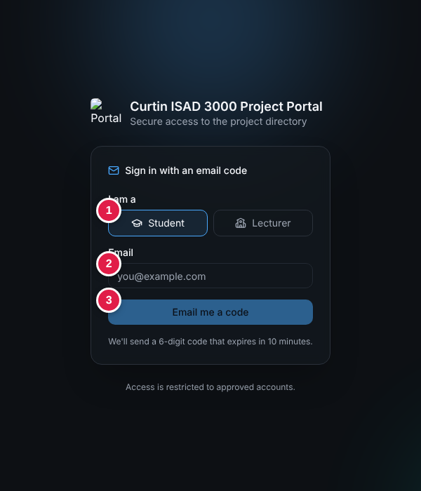
Sign-in page: (1) role choice, (2) email, (3) Email me a code
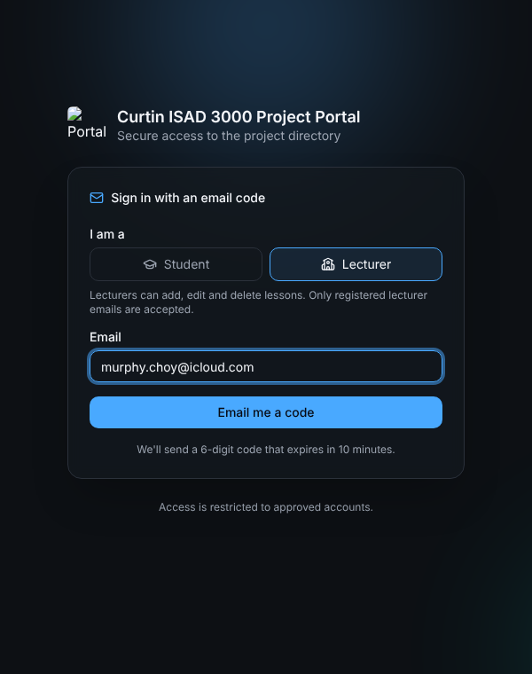
Lecturer option with its note

2.2 Lessons & Videos
A Lessons button in the top bar opens the lessons page. Everyone who is signed in can search, watch and download. Lessons are stored by the Portal, so lecturers can keep adding material without a new release.
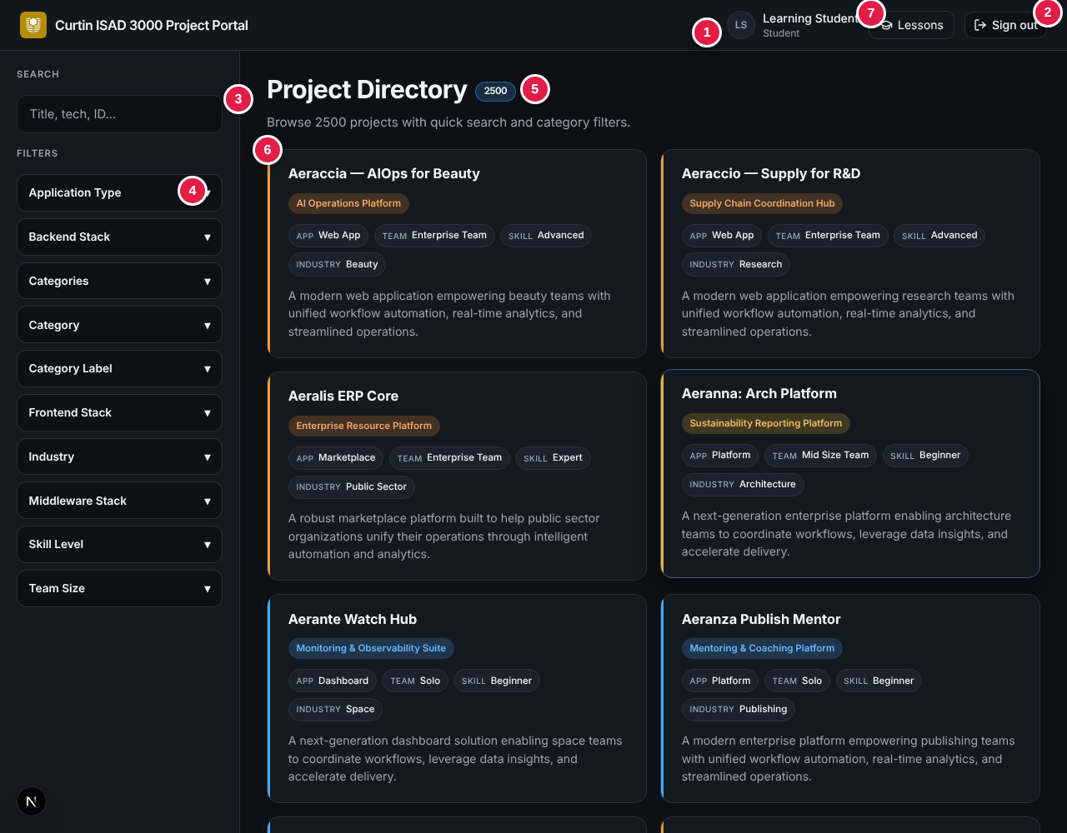
Project directory with the new Lessons button (7) in the header
For | Capabilities
Students | Search lessons (title, description, section); filter by section; Watch or Open a lesson; play an uploaded video (seeking works) or a YouTube video; Download documents; Hide; Back to directory.
Lecturers | Everything students can do, plus Add lesson and a trash button to delete a lesson.
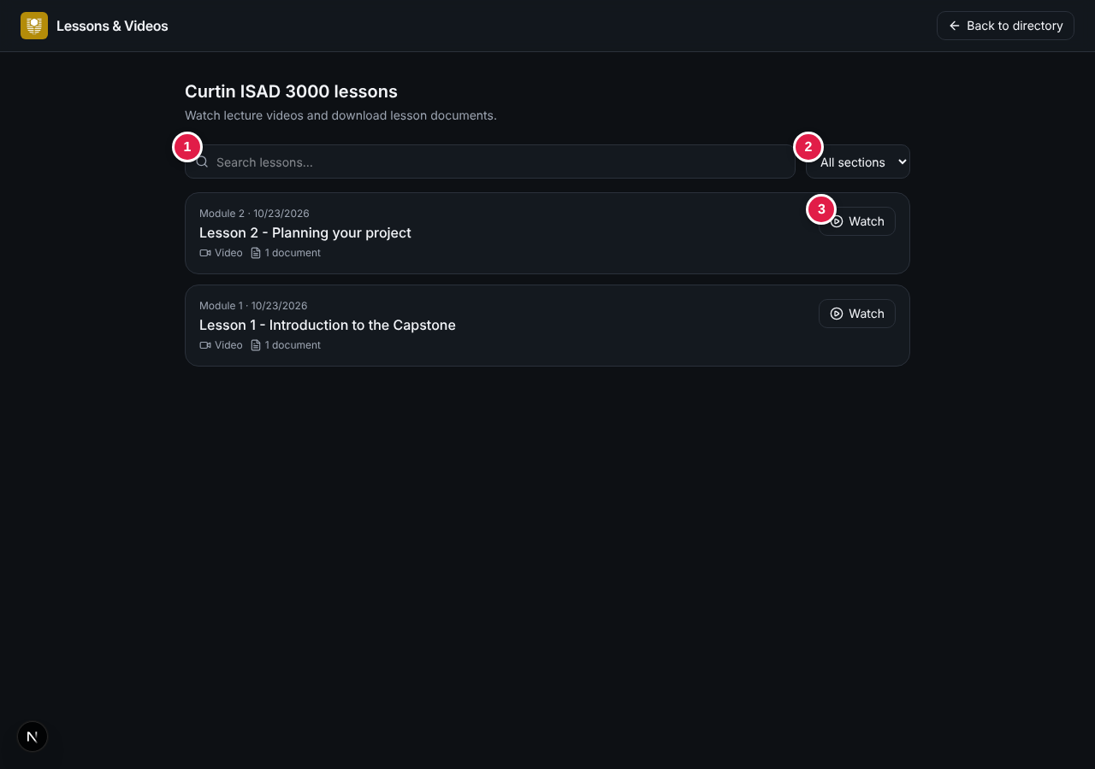
Lessons page for a student: (1) search, (2) section list, (3) Watch
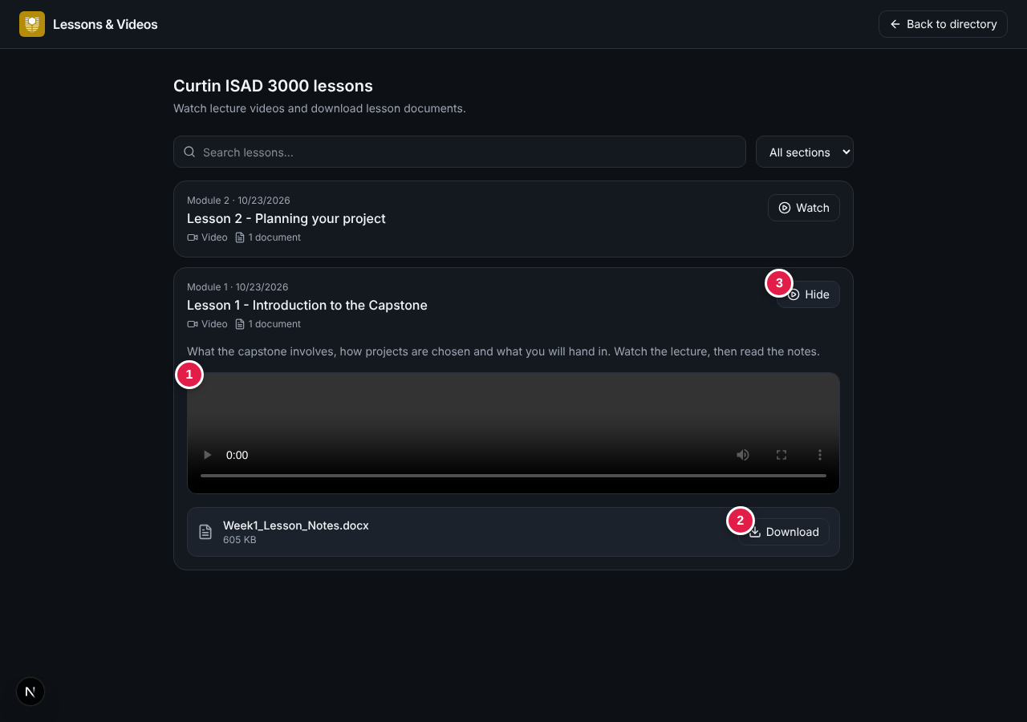
Open lesson: (1) video, (2) Download, (3) Hide

Adding a lesson (lecturers)
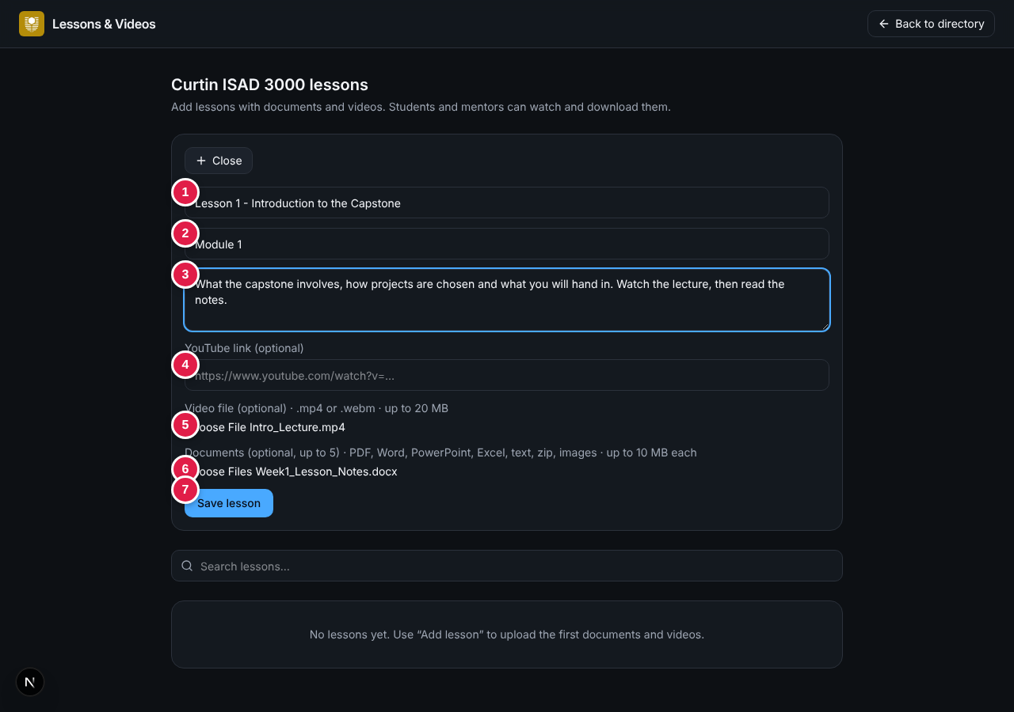
Add lesson form: (1) title, (2) section, (3) description, (4) YouTube link, (5) video file, (6) documents, (7) Save lesson
Field | Rule
Title | Required, up to 160 characters
Section / module, description | Optional (80 and 2,000 characters)
YouTube link | Optional; watch, youtu.be, embed or shorts links, or an 11-character id
Video file | Optional; one .mp4 or .webm up to 20 MB
Documents | Optional; up to 5 files of 10 MB: PDF, Word, PowerPoint, Excel, text, Markdown, zip, PNG, JPEG
Required overall | A title and at least one document, video file or YouTube link
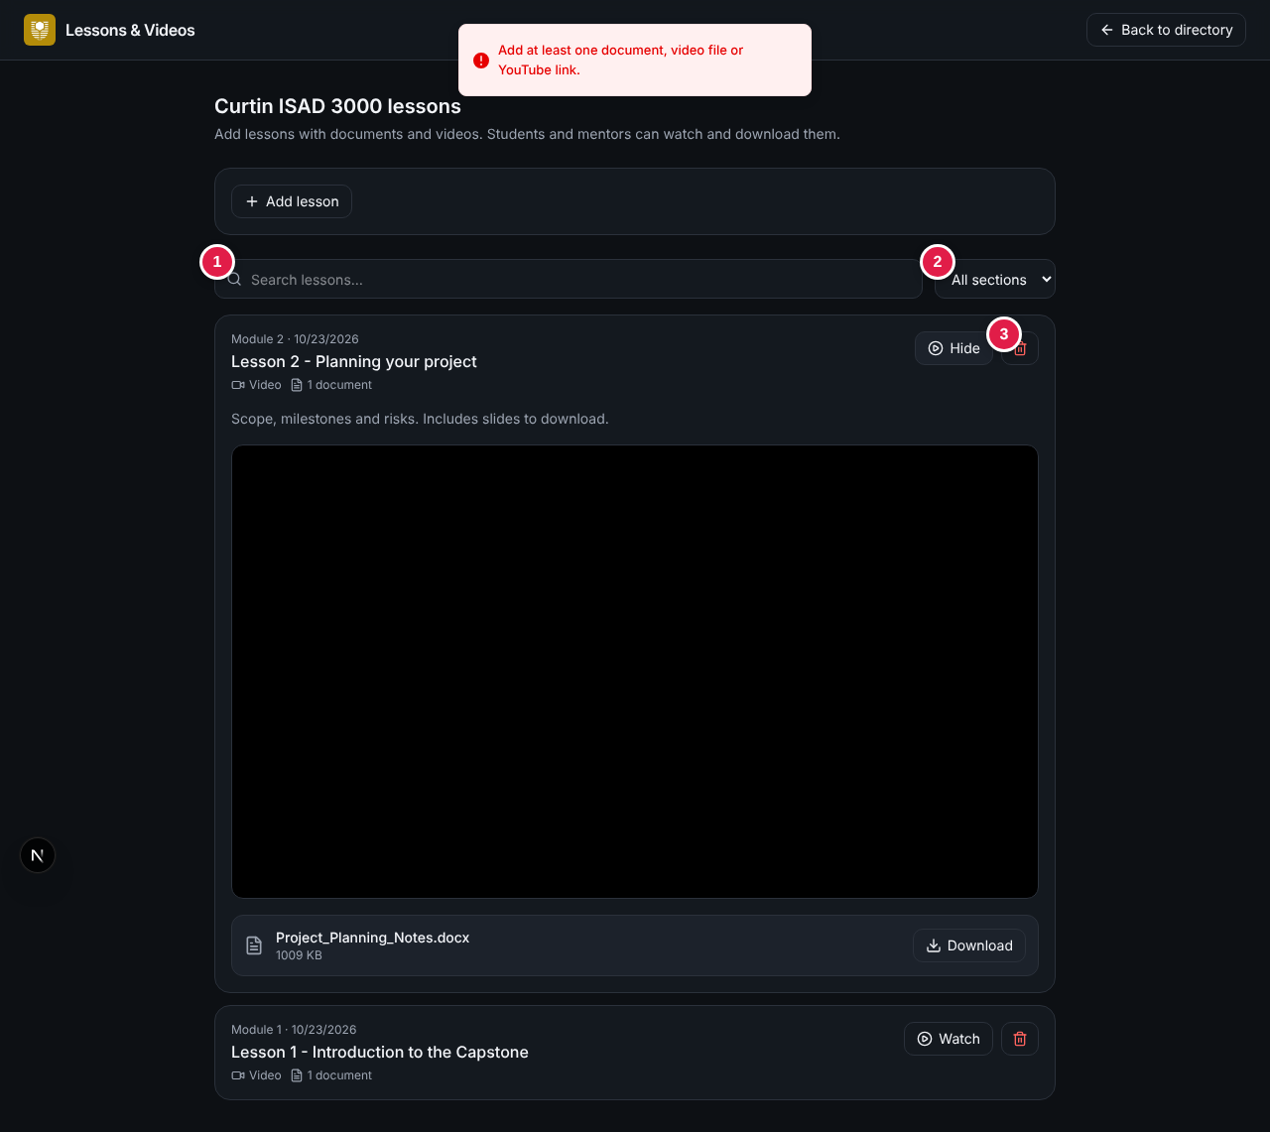
Lecturer view: (1) search, (2) section list, (3) delete
WARNING
Uploaded files are stored in the database. On a hosted deployment a writable libSQL / Turso database must be configured, or uploads cannot be saved (the Portal shows a hint).

2.3 Maintenance notice
After signing in, users see a short dialog that the Portal has been updated. It appears once per person for each notice. Administrators change the wording by editing one data file (see CP-DAG-001, section 5).
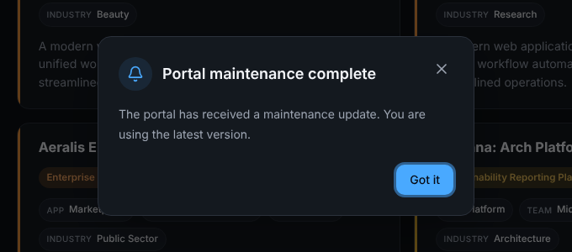
Maintenance notice shown after sign-in

2.4 Other changes
Area | Change
Sign-in email | Default sender is "Capstone Portal <no-reply@alionova.online>".
Quality | New automated test checks the maintenance-notice file; existing checks remain.
Documentation | README gains a "Maintenance notifications" section.
Removed | The fixed list of 90 course modules and bundled lesson documents is no longer part of the Portal; lessons now start empty and are added by lecturers.

3. Verification checklist
ID | Check | Expected result | Pass?
RN-01 | Sign-in page: look at "I am a". | Student (selected) and Lecturer options.
RN-02 | Sign in as murphy.choy@icloud.com choosing Lecturer. | Signed in; header shows role Lecturer.
RN-03 | Choose Lecturer with a student email. | Refused with "This email is not registered as a lecturer..."
RN-04 | Sign in as a student; read and dismiss the notice. | Notice appears once; Got it closes it for good.
RN-05 | Student opens Lessons. | No Add lesson or trash buttons.
RN-06 | Lecturer: Add lesson with a video file and a document. | "Lesson added."; lesson listed first.
RN-07 | Lecturer: add a lesson with only a title. | "Add at least one document, video file or YouTube link."
RN-08 | Student: search, open the lesson, play the video, drag the bar. | Video plays and seeks.
RN-09 | Student: Download the document. | File downloads and opens.
RN-10 | Lecturer: delete the test lesson and confirm. | "Lesson deleted."; it disappears for students too.
RN-11 | Open /lessons while signed out. | Redirected to the sign-in page.

4. Known issues and recommendations
No. | Item | Recommendation
1 | The logo image does not show on the sign-in page for signed-out visitors (the route guard also blocks /logo.png). | Exclude the logo path in proxy.ts.
2 | .env.example contains a realistic SESSION_SECRET. | Replace with a placeholder and rotate the live secret.
3 | README still describes an older password sign-in in places. | Update it to the emailed-code flow.
4 | The Lecturer note says lecturers can "edit" lessons, but only add and delete exist. | Add an edit function or change the wording.
5 | Videos are stored inside the database (up to 20 MB each), which can grow quickly. | Prefer YouTube links for long videos; consider object storage later.
6 | The notice is remembered per browser, not per account across devices. | Store dismissals with the account if needed.
7 | The lecturer "Upload" link and /admin page (project upload) remain in the code although the Portal is described as having no project upload. | Remove them if not wanted.

