CURTIN ISAD 3000 · PROJECT PORTAL
Login Guide
Curtin ISAD 3000 Project Portal
Project | Curtin ISAD 3000 Project Portal
Document ID | CP-LG-001
Version | 2.0
Date | 21 October 2026
Author | Darren
Status | Draft for review
Classification | Internal

How to sign in to the Curtin ISAD 3000 Project Portal with an emailed 6-digit code, what each message means, and how to fix the most common problems.

Document Control

Document information
Document title | Login Guide
Document ID | CP-LG-001
Project | Curtin ISAD 3000 Project Portal
Document type | Short illustrated sign-in guide
Version | 2.0
Author | Darren
Date issued | 21 October 2026
Status | Draft for review
Classification | Internal
Intended audience | All users; the last section is for administrators

Revision history
Version | Date | Author | Description of change
1.0 | 21 October 2026 | Darren | First full-length version.
2.0 | 21 October 2026 | Darren | Shortened and rebuilt with screenshots of the Portal.

Review and approval
Role | Name | Signature | Date
Author | Darren |  | 21 October 2026
Reviewer
Approver

Related documents
Document ID | Title
CP-SRS-001 | Software Requirements Specification
CP-UAT-001 | User Acceptance Testing (UAT) Document
CP-UG-001 | User Guide
CP-LG-001 (this document) | Login Guide

1. How sign-in works
Portal address: https://capstone-portal-test.tranphucdang0709.workers.dev/
There is no password. You enter your email, the Portal emails you a 6-digit code, and you type it in. Each code works once and lasts 10 minutes. You then stay signed in for 8 hours.
1 | 2 | 3 | 4
Enter your email | Click "Email me a code" | Read the code in your email | Type the 6 digits

NOTE
Only approved email addresses receive a code. Ask your lecturer if you are unsure which address is approved.

2. Step by step

Step 1 - Enter your email
Open the Portal address. Click the Email box (1), type your address, then click Email me a code (2). The button is grey until you type something.
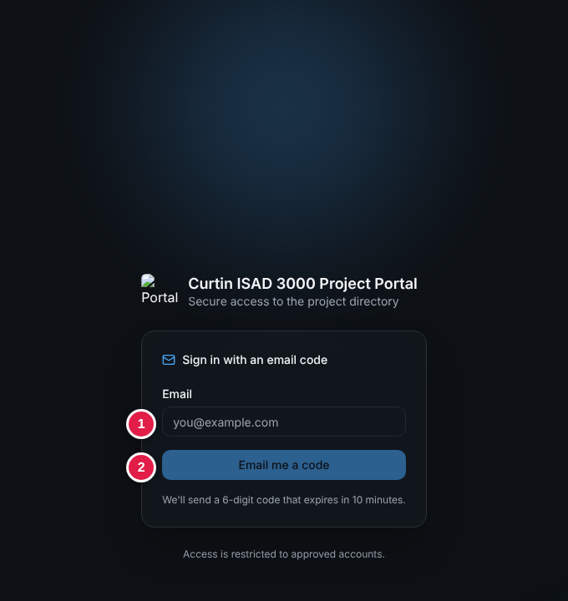
Sign-in page

Step 2 - Get the code
A green message says "If that email has access, a code is on its way." (the same message appears for every address). Open your mailbox and find:
Subject: Your Capstone Portal sign-in code: 482915

The email shows a large 6-digit code. It normally arrives within a minute; check Spam / Junk if not. Only the newest code works.

Step 3 - Type the code
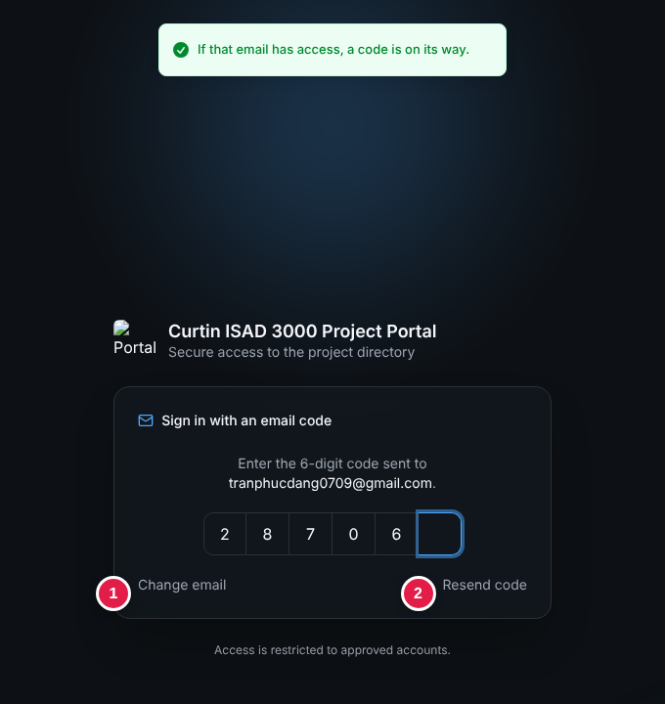
Code step: (1) Change email, (2) Resend code
Click the first box and type all six digits (or paste them). The Portal checks the code automatically on the sixth digit - there is no button to press.
Link | Use it when
(1) Change email | You typed the wrong address.
(2) Resend code | The email did not arrive or the code expired. Wait 30 seconds between requests.

Step 4 - You are in
A green "Signed in." message appears and the Project Directory opens. Your name and role are at the top right.
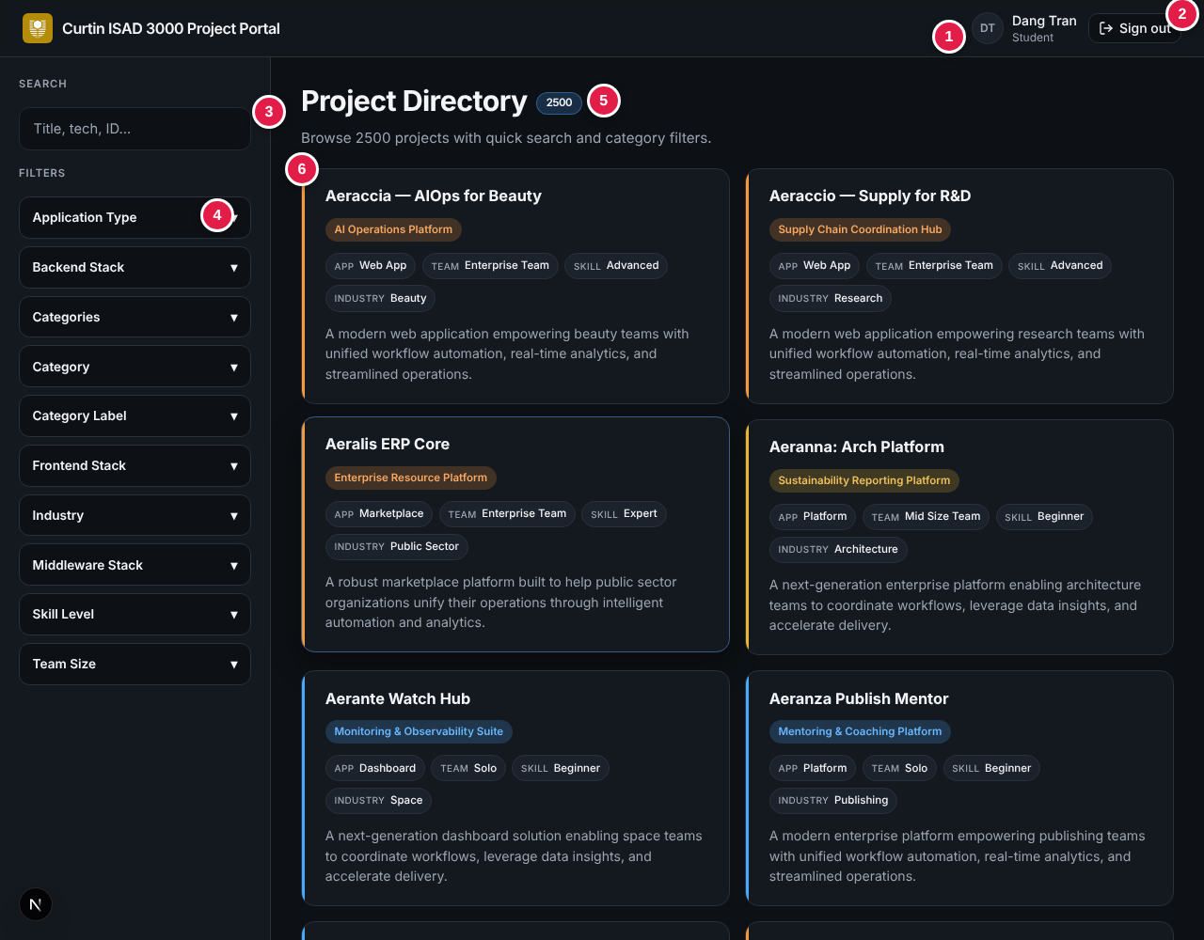
Signed in: the directory opens with your name and role top right

If the code is wrong
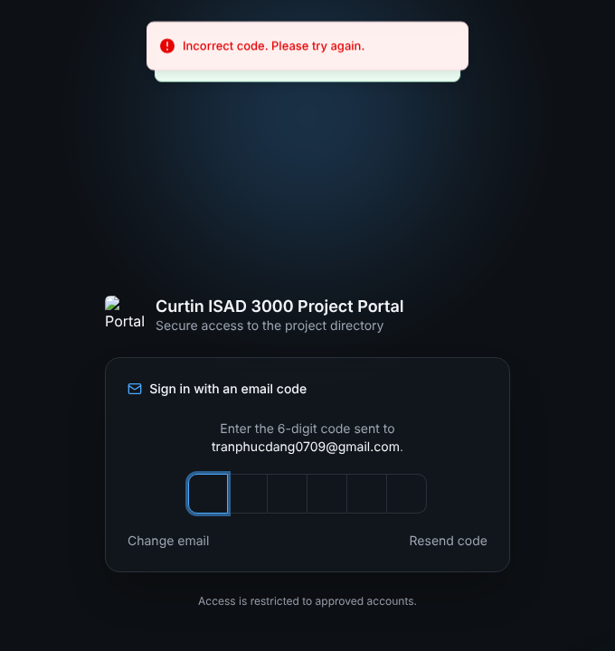
Wrong code: the boxes clear and you can try again
You get 5 tries per code. After that, request a new code.

3. Rules at a glance
Rule | Value
Code | 6 digits, one use, valid 10 minutes
Wrong tries | Up to 5 per code, then request a new one
Request a new code | Wait 30 seconds between requests
Session | 8 hours, then sign in again
Sign out | Sign out button, top right of every page

4. Troubleshooting
Message or problem | What to do
Please enter a valid email address. | Check the address for typos or a missing @.
Please wait Ns before requesting another code. | Wait the seconds shown, then click Resend code.
Incorrect code. Please try again. | Use the newest email and retype the digits.
Too many attempts. Request a new code. | Click Resend code (after 30 s) and use the new code.
No code was requested, or it expired. | More than 10 minutes passed, or cookies are blocked. Request a new code and allow cookies.
No email arrives | Wait 2 minutes, check Spam, confirm the address is approved, then Resend code.
Sent back to sign-in | Your 8-hour session ended. Sign in again.

TIP
Request the code and type it in the same browser. Do not clear cookies between the two steps.

5. Stay safe
- Never share your code. Nobody from the course will ask for it.
- Ignore a code email you did not request - it cannot be used without your email.
- Sign out on shared computers.

6. For administrators (summary)
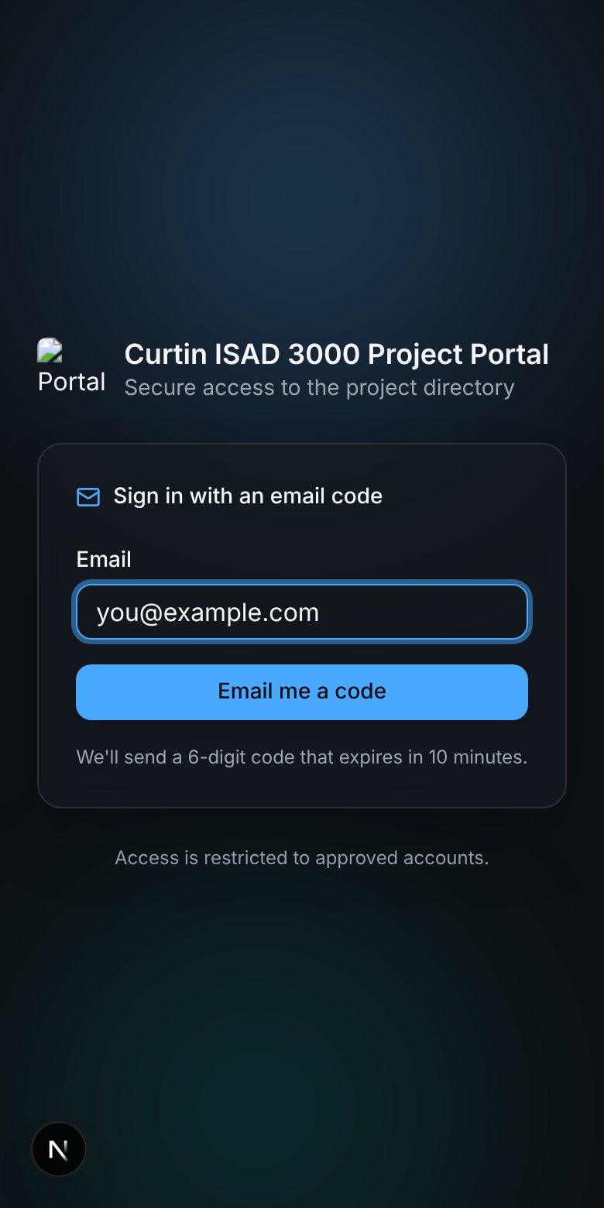
The sign-in page also works on a phone
Setting | Purpose
SESSION_SECRET | Required. 16+ characters. Without it sign-in fails with "Server error".
ALLOWED_EMAILS | Comma-separated approved emails. If empty, any valid email can sign in (development only).
RESEND_API_KEY or SMTP_* | How the code email is sent (Resend API, or SMTP such as Gmail with an app password). EMAIL_FROM sets the sender.
data/users.json | Names and roles (Lecturer or Student) shown after sign-in.
AUTH_DEV_ECHO=1 | Development only: shows the code on screen. Never use in production.

