CURTIN ISAD 3000 · PROJECT PORTAL
User Guide
Curtin ISAD 3000 Project Portal
Project | Curtin ISAD 3000 Project Portal
Document ID | CP-UG-001
Version | 2.0
Date | 21 October 2026
Author | Darren
Status | Draft for review
Classification | Internal

A short, picture-based guide to the Curtin ISAD 3000 Project Portal: sign in, find a capstone project with search and filters, and read project details.

Document Control

Document information
Document title | User Guide
Document ID | CP-UG-001
Project | Curtin ISAD 3000 Project Portal
Document type | Short illustrated user guide
Version | 2.0
Author | Darren
Date issued | 21 October 2026
Status | Draft for review
Classification | Internal
Intended audience | Students and lecturers who use the Portal

Revision history
Version | Date | Author | Description of change
1.0 | 21 October 2026 | Darren | First full-length version.
2.0 | 21 October 2026 | Darren | Shortened and rebuilt with screenshots of the Portal.

Review and approval
Role | Name | Signature | Date
Author | Darren |  | 21 October 2026
Reviewer
Approver

Related documents
Document ID | Title
CP-SRS-001 | Software Requirements Specification
CP-UAT-001 | User Acceptance Testing (UAT) Document
CP-UG-001 (this document) | User Guide
CP-LG-001 | Login Guide

1. Open the Portal
The Portal lists 2,500 capstone project ideas that you can search, filter and read in detail.
Portal address: https://capstone-portal-test.tranphucdang0709.workers.dev/
TIP
You need a web browser and an approved email address you can open. There is no password: the Portal emails you a 6-digit code each time you sign in.

2. Sign in
- Open the Portal address. You land on the sign-in page.
- Type your email and select Email me a code.
- Open the email "Your Capstone Portal sign-in code" and type the 6 digits. You are signed in automatically.
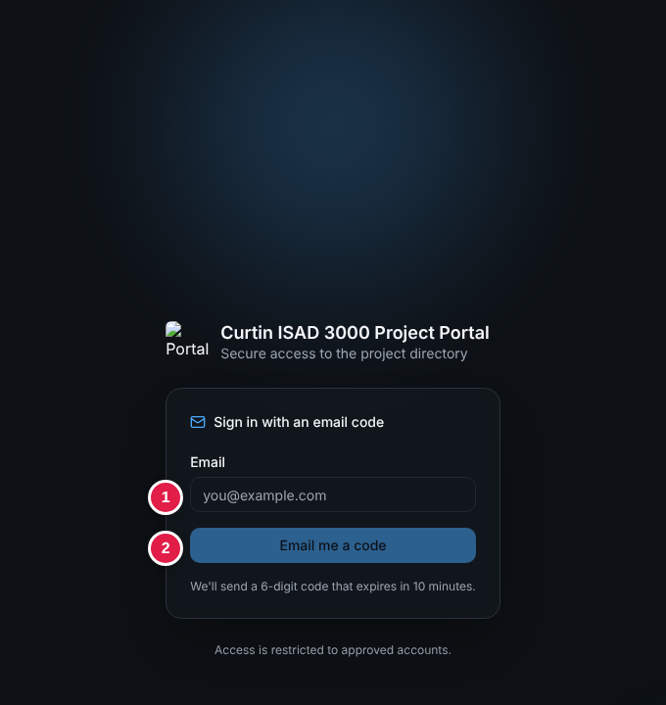
Sign-in page: (1) email box, (2) "Email me a code"
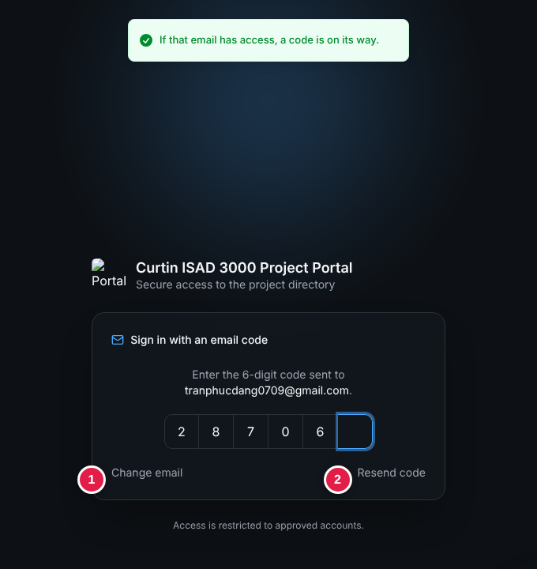
Code step: type the six digits from your email
Need more detail or having trouble? See the Login Guide (CP-LG-001).

3. The Project Directory
After sign-in you see the directory. The numbers match the table.
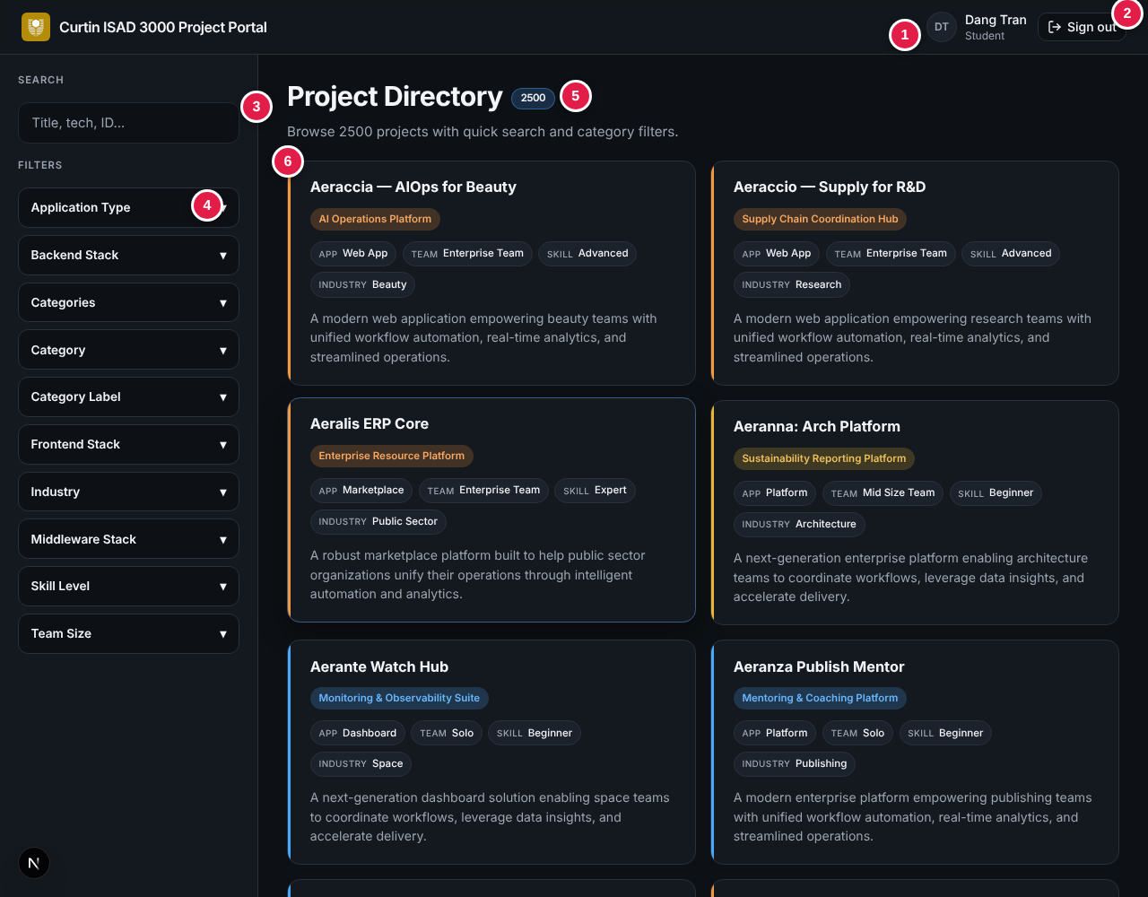
Project Directory (student view)
No. | What it is
1 | Your initials, name and role (Student or Lecturer).
2 | Sign out - ends your session.
3 | Search box - type to find projects.
4 | Filters - click a group name to open it.
5 | Total number of projects (2500).
6 | A project card: title, category, App / Team / Skill / Industry labels and a short description. Click it to open.

4. Search
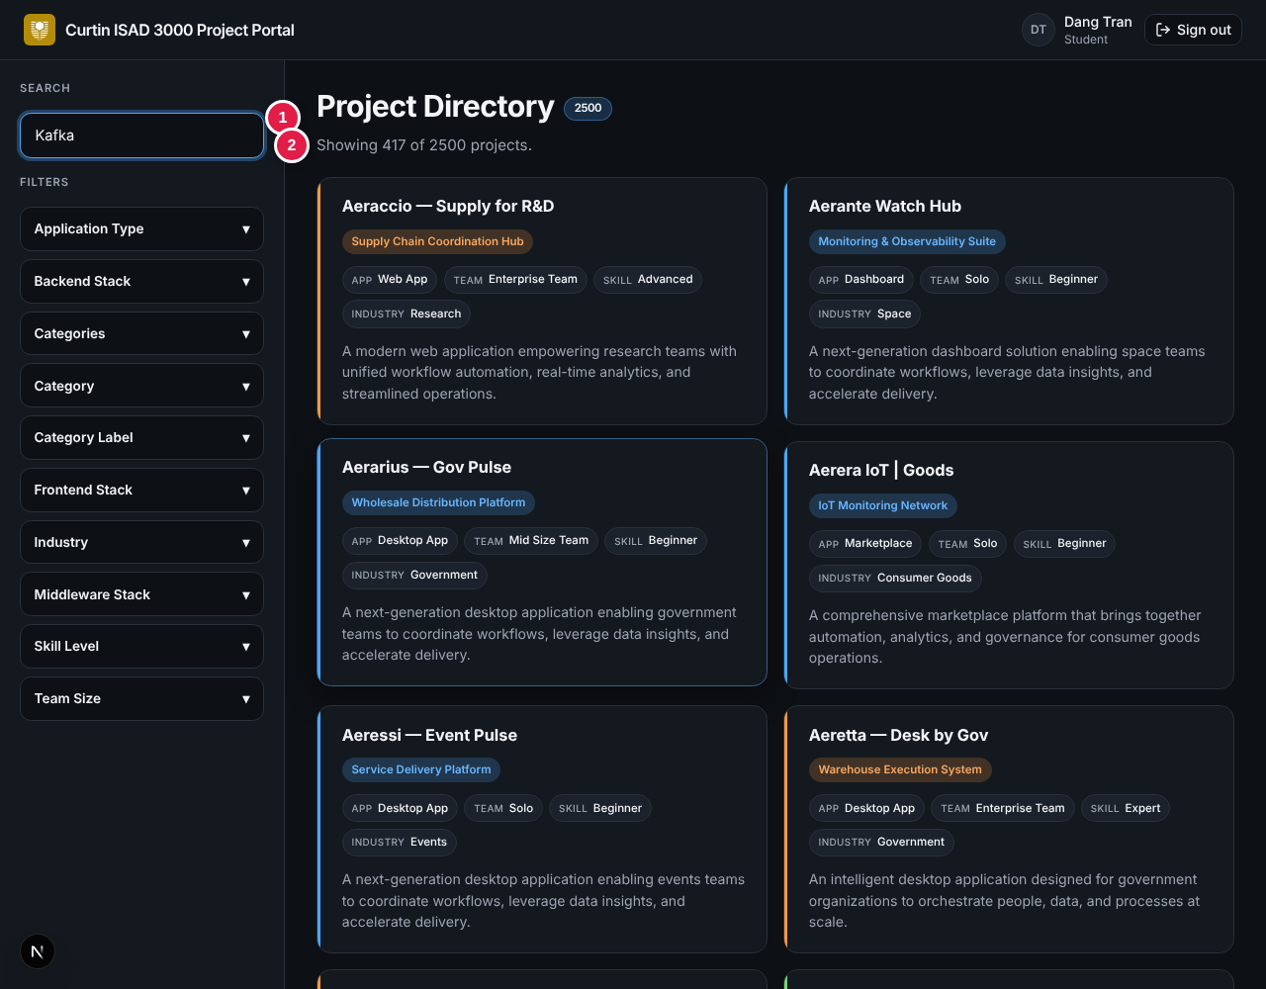
Searching for "Kafka": (1) search box, (2) result count
- Type words from the title, description, ID or technology. The list updates as you type.
- Not case sensitive. With several words, projects containing more of them appear first.
- The line under the title shows the result: "Showing 417 of 2500 projects." Delete the text to see everything again.
Try | You get
PRJ-0001 | That single project
Kafka | 417 projects that use Kafka
zzzz | "Showing 0 of 2500 projects" - try other words

5. Filters
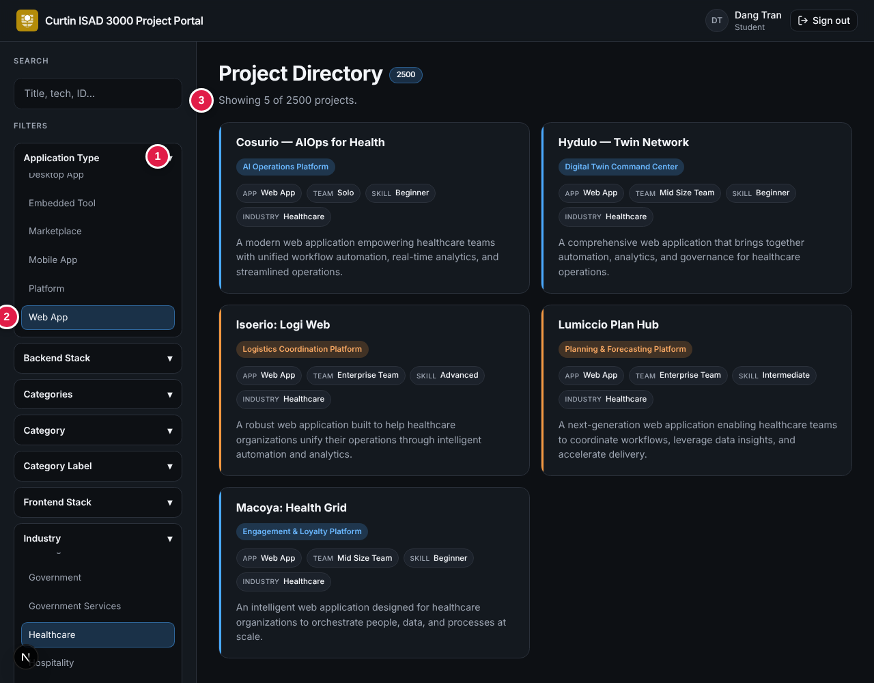
Filters: (1) open a group, (2) pick an option, (3) result count
- Click a group such as Application Type or Industry to open it.
- Click one option. It turns blue and the list narrows at once.
- Open another group to narrow further - all filters apply together. In the picture, Web App + Healthcare gives 5 projects.
- Click All in a group to remove its filter.
Group | Use it to...
Skill Level | Match difficulty: Beginner, Intermediate, Advanced, Expert.
Team Size | Solo, Mid Size Team or Enterprise Team.
Industry / Application Type | Pick a sector or the kind of app (Web, Mobile, API, Dashboard...).
Frontend / Backend / Middleware Stack | Find projects using technology you know.
WARNING
If you see "Showing 0 of ...", the filters cannot match together. Choose All in one group.

6. Project details
Click any card to open the full project.
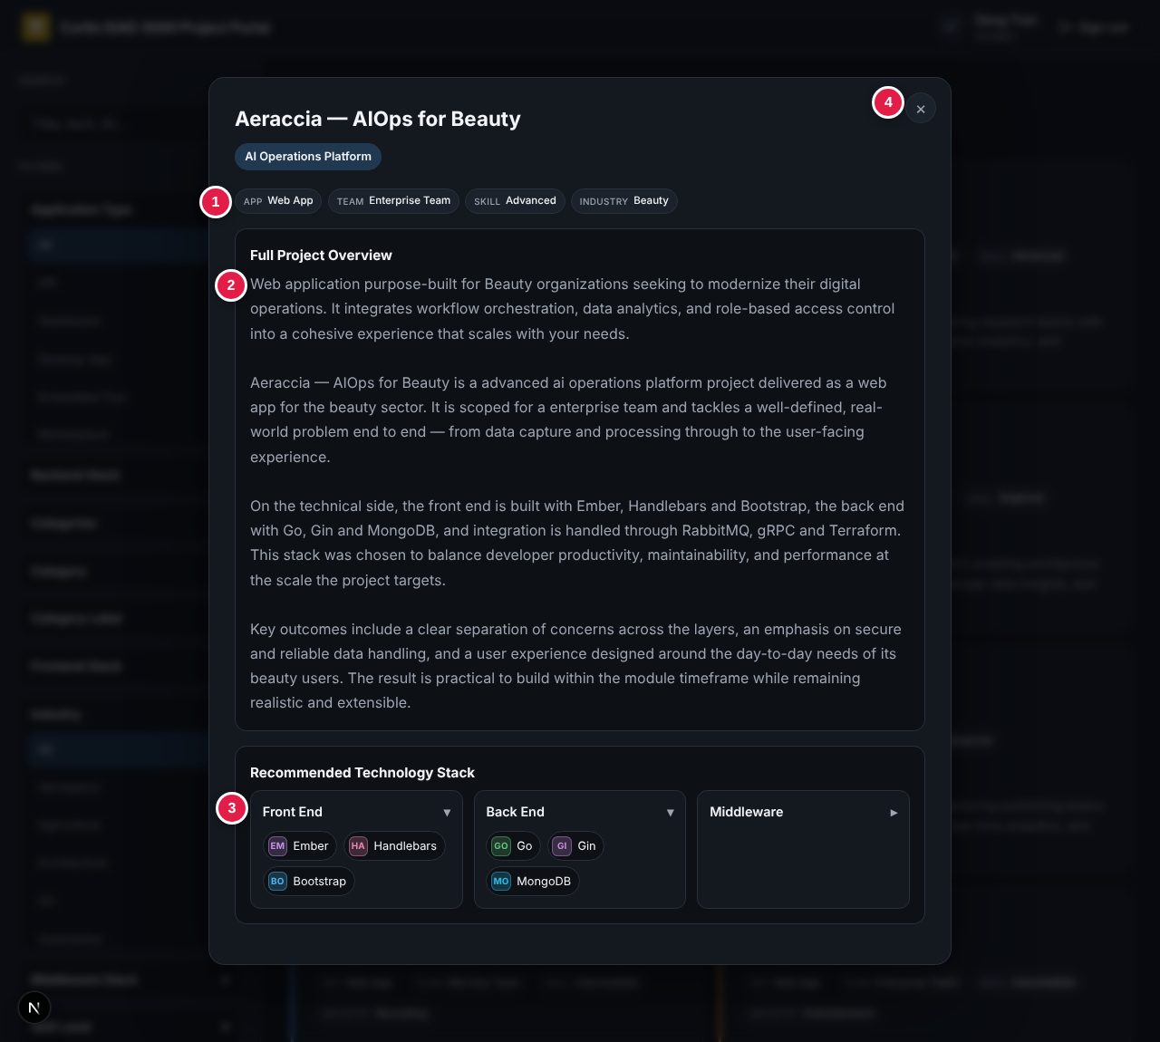
Project window: (1) labels, (2) overview, (3) technology stack, (4) close
- Overview explains the project, the sector and the expected outcomes.
- Technology stack has three sections - Front End, Back End, Middleware. Click one to open or close it.
- Close with the × or by clicking the dark area outside. You return to the same list.

7. Sign out and quick help
Click Sign out (top right). You are also signed out after 8 hours. Always sign out on shared computers.
Problem | What to do
Back at the sign-in page | Your 8-hour session ended. Sign in again.
"Showing 0 of 2500" | Clear the search box and choose All in each filter group.
"Unable to load project data." | Refresh the page; if it persists, tell your lecturer.
No sign-in code arrives | Check spam and see the Login Guide.

