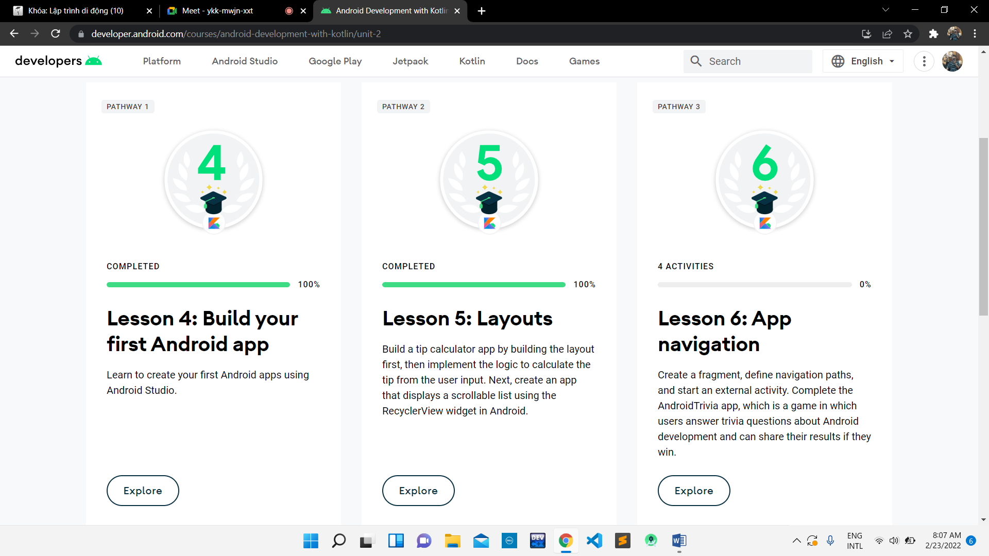

https://github.com/TranBao150802/Lab3_Android.git