VIETNAMESE – GERMAN UNIVERSITY
FACULTY OF ENGINEERING
COMPUTER SCIENCE DEPARTMENT

JAVA PROJECT REPORT
<BUS TICKET SYSTEM>

Module 61CSE215: Object Oriented Programming in JAVA
- <Tran Gia Huan – 10423043>
- <Cao Dang Tri – 10423112>
- <Ngo Trung Kien - 10423065>

Lecturer: Dr. Tran Hong Ngoc

VGU, WS2025
This page intentionally left blank.
Table of Contents
INTRODUCTION 1
Stakeholder Roles 1
CLASS ANALYSIS 3
Object Analysis 3
Grouping and Analysis 3
CLASS DESIGN 5
Class Diagrams 5
Class Details 8
Abstract Classes 11
Object-Orientated Programming Techniques 12
PACKAGE DESIGN 15
INTERFACE DESIGN 16
ACCESS CONTROL 17
Data Access Control 17
Method access control 18
ENCAPSULATION, INHERITENCE AND POLYMORPHISM 20
Encapsulation 20
Inheritance 20
Polymorphism 20
EXPERIMENT 21
Project functions 21
Database design 22
GUI 24
CONCLUSION 28

INTRODUCTION
In this project, we evaluate the business requirements of a Bus Ticket Management System for our university transit system. The currently in operation system makes use of Google Forms to record tickets, a method that is prone to mistakes and naturally time-consuming. Therefore, this project aims to compliment the current system with a dedicated desktop application in hopes of providing a fast and stable system that manages tickets and trips for both students and staff.
The application in this project provides the users with the following functionalities:
- The user can register a new account and log into their account using a password.
- The user can purchase various types of tickets.
- The user can query and see all purchased tickets that are tied to their account.
There is naturally always room for more features and further development. That being said, we focus mainly on GUI design, Java classes, and database implementation for this project.

Stakeholder Roles
No. | Role | Description
1 | Admin/Staff | Manages the bus system and is responsible for any changes in the application.
2 | Student/Professor | Uses the system to create an account, create bookings and view ticket information.

CLASS ANALYSIS

Object Analysis
No | Object Name | States (Attributes) | Behaviours (Methods)
1 | Student1 | first_name = “Huan”  last_name = “Tran”  email = “abc@vgu.edu.vn”  password = “***”  id = “10423043” | getFirstName()  getLastName()  getEmailAddress()  getPassword()  getID()
2 | LongTermTicket1 | id = 10423043  start_date = 11-25-2025  location = “Turtle Lake”  ticket_type = ONEWAY  direction = FROM | getID()  getStartDate()  getLocation()  getTicketType()  getDirection()
3 | DatabaseController1 |  | close()  insert(User u), insert(Ticket t)  search_tickets(String id)  search_user(String id)
4 | OneWayDetails1 | id = 10423043  start_date = 11-25-2025  location = “Turtle Lake”  ticket_type = ONEWAY  price = 150000  type = ONEWAY  direction = FROM  pickuptime = 16:30 | returnTicketDetails()

Grouping and Analysis
- Student1 is an instance of Student, a subclass of User.
- LongTermTicket1 instances of LongTermTicket, both are subclasses of Ticket.
- OneWayDetails1 is an instances of OneWayDetails – a subclass of TicketDetails.
- DatabaseController1 is an instance of DatabaseController.

CLASS DESIGN

Class Diagrams
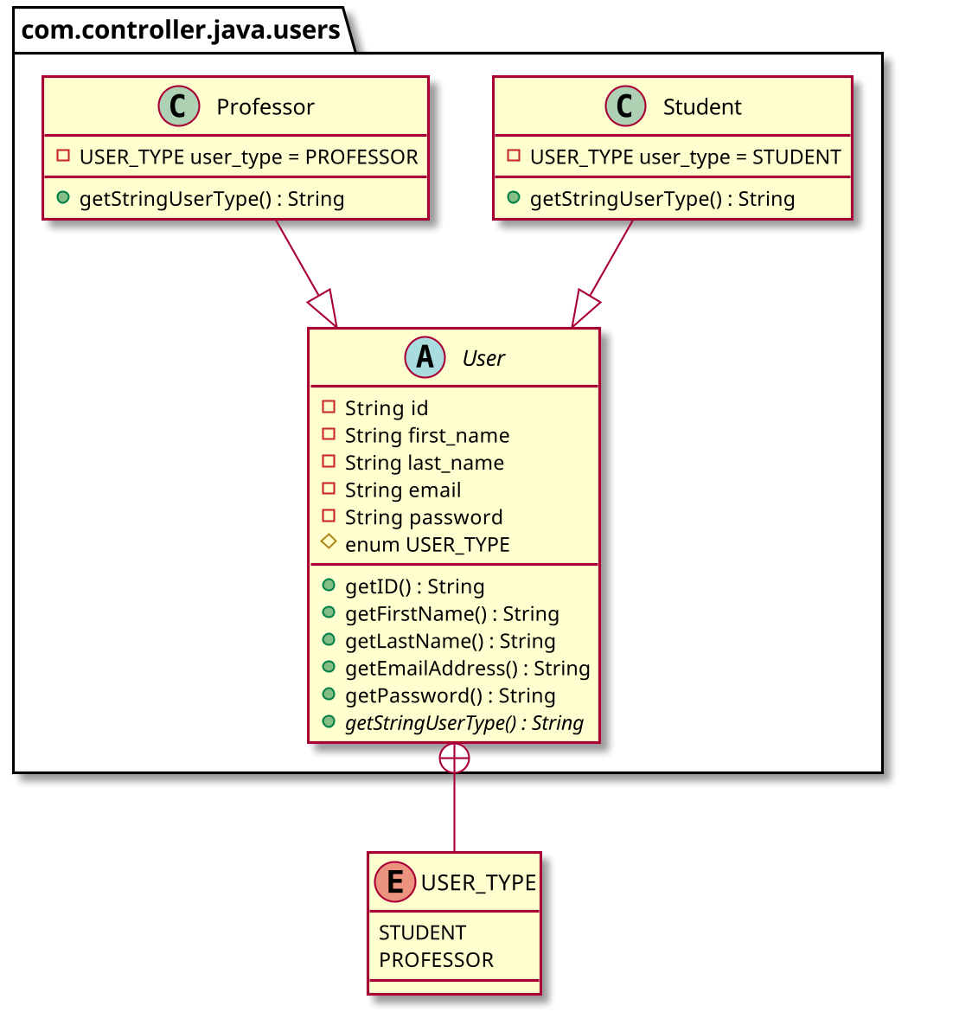
Figure 1: UML class diagram for package com.controller.java.users
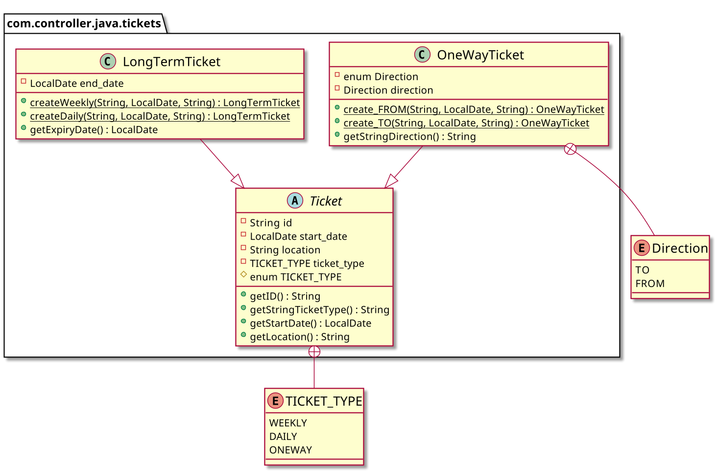
Figure 2: UML class diagram for com.controller.java.ticket
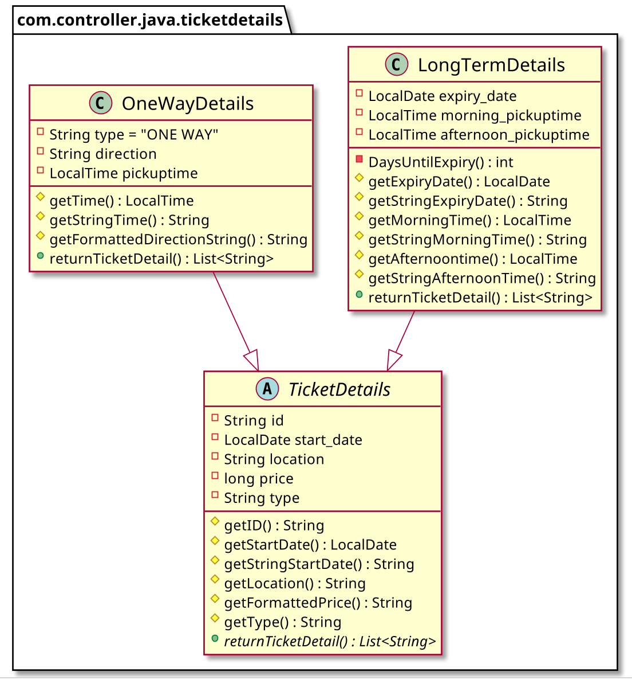
Figure 3: UML class diagram for com.controller.java.ticketdetails

Class Details
No | Class | Instance Variables | Methods | Description
1 | User | private final String id  private final USER_TYPE user_type  private final String first_name  private final String last_name  private final String email;  private final String password  private final double user_price_multiplier  protected enum USER_TYPE{STUDENT, PROFESSOR} | private User()  public String getID()  public String getUserType()  public String getFirstName()  public String getLastName()  public String getEmailAddress()  public String getPassword()  public double getPriceMultiplier() | Base abstract class for all User objects.
2 | Student |  | public Student() | Subclass of User.
3 | Professor |  | public Professor() | Subclass of Professor
4 | Ticket | private final String id  private final LocalDate start_date  private final String location  private final TICKET_TYPE ticket_type  protected enum TICKET_TYPE{WEEKLY, DAILY, ONEWAY} | private Ticket()  public String getID()  public String getTicketType()  public LocalDate getStartDate()  public String getLocation() | Base abstract class for all  Ticket objects. Used for inserting new tickets into database.
5 | LongTermTicket | private final LocalDate end_date | private LongTermTicket()  public static LongTermTicket createWeekly()  public static LongTermTicket createDaily()  public LocalDate getExpiryDate() | Subclass of Ticket. This includes long-term weekly and daily tickets.
7 | OneWayTicket | private enum Direction{TO, FROM}  private final Direction direction | OneWayTicket()  create_FROM()  create_TO()  public String getDirection() | Subclass of Ticket. This is used for one-way trips.
8 | TicketDetails | private final String id  private final LocalDate start_date  private final String location  private final long price  private final String type | protected final String getID()  protected final LocalDate getStartDate()  protected String getFormattedPrice()  protected String getType()  public abstract List<String> returnTicketDetail(); | Base abstract class for all TicketDetails  object. Used for querying ticket information retrieved from database.
9 | LongTermDetails | private final LocalDate expiry_date  private final LocalTime morning_pickuptime  private final LocalTime afternoon_pickuptime | public LongTermDetails()  private int DaysUntilExpiry()  protected String getExpiryDate()  protected String getMorningTime()  protected String getAfternoonTime()  public final List<String> returnTicketDetail() | Subclass of TicketDetails. Used for showing information of all weekly and daily tickets.
10 | OneWayDetails | private final String direction  private final LocalTime pickuptime | protected String getTime()  protected String getDirection()  public final List<String> returnTicketDetail() | Subclass of TicketDetails. Used for showing information of all one-way tickets.
11 | DatabaseController |  | DatabaseController()  public void close()  public void insert(Ticket t)  public void insert(User u)  public Map<String, List> search_tickets(String id)  public User search_user(String id) | Database controller that interacts with GUI and underlying Database for CRUD operations.

Abstract Classes
No. | Abstract class | Abstract methods | Concrete methods | Description
1 | User | None | private User()  public String getID()  public String getUserType()  public String getFirstName()  public String getLastName()  public String getEmailAddress()  public String getPassword()  public double getPriceMultiplier() | Used by Student and Professor. This class cannot be directly instantiated and its variables are defined by its subclasses.
2 | Ticket | None | private Ticket()  public String getID()  public String getTicketType()  public LocalDate getStartDate()  public String getLocation() | Used by LongTermTicket and OneWayTicket. This class cannot be directly instantiated and its variables are defined by its subclasses.
3 | TicketDetails | public abstract List<String> returnTicketDetail() | protected final String getID()  protected final LocalDate getStartDate()  protected String getFormattedPrice()  protected String getType() | Used by LongTermDetails and OneWayDetails. It has an abstract method that changes based on the created subclass.

Object-Orientated Programming Techniques
Inheritance
We use several inheritance-related techniques in this project:
- User extends Student and Professor.
- Ticket extends LongTermTicket and OneWayTicket.
- TicketDetails extends LongTermDetails and OneWayDetails.
These superclasses are declared as abstract such that they cannot be instantiated directly.
Overloading
com.database.CRUD.CRUD_Tickets.java
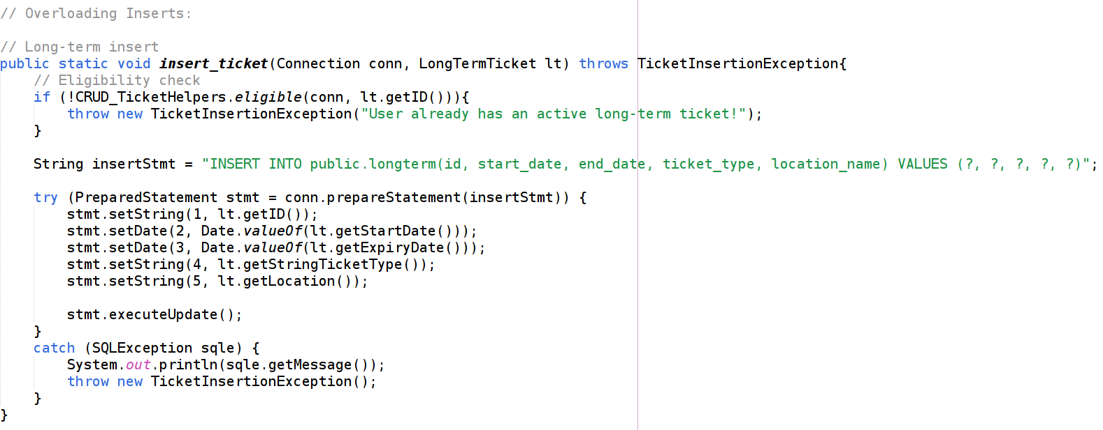
Figure 4: Overloaded insert_ticket(LongTermTicket)
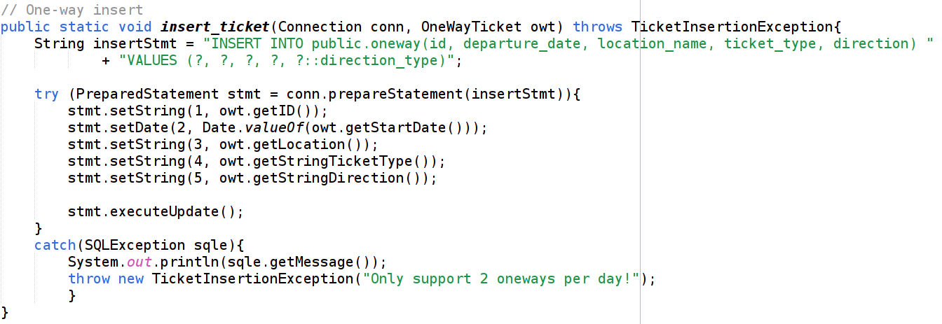
Figure 5: Overloaded insert_ticket(OneWayTicket)

Overriding
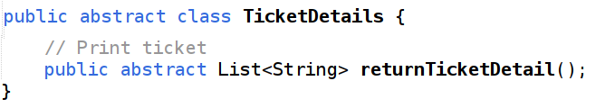
Figure 6: Abstract returnTicketDetail()
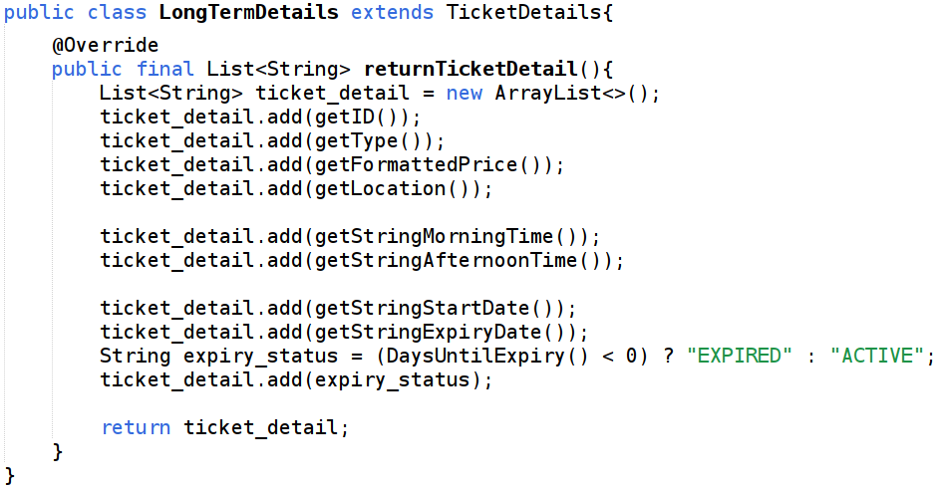
Figure 7: Overriding in LongTermDetails.java
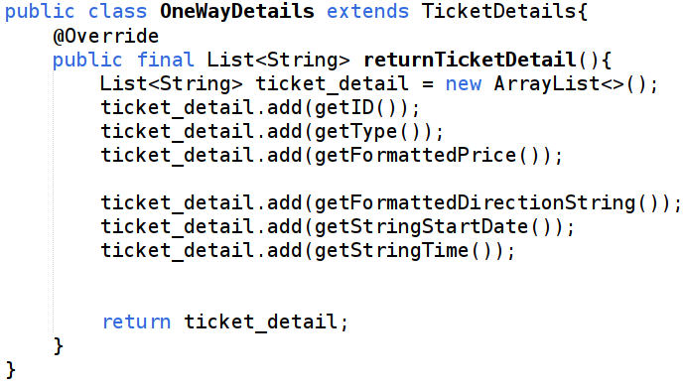
Figure 8: Overriding in OneWayDetails.java

Three-Tier Model
Conceptually, the system follows a three-tier architecture to separate concerns:
- Presentation Layer
  - GUI interacts with the user and calls methods from database controller and ticket-related classes.
- Controller Layer
  - Domain classes implement business rules such as ticket validity, journey direction, and printing ticket details.
  - Database controller acts as a bridge between GUI and Database by passing user data to underlying database system.
- Database Layer
  - Database connector establishes connection with database.
  - CRUD operations defines and enacts SQL functionalities (insert, select).

PACKAGE DESIGN
- gui
  - Classes: MainMenu, UserLogIn, NewUser, UserMenu, BusBooking.
  - Provides a graphical interface for better user experience.
- controller.java.users
  - Classes: User, Student, Professor.
  - Represents user entities and user-related logic.
- controller.java.tickets
  - Classes: Ticket, LongTermTicket, OneWayTicket.
  - Represents ticket entities and ticket-specific logic.
- controller.java.ticketdetails
  - Classes: TicketDetails, LongTermDetails, OneWayDetails.
  - Represents how ticket information is formatted, presented, and printed.
- controller.database
  - Class: DatabaseController.
  - Manages communication with the database by delegating low-level operations to DatabaseConnection.
- database
  - Class: DatabaseConnection.
  - Connects to database and calls CRUD operations.
- database.CRUD
  - Classes: CRUD_Tickets, CRUD_TicketHelper, CRUD_Users
  - Defines and enacts CRUD operations.
- exceptions
  - Classes: DatabaseConnectionException, NewUserException, LogInException, TicketInsertionException, UserSelectionException, TicketSelectionException.
  - Models different error situations in a clear and structured way.

INTERFACE DESIGN
We use interface to store database configurations (like database username, url and password). DatabaseConnection accesses this interface to retrieve credentials for establing a connection with the underlying PostgreSQL Database.
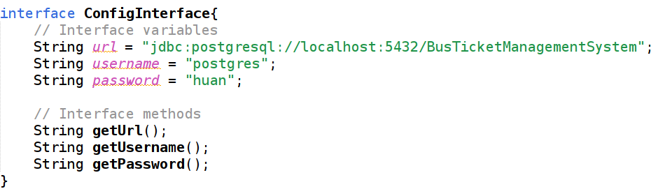
Figure 9: ConfigInterface

ACCESS CONTROL
We analyse and discuss the access control applied to variables (data) and methods in the system. In general, sensitive or identity-related data is declared private final to enforceencapsulation and immutability, while controlled access is provided through public getters or well-defined service methods (e.g., database operations). Data types that are only relevant within their packages are declared as protected.

Data Access Control
No | Data | Class | Access Modifier | Description
1 | id, user_type, first_name, last_name, email, password, user_price_modifier | User | private final | Sensitive data regarding user’s account and identity.  Cannot be modified and can only be accessed via getters.
2 | enum USER_TYPE {STUDENT, PROFESSOR} | User | protected | Specify user type (Student or Professor). Only relevant within User package.
3 | id, start_date, location, ticket_type. | Ticket | private final | Sensitive ticket data
4 | enum TICKET_TYPE {WEEKLY, DAILY, ONEWAY} | Ticket | protected | Specify ticket type. Only relevant within Ticket package.
5 | end_date | LongTermTicket | private final | Sensitive data of long-term tickets’ expiry date
6 | direction | OneWayTicket | private final | Sensitive data of one-way ticket’s direction
7 | enum Direction{TO, FROM} | OneWayTicket | private | Specify direction of one-way tickets. Only relevant within OneWayTicket class.
8 | id, start_date, location, price, type | TicketDetails | private final | Sensitive queried ticket data
9 | expiry_date, morning_pickuptime, afternoon_pickuptime | LongTermDetails | private final | Sensitive long-term ticket data
10 | direction, pickuptime | OneWayDetails | private final | Sensitive one-way ticket data

Method access control
No. | Method | Class | Modifier | Description
1 | getID(), getType(), getFirstName(), getLastName(), getEmailAddress(), getPassword(), getPriceMultiplier() | User | public | Getters to access aforementioned private variables in User.
2 | User() | User | protected | Protected constructor since only constructors in Student and Professor are supposed to be called, which will call this constructor using super()
3 | Student(), Professor() | Student  Professor | public | These constructors will be called when a new user is created.
4 | getID(),  getTicketType(),  getStartDate(),  getLocation() | Ticket | public | Getters to access the aforementioned private variables in Ticket.
5 | Ticket() | Ticket | protected | Protected constructor since only constructors in LongTermTicket and OneWayTicket are supposed to be called, which will call this constructor using super()
6 | getExpiryDate() | LongTermTicket | public | Getter to access private variable end_date in LongTermTicket.
7 | LongTermTicket() | LongTermTicket | private | This constructor is not meant to be called directly by other classes. It is only evoked via the two following class methods. Hence, it is only relevant inside the LongTermTicket class and given a private modifier.
8 | createWeekly()  createDaily() | LongTermTicket | public | Class methods that call the private constructor in LongTermTicket and defines ticket_type based on which one is called.
9 | getDirection() | OneWayTicket | public | Getter to access private variable direction in LongTermTicket.
10 | OneWayTicket() | OneWayTicket | private | This constructor is not meant to be called directly by other classes. It is only evoked via the two following class methods. Hence, it is only relevant inside the OneWayTicket class and given a private modifier.
11 | create_TO()  create_FROM() | OneWayTicket | public | Class methods that call the private constructor in OneWayTicket and defines direction based on which one is called
12 | getID(), getPrice() getStartDate(), getLocation(), getTicketType() | TicketDetails | public | Getters to access the aforementioned private variables in TicketDetails.
13 | returnTicketDetail() | TicketDetails | public abstract | Calling this method to make use of dynamic runtime polymorphism to flexibly print ticket details
14 | returnTicketDetail() | LongTermDetails  OneWayDetails | public | This method overrides the abstract method in TicketDetails

ENCAPSULATION, INHERITENCE AND POLYMORPHISM

Encapsulation
For encapsulation, we enclose data using private final fields, and provide public getters for variable access. For example, the Ticket class keeps most of its variables private and provides public getters. This ensures that once a ticket is created, its data can only be accessed through public getters and cannot be modified without permission.
Certain elements are set to protected as they are only meant to be used within their package. For example, the Ticket class has a protected enumeration for ticket types as this enumeration is only meant to be used for ticket creation and nowhere else. This enumeration is therefore visible to every file in its package to make use of it (Ticket, LongTermTicket, OneWayTicket) but not to external files.

Inheritance
Inheritance allow us to have multiple related classes containing the same variables and methods. For instance: Student and Professor are subclasses of User.

Polymorphism
Polymorphism is used to generalize different subclasses by assigning their references to a parent class object. For example, in com.gui.BusBooking, a Ticket object is created and then passed references of its subclasses depending on the option picked.
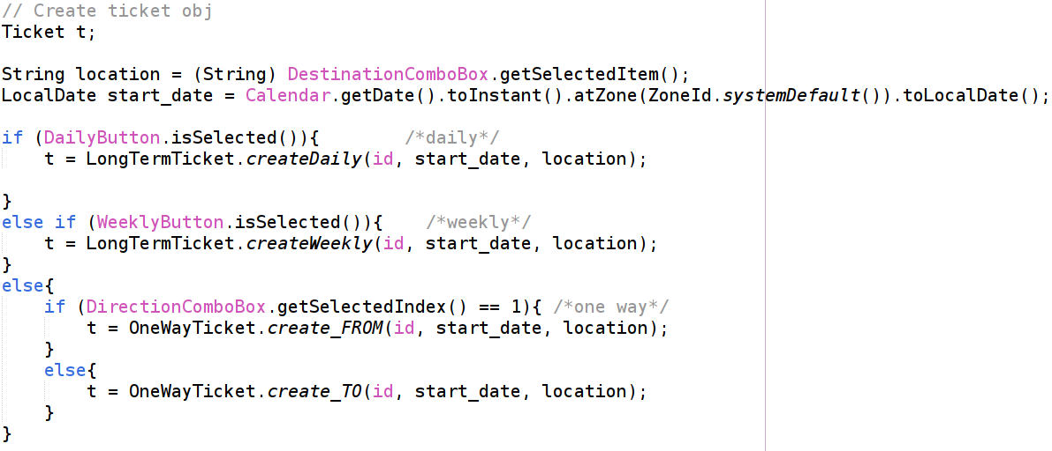
Figure 10: Example of Polymorphism

EXPERIMENT

Project functions
No | Name of function | Description
1 | Support for different user types | User can log in as a Student or a Professor, which affects the pricing of tickets.
2 | Account register | User can register for an account, which requires them to input necessary data like name, ID, password and email.
3 | Log In | User must have an existing account and provide the correct password in order to log in
4 | Buy Tickets | After logging in, user can buy tickets by specifying station, ticket type, departure date, and in the case of one-way tickets, direction.
5 | See Tickets | User can see all tickets that they have purchased in a summary table.

Database design
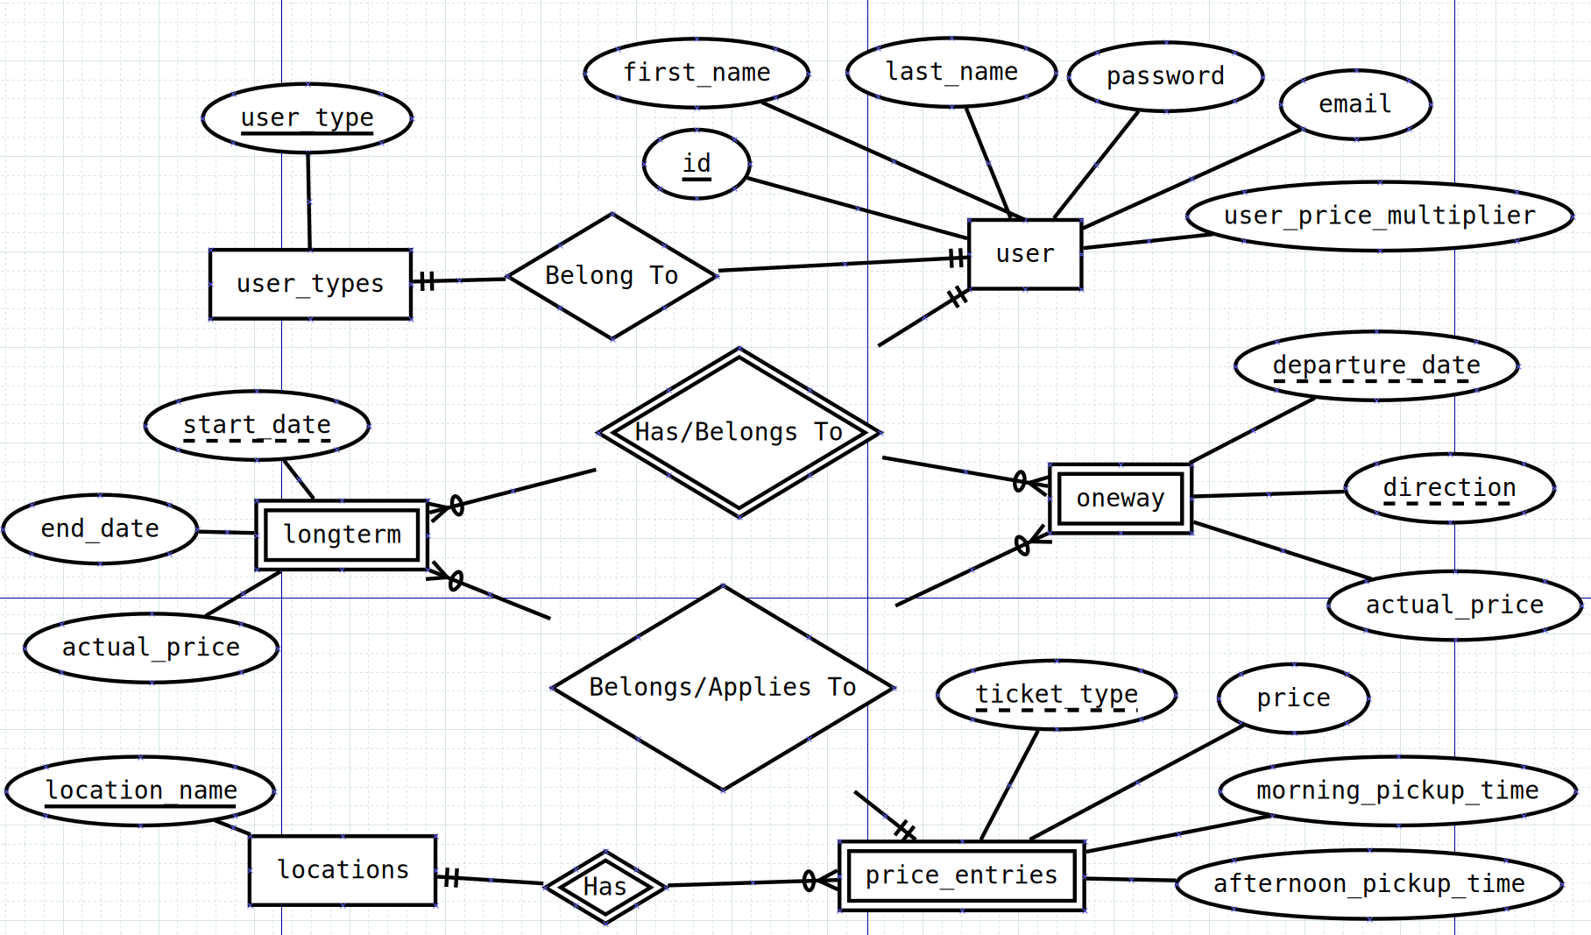
Figure 11: Entity – Relationship Diagram of Database
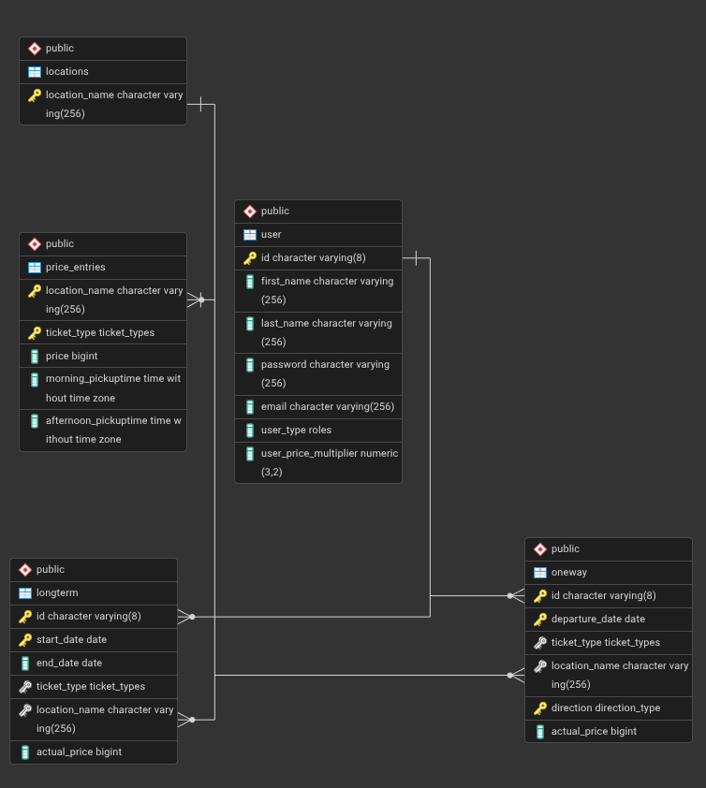
Figure 12: Relational Diagram of Database

GUI
No | Name | Description | Floats Into
1 | MainMenu | - User picks between Log In as Student and Log In as Professor.  - GUI keeps track of user type and passes it to the next window. | UserLogIn with user type of option picked
2 | UserLogIn | - User inputs ID and password to log in. Requires existing account and valid password.  - User can exit to main menu with Back.  - User can create a new account with SignUp. | - MainMenu if Back.  - NewUp if Signup.  - UserMenu with correct credentials.
3 | NewUser | - User provides necessary data (ID, first name, last name, password, email) for account registration. Rejects if ID already existed in database. | - UserLogIn if Back.
4 | UserMenu | - User can buy tickets with Buy Tickets.  - User can see bought tickets with See Tickets.  - User can sign out with SignOut. | - UserLogIn if Sign Out.  - BusBooking if Buy Tickets.
5 | BusBooking | - User fills out form to buy tickets. | - UserMenu if Back

Illustrations:
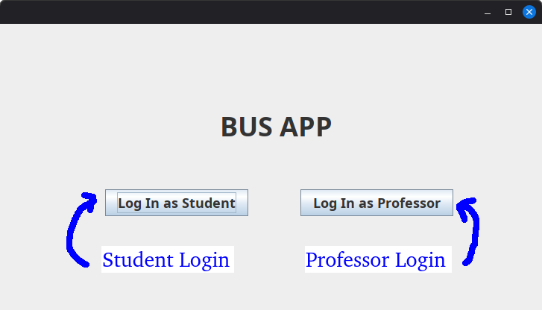
Figure 13: MainMenu
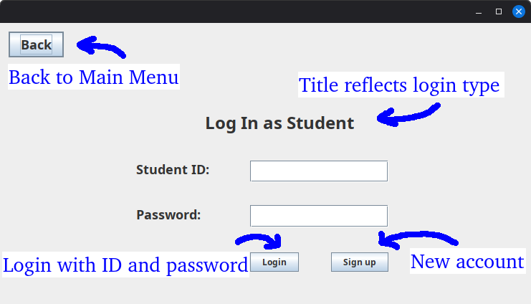
Figure 14: UserLogIn
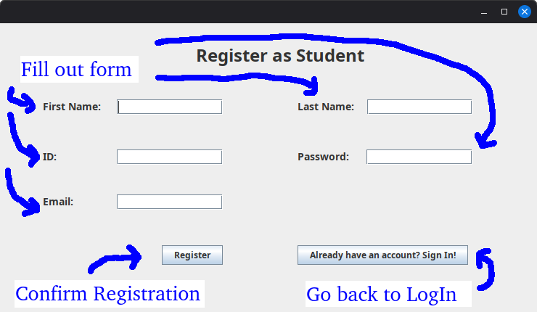
Figure 15: UserLogIn
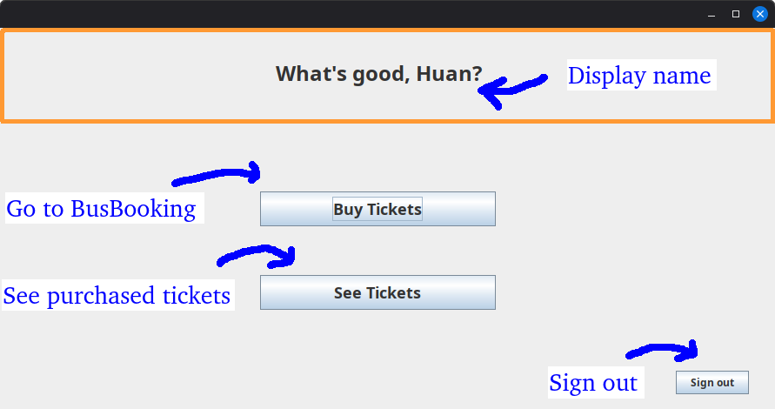
Figure 16: UserMenu
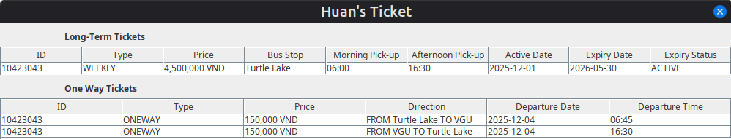
Figure 17: See Tickets
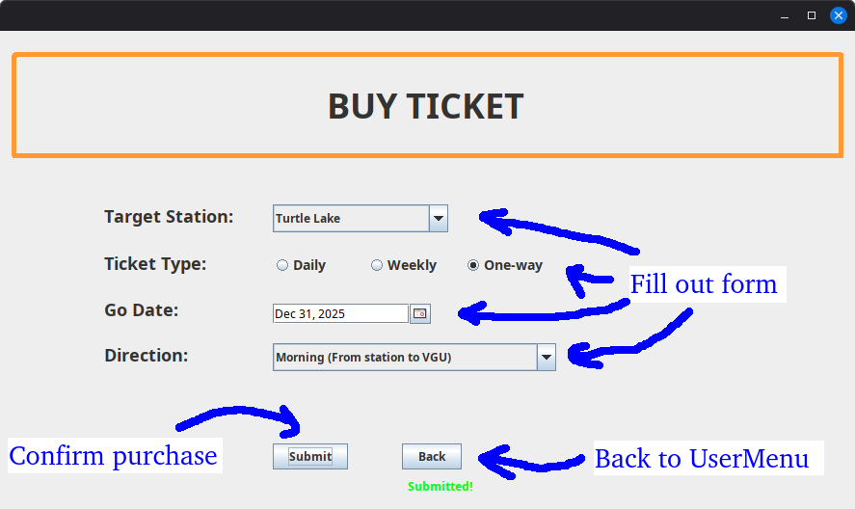
Figure 18: Buy Tickets

CONCLUSION
Overall, the application provides some of the most basic functionalities to be expected from a bus ticket app. The user can register for an account, log into such account with a password. Once logged in, the user can purchase tickets and see a log of all purchased tickets.
The project has been tested carefully and many safeguards have been implemented to prevent potential user errors. For example, the user cannot attempt to log into an account that has not been registered in the database. Also they cannot finalize any transactions before completely filling out the form when attempting to purchase a ticket.
The biggest downside of the project is that the graphical user interface is still very basic and admittedly uncomfortable to use, as our main focus is on the functionalities of the application, and not the form. If we ever revisit this project in the future, improving the GUI is one of our highest priorities.
DUTY ROSTER

ID | Task | In Charge | State | Note
1 | Design:  com.ui | Cao Dang Tri  Tran Gia Huan | Done
2 | Design:  com.controller.java.users | Ngo Trung Kien | Done
3 | Design:  com.controller.database  com.controller.java.tickets  com.controller.java.ticketdetails  com.database  com.database.CRUD  com.exceptions | Tran Gia Huan | Done | I wrote everything inside those packages and then some btw.
4 | Set up, design and refine database architecture  Write set up file for database  Draw entity – relationship diagram  Draw relational diagram | Tran Gia Huan | Done
5 | Connect GUI to controller  Connect controller to database | Tran Gia Huan | Done
6 | Fix UI bugs (like adding check conditions to input fields, fixing inconsistent error messages) | Tran Gia Huan  Cao Dang Tri | Done | Tri fixes design bugs.  Huan fixes logical bugs
7 | Set up and manage GitHub repo | Tran Gia Huan | Done
8 | Write first draft of report | Ngo Trung Kien | Done
9 | Rewrite report. Add visuals | Tran Gia Huan | Done

