**HOMEWORK**

**Họ và tên: Trần Hạo Đông**

**MSSV: 20146166**

**Bài 4.1:**

|  |  |  |  |  |  |
| --- | --- | --- | --- | --- | --- |
| **#** | **θ** | **L** | **α** | **d** | **Var** |
| **1** | θ1 | L2 |  | L1 | θ1 |
| **2** | θ2 | L4 |  | L3 | θ2 |
| **3** | θ3 | L5 |  | L6 | θ3 |
| **4** | θ4 | L7 | π | L8 | θ4 |

**Bài 4.2:**

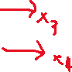

|  |  |  |  |  |  |
| --- | --- | --- | --- | --- | --- |
| **#** | **θ** | **L** | **d** | **α** | **Var** |
| 1 | θ1 | L4 | L1+L2 | 0 | θ1 |
| 2 | θ2 | L5 | L3 | π | θ2 |
| 3 | 0 | 0 | L6+S | 0 | S |
| 4 | θ3 | 0 | L7 | 0 | θ3 |

**



|  |  |  |  |  |  |
| --- | --- | --- | --- | --- | --- |
| **#** | **θ** | **L** | **d** | **α** | **Var** |
| **1** | θ1 | L2 | L1+L3 |  | θ1 |
| **2** | θ2 | L4 | 0 | 0 | θ2 |
| **3** | θ3 | L5 | 0 | 0 | θ3 |
| **4** | θ4 | L6 | 0 | 0 | θ4 |

**Bài 4.4:**

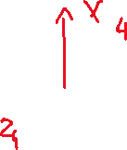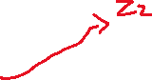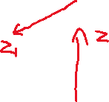

|  |  |  |  |  |  |
| --- | --- | --- | --- | --- | --- |
| **#** | **θ** | **L** | **d** | **α** | **Var** |
| **1** | θ1 | 0 | L1 |  | θ1 |
| **2** |  | 0 | 0 |  | θ2 |
| **3** | 0 | 0 | L4+L5 |  | L5 |
| **4** | θ4+ | L6 | 0 | 0 | θ4 |

**Bài 4.5:**

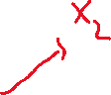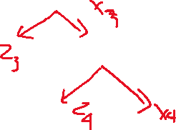

|  |  |  |  |  |  |
| --- | --- | --- | --- | --- | --- |
| **#** | **θ** | **L** | **d** | **α** | **Var** |
| **1** | θ1 | 0 | L1+L2 |  | θ1 |
| **2** | θ2 | L3 | 0 |  | θ2 |
| **3** | θ3 | L4 | 0 | 0 | θ3 |
| **4** | θ4 |  | 0 | 0 | θ4 |

**Bài 4.6:**

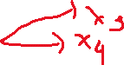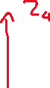

|  |  |  |  |  |  |
| --- | --- | --- | --- | --- | --- |
| **#** | **θ** | **L** | **d** | **α** | **Var** |
| **1** | θ1 | L1 | L2 |  | θ1 |
| **2** | θ2 | L3 | 0 |  | θ2 |
| **3** | θ3 | L4 | 0 | π | θ3 |
| **4** | θ4 | 0 | 0 |  | θ4 |
| **5** | θ5 | L5 | L6 |  | θ5 |