ID: GG Sheet: 1vtlNTrRIFvqgbpYdUGKT1qy81kPXllunk8H348RBTms

URL App: <https://script.google.com/macros/s/AKfycbyiaT6zQKNmvzMelMgjwfYLUDcyt_ij-uqzbR-lBfeh3z1MpTKOHwTeZivcwIaonTSicg/exec>

?giatri1=hovaten&giatri2=BuiNgocLong

ID triển khai

AKfycbxZMOsoJOZuDHSVLgxxh-ic8A6xFcE-jwlgEf1SsQP4QqY8QwpsWwXJm4XX3AHQssnggg

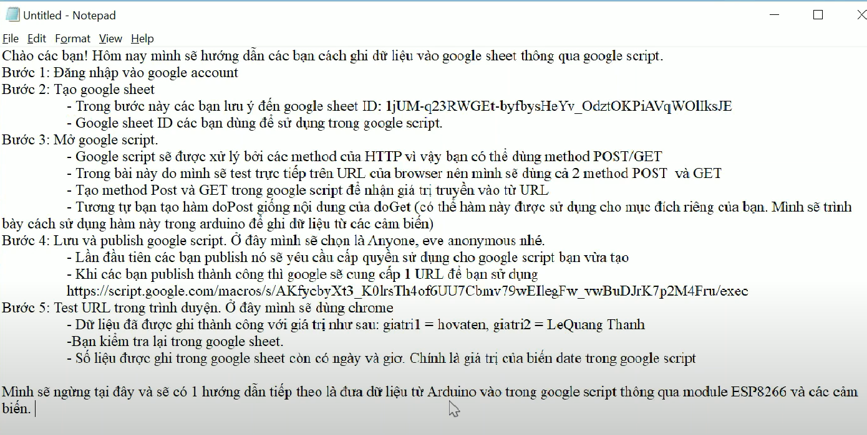

Link Script: <https://script.google.com/home/projects/1ut6Gi0kqcvuJQiiam2ejmeZdXRvb2-fqElMB3w0xlYu3la467PJITdhq/edit>

Link gg Sheet: <https://docs.google.com/spreadsheets/d/1vtlNTrRIFvqgbpYdUGKT1qy81kPXllunk8H348RBTms/edit#gid=0>

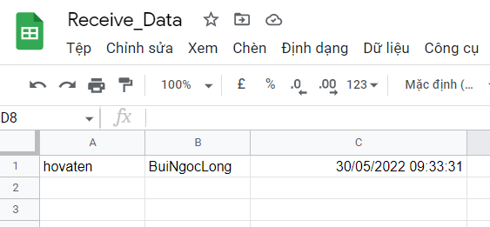

Code:

//khai báo

var ss = SpreadsheetApp.openById('1vtlNTrRIFvqgbpYdUGKT1qy81kPXllunk8H348RBTms');

//Khai báo tên sheet được sử dụng

var name = ss.getSheetByName('Data');

//Tạo hàm doGet để nhận giá trị từ browser

function doGet(e)

{

  var giatri1 = e.parameter.giatri1;

  var giatri2 = e.parameter.giatri2;

  var date    = Utilities.formatDate(new Date(), "GMT+7", "dd/MM/yyy HH:mm:ss"); //ngày h ghi dữ liệu

  name.appendRow([giatri1,giatri2, date]); // chèn dữ liệu vào gg sheet

  return ContentService.createTextOutput("Dữ liệu được ghi: " + giatri1 + ' ' + giatri2);// do hàm doGet nên phải có return

  SpreadsheetApp.flush();

}

//Funcion goPost

function doPost(c)

{

  var giatri1 = e.parameter.giatri1;

  var giatri2 = c.parameter.giatri2;

  var date    = Utilities.formatDate(new Date(), "GMT+7", "dd/MM/yyy HH:mm:ss"); //ngày h ghi dữ liệu

  name.appendRow([giatri1,giatri2, date]); // chèn dữ liệu vào gg sheet

  SpreadsheetApp.flush();

}

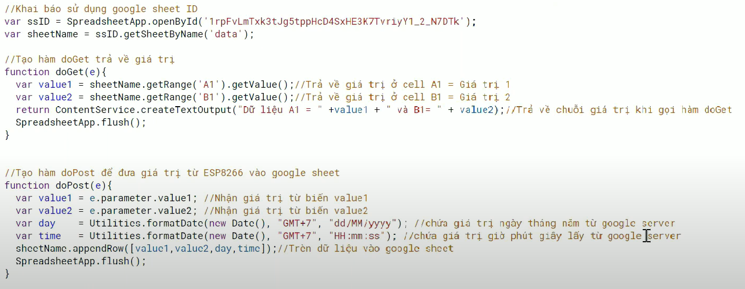**ESP32 – DATA LOG**

**Code:** //khai báo

var ssID = SpreadsheetApp.openById('1cKRXxbE-Rhe-x8rL5nGz99Uh2Tqi1xsxA0mhC-4AATE');

//Khai báo tên sheet được sử dụng

var sheetName = ssID.getSheetByName('DULIEU');

//Tạo hàm doGet để nhận giá trị

function doGet(e)

{

  var value1 = sheetName.getRange("A1").getValue(); //Trả về giá trị ở cell A1 = giá trị 1

  var value2 = sheetName.getRange("B1").getValue(); //Trả về giá trị ở cell B1 = giá trị 2

  return ContentService.createTextOutput("Dữ liệu A1 = " + value1 + ' và B1 =  ' + value2);// trả về chuỗi giá trị khi gọi hàm doGet

  SpreadsheetApp.flush();

}

//Funcion doPost để đưa giá trị từ Esp32 vào google sheet

function doPost(e)

{

  var value1 = e.parameter.value1; //Nhận giá trị từ biến value 1

  var value2 = c.parameter.value2;

  var day    = Utilities.formatDate(new Date(), "GMT+7", "dd/MM/yyy"); //Chứa giá trị ngày tháng năm từ google server

  var time   = Utilities.formatDate(new Date(), "GMT+7", "HH:mm:ss"); //Chứa giá trị giờ phút giây từ google server

  name.appendRow([value1,value2, day, time]); // chèn dữ liệu vào gg sheet

  SpreadsheetApp.flush();

}

- GG Script: <https://script.google.com/u/0/home/projects/1ZoVtC--ivvYPJJmoLbGfgyXPrzlew2JQJSazaiV0wszx2snISdc0hC0r/edit>

- Web App: <https://script.googleusercontent.com/macros/echo?user_content_key=sCXOKt_di2nDcURxhpLx2fecNIqC99z1nc9_U4AJdh_OSM-OKmf0r0xsKAILsOdVBNhcNxHxVV2XiQ0oB1PZSArOKR61Tx4mm5_BxDlH2jW0nuo2oDemN9CCS2h10ox_1xSncGQajx_ryfhECjZEnBirlNVbUPDIPn3nkcQ41P0ZS1tDiUhyDqAjlpYBWXvLt3EhvNYemec0RHpmJfB_weukLidCKVOTlwp2NFbqyT9revtnZ8zKBw&lib=M3D_hyXAjqBb4U9AVnfb45Gb-c7rEWU4q>

- GG Sheet: <https://docs.google.com/spreadsheets/d/1cKRXxbE-Rhe-x8rL5nGz99Uh2Tqi1xsxA0mhC-4AATE/edit#gid=0>

<https://script.google.com/macros/s/AKfycbwhAewlnz2BepvLmH8puqDrJbXvLu_ADdnixdIyq79F1vCOuj5-B9GJIlUEy1eSYg1D/exec>

esp32_test:

<https://script.google.com/macros/s/AKfycbwJFroE6Ihljzh8ZqEaaq2cmGDrWwg4qK2WmQWjtGAC0SIa6nEvA3xewTttiN4nIboh/exec>

V1:

<https://script.google.com/macros/s/AKfycbxAAXgiCfUXMR13y-fEbMVL3spZSzlPXuEYaH0yGN9zMywRPi2H4zDg-g8z_RUMoBi9/exec>

v2:

https://script.google.com/macros/s/AKfycbweEcBQYbhYUGUXdC50I1odydI_xZbFOaymSZfZzwCfWZAeQjyMxS7rEIhbcPDhyjNo/exec