

Research Paper Management System
Software Design Document
Project Code: Labverse
Document Code: Labverse– v1

– Hanoi, November 2025 –
Table of Contents
1 Introduction 3
1.1 Purpose 3
1.2 Definitions, Acronyms and Abbreviations 3
1.3 References 3
2 System Architecture 3
2.1 System Overview 3
2.3 Assumptions 4
2.4 Design Constraints 4
3 Software Architecture Design 5
3.1 Architectural Representation 5
3.2 Software Architecture 5
4 Detailed Component Design 10
4.1 Common Design 10
4.2 <Use-Case ID/Feature ID> - <Use case Name/Feature Name> 10
4.3 <Use-Case ID/Feature ID> - <Use case Name/Feature Name 2> 13
4.3 <Name of Function Group > 14
5. Database Design 14
5.1 Database Design 14
5.2 Data File Design 15

1 Introduction

1.1 Purpose
The purpose of this Software Design Document (SDD) is to describe the architecture, high-level and low-level design, component interactions, data models, user interface structure, and technology choices for the LabVerse Web application and its supporting backend system.
This document provides a blueprint for implementation, enabling development teams to:
- Understand how the system fulfills the requirements defined in the Software Requirements Specification (SRS).
- Implement consistent, maintainable, and scalable code.
- Make informed decisions on design patterns, libraries, and integration strategies.
- Support code reviews, testing, onboarding, and future enhancements.
The primary audience includes:
- Android Developers and Web Developers (client-side implementation)
- Backend Engineers (API, database, and service design)
- UI/UX Designers (for screen flow and interaction consistency)
- DevOps & System Architects (deployment, scalability, offline sync)
- QA Engineers (for test case derivation and boundary validation)
This SDD covers:
- System architecture (client-server, offline-first)
- Module decomposition (Android app modules, backend services)
- Data flow and synchronization
- UI component hierarchy and navigation
- Security and authentication mechanisms
- Integration with third-party services
It does not include:
- Detailed source code
- Unit test implementations
- Deployment scripts or CI/CD pipelines (covered in separate DevOps docs)

1.2 Definitions, Acronyms and Abbreviations

Term | Definition
LabVerse | The complete research paper management system comprising the Android mobile application, backend server, and database
PI | Principal Investigator – A lab head or team leader with administrative privileges in the system
Researcher | A Postdoc or PhD student who is the primary active user of the system for managing personal and shared paper libraries
Student/Intern | A user with limited or read-only access to shared collections, typically assigned reading tasks
Collection | A shared, curated group of research papers tied to a specific project, topic, or research team. Also referred to as a "Project" or "Team Library"
Reading List | A user-created, manually curated list of papers, often used for journal clubs, literature reviews, or personal study plans.
Journal Club | A collaborative reading list with optional discussion features, typically used in academic group settings
Annotation | User-added content overlaid on a PDF, including highlights, underlines, sticky notes, freehand drawings, or text comments
Metadata | Structured bibliographic information about a paper (title, authors, journal, year, DOI, abstract, etc.)
Grobid | GeneRation Of BIbliographic Data – An open-source machine learning tool used by the backend to extract metadata and references from PDF documents
BibTeX | A standard plain-text format for describing bibliographic references, commonly exported from reference managers like Zotero, Mendeley, or EndNote
JWT | JSON Web Token – A compact, URL-safe means of representing claims to be transferred between client and server, used for secure authentication
OAuth2 | An authorization framework enabling third-party applications (e.g., Google Sign-In) to obtain limited access to user accounts
FCM | Firebase Cloud Messaging – Google’s platform for sending push notifications to Android devices
RoomDB | Android’s persistence library providing an abstraction layer over SQLite for local data storage and offline access
WorkManager | Android Jetpack library for deferrable, guaranteed background work (e.g., data synchronization)
API | Application Programming Interface – Set of RESTful endpoints exposed by the backend for client-server communication
CRUD | Create, Read, Update, Delete – Basic operations performed on data entities
FAB | Floating Action Button – A circular button in Material Design that triggers primary actions (e.g., "Import New Paper")
RecyclerView | Android UI component for efficiently displaying large, scrollable lists of data
BottomSheetDialog | A modal UI element that slides up from the bottom of the screen, used for filters, actions, or status updates.
SRS | Software Requirements Specification – This document
DOI | Digital Object Identifier – A persistent identifier for academic publications
Offline-first | A design approach where the app functions fully without internet and syncs changes when connectivity is restored

1.3 References

2 System Architecture

2.1 System Overview
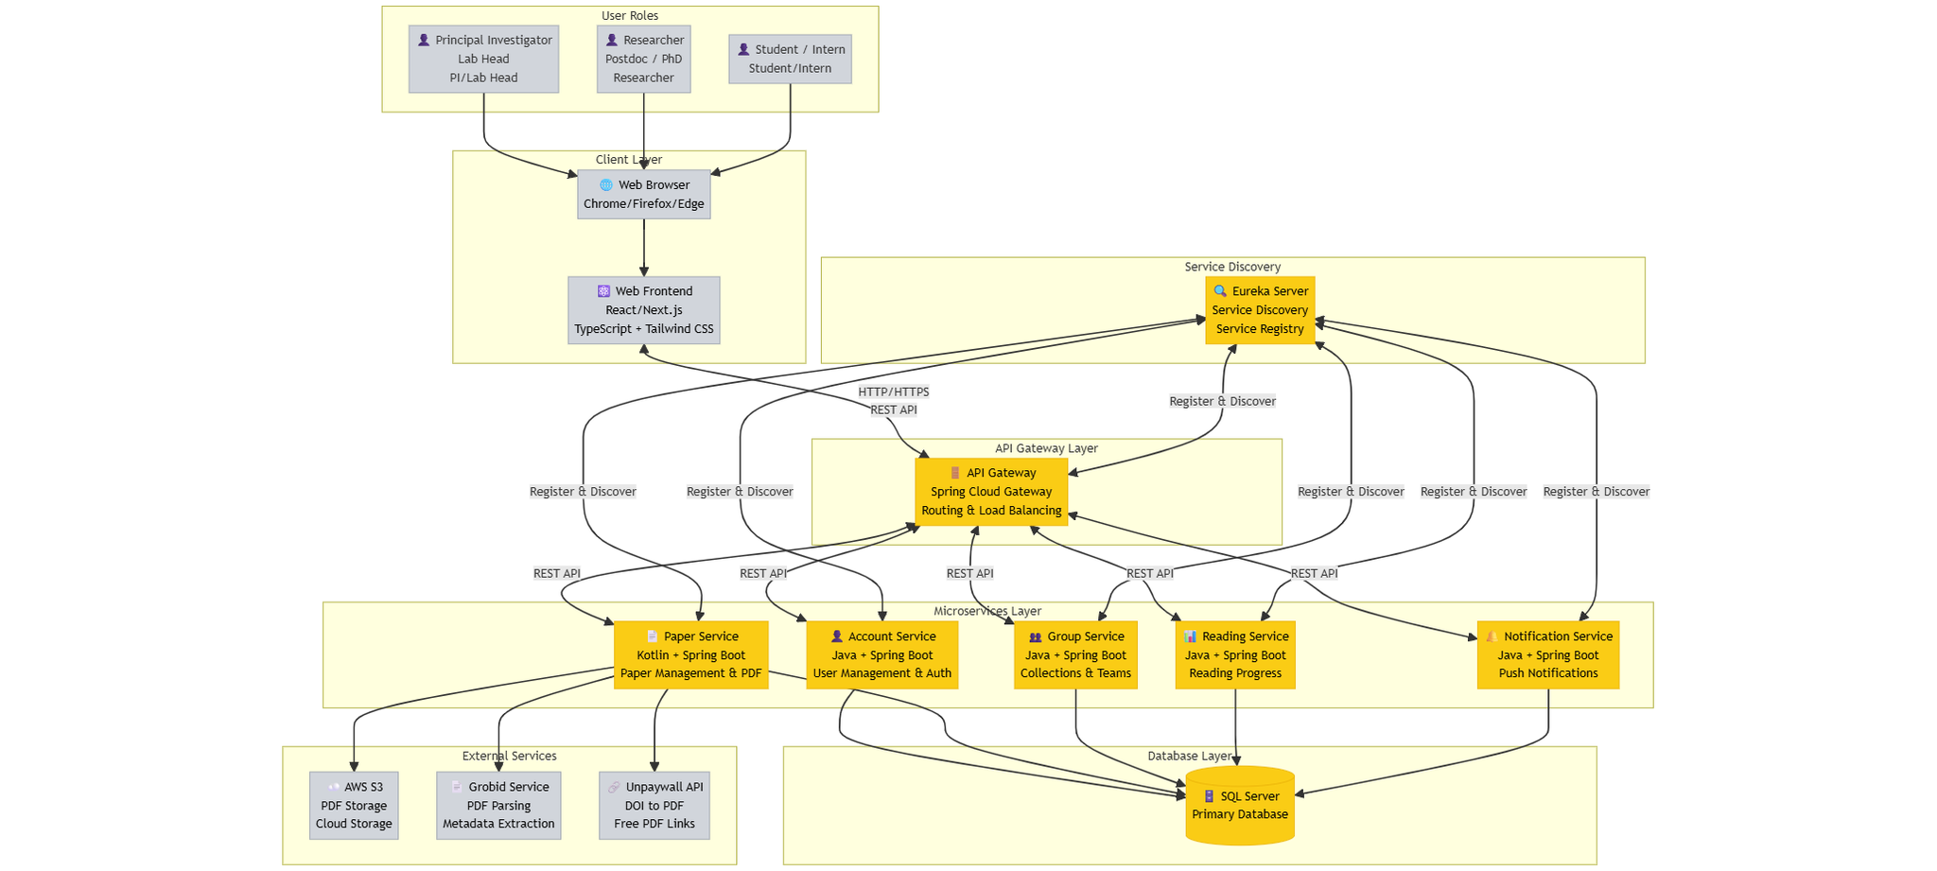
Figure 2-1: System Architectural Overview
- User Access: A User initiates interaction via a Web Browser.
- Secure Connection: The browser connects to the system using the secure HTTPS protocol.
- API Gateway: All incoming requests first hit the API Gateway. This acts as the single entry point, handling routing, security, and potentially rate limiting.
- Service Discovery: The API Gateway communicates with Eureka. Eureka is a service discovery server that allows the system to locate the various microservices within the LabVerse Software box.
- AccountService: Likely handles user registration, login, and profile management.
- PaperService: Likely manages the core functionality related to research papers or documents.
- NotificationService: Handles sending notifications, likely integrating with an external mail service.
- GroupService: Manages user groups, teams, or collaborative features.
- ReadingService: Possibly tracks user reading activity or provides paper viewing/annotation features.
- Google Service (OAuth2): The LabVerse Software integrates with an external Google Service using the OAuth2 protocol. As per your description, this is the Google Mail Service used for user authentication and sending email notifications.
- Database Access (Polyglot Persistence): The system uses a polyglot persistence approach, utilizing two different database types:
- MongoDB, AWS: This likely serves as a primary, scalable NoSQL data store (hosted on AWS) for unstructured or semi-structured data, such as paper content or large documents, accessed by the PaperService.
- SQL Server: This relational database is used by several services (GroupService, NotificationService, and ReadingService) via JDBC (Java Database Connectivity), suggesting it stores structured data like user accounts, group memberships, or notification logs.

2.2 Assumptions
- Cenabled Service Workers, and permission to load PDF.js workers from /public.
- Web Build Tooling: Node.js 20+ with Vite + React 18; npm/yarn availability for dependency installs; CI runners provide at least 4 GB RAM for builds.
- Backend Runtime: Java 17+, Spring Boot microservices (Account, Group, Notification, Gateway, Eureka) deployed on Linux hosts or containers with outbound Internet for FCM.
- Security & Auth: All HTTP requests carry valid JWTs issued by AccountService; reverse proxies terminate TLS and forward Authorization headers intact.
- Database Layer: SQL Server 2019 (or Azure SQL equivalent) reachable from services, with proper schema migrations applied before deployment.
- Messaging/Notifications: Firebase Cloud Messaging project active, service accounts configured, and outbound HTTPS to FCM allowed.
- File Handling: Server has access to shared storage (e.g., S3-compatible bucket) for exported annotations; web client can download files via HTTPS.
- Network Conditions: Gateway/Eureka cluster remains available; API Gateway routes traffic consistently; DNS entries stable.
- Future Changes: Potential roadmap items (collaborative annotations, richer notification channels, admin dashboards) will reuse existing REST APIs; React component structure and Spring service boundaries are designed to accommodate these expansions without major rewrites.lient Browsers: Chrome, Edge, or Firefox (latest two versions) with ECMAScript 2020 support,

2.3 Design Constraints
- Scope: Applies only to Web Frontend and Backend Services (excludes Android).
- Environment: Modern browsers (Chrome, Firefox, Edge, Safari) support; minimum 1 Mbps bandwidth.
- Architecture: Microservices with API Gateway (port 8080) as the single entry point.
- Protocols: HTTPS (Production) / HTTP (Dev); Standard RESTful APIs (/v1/api);
- Performance: Max 10s response time; support for 100+ concurrent users; 50MB upload in <30s.
- Security: JWT Authentication (via Supabase); TLS 1.2+ encryption; CSRF protection; strict input validation.
- Database: Database-per-service pattern (SQL Server for core, MongoDB for papers, Supabase for Auth).
- Storage: Files stored on AWS S3 (max 50MB/file, 10GB/user); daily DB backups.
- Networking: Netflix Eureka for service discovery; REST for inter-service communication; CORS enabled for frontend.
- Tech Stack: Java 21/Spring Boot 3.4.3 (Backend); TypeScript/React 18+ (Frontend).
- Reliability: 99% Uptime target; circuit breakers for external APIs (Grobid, Unpaywall).
- Quality & Ops: Min 70% unit test coverage; Docker containerization; CI/CD pipelines; Swagger/OpenAPI documentation.

3 Software Architecture Design

3.1 Architectural Representation
The software architecture of the LabVerse system is designed based on the Microservices Architecture model, featuring the following main components:
- Frontend Layer: Web application (React/TypeScript).
- API Gateway Layer: The single entry point for all client requests.
- Service Layer: Independent microservices handling different business logic.
- Data Layer: Database and storage services.
- Infrastructure Layer: Service discovery, message queuing, and support services.
The system uses the following views to describe the architecture:
- Process View: Describes the business processes and main processing flows of the system, focusing on dynamic behavior and concurrency.
- Logical View: Describes the layered architecture and key logical components.
- Development View: Describes the source code structure, package organization, and component structure.
- Deployment View: Describes how components are deployed on the infrastructure.
Each view contains appropriate model elements:
- Process View: Activity diagrams, sequence diagrams, process flows.
- Logical View: Class diagrams, component diagrams, layer diagrams.
- Development View: Package diagrams, module diagrams, component structure.
- Deployment View: Deployment diagrams, node diagrams, infrastructure topology.

3.2 Software Architecture
The LabVerse system utilizes the Layered Microservices Architecture Pattern combined with the API Gateway Pattern and Service Discovery Pattern. This architecture is divided into the following layers:

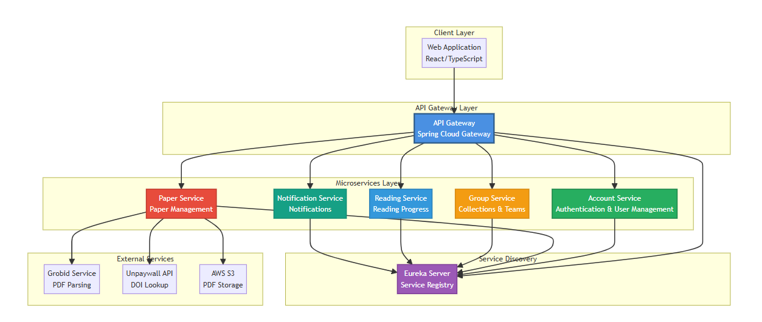

1. Client Layer
- Web Application: React/TypeScript application providing the web interface for users.
2. API Gateway Layer
- API Gateway: Spring Cloud Gateway acting as the single entry point, handling routing, authentication, and load balancing.
Responsibilities:
  - Request routing to appropriate microservices.
  - Authentication and authorization.
  - Rate limiting and security.
  - Request/Response transformation.
3. Service Discovery Layer
- Eureka Server: Service registry allowing microservices to automatically discover and communicate with each other.
Benefits:
  - Dynamic service registration and discovery.
  - Load balancing.
  - Health checking.
4. Microservices Layer
Each microservice is an independent application:
- Account Service: Manages authentication, user registration, and profile management.
- Paper Service: Manages research papers, PDF uploads, metadata extraction, and search.
- Group Service: Manages collections, teams, annotations, and collaboration features.
- Reading Service: Tracks reading progress, workflows, and reading statistics.
- Notification Service: Sends notifications via Firebase Cloud Messaging (FCM).
5 External Services Layer
- Grobid Service: PDF parsing to extract metadata and citations.
- Unpaywall API: Searches for PDF links using DOI.
- AWS S3: Cloud storage for PDF files.

3.2.1 Process View
The Process View describes the main business processes of the system, focusing on dynamic behavior, concurrency, and synchronization between components. This view contributes to non-functional requirements such as performance, scalability, and availability.

3.2.1.1 User Registration and Authentication Process
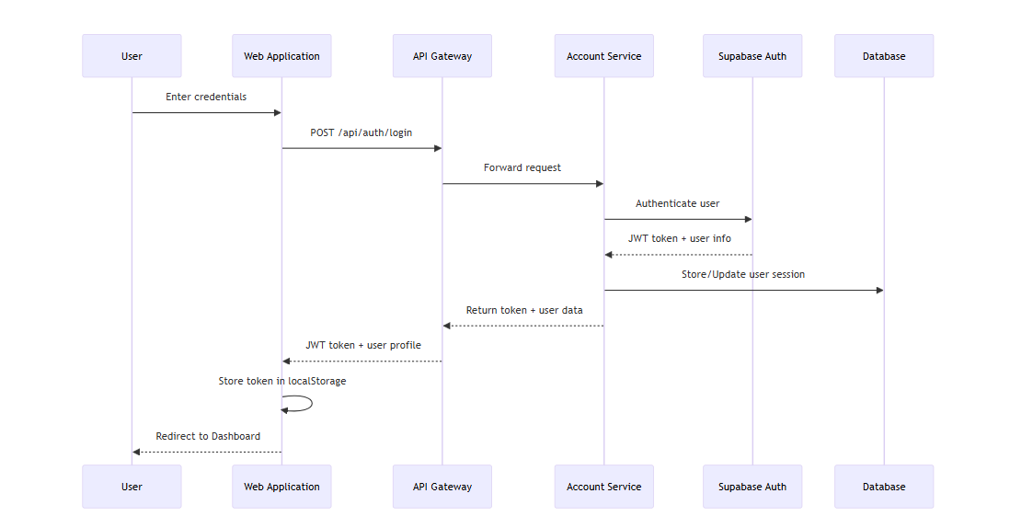
Figure 3-3:User Registration and Authentication Process
Process Description:
Step 1: The user enters login credentials (email/password) on the Web Application or Android Application.
Step 2: The client application sends a request to the API Gateway at the endpoint /api/auth/login.
Step 3: The API Gateway validates the request and forwards it to the Account Service via service discovery (Eureka).
Step 4: The Account Service sends an authentication request to the Supabase Auth service to verify credentials.
Step 5: If credentials are valid, Supabase returns a JWT token and user information.
Step 6: The Account Service stores/updates the session in the database and returns the token along with the user profile.
Step 7: The API Gateway forwards the response to the client application.
Step 8: The client application stores the token (localStorage for Web, EncryptedSharedPreferences for Android) and redirects the user to the Dashboard.

3.2.1.2 Paper Upload and Processing Process
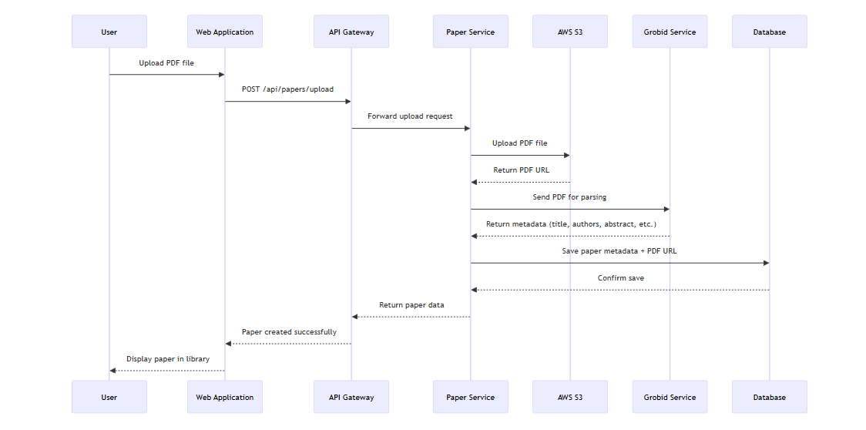
Figure 3-4:Paper Upload and Processing Process

Process Description:
Step 1: The user selects a PDF file from their computer or mobile device and clicks Upload.
Step 2: The Web Application sends a multipart/form-data request to the API Gateway at the endpoint /api/papers/upload with the PDF file and metadata (if any).
Step 3: The API Gateway forwards the request to the Paper Service.
Step 4: The Paper Service uploads the PDF file to AWS S3 storage.
Step 5: AWS S3 returns the public URL of the PDF file.
Step 6: The Paper Service sends the PDF file to the Grobid service to extract metadata (title, authors, abstract, keywords, citations).
Step 7: The Grobid service returns structured metadata in JSON format.
Step 8: The Paper Service saves the paper metadata (title, authors, journal, year, DOI, keywords, abstract) and PDF URL into the Supabase database.
Step 9: The database confirms the save was successful.
Step 10: The Paper Service returns the paper data (including ID, metadata, PDF URL) to the API Gateway.
Step 11: The API Gateway forwards the response to the Web Application.
Step 12: The Web Application displays the new paper in the user's Personal Library.

3.2.1.3 Reading Progress Tracking Process

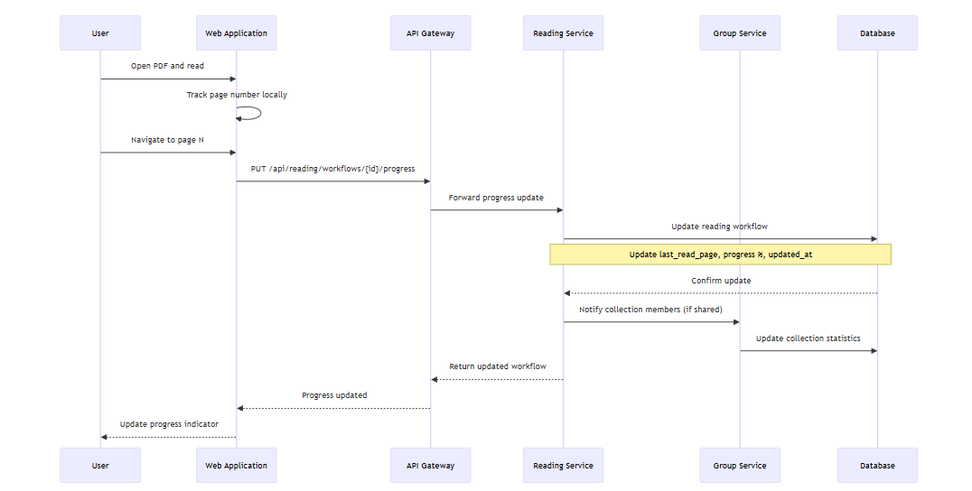
Figure 3-5: Reading Progress Tracking Process

Process Description:
Step 1: The user opens the PDF viewer in the Web Application or Android app.
Step 2: The application tracks the page number locally in memory to ensure a responsive UI.
Step 3: When the user navigates to page N, the application automatically sends an update request.
Step 4: The Web Application sends a PUT request to the API Gateway at the endpoint /api/reading/workflows/{id}/progress with the page number and total pages.
Step 5: The API Gateway forwards the request to the Reading Service.
Step 6: The Reading Service calculates the progress percentage and updates the reading workflow in the database (last_read_page, progress, updated_at).
Step 7: The database confirms the update was successful.
Step 8: If the paper belongs to a shared collection, the Reading Service notifies the Group Service to update collection statistics.
Step 9: The Group Service updates collection-level reading statistics (total pages read by team, average progress, etc.).
Step 10: The Reading Service returns the updated workflow data to the API Gateway.
Step 11: The API Gateway forwards the response to the Web Application.
Step 12: The Web Application updates the progress indicator on the UI (progress bar, page counter).

3.2.1.4 Collection Creation and Team Collaboration Process
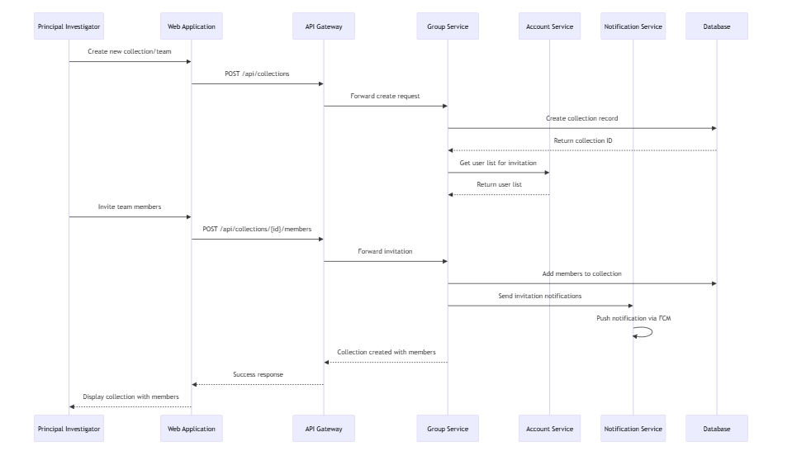
Figure 3-6: Collection Creation and Team Collaboration Process
Process Description:
Step 1: The Principal Investigator (PI) or Lab Head creates a new collection/team via the Web Application.
Step 2: The Web Application sends a POST request to the API Gateway at the endpoint /api/collections with collection metadata (name, description, access level).
Step 3: The API Gateway forwards the request to the Group Service.
Step 4: The Group Service creates a collection record in the database with the PI as the owner.
Step 5: The database returns the collection ID.
Step 6: If the PI wants to invite team members, the Group Service queries the Account Service to get the list of users available for invitation.
Step 7: The Account Service returns the user list.
Step 8: The PI selects members and sends invitations via the Web Application.
Step 9: The Web Application sends a POST request to /api/collections/{id}/members with the list of user IDs and access levels.
Step 10: The Group Service adds members to the collection with appropriate access levels (read-only, contributor, admin).
Step 11: The Group Service sends a request to the Notification Service to send invitation notifications.
Step 12: The Notification Service sends push notifications via Firebase Cloud Messaging (FCM) to the invited members.
Step 13: The Group Service returns the collection data with the members list to the API Gateway.
Step 14: The API Gateway forwards the response to the Web Application.
Step 15: The Web Application displays the new collection with the list of members.

3.2.2 Logical View
The Logical View describes the layered structure of the system and the main logical components. This view uses the Layered Architecture Pattern with the following layers: Presentation, Application, Domain, and Infrastructure.

3.2.2.1 Layered Architecture

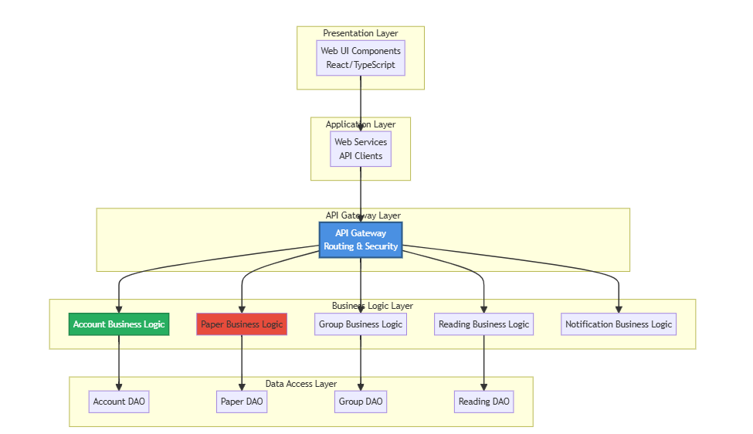

3.2.2.2 Class Diagram - Paper Service
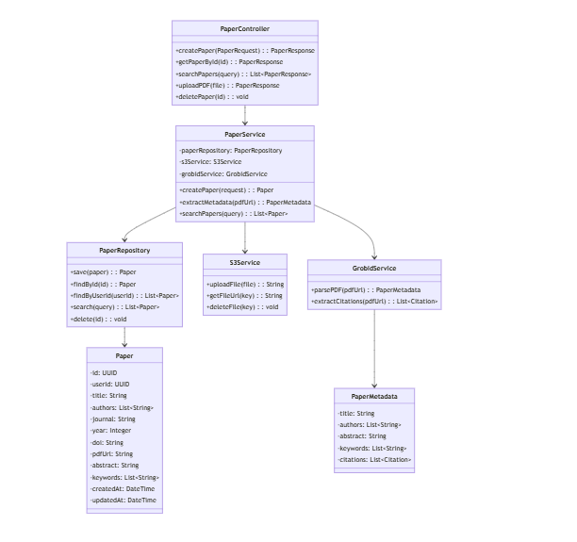
Description of classes:
- PaperController: REST controller that handles HTTP requests, validates input, and returns responses.
- PaperService: Business logic layer handling operations related to papers (create, search, metadata extraction).
- PaperRepository: Data access layer for interacting with the database.
- Paper: Entity class representing a paper in the database.
- S3Service: Service to upload/download files from AWS S3.
- GrobidService: Service to parse PDFs and extract metadata.
- PaperMetadata: DTO containing metadata extracted from the PDF.

3.2.2.3 Class Diagram - Reading Service
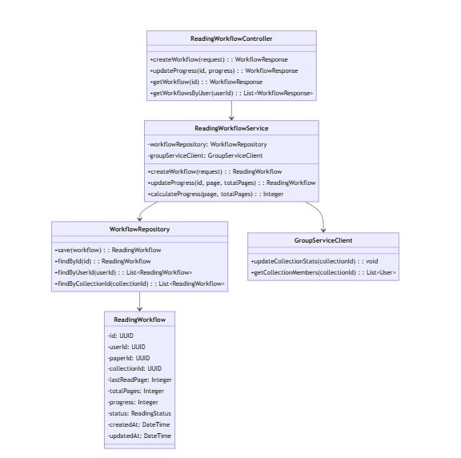
Description of classes:
- ReadingWorkflowController: REST controller for reading workflow operations.
- ReadingWorkflowService: Business logic to manage reading progress and workflows.
- WorkflowRepository: Data access for reading workflows.
- ReadingWorkflow: Entity representing a user's reading workflow for a paper.
- GroupServiceClient: Feign client to communicate with the Group Service.

3.2.3 Development View
The Development View describes the system's source code structure, package organization, and component structure to support development and maintenance.

3.2.3.1 Package Diagram

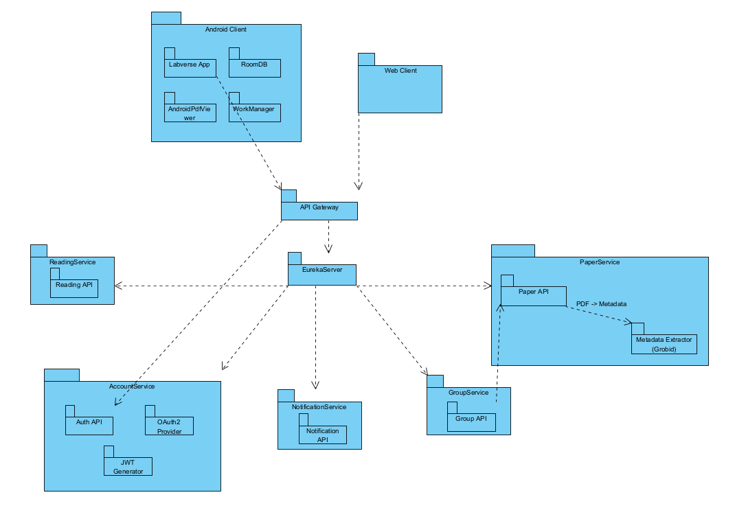
Figure 3-1: Labverse Package Diagram
Packages Description
No | Package | Description
01 | Web client | The web application that interacts with the system through the API Gateway.  Functions: managing research papers, research groups, user interactions, and other features via REST APIs.
02 | API Gateway | The single entry point for Web clients.  - Routes requests to microservices.  - Applies security, routing, and basic load handling.  - Decouples clients from individual services.
03 | Eureka Server | Service Discovery center.  - Registers and monitors microservice availability.  - Enables services to automatically discover and communicate with each other.
04 | Reading Service | Manages reading activities:  - Reading API: Stores reading history, reading progress, and reading time.  Supports synchronization of reading activity across devices.
05 | Account Service | Responsible for authentication and user account management:  - Auth API: Registration, login, and user profile management.  - OAuth2 Provider: Supports standard OAuth2 authentication flows.  - JWT Generator: Generates and validates access tokens.  Used by the API Gateway to secure the system.
06 | Notification Service | Handles system notifications:  - Notification API: Sends notifications to users (push notifications, email, etc.).  Supports alerts for new papers, new groups, and important system updates
07 | Group Service | Manages research group features:  - Group API: Group creation, group membership, member management, and paper sharing within groups.  Supports collaboration among research communities
08 | Paper Service | Handles all operations related to scientific papers:  - Paper API: CRUD operations, metadata management, and query processing.  - Metadata Extractor (Grobid): Receives PDFs → analyzes → extracts metadata (title, authors, abstract, etc.).  Communicates primarily with the API Gateway and client applications.

3.2.3.2 Component Diagram
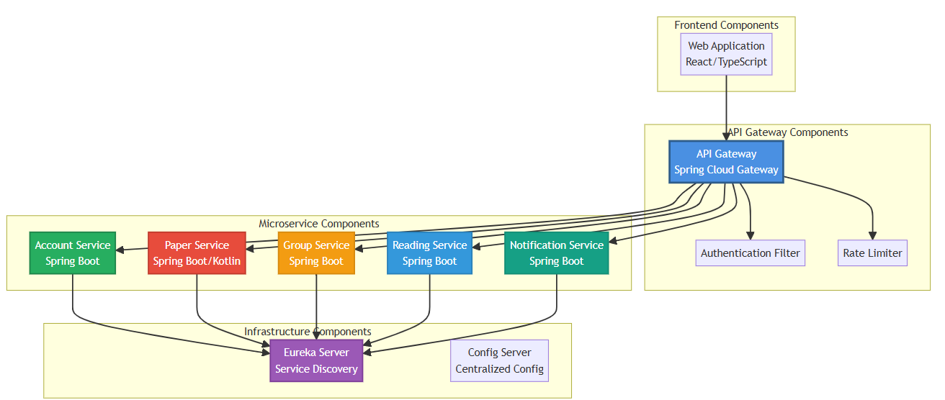

No | Component/Node | Description
1 | Web Application (React/TypeScript) | The frontend client of the system. It interacts solely with the API Gateway, sending all user-initiated actions through authenticated and validated requests.
2 | API Gateway (Spring Cloud Gateway) | The single entry point for all external traffic. It forwards requests to backend services, manages routing rules, and enforces security policies.
3 | Authentication Filter | A custom filter within the API Gateway responsible for validating authentication tokens and applying access control rules before forwarding requests.
4 | Rate Limiter | Controls and restricts the number of incoming requests from clients to prevent overload and ensure fair usage across the system.
5 | Account Service (Spring Boot) | Manages user accounts, authentication data, and profile-related operations. Registers with Eureka and loads configuration from the Config Server.
6 | Paper Service (Spring Boot/Kotlin) | Handles research paper/document management. Provides CRUD operations and serves as a core data service within the system.
7 | Group Service (Spring Boot) | Responsible for group management features, including group creation, membership handling, and collaboration logic.
8 | Reading Service (Spring Boot) | Manages user reading interactions: bookmarks, progress tracking, and related content retrieval.
9 | Notification Service (Spring Boot) | Handles notification events and message distribution. Supports asynchronous communication with other services.
10 | Eureka Server (Service Discovery) | Central registry for all microservices. Enables dynamic discovery, load balancing, and decoupled communication among services.
11 | Config Server (Centralized Config) | Hosts and distributes externalized configuration for all microservices to ensure consistency across environments and simplify maintenance.

3.2.4 Deployment View

3.2.4.1 Deployment Diagram
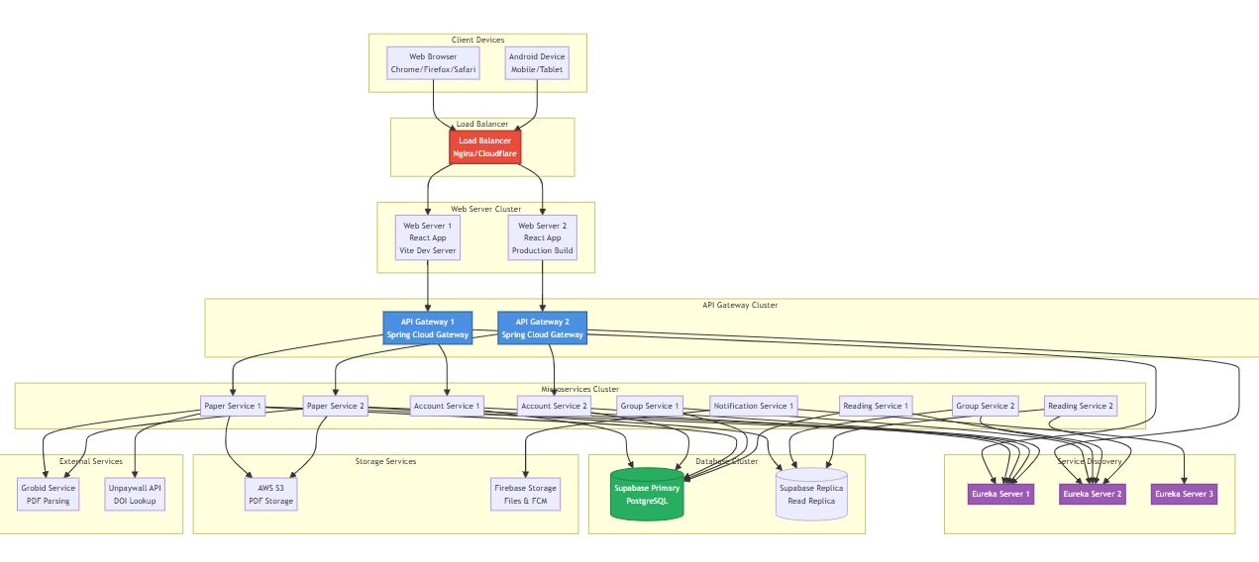
Figure 3-4: Labverse Deployment structure
Configuration Description
No | Component/Node | Description
1 | Load Balancer | Nginx or Cloudflare load balancer distributing requests to web servers and API gateways. Supports SSL/TLS termination and DDoS protection.
2 | Web Server Cluster | Multiple instances of React application (Vite dev server or production build) to ensure high availability and load distribution.
3 | API Gateway Cluster | Multiple instances of Spring Cloud Gateway to handle routing, authentication, and rate limiting. Uses round-robin load balancing.
4 | Eureka Server Cluster | 3 instances of Eureka Server (quorum-based) to ensure service discovery availability. Instances replicate the service registry with each other.
5 | Account Service | 2 instances of Account Service to handle authentication and user management. Stateless design allows for horizontal scaling.
6 | Paper Service | 2 instances of Paper Service to handle paper management and PDF processing. Primary instance writes to database; secondary instance can handle read requests.
7 | Group Service | 2 instances of Group Service to handle collections and teams. Load balanced to distribute collaboration requests.
8 | Reading Service | 2 instances of Reading Service to track reading progress. Stateless service that can scale horizontally.
9 | Notification Service | 1 instance of Notification Service (can scale when needed) to send push notifications via Firebase Cloud Messaging.
10 | Supabase Primary Database | PostgreSQL primary database instance storing all data. Handles write operations and critical reads.
11 | Supabase Read Replica | PostgreSQL read replica to offload read queries from the primary database, improving performance and reducing load.
12 | AWS S3 Bucket | Cloud storage for PDF files. Uses S3 to store and serve PDF documents with CDN integration.
13 | Firebase Storage | Firebase storage for additional files and Firebase Cloud Messaging (FCM) for push notifications.
14 | Grobid Service | External service to parse PDFs and extract metadata. Can be a self-hosted or third-party service.
15 | Unpaywall API | External API service to lookup PDF URLs from DOI. Rate-limited external service.

3.2.4.2 Deployment Architecture Notes
- High Availability: All critical services have at least 2 instances to ensure redundancy.
- Load Balancing: Load balancer distributes traffic evenly between instances.
- Database Replication: Supabase uses a primary-replica setup to improve read performance.
- Service Discovery: Eureka cluster with 3 nodes ensures service discovery availability.
- Stateless Services: Microservices are designed to be stateless for easy horizontal scaling.
- External Dependencies: Grobid and Unpaywall are external services; failures must be handled gracefully.

4 Detailed Component Design

4.1 Common Design
[Provide the common design for all the features/UCs. It include common design for interfaces and process components
- Class Diagram, Class Specifications, and Sequence//Communication Diagram (s)]
This section should contain the design spec of
- Error handling,
- Logging,
- Messages processing,
- UI structures, utility classes/components
- Transaction management

4.2 <Use-Case ID/Feature ID> - <Use case Name/Feature Name>
[Provide the detailed design for the feature <Use case Name1>. It include Class Diagram, Class Specifications, and Sequence Diagram(s)]

4.2.1 Screen Design
[Describe screen design and screen description]

Table 4-x: <Screen Name> Definition
No | Object/Control Name | Type | Required | Length | Description
1
2
3
4

4.2.2 Class/Component Design

4.2.2.1 Classes/Component Structure
[This part presents the class diagram for the relevant feature]
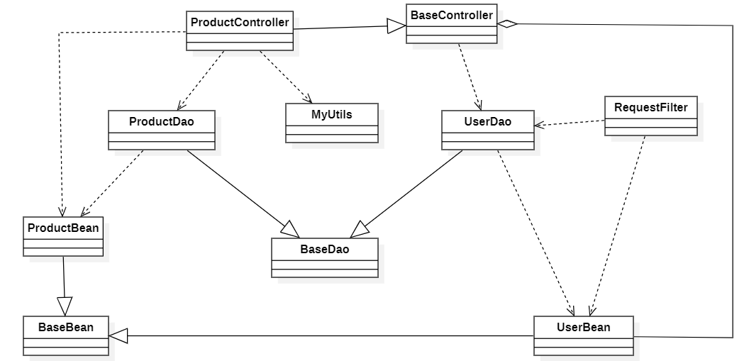

4.2.2.2 Classes/Component Description

[Provide the description for each class, including both Class Attributes and Class Methods information. Those can be in the table format as below.
This section should contain the spec for application class/component logic only to avoid the large spec]
4.2.2.2.1 XYZ Class
[Provide the detailed description for the class methods.]

Class | <Class Name>
Description
Base Class
Constructor
Prototype
Source File
Namespace
Attributes | Name | Type | Description
Methods | Name | Input | Output | Description

4.2.2.2.2 ABC Class
[Provide the detailed description for the class methods]

Class | <Class Name>
Description
Base Class
Constructor
Prototype
Source File
Namespace
Attributes | Name | Type | Description
Methods | Name | Input | Output | Description

4.2.3 Object Interactions (Sequence/Communication) Diagram(s)

4.2 Comm_01 - View paper details

4.2.1 Screen Design
Table 4-2.1: <Screen Name> Definition
No | Object/Control Name | Type | Required | Length | Description
1
2
3
4

4.2.2 Class/Component Design

4.2.2.1 Classes/Component Structure

4.2.2.2 Classes/Component Description
4.2.2.2.1 XYZ Class

Class | <Class Name>
Description
Base Class
Constructor
Prototype
Source File
Namespace
Attributes | Name | Type | Description
Methods | Name | Input | Output | Description

4.2.2.2.2 ABC Class

Class | <Class Name>
Description
Base Class
Constructor
Prototype
Source File
Namespace
Attributes | Name | Type | Description
Methods | Name | Input | Output | Description

4.2.3 Object Interactions (Sequence/Communication) Diagram(s)

4.3 Comm_02 - Discover papers

4.3.1 Screen Design
Table 4-3.1: <Screen Name> Definition
No | Object/Control Name | Type | Required | Length | Description
1
2
3
4

4.3.2 Class/Component Design

4.3.2.1 Classes/Component Structure

4.3.2.2 Classes/Component Description
4.3.2.2.1 XYZ Class

Class | <Class Name>
Description
Base Class
Constructor
Prototype
Source File
Namespace
Attributes | Name | Type | Description
Methods | Name | Input | Output | Description

4.3.2.2.2 ABC Class

Class | <Class Name>
Description
Base Class
Constructor
Prototype
Source File
Namespace
Attributes | Name | Type | Description
Methods | Name | Input | Output | Description

4.3.3 Object Interactions (Sequence/Communication) Diagram(s)

4.4 Comm_03 - View my papers
[Provide the detailed design for the <Feature/ Use case Name2>. It include Class Diagram, Class Specifications, and Sequence Diagram(s)]

4.4.1 Screen Design
[Describe screen design and screen description]

4.4.2 Class/Communication Design

4.4.2.1 Class/Component Structure
[This part presents the class diagram for the relevant feature/usecase]

4.4.2.2 Class/Component Description

[Provide the description for each class, including both Class Attributes and Class Methods information. Those can be in the table format as below]

4.4.3 Object Interaction (Sequence/Communication Diagram(s)
[Provide the sequence/communication diagram(s) for the feature, see the sample below]

4.5 Comm_04 - View my teams

4.5.1 Screen Design
Table 4-5.1: <Screen Name> Definition
No | Object/Control Name | Type | Required | Length | Description
1
2
3
4

4.5.2 Class/Component Design

4.5.2.1 Classes/Component Structure

4.5.2.2 Classes/Component Description
4.5.2.2.1 XYZ Class

Class | <Class Name>
Description
Base Class
Constructor
Prototype
Source File
Namespace
Attributes | Name | Type | Description
Methods | Name | Input | Output | Description

4.5.2.2 ABC Class

Class | <Class Name>
Description
Base Class
Constructor
Prototype
Source File
Namespace
Attributes | Name | Type | Description
Methods | Name | Input | Output | Description

4.5.3 Object Interactions (Sequence/Communication) Diagram(s)

4.6 Comm_05 - Import paper by BibTeX

4.6.1 Screen Design
Table 4-6.1: <Screen Name> Definition
No | Object/Control Name | Type | Required | Length | Description
1
2
3
4

4.6.2 Class/Component Design

4.6.2.1 Classes/Component Structure

4.6.2.2 Classes/Component Description
4.6.2.1 XYZ Class

Class | <Class Name>
Description
Base Class
Constructor
Prototype
Source File
Namespace
Attributes | Name | Type | Description
Methods | Name | Input | Output | Description

4.6.2.2 ABC Class

Class | <Class Name>
Description
Base Class
Constructor
Prototype
Source File
Namespace
Attributes | Name | Type | Description
Methods | Name | Input | Output | Description

4.6.3 Object Interactions (Sequence/Communication) Diagram(s)

4.7 Comm_01 - View paper details

4.7.1 Screen Design
Table 4-7.1: <Screen Name> Definition
No | Object/Control Name | Type | Required | Length | Description
1
2
3
4

4.7.2 Class/Component Design

4.7.2.1 Classes/Component Structure

4.7.2.2 Classes/Component Description
4.7.2.1 XYZ Class

Class | <Class Name>
Description
Base Class
Constructor
Prototype
Source File
Namespace
Attributes | Name | Type | Description
Methods | Name | Input | Output | Description

4.7.2.2 ABC Class

Class | <Class Name>
Description
Base Class
Constructor
Prototype
Source File
Namespace
Attributes | Name | Type | Description
Methods | Name | Input | Output | Description

4.7.3 Object Interactions (Sequence/Communication) Diagram(s)

4.8 Collection_01 - View Collection
Description: This feature allows users to view a list of collections they own or that have been shared with them. Users can switch between the "My Collections" and "Shared Collections" tabs, view overview information for each collection (number of papers, number of members), and perform actions such as creating, editing, and deleting collections

4.8.1 Screen Design

The Collections Page allows users to manage their collections. The screen is divided into two main tabs: "My Collections" displays collections owned by the user, and "Shared Collections" displays collections shared with the user. Each collection is displayed as a card with overview information. Users can create new, edit, delete collections (only applicable to My Collections), and click on a card to view details
Table 4-8.1: <Screen Name> Definition
No | Object/Control Name | Type | Required | Length | Description
1 | Page Title | Text | Yes | - | Displays title "Team Collections"
2 | Page Description | Text | Yes | - | Displays description "Collaborate on research with your team"
3 | Create Collection Button | Button | Yes | - | Button to open the new collection creation dialog
4 | Tabs Container | Tabs | Yes | - | Container holding "My Collections" and "Shared Collections" tabs
5 | My Collections Tab | TabTrigger | Yes | - | Tab to display collections owned by the user
6 | Shared Collections Tab | TabTrigger | Yes | - | Tab to display collections shared with the user
7 | Collections Grid | Grid | Yes | - | Grid displaying the list of collection cards
8 | Collection Card | Card | Yes | - | Card displaying information for a single collection
9 | Collection Name | Text | Yes | 255 | Name of the collection, may be truncated if too long (line-clamp-2)
10 | More Options Button | Button | Yes | - | Dropdown menu button to display options (Edit, Delete)
11 | Edit Menu Item | MenuItem | No | - | Menu item to edit the collection (visible only for My Collections)
12 | Delete Menu Item | MenuItem | No | - | Menu item to delete the collection (visible only for My Collections)
13 | Papers Count | Text | Yes | - | Displays the number of papers in the collection
14 | Members Count | Text | Yes | - | Displays the number of members in the collection
15 | Access Level Badge | Badge | No | - | Displays user's access level (READ_ONLY, CONTRIBUTOR, AUTHOR)
16 | Creator Name | Text | No | - | Name of the collection creator (visible only for Shared Collections)
17 | Shared Icon | Icon | No | - | Users Icon to mark the collection as shared
18 | Loading Spinner | Spinner | No | - | Displayed while data is loading
19 | Empty State Card | Card | No | - | Displayed when there are no collections
20 | Empty State Message | Text | No | - | Notification message when the collection list is empty
21 | Create Collection Dialog | Dialog | No | - | Dialog to create a new collection
22 | Collection Name Input | Input | Yes | 255 | Input field to enter the new collection name
23 | Create Button (Dialog) | Button | Yes | - | Button to confirm collection creation
24 | Edit Collection Dialog | Dialog | No | - | Dialog to edit the collection name
25 | Edit Name Input | Input | Yes | 255 | Input field to edit the collection name
26 | Save Button (Dialog) | Button | Yes | - | Button to save changes to the collection name
27 | Delete Confirmation | Confirm | No | - | Confirmation dialog before deleting a collection

4.8.2 Class/Component Design

4.8.2.1 Classes/Component Structure
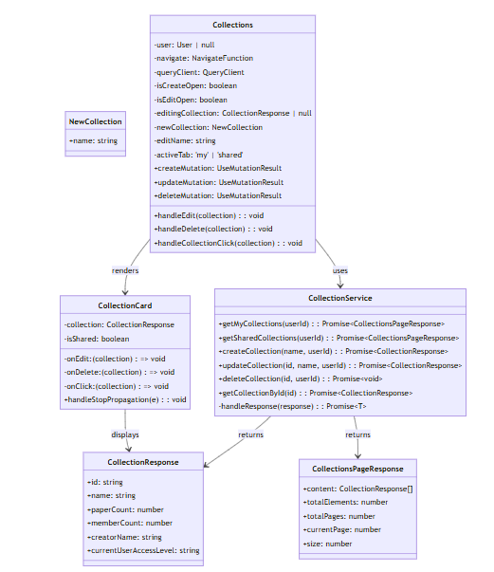

4.8.2.2 Classes/Component Description

4.8.2.2.1 Collections Component

Class | Collections
Description | The main component managing the display of the user's collections list, including both owned and shared collections. This component handles basic CRUD operations for collections.
Base Class | React.FC (React Functional Component)
Constructor | N/A (Functional Component)
Prototype | const Collections: React.FC = () => { ... }
Source File | web/src/pages/Collections.tsx
Namespace | @/pages
Attributes | Name | Type | Description
 | user | User | null | User object from AuthContext, containing current user info
 | Maps | MapsFunction | Function from react-router-dom for navigation
 | queryClient | QueryClient | React Query client for cache management and query invalidation
 | isCreateOpen | boolean | State controlling the opening/closing of the create collection dialog
 | isEditOpen | boolean | State controlling the opening/closing of the edit collection dialog
 | editingCollection | CollectionResponse | null | The collection currently being edited
 | newCollection | {name: string} | Object containing info for the new collection being created
 | editName | string | Name of the collection being edited
 | activeTab | my' | 'shared' | The currently selected tab
Methods | Name | Input | Output | Description
 | createMutation.mutate | void | Promise<void> | Mutation to create a new collection, calls createCollection API
 | updateMutation.mutate | void | Promise<void> | Mutation to update collection name, calls updateCollection API
 | deleteMutation.mutate | collection: CollectionResponse | Promise<void> | Mutation to delete a collection, calls deleteCollection API
 | handleEdit | collection: CollectionResponse | void | Handler to open the edit dialog with the selected collection
 | handleDelete | collection: CollectionResponse | void | Handler to delete the collection after confirmation
 | handleCollectionClick | collection: CollectionResponse | void | Handler to navigate to the collection details page
 | createMutation.mutate | void | Promise<void> | Mutation to create a new collection, calls createCollection API

4.8.2.2.2 CollectionCard Component

Class | CollectionCard
Description | Component displaying information of a single collection as a card. This card is clickable to view details and contains a dropdown menu to perform actions (Edit, Delete) if it belongs to the user.
Base Class | React.FC
Constructor | N/A (Functional Component)
Prototype | const CollectionCard: React.FC<Props> = ({collection, isShared, onEdit, onDelete, onClick}) => { ... }
Source File | web/src/pages/collection/components/CollectionCard.tsx
Namespace | @/pages/collection/components
Attributes | Name | Type | Description
 | collection | CollectionResponse | Object containing collection info to display
 | isShared | boolean | Flag determining if the collection is a shared collection
 | onEdit | (collection: CollectionResponse) => void | Callback function when user clicks Edit
 | onDelete | (collection: CollectionResponse) => void | Callback function when user clicks Delete
Methods | Name | Input | Output | Description
 | handleStopPropagation | e: React.MouseEvent | void | Prevents event bubbling when clicking on the dropdown menu

4.2.2.2.3 CollectionService

Class | CollectionService
Description | Service module containing functions to call collection-related APIs. This module uses the fetch API to communicate with the backend.
Base Class | React.FC
Constructor | N/A
Prototype | N/A (Module exports)
Source File | web/src/services/collection.service.ts
Namespace | @/service
Attributes | Name | Type | Description
 | N/A | N/A | Service module does not have attributes
Methods | Name | Input | Output | Description
 | getMyCollections | userId: string | Promise<CollectionsPageResponse> | Retrieve list of collections owned by the user
 | getSharedCollections | userId: string | Promise<CollectionsPageResponse> | Retrieve list of collections shared with the user
 | createCollection | name: string, userId: string | Promise<CollectionResponse> | Create a new collection
 | updateCollection | id: string, name: string, userId: string | Promise<CollectionResponse> | Update collection name
 | deleteCollection | id: string, userId: string | Promise<void> | Delete a collection
 | getCollectionById | id: string | Promise<CollectionResponse> | Retrieve detailed collection info by ID
 | handleResponse | response: Response | Promise<T> | Helper function to process API response and error handling

4.8.3 Object Interactions (Sequence/Communication) Diagram(s)
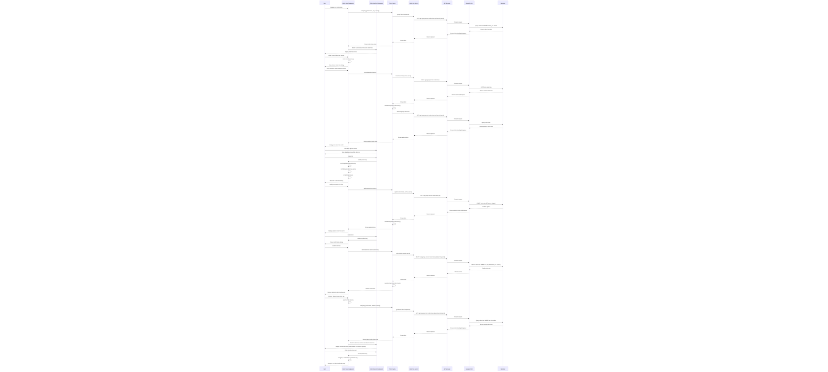

4.9 Comm_01 - View paper details

4.9.1 Screen Design
Table 4-9.1: <Screen Name> Definition
No | Object/Control Name | Type | Required | Length | Description
1
2
3
4

4.9.2 Class/Component Design

4.9.2.1 Classes/Component Structure

4.9.2.2 Classes/Component Description
4.9.2.1 XYZ Class

Class | <Class Name>
Description
Base Class
Constructor
Prototype
Source File
Namespace
Attributes | Name | Type | Description
Methods | Name | Input | Output | Description

4.9.2.2 ABC Class

Class | <Class Name>
Description
Base Class
Constructor
Prototype
Source File
Namespace
Attributes | Name | Type | Description
Methods | Name | Input | Output | Description

4.9.3 Object Interactions (Sequence/Communication) Diagram(s)

4.10 Comm_01 - View paper details

4.10.1 Screen Design
Table 4-10.1: <Screen Name> Definition
No | Object/Control Name | Type | Required | Length | Description
1
2
3
4

4.10.2 Class/Component Design

4.10.2.1 Classes/Component Structure

4.10.2.2 Classes/Component Description
4.10.2.2.1 XYZ Class

Class | <Class Name>
Description
Base Class
Constructor
Prototype
Source File
Namespace
Attributes | Name | Type | Description
Methods | Name | Input | Output | Description

4.2.2.2.2 ABC Class

Class | <Class Name>
Description
Base Class
Constructor
Prototype
Source File
Namespace
Attributes | Name | Type | Description
Methods | Name | Input | Output | Description

4.10.3 Object Interactions (Sequence/Communication) Diagram(s)

4.11 Comm_01 - View paper details

4.11.1 Screen Design
Table 4-11.1: <Screen Name> Definition
No | Object/Control Name | Type | Required | Length | Description
1
2
3
4

4.11.2 Class/Component Design

4.11.2.1 Classes/Component Structure

4.11.2.2 Classes/Component Description
4.11.2.2.1 XYZ Class

Class | <Class Name>
Description
Base Class
Constructor
Prototype
Source File
Namespace
Attributes | Name | Type | Description
Methods | Name | Input | Output | Description

4.11.2.2.2 ABC Class

Class | <Class Name>
Description
Base Class
Constructor
Prototype
Source File
Namespace
Attributes | Name | Type | Description
Methods | Name | Input | Output | Description

4.9 Not_01 - View notification list

4.9.1 Screen Design
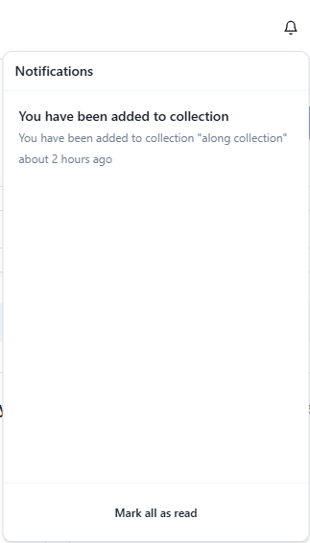
Table 4-9.1: <Screen Name> Definition
No | Object/Control Name | Type | Required | Length | Description
1 | NotificationListPage | Screen | Yes | – | Main page showing all notifications for the signed-in user.
2 | RefreshButton | Button | No | – | Triggers refetch via React Query to sync with server.
3 | NotificationItemCard | List Item | Yes | – | Displays title, body, createdAt, read status; clickable to open detail link.
4 | MarkAsReadAction | Icon/Button | No | – | Calls API to mark a notification as read and updates UI state.

4.9.2 Class/Component Design

4.12.2.1 Classes/Component Structure
- Web (React): NotificationListPage → NotificationItem (child component) → hooks (useNotificationsQuery, useMarkAsReadMutation).
- Service (Spring Boot): NotificationController → NotificationService → NotificationRepository + NotificationMapper.

4.9.2.2 Classes/Component Description
- Class: NotificationListPage
- Description: React screen that lists notifications, handles loading/error states, and exposes refresh / mark-as-read actions.
- Base Class: Function component (React.FC)
- Constructor: N/A (function component).
- Prototype: NotificationListPage(): JSX.Element
- Source File: web/src/pages/notifications/NotificationListPage.tsx
- Namespace: @/pages/notifications
4.12.2.2.1 NotificationController Class

Class | <notificationService>
Description | REST controller that exposes /v1/api/notifications endpoints (list, mark-as-read, register device, queue intake).
Base Class | None (annotated @RestController).
Constructor | Generated by Lombok @RequiredArgsConstructor (injects NotificationService, NotificationQueueService).
Prototype | @RestController @RequestMapping("/v1/api/notifications") class NotificationController
Source File | services/NotificationService/src/main/java/com/se1853_jv/controller/NotificationController.java
Namespace | com.se1853_jv.controller
Attributes | Name | Type | Description
 | notificationService | NotificationService | Performs business logic for user notification CRUD.
 | queueService | NotificationQueueService | Manages async queue storage and background processing.
Methods | Name | Input | Output | Description
 | registerDevice | RegisterDeviceRequest request, Authentication auth | ResponseEntity<Void> | Stores/updates the user’s FCM token.
 | getNotifications | Authentication auth | ResponseEntity<List<NotificationResponse>> | Returns notifications for the user ID found in JWT subject.
 | markAsRead | UUID id, Authentication auth | ResponseEntity<Void> | Sets readAt for the specified notification if it belongs to the user.
 | createNotificationEvent | NotificationRequestEvent event | ResponseEntity<Void> (202) | Public endpoint: enqueue an incoming notification event.
 | getQueueStatus | @RequestParam(required = false) String status | ResponseEntity<List<QueueStatusResponse>> | Debug endpoint listing queue items (optionally filtered by status).
 | testQueueEndpoint | – | ResponseEntity<String> | Simple health check (“Queue endpoint is working!”).
 | getUserIdFromAuthentication | Authentication auth | UUID | Helper that extracts UUID (JWT subject) or throws when missing/invalid.

4.12.2.2.2 ABC Class

Class | <NotificationService>
Description | Core business service: persists device tokens, fetches notification lists, marks them read, and orchestrates queue → FCM delivery.
Base Class | Implements interface NotificationService.
Constructor | Lombok @RequiredArgsConstructor injecting required repositories and Firebase service.
Prototype | @Service class NotificationServiceImpl implements NotificationService
Source File | services/NotificationService/src/main/java/com/se1853_jv/service/Impl/NotificationServiceImpl.java
Namespace | com.se1853_jv.service.impl
Attributes | Name | Type | Description
 | notificationRepository | NotificationRepository | CRUD access to the notifications table. | notificationRepository
 | deviceRepository | NotificationDeviceRepository | Stores per-user device tokens / platforms. | deviceRepository
 | firebaseService | FirebaseService | Sends push notifications through FCM. | firebaseService
 | notificationMapper | NotificationMapper | Maps entities ↔ DTOs for REST responses. | notificationMapper
Methods | Name | Input | Output | Description
 | registerDevice | UUID userId, RegisterDeviceRequest req | void | Upserts device token, platform, timestamps.
 | getNotificationsForUser | UUID userId | List<NotificationResponse> | Loads notifications (usually sorted DESC) and maps to DTOs.
 | markAsRead | UUID userId, UUID notificationId | void | Validates ownership, sets readAt, persists changes.
 | enqueueNotification / processQueue | NotificationRequestEvent or queue entity | void | Persists event into queue and background job picks it up.
 | sendPushNotification (if exposed) | Notification entity | void | Invokes firebaseService.send(...), handles exceptions/retries.

4.9.3 Object Interactions (Sequence/Communication) Diagram(s)

5. Database Design

5.1 Database Design
[Provide the tables relationship like example below]
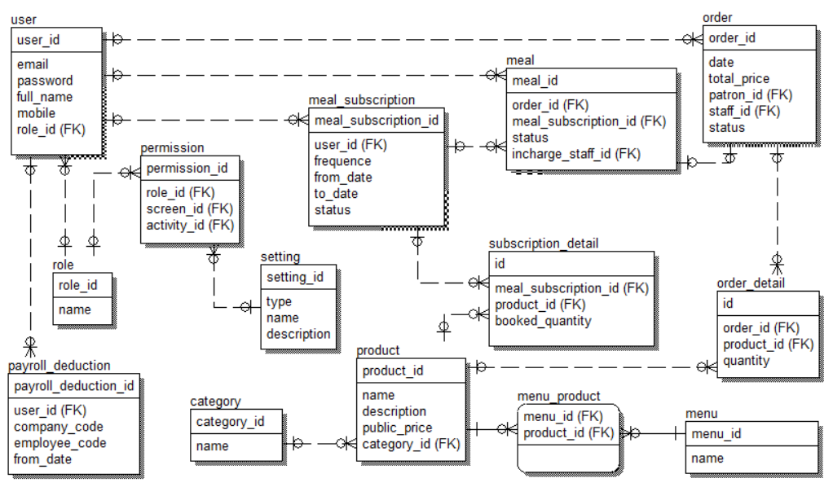

a. Table name 1
[Give some lines about the table here>>
[Table fields, in the form of table format as below]
# | Field name | Type | Size | Unique | Not Null | PK/FK | Notes
1 | Field name1
2 | Field name2

b. Table name 2…

5.2 Data File Design
[File List, in the table format as below]
# | File Name | Type | Notes
1 | Class name1
2 | Class name2
3 | ..

