

Research Paper Management System
Software Requirement Specification
Project Code: RPMS
Document Code: RPMS -- v1.0

– Hanoi, September 2025 –

Table of Contents
I. Record of Changes 3
II. Software Requirement Specification 4
1. Product Overview 4
2. User Requirements 5
2.1 Actors 5
2.2 Use Cases 5
3. Software Features 18
3.1 Functional Overview 18
3.2 Authentication 26
3.3 Notification 30
3.4 Common 34
3.5 PI 65
4. Non-Functional Requirements 78
4.1 External Interfaces 78
4.2 Quality Attributes 78
5. Requirement Appendix 79
5.1 Business Rules 79
5.2 Common Requirements 80
5.3 Application Messages List 81
5.4 Other Requirements… 81

I. Record of Changes
Date | A*  M, D | In charge | Change Description
2/10/2025 | A | HoanTX | Add ERD and entity specifications
6/10/2025 | A | HoanTX | Add screen flow and specifications
6/10/2025 | A | HoanTX | Add screen authorization, non-functional requirement, non-screen features
10/10/2025 | M | HoanTX | Modify screen flow and specifications
11/10/2025 | A | TuanPA | Add use case diagram of PI
5/11/2025 | A | HoanTX | Create UC specification for Comm_01
9/11/2025 | A | HoanTX | Create UC specifications for Comm_02, Comm_03, Comm_04, Comm_05
9/11/2025 | A | HoanTX | Create UCD for Student/Intern role
9/11/2025 | A | LongLD | Create UC specification for Not_01
*A - Added M - Modified D - Deleted

II. Software Requirement Specification

1. Product Overview

The LabVerse - Research Paper Management System is a comprehensive Android application designed for laboratories and research teams across Vietnam and globally. The system serves as a centralized platform for discovering, organizing, annotating, and collaborating on academic research papers, aiming to streamline the literature review process and foster collaborative knowledge sharing.
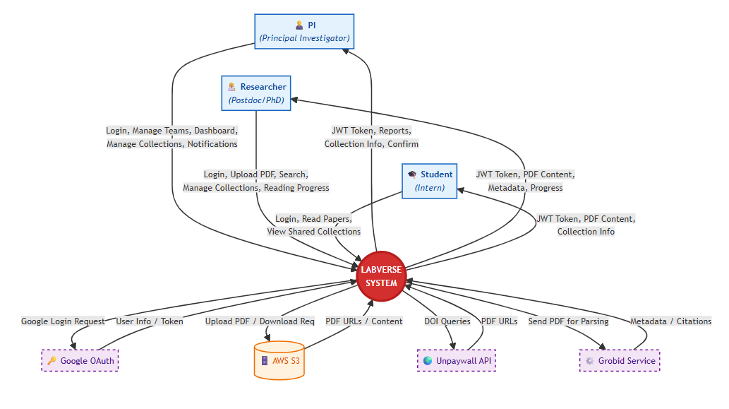
Figure 1-1: Labverse system overview

As described in the figure above, the system will have the following components:
LabVerse System: this component is the central processing hub of the architecture. It acts as the intermediary between users and external services, handling core business logic such as authentication management, collection organization, reading progress synchronization, and the generation of aggregated reports for Principal Investigators.
User Actors (PI, Researcher, Student): these represent the different client-side roles interacting with the application. The PI manages teams and views dashboards; the Researcher searches for papers and manages shared collections; and the Student accesses materials for reading and updates their progress.
AWS S3 Storage: this component is the cloud storage service responsible for hosting the raw PDF files. It handles file upload requests from the system and streams PDF content or provides download URLs to users upon request.
Grobid Service: this component is a machine learning-based service used for document parsing. It receives PDF files from the LabVerse System and extracts structured metadata (titles, authors, citations) to populate the database.
Unpaywall API: this component is an external reference service used to locate open-access versions of academic papers. The system queries this API using DOIs to retrieve valid public PDF URLs for users.
Google OAuth: this component is the external authentication provider. It handles the verification of user credentials and issues tokens to ensure secure login access to the LabVerse System.

2. User Requirements

2.1 Actors

# | Actor | Description
1 | Principal Investigator (PI) / Lab Head | Administrative oversight role. Can create and manage team collections, invite members, view team-wide reading progress, assign priorities, and manage user permissions within their laboratory or research group.
2 | Researcher (Postdoc / PhD) | The primary user. Can manage a personal library, contribute to team collections, annotate papers, and engage in discussions.
3 | Student / Intern | Limited access role. Can be granted read-only or contributor access to specific collections. Primarily reads assigned papers, adds personal notes, and participates in designated discussions under supervision

2.2 Use Cases

2.2.1 Diagram(s)
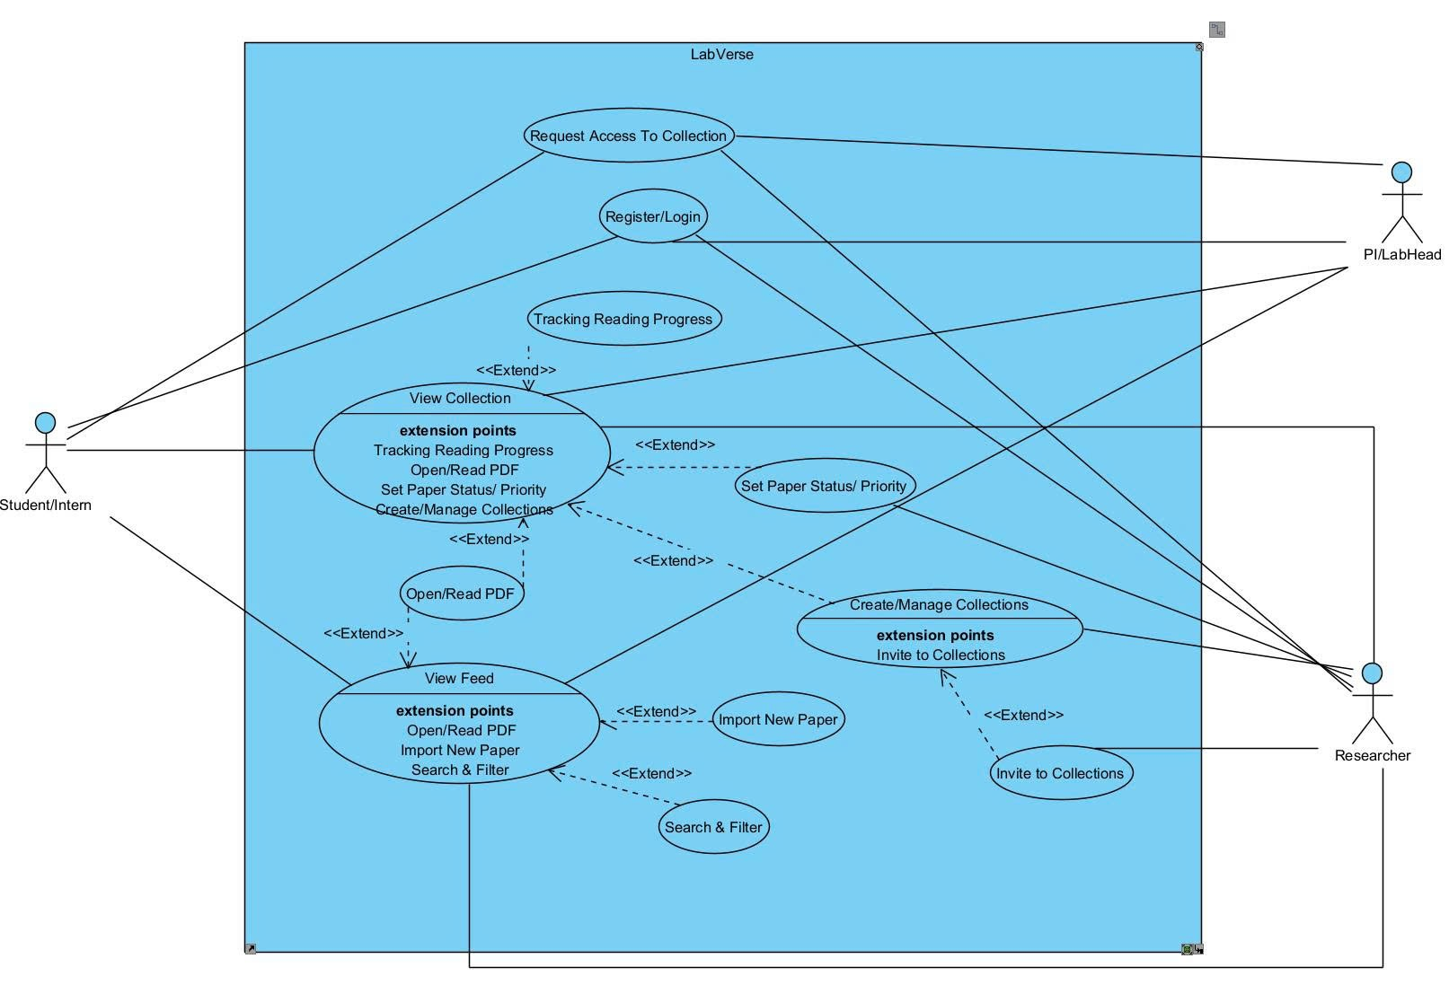
Figure 2-1: Use case diagram of Labverse system

2.2.2 Descriptions

ID | Group function | Use Case | Actors | Use Case Description & Main Flow
1 | Reading Management | View Reading List | Student/ Intern | Description: Allows a student or intern to view their assigned reading list. Main Flow: The user logs in, accesses their reading list, and views the available papers to read.
2 | Reading Management | Track Reading Progress | Student/ Intern | Description: Enables a student/intern to monitor their reading progress for each paper.  Main Flow: The user marks the progress (e.g., not started, in progress, completed) for each paper in the list.
3 | PDF Interaction | Open / Read PDF | Student/ Intern | Description: Allows users to open and read research papers in PDF format within the system.  Main Flow: The user selects a paper from the reading list or collection and opens it to read.
4 | Annotation Management | Add Annotations | Student/ Intern | Description: Enables users to add notes or highlights to specific sections of a PDF.  Main Flow: While reading a paper, the user selects text and adds annotations, which are saved in the system.
5 | Annotation Management | Export Annotations | PI/Lab Head, Researcher | Description: Allows exporting annotations for sharing or external analysis.  Main Flow: The user selects a paper and exports all annotations into a separate file or report.
6 | Paper Management | Set Paper Status / Priority | Researcher | Description: Researchers can define the review status or priority of papers in a collection.  Main Flow: The user selects a paper and assigns a status (e.g., To Read, Reviewed, Important).
7 | Collection Management | View Collections | Student/ Intern, Researcher | Description: Enables viewing of all available collections or categories of papers.  Main Flow: The user accesses the “Collections” section to browse available or shared paper groups.
8 | Collection Management | Create & Manage Collections | Researcher | Description: Researchers can create, edit, and delete collections of research papers. Main Flow: The user creates a new collection, adds papers, and manages member access.
9 | Collaboration | Invite to Collections | Researcher | Description: Allows a researcher to invite other users to access specific collections. Main Flow: The researcher selects a collection and sends invitations to collaborators.
10 | Paper Management | Import New Paper | Researcher | Description: Researchers can upload or import new papers into the system.  Main Flow: The user uploads a paper file or imports it from an external database (e.g., DOI or URL).
11 | Team Management | View Teams List | Student/ Intern, Researcher | Description: Allows users to view a list of existing research teams.  Main Flow: The user navigates to the “Teams” section and views teams they are part of.

2.2.3 Use Case Diagram of Principal Investigator (PI) / Lab Head

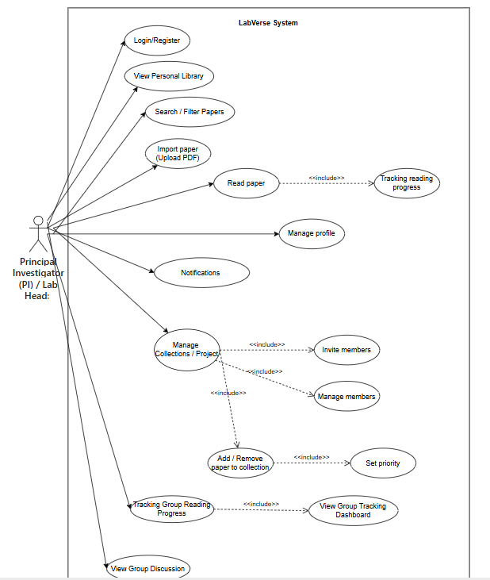
Figure 2-2: Use case diagram of PI

2.2.3.1 Descriptions

ID | Group function | Use Case | Actors | Use Case Description & Main Flow
01 | Authentication | Login / Register | PI | Description: Allows the PI to register or log in using email or Google account.  Main Flow: (1) User enters credentials → (2) System authenticates → (3) Returns JWT token → (4) Token is securely stored in encrypted preferences.
02 | Library Management | View Personal Library | PI | Description: Displays the PI’s personal paper library (Recently Added, Recently Read, Favorites).  Main Flow: (1) App calls API to fetch papers → (2) Saves locally (Room DB) → (3) Displays in RecyclerView.
03 |  | Search & Filter Papers | PI | Description: Enables PI to search and filter papers by keyword, author, year, tag, or journal.  Main Flow: (1) Enter keyword → (2) Apply filters → (3) Results are retrieved from Room DB or server.
04 |  | Import Paper | PI | Description: Adds a new research paper to the library.  Main Flow: (1) Click “Upload PDF” → (2) Select file → (3) Uploads to cloud (Firebase/S3) → (4) Metadata saved in backend.
05 | Reading | Read Paper | PI | Description: Allows reading, highlighting, and annotating PDFs.  Main Flow: (1) Open PDF via AndroidPdfViewer → (2) Add notes/highlights → (3) Save annotations locally and sync to server.
08 | Team Management | Manage Shared Collections | PI | Description: Create a shared collection or project for collaboration.  Main Flow: (1) Click “Create Collection” → (2) Enter name & description → (3) Save collection → (4) Add members.
09 |  | Invite Members to Collection | PI | Description: Invite team members to join a shared collection.  Main Flow: (1) Enter email → (2) Backend sends invitation → (3) User accepts → (4) Added to group.
10 |  | Set Paper Status & Priority | PI | Description: Define paper’s workflow status and priority.  Main Flow: (1) Select paper → (2) Open status sheet → (3) Choose priority → (4) API updates record.
11 |  | View Team Reading Progress | PI | Description: Monitor team members’ reading progress.  Main Flow: (1) Fetch progress data via API → (2) Display per-member stats → (3) Drill-down to detailed paper progress.
10 |  | View Team Discussions | PI | PI views team discussions about papers. Flow: Select collection/paper → View comments and discussions from team members.
11 | User Management | Manage Profile & | Pi | Description: Update personal details, affiliation, password, and notifications.  Main Flow: (1) Edit info → (2) Submit request → (3) Backend updates → (4) Success message displayed.

2.2.5 Use Case Diagram of Researcher
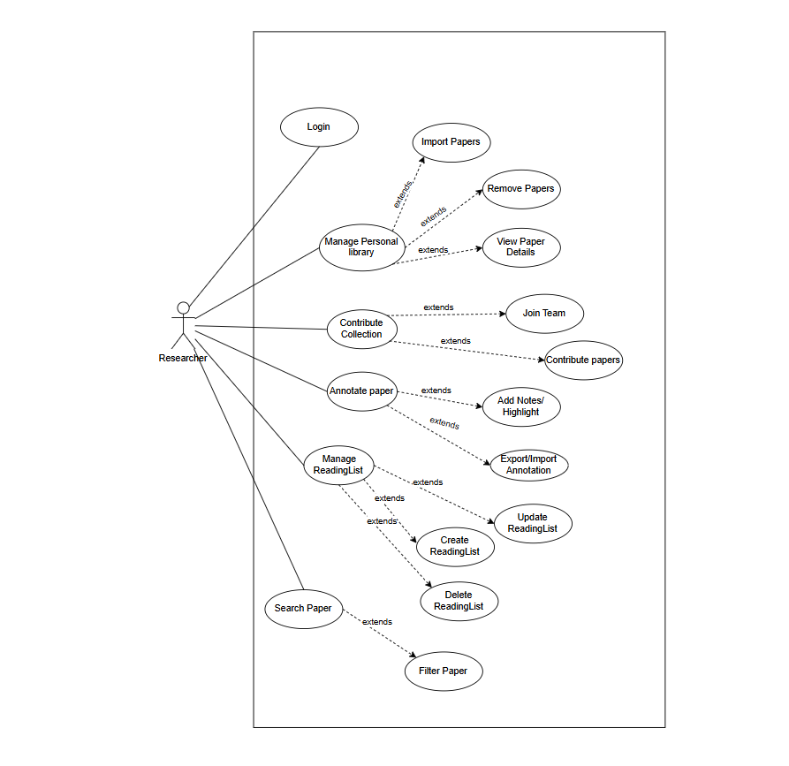
Figure 2-1: Use case diagram of Researcher

2.2.5.1 Descriptions

ID | Group function | Use Case | Actors | Use Case Description & Main Flow
01 | Authentication | Login / Register | Researcher | Description: Allows Researcher to register or log in using email or Google account.  Main Flow: (1) User enters credentials → (2) System authenticates → (3) Returns JWT token → (4) Token is securely stored in encrypted preferences.
02 | Personal Library Management | Manage Personal Library | Researcher | Description: Enables the researcher to manage their personal paper library, including importing, viewing, and removing research papers.  Main Flow: (1) User opens “My Library” → (2) System displays paper list → (3) User selects action (Import / View / Remove) → (4) System executes action and updates library.
03 |  | Import Papers | Researcher | Description: Allows the researcher to import research papers (PDFs or metadata) into their personal library.  Main Flow: (1) User selects “Import Papers” → (2) Uploads PDF or DOI → (3) System parses metadata → (4) Paper saved into personal library.
04 |  | Remove Papers | Researcher | Description: Enables the researcher to remove papers from their personal library.  Main Flow: (1) User selects a paper → (2) System displays confirmation → (3) User confirms deletion → (4) System removes paper and updates library.
05 | Paper Interaction | View Paper Details | Researcher | Description: Displays metadata and detailed info for a selected paper.  Main Flow: (1) User selects paper → (2) System retrieves details → (3) System displays title, author, DOI, abstract, and annotation options.
06 | Collaboration | Contribute Collection | Researcher | Description: Allows contributing selected papers to a shared collection.  Main Flow: (1) User selects “Contribute Collection” → (2) Chooses shared team/group → (3) System uploads metadata → (4) Paper added to shared collection.
07 |  | Join Team | Researcher | Description: Enables joining a research collaboration team.  Main Flow: (1) User selects “Join Team” → (2) Enters invitation code → (3) System verifies → (4) Adds user to team list.
 |  | Annotate Paper | Researcher | Description: Enables users to highlight and comment on specific text sections.  Main Flow: (1) User opens paper → (2) Selects text → (3) Adds note/highlight → (4) System saves annotation locally.
 |  | Export/Import Annotation | Researcher | Description: Allows exporting or importing annotations for reuse.  Main Flow: (1) User selects annotated paper → (2) Chooses Export/Import → (3) System processes file → (4) Updates annotation data.
 | Reading List Management | Manage Reading List | Researcher | Description: Allows full control over user reading lists.  Main Flow: (1) User opens “Manage Reading List” → (2) Views all lists → (3) Performs Create/Update/Delete → (4) System applies changes.
 |  | Create Reading List | Researcher | Description: Allows creation of a new reading list.  Main Flow: (1) User selects “Create Reading List” → (2) Inputs title/description → (3) System creates new list → (4) Displays confirmation.
 |  | Update Reading List | Researcher | Description: Allows updating existing reading lists.  Main Flow: (1) User opens reading list → (2) Edits metadata or papers → (3) Saves changes → (4) System updates list.
 |  | Delete Reading List | Researcher | Description: Allows deletion of an existing reading list.  Main Flow: (1) User selects list → (2) System asks for confirmation → (3) User confirms → (4) List removed from database.
 | Paper Search | Search Paper | Researcher | Description: Enables searching papers by keyword, author, or DOI.  Main Flow: (1) User enters query → (2) System searches indexed database → (3) Displays matching results → (4) User opens or saves paper.
 |  | Filter Paper | Researcher | Description: Allows filtering of papers based on attributes.  Main Flow: (1) User applies filters (e.g., date, author, tags) → (2) System processes filters → (3) Displays refined result set.

2.2.6 Use Case Diagram of Student

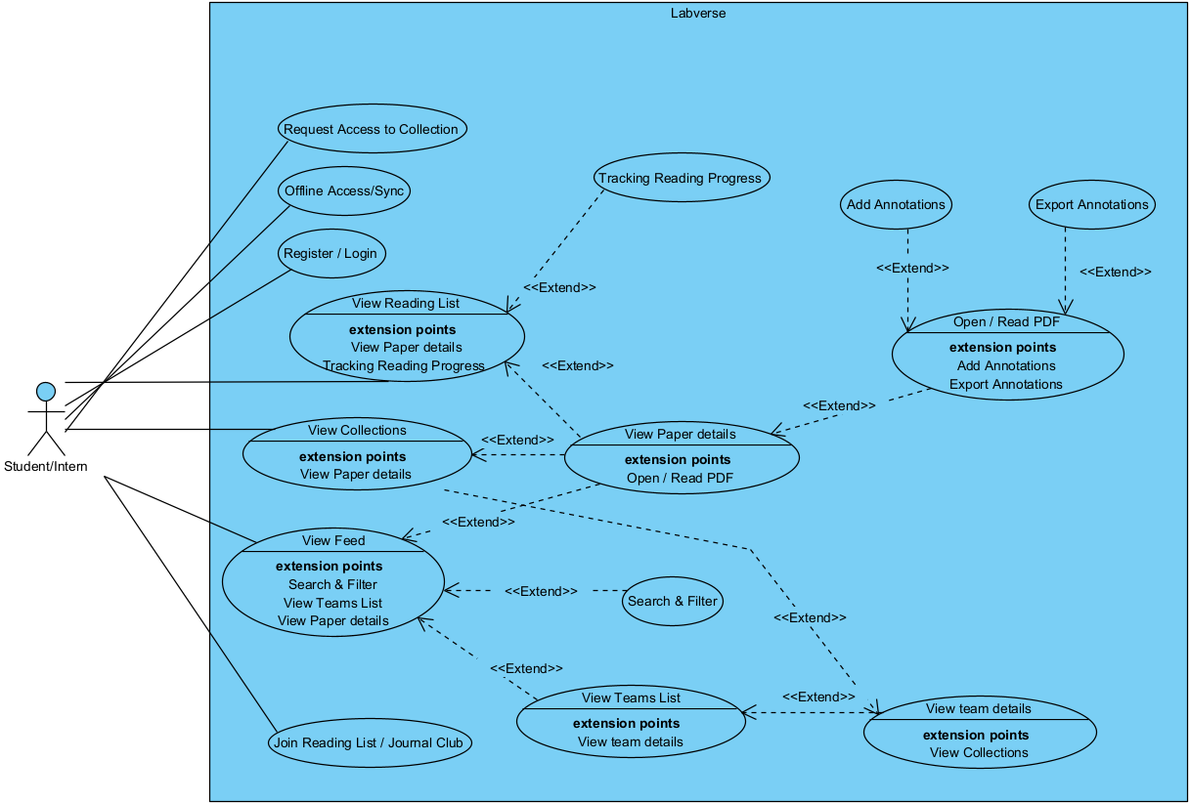
Figure 2-1: Use case diagram of Student

2.2.6.1 Descriptions

ID | Group function | Use Case | Use Case Description & Main Flow
01 |  | Request access to collection | Allow users (mainly Students/Interns) to request access to a restricted collection created by a PI.  Main Flow:  1. User navigates to "Teams" or "Collections" screen.  2. Selects a collection with "Restricted" status.  3. Taps "Request Access" button.  4. System sends request to PI via backend (API POST /collections/{id}/request).  5. PI receives notification and approves/denies.  6. User receives approval status via in-app notification.
02 |  | Offline access / Sync | Enable reading, annotating, and syncing data while offline.  Main Flow:  1. App pre-downloads PDFs, metadata, and annotations when online.  2. Stores data in Room DB and local file system.  3. When offline: user can open PDFs, add annotations, update reading status.  4. WorkManager schedules sync jobs when connectivity is restored.  5. Sync: pushes local changes to server, pulls remote updates
03 |  | Register / Login | Authenticate users to access personal and team libraries.  Main Flow:  1. App opens → Login screen.  2. Enter email + password or select Google OAuth.  3. Call login API → receive JWT.  4. Securely store JWT using EncryptedSharedPreferences.  5. If no account → tap "Register" → fill form → call register API → return to login
04 |  | View reading list | Display papers in a personal or journal club reading list.  Main Flow:  1. Navigate to "Reading Lists" tab.  2. RecyclerView shows lists (name, paper count, status).  3. Tap a list → view details: paper list, reading status, priority tags.  4. Pull-to-refresh triggers sync
05 |  | View collection | View papers in a shared team/project collection.  Main Flow:  1. Go to "Collections" tab.  2. Display collections user has access to (created by PI, invited, or public).  3. Tap collection → show paper list, team status, progress indicators.  4. PI sees extra: "Invite Members", "Manage Access" buttons
06 |  | View feed | Show personalized recommendations of new papers.  Main Flow:  1. Open "Discover" tab.  2. RecyclerView displays recommended papers (from arXiv, PubMed, etc.).  3. Each item: title, authors, short abstract, "Add to Library" button.  4. Auto-refresh on tab open or pull-to-refresh
07 |  | Join reading list / Journal club | Join a shared reading list or journal club.  Main Flow:  1. Receive invite link (email or in-app notification).  2. Tap link → opens app → confirm join.  3. System adds user to list with read-only or contributor role.  4. List appears in "Reading Lists" tab
08 |  | View teams list | Display all labs/teams the user is part of.  Main Flow:  1. Navigate to "Teams" tab.  2. RecyclerView shows: lab name, PI, member count, collection count.  3. PI sees "Create Team" button.  4. Tap team → go to "View team details".
09 |  | View team details | View detailed activity and progress of a team.  Main Flow:  1. From "Teams List" → select a team.  2. Display: member list, collections, reading progress dashboard (charts % completed).  3. PI can: invite members, create new collection, view reports.
10 |  | Search & Filter | Search and filter papers in personal or team libraries.  Main Flow:  1. Tap SearchView in toolbar.  2. Type keyword → instant full-text search in Room DB.  3. Tap Filter → open BottomSheet: select author, journal, year, tag, status.  4. Apply → trigger advanced API query if needed → update RecyclerView
11 |  | View paper details | View full metadata of a research paper.  Main Flow:  1. From any list → tap a paper.  2. Open details screen: title, authors, abstract, DOI, citations (APA/BibTeX), tags, status, priority.  3. Buttons: "Open PDF", "Add to Collection", "Set Status"
12 |  | Tracking reading progress | Track individual and team reading progress.  Main Flow:  1. In paper lists: show status icons (Unread/Reading/Finished) + progress bar (% pages read).  2. While reading PDF: auto-save last page → update progress.  3. Periodic sync → PI views team progress dashboard
13 |  | Add annotations | Highlight, underline, note, or draw on PDF.  Main Flow:  1. Open PDF → select tool: highlight, note, freehand.  2. Apply on page → save data (position, text, page) locally in Room DB.  3. Sync to server when online → visible to team if in shared collection
14 |  | Export annotations | Export annotations to a shareable file.  Main Flow:  1. In PDF viewer → Menu → "Export Annotations".  2. Choose format (JSON/XML).  3. Save file → open Share Sheet → send via email, Drive, etc.  4. File includes: paper ID, page, type, coordinates, text
15 |  | Open / Read pdf | Open and read PDF documents within the app.  Main Flow:  1. From paper details → tap "Open PDF".  2. Load from local cache or download from server if missing.  3. Render using AndroidPdfViewer.  4. Support: zoom, page jump, view/add annotations

3. Software Features

3.1 Functional Overview

3.1.1 Screens Flow
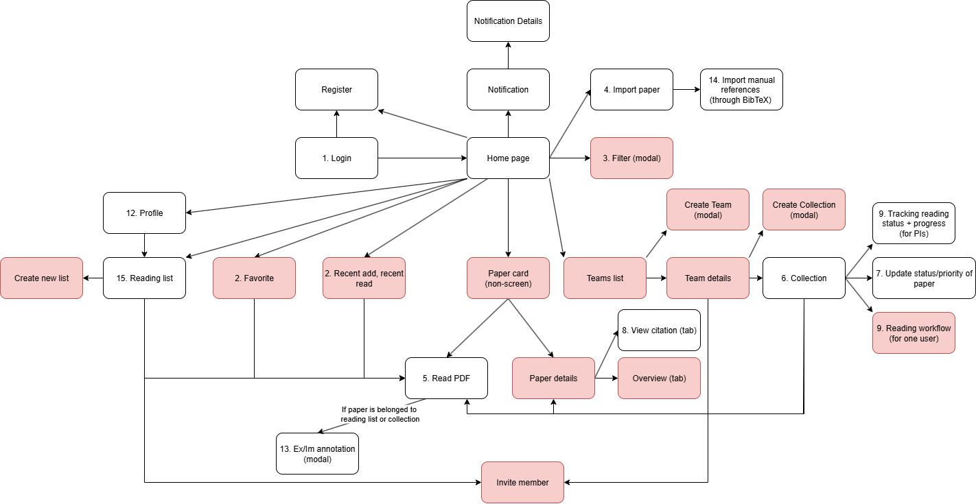

3.1.2 Screen Descriptions
# | Feature | Screen | Description
1 | Authentication | Register | Allows new users to sign up using email and password (or Google account). Includes input fields for name, email, and password confirmation. Submits data to backend API for account creation.
2 |  | Login | Provides secure access for registered users. Includes email/password fields and login button. Authenticates via backend API and stores JWT token securely on-device.
3 | Notification | Notification Details | Displays full content of a selected notification (e.g., new shared paper, team comment, or system update). Allows marking as read.
 |  | Notification | Shows a chronological list of alerts and updates relevant to the user or their research groups. Pull-to-refresh supported.
4 | Common | Home page | Main landing screen after login. Displays personalized paper recommendations, recently added papers, and quick navigation to library, collections, and notifications.
 |  | Profile | Allows user to view and edit their personal information, such as name, affiliation, and notification preferences. Includes “Change Password” option.
 |  | Reading List | Displays user-created or shared reading lists. Each list shows title, number of papers, and collaborators. Provides FAB to create new lists.
 |  | Create new list
 |  | Collection | Shows all shared collections the user is part of. Each card displays project title, member count, and paper count. PIs can create or manage collections here.
 |  | Import manual references | Enables importing papers from a BibTeX file. Displays parsed entries in a list with checkboxes for selective import.
 |  | Read PDF | In-app PDF viewer screen. Supports highlights, annotations, and note-taking. Displays reading progress and annotation toolbar.
 |  | Teams tab | Central place for managing team-based research collections. Lists all teams the user belongs to, and allows access to shared papers.
 |  | Import paper | Provides dialog to import papers by uploading a PDF or entering DOI/link. Syncs uploaded papers to the backend and displayed in the personal library.
 |  | Export/Import annotation | Allows exporting annotations as JSON or importing from another user. Displays import/export status and merge confirmation dialog.
 |  | View citation | Displays automatically extracted citation data (APA, MLA, BibTeX). Includes buttons to copy or share citations.
 |  | Overview | Display the paper information such as thumbnail image, authors, paper’s title, doi,...
 |  | Recent add, recent read | Display paginating papers that the user has been adding (to their reading list, collections) or reading. User can delete paper (for tab “Recently Read”) or like (for tab “Recently Added”) and continue to read
 |  | Favorite | Display the paginating papers that the user has been liking. User can delete or continue to read these papers
 |  | Filter | This is a popup modal, allowing users to filter paper in the dashboard by author, journal, publication year or keywords,...
 |  | Teams list | Allows users to view all teams that they are members
 |  | Team details | Allows user to view team details
 |  | Create team | Allows users to create new teams, invite and create collections of papers for researching and discussing
 |  | Create collection | Allows PIs to create collection in order to group papers that related to their research topic
 |  | Reading workflow | Allows users to view their reading paper workflow with the information of progress, the last page number,...
 |  | Paper details | Display the information of a specific paper with 3 tab: Citation, References, Overview
 |  | Invite member | Allow normal users or PIs to invite others to their group or reading list
6 | PI feature | Tracking reading status + progress | Provides overview for Principal Investigator to monitor team members’ reading progress. Displays visual indicators or progress bars per paper/user.
 |  | Update status/priority of paper | Allows PI or authorized members to update the reading status (“To Read,” “Reading,” “Finished”) or assign priority levels (“High,” “Medium,” “Low”) for papers in shared collections.

3.1.3 Screen Authorization
# | Screen | PI/Lab Head | Researcher | Student/Intern
1 | Register | X | X | X
2 | Login | X | X | X
3 | Notification Details | X | X | X
4 | Notification | X | X | X
5 | Home page | X | X | X
6 | Profile | X | X | X
6.1 | <<Update information>> | X | X | X
7 | Reading List | X | X | X
7.1 | <<Create>> | X | X | X
7.2 | <<Update>> | X | X | X
7.3 | <<Delete>> | X | X | X
7.4 | <<Invite member>> | X | X | X
8 | Collection | X | X | X
8.1 | <<Create>> | X
8.2 | <<Update>> | X
8.3 | <<Delete>> | X
8.4 | <<Invite member>> | X
9 | Import manual references | X | X | X
10 | Read PDF | X | X | X
11 | Teams tab | X | X | X
11.1 | <<Create>> | X
11.2 | << Update>> | X
11.3 | <<Delete>> | X
11.4 | <<Invite member>> | X
12 | Import paper | X | X | X
13 | Export/Import annotation | X | X | X
13.1 | <<Export>> | X | X | X
13.2 | < Import>> | X | X | X
14 | View citation | X | X | X
15 | Tracking reading status + progress | X
15.1 | <<Create + Update>> | X
16 | Update status/priority of paper | X

3.1.4 Non-Screen Functions
# | Feature | System Function | Description
1 | Security | Authentication & Authorization | Define permissions per user role (PI, Researcher, Student) at backend level to control access to collections, annotations, and management functions.
2 | Data Privacy | Data Encryption & Protection | All personal data, research papers, and annotations must be encrypted at rest and during transit; only authorized users can access team collections.
3 | Performance | Fast Data Access & Query | Backend and local database (Room) must ensure quick retrieval of library metadata, annotations, and collections, supporting full-text search and filtered queries efficiently.
4 | Scalability | Multi-user & Team Support | The backend must support concurrent access for multiple users, collections, projects, and teams without degradation of performance.
5 | Availability | Offline Support & Sync | Users can read and annotate papers offline; a background service (WorkManager) must handle bidirectional sync with the backend when connectivity is restored.
6 | Reliability | Data Consistency & Integrity | Changes to papers, annotations, reading progress, and collection membership must be consistently reflected across devices and backend to prevent conflicts or data loss.
7 | Usability | Intuitive UI/UX | The interface must be user-friendly, leveraging RecyclerViews, CardViews, BottomSheetDialogs, FABs, and Tabs to optimize reading and annotation workflows.
8 | Maintainability | Modular Service Architecture | Backend services and mobile app code must be modular to allow easier maintenance, updates, and addition of new features like analytics or annotation sharing.
9 | Data Resilience | Data Resilience | Backend must support automatic backups and recovery procedures to prevent permanent data loss in case of system failure.
10 | Interoperability | External Tools & APIs | System must support importing/exporting BibTeX, integrating with Zotero, Mendeley, Google Scholar, and connecting with cloud storage (Firebase/S3) for PDFs.
11 | Responsiveness | Real-time Data Updates | Backend should support near real-time updates for shared collections, status changes, and annotations to ensure all users see the latest data promptly.
12 | Logging & Monitoring | Error Reporting & Audit | All backend operations, sync tasks, and errors must be logged; system must provide mechanisms for monitoring performance, crash reporting, and auditing user actions.
13 | Notification | Event-based Alerts | Backend must generate push notifications for new papers, shared collection updates, or team activity, delivered via Firebase Cloud Messaging.
14 | Storage Efficiency | Local & Cloud Storage | PDFs, metadata, annotations, and collections must be stored efficiently in local and cloud storage, optimizing disk usage and minimizing redundant data.
15 | Internationalization | Standardized Data Formats | System should store dates, times, and author metadata in standardized formats (ISO 8601, UTF-8) for consistency and potential multi-language support.

3.1.5 Entity Relationship Diagram
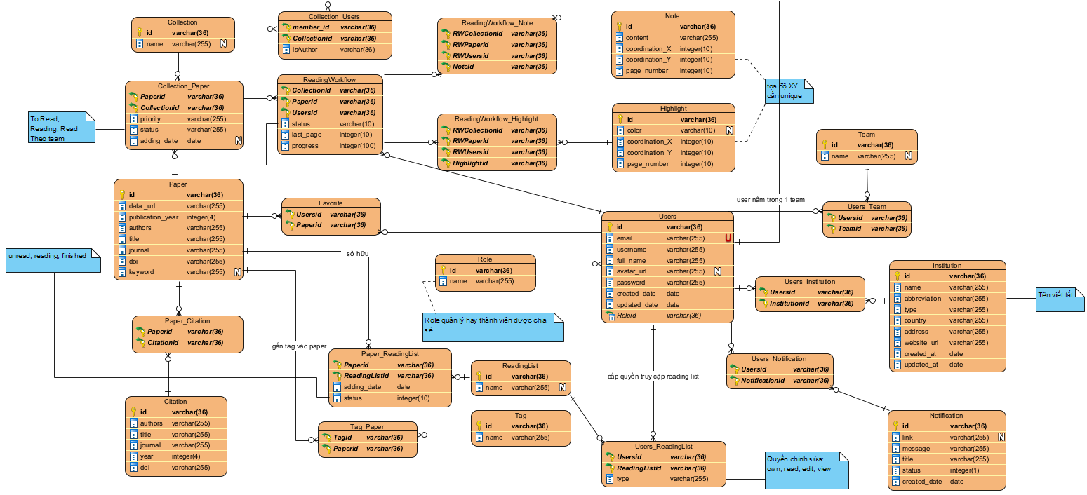
Entities Description

# | Entity | Description
1 | Collection | Represents a shared project or themed paper group within a team
2 | Paper | Represents a research paper in the system
3 | Citation | Stores structured citation metadata for a paper
4 | Role | Defines the user's role within a team or collection (e.g., PI, Researcher, Intern)
5 | Favorite | Stores papers marked as favorites by users
6 | ReadingWorkflow | Represents a reading workflow or research phase within a collection
7 | Users | Represents individual users of the LabVerse app (PI, researcher, student)
8 | ReadingList | Represents a curated list of papers for journal clubs or themed discussions
9 | Tag | Represents a keyword or thematic label for categorizing papers
10 | Team | Represents a research team or lab group
11 | Note | Represents a user’s note on a paper or workflow
12 | Highlight | Represents a highlighted section of a paper
13 | Notification | Represents system alerts or updates for users
14 | Institution | Represents institution information where users have been working in

3.1.6 Entity Details
- Collection
# | Attribute name | PK | Type | Mandatory | Description
1 | id | x | String | Yes | Primary key
2 | name |  | String | No | Collection name

- Paper
# | Attribute name | PK | Type | Mandatory | Description
1 | id | x | String | Yes | Primary key
2 | data_url |  | String | Yes | Data file URL
3 | publication_year |  | Integer | Yes | Year of publication
4 | authors |  | String | Yes | Authors
5 | title |  | String | Yes | Paper title
6 | journal |  | String | Yes | Journal
7 | doi |  | String | Yes | Digital Object Identifier
8 | keywork |  | String | No | Keywords

- Citation
# | Attribute name | PK | Type | Mandatory | Description
1 | id | x | String | Yes | Primary key
2 | authors |  | String | Yes | Authors
3 | title |  | String | Yes | Title
4 | journal |  | String | Yes | Journal
5 | year |  | Integer | Yes | Year
6 | doi |  | String | Yes | Digital Object Identifier

- Role
# | Attribute name | PK | Type | Mandatory | Description
1 | id | x | String | Yes | Primary key
2 | name |  | String | Yes | Role name

- Favorite
# | Attribute name | PK | Type | Mandatory | Description
1 | user_id | x | String | Yes | Linked to Users
2 | paper_id | x | String | Yes | Linked to Papers

- ReadingWorkflow
# | Attribute name | PK | Type | Mandatory | Description
1 | user_id | x | String | Yes | User reference
2 | paper_id | x | String | Yes | Paper reference
3 | citation_id | x | String | Yes | Collection reference
4 | status |  | String | Yes | Reading status
5 | progress |  | Integer | Yes | Last page read
6 | last_page |  | Integer | Yes | Reading progress (%)

- Users
# | Attribute name | PK | Type | Mandatory | Description
1 | id | x | String | Yes | Primary key
2 | email |  | String | Yes | Email address
3 | username |  | String | Yes | Username
4 | full_name |  | String | Yes | Full name
5 | avatar_url |  | String | No | Profile picture
6 | created_date |  | Date | Yes | Date created
7 | password |  | String | Yes | Encrypted password
8 | updated_date |  | Date | Yes | Date updated
9 | role_id |  | String | Yes | Role reference

- Reading List
# | Attribute name | PK | Type | Mandatory | Description
1 | id | x | String | Yes | Primary key
2 | name |  | String | No | Reading list name

- Tag
# | Attribute name | PK | Type | Mandatory | Description
1 | id | x | String | Yes | Primary key
2 | name |  | String | Yes | Tag name

- Team
# | Attribute name | PK | Type | Mandatory | Description
1 | id | x | String | Yes | Primary key
2 | name |  | String | Yes | Team name

- Note
# | Attribute name | PK | Type | Mandatory | Description
1 | id | x | String | Yes | Primary key
2 | content |  | String | Yes | Note content
3 | coordination_x |  | Integer | Yes | X coordinate
4 | coordination_y |  | Integer | Yes | Y coordinate
5 | page_number |  | Integer | Yes | Page number

- Highlight
# | Attribute name | PK | Type | Mandatory | Description
1 | id | x | String | Yes | Primary key
2 | color |  | String | Yes | Highlight color
3 | coordination_x |  | Integer | Yes | X coordinate
4 | coordination_y |  | Integer | Yes | Y coordinate
5 | page_number |  | Integer | Yes | Page number

- Notification
# | Attribute name | PK | Type | Mandatory | Description
1 | id | x | String | Yes | Primary key
2 | link |  | String | Yes | Related link
3 | message |  | String | Yes | Notification message
4 | title |  | String | Yes | Notification title
5 | status |  | String | Yes | Status
6 | created_at |  | Date | Yes | Created timestamp

- Institution
# | Attribute name | PK | Type | Mandatory | Description
1 | id | x | String | Yes | Primary key
2 | name |  | String | Yes | Institution name
3 | abbreviation |  | String | Yes | Short name / abbreviation
4 | type |  | String | Yes | Type of institution (e.g., university, lab)
5 | country |  | String | Yes | Country
6 | address |  | String | Yes | Address
7 | website_url |  | String | Yes | Official website
8 | created_at |  | Date | Yes | Created timestamp
9 | updated_at |  | Date | Yes | Updated timestamp

3.2 Authentication

3.2.1 Login
3.2.1.1 Screen Mock-up
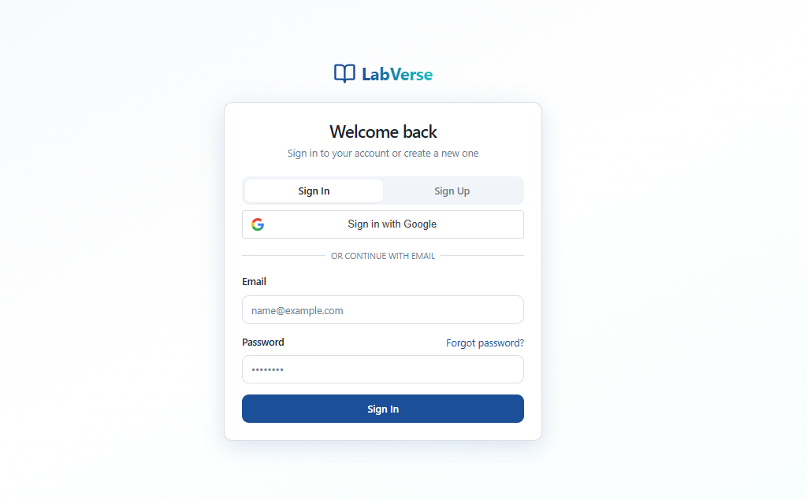
Figure 3-1: Screen Design of Login

Table 3-1: Screen Definition
# | Field Name | Type | Mandatory | Max Length | Description
1 | Email Address | Text | Yes | 254 | Used to enter the user's email address for logging in or registering
2 | Password | Text | Yes | 64 | Used to enter the user's password. The password is obscured and there is an eye icon to toggle its visibility.
3 | Remember me | Check Box | No | N/A | An option to save login information (typically a token) on the device, allowing the user to stay logged in for a certain period.
4 | Forgot password? | Link | N/A | N/A | A link that directs the user to the password recovery page in case they have forgotten their password.
 | Sign In | Button | Yes (To complete the process) | N/A | The button used to submit the Email and Password information to proceed with authentication and log into the system.
 | Continue with Google | Button (Social Login) | No | N/A | The button used for quick login/registration via the user's Google account.

3.2.1.2 Use Case Description
Use Case ID |  | UC-01 | Use Case Name |  | Log In
Author |  | HieuDM | Version | 1.0 | Date | 1/11/2025
Actor |  | User (all Role)
Description |  | Allows a user with an existing account to securely access their personal and team libraries.
Precondition |  | The User has opened the Login screen (or selected the Login tab).
Trigger |  | The User fills in both the Email Address and Password, then clicks the Sign In button.
Post-Condition |  | The User is successfully redirected to the feed of LabVerse.
Main flows
Step | Actor | Action
1 | User | Enters the Email Address into the Email Address field.
2 | User | Enters the Password into the Password field.
3 | User | Clicks the Sign In button
4 | System | Validates the login credentials.
5 | System | If credentials are valid, grants a login session and redirects the User to the Homepage.
6 | System | If credentials are invalid, displays an error message.
7 | User | Clicks Continue with Google

Alternative flows
AT1 | Forgot Password
Sub step | Actor | Action
AT1.1 | User | Clicks the Forgot password? link.
AT1.2 | System | Redirects the User to the Password Recovery screen.
AT1.3 | User | Enters the registered email address.
AT1.4 | System | Sends a password reset instruction email and notifies the User.

Business Rules
# | Rule Description
BR-01 | The Email Address field must be a valid email format (e.g., user@example.com).
BR-02 | Both Email Address and Password fields are mandatory and cannot be empty when clicking Sign In.
BR-03 | The password entered must match the stored password for the corresponding email account in the system.
BR-04 | If the login process fails after a certain number of attempts (e.g., 5 times), the system must temporarily lock the account.
BR-05 | Google sign-in (social login) must either create a new LabVerse account or link an existing account to the authorized Google email address.

3.2.2 Register
3.2.1.1 Screen Mock-up
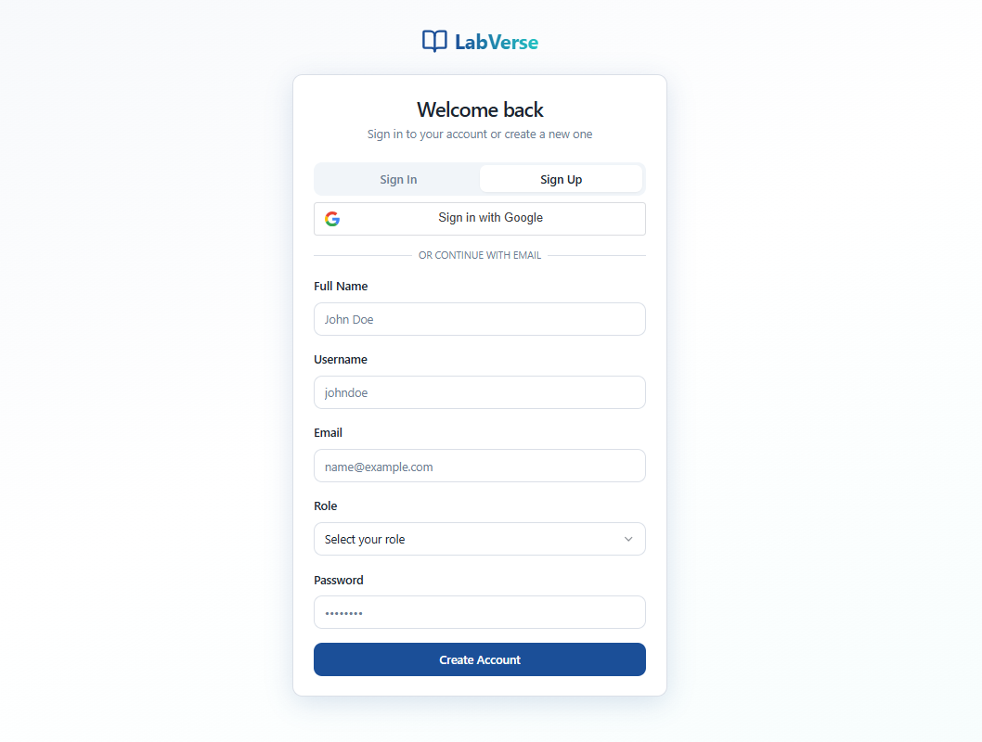
Figure 3-1: Screen Design of Login

Table 3-1: Screen Definition
# | Field Name | Type | Mandatory | Max Length | Description
1 | Email Address | Text | Yes | 254 | Used to enter the user's email address for registration.
2 | Password | Text | Yes | 64 | Used to enter the user's password. The password is obscured and there is an eye icon to toggle its visibility.
3 | Repeat Password | Text | Yes | 65 | Used to repeat the user's password.The password is obscured and there is an eye icon to toggle its visibility
4 | Role | Drop Down | Yes | N/A | Used to select the user's role in the research community (e.g., Researcher, Student, etc.) from a predefined list.
4 | Create Account | Button | Yes | N/A | The button used to submit the registration information to create a new user account.
5 | Continue with Google | Button (Social Login) | No | N/A | The button used for quick login/registration via the user's Google account.

3.2.1.2 Use Case Description
Use Case ID |  | UC-02 | Use Case Name |  | Register
Author |  | HieuDM | Version | 1.0 | Date | 1/11/2025
Actor |  | User (all Role)
Description |  | Allows a new user to securely create an account and join the global research community.
Precondition |  | The User has opened the Registration (Get Started) screen.
Trigger |  | The User fills in Email Address, Password, and selects a Role, then clicks the Create Account button.
Post-Condition |  | The User is successfully logged in and redirected to the feed of LabVerse, and a new account is created.
Main flows
Step | Actor | Action
1 | User | Enters the Email Address into the Email Address field.
2 | User | Enters the Password into the Password field.
3 | User | Clicks the Sign In button
4 | System | Validates the login credentials.
5 | System | If credentials are valid, grants a login session and redirects the User to the Homepage.
6 | System | If credentials are invalid, displays an error message.
7 | User | Clicks Continue with Google

Alternative flows
AT1 | Forgot Password
Sub step | Actor | Action
AT1.1 | User | Clicks the Forgot password? link.
AT1.2 | System | Redirects the User to the Password Recovery screen.
AT1.3 | User | Enters the registered email address.
AT1.4 | System | Sends a password reset instruction email and notifies the User.

Business Rules
# | Rule Description
BR-01 | The Email Address field must be a valid email format (e.g., user@example.com).
BR-02 | The Email Address, Password, and Role fields are mandatory and cannot be empty when clicking Create Account.
BR-03 | The Password must meet the defined strength requirements (e.g., min 8 characters, mix of case, numbers, special characters).
BR-04 | The system must check if the entered Email Address already exists. If it does, an error message must be displayed prompting the user to sign in instead.
BR-05 | Google and Microsoft sign-up (social login) must create a new LabVerse account linked to the authorized social email address. If the email is already registered, the system should inform the user they can Sign In or link the accounts.

3.3 Notification

3.3.1 Notification_01 Register
3.3.1.1 Screen Mock-up
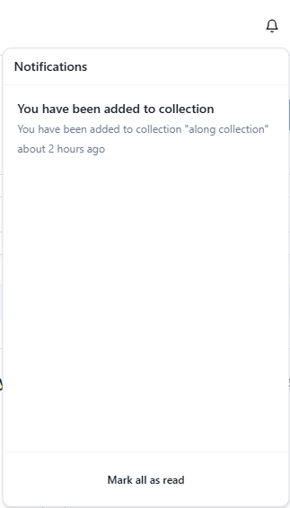

Table 3-1: Screen Definition
# | Field Name | Type | Mandatory | Max Length | Description
1 | Notification Title | String | Yes | 255 | The main title of the notification displayed to the user (e.g., “You’ve been added to a collection”).
2 | Notification Message | String | Yes | 500 | The detailed message content of the notification (e.g., “You’ve been added to the collection ‘test’”).
3 | Timestamp | Datetime | Yes | — | The time when the notification was created or received (e.g., 21 hours ago).
4 | Read Status | Boolean | Yes | — | Indicates whether the notification has been read (true = read, false = unread).
5 | Notification ID | String / UUID | Yes | 36 | Unique identifier for each notification entry in the system.
6 | User ID | String / UUID | Yes | 36 | The ID of the user who received the notification.
7 | Collection Name | String | No | 255 | The name of the collection associated with the notification (e.g., “test”).
8 | Notification Type | Enum | Yes | 50 | Type/category of the notification (e.g., InviteAccepted, AddedToCollection, CommentMention).

3.3.1.2 Use Case Description
Use Case ID |  | Not_01 | Use Case Name |  | Notification: User Added to Collection
Author |  | LongLD | Version | 1.0 | Date | 9/11/2025
Actor |  | PI/Lab Head, User (Student/Intern/Researcher)
Description |  | This use case describes how the system notifies a user when a Principal Investigator (PI) or Lab Head adds them to a research collection.  The system generates a notification, displays it in the user’s notification list, and allows the user to view and mark it as read.
Precondition |  | - The PI/Lab Head is logged into the system.  - The user to be added already has a valid account.  - The collection exists in the system.
Trigger |  | The PI/Lab Head adds a user to an existing collection.
Post-Condition |  | - A new notification is created and stored in the system.  - The notification is sent to the user’s notification center.  - Once the user views it, the notification status changes to “Read”.
Main flows
Step | Actor | Action
1 | PI/Lab Head | Selects an existing collection in the system.
2 | PI/Lab Head | Adds a user (student/researcher/intern) to the selected collection.
3 | System | Validates the user and collection details.
4 | System | Creates a new notification record with the message: “You’ve been added to collection <Collection Name>.”
5 | System | Sends the notification to the user’s account.
6 | User | Receives the notification in their notification center.
7 | User | Clicks on the notification to open and read it.
8 | System | Displays the full message and updates the notification status to “Read”.

Alternative flows
AT1
Sub step | Actor | Action
3a | System | If the user does not exist or collection is invalid, the system displays an error and does not send any notification.
AT2
6a | User | If the user does not open the notification, it remains marked as “Unread”.

Business Rules
# | Rule Description
BR1 | A notification must be generated automatically whenever a user is added to a collection.
BR2 | Each notification must contain a timestamp and unique ID.
BR3 | Notifications must be stored until manually cleared or archived.
BR4 | Once opened, the notification status automatically changes to “Read”.
BR5 | Only valid, active users can receive notifications.
BR6 | The notification message must include the collection name and the actor (PI/Lab Head) who initiated the action.

3.4 Common

3.4.1 View paper details

3.4.1.1 Screen Mock-up

Figure 3-1: Screen Design of Description tab

Table 3-1: Screen Definition
# | Field Name | Type | Mandatory | Max Length | Description
1 | Title | Label | Yes | 100 | Paper title: "Deep Learning for Biomedical Text Mining"
2 | Priority Badge | Badge | No |  | Displays priority level (e.g., "Priority" with orange background)
3 | Authors | Label | Yes | 250 | Author names: "Nguyen Van A, Tran Thi B"
4 | Journal | Label | Yes | 150 | Journal name: "Journal of AI in Medicine"
5 | DOI | Label + Link | Yes | 100 | DOI of the paper: "10.1007/ai-med.2022.001" (clickable link)
6 | Tab: Description | Tab Button | Yes |  | Currently selected tab (highlighted)
7 | Tab: Details | Tab Button | Yes |  | Unselected tab
8 | Tab: Notes | Tab Button | Yes |  | Unselected tab
9 | Description Section Title | Label | Yes | 50 | Section header: "Description"
10 | Description Content | Text Area | Yes | 2000 | Detailed description text of the paper (paragraph)
11 | Favorite Icon | Icon Button | Yes |  | Star icon to mark as favorite
12 | Download Icon | Icon Button |  |  | Download icon (for PDF or document)

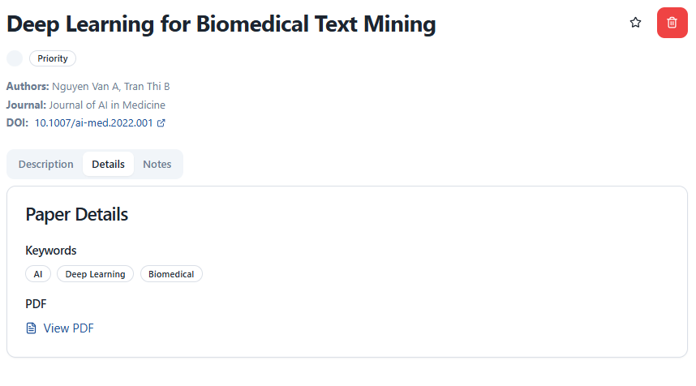
Figure 3-2: Screen Design of Details tab

Table 3-2: Screen Definition
# | Field Name | Type | Mandatory | Max Length | Description
1 | Tab: Description | Tab Button | Yes |  | Unselected tab
2 | Tab: Details | Tab Button | Yes |  | Currently selected tab (highlighted)
3 | Tab: Notes | Tab Button | Yes |  | Unselected tab
4 | Details Section Title | Label | Yes | 50 | Section header: "Paper Details"
5 | Keywords Label | Label | Yes | 50 | Sub-section header: "Keywords"
6 | Keyword Tags | Tag List | No |  | Clickable tags: "AI", "Deep Learning", "Biomedical"
7 | PDF Label | Label | Yes | 50 | Sub-section header: "PDF"
8 | View PDF Button | Button + Icon | Yes |  | Button with file icon and text: "View PDF" (opens PDF)
9 | Favorite Icon | Icon Button | No |  | Star icon to mark as favorite
10 | Download Icon | Icon Button | No |  | Download icon (for PDF or document)

3.4.1.2 Use Case Description
Use Case ID |  | Comm_01 | Use Case Name |  | View paper details
Author |  | HoanTX | Version | 1 | Date | 9/10/2025
Actor |  | PI, Researcher, Student
Description |  | Paper will be automatically extracted citation data in order to show the references that authors have been using. Users can view, copy, export, and download references and citations.
Precondition |  | Users must be in the Library, Reading List, Discover or Collection screen
Trigger |  | Users click the paper card view on the current screen
Post-Condition |  | POST-1: The citation details and Description and Details tab are displayed and be ready to interact  POST-2: If users access this screen from library section, the delete button will be hidden; unless, it will be displayed and be ready to interact
Main flows
Step | Actor | Action
1 | User | Click the paper card view in the feed
2 | System | Navigate to the paper details screen
3a | System | Fetch the paper details, references and citations
3b | System | Display the paper details and the Description tab content
4 | User | Click the Details tab
5 | System | Display the information of this paper

Alternative flows

AT2 | User copy list of reference information
Sub step | Actor | Action
1 | User | Click the Reference tab
2 | User | Click one of 3 options below the “Copy Reference Formats” title
3 | System | Copy to the clipboard the references by the format that user chooses

AT3 | User click the Star button
Sub step | Actor | Action
1 | User | Click the Star icon
2 | System | Add this paper to the favorite list

AT4 | User click the Delete button
Sub step | Actor | Action
1 | User | Click the Delete button
2 | System | This paper will be removed from reading list or favorites list

AT5 | User click the DOI link
Sub step | Actor | Action
1 | User | Click the Citation tab
2 | System | Navigate to the doi Foundation page (external website)

Business Rules
# | Rule Description
Comm_01_BR1 | Only authenticated users can copy, export, or download references.
Comm_01_BR2 | References and citations must be displayed in APA, MLA, and BibTeX styles.
Comm_01_BR3 | Pagination is required if references or citations exceed 10 items.
Comm_01_BR4 | “Continue to read” must navigate to the correct PDF corresponding to the paper.
Comm_01_BR5 | Downloaded files must preserve original citation format and PDF integrity.

3.4.2 View feed

3.4.2.1 Screen Mock-up
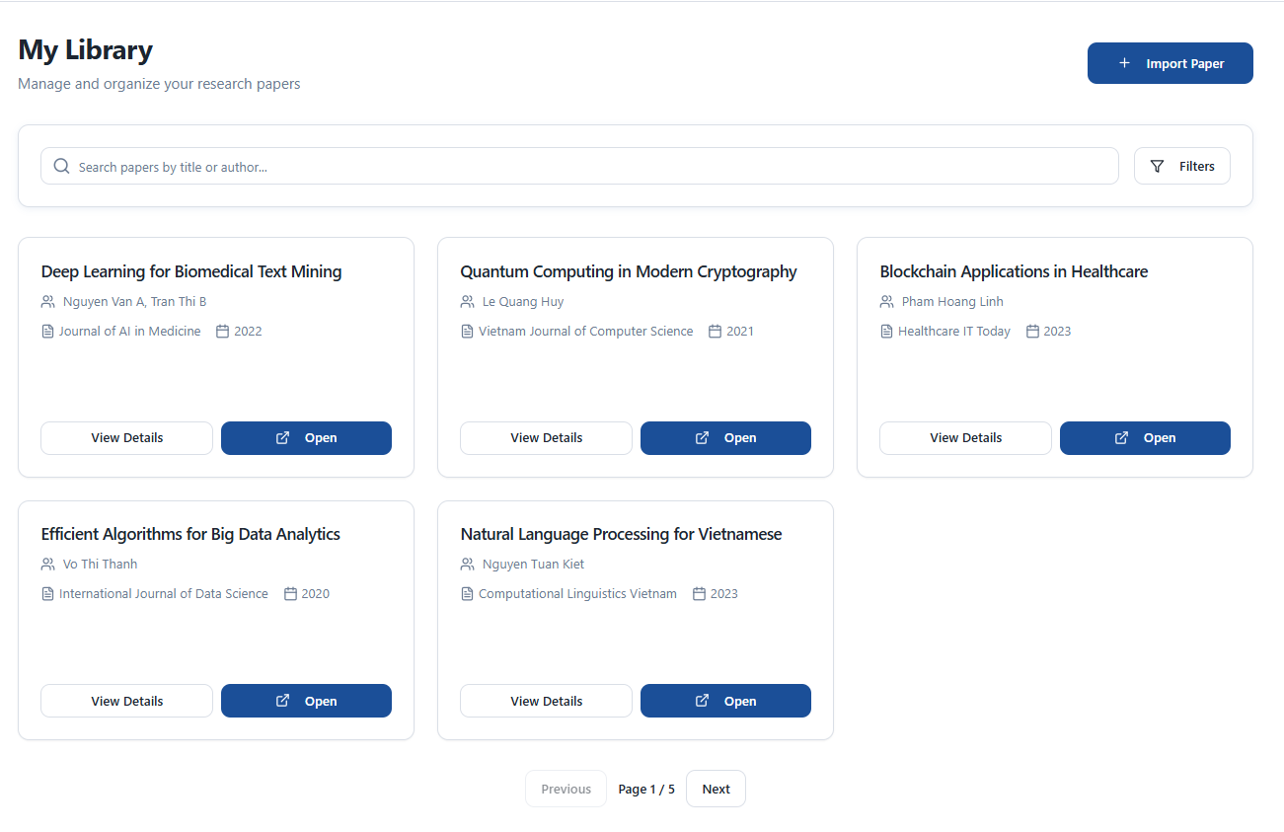
Figure 3-4: Screen Design of Discovery tab of feed screen

Table 3-4: Screen Definition
# | Field Name | Type | Mandatory | Max Length | Description
1 | Page Title ("My Library") | Label | Yes | 50 | Main page title displaying the user’s personal library name.
2 | Subtitle ("Manage and organize your research papers") | Label | No | 100 | Short description of the page’s purpose.
3 | Import Paper Button | Button | Yes |  | Button for uploading or importing a new research paper.
4 | Search Bar | Input Field | No | 100 | Field for searching papers by title or author.
5 | Search Icon | Icon/  Button | No |  | Icon to trigger the search function.
6 | Filters Button | Button | No |  | Opens filter options (year, author, journal, etc.).
7 | Paper Card Container | Container | Yes |  | Area containing a grid of paper cards
8 | Paper Card – Title | Label | Yes | 100 | Displays the research paper’s title.
9 | Paper Card – Author(s) | Label | Yes | 100 | Displays the name(s) of the author(s).
10 | Paper Card – Journal Name | Label | No | 100 | Displays the journal or conference name where the paper was published.
11 | Paper Card – Published Year | Label | No | 4 | Displays the publication year.
12 | Paper Card – View Details Button | Button | Yes |  | Opens a detailed view of the selected paper.
13 | Paper Card – Open Button | Button | Yes |  | Opens the paper file or detailed page.
14 | Pagination Container | Container | Yes |  | Area for navigating between pages of results.
15 | Previous Button | Button | No |  | Navigates to the previous page.
16 | Next Button | Button | No |  | Navigates to the next page.
17 | Page Indicator ("Page 1 / 5") | Label | Yes | 10 | Displays the current page number and total pages.

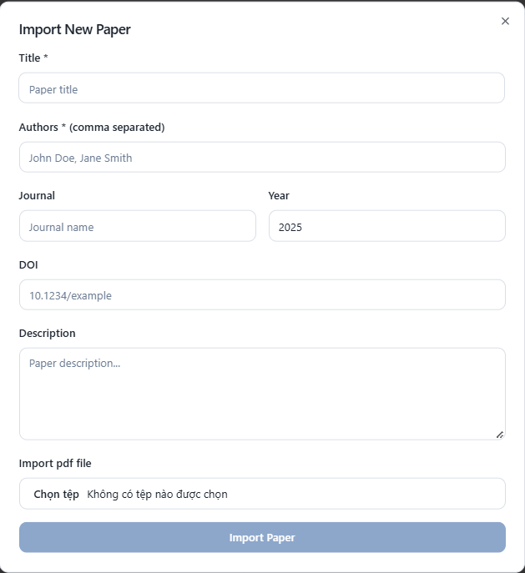
Figure 3-6: Screen Design of Filter modal

Table 3-4: Screen Definition
# | Field Name | Type | Mandatory | Max Length | Description
1 | Modal Title ("Import New Paper") | Label | Yes | 50 | Displays the title of the modal window
2 | Close Icon (X) | Icon/  Button | Yes |  | Closes the modal without saving changes
3 | Title Label | Label | Yes | 50 | Field label for paper title input
4 | Title Input Field | Text Field | Yes | 150 | Allows the user to enter the research paper title
5 | Authors Label ("Authors * (comma separated)") | Label | Yes | 100 | Field label for the authors input field
6 | Authors Input Field | Text Field | Yes | 200 | Allows user to enter one or more author names separated by commas
7 | Journal Label | Label | No | 50 | Field label for the journal input field.
8 | Journal Input Field | Text Field | No | 100 | Allows user to enter the journal or conference name
9 | Year Label | Label | No | 20 | Field label for the publication year input
10 | Year Input Field | Numeric Field | No | 4 | Allows user to specify the publication year (e.g., 2025).
11 | DOI Label | Label | No | 20 | Field label for DOI input field.
12 | DOI Input Field | Text Field | No | 100 | Allows user to input the paper’s DOI (e.g., 10.1234/example)
13 | Description Label | Label | No | 50 | Field label for the paper description.
14 | Description Textarea | Text Area | No | 500 | Allows user to enter a short description or abstract of the paper
15 | File Input | Label | Yes | 50 | Field label for uploading the paper file
16 | File Input | File Input | Yes |  | Allows user to upload the research paper in PDF format.
17 | Import Paper Button | Button | Yes |  | Executes the import action and saves the paper data
18 | Disabled State for Import Button | Interaction | Yes |  | The button remains disabled until all mandatory fields are filled.
19 | Placeholder Text (e.g., “Paper title”, “John Doe, Jane Smith”, “10.1234/example”) | Text | No | 150 | Provides examples or hints for data input
20 | Modal Background Overlay | Layout | Yes |  | Semi-transparent overlay behind the modal to keep user focus on it.

3.4.2.2 Use Case Description
Use Case ID |  | Comm_02 | Use Case Name |  | Discover papers
Author |  | HoanTX | Version | 1 | Date | 6/11/2025
Actor |  | PI, Researcher, Student
Description |  | This scrollable screen allows users to view all the new, recently read, favorite papers in the platform. Users can read, filter, search and import papers.
Precondition |  | PRE-1: Users have available credentials  PRE-2: Users have stable Internet connection
Trigger |  | TRG-1: Users open the application if the credentials are still available and valid  TRG-2: Users have logged in successfully if the credentials are not available  TRG-3: Users click the “Library” tab of dashboard screen‘s header
Post-Condition |  | Tabs, Search field, Buttons, Card views,... are ready to interact
Main flows
Step | Actor | Action
1 | Users | Access the application with valid credentials
2 | System | Fetch the first page of papers list and display card views
3 | System | Display card views
4a | User | Search for papers with keywords
5a | System | Fetch and display the papers list that have the keywords
4b | User | Filter papers list with author name, journal, publication year
5b | System | Filter the papers list with the information inputted by users
4c | User | Click the next/previous button
5c | System | Fetch the next/previous page of papers and update the pagination title

Alternative flows
AT1 | Open paper
Sub step | Actor | Action
1 | User | Click the Open button in the bottom of card view
2 | System | Navigate to the read paper screen

AT2 | Import paper
Sub step | Actor | Action
1 | User | Click the Import paper button in the header of main content
2 | System | Open the modal
3 | User | Enter all information of the new paper
4 | System | Validate and save the new paper to the server

Business Rules
# | Rule Description
Comm_02_BR1 | Publication Year "From" must not exceed the current year and must be ≥ 1900.
Comm_02_BR2 | Publication Year "To" must be ≥ "From" value; if "From" is filled and "To" is empty, system auto-fills "To" with current year.
Comm_02_BR3 | Apply Filters button is disabled (grayed out) if all filter fields are empty or in default state.
Comm_02_BR4 | Reset button is disabled if no changes have been made since popup opened or last reset
Comm_02_BR5 | Filter criteria are combined using AND logic: a paper must match all selected filters to appear in results.
Comm_02_BR6 | Filtered results maintain pagination state; navigating pages after filtering fetches data matching the active filter set.

3.4.6 Search

3.4.6.1 Screen Mock-up

Table 3-1: Screen Definition
# | Field Name | Type | Mandatory | Max Length | Description
1 | Search Input Field | Text Input | Yes | 254 | Used to enter search keywords (papers, authors, keywords). Includes a magnifying glass icon
2 | Filter/Setting Icon | Button | Yes | 64 | Used to access advanced filtering and sorting options for the search results.
3 | Result Count | Check Box | Text | N/A | Displays the total number of papers found (e.g., "1,247 papers").

3.4.6.2 Use Case Description
Use Case ID |  | Comm-06 | Use Case Name |  | Search paper
Author |  | HieuDM | Version | 1.0 | Date | 1/11/2025
Actor |  | User (all Role)
Description |  | Allows a user to view, filter, and interact with scientific papers based on their search query.
Precondition |  | The User is logged in and has executed a successful search query, or has navigated to this screen.
Trigger |  | The system displays the results after the user hits Enter/Search from the previous screen, or clicks one of the navigation tabs.
Post-Condition |  | The User can view the list of relevant papers and interact with them.
Main flows
Step | Actor | Action
1 | User | Clicks the Bookmark Icon to mark the paper.
2 | system | Saves the status to the library and changes the icon state (e.g., from outlined to filled).
3 | User | Clicks one of the Navigation Tabs (e.g., Favorites).
4 | System | Instantly filters the results list according to the selected tab (e.g., only showing bookmarked papers).

Alternative flows
AT1
Sub step | Actor | Action
AT1.1 | User | Edits or enters a new search term into the Search Input Field.
AT1.2 | User | Clicks the search icon or presses Enter.
AT1.3 | System | Processes the new query against the database.
AT1.4 | System | Replaces the current results with the new set of papers, updates the Result Count, and resets the active tab to "All Papers".

Business Rules
# | Rule Description
1 | Search results must be paginated or use infinite scrolling to handle a large number of papers (displaying $\text{N}$ items at a time).
2 | The navigation tabs (Recent, Favorites, My Library) must act as instantaneous filters on the overall search results.
3 | The Bookmark Icon must clearly reflect the current status (saved or unsaved) for the current user.
4 | The Display Data (Title, Author, Year, Journal) must match the information stored in the database for that paper.

3.4.7 Filter

3.4.7.1 Screen Mock-up
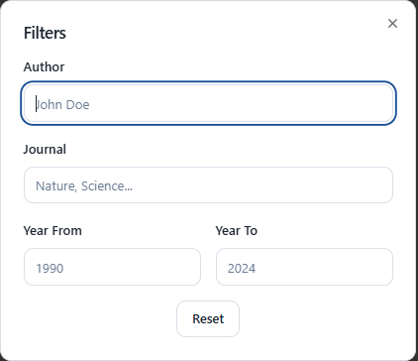

Table 3-1: Screen Definition
# | Field Name | Type | Mandatory | Max Length | Description
1 | Author | Text Input | Yes | 254 | Allows the user to enter an author's name to filter results. May support autocomplete suggestions.
2 | Journal | Button | Yes | 64 | Allows the user to select a specific journal or keep the default "All Journals".
3 | Publication Year (From) | Text/Input | Text | N/A | The starting year field for the publication range.
4 | Publication Year (To) | Text/input | No | No | The starting year field for the publication range.
5 | Reset Button | Button | N/A | N/A | Used to clear all entered values in the filter fields and restore them to their default state.

3.4.7.2 Use Case Description
Use Case ID |  | Comm-07 | Use Case Name |  | Filter for search
Author |  | HieuDM | Version | 1.0 | Date | 1/11/2025
Actor |  | User (all Role)
Description |  | Allows the user to refine the current set of search results by applying multiple advanced filtering criteria.
Precondition |  | PRE-1: The User is on the Library screen.
Trigger |  | The User enters/selects at least one filter criterion
Post-Condition |  | The Search Results screen is updated with the filtered results, and the Filter Papers screen is closed.
Main flows
Step | Actor | Action
1 | User | Enters text into the Author and Journal fields and/or specifies a Publication Year (From/To) range.
3 | System | Processes the currently displayed search results based on the collected criteria (per BR-01).
4 | System | Closes the Filter Papers screen and displays the filtered list of papers on the Search Results screen.
5 | System | Updates the Result Count text to reflect the number of papers remaining after filtering.

Alternative flows
AT1 | Reset Filters
Sub step | Actor | Action
AT1.1 | User | Clicks the Reset button.
AT1.2 | User | Clears all text input fields (Author, Keywords/Tags, Year From/To) and sets the Journal dropdown back to "All Journals".
AT1.3 | System | The user can now either input new criteria or close the screen

Business Rules
# | Rule Description
1 | When applying filters, the system must only filter the results from the initial search query; it should not execute a new global search.
2 | If the user enters values in both the Publication Year (From) and (To) fields, the 'From' year must be less than or equal to the 'To' year.
3 | If only one year field is entered, the system must apply an open-ended filter (e.g., 'From' filters results after that year; 'To' filters results before that year).

3.4.5 View Dashboard

3.4.5.1 Screen Mock-up
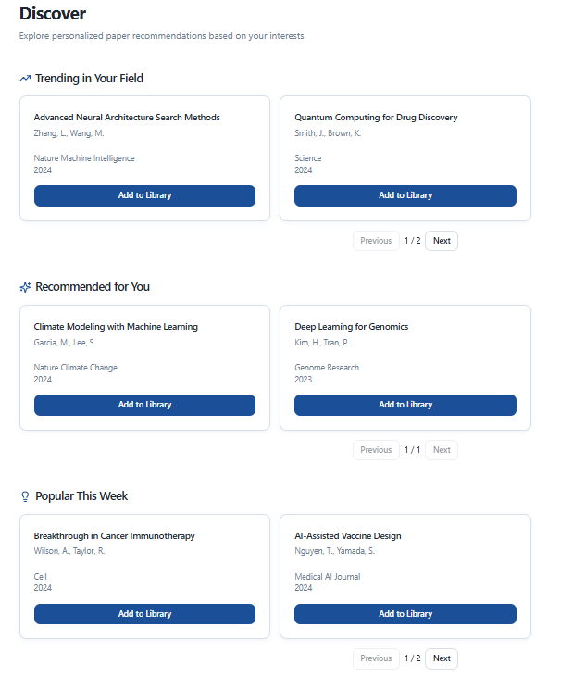
Figure 3-4: Screen Design of Discovery screen

Table 3-1: Screen Definition
# | Field Name | Type | Mandatory | Max Length | Description
1 | Page Title | Heading | Yes |  | “Discover” – Main page title
2 | Page Subtitle | Text | Yes |  | “Explore personalized paper recommendations based on your interests.” – Brief description of the page purpose
3 | Section: Trending In Your Field | Section Header | Yes |  | Section title: “Trending In Your Field” – Includes a TrendingUp icon
4 | Paper Card (Trending) | Card (rounded) | Yes |  | Displays a trending paper in the user’s field. Each card includes: Title, Author(s), Journal, Year, Progress bar, “Add to Library” button
5 | Paper Title (Trending) | Text (strong) | Yes | 200 | Paper title (e.g., Advanced Neural Architecture Search Methods)
6 | Author(s) (Trending) | Text | Yes | 150 | List of authors, comma-separated (e.g., Zhang, L. Wang, M.).
7 | Journal & Year (Trending) | Text | Yes | 100 | Journal name and publication year (e.g., Nature Machine Intelligence 2024).
8 | Progress Bar (Trending) | Progress | Yes |  | Journal name and publication year (e.g., Nature Machine Intelligence 2024).
9 | Add to Library Button (Trending) | Button | Yes |  | “Add to Library” button – Dark blue, rounded, with states: default / loading / success.
10 | Pagination (Trending) | Pagination Controls | Yes |  | Previous, Next buttons and page indicator “1 / 2” – Centered below the list.
11 | Section: Recommended for You | Section Header | Yes |  | Section title: “Recommended for You” – Includes a Sparkles icon
12 | Paper Card (Recommended) | Card | Yes |  | Similar to Trending card, but populated with personalized AI recommendations.
13 | Paper Title (Recommended) | Text | Yes | 200 | Recommended paper title
14 | Author(s) (Recommended) | Text | Yes | 150 | Authors of the recommended paper
15 | Journal & Year (Recommended) | Text | Yes | 100 | Journal and year
16 | Add to Library Button (Recommended) | Button | Yes |  | Button to add the paper to the user’s library.
17 | Pagination (Recommended) | Pagination Controls | Yes |  | Previous, 1 / 1, Next – Centered
18 | Section: Popular This Week | Section Header | Yes |  | Section title: “Popular This Week” – Includes a BarChart icon
19 | Paper Card (Popular) | Card | Yes |  | Displays top papers trending this week
20 | Paper Title (Popular) | Text | Yes | 200 | Popular paper title
21 | Author(s) (Popular) | Text | Yes | 150 | Authors
22 | Journal & Year (Popular) | Text | Yes | 100 | Journal and year.
23 | Add to Library Button (Popular) | Button | Yes |  | Button to add to library
24 | Pagination (Popular) | Pagination Controls | Yes |  | Previous, 1 / 2, Next – Centered.

3.4.5.2 Use Case Description
Use Case ID |  | Comm-08 | Use Case Name |  | View Dashboard
Author |  | HieuDM | Version | 1.0 | Date | 1/11/2025
Actor |  | User (all Role)
Description |  | Allows a user to discover new recommended papers on the platform.
Precondition |  | PRE-1: The User has successfully logged in and navigated to the Library tab.
Trigger |  | TRG-1: Users click the Discover tab in the header
Post-Condition |  | POST-1: Papers list of “Trending in your field”, “Recommended for you” and “Popular this week” sections are displayed  POST-2: Buttons, card views,... are ready to interact
Main flows
Step | Actor | Action
1 | System | Loads the recommended, trending papers, displaying them in cards categorized.
2 | User | Click the Previous or Next button
3 | System | Fetch the next/previous page of papers list

Alternative flows
AT1 | Add to library
Sub step | Actor | Action
1 | Users | Click the “Add to Library” button
2 | System | Add paper to the user’s reading list

Business Rules
# | Rule Description
1 | The counts displayed on the Status Tabs (Unread, Reading) must dynamically update based on the number of papers currently meeting that criteria.
2 | The Progress Bar for Reading items must accurately reflect the last page/percentage read, based on system tracking.
3 | Clicking Continue Reading must navigate the user to the exact page number indicated
4 | The library list must retain any applied filtering (from the Filter Button) when navigating between the quick Status Tabs.

3.4.6 View profiles

3.4.6.1 Screen Mock-up
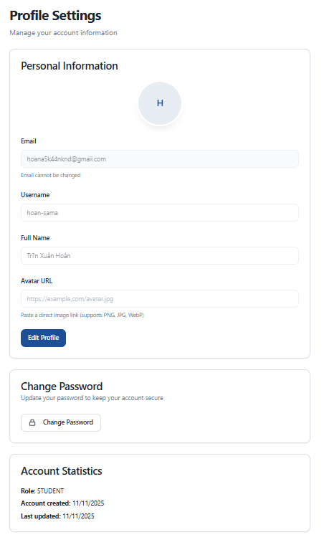
Figure 3-4: Screen Design of Profile screen
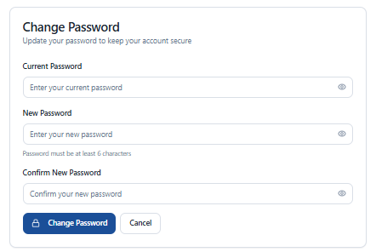
Figure 3-4: Screen Design of Change password dropdown

Table 3-4: Screen Definition
# | Field Name | Type | Mandatory | Max Length | Description
1 | Email | Input | Yes |  | Displays the registered email address. Cannot be edited
2 | Username | Input | Yes |  | Unique username. Required, length between 3–50 characters
3 | Full Name | Input | Yes |  | Full name of the user. Required
4 | Avatar URL | Input | No |  | Direct link to the avatar image (PNG, JPG, WebP). Shows live preview when entered.
5 | Current Password | Input | Yes |  | Current password. Required for authentication.
6 | New Password | Input | Yes |  | New password. Minimum length 6 characters
7 | Confirm New Password | Input | Yes |  | Re-enter new password. Must match the New Password field
8 | Edit Profile | Button | Yes |  | Switches to edit mode for personal information
9 | Save Changes | Button | Yes |  | Saves changes (fullName, username, avatarUrl). Shows Save icon and “Saving…” state.
10 | Cancel (Profile) | Button | Yes |  | Cancels editing and restores original data.
11 | Change Password | Button | Yes |  | Opens the password change form.
12 | Change Password | Button | Yes |  | Submits password change request. Shows Lock icon and “Changing…” state
13 | Cancel (Password) | Button | Yes |  | Cancels password change and clears entered data
14 | Role | Text | Yes |  | Account role (e.g., STUDENT, PI, RESEARCHER)
15 | Account created | Text | Yes |  | Account creation date, formatted as DD/MM/YYYY
16 | Last updated | Text | Yes |  | Last update date, formatted as DD/MM/YYYY
17 | Avatar Preview | Avatar component | No |  | Displays the avatar image (size lg). If no URL, shows the first letter of the username or fallback “U”

3.4.6.2 Use Case Description
Use Case ID |  | Comm_06 | Use Case Name |  | View profiles
Author |  | HoanTX | Version | 1 | Date | 12/11/2025
Actor |  | PI, Researcher, Student
Description
Precondition
Trigger
Post-Condition
Main flows
Step | Actor | Action
 | Users
 | System
 | System
 | User
 | System
 | User
 | System
 | User
 | System

Alternative flows
AT1 | Filter by tag chips
Sub step | Actor | Action
1 | Users
2 | System
3 | System

AT2 | View all the recommend papers
Sub step | Actor | Action
1 | User
2 | System

AT3 | Save paper
Sub step | Actor | Action
1 | User
2 | System
3 | System

AT4 | Share paper
Sub step | Actor | Action
1 | User
2 | System
3 | User
4 | System

AT5 | Read paper
Sub step | Actor | Action
1 | User
2 | System

Business Rules
# | Rule Description

3.5 PI

3.5.1 View My Collection
3.5.1.1 Screen Mock-up
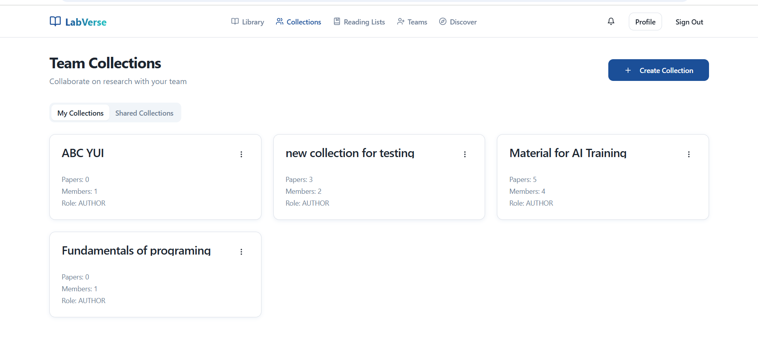

Table 3-1: Screen Definition
# | Field Name | Type | Mandatory | Max Length | Description
1 | App Logo & Title | Image + Link | Yes | N/A | Displays the logo and "LabVerse" application name in the top-left corner. Click to navigate to the homepage.
2 | Main Navigation | Menu Bar | Yes | N/A | Central navigation bar containing links: Library, Collections (selected/active), Reading Lists, Teams, Discover.
3 | Notification Icon | Icon Button | Yes | N/A | Bell icon. Press to view system notifications.
4 | Profile Button | Button | Yes | N/A | Button labeled "Profile". Press to access the current user's profile page.
5 | Sign Out | Text Link | Yes | N/A | "Sign Out" link/button to log out of the system.
6 | Page Title | Text Label | Yes | N/A | The main title of the page, displaying the text "Team Collections".
7 | Page Subtitle | Text Label | Yes | N/A | Subtitle text below the header: "Collaborate on research with your team".
8 | Create Collection Button | Button | Yes | N/A | Blue button on the right with a plus (+) icon and text "Create Collection". Press to initiate the creation of a new collection.
9 | Tab Filter | Tab Control | Yes | N/A | Tab-style filter including: "My Collections" (currently selected) and "Shared Collections". Used to toggle the list view.
10 | Collection Card | Card View | No | N/A | Container for a specific collection item. Displays summary information about the collection.
11 | Collection Title | Text Label | Yes | ~50 chars | The name of the collection displayed in bold within the card (e.g., "new collection for testing").
12 | Card Options Menu | Icon Button | Yes | N/A | Vertical ellipsis icon (⋮) in the top-right corner of each card. Press to open the action menu (e.g., Edit, Delete).
13 | Collection Stats | Text Label | Yes | N/A | Displays the count of items in the collection: "Papers" count and "Members" count.
14 | User Role | Text Label | Yes | N/A | Indicates the current user's permission level for the collection (e.g., "Role: AUTHOR").

3.5.1.2 Use Case Description
Use Case ID |  | UC-COL-001 | Use Case Name |  | View My Collections
Author |  | TuanPA | Version | 1.0 | Date | 11/5/2025
Actor |  | Principal Investigator (PI) / Lab Head
Description |  | View list of collections where user is AUTHOR (isAuthor = true).
Precondition |  | - User is logged in  - User has valid userId
Trigger |  | UUser selects "Collections"
Post-Condition |  | List of collections  - Each collection displays: name, paperCount, memberCount, creatorName, creatorAvatarUrl, currentUserAccessLevel
Main flows
Step | Actor | Action
1 | User | Selects “Collections"
2 | System | Sends request with userId
3 | System | Finds all CollectionUser with memberId = userId and isAuthor = true
4 | System | For each collection, counts papers (paperCount)
5 | System | For each collection, counts members (memberCount)
6 | System | Gets creator information (user with isAuthor = true) from UserService
7 | System | Sets currentUserAccessLevel for each collection
8 | System | Displays collection list

Alternative flows
AT1 | User has not created any collections
Sub step | Actor | Action
1 | System | No collections found
2 | System | Returns empty list

Business Rules

# | Rule Description
BR1 | Only displays collections where user is AUTHOR (isAuthor = true)
BR2 | currentUserAccessLevel is always AUTHOR for collections in "My Collections"

3.5.2 View Shared Collection
3.5.2.1 Screen Mock-up
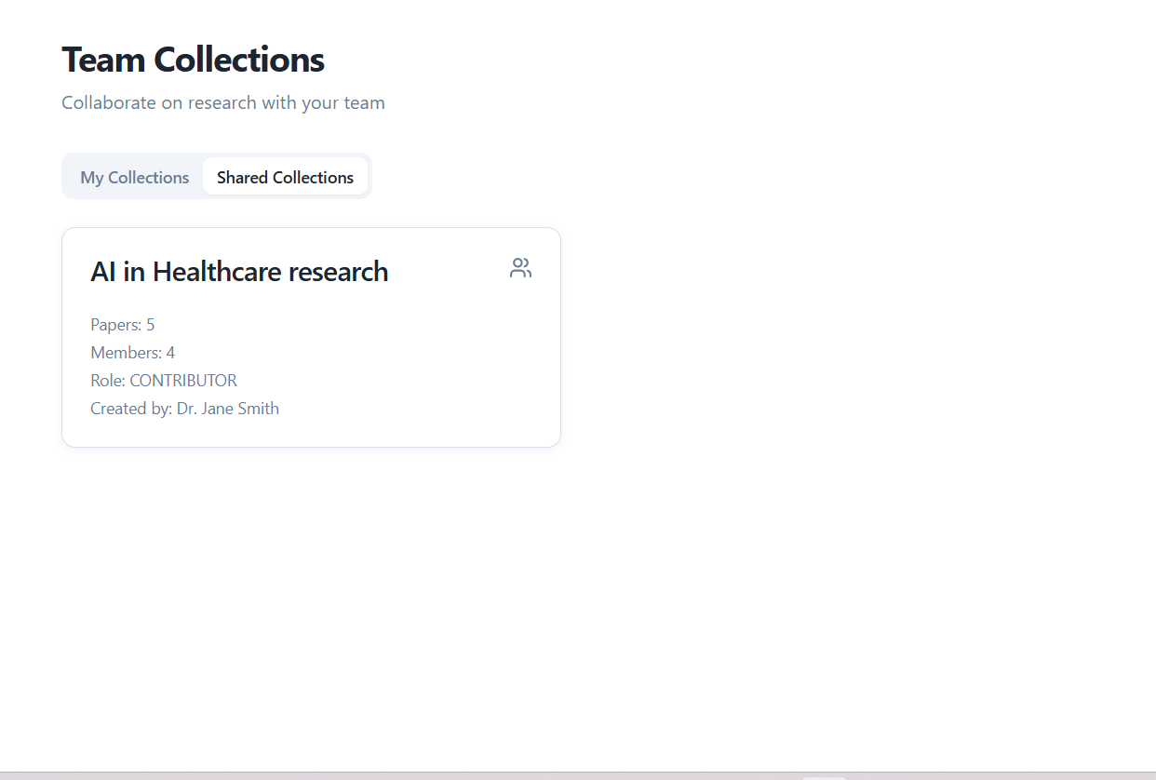

Table 3-2: Screen Definition
# | Field Name | Type | Mandatory | Max Length | Description
1 | Page Title | Text Label | Yes | N/A | The main title of the page, displaying "Team Collections".
2 | Page Subtitle | Text Label | Yes | N/A | Subtitle text below the header: "Collaborate on research with your team".
3 | Tab Filter | Tab Control | Yes | N/A | Tab-style filter. "Shared Collections" is currently selected/active (white background), while "My Collections" is inactive (gray background).
4 | Collection Card | Card View | No | N/A | Container for a specific shared collection. Displays summary information.
5 | Collection Title | Text Label | Yes | ~50 chars | The name of the shared collection displayed in bold (e.g., "AI in Healthcare research").
6 | Group Icon | Icon | Yes | N/A | A "People/Group" outline icon in the top-right corner of the card, indicating this is a shared team space.
7 | Collection Stats | Text Label | Yes | N/A | Displays quantitative data: count of "Papers" and "Members".
8 | User Role | Text Label | Yes | N/A | Indicates the current user's permission level within this shared collection (e.g., "Role: CONTRIBUTOR").
9 | Creator Info | Text Label | Yes | N/A | Displays the name of the person who originally created the collection (e.g., "Created by: Dr. Jane Smith").

3.5.2.2 Use Case Description
Use Case ID |  | UC-COL-002 | Use Case Name |  | View Shared Collections
Author |  | TuanPA | Version | 1.0 | Date | 11/5/2025
Actor |  | User (CONTRIBUTOR, READ_ONLY)
Description |  | View list of collections where user is a member but not AUTHOR (isAuthor = false)
Precondition |  | - User is logged in  - User has valid userId
Trigger |  | UUser selects "Collections"
Post-Condition |  | List of collections  - Each collection displays: name, paperCount, memberCount, creatorName, creatorAvatarUrl, currentUserAccessLevel
Main flows
Step | Actor | Action
1 | User | Selects “Collections"
2 | System | Sends request with userId
3 | System | Finds all CollectionUser with memberId = userId and isAuthor = false
4 | System | For each collection, counts papers (paperCount)
5 | System | For each collection, counts members (memberCount)
6 | System | Gets creator information from UserService
7 | System | Sets currentUserAccessLevel for each collection
8 | System | Displays collection list

Alternative flows
AT1 | User has no shared collections
Sub step | Actor | Action
1 | System | No collections found
2 | System | Returns empty list

Business Rules
# | Rule Description

BR1 | Only displays collections where user is a member but not AUTHOR (isAuthor = false)
BR2 | currentUserAccessLevel can be CONTRIBUTOR or READ_ONLY

3.5.3 Create Collection
3.5.3.1 Screen Mock-up
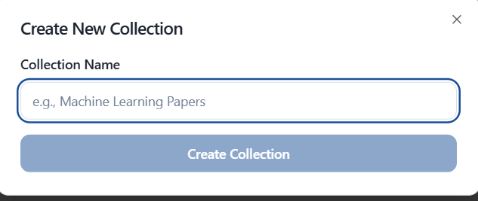

Table 3-3: Screen Definition
# | Field Name | Type | Mandatory | Max Length | Description
1 | Collection Name | Text (String) | Yes | 255 | The name that the user enters for the new collection

3.5.2.2 Use Case Description
Use Case ID |  | UC-COL-003 | Use Case Name
Author |  | TuanPA | Version | 1.0 | Date | 11/5/2025
Actor |  | Principal Investigator (PI) / Lab Head
Description |  | PI/Lab Head creates a new collection to organize papers by project/topic. The creator automatically becomes AUTHOR and has full management rights.
Precondition |  | - User is logged in  - User has PI/Lab Head role
Trigger |  | User selects "Create New Collection" and enters collection name
Post-Condition |  | New collection is created with unique ID  - Creator is added to collection with AUTHOR role (isAuthor = true, accessLevel = AUTHOR)  - Collection is saved to database and Firestore  - Collection appears in "My Collections" list
Main flows
Step | Actor | Action
1 | User | Selects "Create New Collection"
2 | System | Displays form to enter collection name
3 | User | Enters collection name and submits request
4 | System | Validates collection name is not blank
5 | System | Checks for duplicate name, appends (1), (2)... if duplicate
6 | System | Creates collection entity with UUID
7 | System | Saves collection to database
8 | System | Automatically adds creator to collection_user with isAuthor=true, accessLevel=AUTHOR
9 | System | Returns CollectionResponse with created collection information

Alternative flows
AT1 | Collection name already exists
Sub step | Actor | Action
1 | System | Detects duplicate collection name
2 | System | Automatically appends (1) to end of name
3 | System | Continues main flow from step 7

Business Rules
# | Rule Description
BR1 | Only PI/Lab Head (AUTHOR) can create collections
BR2 | Collection name cannot be blank

3.5.4 Edit Collection
3.5.3.1 Screen Mock-up
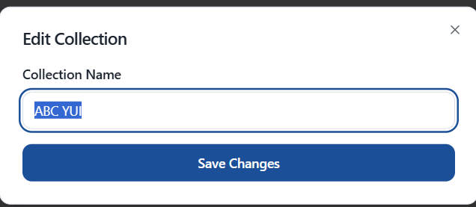

Table 3-3: Screen Definition
# | Field Name | Type | Mandatory | Max Length | Description
1 | Dialog Title | Text Label | Yes | N/A | Displays the purpose of the dialog: "Edit Collection".
3 | Field Label | Text Label | Yes | N/A | Label for the input field: "Collection Name".
4 | Name Input | Text Input | Yes | 50 chars | Input field pre-filled with the current collection name (e.g., "Tesst status"). User edits the text here.
5 | Cancel Button | Text Button | Yes | N/A | Press to close the dialog without saving any changes.
6 | Save Button | Text Button | Yes | N/A | Press to commit the changes to the collection name and close the dialog.

3.5.4.2 Use Case Description
Use Case ID |  | UC-COL-004 | Use Case Name
Author |  | TuanPA | Version | 1.0 | Date | 11/5/2025
Actor |  | Principal Investigator (PI) / Lab Head
Description |  | AUTHOR updates collection information, primarily the collection name.
Precondition |  | - User is logged in  - User is AUTHOR of the collection  - Collection exists  - CollectionId is valid
Trigger |  | AUTHOR selects collection and chooses "Edit Collection"
Post-Condition |  | - Collection name is updated  - Updated information is saved to database  - Updated information is synced to Firestore
Main flows
Step | Actor | Action
1 | User | Selects collection to update
2 | System | Selects "Edit Collection"
3 | User | Displays edit form with current collection name
4 | System | Enters new collection name
5 | System | Submits request (collectionId, name, userId)
6 | System | Verifies collection exists
7 | System | Verifies user is AUTHOR of collection
8 | System | Validates collection name is not blank
9 | System | Returns CollectionResponse with created collection information
10 | System | Updates collection name
11 | System | Saves changes to database

Alternative flows
AT1 | Collection name is blank
Sub step | Actor | Action
1 | System | Detects blank collection name
2 | System | Returns error "Collection name must not be blank”

Business Rules
# | Rule Description
BR1 | Only PI/Lab Head (AUTHOR) can edit collections
BR2 | Collection name cannot be blank

3.5.5 Delete Collection
3.5.3.1 Screen Mock-up
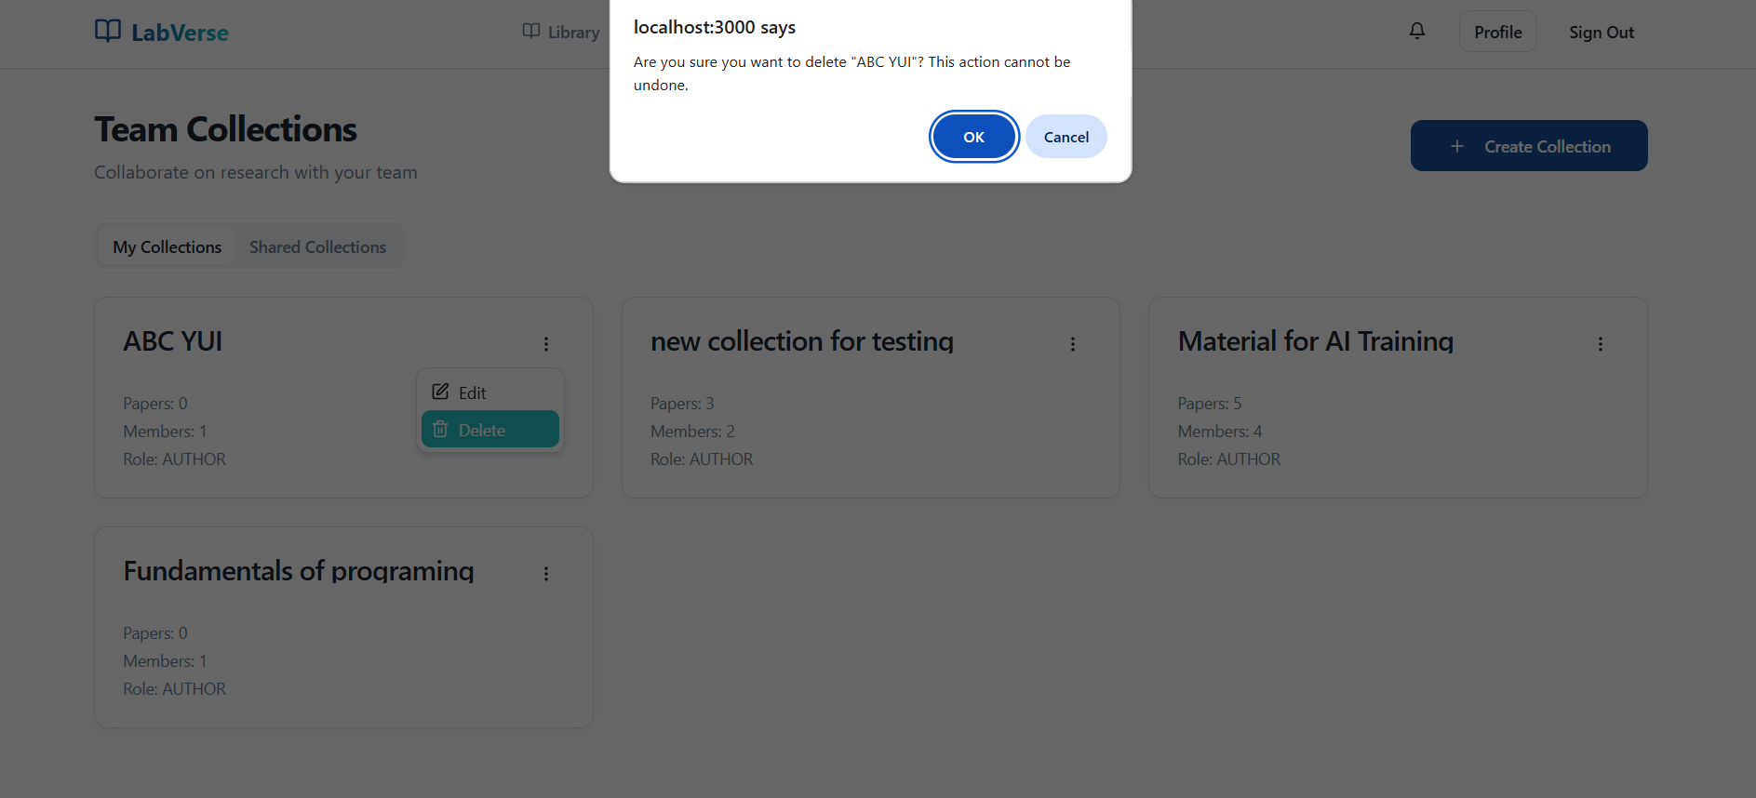

Table 3-3: Screen Definition
# | Field Name | Type | Mandatory | Max Length | Description
1 | Dialog Title | Text Label | Yes | N/A | Displays the warning header: "Delete Collection".
2 | Confirmation Message | Text Label | Yes | N/A | Dynamic text asking for confirmation: "Are you sure you want to delete "[Collection Name]"? This action cannot be undone."
3 | Cancel Button | Text Button | Yes | N/A | Press to dismiss the dialog and cancel the deletion process.
4 | Delete Button | Text Button | Yes | N/A | Press to confirm and permanently delete the selected collection.

3.5.5.2 Use Case Description
Use Case ID |  | UC-COL-005 | Use Case Name
Author |  | TuanPA | Version | 1.0 | Date | 11/5/2025
Actor |  | Principal Investigator (PI) / Lab Head
Description |  | AUTHOR deletes a collection. All related papers and members are also deleted
Precondition |  | User is logged in  - User is AUTHOR of the collection  - Collection exists
Trigger |  | AUTHOR selects collection and chooses "Delete Collection"
Post-Condition |  | - Collection is deleted from database  - All related CollectionPaper records are deleted  - All related CollectionUser records are deleted  - Collection no longer appears in lists
Main flows
Step | Actor | Action
1 | User | Selects collection to delete
2 | System | Selects "Delete Collection"
3 | User | Displays confirmation dialog
4 | System | Confirms deletion
5 | System | Verifies collection exists
6 | System | Verifies user is AUTHOR of collection
7 | System | Deletes all related CollectionPaper records
8 | System | Deletes all related CollectionUser records
9 | System | Deletes collection from database

Alternative flows
AT1 | User is not AUTHOR
Sub step | Actor | Action
1 | System | Detects user is not AUTHOR
2 | System | Returns error "Only the collection author can perform this action"

Alternative flows
AT2 | Collection does not exist
Sub step | Actor | Action
1 | System | Collection not found
2 | System | Returns error "Collection not found"

Business Rules
# | Rule Description
BR1 | Only AUTHOR can delete collection
BR2 | Papers in collection are deleted, but papers in paper-service are not deleted

3.5.6 Invite member
3.5.3.1 Screen Mock-up
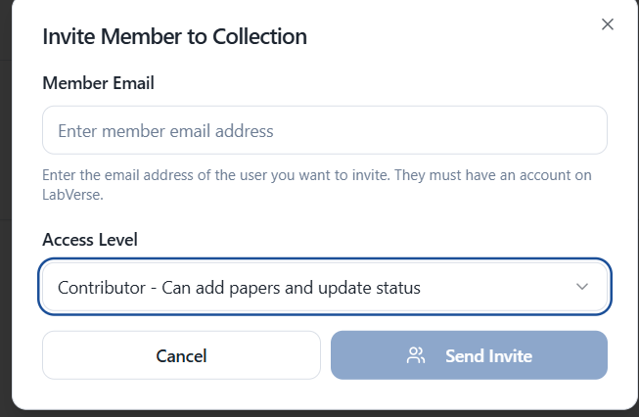

Table 3-3: Screen Definition
# | Field Name | Type | Mandatory | Max Length | Description
1 | Collection | Text (Display) | N/A (Pre-filled) | N/A | Displays the name of the collection (context) the user is inviting members to.
2 | Member Email | Email (Text) | Yes | 255 | Email address of the person to be invited.
3 | Access Level | Dropdown (Select) | Yes | N/A | The access level will be assigned to the new member (e.g. READ_ONLY, EDITOR).

3.5.3.2 Use Case Description
Use Case ID |  | UC-COL-006 | Use Case Name |  | Invite member
Author |  | TuanPA | Version | 1.0 | Date | 11/5/2025
Actor |  | AUTHOR
Description |  | AUTHOR adds a member to a collection with a specified accessLevel (READ_ONLY, CONTRIBUTOR, AUTHOR).
Precondition |  | User is logged in  - User is AUTHOR of the collection  - Collection exists  - User to be added (memberId) exists in the system
Trigger |  | AUTHOR selects "Add Member" and enters member information
Post-Condition |  | Member is added to collection  - Member has specified accessLevel  - Member is added to collection_user table  - Information is synced to Firestore
Main flows
Step | Actor | Action
1 | Author | Selects collection and chooses "Add Member"
2 | System | Displays add member form
3 | Author | Enters email and selects accessLevel (READ_ONLY, CONTRIBUTOR, AUTHOR)
4 | Author | Submits request (collectionId, memberId, accessLevel)
5 | System | Verifies collection exists
6 | System | Creates CollectionUser entity with collectionId, memberId, accessLevel
7 | System | Sets isAuthor = true if accessLevel = AUTHOR, otherwise false
8 | System | Saves CollectionUser to database

Alternative flows
AT1 | Member already exists in collection
Sub step | Actor | Action
1 | User | Detects memberId already exists in collection
2 | System | Returns error "Member already in collection"

Business Rules
# | Rule Description
BR1 | Only collection authors can add members

3.5.7 Manage member
3.5.4.1 Screen Mock-up

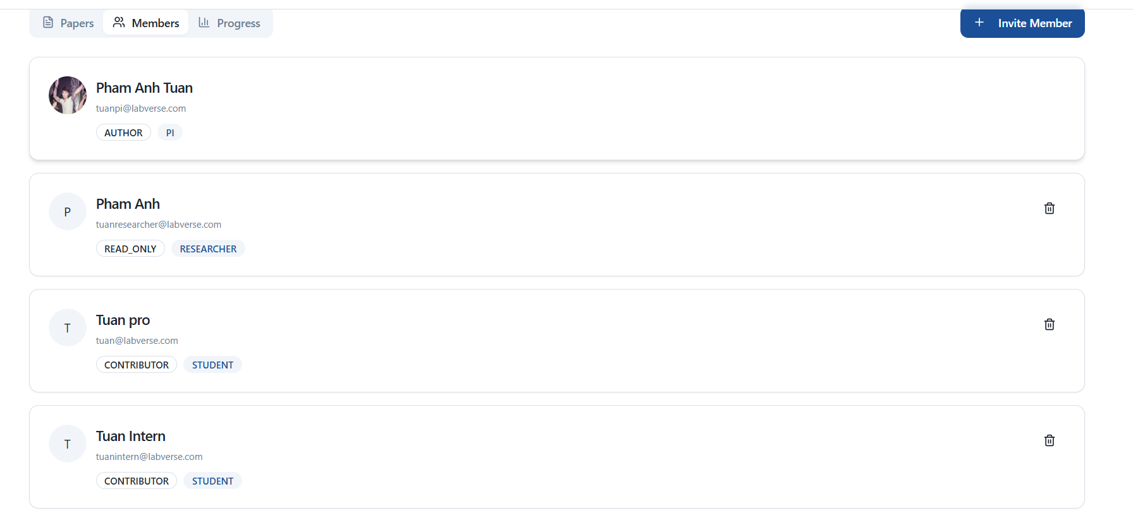

Table 3-4: Screen Definition
# | Field Name | Type | Mandatory | Max Length | Description
1 | Member Avatar | Image | N/A (Display) | N/A | Member's profile picture.
2 | Member Name | Text (Display) | N/A (Display) | N/A | Full name of the member. Displays "(You)" if it is the user viewing.
3 | Member Email | Text (Display) | N/A (Display) | N/A | Member's email address.
4 | Access Level | Badge (Display) | N/A (Display) | N/A | Color labels show the member's access level (e.g., READ_ONLY, CONTRIBUTOR, AUTHOR).
5 | Change | Link / Button | N/A (Display) | N/A | (Action) Allow the owner (Author) to change the member's access level.
6 | Remove | Link / Button | N/A (Display) | N/A | (Action) Allows the owner (Author) to remove this member from the collection.

3.5.7.2 Use Case Description
Use Case ID |  | UC-COL-007 | Use Case Name |  | Manage member
Author |  | tuanPA | Version | 1.0 | Date | 11/5/2025
Actor |  | AUTHOR
Description |  | AUTHOR updates the accessLevel of a member in a collection, remove member
Precondition |  | - User is logged in  - User is AUTHOR of the collection  - Member to be updated is a member of the collection  - Collection exists
Trigger |  | AUTHOR selects member
Post-Condition |  | Member's accessLevel is updated  - isAuthor is updated accordingly (true if AUTHOR, false otherwise)  Member is removed in collection
Main flows
Step | Actor | Action
1 | User | Selects collection and views member list
2 | User | Selects member to update
3 | User | Selects "Update Access Level" or remove user
4 | System | Displays form with current accessLevel or dialog confirm remove
5 | User | Submits request (collectionId, memberId, userId, accessLevel) or confirm
6 | System | Verifies user (requester) is AUTHOR
7 | System | Updates member's accessLevel or remove member
8 | System | Saves changes to database

Alternative flows
AT1 | User is not AUTHOR
Sub step | Actor | Action
1 | System | Detects user is not AUTHOR
2 | System | Returns error "Only collection authors can update member access levels"

Business Rules
# | Rule Description
BR1 | Only AUTHOR can update member access levels, AUTHOR cannot change their own access level

3.5.8 Collection details
3.5.5.1 Screen Mock-up

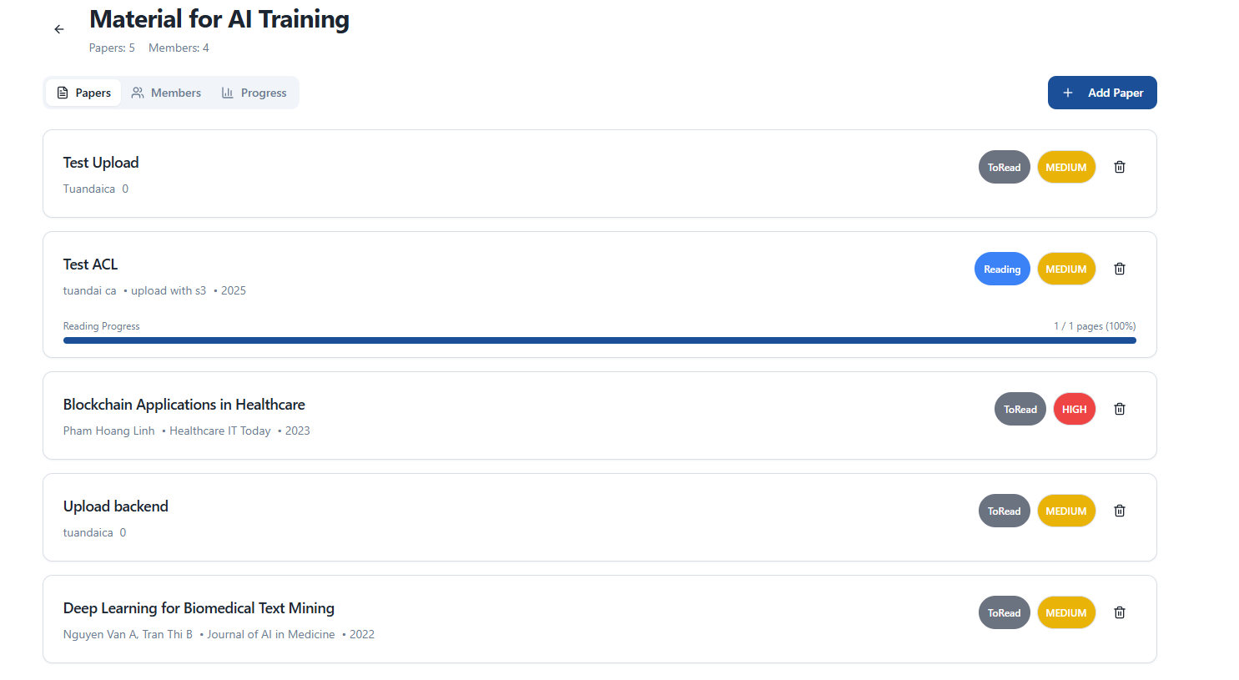

Table 3-5: Screen Definition
# | Field Name | Type | Mandatory | Max Length | Description
1 | Add Paper | Button | N/A (Action) | N/A | The button at the top of the screen to start the stream adds a new paper to this collection.
2 | Paper Title | Text (Display) | N/A (Display) | N/A | Title of the article (e.g., "Reinforcement Learning in Autonomous Driving").
3 | Author(s) | Text (Display) | N/A (Display) | N/A | Name(s) of the article's author(s) (e.g., "Doan Minh Tri").
4 | Publication Info | Text (Display) | N/A (Display) | N/A | Publication information, typically including journal name and year (e.g., "AI & Robotics Journal • 2022").
5 | Reading Status | Badge (Display) | N/A (Display) | N/A | Colored labels show the reading status of the article (e.g., "ToRead", "Reading").
6 | Priority | Badge (Display) | N/A (Display) | N/A | A colored label showing the priority level or a custom label (e.g. "MEDIUM").

3.5.8.2 Use Case Description
Use Case ID |  | UC-COL-008 | Use Case Name |  | View Collection Details
Author |  | tuanPA | Version | 1.0 | Date | 11/5/2025
Actor |  | User
Description |  | View detailed information of a collection by collectionId
Precondition |  | User is logged in  - Collection exists  - CollectionId is valid
Trigger |  | User selects a collection from the list
Post-Condition |  | Collection detail information is displayed  - Displays name, paperCount, memberCount (if available)
Main flows
Step | Actor | Action
1 | User | Selects collection from list
2 | System | Sends request with collectionId
3 | System | Finds collection in database
4 | System | Verifies collection exists
5 | System | Returns CollectionResponse with collection information
6 | System | Displays collection detail information

Alternative flows
AT1 | Collection does not exist
Sub step | Actor | Action
1 | System | Collection not found
2 | System | Returns error "Collection not found"

Business Rules
# | Rule Description
BR1 | Any user can view collection details if they have collectionId
BR2 | CollectionResponse contains basic information: id, name, paperCount, memberCount

3.5.9 Add paper to collection
3.5.6.1 Screen Mock-up

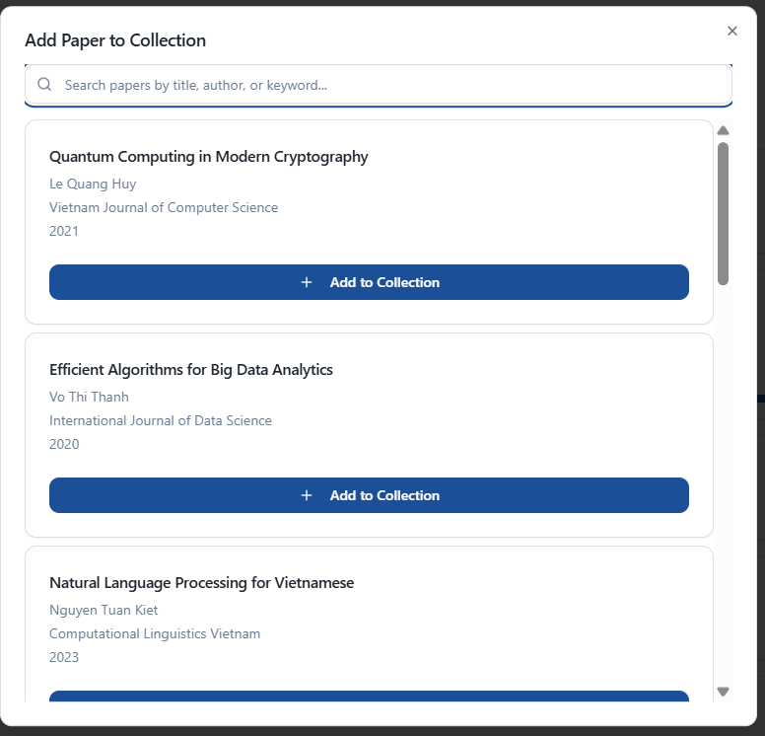

Table 3-5: Screen Definition
# | Field Name | Type | Mandatory | Max Length | Description
1 | Search Papers | Text Input (Search) | No | 255 | The search field allows users to filter the article list by title, author, or journal.
2 | Paper Title | Text (Display) | N/A (Display) | N/A | Title of the article in the results list.
3 | Author(s) | Text (Display) | N/A (Display) | N/A | Name(s) of the article's author(s).
4 | Publication Info | Text (Display) | N/A (Display) | N/A | Publication information (e.g., journal name and year).
5 | Add | Button | N/A (Action) | N/A | (Action) Button to add this article to the current collection.

3.5.9.2 Use Case Description
Use Case ID |  | UC-COL-009 | Use Case Name |  | Add Paper to Collection
Author |  | tuanPA | Version | 1.0 | Date | 11/5/2025
Actor |  | Author, Contributor
Description |  | Add a paper to a collection. READ_ONLY users cannot add papers.
Precondition |  | User is logged in  - User is a member of the collection (AUTHOR or CONTRIBUTOR)  - Collection exists  - Paper exists in the system
Trigger |  | User selects "Add Paper to Collection" and chooses a paper
Post-Condition |  | Paper is added to collection  - Paper has default status and priority (if provided)  - Paper is linked to collection in database  - AddingDate is set to current date
Main flows
Step | Actor | Action
1 | User | Selects collection and chooses "Add Paper"
2 | System | Displays list of papers to choose from
3 | User | Selects paper and submits request (collectionId, paperId, userId, priority, status)
4 | System | Verifies user's accessLevel (not READ_ONLY)
5 | System | Creates CollectionPaper entity with collectionId, paperId, priority, status, addingDate
6 | System | Saves CollectionPaper to database

Alternative flows
AT1 | Paper already exists in collection
Sub step | Actor | Action
1 | System | Detects paper already exists in collection
2 | System | Returns error "Paper already exists in this collection"

Business Rules
# | Rule Description
BR1 | Only AUTHOR and CONTRIBUTOR can add papers, READ_ONLY cannot
2 | A paper cannot be added duplicate in the same collection

3.5.10 Set priority paper
3.5.6.1 Screen Mock-up

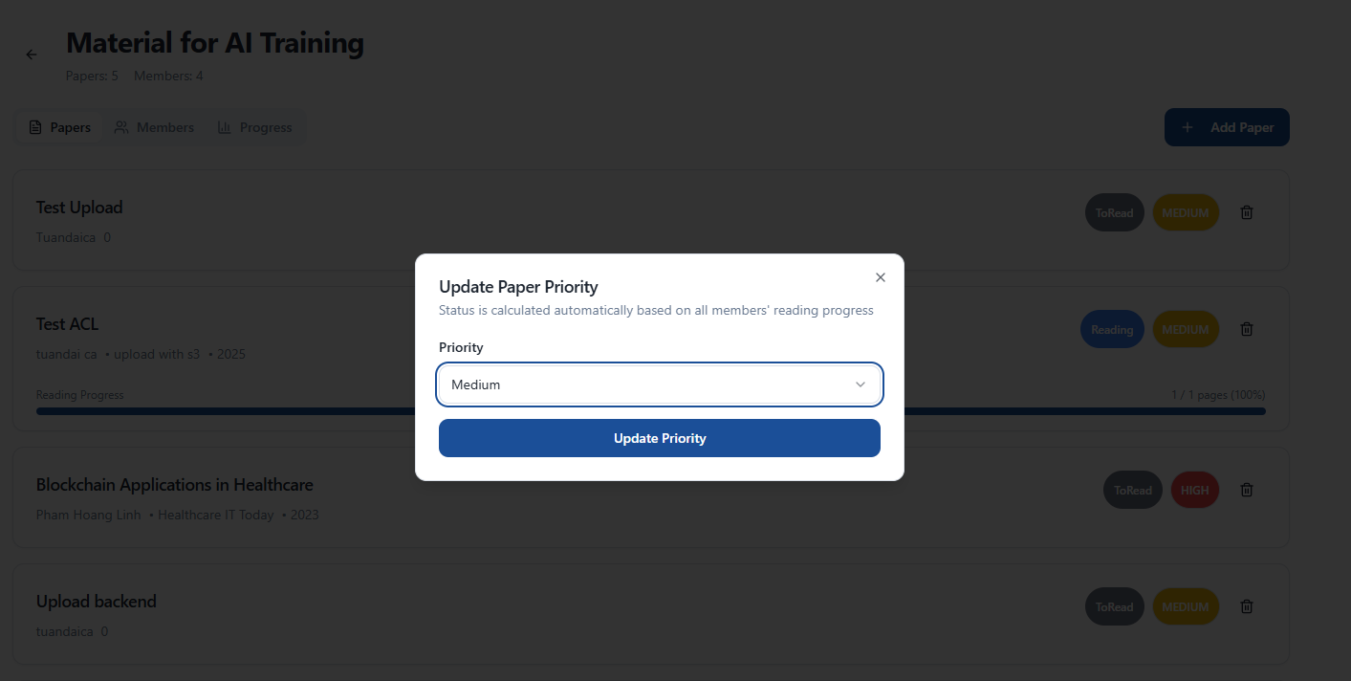

Table 3-10: Screen Definition
# | Field Name | Type | Mandatory | Max Length | Description
1 | Dialog Title | Text Label | Yes | N/A | Displays the title of the action: "Update Priority".
2 | Field Label | Text Label | Yes | N/A | Label indicating what the user is selecting: "Priority".
3 | Dropdown List | Menu / Popup | Yes | N/A | The expanded container displaying available options. Overlays other dialog elements.
4 | Menu Item (HIGH) | Text / Button | Yes | N/A | Selects "HIGH" priority.
5 | Menu Item (MEDIUM) | Text / Button | Yes | N/A | Selects "MEDIUM" priority.
6 | Menu Item (LOW) | Text / Button | Yes | N/A | Selects "LOW" priority.
7 | Action Button | Button | Yes | N/A | (Partially Obscured) A blue button, likely "Save" or "Update", visible behind the dropdown menu.

3.5.10.2 Use Case Description
Use Case ID |  | UC-COL-010 | Use Case Name |  | Set priority
Author |  | TuanPA | Version | 1.0 | Date | 11/5/2025
Actor |  | Author
Description |  | Set priority ( High, medium, low) for papers in collection
Precondition |  | User is logged in  - User is a member of the collection (AUTHOR or CONTRIBUTOR)  - Collection exists  - Paper exists in the system
Trigger |  | User tap on chip priority on papers item
Post-Condition |  | Priority level changes according to author settings  color also changes according to level
Main flows
Step | Actor | Action
1 | User | Tap on chip priority in paper item in collection details
2 | System | Display a dialog bottom sheet including dropdown (High, Medium, Low) and button save changes
3 | User | Select priority and tap save
4 | System | Update priority by user selection
5 | System | Saves CollectionPaper to database

Alternative flows
AT1 | User is not AUTHOR
Sub step | Actor | Action
1 | System | Detects user is not PI (Author)
2 | System | Returns error "Only PI (Author) can update priority "

Business Rules
# | Rule Description
BR1 | Only AUTHOR and CONTRIBUTOR can add papers, READ_ONLY cannot
2 | A paper cannot be added duplicate in the same collection

3.5.11 Remove paper
3.5.6.1 Screen Mock-up

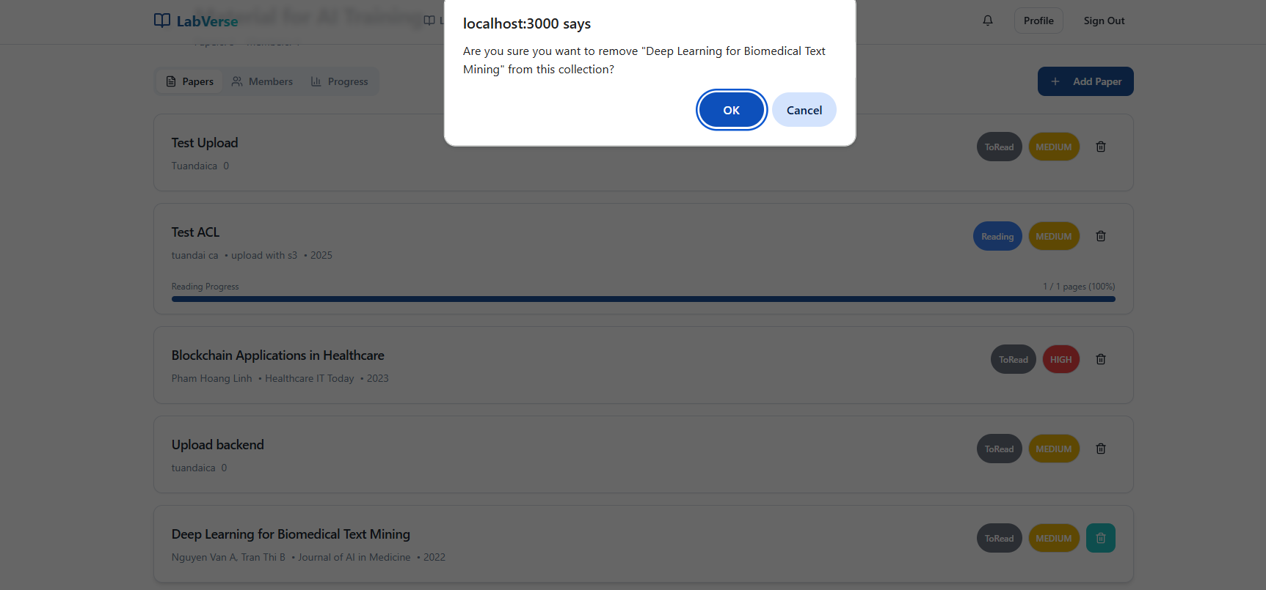

Table 3-5: Screen Definition
# | Field Name | Type | Mandatory | Max Length | Description
1 | Dialog Overlay | Modal/Dialog | Yes | N/A | The pop-up container that dims the "Collection Details" screen in the background.
2 | Dialog Title | Text Label | Yes | N/A | Displays the warning header: "Remove Paper".
3 | Confirmation Message | Text Label | Yes | N/A | Dynamic text: "Are you sure you want to remove '[Paper Title]' from this collection?".
4 | Cancel Button | Text Button | Yes | N/A | Press to dismiss the dialog without removing the paper.
5 | Remove Button | Text Button | Yes | N/A | Press to confirm the action and remove the paper from the list.
6 | Screen Title (Background) | Text Label | Yes | N/A | The title of the main screen: "Collection Details" and the specific collection name "Tesst status".
7 | Add Paper Button (Background) | Button | Yes | N/A | Large blue button with a "+" icon to add new papers.
8 | Paper Item Card (Background) | Card View | Yes | N/A | Shows paper details including Title, Author, Journal, Status Tags (e.g., "Finished", "ToRead"), Priority Tags (e.g., "MEDIUM"), and a "Remove" link.

3.5.5.2 Use Case Description
Use Case ID |  | UC-COL-011 | Use Case Name |  | Remove paper from Collection
Author |  | tuanPA | Version | 1.0 | Date | 11/5/2025
Actor |  | AUTHOR, CONTRIBUTOR
Description |  | Remove a paper from a collection. READ_ONLY users cannot remove papers.
Precondition |  | - User is logged in  - User is a member of the collection (AUTHOR or CONTRIBUTOR)  - Paper already exists in collection  - Collection exists
Trigger |  | User selects paper in collection and chooses "Remove from Collection"
Post-Condition |  | - Paper is removed from collection  - CollectionPaper link is deleted from database  - Paper still exists in paper-service (only removed from collection)
Main flows
Step | Actor | Action
1 | User | Selects paper in collection
2 | System | Selects "Remove from Collection"
3 | User | Displays confirmation dialog
4 | System | Confirms removal
5 | System | Verifies user is a member of collection
6 | System | Verifies user's accessLevel (not READ_ONLY)
7 | System | Verifies paper exists in collection
8 | System | Deletes CollectionPaper entity from database

Alternative flows
AT1 | User does not have permission (READ_ONLY)
Sub step | Actor | Action
1 | System | Detects user has accessLevel = READ_ONLY
2 | System | Returns error "Read-only users cannot remove papers from the collection"

Business Rules
# | Rule Description
BR1 | Only AUTHOR and CONTRIBUTOR can remove papers, READ_ONLY cannot
BR2 | Removing paper deletes all related information (status, priority, addingDate) in collection

4. Non-Functional Requirements

4.1 External Interfaces
[This section provides information to ensure that the system will communicate properly with users and with external hardware or software/system elements.]

4.2 Quality Attributes

4.2.1 Security
The system must provide secure login, supporting email/password and Google OAuth2, with JWT tokens stored in Encrypted SharedPreferences to protect user data.

4.2.2 Data Privacy
Personal information and research papers must be kept confidential. Annotation data must be encrypted locally and during synchronization with the backend.

4.2.3 Performance
Personal library and paper lists must load quickly using local caching via Room database. Full-text search must provide near-instant results.

4.2.4 Scalability
The backend must support multiple concurrent users, including management of collections, team projects, annotations, and personalized feeds.

4.2.5 Availability
Users must be able to read and annotate PDFs offline. All changes are automatically synced to the server once connectivity is restored via WorkManager.

4.2.6 Reliability
Reading progress, annotations, paper status, and collections must remain consistent between device and backend to prevent data loss or conflicts.

4.2.7 Usability
The interface must be user-friendly, leveraging RecyclerViews, CardViews, BottomSheetDialogs, FABs, and Tabs to optimize reading and annotation workflows.

4.2.8 Maintainability
The app must follow a modular architecture (Activities, ViewModels, Repositories) for easy maintenance and future feature expansion, such as PDF annotation or shared collections.

4.2.9 Compatibility
The app must support a range of Android versions and screen sizes, ensuring smooth operation on both smartphones and tablets.

4.2.10 Interoperability
The system must support importing BibTeX from Zotero, Mendeley, Google Scholar, and integrate with cloud storage (Firebase/S3) for PDF upload/download.

4.2.11 Responsiveness
Changes in status, annotations, or comments must be reflected immediately across devices and updated on the UI in real time.

4.2.12 Logging & Monitoring
The system must log errors, crashes, and key events to facilitate monitoring, debugging, and maintenance.

4.2.13 Notification
Provide push notifications (via Firebase Cloud Messaging) for new papers, status updates, or alerts from team collections.

4.2.14 Storage Efficiency
PDFs, metadata, annotations, and collection structures must be stored efficiently to minimize device storage usage and support backend synchronization.

4.2.15 Internationalization
The system should support international formats for dates, times, and author names, with potential for multi-language support.

5. Requirement Appendix
[Provide business rules, common requirements, or other extra requirements information here]

5.1 Business Rules
[Provide common business rules that you must follow. The information can be provided in the table format as the sample below]
ID | Rule Definition
Comm_01_BR1 | Only authenticated users can copy, export, or download references.
Comm_01_BR2 | References and citations must be displayed in APA, MLA, and BibTeX styles.
Comm_01_BR3 | Pagination is required if references or citations exceed 10 items.
Comm_01_BR4 | “Continue to read” must navigate to the correct PDF corresponding to the paper.
Comm_01_BR5 | Downloaded files must preserve original citation format and PDF integrity.
Comm_02_BR1 | The Journal dropdown must include "All Journals" as the default and first option.
Comm_02_BR2 | Publication Year "From" must not exceed the current year and must be ≥ 1900.
Comm_02_BR3 | Publication Year "To" must be ≥ "From" value; if "From" is filled and "To" is empty, system auto-fills "To" with current year.
Comm_02_BR4 | Keywords/Tags input must trim whitespace and ignore empty entries (e.g., tag1,, tag2 → tag1, tag2)
Comm_02_BR5 | Apply Filters button is disabled (grayed out) if all filter fields are empty or in default state.
Comm_02_BR6 | Reset button is disabled if no changes have been made since popup opened or last reset
Comm_02_BR7 | Filter criteria are combined using AND logic: a paper must match all selected filters to appear in results.
Comm_02_BR8 | Filtered results maintain pagination state; navigating pages after filtering fetches data matching the active filter set.
Comm_02_BR9 | If no papers match the filter criteria, display an empty state with message: "No papers found matching your filters. Try adjusting the criteria." and a "Clear Filters" action.
Comm_03_BR1 | System must display the most recently modified papers first in Recently Added mode.
Comm_03_BR2 | System must track and display reading progress status for each paper
Comm_03_BR3 | Only papers explicitly marked “Favorite” by the user appear in the Favorites tab
Comm_03_BR4 | UI must preserve pagination or infinite scrolling for large lists
Comm_05_BR1 | Only .bib file formats are accepted.
Comm_05_BR2 | The system must validate file structure before parsing records.
Comm_05_BR3 | Duplicate records must be flagged and require user confirmation before import.
Comm_05_BR4 | Imported paper data must follow the system's metadata schema standards.

5.2 Common Requirements
[Fill all the common requirements here..]

5.3 Application Messages List
# | Message code | Message Type | Context | Content

5.4 Other Requirements…

