Business Requirements Document (BRD)

MCP Tool Orchestration — MTO-12: Auto File Proxy (Input + Output)

Document Information
Field | Value
Jira Ticket | MTO-12
Title | Auto File Proxy - Wrapper tool tự động cho upstream MCP tools nhận/trả file
Author | BA Agent
Version | 1.0
Date | 2026-05-05
Status | Draft

Author Tracking
Role | Name - Position | Responsibility
Author | BA Agent – Business Analyst | Create document
Peer Reviewer | Duc Nguyen – Project Lead | Review document

Revision History
Version | Date | Author | Changes
1.0 | 2026-05-05 | BA Agent | Initial draft — auto-generated from Jira ticket MTO-12. Covers Part A (Input File Proxy) and Part B (Output File Proxy).

Sign-Off
Name | Signature and date
Duc Nguyen | ☐ I agree and confirm all criteria on this BRD as expected requirements
 | ☐ I agree and confirm all criteria on this BRD as expected requirements

1. Introduction

1.1 Scope
This BRD covers the Auto File Proxy feature for the MCP Orchestrator Server, addressing two complementary capabilities:
- Part A: Input File Proxy — Automatically detect upstream MCP tools that accept base64/file content parameters, create wrapper tools that accept simple file_path (STDIO mode) or file_id (HTTP/SSE mode), and handle file reading + encoding transparently. This eliminates the need for AI agents to load file content into their context window (saving 100% of file-related context usage).
- Part B: Output File Proxy — Automatically detect upstream MCP tools that return file content in their response (as file paths or base64 strings), add an optional output_path parameter to wrapper tools, and handle file copying/decoding transparently.
Both parts include a database registry (file_proxy_registry table) for tracking file lifecycle with session-scoped cleanup, and comprehensive lifecycle management (startup cleanup, shutdown cleanup, per-request cleanup).

1.2 Out of Scope
- Streaming/chunked file transfer for very large files (beyond configurable max size)
- File format conversion or transformation
- Encryption of files at rest in the proxy layer
- UI for file management (proxy is fully transparent to AI agents)
- Changes to upstream MCP server tool implementations
- File compression before transfer

1.3 Preliminary Requirements
- MCP Orchestrator Server running (Kotlin 2.3.20, Ktor 3.4.0, Koin 4.1.1)
- PostgreSQL 16+ instance with existing database (jira_assistant)
- Upstream MCP servers with tools that accept/return file content
- File system access for temporary file storage and output path writing

2. Business Requirements

2.1 High Level Process Map
The Auto File Proxy operates at two interception points in the MCP tool call lifecycle:
Input Proxy Flow: 1. AI Agent calls wrapper tool with file_path (STDIO) or file_id (HTTP/SSE) 2. Orchestrator intercepts the call, reads the file, encodes to base64 3. Orchestrator calls the real upstream tool with base64 content 4. Response returned to AI Agent (file content never enters agent context)
Output Proxy Flow: 1. AI Agent calls wrapper tool with optional output_path parameter 2. Orchestrator forwards call to real upstream tool 3. Upstream returns response containing file (path or base64) 4. Orchestrator copies/decodes file to output_path 5. Cleaned response returned to AI Agent
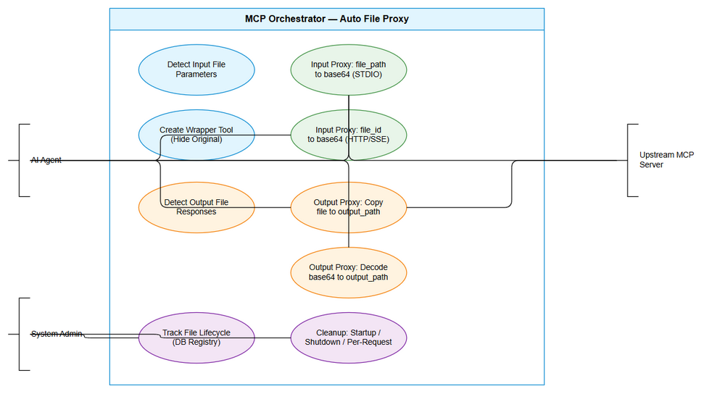
Use Case Diagram
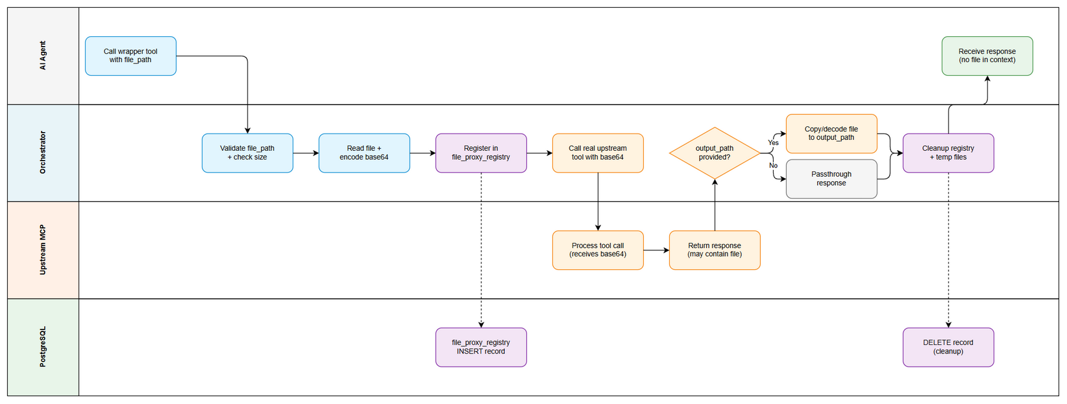
Business Flow

2.2 List of User Stories / Use Cases
# | Story / Use Case | Priority | Source Ticket
1 | As an AI Agent, I want the orchestrator to automatically detect tools requiring base64 file input so that I don’t need to know which tools need file content encoding | MUST HAVE | MTO-12
2 | As an AI Agent, I want to pass a simple file_path instead of base64 content (STDIO mode) so that file content never enters my context window | MUST HAVE | MTO-12
3 | As an AI Agent, I want to upload a file and receive a file_id (HTTP/SSE mode) so that I can reference files without loading content | MUST HAVE | MTO-12
4 | As a System Administrator, I want file lifecycle tracked in a database registry so that orphan files are cleaned up automatically | MUST HAVE | MTO-12
5 | As an AI Agent, I want wrapper tools to hide original tools from discovery so that I always use the optimized proxy version | MUST HAVE | MTO-12
6 | As an AI Agent, I want to specify an output_path when calling tools that return files so that output files are saved to my desired location | MUST HAVE | MTO-12
7 | As an AI Agent, I want the orchestrator to detect tools returning file content in responses so that output proxying is automatic | MUST HAVE | MTO-12
8 | As a System Administrator, I want configurable max file size limits so that the system rejects oversized files gracefully | SHOULD HAVE | MTO-12
9 | As a System Administrator, I want automatic cleanup on server restart and shutdown so that no orphan files or stale records persist | MUST HAVE | MTO-12

2.3 Details of User Stories

STORY 1: Auto-Detection of Input File Parameters
As an AI Agent, I want the orchestrator to automatically detect tools requiring base64 file input so that I don’t need to know which tools need file content encoding.
Requirement Details: 1. On tool discovery, scan each tool’s inputSchema for parameters matching file content patterns. 2. Detection heuristics: Parameter type=base64/binary, description keywords (file content, base64 encoded), name patterns (content, file_content, data). 3. Support multiple file parameters within a single tool schema. 4. Store detection results in memory for wrapper generation.
Acceptance Criteria: 1. Orchestrator automatically detects upstream tools with base64 file content parameters. 2. Detection works for type declarations, description keywords, and name patterns. 3. Multiple base64 parameters in the same tool are all detected. 4. Detection runs on server startup and when new upstream servers connect.

STORY 2: Input File Proxy — STDIO Mode (file_path)
As an AI Agent, I want to pass a simple file_path instead of base64 content so that file content never enters my context window.
Requirement Details: 1. Wrapper tool replaces base64 parameter with file_path parameter. 2. Orchestrator reads file, validates size, encodes base64, registers in DB, calls upstream, cleans up. 3. AI Agent context window never loaded with file content.
Data Fields:
Field | Type | Required | Description
file_path | String | Yes | Absolute path to the input file
file_id | UUID | Auto | Generated tracking ID in registry
session_id | UUID | Auto | Current server session ID
file_size | Long | Auto | File size in bytes
status | Enum | Auto | PENDING / PROCESSED / FAILED
Acceptance Criteria: 1. AI Agent passes only file_path string. 2. File content never appears in tool call arguments visible to Agent. 3. File registered in file_proxy_registry before processing. 4. Registry record cleaned up after success or failure.
Validation Rules: - file_path must be absolute path - File must exist and be readable - File size must not exceed configurable maximum (default: 50MB) - No path traversal sequences

STORY 3: Input File Proxy — HTTP/SSE Mode (file_id)
As an AI Agent, I want to upload a file and receive a file_id so that I can reference files without loading content.
Requirement Details: 1. upload_file endpoint accepts file uploads, returns file_id (UUID). 2. Wrapper tool accepts file_id, resolves to file content internally. 3. TTL-based expiration for uploaded files.
Acceptance Criteria: 1. HTTP/SSE mode provides upload_file tool/endpoint. 2. Upload returns file_id usable in subsequent tool calls. 3. Wrapper resolves file_id to content internally. 4. Files cleaned up after processing or TTL expiration.

STORY 4: Database Registry for File Lifecycle Tracking
As a System Administrator, I want file lifecycle tracked in a database registry so that orphan files are cleaned up automatically.
Database Schema:
Field | Type | Required | Description
file_id | UUID | PK | Unique file identifier
session_id | UUID | Yes | Running session ID
file_path | VARCHAR(500) | Yes | Path to file on disk
file_name | VARCHAR(255) | No | Original filename
file_size | BIGINT | No | File size in bytes
real_tool_name | VARCHAR(255) | No | Upstream tool being called
upstream_server | VARCHAR(255) | No | Upstream server name
direction | VARCHAR(10) | Yes | INPUT or OUTPUT
status | VARCHAR(20) | Yes | PENDING / PROCESSED / FAILED
created_at | TIMESTAMP | Yes | Record creation time
processed_at | TIMESTAMP | No | Processing completion time
Acceptance Criteria: 1. Every file proxy operation creates a registry record before processing. 2. Records deleted after successful processing. 3. On server restart, previous session records purged with orphan files. 4. Session ID changes on every restart.

STORY 5: Wrapper Tool Hiding Original Tools
As an AI Agent, I want wrapper tools to hide original tools from discovery so that I always use the optimized proxy version.
Acceptance Criteria: 1. find_tools shows wrapper instead of original tool. 2. Wrapper has same name as original (transparent). 3. Description indicates file proxy capability. 4. Original tool still callable internally. 5. Graceful degradation if wrapper fails.

STORY 6: Output File Proxy — Save to output_path
As an AI Agent, I want to specify an output_path when calling tools that return files so that output files are saved to my desired location.
Requirement Details: 1. Wrapper adds optional output_path parameter for output-proxied tools. 2. File path response → copy to output_path. 3. Base64 response → decode and save to output_path. 4. No output_path → passthrough (backward compatible).
Acceptance Criteria: 1. Wrapper supports optional output_path parameter. 2. File path responses copied to output_path. 3. Base64 responses decoded and saved to output_path. 4. No output_path = identical to original tool behavior. 5. Detection heuristic identifies tools with artifacts[].path or outputSchema.

STORY 7: Auto-Detection of Output File Responses
As an AI Agent, I want the orchestrator to detect tools returning file content in responses so that output proxying is automatic.
Requirement Details: 1. Static detection: outputSchema declares file/binary/base64, description mentions artifacts/file path, name matches export_/generate_/convert_*. 2. Runtime detection: inspect first response for artifacts[].path or long base64 strings. 3. Once detected, wrapper updated with output_path parameter.

STORY 8: Configurable Max File Size
As a System Administrator, I want configurable max file size limits so that the system rejects oversized files gracefully.
Requirement Details: 1. Property: file-proxy.max-size-mb (default: 50MB). 2. Per-server override: file-proxy.servers.{server-name}.max-size-mb. 3. Clear error message with limit and actual size.

STORY 9: Lifecycle Cleanup (Startup, Shutdown, Per-Request)
As a System Administrator, I want automatic cleanup on server restart and shutdown so that no orphan files or stale records persist.
Requirement Details: 1. Startup: new session UUID, purge old records + orphan files. 2. Shutdown: cleanup current session records + files. 3. Per-request: delete record + temp file in finally block. 4. Background TTL: scheduled job every 15 minutes.

3. Dependencies
Dependency | Type | Related Ticket | Description
PostgreSQL 16+ | Infrastructure | N/A | Required for file_proxy_registry table
MCP Orchestrator Core | System | MTO-10 | Base orchestrator with tool discovery
Upstream MCP Servers | External | N/A | Must expose tool schemas with inputSchema
File System Access | Infrastructure | N/A | Read/write access to temp directory and output paths

4. Stakeholders
Role | Name / Team | Responsibility | Source
Project Lead | Duc Nguyen | Review and approve requirements | MTO-12 Reporter
Development Team | Unassigned | Implement file proxy feature | MTO-12 Assignee
AI Agent Users | All AI Agents | Primary consumers of file proxy wrappers | End users
System Administrators | DevOps Team | Configure max sizes, monitor cleanup | Operations

5. Risks and Assumptions

5.1 Risks
Risk | Impact | Likelihood | Mitigation
False positive detection | Medium | Medium | Conservative heuristics + manual override
Temp file accumulation | High | Low | Multiple cleanup strategies
Path traversal attacks | High | Low | Strict validation: absolute paths only
Large file blocking event loop | Medium | Medium | Kotlin coroutines + IO dispatcher
Schema changes breaking detection | Medium | Low | Re-scan on reconnection

5.2 Assumptions
- Upstream MCP servers provide accurate inputSchema declarations.
- File system has sufficient space for temporary storage.
- PostgreSQL database is available and accessible.
- AI Agents have knowledge of file paths on the system.
- Base64 encoding overhead (33%) is acceptable internally.

6. Non-Functional Requirements
Category | Requirement | Details
Performance | Proxy overhead < 100ms | Excluding file I/O time
Performance | Max 50 concurrent file operations | Without degradation
Security | Path traversal prevention | Absolute paths only, no ../
Security | Temp file permissions | Owner read/write only
Scalability | Indexed registry table | session_id and status indexes
Availability | Graceful degradation | Original tools remain if proxy fails
Reliability | Zero orphan file guarantee | Multiple cleanup strategies

7. Related Tickets
Ticket Key | Summary | Status | Type | Relationship
MTO-12 | Auto File Proxy - Wrapper tool | Docs Review | Story | Main ticket
MTO-10 | Upgrade MCP Orchestrator | Done | Story | Prerequisite

8. Appendix

Database Schema
CREATE TABLE file_proxy_registry (
file_id UUID PRIMARY KEY,
session_id UUID NOT NULL,
file_path VARCHAR(500) NOT NULL,
file_name VARCHAR(255),
file_size BIGINT,
real_tool_name VARCHAR(255),
upstream_server VARCHAR(255),
direction VARCHAR(10) DEFAULT 'INPUT',
status VARCHAR(20) DEFAULT 'PENDING',
created_at TIMESTAMP DEFAULT NOW(),
processed_at TIMESTAMP
);
CREATE INDEX idx_file_proxy_session ON file_proxy_registry(session_id);
CREATE INDEX idx_file_proxy_status ON file_proxy_registry(status);

Configuration Properties
file-proxy:
enabled: true
max-size-mb: 50
temp-directory: "/tmp/mcp-file-proxy"
ttl-minutes: 60
cleanup-interval-minutes: 15
shutdown-timeout-seconds: 30
servers:
pdf-tools:
max-size-mb: 100

Glossary
Term | Definition
File Proxy | Transparent wrapper handling file I/O on behalf of AI agents
Input Proxy | Converts file_path/file_id to base64 for upstream tools
Output Proxy | Saves upstream file responses to agent-specified output_path
Running Session ID | UUID generated on each server startup
Wrapper Tool | Proxy tool replacing original in discovery responses
file_id | UUID reference to uploaded file (HTTP/SSE mode)
TTL | Time-To-Live for file registry records

