Functional Specification Document (FSD)

MCP Orchestration Server — MTO-5: Create MCP Tool Orchestration

Document Information
Field | Value
Jira Ticket | MTO-5
Title | Create MCP Tool Orchestration
Author | BA Agent
Version | 1.0
Date | 2026-05-01
Status | Draft

1. Introduction
This FSD specifies the functional and technical design of the MCP Orchestration Server — a Kotlin/Ktor application that acts as an intelligent proxy between the Kiro AI IDE and multiple upstream MCP Servers. The server exposes exactly two MCP tools (find_tools and execute_dynamic_tool).

2. System Overview

2.1 System Context Diagram
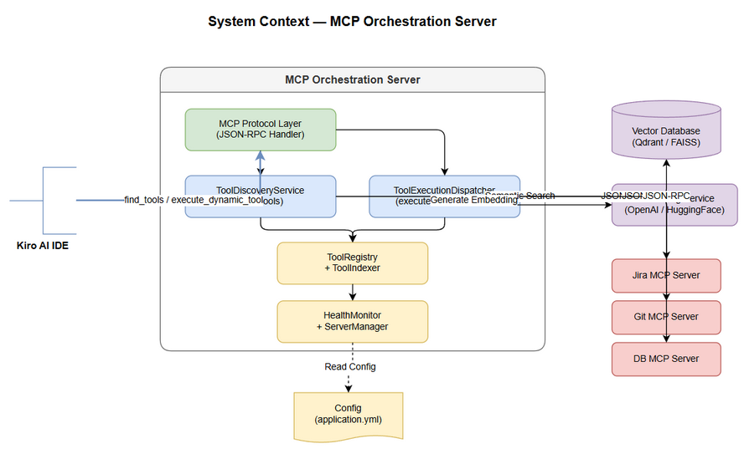
System Context

2.2 System Architecture
The system follows a layered architecture: Transport Layer, MCP Protocol Layer, Orchestration Layer, and Infrastructure Layer.

3. Functional Requirements

3.1 Tool Discovery (find_tools) — UC-01
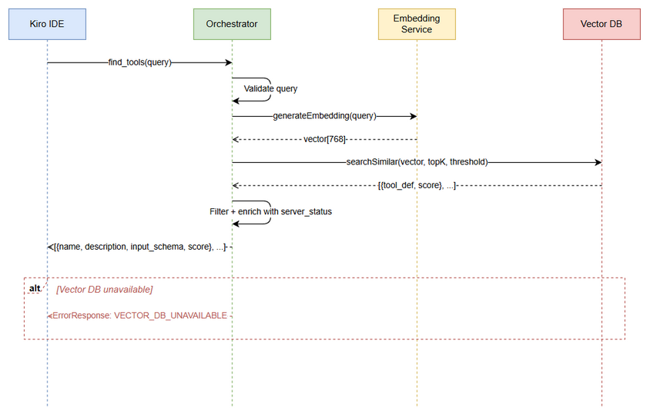
Sequence - find_tools

3.2 Dynamic Tool Execution (execute_dynamic_tool) — UC-02
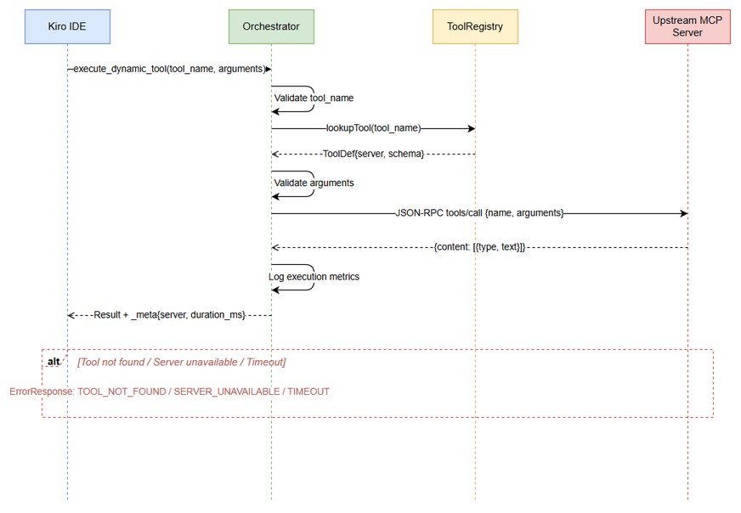
Sequence - execute_dynamic_tool

3.5 Health Monitoring — UC-05
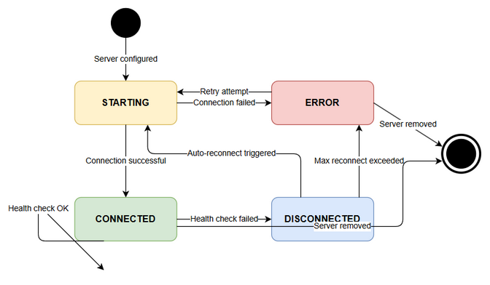
State - Server Health

4. Data Model

4.1 Entity Relationship Diagram
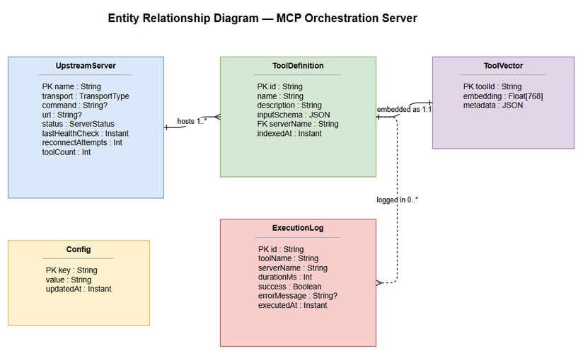
ER Diagram
Note: This is a summary DOCX export. Full content available in FSD.md.

