Technical Design Document (TDD)

MCP Orchestration Server — MTO-5: Create MCP Tool Orchestration

Document Information
Field | Value
Jira Ticket | MTO-5
Title | Create MCP Tool Orchestration
Author | SA Agent
Version | 1.0
Date | 2026-05-02
Status | Draft

1. Introduction
This TDD specifies the technical architecture and detailed design of the MCP Orchestration Server — a Kotlin/Ktor application. Technology stack: Kotlin 2.3.20, Ktor 3.4.0, Koin 4.1.1, Qdrant, OpenAI Embeddings.

2. System Architecture

2.1 Architecture Overview
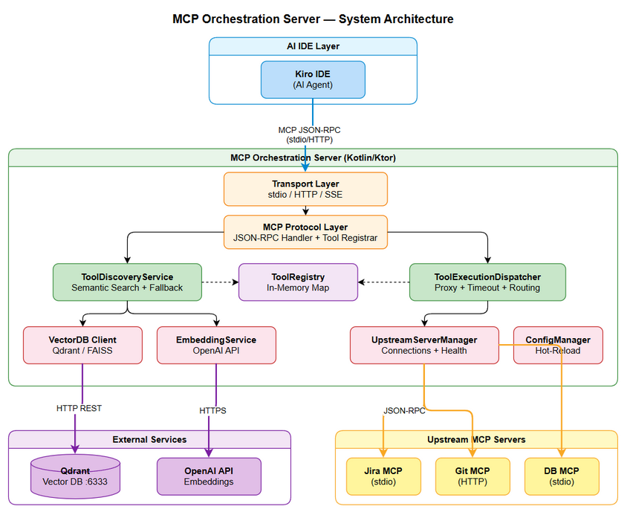
Architecture Diagram

2.2 Component Diagram
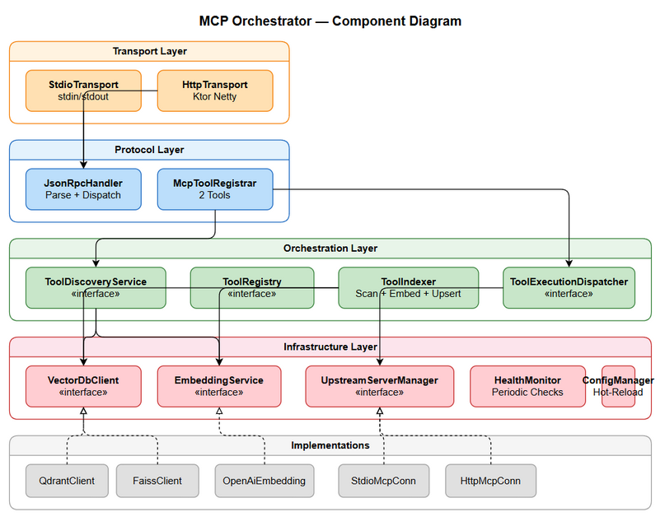
Component Diagram

2.3 Deployment Architecture
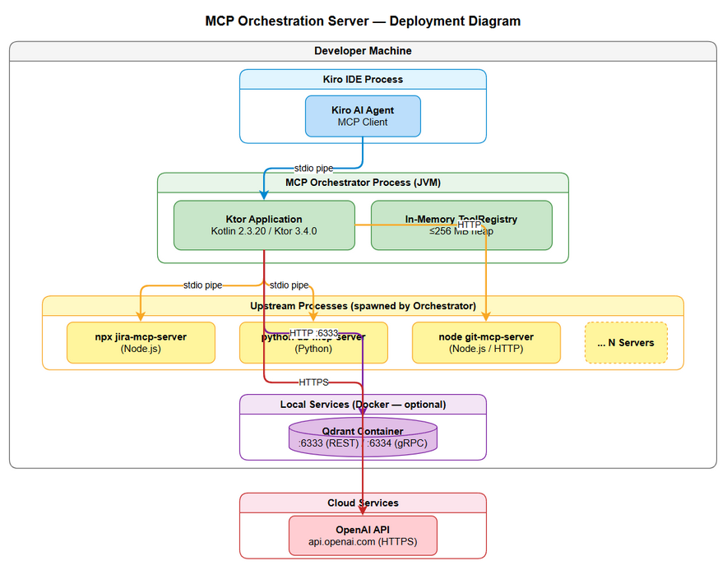
Deployment Diagram

3. API Design

3.1 find_tools
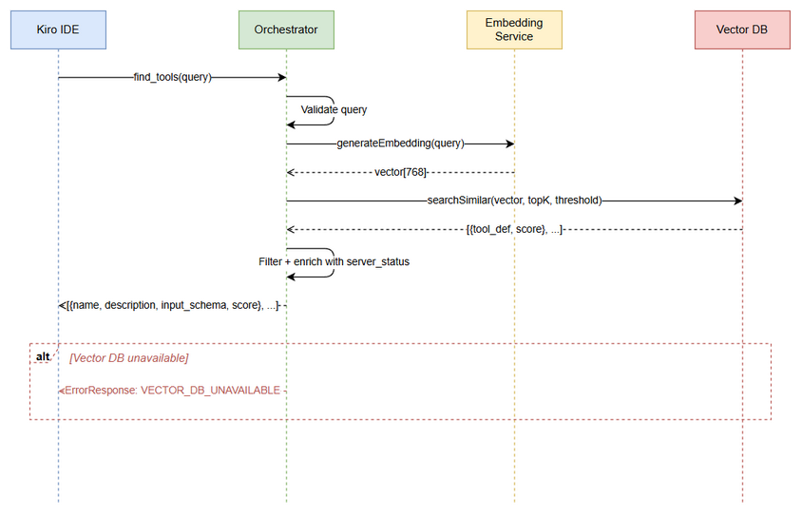
API Sequence - find_tools

3.2 execute_dynamic_tool
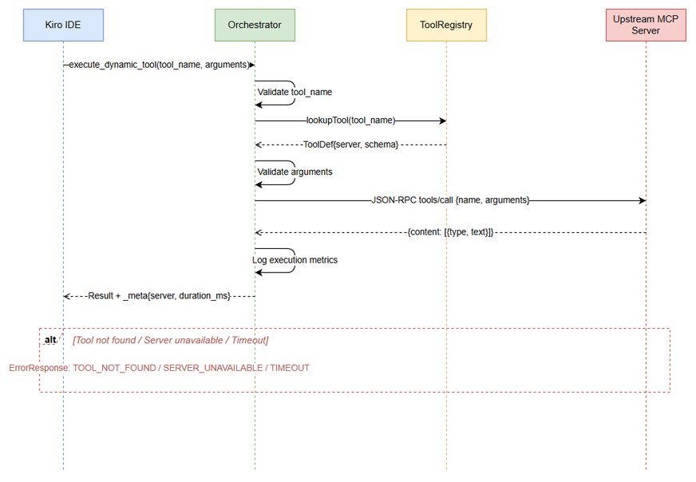
API Sequence - execute_dynamic_tool

4. Database Design

4.1 Schema Overview
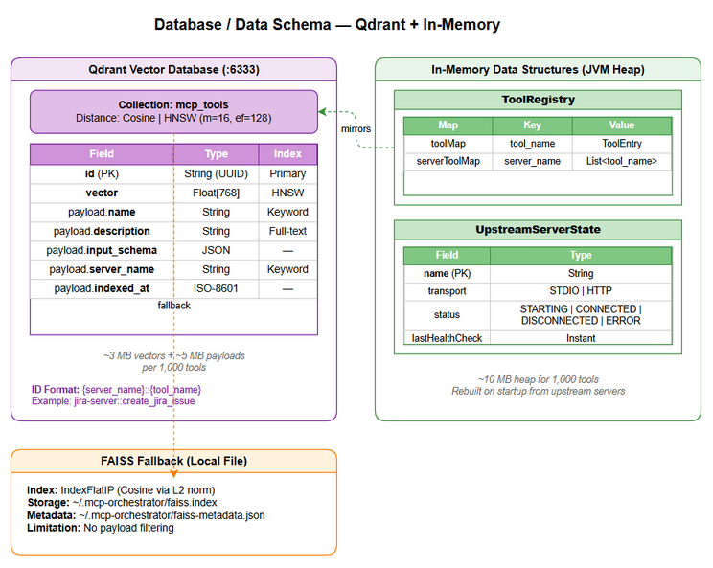
Database Schema

5. Class / Module Design

5.3 Class Diagram
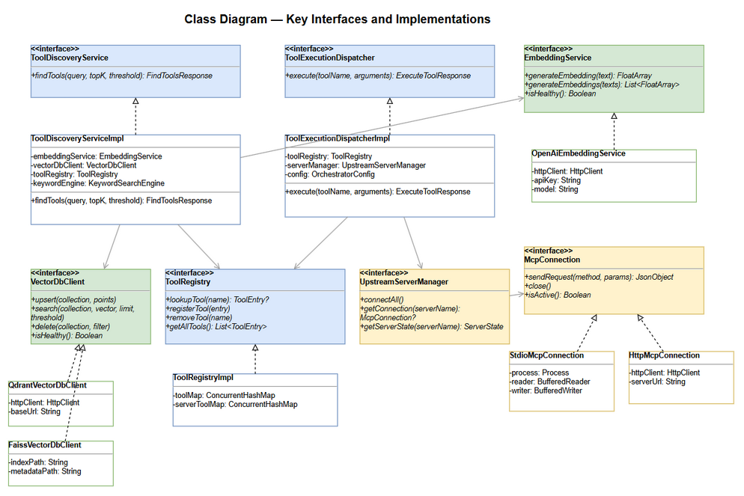
Class Diagram

FSD Diagrams (Referenced)

System Context
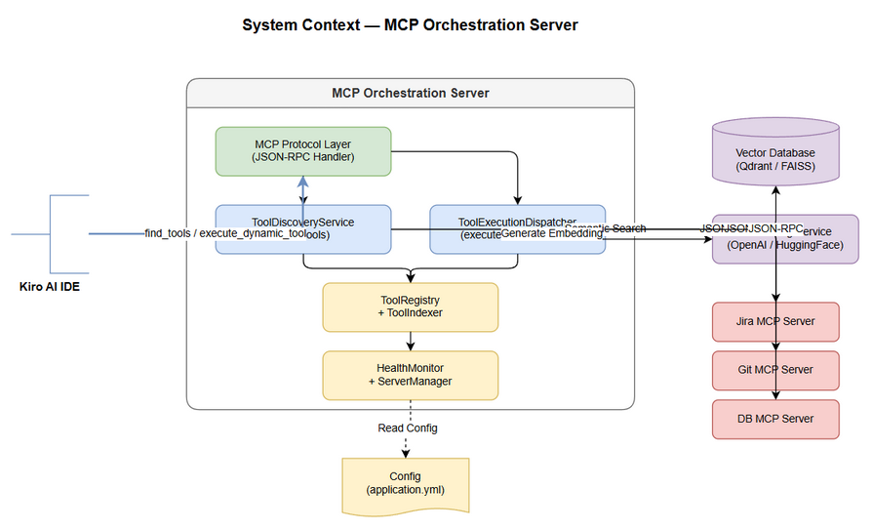
System Context

ER Diagram
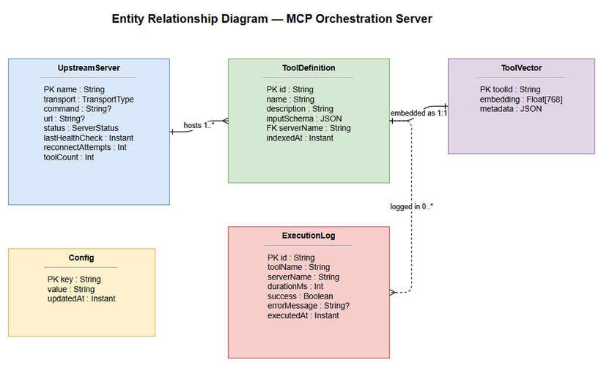
ER Diagram

State - Server Health
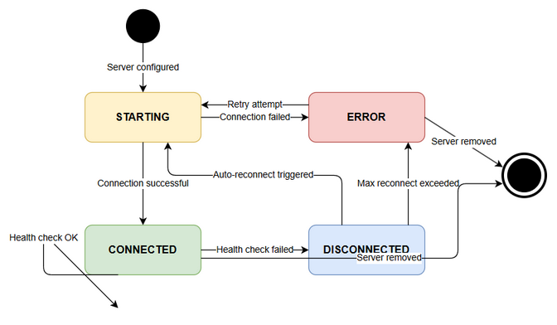
State - Server Health
Note: This is a summary DOCX export with all diagrams. Full content available in TDD.md.

