Functional Specification Document (FSD)

MCP Orchestration Server — MTO-5: Create MCP Tool Orchestration

Document Information
Field | Value
Jira Ticket | MTO-5
Title | Create MCP Tool Orchestration
Author | BA Agent
Version | 1.0
Date | 2026-05-01
Status | Draft
Related BRD | BRD-v2-MTO-5.docx
Related SRS | requirement/mcp_orchestration.md

Revision History
Version | Date | Author | Changes
1.0 | 2026-05-01 | BA Agent | Initial document — auto-generated from BRD and Jira ticket MTO-5

1. Introduction

1.1 Purpose
This FSD specifies the functional and technical design of the MCP Orchestration Server — a Kotlin/Ktor application that acts as an intelligent proxy between the Kiro AI IDE and multiple upstream MCP (Model Context Protocol) Servers. The server exposes exactly two MCP tools (find_tools and execute_dynamic_tool) to minimize AI context window consumption while providing access to an unlimited number of upstream tools via semantic search and dynamic proxying.

1.2 Scope
In Scope: - MCP-compliant server exposing find_tools and execute_dynamic_tool tools - Semantic search over tool definitions using a Vector Database (Qdrant, Milvus, or local FAISS) - Dynamic proxy execution to upstream MCP Servers via JSON-RPC - Tool registration, indexing, and metadata extraction from upstream servers - Server health monitoring with auto-reconnect - Configuration via application.yml / config.json with hot-reload support - Support for stdio and HTTP transports
Out of Scope: - UI/Dashboard for tool management (future phase) - Authentication/authorization between Kiro IDE and Orchestrator (relies on local transport security) - Custom tool creation within the Orchestrator itself

1.3 Definitions & Acronyms
Term | Definition
MCP | Model Context Protocol — open standard for AI tool communication
Orchestrator | The MCP Orchestration Server being specified in this document
Upstream Server | An external MCP Server that hosts actual tools (e.g., Jira MCP, Git MCP)
Tool Definition | Metadata describing a tool: name, description, input_schema
Vector DB | Vector Database used for semantic similarity search (Qdrant, Milvus, FAISS)
Embedding | Dense vector representation of text, used for semantic search
Top-K | The K most similar results returned from a vector search
JSON-RPC | JSON Remote Procedure Call — the wire protocol used by MCP
Context Window | The limited token budget available to an AI model per request
Kiro IDE | The AI-powered IDE that consumes MCP tools
Hot-Reload | Ability to update configuration without restarting the server

1.4 References
Document | Location
BRD | BRD-v2-MTO-5.docx
SRS | requirement/mcp_orchestration.md
MCP Specification | https://modelcontextprotocol.io/specification
Ktor Documentation | https://ktor.io/docs/

2. System Overview

2.1 System Context Diagram
graph TB
subgraph "AI IDE Layer"
KIRO["Kiro IDE<br/>(AI Agent)"]
end
subgraph "Orchestration Layer"
ORCH["MCP Orchestration Server<br/>(Kotlin/Ktor)"]
VDB["Vector Database<br/>(Qdrant/FAISS)"]
EMB["Embedding Service<br/>(OpenAI/HuggingFace)"]
CFG["Config Store<br/>(application.yml)"]
end
subgraph "Upstream MCP Servers"
MCP1["Jira MCP Server"]
MCP2["Git MCP Server"]
MCP3["Database MCP Server"]
MCPN["... N MCP Servers"]
end
KIRO -->|"find_tools(query)"| ORCH
KIRO -->|"execute_dynamic_tool(name, args)"| ORCH
ORCH -->|"Semantic Search"| VDB
ORCH -->|"Generate Embeddings"| EMB
ORCH -->|"JSON-RPC Proxy"| MCP1
ORCH -->|"JSON-RPC Proxy"| MCP2
ORCH -->|"JSON-RPC Proxy"| MCP3
ORCH -->|"JSON-RPC Proxy"| MCPN
ORCH -->|"Read Config"| CFG
EMB -->|"Store Vectors"| VDB
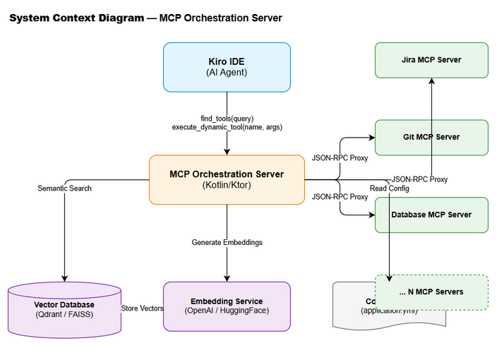
System Context
The MCP Orchestration Server sits between the Kiro AI IDE and multiple upstream MCP Servers. Kiro only sees two tools (find_tools, execute_dynamic_tool), while the Orchestrator manages discovery and routing to potentially hundreds of tools across dozens of upstream servers.

2.2 System Architecture
The system follows a layered architecture with clear separation of concerns:
┌─────────────────────────────────────────────────┐
│ Transport Layer │
│ (stdio / HTTP / SSE adapters) │
├─────────────────────────────────────────────────┤
│ MCP Protocol Layer │
│ (JSON-RPC handler, tool registration) │
├─────────────────────────────────────────────────┤
│ Orchestration Layer │
│ ┌──────────────┐ ┌──────────────────────────┐ │
│ │ ToolDiscovery │ │ ToolExecutionDispatcher │ │
│ │ Service │ │ │ │
│ └──────┬───────┘ └──────────┬───────────────┘ │
│ │ │ │
├─────────┼─────────────────────┼──────────────────┤
│ │ Infrastructure Layer │
│ ┌──────▼───────┐ ┌─────────▼────────────────┐ │
│ │ VectorDB │ │ UpstreamServerManager │ │
│ │ Client │ │ (connection pool, health)│ │
│ └──────┬───────┘ └──────────┬───────────────┘ │
│ │ │ │
│ ┌──────▼───────┐ ┌─────────▼────────────────┐ │
│ │ Embedding │ │ ConfigurationManager │ │
│ │ Service │ │ (hot-reload, validation) │ │
│ └──────────────┘ └─────────────────────────┘ │
└─────────────────────────────────────────────────┘
Key Components:
Component | Responsibility
Transport Layer | Handles stdio and HTTP communication with Kiro IDE
MCP Protocol Layer | Parses JSON-RPC messages, registers the 2 exposed tools
ToolDiscoveryService | Converts queries to embeddings, searches Vector DB, returns Top-K tools
ToolExecutionDispatcher | Routes execute_dynamic_tool calls to the correct upstream server
VectorDB Client | Abstraction over Qdrant/Milvus/FAISS for vector storage and search
Embedding Service | Generates vector embeddings via OpenAI API or local HuggingFace model
UpstreamServerManager | Manages connections, health checks, and reconnection to upstream MCP servers
ConfigurationManager | Loads, validates, and hot-reloads configuration from YAML/JSON files

3. Functional Requirements

3.1 Feature: Tool Discovery (find_tools)
Source: BRD User Story #1 — Tool Discovery, SRS Section 3.A

3.1.1 Description
The find_tools tool accepts a natural-language query describing what the AI agent wants to accomplish. It converts the query into a vector embedding, performs a semantic similarity search against the Vector Database containing all indexed tool definitions, and returns the Top-K most relevant tool definitions including their full input_schema. This enables the AI to dynamically discover tools without having all tool schemas loaded in its context window.

3.1.2 Use Case
Use Case ID: UC-01 Actor: Kiro AI Agent Preconditions: - MCP Orchestration Server is running and connected to Kiro IDE - Vector Database is populated with at least one tool definition - Embedding service is available
Postconditions: - AI Agent receives a list of 0 to K tool definitions matching the query - No state change on the server (read-only operation)
Main Flow:
Step | Actor | System | Description
1 | Kiro AI Agent |  | Sends find_tools request with query parameter (e.g., “check logs and create Jira ticket”)
2 |  | Orchestrator | Validates the query parameter is non-empty and within max length (2000 chars)
3 |  | Embedding Service | Converts the query string into a vector embedding
4 |  | Vector DB | Performs approximate nearest neighbor (ANN) search with the query vector
5 |  | Orchestrator | Filters results by minimum similarity threshold (configurable, default 0.7)
6 |  | Orchestrator | Limits results to Top-K (configurable, default 5)
7 |  | Orchestrator | Assembles response with name, description, input_schema, server_name, and similarity_score for each match
8 |  | Kiro AI Agent | Returns JSON array of tool definitions
Alternative Flows:
ID | Condition | Steps
AF-01 | No tools match above similarity threshold | Return empty array [] with a message: “No tools found matching the query. Try rephrasing.”
AF-02 | Vector DB is unavailable | Fall back to keyword-based search over cached tool definitions in memory. Log warning.
AF-03 | Embedding service is unavailable | Fall back to keyword-based search. Log warning. Return results with search_mode: "keyword" flag.
AF-04 | Query matches tools from offline upstream servers | Include tools in results but add server_status: "DISCONNECTED" flag per tool
Exception Flows:
ID | Condition | Steps
EF-01 | Query parameter is empty or null | Return MCP error: INVALID_PARAMS with message “Query parameter is required and must be non-empty”
EF-02 | Query exceeds max length (2000 chars) | Return MCP error: INVALID_PARAMS with message “Query exceeds maximum length of 2000 characters”
EF-03 | Internal server error during search | Return MCP error: INTERNAL_ERROR with message “Tool discovery failed. Please retry.” Log full stack trace.
sequenceDiagram
participant K as Kiro IDE
participant O as Orchestrator
participant E as Embedding Service
participant V as Vector DB
K->>O: find_tools(query: "check logs and create Jira ticket")
O->>O: Validate query (non-empty, max 2000 chars)
O->>E: generateEmbedding(query)
E-->>O: vector[768]
O->>V: searchSimilar(vector, topK=5, threshold=0.7)
V-->>O: [{tool_def, score}, ...]
O->>O: Enrich with server_status
O-->>K: [{name, description, input_schema, similarity_score}, ...]
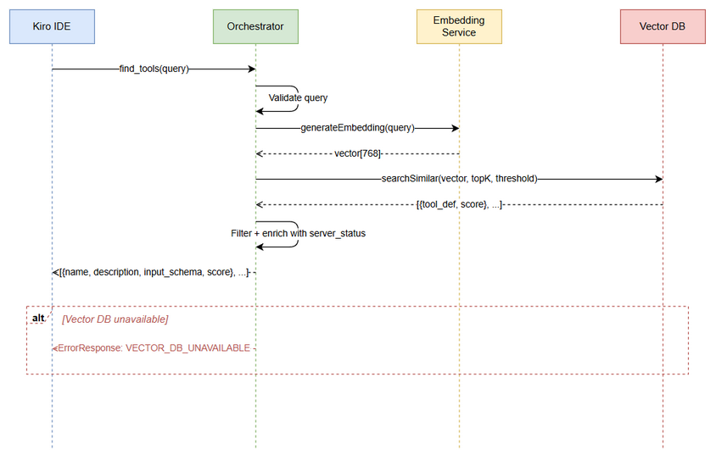
Sequence - find_tools

3.1.3 Business Rules
Rule ID | Rule | Source
BR-01 | find_tools must return results within 500ms at p95 latency | BRD NFR, SRS §1
BR-02 | Top-K value must be configurable (default: 5, range: 1–20) | BRD Story #1
BR-03 | Similarity threshold must be configurable (default: 0.7, range: 0.0–1.0) | BRD Story #1
BR-04 | Each result must include name, description, and input_schema | SRS §3.A
BR-05 | If Vector DB is down, system must fall back to keyword search | BRD NFR — Reliability
BR-06 | Results must be sorted by similarity score descending | Derived from semantic search behavior
BR-07 | Tool definitions from DISCONNECTED servers should still be returned but flagged | BRD Story #5

3.1.4 Data Specifications
Input Data:
Field | Type | Required | Validation | Description
query | String | Y | Non-empty, max 2000 chars, trimmed | Natural language description of desired action
Output Data:
Field | Type | Description
tools | Array<ToolDefinition> | List of matching tool definitions
tools[].name | String | Unique tool name (e.g., read_logs)
tools[].description | String | Human-readable description of the tool
tools[].input_schema | Object (JSON Schema) | Full JSON Schema defining the tool’s input parameters
tools[].server_name | String | Name of the upstream MCP server hosting this tool
tools[].server_status | String | Current status: CONNECTED, DISCONNECTED, ERROR
tools[].similarity_score | Float | Cosine similarity score (0.0–1.0)
search_mode | String | "semantic" or "keyword" (indicates fallback)
total_indexed | Integer | Total number of tools in the index

3.1.5 API Specifications
MCP Tool Definition:
{
"name": "find_tools",
"description": "Search for available MCP tools by describing what you want to accomplish. Returns tool definitions with input schemas so you can call them via execute_dynamic_tool.",
"inputSchema": {
"type": "object",
"properties": {
"query": {
"type": "string",
"description": "Natural language description of the action you want to perform",
"maxLength": 2000
},
"top_k": {
"type": "integer",
"description": "Maximum number of results to return (default: 5)",
"default": 5,
"minimum": 1,
"maximum": 20
},
"threshold": {
"type": "number",
"description": "Minimum similarity score threshold (default: 0.7)",
"default": 0.7,
"minimum": 0.0,
"maximum": 1.0
}
},
"required": ["query"]
}
}
Success Response Example:
{
"content": [
{
"type": "text",
"text": "{\"tools\":[{\"name\":\"read_logs\",\"description\":\"Read application log files\",\"input_schema\":{\"type\":\"object\",\"properties\":{\"path\":{\"type\":\"string\"},\"lines\":{\"type\":\"integer\",\"default\":100}}},\"server_name\":\"log-server\",\"server_status\":\"CONNECTED\",\"similarity_score\":0.92},{\"name\":\"create_jira_issue\",\"description\":\"Create a new Jira issue\",\"input_schema\":{\"type\":\"object\",\"properties\":{\"project_key\":{\"type\":\"string\"},\"summary\":{\"type\":\"string\"},\"issue_type\":{\"type\":\"string\"}}},\"server_name\":\"jira-server\",\"server_status\":\"CONNECTED\",\"similarity_score\":0.87}],\"search_mode\":\"semantic\",\"total_indexed\":150}"
}
]
}
Error Codes:
Code | Message | Description
INVALID_PARAMS | Query parameter is required and must be non-empty | Empty or null query
INVALID_PARAMS | Query exceeds maximum length of 2000 characters | Query too long
INTERNAL_ERROR | Tool discovery failed. Please retry. | Unrecoverable internal error

3.2 Feature: Dynamic Tool Execution (execute_dynamic_tool)
Source: BRD User Story #2 — Tool Execution, SRS Section 3.B

3.2.1 Description
The execute_dynamic_tool tool accepts a tool name and arguments, resolves which upstream MCP Server hosts that tool, proxies the execution request via JSON-RPC, and returns the result. This enables the AI agent to execute any discovered tool without needing a direct connection to the upstream server.

3.2.2 Use Case
Use Case ID: UC-02 Actor: Kiro AI Agent Preconditions: - Tool name exists in the tool registry - The upstream MCP Server hosting the tool is in CONNECTED state - Arguments conform to the tool’s input_schema
Postconditions: - Tool execution result is returned to the AI Agent - Execution metrics are logged (duration, success/failure, server)
Main Flow:
Step | Actor | System | Description
1 | Kiro AI Agent |  | Sends execute_dynamic_tool with tool_name and arguments
2 |  | Orchestrator | Validates tool_name is non-empty
3 |  | ToolRegistry | Looks up the tool definition and its hosting upstream server
4 |  | Orchestrator | Validates arguments against the tool’s input_schema (optional, configurable)
5 |  | UpstreamServerManager | Retrieves the active connection to the target upstream server
6 |  | Orchestrator | Constructs JSON-RPC tools/call request with tool_name and arguments
7 |  | Upstream MCP Server | Forwards the request to the upstream server
8 |  | Upstream MCP Server | Executes the tool and returns the result
9 |  | Orchestrator | Receives the response, logs execution metrics
10 |  | Kiro AI Agent | Returns the tool execution result (pass-through)
Alternative Flows:
ID | Condition | Steps
AF-05 | Upstream server responds slowly (approaching timeout) | Log warning. Continue waiting until configurable timeout (default: 30s).
AF-06 | Tool exists on multiple upstream servers | Use the first registered server. Log info about alternatives.
AF-07 | Arguments validation is disabled in config | Skip step 4, pass arguments as-is to upstream server.
Exception Flows:
ID | Condition | Steps
EF-04 | tool_name not found in registry | Return MCP error with code TOOL_NOT_FOUND: “Tool ‘{tool_name}’ is not registered. Use find_tools to discover available tools.”
EF-05 | Upstream server is DISCONNECTED | Return MCP error with code SERVER_UNAVAILABLE: “Server hosting ‘{tool_name}’ is currently unavailable. Status: DISCONNECTED.”
EF-06 | Upstream server execution timeout (>30s default) | Return MCP error with code EXECUTION_TIMEOUT: “Tool execution timed out after {timeout}s.”
EF-07 | Upstream server returns an error | Pass through the upstream error to the AI Agent with additional context: upstream_server, upstream_error_code.
EF-08 | Arguments fail schema validation | Return MCP error with code INVALID_PARAMS: “Argument validation failed: {details}”
sequenceDiagram
participant K as Kiro IDE
participant O as Orchestrator
participant R as ToolRegistry
participant U as Upstream MCP Server
K->>O: execute_dynamic_tool(tool_name: "read_logs", args: {path: "/var/log/app.log"})
O->>O: Validate tool_name non-empty
O->>R: lookupTool("read_logs")
R-->>O: ToolDef{server: "log-server", schema: {...}}
O->>O: Validate args against input_schema
O->>U: JSON-RPC tools/call {name: "read_logs", arguments: {path: "/var/log/app.log"}}
U-->>O: {content: [{type: "text", text: "log data..."}]}
O-->>K: {content: [{type: "text", text: "log data..."}]}
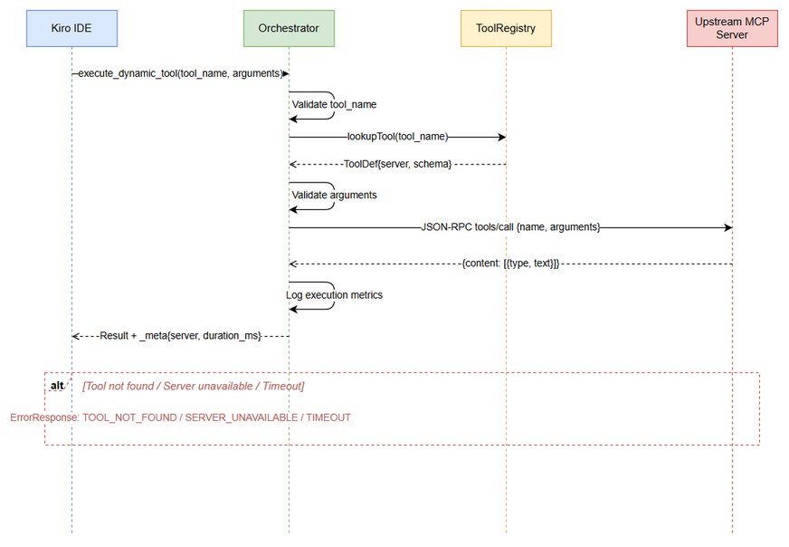
Sequence - execute_dynamic_tool

3.2.3 Business Rules
Rule ID | Rule | Source
BR-08 | Proxy overhead must be <100ms (excluding upstream execution time) | BRD NFR
BR-09 | Execution timeout is configurable (default: 30s, range: 5s–300s) | Derived from reliability requirements
BR-10 | Tool name lookup must be case-sensitive and exact match | Derived from MCP protocol
BR-11 | Upstream errors must be passed through transparently with added context | BRD Story #2
BR-12 | All executions must be logged with: tool_name, server, duration_ms, success/failure | BRD NFR — Observability
BR-13 | Schema validation of arguments is optional and configurable (default: enabled) | Derived from flexibility requirement

3.2.4 Data Specifications
Input Data:
Field | Type | Required | Validation | Description
tool_name | String | Y | Non-empty, must exist in registry | Name of the tool to execute
arguments | Object | N | Must conform to tool’s input_schema (if validation enabled) | Arguments to pass to the tool
Output Data:
Field | Type | Description
content | Array<Content> | MCP content array — pass-through from upstream server
content[].type | String | Content type: "text", "image", "resource"
content[].text | String | Text content (for type "text")
_meta.upstream_server | String | Name of the server that executed the tool
_meta.execution_time_ms | Integer | Total execution time in milliseconds

3.2.5 API Specifications
MCP Tool Definition:
{
"name": "execute_dynamic_tool",
"description": "Execute a tool on an upstream MCP server. Use find_tools first to discover available tools and their input schemas.",
"inputSchema": {
"type": "object",
"properties": {
"tool_name": {
"type": "string",
"description": "The exact name of the tool to execute (as returned by find_tools)"
},
"arguments": {
"type": "object",
"description": "Arguments to pass to the tool, conforming to its input_schema",
"additionalProperties": true
}
},
"required": ["tool_name"]
}
}
Error Codes:
Code | Message | Description
TOOL_NOT_FOUND | Tool ‘{name}’ is not registered | Tool name not in registry
SERVER_UNAVAILABLE | Server hosting ‘{name}’ is currently unavailable | Upstream server disconnected
EXECUTION_TIMEOUT | Tool execution timed out after {N}s | Upstream did not respond in time
INVALID_PARAMS | Argument validation failed: {details} | Arguments don’t match input_schema
UPSTREAM_ERROR | Upstream error: {message} | Error from the upstream MCP server

3.3 Feature: Tool Registration & Indexing
Source: BRD User Story #3 — Tool Registration & Indexing, SRS Section 4.1

3.3.1 Description
The system must be able to scan upstream MCP Servers, extract tool metadata (name, description, input_schema), generate vector embeddings for each tool description, and store them in the Vector Database. This process runs at startup and can be triggered on-demand or on configuration change.

3.3.2 Use Case
Use Case ID: UC-03 Actor: System (automatic), Administrator (manual trigger) Preconditions: - At least one upstream MCP Server is configured - Embedding service is available - Vector DB is accessible
Postconditions: - All tools from reachable upstream servers are indexed in Vector DB - Tool-to-server mapping is stored in the ToolRegistry
Main Flow:
Step | Actor | System | Description
1 | System |  | Startup trigger or config change detected
2 |  | ConfigManager | Load list of upstream MCP servers from configuration
3 |  | UpstreamServerManager | Establish connections to each configured server (parallel via coroutines)
4 |  | Orchestrator | For each connected server: send tools/list JSON-RPC request
5 |  | Upstream Server | Returns list of tool definitions
6 |  | EmbeddingService | Generate embedding vector for each tool’s description field
7 |  | VectorDB | Upsert tool vectors with metadata (name, description, input_schema, server_name)
8 |  | ToolRegistry | Update in-memory tool-to-server mapping
9 |  | System | Log summary: “{N} tools indexed from {M} servers”
Alternative Flows:
ID | Condition | Steps
AF-08 | An upstream server is unreachable during scan | Skip that server, log warning, continue with remaining servers. Mark server as DISCONNECTED.
AF-09 | Embedding service is unavailable during indexing | Use keyword-based indexing (store raw text, no vectors). Log warning.
AF-10 | Incremental update — server already indexed | Compare tool lists. Add new tools, remove deleted tools, update changed tools.
Exception Flows:
ID | Condition | Steps
EF-09 | Vector DB is completely unavailable | Fall back to in-memory keyword index. Log error. System operates in degraded mode.
EF-10 | All upstream servers are unreachable | Log critical error. System starts with empty tool registry. Retry on next health check cycle.

3.3.3 Business Rules
Rule ID | Rule | Source
BR-14 | Tool indexing must support incremental updates (add/remove/update) | BRD Story #3
BR-15 | Indexing must be resilient — failure of one server must not block others | BRD Acceptance Criteria
BR-16 | Each tool must be uniquely identified by server_name + tool_name composite key | Derived from multi-server architecture
BR-17 | Tool descriptions must be embedded using the same model used for query embedding | Consistency requirement
BR-18 | Indexing must run at server startup and on configuration change | BRD Story #7

3.4 Feature: Server Configuration Management
Source: BRD User Story #4 — Server Configuration, SRS Section 4.3

3.4.1 Description
The system reads upstream MCP Server configurations from application.yml or config.json. Configuration includes server names, transport types (stdio/HTTP), connection parameters, and orchestrator settings (Top-K, thresholds, timeouts). The system supports hot-reload — configuration changes are detected and applied without server restart.

3.4.2 Use Case
Use Case ID: UC-04 Actor: Administrator / DevOps Preconditions: - Configuration file exists and is valid YAML/JSON
Postconditions: - Server operates with the updated configuration - New upstream servers are connected; removed servers are disconnected
Main Flow:
Step | Actor | System | Description
1 | Admin |  | Modifies application.yml or config.json
2 |  | ConfigManager | Detects file change via file watcher (or periodic poll)
3 |  | ConfigManager | Parses and validates the new configuration
4 |  | ConfigManager | Computes diff: added servers, removed servers, changed settings
5 |  | UpstreamServerManager | Connects to newly added servers
6 |  | UpstreamServerManager | Disconnects from removed servers
7 |  | ToolRegistry | Re-indexes tools for changed servers
8 |  | System | Applies new settings (Top-K, thresholds, timeouts)
9 |  | System | Logs: “Configuration reloaded. Added: {N}, Removed: {M}, Updated: {P}”
Exception Flows:
ID | Condition | Steps
EF-11 | New configuration is invalid (parse error) | Reject the change, keep current config. Log error with validation details.
EF-12 | New server in config is unreachable | Mark as DISCONNECTED, continue with other changes. Schedule retry.

3.4.3 Business Rules
Rule ID | Rule | Source
BR-19 | Configuration must support both YAML and JSON formats | BRD Story #4
BR-20 | Hot-reload must not cause downtime or dropped requests | BRD Acceptance Criteria
BR-21 | Invalid configuration must be rejected — system keeps previous valid config | Derived from reliability
BR-22 | Both stdio and HTTP transports must be supported for upstream connections | SRS §2

3.4.4 Configuration Schema
# application.yml
orchestrator:
server:
port: 8080
transport: stdio # stdio | http
discovery:
top_k: 5
similarity_threshold: 0.7
max_query_length: 2000
fallback_to_keyword: true
execution:
timeout_seconds: 30
validate_arguments: true
max_retries: 1
embedding:
provider: openai # openai | huggingface
model: text-embedding-3-small
api_key: ${OPENAI_API_KEY} # environment variable reference
dimensions: 768
vector_db:
provider: qdrant # qdrant | milvus | faiss
host: localhost
port: 6333
collection_name: mcp_tools
health:
check_interval_seconds: 30
auto_reconnect: true
max_reconnect_attempts: 5
upstream_servers:
- name: jira-server
transport: stdio
command: npx
args: ["-y", "@modelcontextprotocol/server-jira"]
env:
JIRA_URL: "https://mycompany.atlassian.net"
JIRA_TOKEN: ${JIRA_TOKEN}
- name: git-server
transport: http
url: "http://localhost:3001/mcp"
- name: database-server
transport: stdio
command: python
args: ["-m", "mcp_server_database"]

3.5 Feature: Health Monitoring & Auto-Reconnect
Source: BRD User Story #5 — Health Monitoring, SRS Section 4.2

3.5.1 Description
The system periodically checks the health of all upstream MCP Servers. Each server has a state machine with states: STARTING, CONNECTED, DISCONNECTED, ERROR. When a server becomes disconnected, the system automatically attempts to reconnect with exponential backoff.

3.5.2 Use Case
Use Case ID: UC-05 Actor: System (automatic) Preconditions: - At least one upstream server is configured - Health check interval is configured (default: 30s)
Postconditions: - Server states are up-to-date - Disconnected servers are reconnected when possible - Tool registry is updated to reflect server availability
Main Flow:
Step | Actor | System | Description
1 |  | HealthMonitor | Timer fires at configured interval (default: 30s)
2 |  | HealthMonitor | For each upstream server: send ping or tools/list request
3 |  | Upstream Server | Responds (or times out)
4 |  | HealthMonitor | Update server state based on response
5 |  | HealthMonitor | If state changed: log state transition, update ToolRegistry
6 |  | HealthMonitor | If DISCONNECTED and auto_reconnect enabled: schedule reconnect
State Machine:
stateDiagram-v2
[*] --> STARTING: Server configured
STARTING --> CONNECTED: Connection successful
STARTING --> ERROR: Connection failed
CONNECTED --> DISCONNECTED: Health check failed
CONNECTED --> CONNECTED: Health check OK
DISCONNECTED --> STARTING: Auto-reconnect triggered
ERROR --> STARTING: Retry attempt
DISCONNECTED --> ERROR: Max reconnect attempts exceeded
ERROR --> [*]: Server removed from config
CONNECTED --> [*]: Server removed from config
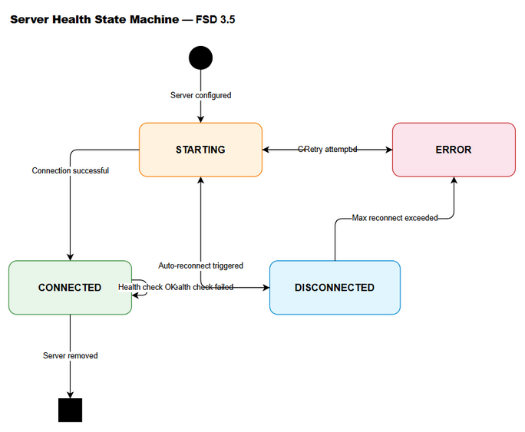
State - Server Health

3.5.3 Business Rules
Rule ID | Rule | Source
BR-23 | Health check interval must be configurable (default: 30s) | BRD Story #5
BR-24 | Auto-reconnect must use exponential backoff (1s, 2s, 4s, 8s, …) | Derived from reliability
BR-25 | Max reconnect attempts must be configurable (default: 5) | BRD Acceptance Criteria
BR-26 | Server state transitions must be logged | BRD NFR — Observability
BR-27 | Tools from DISCONNECTED servers remain in search results but flagged | BR-07

4. Data Model

4.1 Entity Relationship Diagram
erDiagram
UPSTREAM_SERVER ||--o{ TOOL_DEFINITION : hosts
TOOL_DEFINITION ||--|| TOOL_VECTOR : "embedded as"
UPSTREAM_SERVER {
string name PK
string transport
string command
string url
string status
timestamp last_health_check
int reconnect_attempts
}
TOOL_DEFINITION {
string id PK
string name
string description
json input_schema
string server_name FK
timestamp indexed_at
}
TOOL_VECTOR {
string tool_id PK
float[] embedding
float[] metadata
}
CONFIG {
string key PK
string value
timestamp updated_at
}
EXECUTION_LOG {
string id PK
string tool_name
string server_name
int duration_ms
boolean success
string error_message
timestamp executed_at
}
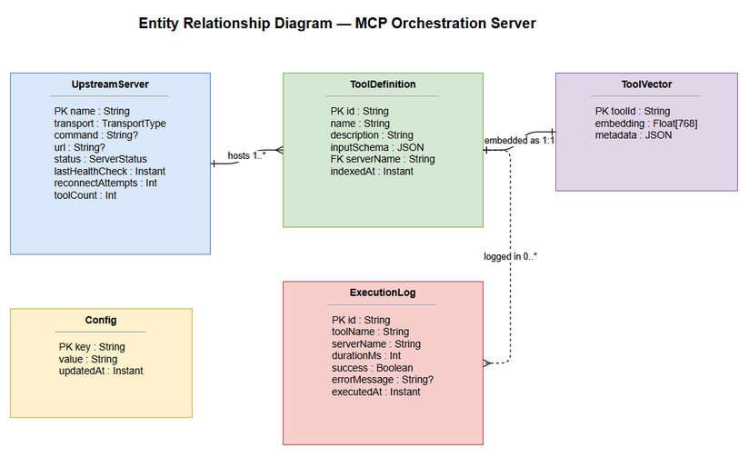
ER Diagram

4.2 Data Structures
Note: This system uses a Vector Database (not a traditional RDBMS). The following describes the logical data structures stored in Vector DB collections and in-memory registries.

Collection: mcp_tools (Vector DB)
Field | Type | Indexed | Description
id | String (UUID) | Y (primary) | Unique identifier: {server_name}::{tool_name}
name | String | Y (payload) | Tool name as registered in MCP
description | String | N (payload) | Human-readable tool description
input_schema | JSON | N (payload) | Full JSON Schema for tool input
server_name | String | Y (payload filter) | Name of the hosting upstream server
embedding | Float[768] | Y (vector) | Embedding vector of the description
indexed_at | Timestamp | N (payload) | When this tool was last indexed
Vector Index Configuration:
Parameter | Value
Distance Metric | Cosine Similarity
Vector Dimensions | 768 (configurable per embedding model)
Index Type | HNSW (Hierarchical Navigable Small World)
ef_construct | 128
M | 16

In-Memory: ToolRegistry
Field | Type | Description
toolMap | Map<String, ToolEntry> | Key: tool_name, Value: ToolEntry
serverToolMap | Map<String, List<String>> | Key: server_name, Value: list of tool_names

In-Memory: ToolEntry
Field | Type | Description
name | String | Tool name
description | String | Tool description
inputSchema | JsonObject | JSON Schema for input
serverName | String | Hosting server name
serverStatus | ServerStatus | Current server status enum

In-Memory: UpstreamServerState
Field | Type | Description
name | String | Server name (from config)
transport | TransportType | STDIO or HTTP
status | ServerStatus | STARTING, CONNECTED, DISCONNECTED, ERROR
connection | McpConnection? | Active MCP connection (nullable)
lastHealthCheck | Instant | Timestamp of last health check
reconnectAttempts | Int | Current reconnect attempt count
toolCount | Int | Number of tools hosted by this server

Enum: ServerStatus
Value | Description
STARTING | Initial connection in progress
CONNECTED | Active and healthy
DISCONNECTED | Health check failed, may auto-reconnect
ERROR | Failed after max reconnect attempts

Enum: TransportType
Value | Description
STDIO | Standard I/O transport (subprocess)
HTTP | HTTP/SSE transport

5. Integration Specifications

5.1 External System: Upstream MCP Servers
Attribute | Value
Protocol | MCP (Model Context Protocol) over JSON-RPC 2.0
Transport | stdio (subprocess) or HTTP (SSE)
Authentication | Per-server via environment variables (API keys, tokens)
Data Format | JSON
Supported MCP Methods (Outbound):
Method | Purpose | When Used
initialize | Establish MCP session with upstream server | On connection
tools/list | Retrieve all tool definitions from upstream | During indexing and health checks
tools/call | Execute a specific tool | During execute_dynamic_tool
ping | Health check | During periodic health monitoring
Data Mapping — Tool Discovery:
Source (Upstream tools/list) | Target (Vector DB) | Transformation
tool.name | name | Direct copy
tool.description | description | Direct copy
tool.description | embedding | Vectorize via Embedding Service
tool.inputSchema | input_schema | Direct copy (JSON)
(connection context) | server_name | From config

5.2 External System: Embedding Service
Attribute | Value
Protocol | REST API (HTTPS)
Endpoint | https://api.openai.com/v1/embeddings (OpenAI) or local HTTP endpoint (HuggingFace)
Authentication | API Key via Authorization: Bearer {key} header
Data Format | JSON
Request:
{
"model": "text-embedding-3-small",
"input": "Read application log files and return recent entries"
}
Response:
{
"data": [
{
"embedding": [0.0023, -0.0091, ...],
"index": 0
}
],
"usage": {
"prompt_tokens": 12,
"total_tokens": 12
}
}

5.3 External System: Vector Database (Qdrant)
Attribute | Value
Protocol | gRPC or REST API
Endpoint | http://localhost:6333 (default)
Authentication | API Key (optional)
Data Format | JSON
Key Operations:
Operation | Qdrant API | Description
Create Collection | PUT /collections/{name} | Initialize tool vector collection
Upsert Points | PUT /collections/{name}/points | Add/update tool vectors
Search | POST /collections/{name}/points/search | Semantic similarity search
Delete Points | POST /collections/{name}/points/delete | Remove tools from index

5.4 External System: Kiro AI IDE
Attribute | Value
Protocol | MCP (Model Context Protocol) over JSON-RPC 2.0
Transport | stdio (primary) or HTTP
Direction | Inbound — Kiro calls the Orchestrator
Data Format | JSON
Exposed MCP Tools (Inbound):
Tool | Description
find_tools | Semantic search for tools (UC-01)
execute_dynamic_tool | Proxy execution to upstream servers (UC-02)

6. Processing Logic

6.1 Server Startup Process
Trigger: Application launch Schedule: One-time at startup Input: Configuration file (application.yml / config.json) Output: Fully initialized Orchestrator with indexed tools
Processing Steps:
Step | Description | Error Handling
1 | Load and validate configuration file | Exit with error if config is invalid
2 | Initialize Vector DB connection | Fall back to in-memory keyword index
3 | Initialize Embedding Service connection | Fall back to keyword-based indexing
4 | Connect to each upstream MCP server (parallel coroutines) | Mark failed servers as ERROR, continue with others
5 | For each connected server: fetch tools/list | Skip server, mark as ERROR
6 | Generate embeddings for all tool descriptions (batch) | Use keyword index for failed embeddings
7 | Upsert all tool vectors into Vector DB | Fall back to in-memory index
8 | Build in-memory ToolRegistry | Critical — must succeed
9 | Register find_tools and execute_dynamic_tool as MCP tools | Critical — must succeed
10 | Start health monitoring coroutine | Log warning if fails, system operates without health checks
11 | Start config file watcher for hot-reload | Log warning if fails
12 | Begin accepting MCP requests from Kiro IDE | Server is ready
flowchart TD
A([Start]) --> B[Load Configuration]
B --> C{Config Valid?}
C -->|No| Z([Exit with Error])
C -->|Yes| D[Init Vector DB]
D --> E[Init Embedding Service]
E --> F[Connect Upstream Servers]
F --> G[Fetch tools/list from each server]
G --> H[Generate Embeddings]
H --> I[Upsert to Vector DB]
I --> J[Build ToolRegistry]
J --> K[Register MCP Tools]
K --> L[Start Health Monitor]
L --> M[Start Config Watcher]
M --> N([Ready — Accept Requests])
D -.->|Failed| D2[Use In-Memory Index]
D2 --> E
E -.->|Failed| E2[Use Keyword Indexing]
E2 --> F
F -.->|Server Failed| F2[Mark as ERROR, Continue]
F2 --> G

6.2 Tool Indexing Process
Trigger: Startup, config change, manual trigger, or periodic re-index Input: List of upstream MCP servers Output: Updated Vector DB and ToolRegistry
Processing Steps:
Step | Description | Error Handling
1 | Determine which servers need (re-)indexing | —
2 | For each server: send tools/list request | Skip server on timeout/error
3 | Compare returned tools with existing index | —
4 | Identify: new tools, removed tools, updated tools | —
5 | For new/updated tools: generate embeddings (batch, max 100 per request) | Retry once, then skip tool
6 | Upsert new/updated vectors to Vector DB | Retry once, then use in-memory
7 | Delete removed tool vectors from Vector DB | Log warning on failure
8 | Update in-memory ToolRegistry | Must succeed
9 | Log summary: “Indexed {added} new, {updated} updated, {removed} removed tools from {server}” | —

6.3 Health Check Process
Trigger: Periodic timer (configurable interval, default: 30s) Input: List of upstream servers with current states Output: Updated server states, reconnection attempts
Processing Steps:
Step | Description | Error Handling
1 | For each server in CONNECTED state: send ping | If fails → transition to DISCONNECTED
2 | For each server in DISCONNECTED state (if auto_reconnect enabled): attempt reconnect | If fails → increment reconnect_attempts
3 | If reconnect_attempts > max_reconnect_attempts: transition to ERROR | Log critical warning
4 | For each server in STARTING state: check if connection completed | If timeout → transition to ERROR
5 | For reconnected servers: re-index tools | If indexing fails → keep old tool data
6 | Log all state transitions | —

6.4 Request Routing Process (execute_dynamic_tool)
Trigger: Incoming execute_dynamic_tool call from Kiro IDE Input: tool_name, arguments Output: Tool execution result or error
Processing Steps:
Step | Description | Error Handling
1 | Look up tool_name in ToolRegistry | Return TOOL_NOT_FOUND error
2 | Get the hosting server’s connection | Return SERVER_UNAVAILABLE if DISCONNECTED/ERROR
3 | Optionally validate arguments against input_schema | Return INVALID_PARAMS on failure
4 | Construct JSON-RPC tools/call message | —
5 | Send request to upstream server with timeout | Return EXECUTION_TIMEOUT on timeout
6 | Receive response from upstream | Return UPSTREAM_ERROR on error
7 | Add execution metadata (_meta) to response | —
8 | Log execution: tool, server, duration, success | —
9 | Return result to Kiro IDE | —

7. Security Requirements

7.1 Authentication & Authorization
Role | Permissions | Context
Kiro IDE (AI Agent) | Full access to find_tools and execute_dynamic_tool | Local transport (stdio) — no auth needed
Administrator | Configuration management, server restart | OS-level access to config files
Upstream MCP Servers | Receive proxied tool calls | Authenticated via per-server API keys/tokens in config
Note: Since the Orchestrator communicates with Kiro IDE via local stdio transport, no additional authentication layer is required for the IDE-to-Orchestrator connection. Security is enforced at the OS process level.

7.2 Data Security
Data Type | Security Measure | Details
API Keys (OpenAI, Jira, etc.) | Environment variable references | Config files use ${ENV_VAR} syntax — never store plaintext secrets
Upstream server credentials | Environment variable injection | Passed to subprocess via env config, never logged
Tool execution arguments | No logging of argument values | Only tool_name and server_name are logged, not argument content
Vector embeddings | No PII in embeddings | Embeddings are generated from tool descriptions only (no user data)

7.3 Audit Trail
Event | Logged Fields | Retention
Tool Discovery | query (truncated to 100 chars), result_count, search_mode, duration_ms | Application logs
Tool Execution | tool_name, server_name, duration_ms, success/failure, error_code | Application logs
Server State Change | server_name, old_state, new_state, timestamp | Application logs
Config Reload | added_servers, removed_servers, changed_settings | Application logs
Indexing | server_name, tools_added, tools_removed, tools_updated | Application logs

8. Non-Functional Specifications
Category | Specification | Target
Performance — find_tools | End-to-end latency including embedding generation and vector search | < 500ms at p95
Performance — execute_dynamic_tool | Proxy overhead (excluding upstream execution time) | < 100ms
Performance — Indexing | Time to index all tools from a single server | < 5s for 100 tools
Scalability — Tools | Maximum number of tools in the vector index | 1,000+ tools
Scalability — Servers | Maximum number of concurrent upstream server connections | 50+ servers
Scalability — Concurrent Requests | Simultaneous find_tools + execute requests | 100+ concurrent
Availability | System uptime target | 99.9% (during IDE session)
Reliability — Fallback | Keyword search fallback when Vector DB is unavailable | Must be functional
Reliability — Graceful Degradation | System must remain operational if some upstream servers are down | Partial functionality
Memory | Maximum heap usage for ToolRegistry with 1000 tools | < 256 MB
Startup Time | Time from process start to accepting first request | < 10s (with 5 servers)
Kotlin Coroutines | All I/O operations must be non-blocking | Coroutine-based
Code Quality | SOLID principles compliance | Required
Test Coverage | Unit test coverage for core logic | > 80%

9. Error Handling & Logging

9.1 Error Codes
Code | Severity | Message | User Action | System Action
INVALID_PARAMS | Warning | Query/arguments validation failed | Fix input and retry | Return error response, log at WARN
TOOL_NOT_FOUND | Warning | Tool ‘{name}’ is not registered | Use find_tools to discover tools | Return error response, log at WARN
SERVER_UNAVAILABLE | Error | Server hosting ‘{name}’ is unavailable | Retry later or use alternative tool | Return error, trigger health check, log at ERROR
EXECUTION_TIMEOUT | Error | Tool execution timed out after {N}s | Retry with simpler request | Return error, log at ERROR, increment timeout counter
UPSTREAM_ERROR | Error | Upstream server returned error | Check tool arguments | Pass through upstream error, log at ERROR
INTERNAL_ERROR | Critical | Internal server error | Retry request | Log full stack trace at ERROR, return generic error
VECTOR_DB_UNAVAILABLE | Warning | Vector DB is unavailable, using keyword fallback | No action needed | Switch to keyword search, log at WARN, attempt reconnect
EMBEDDING_SERVICE_ERROR | Warning | Embedding service unavailable | No action needed | Switch to keyword search, log at WARN
CONFIG_INVALID | Critical | Configuration file is invalid | Fix configuration file | Reject config change, keep previous config, log at ERROR

9.2 Logging Specifications
Log Type | Level | Content | Destination
Request Log | INFO | tool_name, request_id, timestamp | stdout / log file
Response Log | INFO | tool_name, request_id, duration_ms, status | stdout / log file
Health Check | DEBUG | server_name, status, response_time_ms | stdout / log file
State Transition | INFO | server_name, old_state → new_state | stdout / log file
Error | ERROR | error_code, message, stack_trace (if applicable) | stderr / log file
Indexing | INFO | server_name, tools_count, duration_ms | stdout / log file
Config Reload | INFO | changes_summary | stdout / log file
Startup | INFO | version, config_path, servers_count, tools_count | stdout / log file
Logging Framework: SLF4J with Logback (Kotlin idiomatic)
Log Format:
{timestamp} [{level}] [{coroutine-name}] {logger} - {message}
Example:
2026-05-01T10:30:00.123Z [INFO] [find-tools-handler] ToolDiscoveryService - Query: "check logs...", Results: 3, Mode: semantic, Duration: 45ms

10. Testing Considerations

10.1 Test Scenarios
ID | Scenario | Input | Expected Output | Priority
TC-01 | find_tools with valid query | query: “read log files” | Array of matching tools with similarity scores | High
TC-02 | find_tools with empty query | query: "" | INVALID_PARAMS error | High
TC-03 | find_tools with no matching tools | query: “quantum computing simulation” | Empty array with message | Medium
TC-04 | find_tools with Vector DB down | query: “read logs” (VDB offline) | Results via keyword fallback, search_mode: “keyword” | High
TC-05 | find_tools with custom top_k | query: “jira”, top_k: 2 | Maximum 2 results | Medium
TC-06 | execute_dynamic_tool success | tool_name: “read_logs”, args: {path: “/var/log”} | Tool execution result from upstream | High
TC-07 | execute_dynamic_tool — tool not found | tool_name: “nonexistent_tool” | TOOL_NOT_FOUND error | High
TC-08 | execute_dynamic_tool — server unavailable | tool_name: “read_logs” (server DISCONNECTED) | SERVER_UNAVAILABLE error | High
TC-09 | execute_dynamic_tool — timeout | tool_name: “slow_tool” (>30s) | EXECUTION_TIMEOUT error | High
TC-10 | execute_dynamic_tool — upstream error | tool_name: “failing_tool” | UPSTREAM_ERROR with upstream details | Medium
TC-11 | Tool indexing — new server added | Add server to config | Tools from new server appear in search | High
TC-12 | Tool indexing — server removed | Remove server from config | Tools from removed server no longer in search | Medium
TC-13 | Health check — server goes down | Kill upstream server process | Server state → DISCONNECTED, auto-reconnect starts | High
TC-14 | Health check — server recovers | Restart upstream server | Server state → CONNECTED, tools re-indexed | High
TC-15 | Config hot-reload | Modify application.yml while running | New config applied without restart | Medium
TC-16 | Config hot-reload — invalid config | Write invalid YAML | Config rejected, previous config retained | Medium
TC-17 | Concurrent find_tools requests | 50 simultaneous queries | All return within 500ms p95 | Medium
TC-18 | Startup with no servers reachable | All servers offline | System starts, empty registry, health checks retry | Medium
TC-19 | find_tools — tools from disconnected server | Server DISCONNECTED | Tools returned with server_status: “DISCONNECTED” | Low
TC-20 | execute_dynamic_tool — argument validation | Invalid args for tool schema | INVALID_PARAMS error with details | Medium

11. Appendix

11.1 Diagrams
Diagram | File
System Context Diagram | system-context.png
ER Diagram | er-diagram.png
Sequence — find_tools (UC-01) | sequence-find-tools.png
Sequence — execute_dynamic_tool (UC-02) | sequence-execute-tool.png
State — Server Health (UC-05) | state-server-health.png

11.2 Change Log from BRD
Item | BRD Statement | FSD Clarification
Top-K default | “Top-K configurable” | Specified default: 5, range: 1–20
Similarity threshold | Not explicitly stated in BRD | Added configurable threshold, default: 0.7
Execution timeout | “<100ms overhead” | Clarified: 100ms is proxy overhead only. Total timeout: 30s configurable.
Transport support | “stdio+http transport” | Specified both for IDE-to-Orchestrator and Orchestrator-to-Upstream connections
Keyword fallback | “fallback to keyword search” | Specified triggers: Vector DB down OR Embedding service down
Server states | “CONNECTED/DISCONNECTED/ERROR/STARTING” | Added state machine diagram with transitions
Config format | “application.yml or config.json” | Provided full YAML schema with all configurable parameters
Argument validation | Not in BRD | Added as optional, configurable feature (default: enabled)
Execution metadata | Not in BRD | Added _meta field in execute response with server name and duration

11.3 Kotlin Package Structure (Recommended)
com.orchestrator.mcp/
├── Application.kt # Ktor application entry point
├── config/
│ ├── OrchestratorConfig.kt # Configuration data classes
│ └── ConfigurationManager.kt # Hot-reload logic
├── mcp/
│ ├── McpProtocolHandler.kt # JSON-RPC message handling
│ ├── McpToolRegistrar.kt # Register find_tools + execute_dynamic_tool
│ └── McpTransport.kt # stdio/HTTP transport abstraction
├── discovery/
│ ├── ToolDiscoveryService.kt # find_tools business logic
│ ├── EmbeddingService.kt # Vector embedding generation
│ └── VectorDbClient.kt # Vector DB abstraction (Qdrant/FAISS)
├── execution/
│ ├── ToolExecutionDispatcher.kt # execute_dynamic_tool routing
│ └── UpstreamProxy.kt # JSON-RPC proxy to upstream servers
├── registry/
│ ├── ToolRegistry.kt # In-memory tool-to-server mapping
│ └── ToolIndexer.kt # Scan + index tools from upstream
├── upstream/
│ ├── UpstreamServerManager.kt # Connection lifecycle management
│ ├── HealthMonitor.kt # Periodic health checks
│ └── ServerState.kt # State machine (STARTING/CONNECTED/etc.)
└── model/
├── ToolDefinition.kt # Tool data class
├── ServerConfig.kt # Server configuration data class
└── ErrorCodes.kt # Error code constants

